Maundy Thursday
April 1st, 2021 at 7 pm
The Holy Eucharist: Rite II

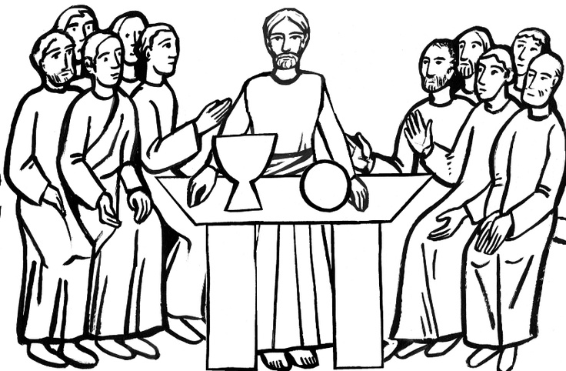

++++++++++++++++++++++++++++++++++++++++++

INFORMATION FOR NEWCOMERS: WELCOME TO CHRIST CHURCH!
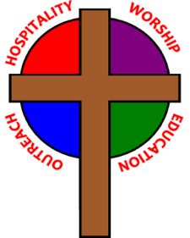
Our motto is true whether you're here for the very first time
or you've been a member for decades –
There is a place for you at God's Table!

Welcome home to Christ Church. We are so very grateful that we can worship together once again. We will need to take special care to ensure the safety of ourselves and others as we worship. Each adult must accept responsibility for his/her own actions. Here are some safety guidelines that will help keep us all safe and healthy:
- Everyone must wear a facemask over mouth and nose at all times while in church buildings, except for a few seconds during Eucharist (see below).
- Maintain a safe distance of six-feet between yourself and others not a part of your household at all times.
- NO informal gathering are allowed in church buildings. Please move directly to seats in the sanctuary upon arrival and exit the building immediately following worship.
- NO singing, even with masks on. Singing spreads the coronavirus much more widely than talking, even with masks on.
- Use the offering plate at the entrance to the sanctuary. Plates will not be passed during worship.
- COMMUNION PROCEDURES: Communion will be in one kind only – Bread only at this time and from the center aisle, not the altar rail. When it is time to come forward for Communion, please form a single line down the center aisle, maintaining six-feet of distance from others. KEEPING YOUR MASK ON, the priest will place a Host in your hands using tongs. RETURN TO YOUR SEAT, then remove your mask momentarily to consume the Host.
THE WORD OF GOD
(*please rise as you are comfortable)
Celebrant: Bless the Lord who forgives all our sins;
People: His mercy endures for ever.
Almighty God, to you all hearts are open, all desires known, and from you no secrets are hid: Cleanse the thoughts of our hearts by the inspiration of your Holy Spirit, that we may
perfectly love you, and worthily magnify your holy Name; through Christ our Lord. Amen.

*COLLECT OF THE DAY
Celebrant: The Lord be with you.
People: And also with you.
Celebrant: Let us pray.
Almighty Father, whose dear Son, on the night before he suffered, instituted the Sacrament of his Body and Blood: Mercifully grant that we may receive it thankfully in remembrance of Jesus Christ our Lord, who in these holy mysteries gives us a pledge of eternal life; and who now lives and reigns with you and the Holy Spirit, one God, for ever and ever. Amen.

THE FIRST LESSON Exodus 12:1-14

The Lord said to Moses and Aaron in the land of Egypt: This month shall mark for you the beginning of months; it shall be the first month of the year for you. Tell the whole congregation of Israel that on the tenth of this month they are to take a lamb for each family, a lamb for each household. If a household is too small for a whole lamb, it shall join its closest neighbor in obtaining one; the lamb shall be divided in proportion to the number of people who eat of it. [Your lamb shall be without blemish, a year-old male; you may take it from the sheep or from the goats. You shall keep it until the fourteenth day of this month; then the whole assembled congregation of Israel shall slaughter it at twilight. They shall take some of the blood and put it on the two doorposts and the lintel of the houses in which they eat it. They shall eat the lamb that same night; they shall eat it roasted over the fire with unleavened bread and bitter herbs. Do not eat any of it raw or boiled in water, but roasted over the fire, with its head, legs, and inner organs. You shall let none of it remain until the morning; anything that remains until the morning you shall burn.] This is how you shall eat it: your loins girded, your sandals on your feet, and your staff in your hand; and you shall eat it hurriedly. It is the Passover of the Lord. For I will pass through the land of Egypt that night, and I will strike down every firstborn in the land of Egypt, both human beings and animals; on all the gods of Egypt I will execute judgments: I am the Lord. The blood shall be a sign for you on the houses where you live: when I see the blood, I will pass over you, and no plague shall destroy you when I strike the land of Egypt.
This day shall be a day of remembrance for you. You shall celebrate it as a festival to the Lord; throughout your generations you shall observe it as a perpetual ordinance.
Lector: The Word of the Lord.
People: Thanks be to God.

*PSALM: 116:1, 10-17 Dilexi, quoniam
1 I love the Lord, because he has heard the voice of my supplication, *
because he has inclined his ear to me whenever I called upon him.
10 How shall I repay the Lord *
for all the good things he has done for me?
11 I will lift up the cup of salvation *
and call upon the Name of the Lord.
12 I will fulfill my vows to the Lord *
in the presence of all his people.
13 Precious in the sight of the Lord *
is the death of his servants.
14 O Lord, I am your servant; *
I am your servant and the child of your handmaid; you have freed me from my bonds.
15 I will offer you the sacrifice of thanksgiving *
and call upon the Name of the Lord.
16 I will fulfill my vows to the Lord *
in the presence of all his people,
17 In the courts of the Lord’s house, *
in the midst of you, O Jerusalem.

THE SECOND LESSON 1 Corinthians 11:23-26
I received from the Lord what I also handed on to you, that the Lord Jesus on the night when he was betrayed took a loaf of bread, and when he had given thanks, he broke it and said, “This is my body that is for you. Do this in remembrance of me.” In the same way he took the cup also, after supper, saying, “This cup is the new covenant in my blood. Do this, as often as you drink it, in remembrance of me.” For as often as you eat this bread and drink the cup, you proclaim the Lord’s death until he comes.
Lector: The Word of the Lord.
People: Thanks be to God.

*THE HOLY GOSPEL
Deacon: The Holy Gospel of our Lord Jesus Christ according to Luke (Luke 22:14-30).
People: Glory to you, Lord Christ.
When the hour came, Jesus took his place at the table, and the apostles with him. He said to them, "I have eagerly desired to eat this Passover with you before I suffer; for I tell you, I will not eat it until it is fulfilled in the kingdom of God." Then he took a cup, and after giving thanks he said, "Take this and divide it among yourselves; for I tell you that from now on I will not drink of the fruit of the vine until the kingdom of God comes." Then he took a loaf of bread, and when he had given thanks, he broke it and gave it to them, saying, "This is my body, which is given for you. Do this in remembrance of me." And he did the same with the cup after supper, saying, "This cup that is poured out for you is the new covenant in my blood. But see, the one who betrays me is with me, and his hand is on the table. For the Son of Man is going as it has been determined, but woe to that one by whom he is betrayed!" Then they began to ask one another, which one of them it could be who would do this.

A dispute also arose among them as to which one of them was to be regarded as the greatest. But he said to them, "The kings of the Gentiles lord it over them; and those in authority over them are called benefactors. But not so with you; rather the greatest among you must become like the youngest, and the leader like one who serves. For who is greater, the one who is at the table or the one who serves? Is it not the one at the table? But I am among you as one who serves.

"You are those who have stood by me in my trials; and I confer on you, just as my Father has conferred on me, a kingdom, so that you may eat and drink at my table in my kingdom, and you will sit on thrones judging the twelve tribes of Israel.
Deacon: The Gospel of the Lord.
People: Praise to you, Lord Christ.

THE SERMON The Rev. Canon Dr. Lee Anne Reat

THE PRAYERS OF THE PEOPLE

In peace, we pray to you Lord God.

Silence

Let us offer prayers to God who has made us a new creation in Christ, saying "Lord, have mercy."

For this parish community, that we may grow in holiness together as we prepare for the Paschal season.
Lord, have mercy.

For Justin, Archbishop of Canterbury; Michael, our Presiding Bishop; Ken, our Diocesan Bishop; Lee Anne, our priest; Rick, our deacon; and all who minister in Christ, that they may be firmly rooted in your truth and love.
Lord, have mercy.

For all the peoples of the earth and for their leaders, that we may move ever closer to your holy reign of peace, dignity, and abundant life for all.
Lord, have mercy.

For the holy work being done through and around us, in ministries such as Rainbow Table, Springfield Promise Neighborhood, Springfield Peace Center, and Partners in Ministry in Liberia, that fruits of love and mercy may be borne continually.
Lord, have mercy.

For all who are sick, afflicted, oppressed, or in need, especially Faye, Chris, Laura, Bonnie, Alice, Diana, James, Joy, Jane, Joni, Kim, Bobby, Sarah, Traudie, Lexie, and Keith, that they may be upheld by your Spirit and restored to wholeness.
Lord, have mercy.

For those celebrating birthdays, especially Wade and Vivian that they may rejoice always in you.
Lord, have mercy.

For those who have fallen asleep in Christ, for all the departed, and for those who grieve.
Lord, have mercy.

*THE COLLECT FOR PEACE
Grant, O God, that your holy and life-giving Spirit may so move every human heart, that barriers which divide us may crumble, suspicions disappear, and hatreds cease; that our divisions being healed, we may live in justice and peace; through Jesus Christ our Lord. Amen.

THE CONFESSION AND ABSOLUTION

Deacon: Let us confess our sins against God and our neighbor.
All: Most merciful God, we confess that we have sinned against you in thought, word, and deed, by what we have done, and by what we have left undone. We have not loved you with our whole heart; we have not loved our neighbors as ourselves. We are truly sorry and we humbly repent. For the sake of your Son Jesus Christ, have mercy on us and forgive us; that we may delight in your will, and walk in your ways, to the glory of your Name. Amen.

Priest: Almighty God, have mercy on you, forgive you all your sins through our Lord Jesus Christ, strengthen you in all goodness, and by the power of the Holy Spirit keep you in eternal life. Amen.
WELCOME AND ANNOUNCEMENTS

THE HOLY COMMUNION
*OFFERTORY

OFFERTORY HYMN: “The Servant Song”

*THE GREAT THANKSGIVING: EUCHARISTIC PRAYER B
Celebrant The Lord be with you.
People And also with you.
Celebrant Lift up your hearts.
People We lift them to the Lord.
Celebrant Let us give thanks to the Lord our God.
People It is right to give our thanks and praise.

It is right, and a good and joyful thing, always and everywhere to give thanks to you, Almighty God, Creator of heaven and earth. Through Jesus Christ our Lord. For our sins he was lifted high upon the cross, that he might draw the whole world to himself; and, by his suffering and death, he became the source of eternal salvation for all who put their trust in him.

Therefore we praise you, joining our voices with Angels and Archangels and with all the company of heaven, who for ever sing this hymn to proclaim the glory of your Name:

Holy, holy, holy Lord, God of power and might,
heaven and earth are full of your glory.
Hosanna in the highest.
Blessed is he who comes in the name of the Lord.
Hosanna in the highest.

We give thanks to you, O God, for the goodness and love which you have made known to us in creation; in the calling of Israel to be your people; in your Word spoken through the prophets; and above all in Jesus Christ, the Word made flesh. For in these last days you sent Jesus to be incarnate from the Virgin Mary, to be the Savior and Redeemer of the world. In Christ, you have delivered us from evil, and made us worthy to stand before you. In Christ, you have brought us out of error
into truth, out of sin into righteousness, out of death into life.

On the night before he died for us, our Savior Jesus Christ took bread; and when he had given thanks to you, he broke it, and gave it to his disciples, and said, “Take, eat: This is my Body,
which is given for you. Do this for the remembrance of me.”

After supper Jesus took the cup of wine; and when he had given thanks, he gave it to them, and said, “Drink this, all of you: This is my Blood of the new Covenant, which is shed for you and for many for the forgiveness of sins. Whenever you drink it, do this for the remembrance of me.”
Therefore, according to his command, O Father,
We remember Christ’s death,
We proclaim Christ’s resurrection,
We await Christ’s coming in glory;

And we offer our sacrifice of praise and thanksgiving to you, O Lord of all; presenting to you, from your creation, this bread and this wine. We pray you, gracious God, to send your Holy Spirit upon these gifts that they may be the Sacrament of the Body of Christ and his Blood of the new Covenant. Unite us in the sacrifice of Jesus Christ, through whom we are acceptable to you, being sanctified by the Holy Spirit.
In the fullness of time, put all things in subjection under your Christ, and bring us to that heavenly country where, with Blessed Mother Mary and all your saints, we may enter the everlasting heritage of your children; through Jesus Christ our Savior, the firstborn of all creation, the head of the Church, and the author of our salvation.
By him, and with him, and in him, in the unity of the Holy Spirit all honor and glory is yours, Almighty Father, now and for ever. AMEN.
And now, as our Savior Christ has taught us, we are bold to say,
Our Father, who art in heaven, hallowed be thy name,
thy kingdom come, thy will be done, on earth as it is in heaven.
Give us this day our daily bread.
And forgive us our trespasses,
as we forgive those who trespass against us.
And lead us not into temptation, but deliver us from evil.
For thine is the kingdom, and the power, and the glory,
for ever and ever. Amen.

THE BREAKING OF THE BREAD: Agnus Dei

Lamb of God, you take away the sins of the world: have mercy on us.
Lamb of God, you take away the sins of the world: have mercy on us.
Lamb of God, you take away the sins of the world: grant us peace.

THE INVITATION TO COMMUNION

PRAYER AFTER COMMUNION
Eternal God, heavenly Father, you have graciously accepted us as living members
of your Son our Savior Jesus Christ, and you have fed us with spiritual food
in the Sacrament of his Body and Blood. Send us now into the world in peace,
and grant us strength and courage to love and serve you
with gladness and singleness of heart; through Christ our Lord. Amen.

*THE BLESSING
Almighty God, we pray you graciously to behold this your family, for whom our Lord Jesus Christ was willing to be betrayed, and given into the hands of sinners, and to suffer death upon the cross; who lives and reigns for ever and ever. Amen.

THE STRIPPING OF THE ALTAR- Chanting of Psalm 22

*THE DISMISSAL Deacon: Go in peace to love and serve the Lord.
People: Thanks be to God.

The congregation departs in silence.

Ministers for April 1st, 2021
Altar Guild: Joan Hurley, Anita Beardsell, Sally Schwartz, and Gretchen Hicks
Lector: Anne Strothman
Ushers:
Music: Fred Bartenstein, Ed Hasecke, and Chris Oldstone-Moore
Music Technician: Fred Bartenstein

General Information
Rector: The Rev. Canon Dr. Lee Anne Reat
Deacon: The Rev. Rick Incorvati
Senior Warden: Dawn Ivy
Junior Warden: Scott Yeazell
Treasurer: Ken Bladh
Vestry at Large: Bonnie Bingman, Kay Koeninger, Jimmy Ryan,
Linda Mortensen, Joyce Spangler, Denise Sharp, Keith Doubt, and Leeza Wheeler
Parish Administrator & Program Coordinator: Kelly Zeller
Director of Music: Dr. Christopher Durrenberger
Nursery Attendant: Jerushia Knox
Facility Manager: Paul McAfee
Bookkeeper: Tina Knox

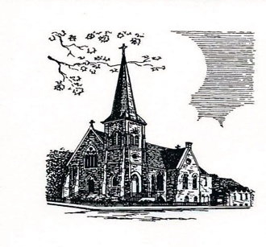

Christ Episcopal Church
409 East High Street
Springfield, Ohio 45505
937-323-8651
www.christspringfield.org

