The Nativity of our Lord
December 24th, 2019 at 3 pm
The Holy Eucharist: Rite I

++++++++++++++++++++++++++++++++++++++++++

INFORMATION FOR NEWCOMERS: WELCOME TO CHRIST CHURCH!
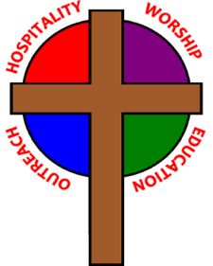
Our motto is true whether you're here for the very first time
or you've been a member for decades –
There is a place for you at God's Table!

The worship service has two main parts: the Liturgy of the Word, which includes Scripture readings and a sermon, and the Liturgy of the Table, which is also called Holy Eucharist or Communion. You will notice moments in the service when people stand, kneel, bow, and make the sign of the cross -- all of these are completely optional. You are encouraged to participate in every aspect of worship, according to your comfort level.
All who seek Christ are welcome at His Table for Communion. If you do not wish to receive communion, you may come forward and request a blessing. If you wish to receive communion in your pew, please notify the ushers. And if you need a gluten-free wafer, just let Rev. Maggie know.

If you have not been baptized, or if you have questions about Holy Baptism, please talk to Rev. Maggie and/or Deacon Rick after the service -- the people of Christ Church would love to walk with you to your baptism and beyond!
THE WORD OF GOD
(*please rise as you are comfortable)
PRELUDE: O Christmas Tree, O Little Town of Bethlehem, Away in a Manger, Greensleeves, We Three Kings, Angels We Have Heard on High, Angels From the Realm of Glory, Joy to the World

PROCESSIONAL HYMN: “O little town of Bethlehem” Hymnal 79

*OPENING ACCLAMATION
Celebrant: Blessed be God: Father, Son, and Holy Spirit.
People: And blessed be his kingdom, now and forever. Amen.

*COLLECT FOR PURITY
Almighty God, unto whom all hearts are open, all desires known, and from whom no secrets are hid: Cleanse the thoughts of our hearts by the inspiration of thy Holy Spirit, that we may perfectly love thee, and worthily magnify thy holy Name; through Christ our Lord. Amen.

*SONG OF PRAISE: “The first Nowell” Hymnal 109 vs. 1

The first Nowell the angel did say was to certain poor shepherds in fields as they lay;
in fields as they lay, keeping their sheep, on a cold winter's night that was so deep.
Nowell, Nowell, Nowell, Nowell, born is the King of Israel.

*COLLECT OF THE DAY
Celebrant: The Lord be with you.
People: And with thy spirit.
Let us pray.

O God, you have caused this holy night to shine with the brightness of the true Light: Grant that we, who have known the mystery of that Light on earth, may also enjoy him perfectly in heaven; where with you and the Holy Spirit he lives and reigns, one God, in glory everlasting. Amen.

THE FIRST LESSON Isaiah 52:7-10

How beautiful upon the mountains are the feet of the messenger who announces peace,
who brings good news, who announces salvation, who says to Zion, "Your God reigns." Listen!
Your sentinels lift up their voices, together they sing for joy; for in plain sight
they see the return of the Lord to Zion.
Break forth together into singing, you ruins of Jerusalem;
for the Lord has comforted his people, he has redeemed Jerusalem.
The Lord has bared his holy arm before the eyes of all the nations; and all the ends of the earth shall see
the salvation of our God.

Lector: The Word of the Lord.
People: Thanks be to God.

THE RESPONSE: Psalm 98
1 Sing to the Lord a new song, *
for he has done marvelous things.
2 With his right hand and his holy arm *
has he won for himself the victory.
3 The Lord has made known his victory; *
his righteousness has he openly shown in the sight of the nations.
4 He remembers his mercy and faithfulness to the house of Israel, *
and all the ends of the earth have seen the victory of our God.
5 Shout with joy to the Lord, all you lands; *
lift up your voice, rejoice, and sing.
6 Sing to the Lord with the harp, *
with the harp and the voice of song.
7 With trumpets and the sound of the horn *
shout with joy before the King, the Lord.
8 Let the sea make a noise and all that is in it, *
the lands and those who dwell therein.
9 Let the rivers clap their hands, *
and let the hills ring out with joy before the Lord,
when he comes to judge the earth.
10 In righteousness shall he judge the world *
and the peoples with equity.

THE SECOND LESSON Hebrews 1:1-4

Long ago God spoke to our ancestors in many and various ways by the prophets, but in these last days he has spoken to us by a Son, whom he appointed heir of all things, through whom he also created the worlds. He is the reflection of God's glory and the exact imprint of God's very being, and he sustains all things by his powerful word. When he had made purification for sins, he sat down at the right hand of the Majesty on high, having become as much superior to angels as the name he has inherited is more excellent than theirs.

Lector: The Word of the Lord.
People: Thanks be to God.

SEQUENCE HYMN: “Come now, O Prince of Peace”
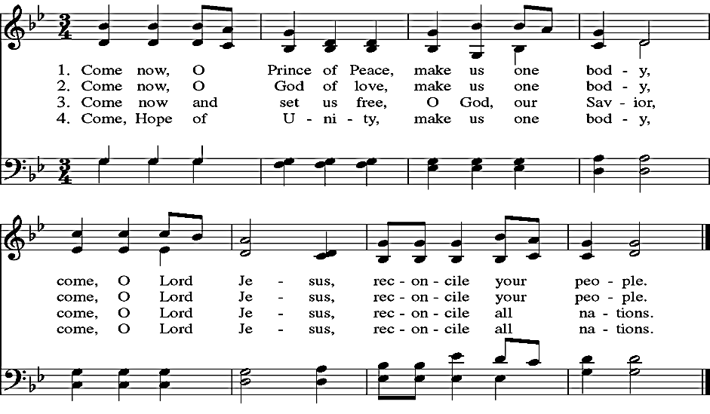

*THE HOLY GOSPEL John 1:1-14

Deacon: The Holy Gospel of our Lord Jesus Christ according to John.
People: Glory be to thee, O Lord.

In the beginning was the Word, and the Word was with God, and the Word was God. He was in the beginning with God. All things came into being through him, and without him not one thing came into being. What has come into being in him was life, and the life was the light of all people. The light shines in the darkness, and the darkness did not overcome it.

There was a man sent from God, whose name was John. He came as a witness to testify to the light, so that all might believe through him. He himself was not the light, but he came to testify to the light. The true light, which enlightens everyone, was coming into the world.

He was in the world, and the world came into being through him; yet the world did not know him. He came to what was his own, and his own people did not accept him. But to all who received him, who believed in his name, he gave power to become children of God, who were born, not of blood or of the will of the flesh or of the will of man, but of God.

And the Word became flesh and lived among us, and we have seen his glory, the glory as of a father's only son, full of grace and truth.

Deacon: The Gospel of the Lord.
People: Praise be to thee, O Christ.

THE SERMON The Rev. Maggie Leidheiser-Stoddard

GOSPEL HYMN: “Lo, how a Rose e’er blooming” Hymnal 81

THE NICENE CREED

We believe in one God, the Father, the Almighty,
maker of heaven and earth, of all that is, seen and unseen.
We believe in one Lord, Jesus Christ, the only Son of God,
eternally begotten of the Father, God from God,
Light from Light, true God from true God,
begotten, not made, of one Being with the Father;
through him all things were made.
For us and for our salvation he came down from heaven: by the power of the Holy Spirit
he became incarnate from the Virgin Mary, and was made man.
For our sake he was crucified under Pontius Pilate;
he suffered death and was buried.
On the third day he rose again in accordance with the Scriptures;
He ascended into heaven and is seated at the right hand of the Father.
He will come again in glory to judge the living and the dead, and his kingdom will have no end.
We believe in the Holy Spirit, the Lord, the giver of life,
who proceeds from the Father and the Son.
With the Father and the Son he is worshiped and glorified.
He has spoken through the prophets.
We believe in one holy catholic and apostolic Church.
We acknowledge one baptism for the forgiveness of sins.
We look for the resurrection of the dead, and the life of the world to come. Amen.
*THE PRAYERS OF THE PEOPLE
The people respond after each petition: Hear our prayer.

Let us pray for the whole state of Christ’s Church and the world.

Almighty and everliving God, who in thy holy Word hast taught us to make prayers, and supplications, and to give thanks for all people: Receive these our prayers which we offer unto thy divine Majesty, beseeching thee to inspire continually the Universal Church with the spirit of truth, unity, and concord; and grant that all those who do confess thy holy Name may agree in the truth of thy holy Word, and live in unity and godly love.
Lord in thy mercy
Hear our prayer.

Give grace, O heavenly Father, to all bishops and other ministers, that they may, both by their life and doctrine, set forth thy true and lively Word, and rightly and duly administer thy holy sacraments.
Lord in thy mercy
Hear our prayer.

And to all thy people give thy heavenly grace, and especially to this congregation here present; that, with meek heart and due reverence, they may hear and receive thy holy Word, truly serving thee in holiness and righteousness all the days of their life.
Lord in thy mercy
Hear our prayer.

We beseech thee also so to rule the hearts of those who bear the authority of government in this and every land, that they may be led to wise decisions and right actions for the welfare and peace of the world.
Lord in thy mercy
Hear our prayer.

Open, O Lord, the eyes of all people to behold thy gracious hand in all thy works, that, rejoicing in thy whole creation, they may honor thee with their substance, and be faithful stewards of thy bounty.
Lord in thy mercy
Hear our prayer.

And we most humbly beseech thee, of thy goodness, O Lord, to comfort and succor all those who, in this transitory life, are in trouble, sorrow, need, sickness, or any other adversity.
Lord in thy mercy
Hear our prayer.

And we also bless thy holy Name for all thy servants departed this life in thy faith and fear, beseeching thee to grant them continual growth in thy love and service; and to grant us grace so to follow the good examples of all thy saints, that with them we may be partakers of thy heavenly kingdom.
Lord in thy mercy
Hear our prayer.

Grant these our prayers, O Father, for Jesus Christ’s sake, our only Mediator and Advocate. Amen.

*THE COLLECT FOR PEACE
Grant, O God, that your holy and life-giving Spirit may so move every human heart, that barriers which divide us may crumble, suspicions disappear, and hatreds cease; that our divisions being healed, we may live in justice and peace; through Jesus Christ our Lord. Amen.

THE CONFESSION AND ABSOLUTION

Deacon: Let us humbly confess our sins unto Almighty God.
All: Most merciful God, we confess that we have sinned against thee in thought, word, and deed,
by what we have done, and by what we have left undone. We have not loved thee with our whole heart;
we have not loved our neighbors as ourselves. We are truly sorry and we humbly repent.
For the sake of thy Son Jesus Christ, have mercy on us and forgive us; that we may delight in thy will,
and walk in thy ways, to the glory of thy Name. Amen.

The Celebrant pronounces the absolution.

*SHARING OF THE PEACE
Celebrant: The peace of the Lord be always with you.
People: And with thy spirit.

WELCOME AND ANNOUNCEMENTS

THE HOLY COMMUNION

THE OFFERTORY: Good King Wenceslas - O Come, All Ye Faithful

*PRESENTATION HYMN: “Away in a manger” Hymnal 101

*THE GREAT THANKSGIVING: EUCHARISTIC PRAYER II
Celebrant The Lord be with you.
People And with thy spirit.
Celebrant Lift up your hearts.
People We lift them up unto the Lord.
Celebrant Let us give thanks unto our Lord God.
People It is meet and right so to do.

It is very meet, right, and our bounden duty, that we should at all times, and in all places, give thanks unto thee, O Lord, holy Father, almighty, everlasting God. Because thou didst give Jesus Christ, thine only Son, to be
born for us; who, by the mighty power of the Holy Ghost, was made very Man of the substance of the Virgin Mary his mother; that we might be delivered from the bondage of sin, and receive power to become thy children.

Therefore with Angels and Archangels, and with all the company of heaven, we laud and magnify thy glorious
Name; evermore praising thee, and saying,

Holy, holy, holy, Lord God of Hosts:
Heaven and earth are full of thy glory.
Glory be to thee, O Lord Most High.
Blessed is he that cometh in the name of the Lord.
Hosanna in the highest.

All glory be to thee, O Lord our God, for that thou didst create heaven and earth, and didst make us in thine own
image; and, of thy tender mercy, didst give thine only Son Jesus Christ to take our nature upon him, and to suffer death upon the cross for our redemption. He made there a full and perfect sacrifice for the whole world; and did institute, and in his holy Gospel command us to continue, a perpetual memory of that his precious death and sacrifice, until his coming again.

For in the night in which he was betrayed, he took bread; and when he had given thanks to thee, he broke it, and gave it to his disciples, saying, "Take, eat, this is my Body, which is given for you. Do this in remembrance of me."

Likewise, after supper, he took the cup; and when he had given thanks, he gave it to them, saying, "Drink this, all of you; for this is my Blood of the New Covenant, which is shed for you, and for many, for the remission of sins. Do this, as oft as ye shall drink it, in remembrance of me."

Wherefore, O Lord and heavenly Father, we thy people do celebrate and make, with these thy holy gifts which we now offer unto thee, the memorial thy Son hath commanded us to make; having in remembrance his blessed passion and precious death, his mighty resurrection and glorious ascension; and looking for his coming again with power and great glory.

And we most humbly beseech thee, O merciful Father, to hear us, and, with thy Word and Holy Spirit, to bless and sanctify these gifts of bread and wine, that they may be unto us the Body and Blood of thy dearly-beloved Son Jesus Christ.

And we earnestly desire thy fatherly goodness to accept this our sacrifice of praise and thanksgiving, whereby we offer and present unto thee, O Lord, our selves, our souls and bodies. Grant, we beseech thee, that all who partake of this Holy Communion may worthily receive the most precious Body and Blood of thy Son Jesus
Christ, and be filled with thy grace and heavenly benediction; and also that we and all thy whole Church may be made one body with him, that he may dwell in us, and we in him; through the same Jesus Christ our Lord;
By whom, and with whom, and in whom, in the unity of the Holy Ghost all honor and glory be unto thee, O Father Almighty, world without end. AMEN.

And now, as our Savior Christ hath taught us, we are bold to say,
Our Father, who art in heaven, hallowed be thy name,
thy kingdom come, thy will be done, on earth as it is in heaven.
Give us this day our daily bread.
And forgive us our trespasses,
as we forgive those who trespass against us.
And lead us not into temptation, but deliver us from evil.
For thine is the kingdom, and the power, and the glory,
for ever and ever. Amen.

THE BREAKING OF THE BREAD Hymnal S164
(front section of Hymnal)

Jesus, Lamb of God: have mercy on us.
Jesus, bearer of our sins: have mercy on us.
Jesus, redeemer, redeemer of the world:
give us your peace, give us your peace.

THE INVITATION TO COMMUNION

COMMUNION HYMNS: “What child is this?” Hymnal 115
“Silent Night” Hymnal 111

THE PRAYER AFTER COMMUNION
Almighty and everliving God, we most heartily thank thee for that thou dost feed us, in these holy mysteries, with the spiritual food of the most precious Body and Blood of thy Son our Savior Jesus Christ; and dost assure us thereby of thy favor and goodness towards us; and that we are very
members incorporate in the mystical body of thy Son, the blessed company of all faithful people; and are also heirs, through hope, of thy everlasting kingdom. And we humbly beseech thee, O heavenly Father, so to assist us with thy grace, that we may continue in that holy fellowship, and do all such good works as thou hast prepared for us to walk in; through Jesus Christ our Lord, to whom with thee and the
Holy Ghost, be all honor and glory, world without end. Amen.

*THE BLESSING
The Celebrant pronounces God’s blessing over the people. The people respond: Amen.

*CLOSING HYMN: “The snow lay on the ground” Hymnal 110

*THE DISMISSAL Deacon: Go in peace to love and serve the Lord. Alleluia, alleluia.
People: Thanks be to God. Alleluia, alleluia.

POSTLUDE: Jesu, Joy of Man’s Desiring

If you leave during the postlude, please do so quietly, so that others may enjoy the music. Thank you!

Merry Christmas!

ANNOUNCEMENTS

UPDATE: Financial Support Pledged for 2020
As of December 16th, we have received 75 pledges of financial support for next year, totaling $187,823.44. This includes 9 new pledging units, and 22 established units who increased their pledge amounts. THANK YOU to all who have pledged to support Christ Church in 2020! We still have not reached our pledge goal of $213,000; so if you have not yet pledged, please consider doing so to support your church and its ministries. Extra pledge cards are available in the east entrance.

Church Office Closed
Due to the Christmas and New Year's holidays, the Church Office will be CLOSED from Monday, December 23rd through Friday, January 3rd. Your staff will be enjoying some much-needed vacation time. The office will reopen on Monday, January 6th.

Sunday, December 29th
Join us next Sunday, December 29th for a Combined Rite service of Morning Prayer with carols at 9 am. We’ll return to our regular worship schedule on Sunday, January 5th.

Christmas Flowers 2019

In loving memory of Jim Beardsell by Anita Beardsell

In thanksgiving for Sarah Healy and Lucy Albright and in memory of Clarence Alright by Joann Albright

In memory of Ben Schwartz and Dennis Sullivan by Sally Schwartz and family

In memory of Cal, Merlene and Scott Warren by Kay Koeninger and David Warren

In memory of Henry W. Roberts by Martha Chaney

In memory of our parents and in thanksgiving for our family by Denny and Sharon Wells

In thanksgiving for our daughters Katie and Barbie and their families by Scott and Cathy Yeazell

In memory of Donna Swafford and Jean Smith and in thanksgiving for Madison & Reilly Smith by Lori Swafford and Rand Smith

In memory of Martin C. Hawkins III, Eugenia Nola “Lovey” Williams Ray, and in thanksgiving for Rob, Harrison, Henry, Hamilton, and Jesse by Molly Young

In memory of Don and Dorothy Wiegal by Julie Wiegel Brust

Ministers for December 24, 2019
Altar Guild: Sally Schwartz and Anita Beardsell
Acolyte: Bill Yeazell
Ushers: Dan McGregor, Angus Randolph, and Steve Sharp
Guest Musician: Christina Darding

General Information
Rector: The Rev. Maggie Leidheiser-Stoddard
Deacon: The Rev. Rick Incorvati
Senior Warden: Dawn Ivy
Junior Warden: John Richardson
Treasurer: Ken Bladh
Vestry at Large: Bonnie Bingman, Chris Oldstone-Moore, Cathy Hasecke,
Brian Shelburne, Joyce Spangler, Denise Sharp, and Chris Wells
Parish Administrator & Program Coordinator: Kelly Zeller
Director of Music: Dr. Christopher Durrenberger
Youth Teacher: Abby Glass
Nursery Attendant: Jerushia Knox
Facility Manager: Paul McAfee
Bookkeeper: Tina Knox

Thank you for worshipping at Christ Church today, and may the Lord be with you!

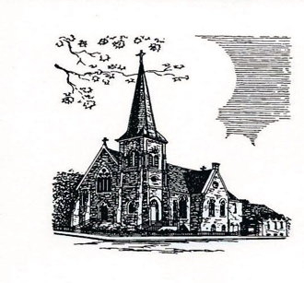

Christ Episcopal Church
409 East High Street
Springfield, Ohio 45505
937-323-8651
www.christspringfield.org

