The Last Sunday after Epiphany
February 23rd 2020 at 9:00 am
The Holy Eucharist: A Combined Rite Service

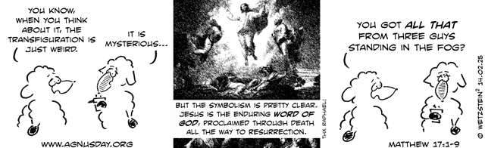

"Agnus Day lectionary comic appears with the permission of www.agnusday.org"

++++++++++++++++++++++++++++++++++++++++++

INFORMATION FOR NEWCOMERS: WELCOME TO CHRIST CHURCH!
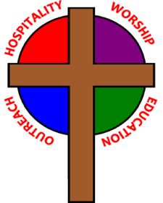
Our motto is true whether you're here for the very first time
or you've been a member for decades –
There is a place for you at God's Table!

The worship service has two main parts: the Liturgy of the Word, which includes Scripture readings and a sermon, and the Liturgy of the Table, which is also called Holy Eucharist or Communion. You will notice moments in the service when people stand, kneel, bow, and make the sign of the cross -- all of these are completely optional. You are encouraged to participate in every aspect of worship, according to your comfort level.

Children of all ages are welcome to stay in worship. There is Nursery care available for babies and toddlers downstairs, and Children’s Chapel during the first part of the service for preschoolers through 5th graders.

All who seek Christ are welcome at His Table for Communion. If you do not wish to receive communion, you may come forward and request a blessing. If you wish to receive communion in your pew, please notify the ushers. And if you need a gluten-free wafer, just let Rev. Maggie know.

Most Sundays, Myra Dean Banion provides personal prayers at the station to the right of the communion rail during the distribution of the Sacrament. All prayer concerns are confidential. The clergy are also available for prayer following the worship service, if desired.

If you have not been baptized, or if you have questions about Holy Baptism, please talk to Rev. Maggie and/or Deacon Rick after the service -- the people of Christ Church would love to walk with you to your baptism and beyond!
THE WORD OF GOD
(*please rise as you are comfortable)
PRELUDE: “Jesu, Joy of Man’s Desiring” (Werde Munter/arr.Keene)

PROCESSIONAL HYMN: “O wondrous type! O vision fair” Hymnal 137

*OPENING ACCLAMATION
Celebrant: Blessed be God: Father, Son, and Holy Spirit.
People: And blessed be his kingdom, now and for ever. Amen.

*COLLECT FOR PURITY
Almighty God, unto whom all hearts are open, all desires known, and from whom no secrets are hid: Cleanse the thoughts of our hearts by the inspiration of thy Holy Spirit, that we may perfectly love thee, and worthily magnify thy holy Name; through Christ our Lord. Amen.

* KYRIE Lord, have mercy. Lord, have mercy. Hymnal S96
Christ, have mercy. Christ, have mercy. (front section of the Hymnal)
Lord, have mercy. Lord, have mercy.
Lord, have mercy, have mercy.

(During the song, any children who wish to attend Children’s Chapel may follow the acolyte out.)

*COLLECT OF THE DAY

Celebrant: The Lord be with you.
People: And with thy spirit.
O God, who before the passion of thy only-begotten Son didst reveal his glory upon the holy mountain: Grant unto us that we, beholding by faith the light of his countenance, may be strengthened to bear our cross, and be changed into his likeness from glory to glory; through the same Jesus Christ our Lord, who liveth and reigneth with thee and the Holy Spirit, one God, for ever and ever. Amen.

THE FIRST LESSON Exodus 24:12-18

The Lord said to Moses, “Come up to me on the mountain, and wait there; and I will give you the tablets of stone, with the law and the commandment, which I have written for their instruction.” So Moses set out with his assistant Joshua, and Moses went up into the mountain of God. To the elders he had said, “Wait here for us, until we come to you again; for Aaron and Hur are with you; whoever has a dispute may go to them.”

Then Moses went up on the mountain, and the cloud covered the mountain. The glory of the Lord settled on Mount Sinai, and the cloud covered it for six days; on the seventh day he called to Moses out of the cloud. Now the appearance of the glory of the Lord was like a devouring fire on the top of the mountain in the sight of the people of Israel. Moses entered the cloud, and went up on the mountain. Moses was on the mountain for forty days and forty nights.

Lector: The Word of the Lord.
People: Thanks be to God.

THE RESPONSE Psalm 99

1 The Lord is King; let the people tremble; *
he is enthroned upon the cherubim; let the earth shake.
2 The Lord is great in Zion; *
he is high above all peoples.
3 Let them confess his Name, which is great and awesome; *
he is the Holy One.
4 "O mighty King, lover of justice, you have established equity; *
you have executed justice and righteousness in Jacob."
5 Proclaim the greatness of the Lord our God and fall down before his footstool; *
he is the Holy One.
6 Moses and Aaron among his priests, and Samuel among those who call upon his Name, *
they called upon the Lord, and he answered them.
7 He spoke to them out of the pillar of cloud; *
they kept his testimonies and the decree that he gave them.
8 O Lord our God, you answered them indeed; *
you were a God who forgave them, yet punished them for their evil deeds.
9 Proclaim the greatness of the Lord our God and worship him upon his holy hill; *
for the Lord our God is the Holy One.

THE SECOND LESSON 2 Peter 1:16-21

We did not follow cleverly devised myths when we made known to you the power and coming of our Lord Jesus Christ, but we had been eyewitnesses of his majesty. For he received honor and glory from God the Father when that voice was conveyed to him by the Majestic Glory, saying, “This is my Son, my Beloved, with whom I am well pleased.” We ourselves heard this voice come from heaven, while we were with him on the holy mountain.

So we have the prophetic message more fully confirmed. You will do well to be attentive to this as to a lamp shining in a dark place, until the day dawns and the morning star rises in your hearts. First of all you must understand this, that no prophecy of scripture is a matter of one’s own interpretation, because no prophecy ever came by human will, but men and women moved by the Holy Spirit spoke from God.

*GOSPEL HYMN: “Christ upon the mountain peak” Hymnal 129 vs 1-2

*THE HOLY GOSPEL Matthew 17:1-9

Deacon: The Holy Gospel of our Lord Jesus Christ according to Matthew.
People: Glory to you, Lord Christ.

Six days later, Jesus took with him Peter and James and his brother John and led them up a high mountain, by themselves. And he was transfigured before them, and his face shone like the sun, and his clothes became dazzling white. Suddenly there appeared to them Moses and Elijah, talking with him. Then Peter said to Jesus, “Lord, it is good for us to be here; if you wish, I will make three dwellings here, one for you, one for Moses, and one for Elijah.” While he was still speaking, suddenly a bright cloud overshadowed them, and from the cloud a voice said, “This is my Son, the Beloved; with him I am well pleased; listen to him!” When the disciples heard this, they fell to the ground and were overcome by fear. But Jesus came and touched them, saying, “Get up and do not be afraid.” And when they looked up, they saw no one except Jesus himself alone.
As they were coming down the mountain, Jesus ordered them, “Tell no one about the vision until after the Son of Man has been raised from the dead.”
Deacon: The Gospel of the Lord.
People: Praise to you, Lord Christ.

*GOSPEL HYMN: “Christ upon the mountain peak” Hymnal 129 vs 3-4

SERMON The Rev. Maggie Leidheiser-Stoddard

*THE NICENE CREED

We believe in one God, the Father, the Almighty,
maker of heaven and earth, of all that is, seen and unseen.
We believe in one Lord, Jesus Christ, the only Son of God,
eternally begotten of the Father, God from God,
Light from Light, true God from true God,
begotten, not made, of one Being with the Father.
Through him all things were made.
For us and for our salvation he came down from heaven, was incarnate of
the Holy Spirit and the Virgin Mary and became truly human.
For our sake he was crucified under Pontius Pilate;
he suffered death and was buried.
On the third day he rose again in accordance with the Scriptures;
he ascended into heaven and is seated at the right hand of the Father.
He will come again in glory to judge the living and the dead, and his kingdom will have no end.
We believe in the Holy Spirit, the Lord, the giver of life,
who proceeds from the Father,
who with the Father and the Son is worshiped and glorified,
who has spoken through the prophets.
We believe in one holy catholic and apostolic Church.
We acknowledge one baptism for the forgiveness of sins.
We look for the resurrection of the dead, and the life of the world to come. Amen.

*THE PRAYERS OF THE PEOPLE

Dear Jesus, you came to bring light and love into the world. Your light shines in the darkness of these winter days and nights. May we also shine brightly.

Light of the World, we ask your light upon the Church and its servants. Enlighten Justin, Archbishop of Canterbury; Michael, our Presiding Bishop; Tom, our bishop; Maggie, our priest; and Rick, our deacon. Grant light to each member and guest of this parish. Grant special light to those celebrating birthdays and anniversaries this week [especially ___________].
May your light be reflected in the Church’s mission and unity.

Light of Life, we pray for your light to shine on the nations of the world and their leaders. Enlighten our president, members of Congress, and local authorities. Give them hearts for justice and peace.
May your light be reflected in the governments of our world.
Light of the World, you have called us to be salt and light in our broken world. Enlighten us in our service and our various ministries, [especially___________].
May your light be reflected in our works of mercy.

Light of Life, your grace shines in our times of sickness and trouble. Shine on those who suffer in body, mind, or spirit, [especially__________].
May your light be reflected in our seasons of pain and difficulty.

Light of the World, you shine in the darkness, and the darkness does not overcome your light. We pray for that eternal light to shine on all who have died [especially__________] and to ease the grief of those who mourn their departing.
May your light be reflected in our loss and grief.

*THE COLLECT FOR PEACE
Grant, O God, that your holy and life-giving Spirit may so move every human heart, that barriers which divide us may crumble, suspicions disappear, and hatreds cease; that our divisions being healed, we may live in justice and peace; through Jesus Christ our Lord. Amen.

THE CONFESSION AND ABSOLUTION

Deacon: Let us humbly confess our sins unto Almighty God.
All: Most merciful God, we confess that we have sinned against thee in thought, word, and deed, by what we have done, and by what we have left undone. We have not loved thee with our whole heart; we have not loved our neighbors as ourselves. We are truly sorry and we humbly repent. For the sake of thy Son Jesus Christ, have mercy on us and forgive us; that we may delight in thy will, and walk in thy ways, to the glory of thy Name. Amen.

The Celebrant pronounces the absolution, and offers the “Comfortable Words.”

*SHARING OF THE PEACE
Celebrant: The peace of the Lord be always with you.
People: And with thy spirit.

WELCOME AND ANNOUNCEMENTS

THE HOLY COMMUNION

THE OFFERTORY: “The First Song of Isaiah” (Jack Noble White)
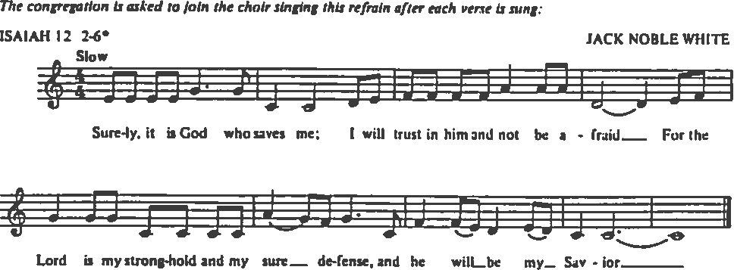

*PRESENTATION: Praise God from whom all blessings flow; Tune: Old 100th
Praise God, all creatures here below;
Praise God for all that love has done:
Creator, Christ, and Spirit, one! Amen.

*THE GREAT THANKSGIVING: EUCHARISTIC PRAYER C
Celebrant The Lord be with you.
People And also with you.
Celebrant Lift up your hearts.
People We lift them to the Lord.
Celebrant Let us give thanks to the Lord our God.
People It is right to give God thanks and praise.

God of all power, Ruler of the Universe, you are worthy of glory and praise. Glory to you for ever and ever.

At your command all things came to be: the vast expanse of interstellar space, galaxies, suns, the planets in their courses, and this fragile earth, our island home. By your will they were created and have their being.

From the primal elements you brought forth the human race, and blessed us with memory, reason, and skill. You made us the stewards of creation. But we turned against you, and betrayed your trust; and we turned against one another. Have mercy, Lord, for we are sinners in your sight.

Again and again, you called us to return. Through prophets and sages you revealed your righteous Law. And in the fullness of time you sent your only Son, born of a woman, to fulfill your Law, to open for us the way of freedom and peace. By his blood, he reconciled us. By his wounds, we are healed.

And therefore we praise you, joining with the heavenly chorus, with prophets, apostles, and martyrs, and with all those in every generation who have looked to you in hope, to proclaim with them your glory, in their unending hymn:

Holy, Holy, Holy Lord, God of power and might, Hymnal S130
Holy, Holy, Holy Lord, God of power and might, (front section of the Hymnal)
heaven and earth are full, full of your glory.
Hosanna in the highest. Hosanna in the highest.
Blessed is he who comes in the name of the Lord.
Hosanna in the highest. Hosanna in the highest.

And so, Father, we who have been redeemed by him, and made a new people by water and the Spirit, now bring before you these gifts. Sanctify them by your Holy Spirit to be the Body and Blood of Jesus Christ our Lord.

On the night he was betrayed he took bread, said the blessing, broke the bread, and gave it to his friends, and said, “Take, eat: This is my Body, which is given for you. Do this for the remembrance of me.”

After supper, he took the cup of wine, gave thanks, and said, “Drink this, all of you: This is my Blood of the new Covenant, which is shed for you and for many for the forgiveness of sins. Whenever you drink it, do this for the remembrance of me.”

Remembering now his work of redemption, and offering to you this sacrifice of thanksgiving,

We celebrate his death and resurrection, as we await the day of his coming.

Lord God of our Ancestors; God of Abraham and Sarah, Isaac and Rebecca, Jacob, Rachel and Leah; God and Father of our Lord Jesus Christ: Open our eyes to see your hand at work in the world about us. Deliver us from the presumption of coming to this Table for solace only, and not for strength; for pardon only, and not for renewal. Let the grace of this Holy Communion make us one body, one spirit in Christ, that we may worthily serve the world in his name. Risen Lord, be known to us in the breaking of the Bread.

Accept these prayers and praises, Father, through Jesus Christ our great High Priest, to whom, with you and the Holy Spirit, your Church gives honor, glory, and worship, from generation to generation. Amen.

And now, as our Savior Christ has taught us, we are bold to say,
Our Father, who art in heaven, hallowed be thy name,
thy kingdom come, thy will be done, on earth as it is in heaven.
Give us this day our daily bread.
And forgive us our trespasses,
as we forgive those who trespass against us.
And lead us not into temptation, but deliver us from evil.
For thine is the kingdom, and the power, and the glory,
for ever and ever. Amen.

THE BREAKING OF THE BREAD Hymnal S164
Jesus, Lamb of God: have mercy on us. (front section of Hymnal)
Jesus, bearer of our sins: have mercy on us.
Jesus, redeemer, redeemer of the world:
give us your peace, give us your peace.

THE INVITATION TO COMMUNION

COMMUNION HYMN: “How lovely is thy dwelling-place” Hymnal 517
During the month of February, this will be our communion hymn. Please sing as you feel moved, and
through the repetition, allow the hymn to become a prayer.

THE PRAYER AFTER COMMUNION
Almighty and everliving God, we most heartily thank thee for that thou dost feed us, in these holy mysteries, with the spiritual food of the most precious Body and Blood of thy Son our Savior Jesus Christ; and dost assure us thereby of thy favor and goodness towards us; and that we are very members incorporate in the mystical body of thy Son, the blessed company of all faithful people; and are also heirs, through hope, of thy everlasting kingdom. And we humbly beseech thee, O heavenly Father, so to assist us with thy grace, that we may continue in that holy fellowship, and do all such good works as thou hast prepared for us to walk in; through Jesus Christ our Lord, to whom with thee and the Holy Ghost, be all honor and glory, world without end. Amen.

*THE BLESSING
The Celebrant pronounces God’s blessing over the people. The people respond: Amen.

*CLOSING HYMN: “When morning gilds the skies” Hymnal 427

*THE SENDING OF THE EUCHARISTIC MINISTER (as needed)
Deacon: In the name of this congregation, I send you forth bearing these holy gifts, that those to whom you go may share with us in the communion of Christ’s body and blood.
People: We who are many are one body, for we all share one bread, one cup.

*THE DISMISSAL Deacon: Go in peace to love and serve the Lord. Alleluia, alleluia.
People: Thanks be to God. Alleluia, alleluia.

POSTLUDE: “Lay Up For Yourselves” (Ned Rorem)

If you leave during the postlude, please do so quietly, so that others may enjoy the music. Thank you!

Please join us for the Annual Meeting downstairs in the Parish Hall following the service!
+++++++++++++++++++++++++++++++++++++++++++++++++++++++++

Ministers for February 23rd, 2020
Altar Guild: Susie Peterson and Joan Hurley
Acolytes: Sarah Schubert and Leeza Wheeler
Chalice Bearers: The Rev. Rick Incorvati and Mark Brooks Hedstrom
Lectors: Sarah Schubert and Ann Chitkara
Prayers: Fred Bartenstein
Ushers: Dan McGregor, Bill Hicks, and Angus Randolph
Children’s Chapel: Cathy Waggoner and Kelly Zeller
Tellers: Pat Duncan and Marilyn Howat
Greeters: Jack Ivy and Ron Dowling

General Information
Rector: The Rev. Maggie Leidheiser-Stoddard
Deacon: The Rev. Rick Incorvati
Senior Warden: Dawn Ivy
Junior Warden: John Richardson
Treasurer: Ken Bladh
Vestry at Large: Bonnie Bingman, Chris Oldstone-Moore, Cathy Hasecke,
Brian Shelburne, Joyce Spangler, Denise Sharp, and Chris Wells
Parish Administrator & Program Coordinator: Kelly Zeller
Director of Music: Dr. Christopher Durrenberger
Youth Teacher: Abby Glass
Nursery Attendant: Jerushia Knox
Facility Manager: Paul McAfee
Bookkeeper: Tina Knox

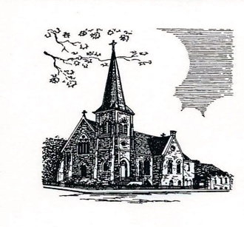

Christ Episcopal Church
409 East High Street
Springfield, Ohio 45505
937-323-8651
www.christspringfield.org

