MORNING PRAYER for August 9th, 2020 at 9 am: Tenth Sunday after Pentecost
Note: We invite you to light a candle on your table or home altar before worship begins.

God is Spirit, and those who worship must worship in spirit and in truth. John 4:24

The Invitatory & Psalter BCP p. 81

Lord, open our lips.
And our mouth shall proclaim your praise.
Glory to the Father, and to the Son, and to the Holy Spirit:
as it was in the beginning, is now, and will be for ever. Amen.

Invitatory Psalm Psalm 67:1-5 Deus misereatur from Enriching Our Worship

O God, be merciful to us and bless us, *
show us the light of your countenance and come to us.
Let your ways be known upon earth, *
your saving health among all nations.
Let the peoples praise you, O God; *
let all the peoples praise you.
Let the nations be glad and sing for joy, *
for you judge the peoples with equity and guide all the nations upon earth.
Let the peoples praise you, O God; *
let all the peoples praise you.

Psalm Appointed Psalm 105:1-6, 16-22, 45b Confitemini Domino BCP p. 738

1 Give thanks to the Lord and call upon his Name; *
make known his deeds among the peoples.
2 Sing to him, sing praises to him, *
and speak of all his marvelous works.
3 Glory in his holy Name; *
let the hearts of those who seek the Lord rejoice.
4 Search for the Lord and his strength; *
continually seek his face.
5 Remember the marvels he has done, *
his wonders and the judgments of his mouth,
6 O offspring of Abraham his servant, *
O children of Jacob his chosen.
16 Then he called for a famine in the land *
and destroyed the supply of bread.
17 He sent a man before them, *
Joseph, who was sold as a slave.
18 They bruised his feet in fetters; *
his neck they put in an iron collar.
19 Until his prediction came to pass, *
the word of the Lord tested him.
20 The king sent and released him; *
the ruler of the peoples set him free.
21 He set him as a master over his household,
as a ruler over all his possessions,
22 To instruct his princes according to his will
and to teach his elders wisdom.
45 Hallelujah!
Glory to the Father, and to the Son, and to the Holy Spirit:
as it was in the beginning, is now, and will be for ever. Amen.

Sequence Hymn: #390 “Praise to the Lord, the Almighty”
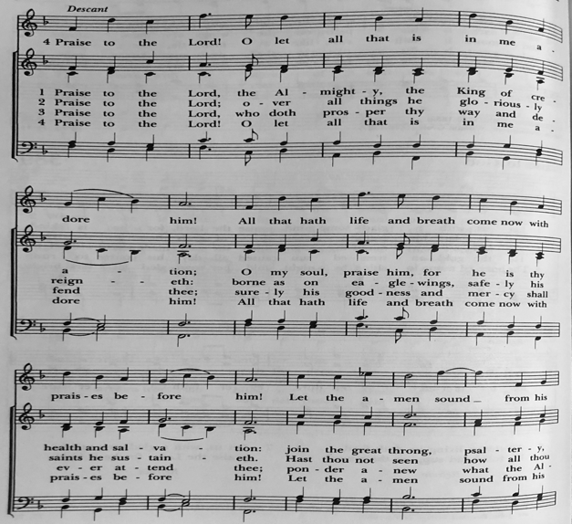

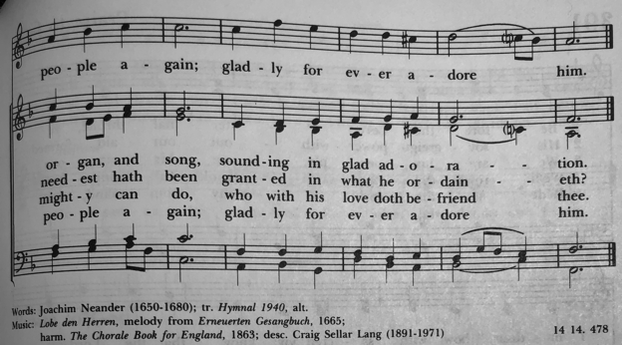

The Lessons & Canticles

A reading from the 37th chapter of the Book of Genesis. (Genesis 37:1-4, 12-28)
Jacob settled in the land where his father had lived as an alien, the land of Canaan. This is the story of the family of Jacob.
Joseph, being seventeen years old, was shepherding the flock with his brothers; he was a helper to the sons of Bilhah and Zilpah, his father’s wives; and Joseph brought a bad report of them to their father. Now Israel loved Joseph more than any other of his children, because he was the son of his old age; and he had made him a long robe with sleeves. But when his brothers saw that their father loved him more than all his brothers, they hated him, and could not speak peaceably to him.
Now his brothers went to pasture their father’s flock near Shechem. And Israel said to Joseph, “Are not your brothers pasturing the flock at Shechem? Come, I will send you to them.” He answered, “Here I am.” So he said to him, “Go now, see if it is well with your brothers and with the flock; and bring word back to me.” So he sent him from the valley of Hebron.
He came to Shechem, and a man found him wandering in the fields; the man asked him, “What are you seeking?” “I am seeking my brothers,” he said; “tell me, please, where they are pasturing the flock.” The man said, “They have gone away, for I heard them say, ‘Let us go to Dothan.’“ So Joseph went after his brothers, and found them at Dothan. They saw him from a distance, and before he came near to them, they conspired to kill him. They said to one another, “Here comes this dreamer. Come now, let us kill him and throw him into one of the pits; then we shall say that a wild animal has devoured him, and we shall see what will become of his dreams.” But when Reuben heard it, he delivered him out of their hands, saying, “Let us not take his life.” Reuben said to them, “Shed no blood; throw him into this pit here in the wilderness, but lay no hand on him” —that he might rescue him out of their hand and restore him to his father. So when Joseph came to his brothers, they stripped him of his robe, the long robe with sleeves that he wore; and they took him and threw him into a pit. The pit was empty; there was no water in it.
Then they sat down to eat; and looking up they saw a caravan of Ishmaelites coming from Gilead, with their camels carrying gum, balm, and resin, on their way to carry it down to Egypt. Then Judah said to his brothers, “What profit is it if we kill our brother and conceal his blood? Come, let us sell him to the Ishmaelites, and not lay our hands on him, for he is our brother, our own flesh.” And his brothers agreed. When some Midianite traders passed by, they drew Joseph up, lifting him out of the pit, and sold him to the Ishmaelites for twenty pieces of silver. And they took Joseph to Egypt.
The Word of the Lord. Thanks be to God.
Canticle 9: The 1st Song of Isaiah Ecce, Deus (Isaiah 12:2-6) BCP p.86

Surely, it is God who saves me; *
I will trust in him and not be afraid.
For the Lord is my stronghold and my sure defense, *
and he will be my Savior.
Therefore you shall draw water with rejoicing *
from the springs of salvation.
And on that day you shall say, *
Give thanks to the Lord and call upon his Name;
Make his deeds known among the peoples; *
see that they remember that his Name is exalted.
Sing the praises of the Lord, for he has done great things, *
and this is known in all the world.
Cry aloud, inhabitants of Zion, ring out your joy, *
for the great one in the midst of you is the Holy One of Israel.
Glory to the Father, and to the Son, and to the Holy Spirit: *
as it was in the beginning, is now, and will be for ever. Amen.

A reading from the 10th chapter of Saint Paul's Letter to the Romans. (Romans 10:5-15)

Moses writes concerning the righteousness that comes from the law, that “the person who does these things will live by them.” But the righteousness that comes from faith says, “Do not say in your heart, ‘Who will ascend into heaven?’” (that is, to bring Christ down) “or ‘Who will descend into the abyss?’” (that is, to bring Christ up from the dead). But what does it say?

“The word is near you,
on your lips and in your heart”

(that is, the word of faith that we proclaim); because if you confess with your lips that Jesus is Lord and believe in your heart that God raised him from the dead, you will be saved. For one believes with the heart and so is justified, and one confesses with the mouth and so is saved. The scripture says, “No one who believes in him will be put to shame.” For there is no distinction between Jew and Greek; the same Lord is Lord of all and is generous to all who call on him. For, “Everyone who calls on the name of the Lord shall be saved.”

But how are they to call on one in whom they have not believed? And how are they to believe in one of whom they have never heard? And how are they to hear without someone to proclaim him? And how are they to proclaim him unless they are sent? As it is written, “How beautiful are the feet of those who bring good news!”

The Word of the Lord. Thanks be to God.

Canticle 15: The Song of Mary Magnificat Luke 1:46-55 BCP p. 91-92

My soul proclaims the greatness of the Lord, my spirit rejoices in God my Savior; *
for he has looked with favor on his lowly servant.
From this day all generations will call me blessed: *
the Almighty has done great things for me, and holy is his Name.
He has mercy on those who fear him *
in every generation.
He has shown the strength of his arm, *
he has scattered the proud in their conceit.
He has cast down the mighty from their thrones, *
and has lifted up the lowly.
He has filled the hungry with good things, *
and the rich he has sent away empty.
He has come to the help of his servant Israel, *
for he has remembered his promise of mercy,
The promise he made to our fathers, *
to Abraham and his children for ever.
Glory to the Father, and to the Son, and to the Holy Spirit: *
as it was in the beginning, is now, and will be for ever. Amen.

A reading from the Holy Gospel of our Lord and Savior Jesus Christ, according to Matthew.
Glory to you, Lord Christ. (Matthew 14:22-33)

Jesus made the disciples get into the boat and go on ahead to the other side, while he dismissed the crowds. And after he had dismissed the crowds, he went up the mountain by himself to pray. When evening came, he was there alone, but by this time the boat, battered by the waves, was far from the land, for the wind was against them. And early in the morning he came walking toward them on the sea. But when the disciples saw him walking on the sea, they were terrified, saying, “It is a ghost!” And they cried out in fear. But immediately Jesus spoke to them and said, “Take heart, it is I; do not be afraid.”

Peter answered him, “Lord, if it is you, command me to come to you on the water.” He said, “Come.” So Peter got out of the boat, started walking on the water, and came toward Jesus. But when he noticed the strong wind, he became frightened, and beginning to sink, he cried out, “Lord, save me!” Jesus immediately reached out his hand and caught him, saying to him, “You of little faith, why did you doubt?” When they got into the boat, the wind ceased. And those in the boat worshiped him, saying, “Truly you are the Son of God.”

The Gospel of the Lord. Praise to you, Lord Christ.

A guest reflection on the theme “seek justice, correct oppression” (Isaiah 1:17b) by Pastor Eli Williams

Sequence Hymn: #800 (Wonder, Love and Praise) “Precious Lord, take my hand”
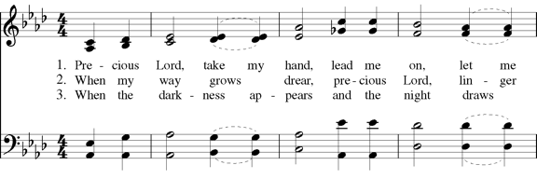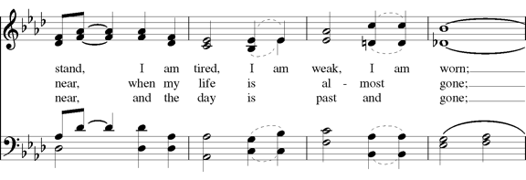
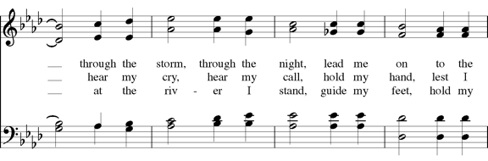

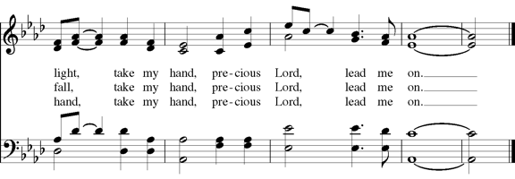

Parting Blessing for Amil Anderson

The church is a family.
United by the common recognition of Jesus Christ as our Savior,
we are all siblings in Christ.
And, for a time, Christ Episcopal Church is our home.
Like every human family,
our church family is formed and reformed over time:
as members are born, as they die,
as members are adopted into our family,
and as they leave our congregation for a new home, in a different place.
For a time, Amil has lived with us.
We have shared with each other good times and bad,
we have shared each other's joys and sorrows,
we have lightened each other's heavy loads.
Together we have laughed and cried,
together we have worshiped and praised God,
together we have lived.

Eternal God, you are the strength and protector of your people.
We humbly place into your hands
our dear brother Amil, who is about to leave us.
We send him forth as a messenger of salvation and peace,
marked with the sign of the cross.
Keep and preserve him, O Lord,
in all health and safety, both of body and soul;
and guide his steps, that they may be always in your light.
This we ask through Jesus Christ our Lord. Amen.

The Apostles’ Creed
I believe in God, the Father almighty,
creator of heaven and earth;
I believe in Jesus Christ, his only Son, our Lord.
He was conceived by the power of the Holy Spirit
and born of the Virgin Mary.
He suffered under Pontius Pilate,
was crucified, died, and was buried.
He descended to the dead.
On the third day he rose again.
He ascended into heaven,
and is seated at the right hand of the Father.
He will come again to judge the living and the dead.
I believe in the Holy Spirit,
the holy catholic Church,
the communion of saints,
the forgiveness of sins
the resurrection of the body,
and the life everlasting. Amen.

The Prayers BCP p. 97-98
The Lord be with you.
And also with you.
Let us pray.

Our Father, who art in heaven,
hallowed be thy Name,
thy kingdom come,
thy will be done,
on earth as it is in heaven.
Give us this day our daily bread.
And forgive us our trespasses,
as we forgive those
who trespass against us.
And lead us not into temptation,
but deliver us from evil.
For thine is the kingdom,
and the power, and the glory,
for ever and ever. Amen.

Save your people, Lord, and bless your inheritance;
Govern and uphold them, now and always.
Day by day we bless you;
We praise your name for ever.
Lord, keep us from all sin today;
Have mercy upon us, Lord, have mercy.
Lord, show us your love and mercy;
For we put our trust in you.
In you, Lord, is our hope;
And we shall never hope in vain.
The Collect of the Day
Grant to us, Lord, we pray, the spirit to think and do always those things that are right, that we, who cannot exist without you, may by you be enabled to live according to your will; through Jesus Christ our Lord, who lives and reigns with you and the Holy Spirit, one God, for ever and ever. Amen.

A Prayer for Mission
O God, you have made of one blood all the peoples of the earth, and sent your blessed Son to preach peace to those who are far off and to those who are near: Grant that people everywhere may seek after you and find you; bring the nations into your fold; pour out your Spirit upon all flesh; and hasten the coming of your kingdom; through Jesus Christ our Lord. Amen.

An Act of Spiritual Communion (for times when we cannot celebrate Holy Eucharist together)

In union, Lord Jesus, with the faithful gathered at every altar of your Church --
in places where your blessed Body and Blood are offered this day,
and in places (like our parish) where your people
now fast from the Holy Eucharist out of love for one another --
we offer you praise and thanksgiving,
for the Creation and all the blessings of this life,
for the redemption won for us by your life, death, and resurrection,
for the means of grace and the hope of glory.

On this day, O Lord, we offer particular gratitude for the blessings of our own lives ...
[share your blessings, aloud or silently]

We are members of your holy, glorious, and blessed Body, O Lord Christ.
We believe that you are truly present in the Holy Sacrament,
and, since we cannot at this time receive communion,
we each entreat you with these words:
I pray you, Lord, to come into my heart.
I unite myself with you and embrace you
with all my heart, my soul, and my mind.
Let nothing separate me from you;
let me serve you in this life until, by your grace,
I come to your glorious kingdom and unending peace. Amen.

Come Lord Jesus, and dwell in our hearts in the fullness of your strength;
be our wisdom and guide us in right pathways;
conform our lives and actions to the image of your holiness;
and, in the power of your gracious might,
rule over every hostile power that threatens or disturbs the growth of your kingdom;
who with God our Creator,
and the Holy Spirit our Sanctifier,
lives and reigns,
one God,
in glory everlasting. Amen.

And now may the peace of God, which passes all understanding,
keep our hearts and minds in the knowledge and love of God,
and of God's Son Jesus Christ our Lord;
and the blessing of our Triune God,
the Creator, the Redeemer, and the Sanctifier, This is an appropriate time to
be with us now and always. Amen. make the sign of the cross.

Let us bless the Lord. Alleluia, alleluia!
Thanks be to God. Alleluia, alleluia!

Closing Hymn: # 637 “How firm a foundation”
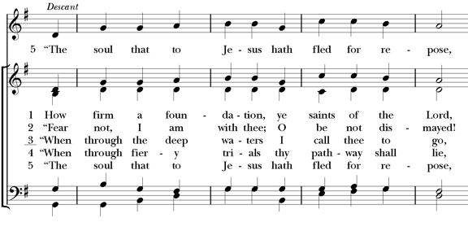
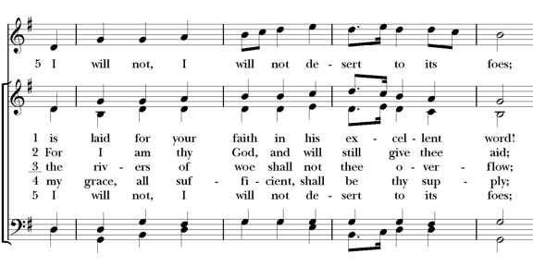
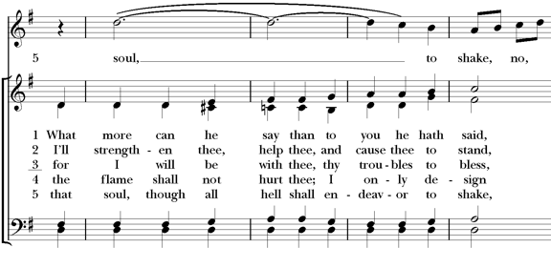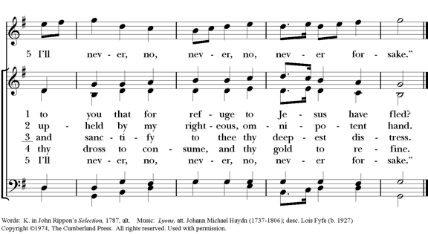

Postlude: “Meditation“ – Glazunov- Isabella Durrenberger, violin

Thank you for your spiritual presence with us this morning!
Although we're physically apart, we are united in prayer, worship, and holy love!

Deacon: The Rev. Dr. Rick Incorvati
Guest preacher: Pastor Eli Williams
Organist/Choirmaster: Dr. Chris Durrenberger
Guest violinist: Isabella Durrenberger
Guest pianist: Kent Brooks
Lector: Anne Strothman
Singers: Liz Wheeler, Joy Carter, Ed Hasecke, Fred Bartenstein
Technology: TBA
Slideshow: Ed Hasecke
Parish Administrator: Kelly Zeller
Coffee Hour Host: TBA

