**MORNING PRAYER for June 7, 2020 at 9 am: Trinity Sunday & Recognition of Graduates**

*Note: We invite you to light a candle on your table or home altar before worship begins.*

Holy, holy, holy is the Lord God Almighty, who was, and is, and is to come! *Revelation 4:8*

The Invitatory & Psalter **BCP p. 81**

Lord, open our lips.

|  |
| --- |
| **And our mouth shall proclaim your praise.**  **Glory to the Father, and to the Son, and to the Holy Spirit:**  **as it was in the beginning, is now, and will be forever. Amen. Alleluia!** |

Invitatory Psalm ***Psalm 67:1-5*** *Deus misereatur* from *Enriching Our Worship*

**O God, be merciful to us and bless us, \***

**show us the light of your countenance and come to us.**

**Let your ways be known upon earth, \***

**your saving health among all nations.**

**Let the peoples praise you, O God; \***

**let all the peoples praise you.**

**Let the nations be glad and sing for joy, \***

**for you judge the peoples with equity and guide all the nations upon earth.**

**Let the peoples praise you, O God; \***

**let all the peoples praise you.**

The Psalm Appointed **Psalm 8** *Domine, Dominus noster***BCP p. 592**

**1 O LORD our Governor, \***  
    how exalted is your Name in all the world!

**2 Out of the mouths of infants and children \***    your majesty is praised above the heavens.

**3 You have set up a stronghold against your adversaries, \***    to quell the enemy and the avenger.

**4 When I consider your heavens, the work of your fingers, \***    the moon and the stars you have set in their courses,

**5 What is man that you should be mindful of him? \***    the son of man that you should seek him out?

**6 You have made him but little lower than the angels; \***    you adorn him with glory and honor;

**7 You give him mastery over the works of your hands; \***    you put all things under his feet:

**8 All sheep and oxen, \***  
    even the wild beasts of the field,

**9 The birds of the air, the fish of the sea, \***  
    and whatsoever walks in the paths of the sea.

**10 O LORD our Governor, \***  
    how exalted is your Name in all the world!

**Glory to the Father, and to the Son, and to the Holy Spirit:**

as it was in the beginning, is now, and will be forever. Amen.

Sequence Hymn: #370 I bind unto myself today

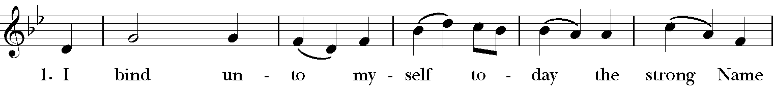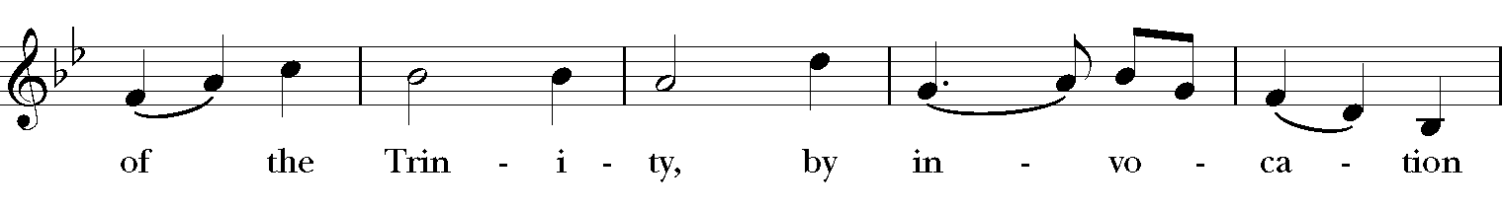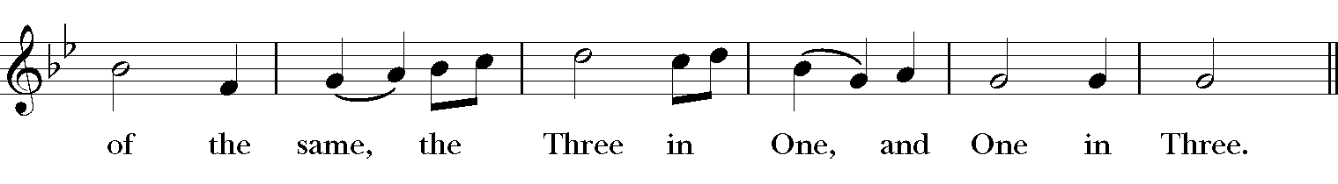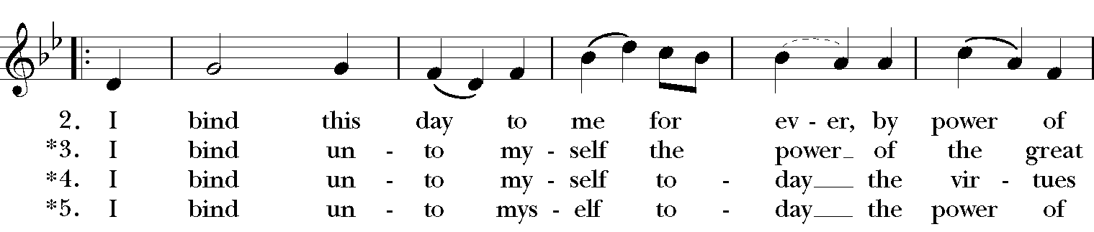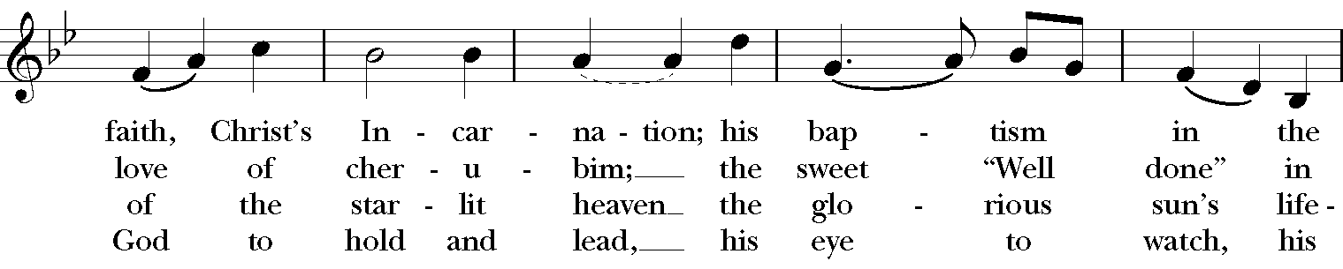

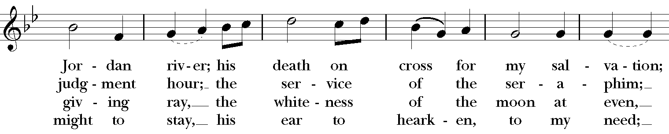

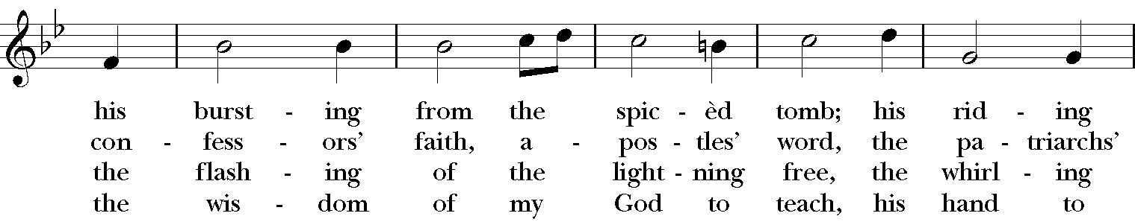

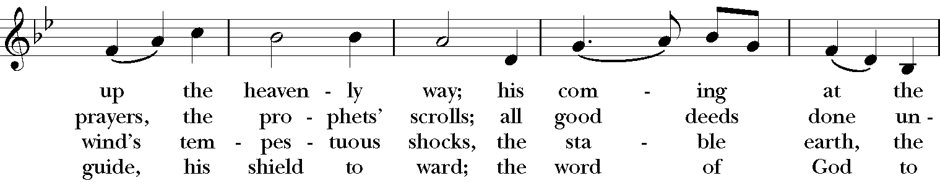

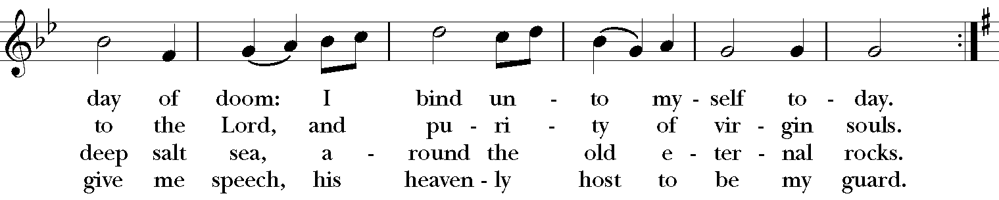

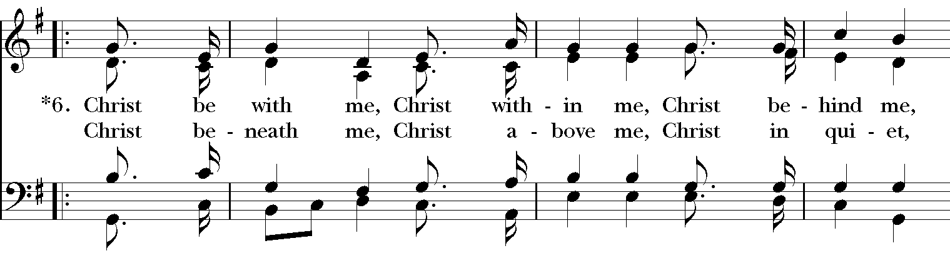

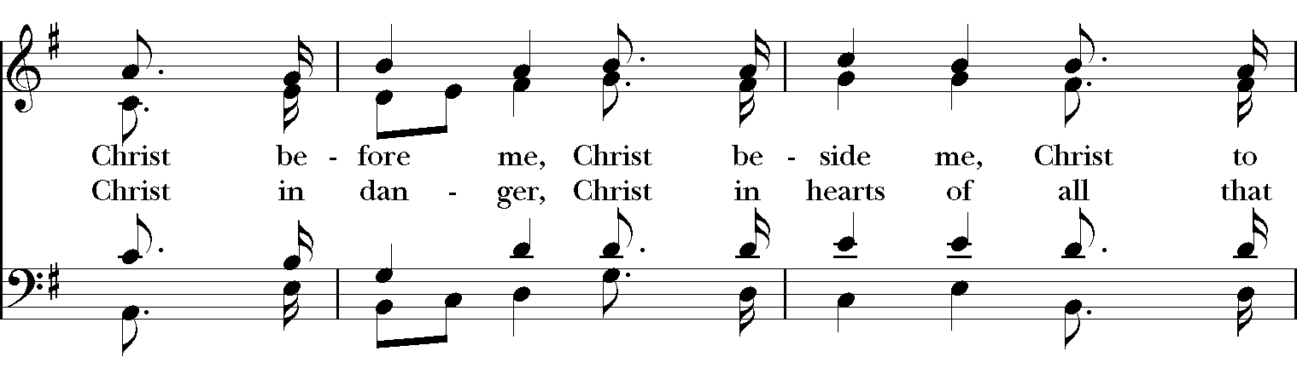

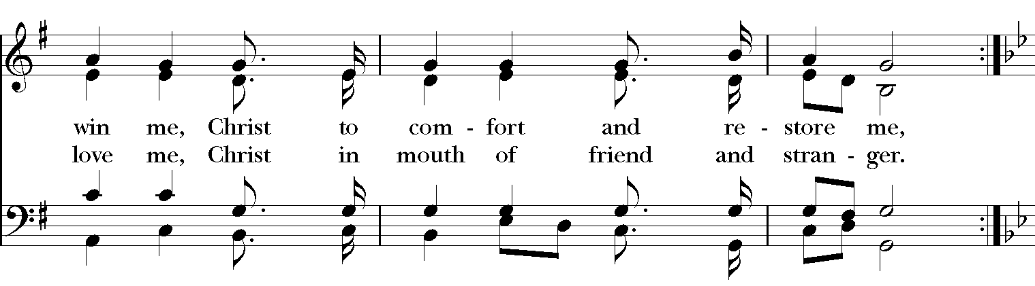

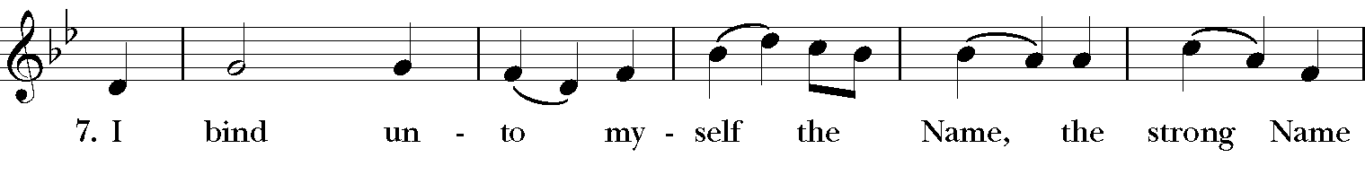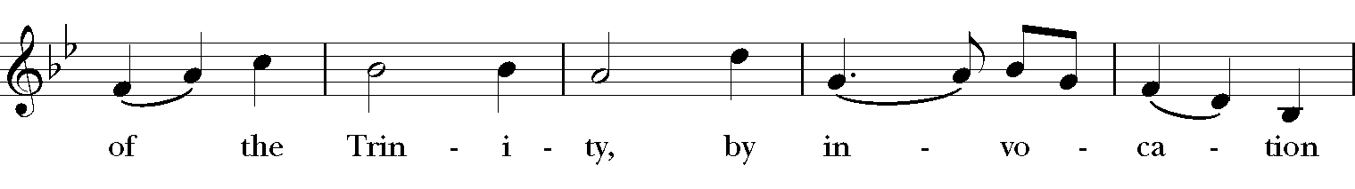

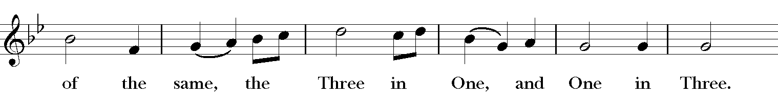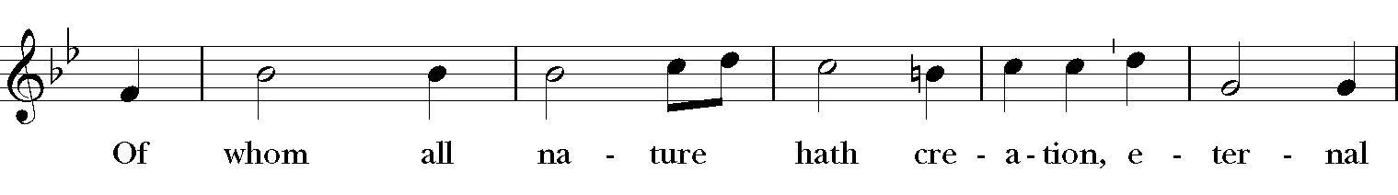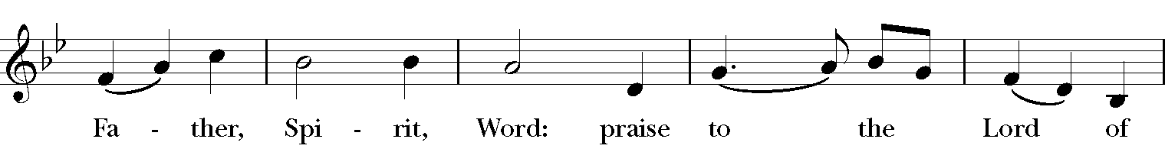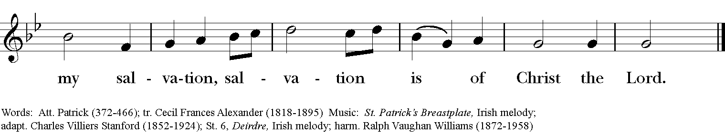

The Lessons & Canticles

A reading from the 13th chapter of Saint Paul's 2nd Letter to the Corinthians.

(2 Corinthians 13:11-13)

Finally, brothers and sisters, farewell. Put things in order, listen to my appeal, agree with one another, live in peace; and the God of love and peace will be with you. Greet one another with a holy kiss. All the saints greet you.

The grace of the Lord Jesus Christ, the love of God, and the communion of the Holy Spirit be with all of you.

The Word of the Lord. **Thanks be to God.**

Canticle 17: The Song of Simeon ***Nunc Dimittis*** *Luke 2:29-32*  **BCP p. 93**

**Lord, you now have set your servant free *   
    to go in peace as you have promised;   
For these eyes of mine have seen the Savior, *   
    whom you have prepared for all the world to see:   
A Light to enlighten the nations, *   
    and the glory of your people Israel.**

**Glory to the Father, and to the Son, and to the Holy Spirit: *   
    as it was in the beginning, is now, and will be for ever. Amen.**

A reading from the Holy Gospel of our Lord and Savior Jesus Christ, according to Matthew

**Glory to you, Lord Christ.** (Matthew 28:16-20)

The eleven disciples went to Galilee, to the mountain to which Jesus had directed them. When they saw him, they worshiped him; but some doubted. And Jesus came and said to them, “All authority in heaven and on earth has been given to me. Go therefore and make disciples of all nations, baptizing them in the name of the Father and of the Son and of the Holy Spirit, and teaching them to obey everything that I have commanded you. And remember, I am with you always, to the end of the age.”

The Gospel of the Lord. **Praise to you, Lord Christ.**

*A homily for honoring graduates, from The Most Rev. Michael B. Curry, 27th Presiding Bishop of The Episcopal Church.*

Note: If you are unable to participate in our livestream worship, you can find Bishop Curry's homily at youtu.be/XCJ5ykT3Cis

**Introduction & Blessing of Graduates**

Holy and Loving God, Source of all wisdom,

We thank you for Katrina, Ava, Sophie, Adam, and Ron.

Hear our prayer for them as they graduate and take the next steps on their life-journeys.

**Direct their steps, O Lord.**

For those who will now begin their careers:

help them to apply what they have learned

and to be salt and light among their fellow workers.

**Direct their steps, O Lord.**

For those who will receive further education:

assist them as they move to more difficult studies.

May they find new faith communities to support them in their journeys.

**Direct their steps, O Lord.**

We thank you for their families, teachers, mentors, and friends

who have helped them reach this milestone.

Bless all those who teach, in or out of the classroom.

**Direct their steps, O Lord.**

Help us each to remember

that we always have more to learn about you and your world.

Help us to use the skills we gain to serve others,

with Christ as our example.

**Direct our steps, O Lord.**

We ask these things in the name of God the Creator,

who gave us birth by the word of truth;

and of Jesus our Example, who increased in wisdom and in stature,

and of the Spirit of Truth, who guides us into all truth. **Amen.**

{The Blessing}

*Before you were even formed, God knew you.  
While in your Mother's womb, God named you.  
At your birth, God's breath filled you with life.  
Today we celebrate what you have become at this moment in time.*

*And so we pray,*

**God of our beginnings,  
We thank you for the gifts of these graduates;  
their excitement, their awesome wonder and curiosity,  
their open speech and encouraging words.  
Their contributions have blessed and challenged us,  
and we have become a richer   
and more diverse community because of them.**

**We ask this blessing upon each of them,  
In the name of the Father, the Son, and the Holy Spirit. AMEN!**



*Ron Dowling,*

*Ava Keebaugh,*

*Katrina Dooley,*

*Adam Szekacs, and*

*Sophie Mortensen!*

Remember Christ's promise to you, and to each one of us:

"**I am with you always, to the end of the age**" (Matthew 28:20).



The Apostles’ Creed

**I believe in God, the Father almighty,   
    creator of heaven and earth;   
I believe in Jesus Christ, his only Son, our Lord.   
    He was conceived by the power of the Holy Spirit   
        and born of the Virgin Mary.   
    He suffered under Pontius Pilate,   
        was crucified, died, and was buried.   
    He descended to the dead.   
    On the third day he rose again.   
    He ascended into heaven,   
        and is seated at the right hand of the Father.   
    He will come again to judge the living and the dead.   
I believe in the Holy Spirit,   
    the holy catholic Church,   
    the communion of saints,   
    the forgiveness of sins  
    the resurrection of the body,   
    and the life everlasting. Amen.**

The Prayers **BCP p. 97-98**

The Lord be with you.

**And also with you.**

Let us pray.

|  |
| --- |
| **Our Father, who art in heaven,      hallowed be thy Name,       thy kingdom come,       thy will be done,           on earth as it is in heaven.  Give us this day our daily bread.  And forgive us our trespasses,       as we forgive those           who trespass against us.  And lead us not into temptation,       but deliver us from evil.  For thine is the kingdom,       and the power, and the glory,       for ever and ever. Amen.** |

Save your people, Lord, and bless your inheritance;   
 **Govern and uphold them, now and always.**  
Day by day we bless you;   
 **We praise your name for ever.**Lord, keep us from all sin today;   
 **Have mercy upon us, Lord, have mercy.**  
Lord, show us your love and mercy;   
 **For we put our trust in you.**  
In you, Lord, is our hope;   
 **And we shall never hope in vain.**

The Collect of the Day

Almighty and everlasting God, you have given to us your servants grace, by the confession of a true faith, to acknowledge the glory of the eternal Trinity, and in the power of your divine Majesty to worship the Unity: Keep us steadfast in this faith and worship, and bring us at last to see you in your one and eternal glory, O Father; who with the Son and the Holy Spirit live and reign, one God, for ever and ever. ***Amen****.*

A Prayer for Mission

O God, you have made of one blood all the peoples of the earth, and sent your blessed Son to preach peace to those who are far off and to those who are near: Grant that people everywhere may seek after you and find you; bring the nations into your fold; pour out your Spirit upon all flesh; and hasten the coming of your kingdom; through Jesus Christ our Lord. ***Amen*.**

An Act of Spiritual Communion (for times when we cannot celebrate Holy Eucharist together)

In union, Lord Jesus, with the faithful gathered at every altar of your Church --

in places where your blessed Body and Blood are offered this day,

and in places (like our parish) where your people

now fast from the Holy Eucharist out of love for one another --

***we offer you praise and thanksgiving,***

***for the Creation and all the blessings of this life,***

***for the redemption won for us by your life, death, and resurrection,***

***for the means of grace and the hope of glory.***

On this day, O Lord, we offer particular gratitude for the blessings of our own lives ...

***[share your blessings, aloud or silently]***

We are members of your holy, glorious, and blessed Body, O Lord Christ.

We believe that you are truly present in the Holy Sacrament,

and, since we cannot at this time receive communion,

we each entreat you with these words:

***I pray you, Lord, to come into my heart.***

***I unite myself with you and embrace you***

***with all my heart, my soul, and my mind.***

***Let nothing separate me from you;***

***let me serve you in this life until, by your grace,***

***I come to your glorious kingdom and unending peace. Amen.***

Come Lord Jesus, and dwell in our hearts in the fullness of your strength;

be our wisdom and guide us in right pathways;

conform our lives and actions to the image of your holiness;

and, in the power of your gracious might,

rule over every hostile power that threatens or disturbs the growth of your kingdom;

***who with God our Creator,***

***and the Holy Spirit our Sanctifier,***

***lives and reigns,***

***one God,***

***in glory everlasting. Amen.***

And now may the peace of God, which passes all understanding,

keep our hearts and minds in the knowledge and love of God,

and of God's Son Jesus Christ our Lord;

and the blessing of our Triune God,

the Creator, the Redeemer, and the Sanctifier, *This is an appropriate time to*

be with us now and always. ***Amen.*** *make the sign of the cross.*

Let us bless the Lord. Alleluia, alleluia!

**Thanks be to God. Alleluia, alleluia!**

Closing Hymn: # 432 O praise ye the Lord!

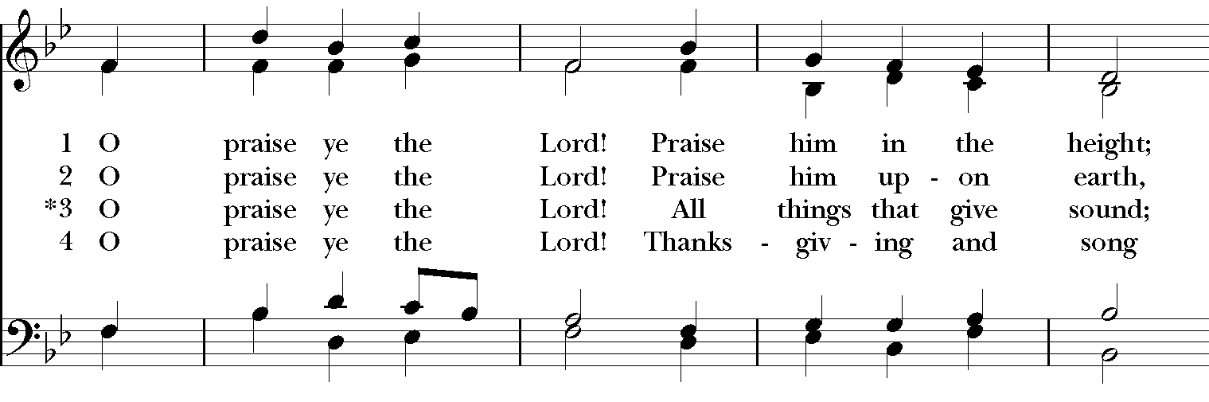

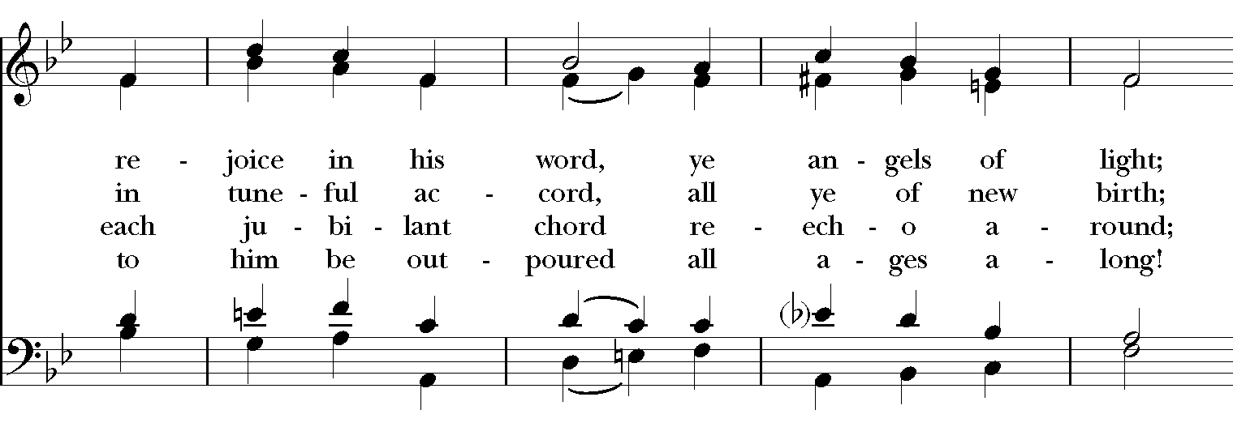

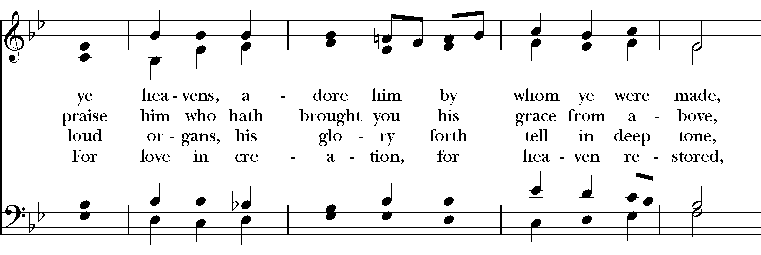

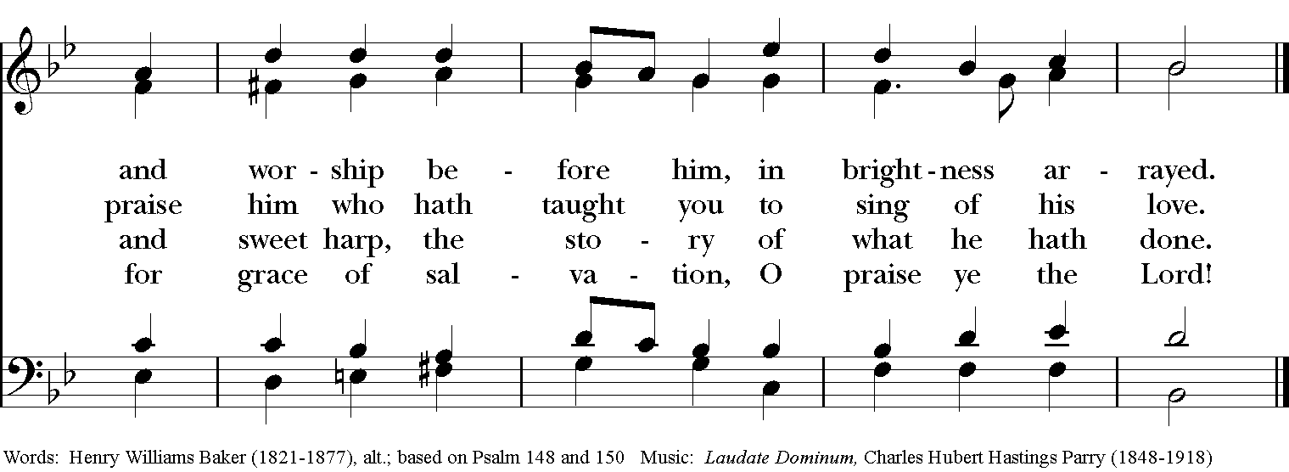

Thank you for your spiritual presence with us this morning!

Although we're physically apart, we are united in prayer, worship, and holy love!

Rector: The Rev. Maggie Leidheiser-Stoddard

Deacon: The Rev. Rick Incorvati

Organist/Choirmaster: Dr. Chris Durrenberger

Lector: Ron Dowling

Singers: Liz Wheeler, Joy Carter, Ed Hasecke, Fred Bartenstein

Technology: Jon Leidheiser-Stoddard

Slideshow: Ed Hasecke

Parish Administrator: Kelly Zeller

Coffee Hour Host: Ron Dowling