MORNING PRAYER for August 16th, 2020 at 9 am: Eleventh Sunday after Pentecost
Note: We invite you to light a candle on your table or home altar before worship begins.

Prelude: “Let All Things Now Living“ – Ash Grove/arr. Lloyd Larson

God is Spirit, and those who worship must worship in spirit and in truth. John 4:24

The Invitatory & Psalter BCP p. 81
Lord, open our lips.
And our mouth shall proclaim your praise.
Glory to the Father, and to the Son, and to the Holy Spirit:
as it was in the beginning, is now, and will be for ever. Amen.

Invitatory Psalm Psalm 67:1-5 Deus misereatur from Enriching Our Worship

O God, be merciful to us and bless us, *
show us the light of your countenance and come to us.
Let your ways be known upon earth, *
your saving health among all nations.
Let the peoples praise you, O God; *
let all the peoples praise you.
Let the nations be glad and sing for joy, *
for you judge the peoples with equity and guide all the nations upon earth.
Let the peoples praise you, O God; *
let all the peoples praise you.

Psalm Appointed Psalm 133 Ecce, quam bonum! BCP p. 787

1 Oh, how good and pleasant it is, *
when brethren live together in unity!
2 It is like fine oil upon the head *
that runs down upon the beard,
3 Upon the beard of Aaron, *
and runs down upon the collar of his robe.
4 It is like the dew of Hermon *
that falls upon the hills of Zion.
5 For there the Lord has ordained the blessing: *
life for evermore.
Glory to the Father, and to the Son, and to the Holy Spirit:
as it was in the beginning, is now, and will be for ever. Amen.
Sequence Hymn: #11 “Awake, my soul, and with the sun”
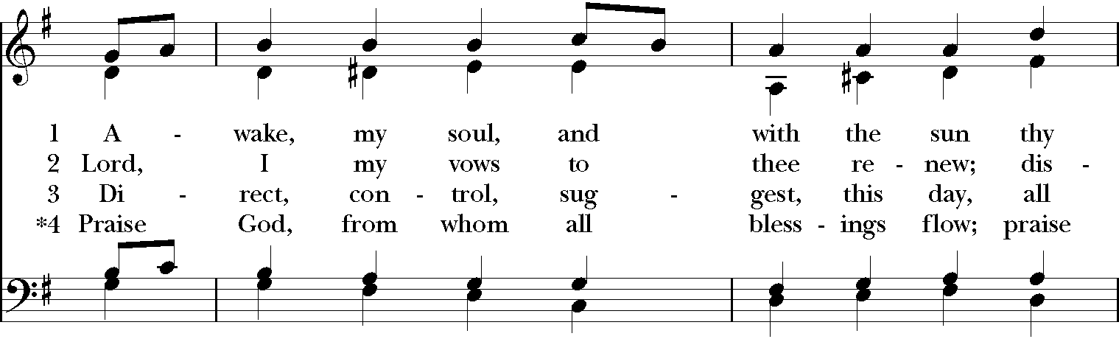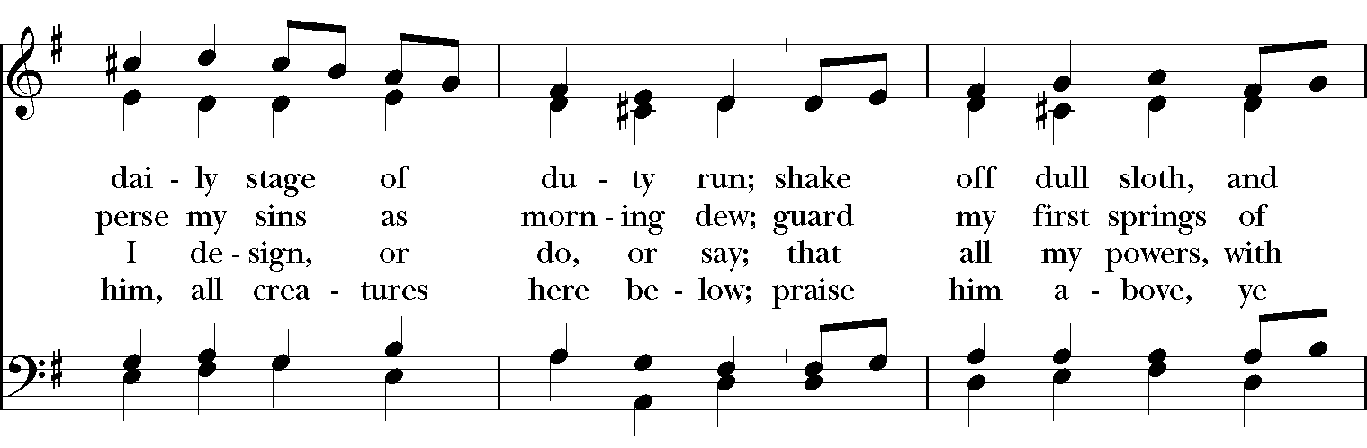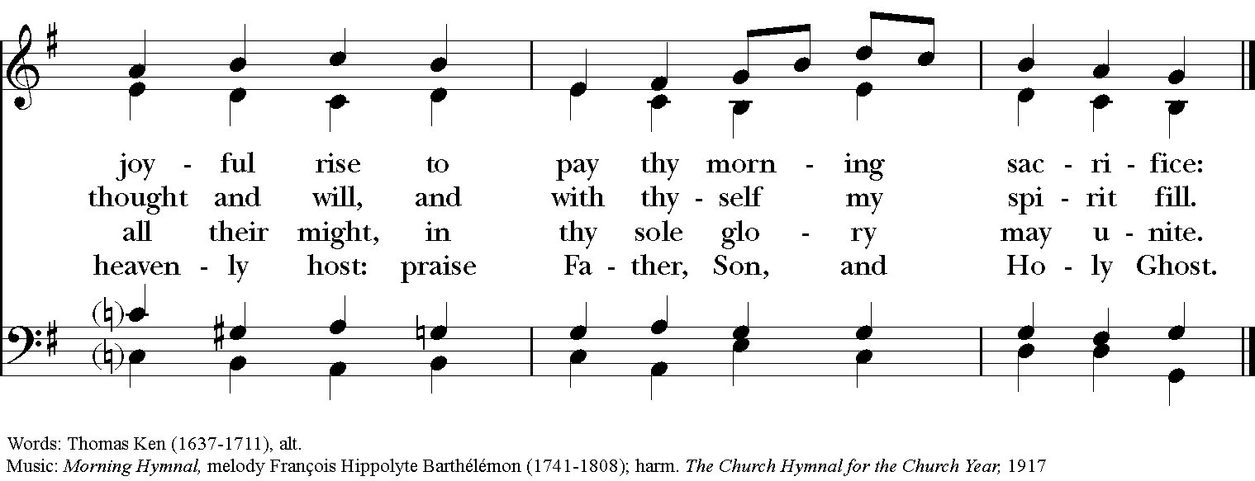

The Lessons & Canticles

A reading from the 45th chapter of the Book of Genesis. (Genesis 45:1-15)
Joseph could no longer control himself before all those who stood by him, and he cried out, “Send everyone away from me.” So no one stayed with him when Joseph made himself known to his brothers. And he wept so loudly that the Egyptians heard it, and the household of Pharaoh heard it. Joseph said to his brothers, “I am Joseph. Is my father still alive?” But his brothers could not answer him, so dismayed were they at his presence.
Then Joseph said to his brothers, “Come closer to me.” And they came closer. He said, “I am your brother, Joseph, whom you sold into Egypt. And now do not be distressed, or angry with yourselves, because you sold me here; for God sent me before you to preserve life. For the famine has been in the land these two years; and there are five more years in which there will be neither plowing nor harvest. God sent me before you to preserve for you a remnant on earth, and to keep alive for you many survivors. So it was not you who sent me here, but God; he has made me a father to Pharaoh, and lord of all his house and ruler over all the land of Egypt. Hurry and go up to my father and say to him, ‘Thus says your son Joseph, God has made me lord of all Egypt; come down to me, do not delay. You shall settle in the land of Goshen, and you shall be near me, you and your children and your children’s children, as well as your flocks, your herds, and all that you have. I will provide for you there—since there are five more years of famine to come—so that you and your household, and all that you have, will not come to poverty.’ And now your eyes and the eyes of my brother Benjamin see that it is my own mouth that speaks to you. You must tell my father how greatly I am honored in Egypt, and all that you have seen. Hurry and bring my father down here.” Then he fell upon his brother Benjamin’s neck and wept, while Benjamin wept upon his neck. And he kissed all his brothers and wept upon them; and after that his brothers talked with him.
The Word of the Lord. Thanks be to God.
Canticle B: A Song of Pilgrimage Priusquam errarem Ecclesiasticus 51:13-16, 20b-22
from Enriching Our Worship
Before I ventured forth, even while I was very young, *
I sought wisdom openly in my prayer.
In the forecourts of the temple I asked for her, *
and I will seek her to the end.
From first blossom to early fruit, *
she has been the delight of my heart.
My foot has kept firmly to the true path, *
diligently from my youth have I pursued her.
I inclined my ear a little and received her; *
I found for myself much wisdom and became adept in her.
To the one who gives me wisdom will I give glory, *
for I have resolved to live according to her way.
From the beginning I gained courage from her, *
therefore I will not be forsaken.
In my inmost being I have been stirred to seek her, *
therefore have I gained a good possession.
As my reward the Almighty has given me the gift of language,*
and with it will I offer praise to God.
Glory to the Father, and to the Son, and to the Holy Spirit:
as it was in the beginning, is now, and will be for ever. Amen.

A reading from the 11th chapter of Saint Paul's Letter to the Romans. (Romans 11:1-2a, 29-32)

I ask, then, has God rejected his people? By no means! I myself am an Israelite, a descendant of Abraham, a member of the tribe of Benjamin. God has not rejected his people whom he foreknew.

For the gifts and the calling of God are irrevocable. Just as you were once disobedient to God but have now received mercy because of their disobedience, so they have now been disobedient in order that, by the mercy shown to you, they too may now receive mercy. For God has imprisoned all in disobedience so that he may be merciful to all.

The Word of the Lord. Thanks be to God.

Canticle 19: The Song of the Redeemed Magna et mirabilia Revelation 15:3-4 BCP p. 94
O ruler of the universe, Lord God, great deeds are they that you have done, *
surpassing human understanding.
Your ways are ways of righteousness and truth, *
O King of all the ages.
Who can fail to do you homage, Lord, and sing the praises of your Name? *
for you only are the Holy One.
All nations will draw near and fall down before you, *
because your just and holy works have been revealed.
Glory to the Father, and to the Son, and to the Holy Spirit: *
as it was in the beginning, is now, and will be for ever. Amen.

A reading from the Holy Gospel of our Lord and Savior Jesus Christ, according to Matthew.
Glory to you, Lord Christ. (Matthew 15:10-28)

Jesus called the crowd to him and said to them, “Listen and understand: it is not what goes into the mouth that defiles a person, but it is what comes out of the mouth that defiles.” Then the disciples approached and said to him, “Do you know that the Pharisees took offense when they heard what you said?” He answered, “Every plant that my heavenly Father has not planted will be uprooted. Let them alone; they are blind guides of the blind. And if one blind person guides another, both will fall into a pit.” But Peter said to him, “Explain this parable to us.” Then he said, “Are you also still without understanding? Do you not see that whatever goes into the mouth enters the stomach, and goes out into the sewer? But what comes out of the mouth proceeds from the heart, and this is what defiles. For out of the heart come evil intentions, murder, adultery, fornication, theft, false witness, slander. These are what defile a person, but to eat with unwashed hands does not defile.”

Jesus left that place and went away to the district of Tyre and Sidon. Just then a Canaanite woman from that region came out and started shouting, “Have mercy on me, Lord, Son of David; my daughter is tormented by a demon.” But he did not answer her at all. And his disciples came and urged him, saying, “Send her away, for she keeps shouting after us.” He answered, “I was sent only to the lost sheep of the house of Israel.” But she came and knelt before him, saying, “Lord, help me.” He answered, “It is not fair to take the children’s food and throw it to the dogs.” She said, “Yes, Lord, yet even the dogs eat the crumbs that fall from their masters’ table.” Then Jesus answered her, “Woman, great is your faith! Let it be done for you as you wish.” And her daughter was healed instantly.
The Gospel of the Lord. Praise to you, Lord Christ.
A reflection on the Scripture is offered.

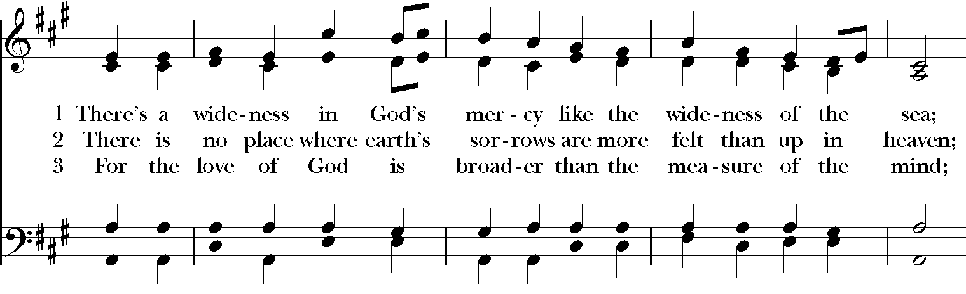
Sequence Hymn: #470 “There’s a wideness in God’s mercy”

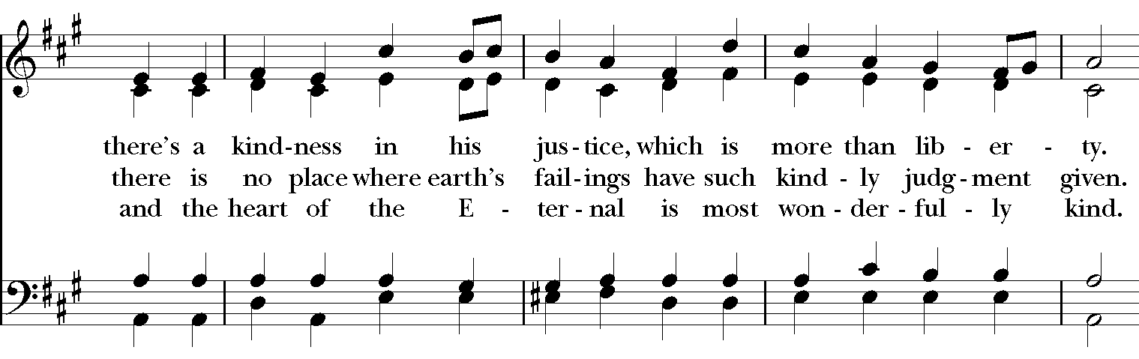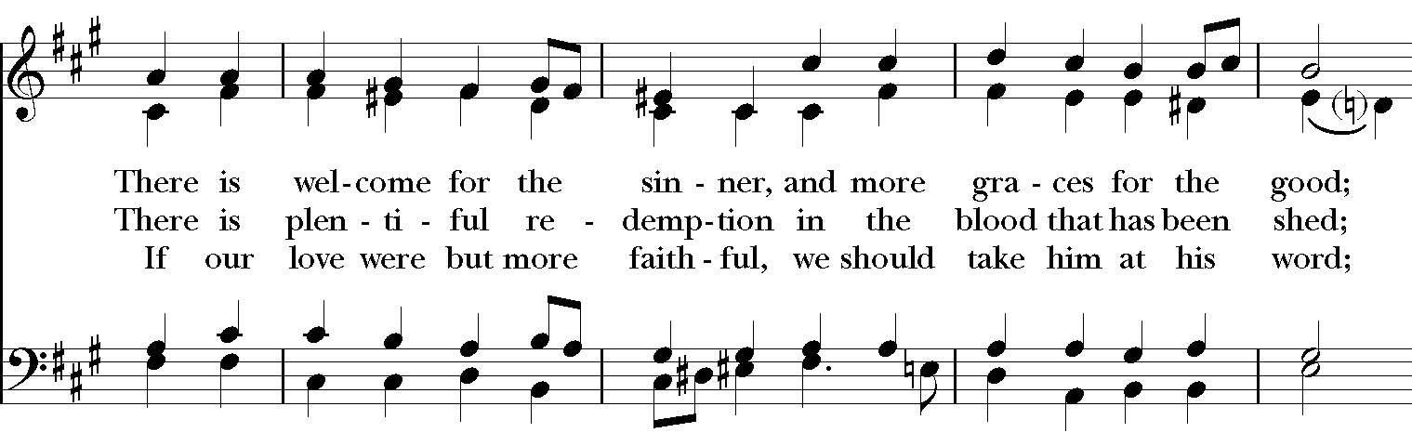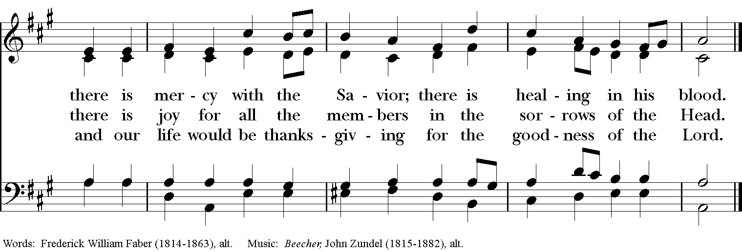

The Apostles’ Creed
I believe in God, the Father almighty,
creator of heaven and earth;
I believe in Jesus Christ, his only Son, our Lord.
He was conceived by the power of the Holy Spirit
and born of the Virgin Mary.
He suffered under Pontius Pilate,
was crucified, died, and was buried.
He descended to the dead.
On the third day he rose again.
He ascended into heaven,
and is seated at the right hand of the Father.
He will come again to judge the living and the dead.
I believe in the Holy Spirit,
the holy catholic Church,
the communion of saints,
the forgiveness of sins
the resurrection of the body,
and the life everlasting. Amen.

The Prayers BCP p. 97-98
The Lord be with you.
And also with you.
Let us pray.

Our Father, who art in heaven,
hallowed be thy Name,
thy kingdom come,
thy will be done,
on earth as it is in heaven.
Give us this day our daily bread.
And forgive us our trespasses,
as we forgive those
who trespass against us.
And lead us not into temptation,
but deliver us from evil.
For thine is the kingdom,
and the power, and the glory,
for ever and ever. Amen.

Save your people, Lord, and bless your inheritance;
Govern and uphold them, now and always.
Day by day we bless you;
We praise your name for ever.
Lord, keep us from all sin today;
Have mercy upon us, Lord, have mercy.
Lord, show us your love and mercy;
For we put our trust in you.
In you, Lord, is our hope;
And we shall never hope in vain.

The Collect of the Day
Almighty God, you have given your only Son to be for us a sacrifice for sin, and also an example of godly life: Give us grace to receive thankfully the fruits of his redeeming work, and to follow daily in the blessed steps of his most holy life; through Jesus Christ your Son our Lord, who lives and reigns with you and the Holy Spirit, one God, now and for ever. Amen.

A Prayer for Mission
O God, you have made of one blood all the peoples of the earth, and sent your blessed Son to preach peace to those who are far off and to those who are near: Grant that people everywhere may seek after you and find you; bring the nations into your fold; pour out your Spirit upon all flesh; and hasten the coming of your kingdom; through Jesus Christ our Lord. Amen.

An Act of Spiritual Communion (for times when we cannot celebrate Holy Eucharist together)

In union, Lord Jesus, with the faithful gathered at every altar of your Church --
in places where your blessed Body and Blood are offered this day,
and in places (like our parish) where your people
now fast from the Holy Eucharist out of love for one another --
we offer you praise and thanksgiving,
for the Creation and all the blessings of this life,
for the redemption won for us by your life, death, and resurrection,
for the means of grace and the hope of glory.

On this day, O Lord, we offer particular gratitude for the blessings of our own lives ...
[share your blessings, aloud or silently]

We are members of your holy, glorious, and blessed Body, O Lord Christ.
We believe that you are truly present in the Holy Sacrament,
and, since we cannot at this time receive communion,
we each entreat you with these words:
I pray you, Lord, to come into my heart.
I unite myself with you and embrace you
with all my heart, my soul, and my mind.
Let nothing separate me from you;
let me serve you in this life until, by your grace,
I come to your glorious kingdom and unending peace. Amen.

Come Lord Jesus, and dwell in our hearts in the fullness of your strength;
be our wisdom and guide us in right pathways;
conform our lives and actions to the image of your holiness;
and, in the power of your gracious might,
rule over every hostile power that threatens or disturbs the growth of your kingdom;
who with God our Creator,
and the Holy Spirit our Sanctifier,
lives and reigns,
one God,
in glory everlasting. Amen.

And now may the peace of God, which passes all understanding,
keep our hearts and minds in the knowledge and love of God,
and of God's Son Jesus Christ our Lord;
and the blessing of our Triune God,
the Creator, the Redeemer, and the Sanctifier, This is an appropriate time to
be with us now and always. Amen. make the sign of the cross.
Let us bless the Lord. Alleluia, alleluia!
Thanks be to God. Alleluia, alleluia!

Closing Hymn: # 405 “All things bright and beautiful”

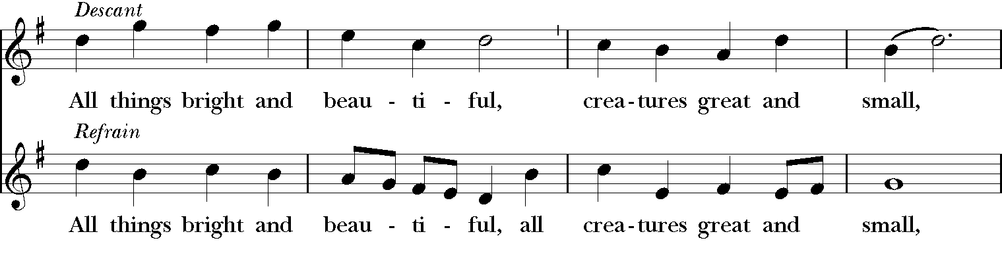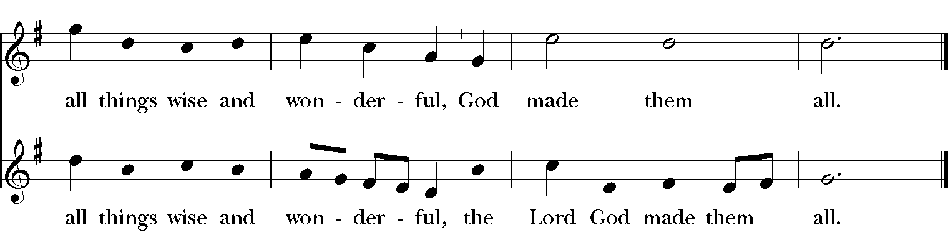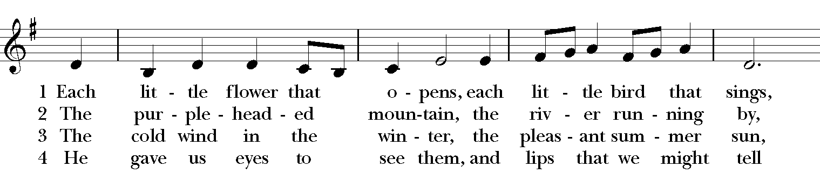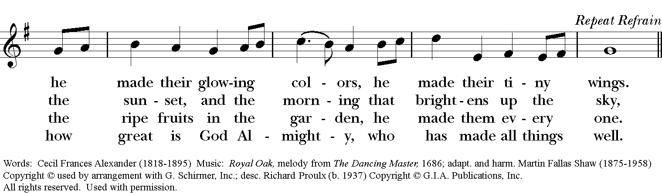
Postlude: “La Gitana” - Fritz Kreisler- Isabella Durrenberger
Thank you for your spiritual presence with us this morning!
Although we're physically apart, we are united in prayer, worship, and holy love!

Deacon: The Rev. Dr. Rick Incorvati
Organist/Choirmaster: Dr. Chris Durrenberger
Guest Violinist: Isabella Durrenberger
Lector: Keith Doubt
Singers: Liz Wheeler, Joy Carter, Ed Hasecke, Fred Bartenstein
Technology: Steve Ide
Slideshow: Ed Hasecke
Parish Administrator: Kelly Zeller
Coffee Hour Host: Ron Dowling

