MORNING PRAYER for August 2nd, 2020 at 9 am: Ninth Sunday after Pentecost
Note: We invite you to light a candle on your table or home altar before worship begins.

Prelude: "Rejoice, Ye Pure in Heart" Marion/setting by Lloyd Larson

God is Spirit, and those who worship must worship in spirit and in truth. John 4:24

The Invitatory & Psalter BCP p. 81

Lord, open our lips.
And our mouth shall proclaim your praise.
Glory to the Father, and to the Son, and to the Holy Spirit:
as it was in the beginning, is now, and will be for ever. Amen.

Invitatory Psalm Psalm 67:1-5 Deus misereatur from Enriching Our Worship

O God, be merciful to us and bless us, *
show us the light of your countenance and come to us.
Let your ways be known upon earth, *
your saving health among all nations.
Let the peoples praise you, O God; *
let all the peoples praise you.
Let the nations be glad and sing for joy, *
for you judge the peoples with equity and guide all the nations upon earth.
Let the peoples praise you, O God; *
let all the peoples praise you.

Psalm Appointed 17:1-7, 16 Exaudi, Domine BCP p. 600

1 Hear my plea of innocence, O Lord; give heed to my cry; *
listen to my prayer, which does not come from lying lips.
2 Let my vindication come forth from your presence; *
let your eyes be fixed on justice.
3 Weigh my heart, summon me by night, *
melt me down; you will find no impurity in me.
4 I give no offense with my mouth as others do; *
I have heeded the words of your lips.
5 My footsteps hold fast to the ways of your law; *
in your paths my feet shall not stumble.
6 I call upon you, O God, for you will answer me; *
incline your ear to me and hear my words.
7 Show me your marvelous loving-kindness, *
O Savior of those who take refuge at your right hand
from those who rise up against them.
16 But at my vindication I shall see your face; *
when I awake, I shall be satisfied, beholding your likeness.
Glory to the Father, and to the Son, and to the Holy Spirit:
as it was in the beginning, is now, and will be for ever. Amen.

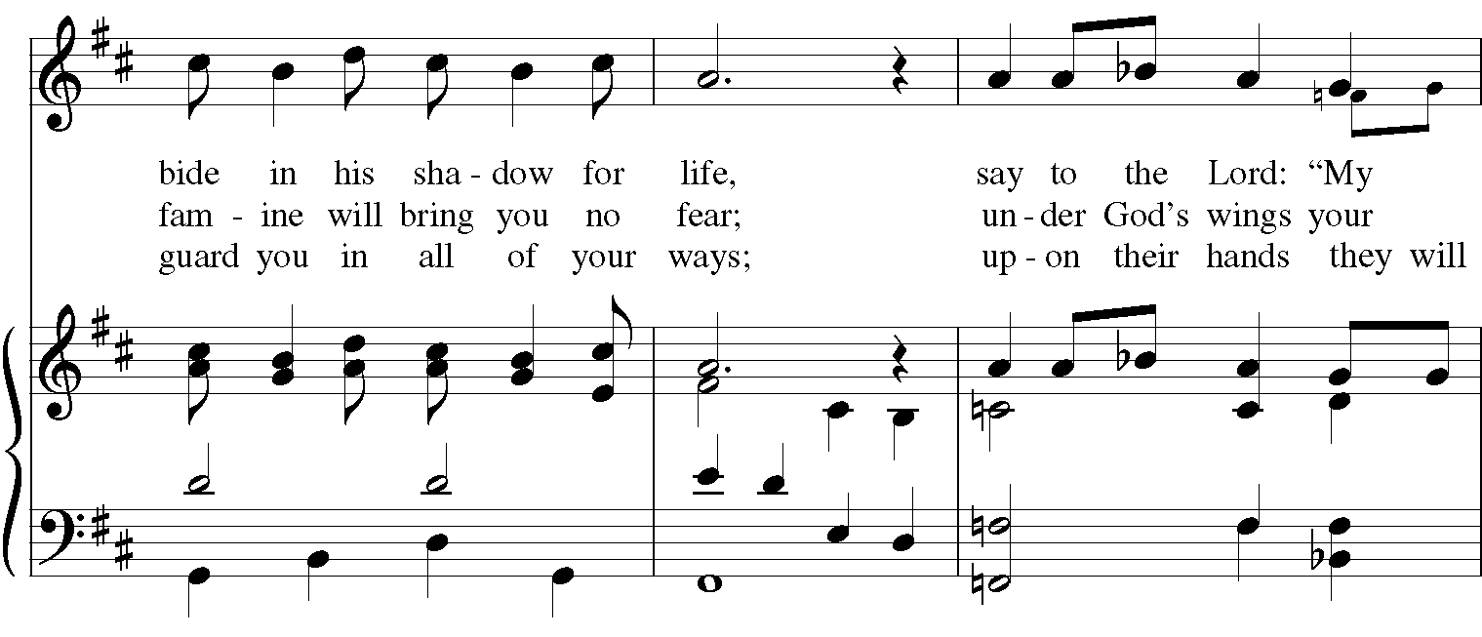
Sequence Hymn: #810 (Wonder, Love and Praise) “You who dwell in the shelter of the Lord”
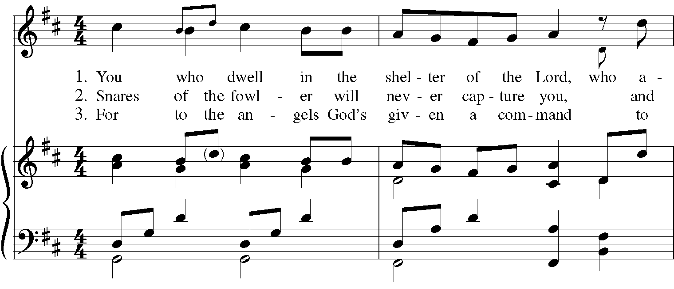
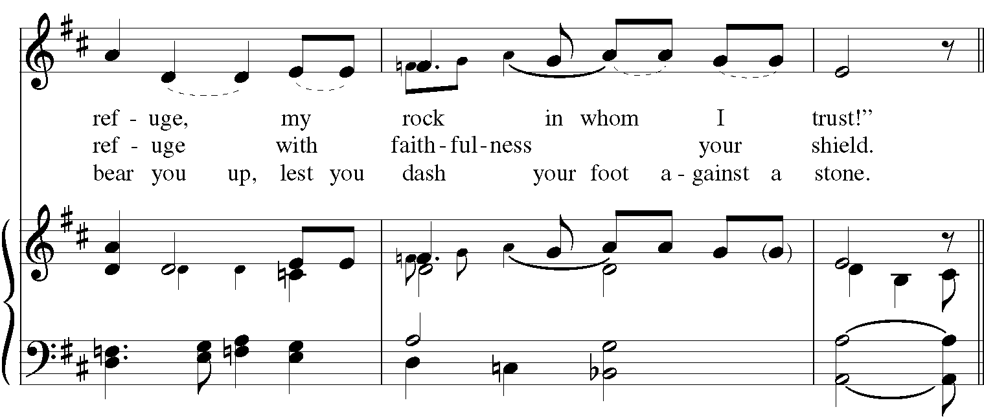

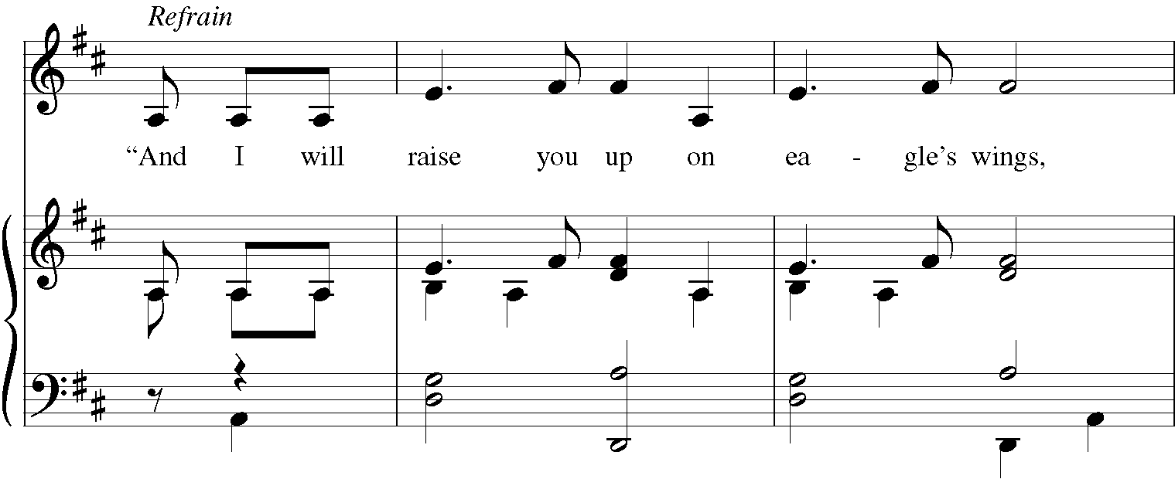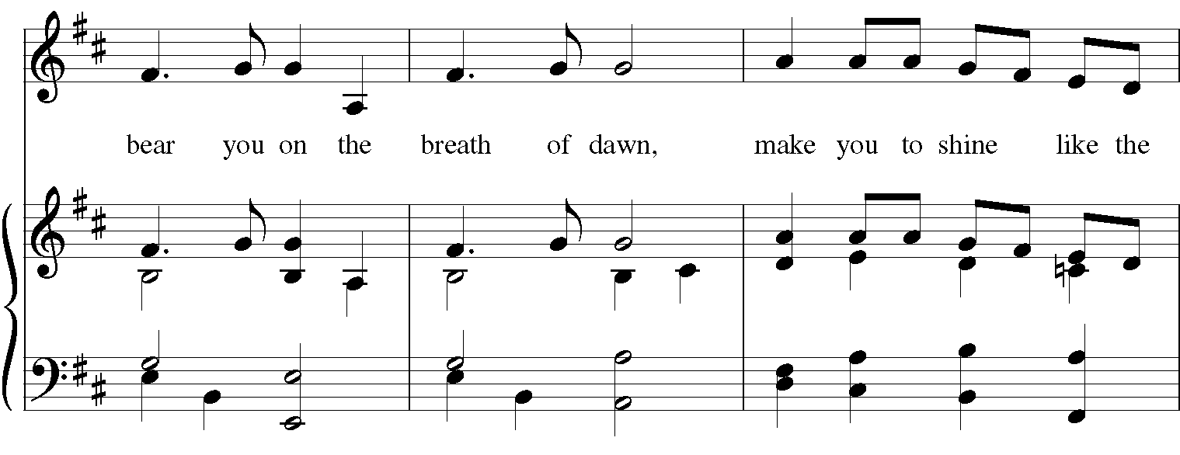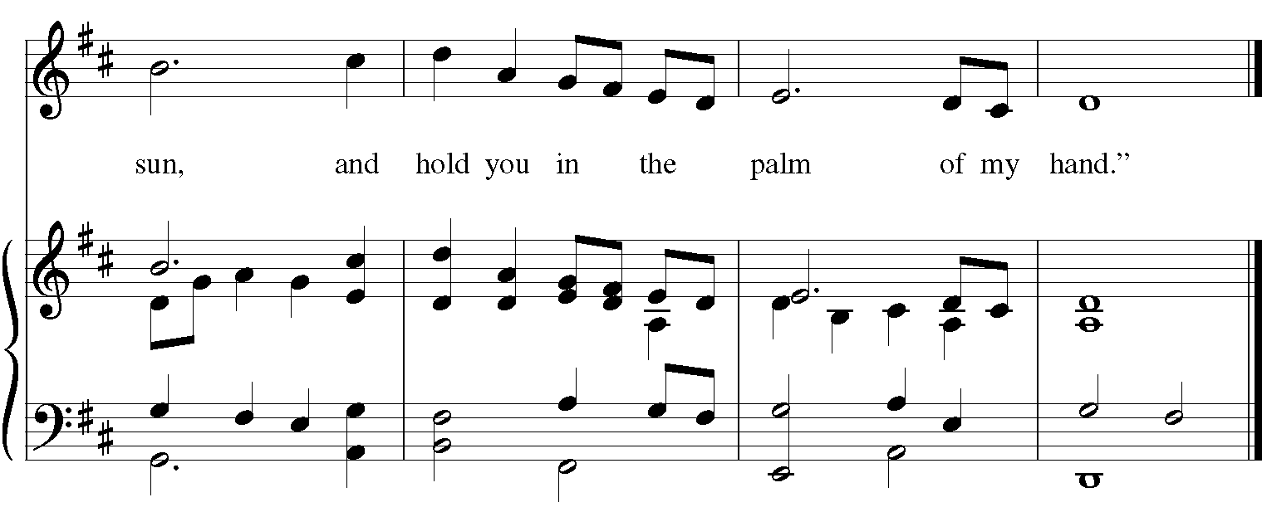

The Lessons & Canticles

A reading from the 32nd chapter of the Book of Genesis. (Genesis 32:22-31)
The same night Jacob got up and took his two wives, his two maids, and his eleven children, and crossed the ford of the Jabbok. He took them and sent them across the stream, and likewise everything that he had. Jacob was left alone; and a man wrestled with him until daybreak. When the man saw that he did not prevail against Jacob, he struck him on the hip socket; and Jacob’s hip was put out of joint as he wrestled with him. Then he said, “Let me go, for the day is breaking.” But Jacob said, “I will not let you go, unless you bless me.” So he said to him, “What is your name?” And he said, “Jacob.” Then the man said, “You shall no longer be called Jacob, but Israel, for you have striven with God and with humans, and have prevailed.” Then Jacob asked him, “Please tell me your name.” But he said, “Why is it that you ask my name?” And there he blessed him. So Jacob called the place Peniel, saying, “For I have seen God face to face, and yet my life is preserved.” The sun rose upon him as he passed Penuel, limping because of his hip.
The Word of the Lord. Thanks be to God.
Canticle 12: Part 1 A Song of Creation: The Cosmic Order BCP p. 88-89
Glorify the Lord, all you works of the Lord, *
praise him and highly exalt him for ever.
In the firmament of his power, glorify the Lord, *
praise him and highly exalt him for ever.
Glorify the Lord, you angels and all powers of the Lord, *
O heavens and all waters above the heavens.
Sun and moon and stars of the sky, glorify the Lord, *
praise him and highly exalt him for ever.
Glorify the Lord, every shower of rain and fall of dew, *
all winds and fire and heat.
Winter and Summer, glorify the Lord, *
praise him and highly exalt him for ever.
Glorify the Lord, O chill and cold, *
drops of dew and flakes of snow.
Frost and cold, ice and sleet, glorify the Lord, *
praise him and highly exalt him for ever.
Glorify the Lord, O nights and days, *
O shining light and enfolding dark.
Storm clouds and thunderbolts, glorify the Lord, *
praise him and highly exalt him for ever.
Glory to the Father, and to the Son, and to the Holy Spirit:
as it was in the beginning, is now, and will be for ever. Amen.

A reading from the 9th chapter of Saint Paul's Letter to the Romans. (Romans 9:1-5)

I am speaking the truth in Christ-- I am not lying; my conscience confirms it by the Holy Spirit-- I have great sorrow and unceasing anguish in my heart. For I could wish that I myself were accursed and cut off from Christ for the sake of my own people, my kindred according to the flesh. They are Israelites, and to them belong the adoption, the glory, the covenants, the giving of the law, the worship, and the promises; to them belong the patriarchs, and from them, according to the flesh, comes the Messiah, who is over all, God blessed forever. Amen.

The Word of the Lord. Thanks be to God.

Canticle K: A Song of Our Adoption Ephesians 1:3-10 from Enriching our Worship

Blessed are you, the God and Father of our Lord Jesus Christ, *
for you have blessed us in Christ
with every spiritual blessing in the heavenly places.
Before the world was made, you chose us to be yours in Christ, *
that we should be holy and blameless before you.
You destined us for adoption as your children through Jesus Christ, *
according to the good pleasure of your will,
To the praise of your glorious grace, *
that you have freely given us in the Beloved.
In you, we have redemption through the blood of Christ, *
the forgiveness of our sins,
According to the riches of your grace *
which you have lavished upon us.
You have made known to us, in all wisdom and insight, *
the mystery of your will,
According to your good pleasure which you set forth in Christ, *
as a plan for the fullness of time,
To gather together all things in Christ, *
things in heaven and things on earth.
Glory to the Father, and to the Son, and to the Holy Spirit:
as it was in the beginning, is now, and will be for ever. Amen.

A reading from the Holy Gospel of our Lord and Savior Jesus Christ, according to Matthew.
Glory to you, Lord Christ. (Matthew 14:13-21)

Jesus withdrew in a boat to a deserted place by himself. But when the crowds heard it, they followed him on foot from the towns. When he went ashore, he saw a great crowd; and he had compassion for them and cured their sick. When it was evening, the disciples came to him and said, “This is a deserted place, and the hour is now late; send the crowds away so that they may go into the villages and buy food for themselves.” Jesus said to them, “They need not go away; you give them something to eat.” They replied, “We have nothing here but five loaves and two fish.” And he said, “Bring them here to me.” Then he ordered the crowds to sit down on the grass. Taking the five loaves and the two fish, he looked up to heaven, and blessed and broke the loaves, and gave them to the disciples, and the disciples gave them to the crowds. And all ate and were filled; and they took up what was left over of the broken pieces, twelve baskets full. And those who ate were about five thousand men, besides women and children.

The Gospel of the Lord. Praise to you, Lord Christ.

A reflection on the Scripture is offered.

A Litany for the Ending of a Pastoral Relationship

The departing Rector addresses the congregation with these words: On the 18th day of January, 2018, I was appointed by Bishop Thomas E. Breidenthal as Rector of Christ Episcopal Church in Springfield. I have, with God’s help and to the best of my abilities, exercised this trust, accepting its privileges and responsibilities. I publicly state that my appointment as Rector of Christ Episcopal Church ends on August 6th, 2020.

Bishop’s Representative: Having witnessed this declaration of the Rev. Margaret Leidheiser-Stoddard do you, the people of Christ Episcopal Church, recognize and accept the conclusion of this pastoral relationship?

People: We do.

Rev. Maggie and the congregation then say together the following prayer:
O God, you have bound us together for a time as priest and people to work for the advancement of your kingdom in this place: We give you humble and hearty thanks for the ministry which we have shared in these years now past.
{Silence}

We thank you for your patience with us despite our blindness and slowness of heart. We thank you for your forgiveness and mercy in the face of our many failures.
{Silence}

Especially we thank you for your never-failing presence with us through these years, and for the deeper knowledge of you and of each other, which we have attained.
{Silence}

We thank you for opening our hearts and minds again and again to your Word, and for feeding us abundantly with the Sacrament of the Body and Blood of your Son.
{Silence}

Now, we pray, be with those who leave and with those who stay; and grant that all of us, by drawing ever nearer to you, may always be close to each other in the communion of your saints. All this we ask for the sake of Jesus Christ, your Son, our Lord. Amen.

Priest The peace of the Lord be always with you.
People And also with you.
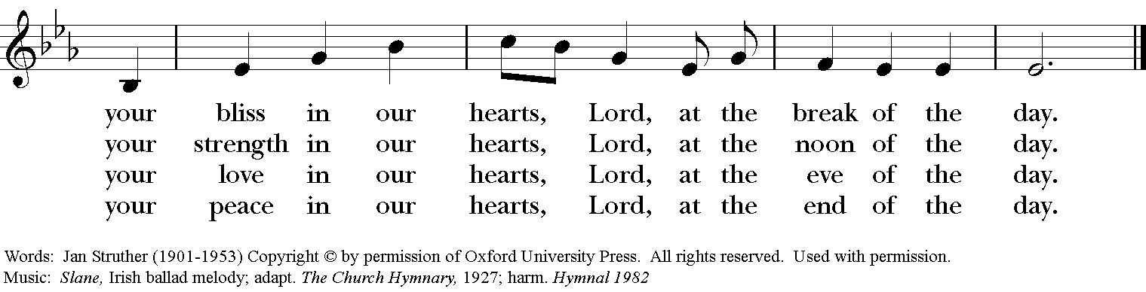
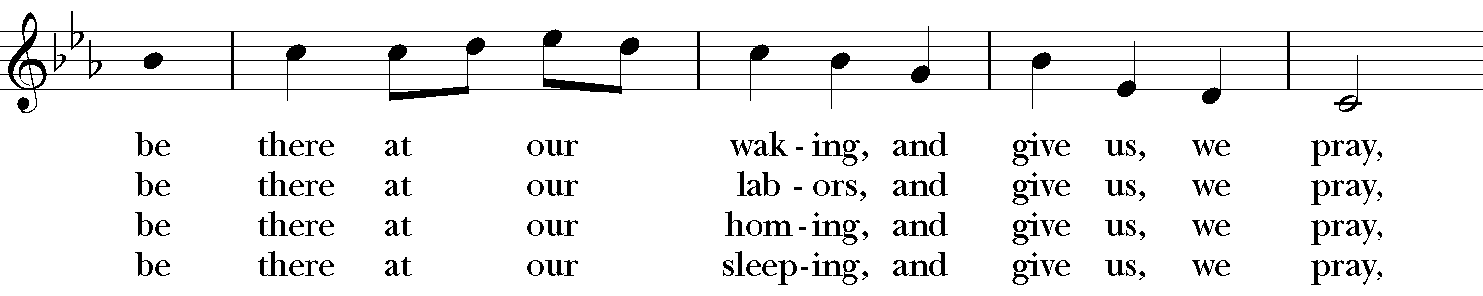
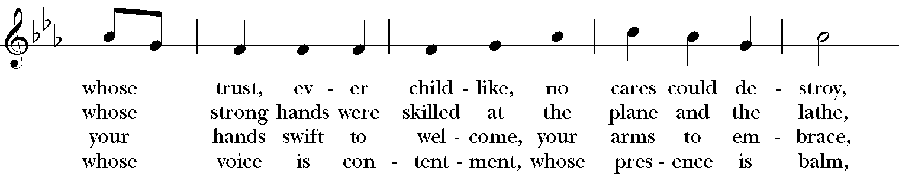
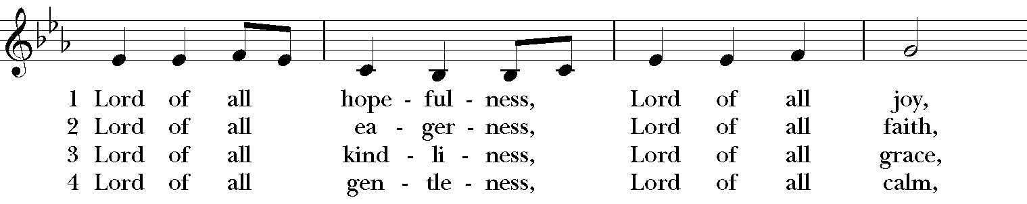
Sequence Hymn: #482 “Lord of all hopefulness”

The Apostles’ Creed
I believe in God, the Father almighty,
creator of heaven and earth;
I believe in Jesus Christ, his only Son, our Lord.
He was conceived by the power of the Holy Spirit
and born of the Virgin Mary.
He suffered under Pontius Pilate,
was crucified, died, and was buried.
He descended to the dead.
On the third day he rose again.
He ascended into heaven,
and is seated at the right hand of the Father.
He will come again to judge the living and the dead.
I believe in the Holy Spirit,
the holy catholic Church,
the communion of saints,
the forgiveness of sins
the resurrection of the body,
and the life everlasting. Amen.
The Prayers BCP p. 97-98
The Lord be with you.
And also with you.
Let us pray.

Our Father, who art in heaven,
hallowed be thy Name,
thy kingdom come,
thy will be done,
on earth as it is in heaven.
Give us this day our daily bread.
And forgive us our trespasses,
as we forgive those
who trespass against us.
And lead us not into temptation,
but deliver us from evil.
For thine is the kingdom,
and the power, and the glory,
for ever and ever. Amen.

Save your people, Lord, and bless your inheritance;
Govern and uphold them, now and always.
Day by day we bless you;
We praise your name for ever.
Lord, keep us from all sin today;
Have mercy upon us, Lord, have mercy.
Lord, show us your love and mercy;
For we put our trust in you.
In you, Lord, is our hope;
And we shall never hope in vain.

The Collect of the Day
Let your continual mercy, O Lord, cleanse and defend your Church; and, because it cannot continue in safety without your help, protect and govern it always by your goodness; through Jesus Christ our Lord, who lives and reigns with you and the Holy Spirit, one God, for ever and ever. Amen.

A Prayer for Mission
O God, you have made of one blood all the peoples of the earth, and sent your blessed Son to preach peace to those who are far off and to those who are near: Grant that people everywhere may seek after you and find you; bring the nations into your fold; pour out your Spirit upon all flesh; and hasten the coming of your kingdom; through Jesus Christ our Lord. Amen.

An Act of Spiritual Communion (for times when we cannot celebrate Holy Eucharist together)

In union, Lord Jesus, with the faithful gathered at every altar of your Church --
in places where your blessed Body and Blood are offered this day,
and in places (like our parish) where your people
now fast from the Holy Eucharist out of love for one another --
we offer you praise and thanksgiving,
for the Creation and all the blessings of this life,
for the redemption won for us by your life, death, and resurrection,
for the means of grace and the hope of glory.

On this day, O Lord, we offer particular gratitude for the blessings of our own lives ...
[share your blessings, aloud or silently]

We are members of your holy, glorious, and blessed Body, O Lord Christ.
We believe that you are truly present in the Holy Sacrament,
and, since we cannot at this time receive communion,
we each entreat you with these words:
I pray you, Lord, to come into my heart.
I unite myself with you and embrace you
with all my heart, my soul, and my mind.
Let nothing separate me from you;
let me serve you in this life until, by your grace,
I come to your glorious kingdom and unending peace. Amen.

Come Lord Jesus, and dwell in our hearts in the fullness of your strength;
be our wisdom and guide us in right pathways;
conform our lives and actions to the image of your holiness;
and, in the power of your gracious might,
rule over every hostile power that threatens or disturbs the growth of your kingdom;
who with God our Creator,
and the Holy Spirit our Sanctifier,
lives and reigns,
one God,
in glory everlasting. Amen.

May God, who has led us in the paths of justice and truth, lead us still,
and keep us in good ways. Amen.
May God, whose Son has loved us and given himself for us, love us still,
and establish us in peace. Amen.
May God, whose Spirit unites us and fills our hearts with joy, illumine us still,
and strengthen us for the years to come. Amen.
And the blessing of our Triune God, the Creator, the Redeemer, and the Sanctifier,
be upon you and remain with you forever. Amen.

Let us bless the Lord. Alleluia, alleluia!
Thanks be to God. Alleluia, alleluia!
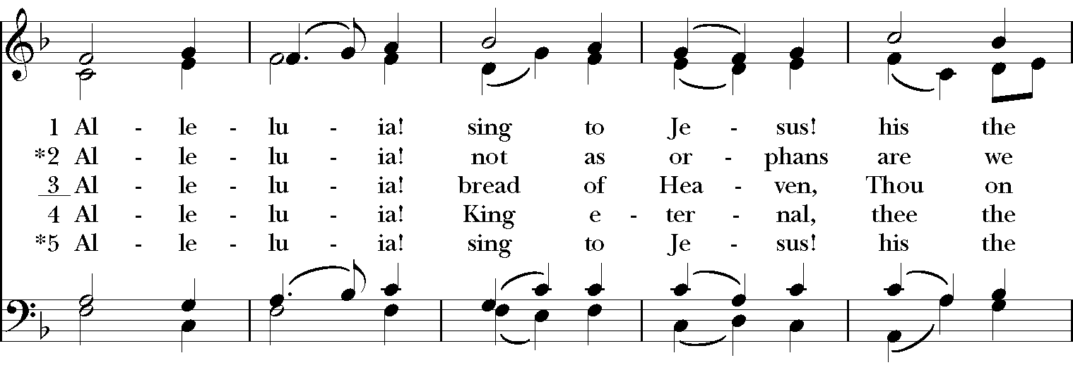
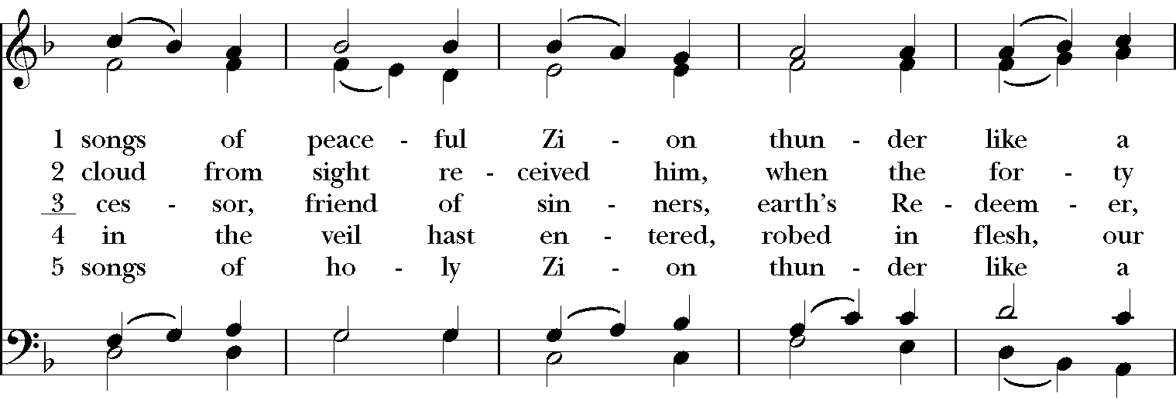
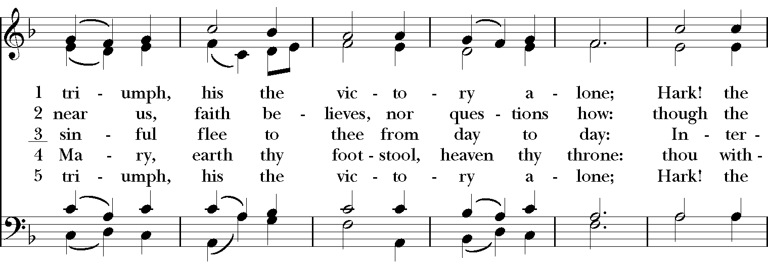
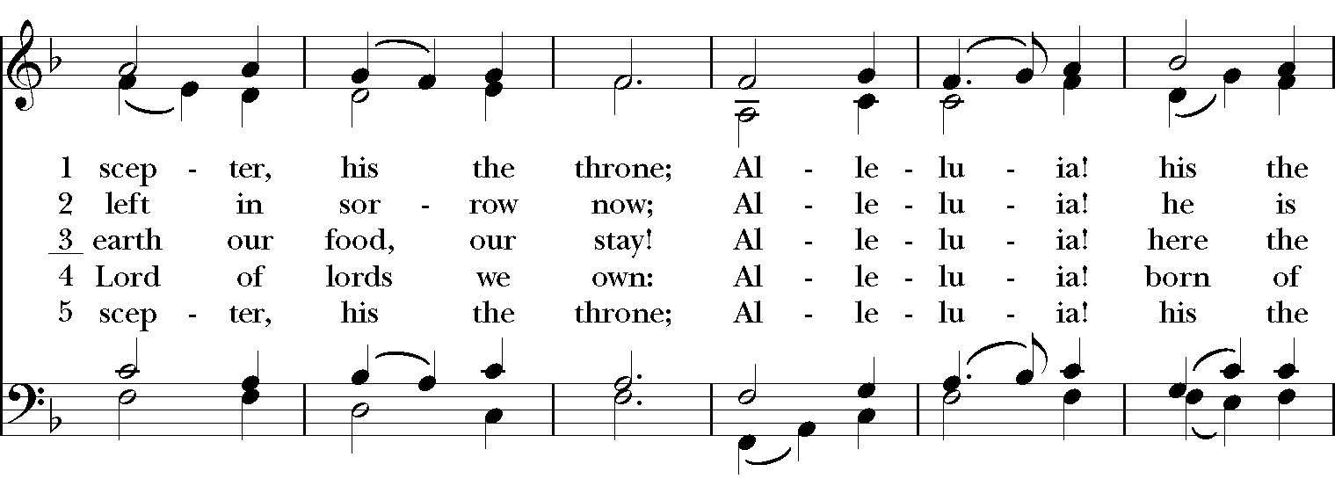
Closing Hymn: #460 “Alleluia! sing to Jesus!”

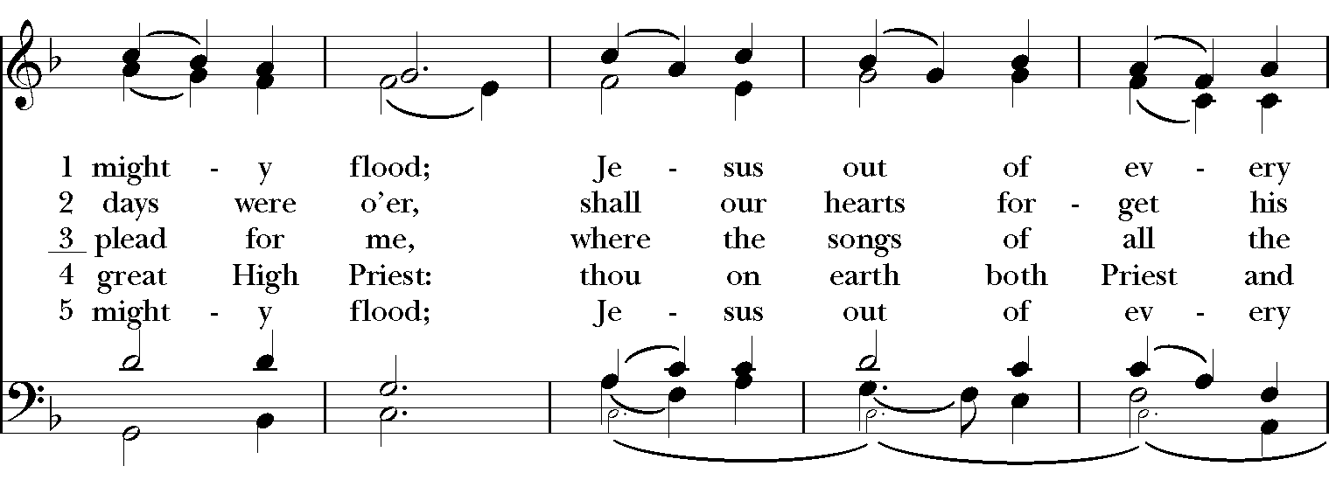
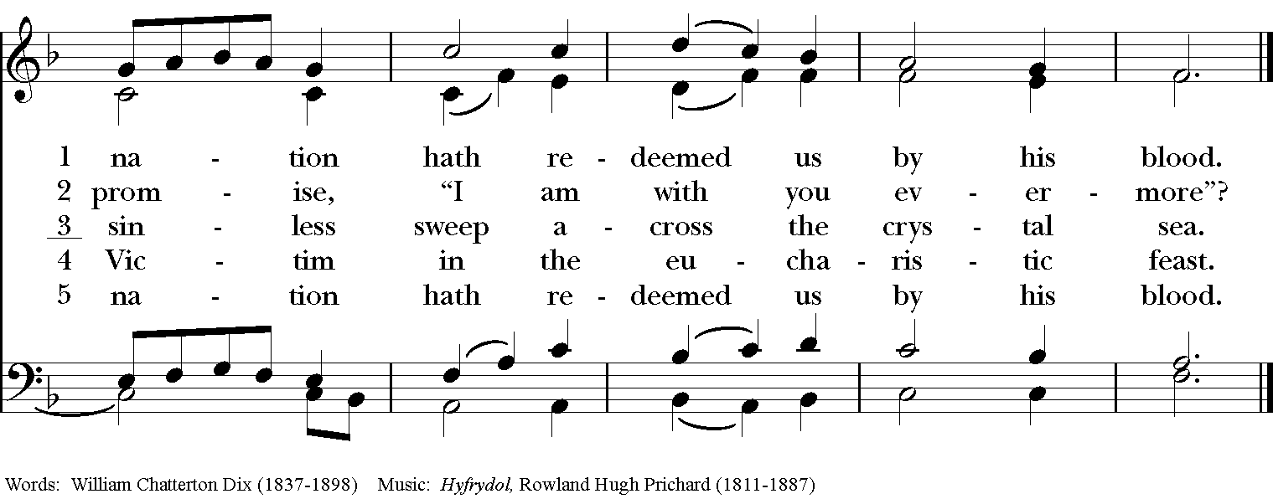

Postlude: "Meditation" for violin and piano Massenet/arr. Marsick
Isabelle Durrenberger, violin

Thank you for your spiritual presence with us this morning!
Although we're physically apart, we are united in prayer, worship, and holy love!

Rector: The Rev. Maggie Leidheiser-Stoddard
Deacon: The Rev. Dr. Rick Incorvati
Music Director: Dr. Chris Durrenberger
Lectors: TBA and Jesse Leidheiser-Stoddard
Singers: Liz Wheeler, Joy Carter, Ed Hasecke, Fred Bartenstein
Technology: Jon Leidheiser-Stoddard
Slideshow: Ed Hasecke
Parish Administrator: Kelly Zeller
Senior Warden: Dawn Ivy
Coffee Hour Host: TBA

