MORNING PRAYER for July 12th, 2020 at 9 am: Sixth Sunday after Pentecost
Note: We invite you to light a candle on your table or home altar before worship begins.

God is Spirit, and those who worship must worship in spirit and in truth. John 4:24

The Invitatory & Psalter BCP p. 81

Lord, open our lips.
And our mouth shall proclaim your praise.
Glory to the Father, and to the Son, and to the Holy Spirit:
as it was in the beginning, is now, and will be for ever. Amen.

Invitatory Psalm Psalm 67:1-5 Deus misereatur from Enriching Our Worship

O God, be merciful to us and bless us, *
show us the light of your countenance and come to us.
Let your ways be known upon earth, *
your saving health among all nations.
Let the peoples praise you, O God; *
let all the peoples praise you.
Let the nations be glad and sing for joy, *
for you judge the peoples with equity and guide all the nations upon earth.
Let the peoples praise you, O God; *
let all the peoples praise you.

The Psalm Appointed 119:105-112 Lucerna pedibus meis BCP p. 772

105 Your word is a lantern to my feet *
and a light upon my path.
106 I have sworn and am determined *
to keep your righteous judgments.
107 I am deeply troubled; *
preserve my life, O Lord, according to your word.
108 Accept, O Lord, the willing tribute of my lips, *
and teach me your judgments.
109 My life is always in my hand, *
yet I do not forget your law.
110 The wicked have set a trap for me, *
but I have not strayed from your commandments.
111 Your decrees are my inheritance for ever; *
truly, they are the joy of my heart.
112 I have applied my heart to fulfill your statutes *
for ever and to the end.
Glory to the Father, and to the Son, and to the Holy Spirit:
as it was in the beginning, is now, and will be for ever. Amen.

Sequence Hymn: #48 “O day of radiant gladness”
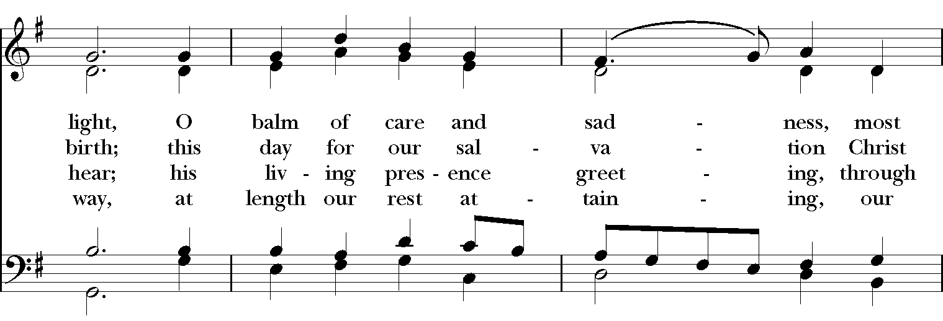
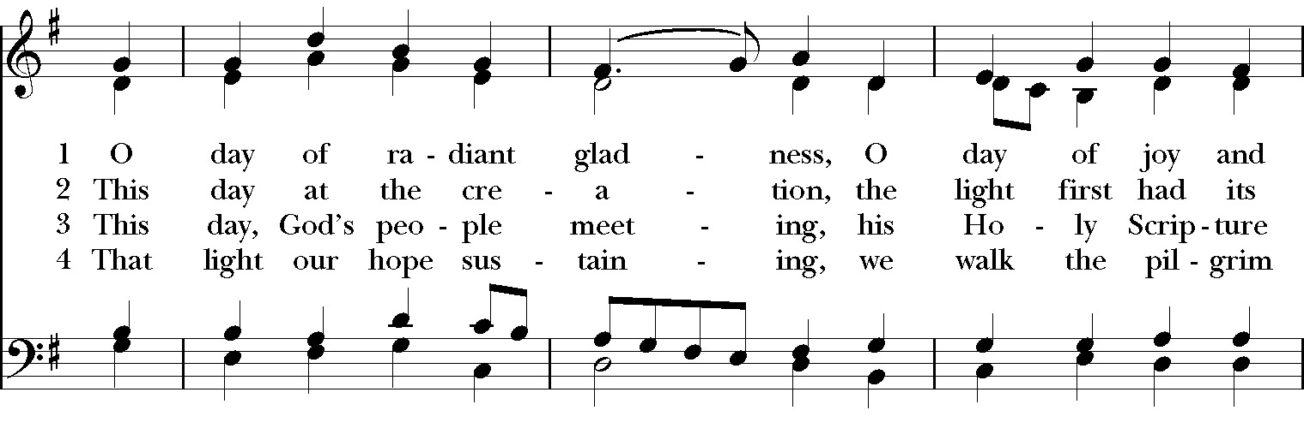
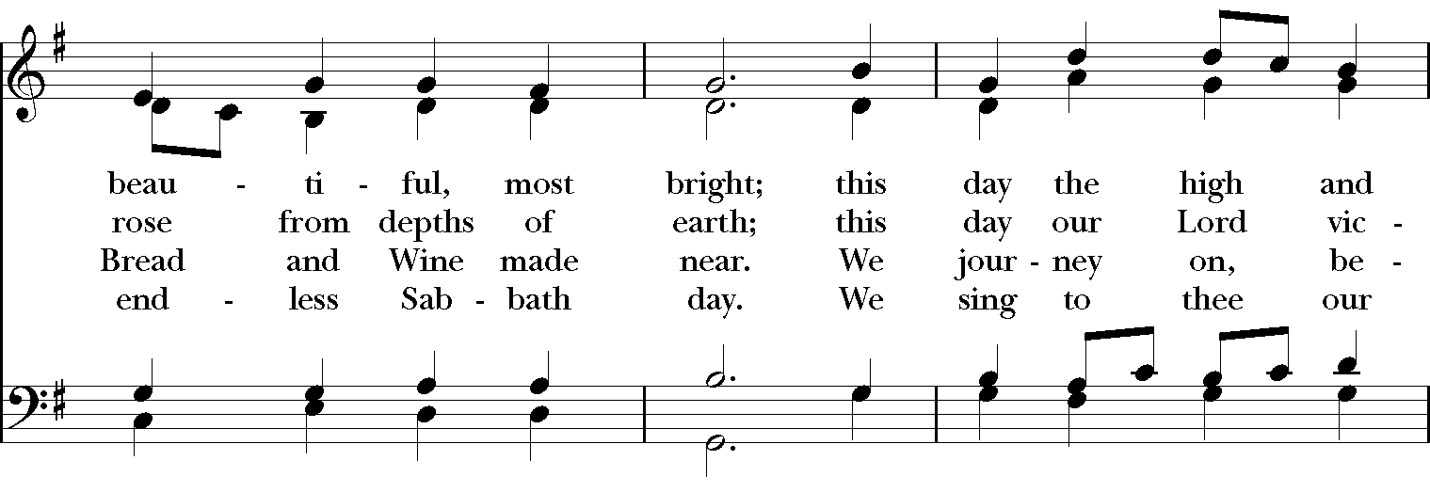
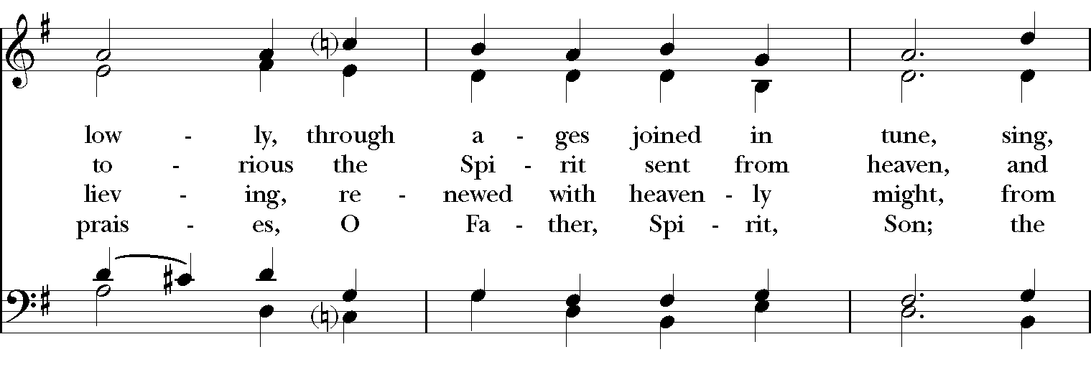

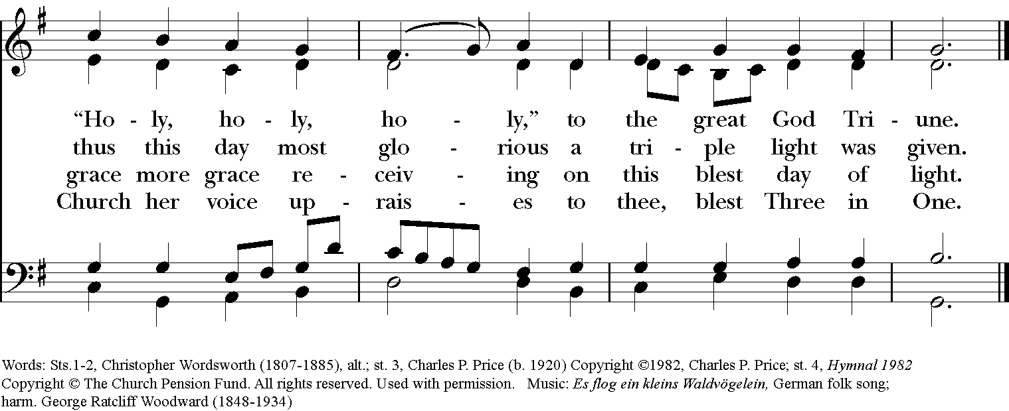

The Lessons & Canticles

A reading from the 25th chapter of the Book of Genesis. (Genesis 25:19-34)
These are the descendants of Isaac, Abraham’s son: Abraham was the father of Isaac, and Isaac was forty years old when he married Rebekah, daughter of Bethuel the Aramean of Paddan-aram, sister of Laban the Aramean. Isaac prayed to the Lord for his wife, because she was barren; and the Lord granted his prayer, and his wife Rebekah conceived. The children struggled together within her; and she said, “If it is to be this way, why do I live?” So she went to inquire of the Lord. And the Lord said to her,
“Two nations are in your womb,
and two peoples born of you shall be divided;
the one shall be stronger than the other,
the elder shall serve the younger.”

When her time to give birth was at hand, there were twins in her womb. The first came out red, all his body like a hairy mantle; so they named him Esau. Afterward his brother came out, with his hand gripping Esau’s heel; so he was named Jacob. Isaac was sixty years old when she bore them.
When the boys grew up, Esau was a skillful hunter, a man of the field, while Jacob was a quiet man, living in tents. Isaac loved Esau, because he was fond of game; but Rebekah loved Jacob.
Once when Jacob was cooking a stew, Esau came in from the field, and he was famished. Esau said to Jacob, “Let me eat some of that red stuff, for I am famished!” (Therefore he was called Edom.) Jacob said, “First sell me your birthright.” Esau said, “I am about to die; of what use is a birthright to me?” Jacob said, “Swear to me first.” So he swore to him, and sold his birthright to Jacob. Then Jacob gave Esau bread and lentil stew, and he ate and drank, and rose and went his way. Thus Esau despised his birthright.
The Word of the Lord. Thanks be to God.
Canticle J: A Song of Judith Judith 16:13-16 from Enriching Our Worship

I will sing a new song to my God, *
for you are great and glorious, wonderful in strength, invincible.
Let the whole creation serve you, *
for you spoke and all things came into being.
You sent your breath and it formed them, *
no one is able to resist your voice.
Mountains and seas are stirred to their depths, *
rocks melt like wax at your presence.
But to those who fear you, *
you continue to show mercy.
No sacrifice, however fragrant, can please you, *
but whoever fears the Lord shall stand in your sight for ever.
Glory to the Father, and to the Son, and to the Holy Spirit:
as it was in the beginning, is now, and will be for ever. Amen.

A reading from the 8th chapter of Saint Paul's Letter to the Romans. (Romans 8:1-11)

There is no condemnation for those who are in Christ Jesus. For the law of the Spirit of life in Christ Jesus has set you free from the law of sin and of death. For God has done what the law, weakened by the flesh, could not do: by sending his own Son in the likeness of sinful flesh, and to deal with sin, he condemned sin in the flesh, so that the just requirement of the law might be fulfilled in us, who walk not according to the flesh but according to the Spirit. For those who live according to the flesh set their minds on the things of the flesh, but those who live according to the Spirit set their minds on the things of the Spirit. To set the mind on the flesh is death, but to set the mind on the Spirit is life and peace. For this reason the mind that is set on the flesh is hostile to God; it does not submit to God's law-- indeed it cannot, and those who are in the flesh cannot please God.
But you are not in the flesh; you are in the Spirit, since the Spirit of God dwells in you. Anyone who does not have the Spirit of Christ does not belong to him. But if Christ is in you, though the body is dead because of sin, the Spirit is life because of righteousness. If the Spirit of him who raised Jesus from the dead dwells in you, he who raised Christ from the dead will give life to your mortal bodies also through his Spirit that dwells in you.
The Word of the Lord. Thanks be to God.
Canticle 16: The Song of Zechariah Benedictus Dominus Deus Luke 1:68-79 BCP p.92-93

Blessed be the Lord, the God of Israel; *
he has come to his people and set them free.
He has raised up for us a mighty savior, *
born of the house of his servant David.
Through his holy prophets he promised of old,
that he would save us from our enemies, *
from the hands of all who hate us.
He promised to show mercy to our fathers *
and to remember his holy covenant.
This was the oath he swore to our father Abraham, *
to set us free from the hands of our enemies,
Free to worship him without fear, *
holy and righteous in his sight all the days of our life.
You, my child, shall be called the prophet of the Most High, *
for you will go before the Lord to prepare his way,
To give his people knowledge of salvation *
by the forgiveness of their sins.
In the tender compassion of our God *
the dawn from on high shall break upon us,
To shine on those who dwell in darkness and the shadow of death, *
and to guide our feet into the way of peace.
Glory to the Father, and to the Son, and to the Holy Spirit: *
as it was in the beginning, is now, and will be for ever. Amen.

A reading from the Holy Gospel of our Lord and Savior Jesus Christ, according to Matthew.
Glory to you, Lord Christ. (Matthew 13:1-9, 18-23)

Jesus went out of the house and sat beside the sea. Such great crowds gathered around him that he got into a boat and sat there, while the whole crowd stood on the beach. And he told them many things in parables, saying: “Listen! A sower went out to sow. And as he sowed, some seeds fell on the path, and the birds came and ate them up. Other seeds fell on rocky ground, where they did not have much soil, and they sprang up quickly, since they had no depth of soil. But when the sun rose, they were scorched; and since they had no root, they withered away. Other seeds fell among thorns, and the thorns grew up and choked them. Other seeds fell on good soil and brought forth grain, some a hundredfold, some sixty, some thirty. Let anyone with ears listen!”
“Hear then the parable of the sower. When anyone hears the word of the kingdom and does not understand it, the evil one comes and snatches away what is sown in the heart; this is what was sown on the path. As for what was sown on rocky ground, this is the one who hears the word and immediately receives it with joy; yet such a person has no root, but endures only for a while, and when trouble or persecution arises on account of the word, that person immediately falls away. As for what was sown among thorns, this is the one who hears the word, but the cares of the world and the lure of wealth choke the word, and it yields nothing. But as for what was sown on good soil, this is the one who hears the word and understands it, who indeed bears fruit and yields, in one case a hundredfold, in another sixty, and in another thirty.”
The Gospel of the Lord. Praise to you, Lord Christ.
A reflection on the Scripture is offered.

Sequence Hymn: #589 “Almighty God, your word is cast”

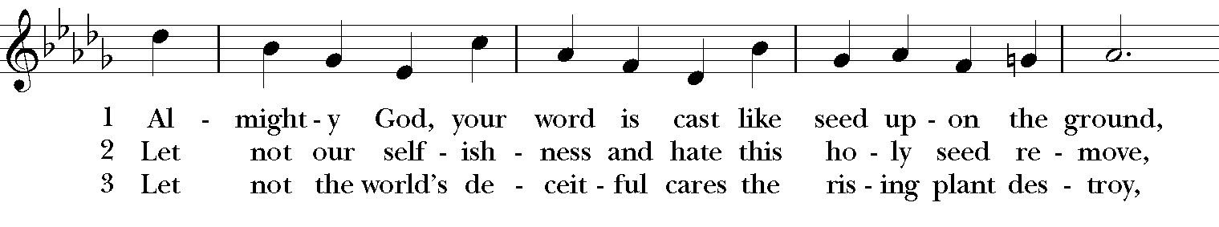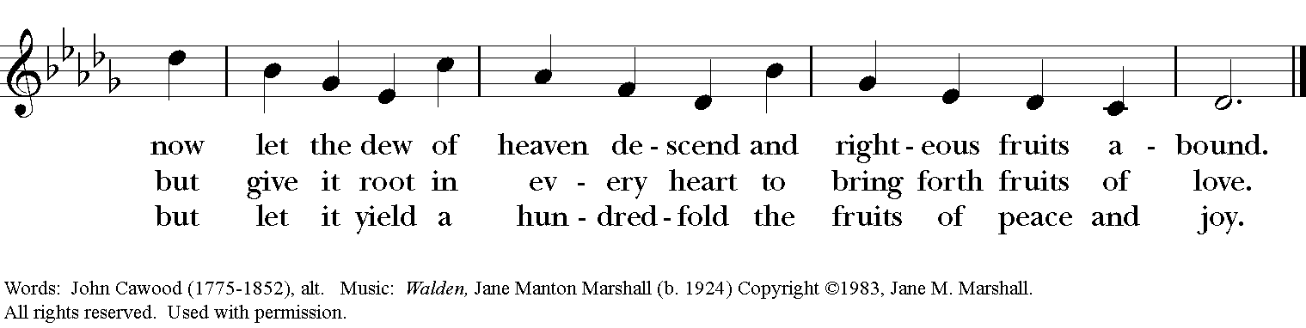

The Apostles’ Creed
I believe in God, the Father almighty,
creator of heaven and earth;
I believe in Jesus Christ, his only Son, our Lord.
He was conceived by the power of the Holy Spirit
and born of the Virgin Mary.
He suffered under Pontius Pilate,
was crucified, died, and was buried.
He descended to the dead.
On the third day he rose again.
He ascended into heaven,
and is seated at the right hand of the Father.
He will come again to judge the living and the dead.
I believe in the Holy Spirit,
the holy catholic Church,
the communion of saints,
the forgiveness of sins
the resurrection of the body,
and the life everlasting. Amen.

The Prayers BCP p. 97-98
The Lord be with you.
And also with you.
Let us pray.

Our Father, who art in heaven,
hallowed be thy Name,
thy kingdom come,
thy will be done,
on earth as it is in heaven.
Give us this day our daily bread.
And forgive us our trespasses,
as we forgive those
who trespass against us.
And lead us not into temptation,
but deliver us from evil.
For thine is the kingdom,
and the power, and the glory,
for ever and ever. Amen.

Save your people, Lord, and bless your inheritance;
Govern and uphold them, now and always.
Day by day we bless you;
We praise your name for ever.
Lord, keep us from all sin today;
Have mercy upon us, Lord, have mercy.
Lord, show us your love and mercy;
For we put our trust in you.
In you, Lord, is our hope;
And we shall never hope in vain.

The Collect of the Day
O Lord, mercifully receive the prayers of your people who call upon you, and grant that they may know and understand what things they ought to do, and also may have grace and power faithfully to accomplish them; through Jesus Christ our Lord, who lives and reigns with you and the Holy Spirit, one God, now and for ever. Amen.

A Prayer for Mission
O God, you have made of one blood all the peoples of the earth, and sent your blessed Son to preach peace to those who are far off and to those who are near: Grant that people everywhere may seek after you and find you; bring the nations into your fold; pour out your Spirit upon all flesh; and hasten the coming of your kingdom; through Jesus Christ our Lord. Amen.

An Act of Spiritual Communion (for times when we cannot celebrate Holy Eucharist together)

In union, Lord Jesus, with the faithful gathered at every altar of your Church --
in places where your blessed Body and Blood are offered this day,
and in places (like our parish) where your people
now fast from the Holy Eucharist out of love for one another --
we offer you praise and thanksgiving,
for the Creation and all the blessings of this life,
for the redemption won for us by your life, death, and resurrection,
for the means of grace and the hope of glory.

On this day, O Lord, we offer particular gratitude for the blessings of our own lives ...
[share your blessings, aloud or silently]

We are members of your holy, glorious, and blessed Body, O Lord Christ.
We believe that you are truly present in the Holy Sacrament,
and, since we cannot at this time receive communion,
we each entreat you with these words:
I pray you, Lord, to come into my heart.
I unite myself with you and embrace you
with all my heart, my soul, and my mind.
Let nothing separate me from you;
let me serve you in this life until, by your grace,
I come to your glorious kingdom and unending peace. Amen.

Come Lord Jesus, and dwell in our hearts in the fullness of your strength;
be our wisdom and guide us in right pathways;
conform our lives and actions to the image of your holiness;
and, in the power of your gracious might,
rule over every hostile power that threatens or disturbs the growth of your kingdom;
who with God our Creator,
and the Holy Spirit our Sanctifier,
lives and reigns,
one God,
in glory everlasting. Amen.

And now may the peace of God, which passes all understanding,
keep our hearts and minds in the knowledge and love of God,
and of God's Son Jesus Christ our Lord;
and the blessing of our Triune God,
the Creator, the Redeemer, and the Sanctifier, This is an appropriate time to
be with us now and always. Amen. make the sign of the cross.

Let us bless the Lord. Alleluia, alleluia!
Thanks be to God. Alleluia, alleluia!

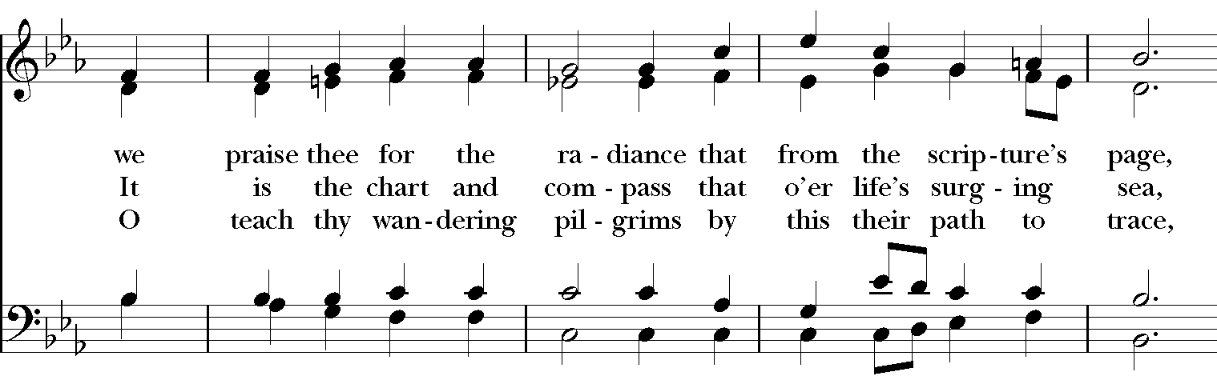
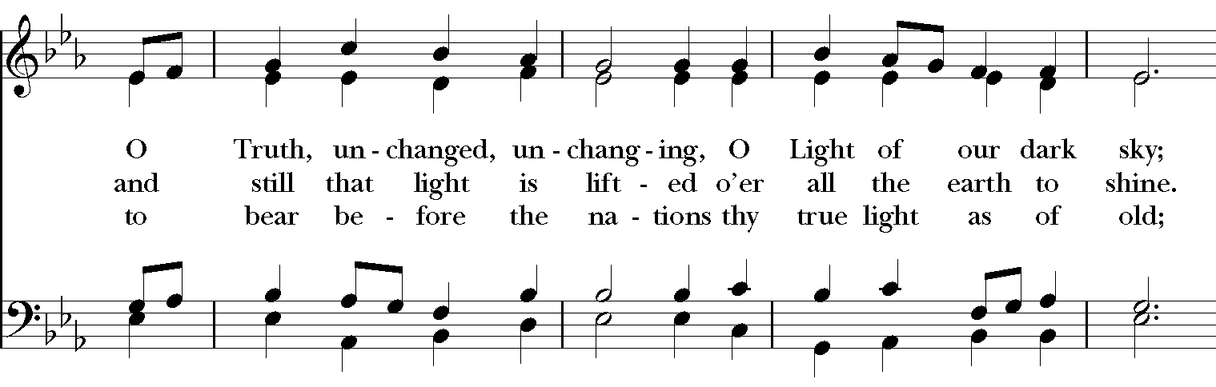
Closing Hymn: # 632 “O Christ, the Word Incarnate”
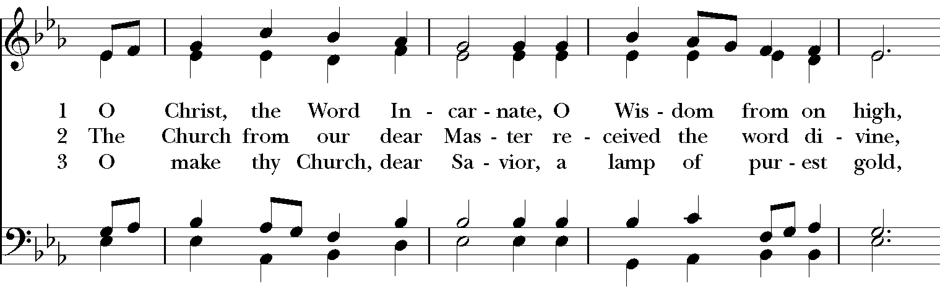

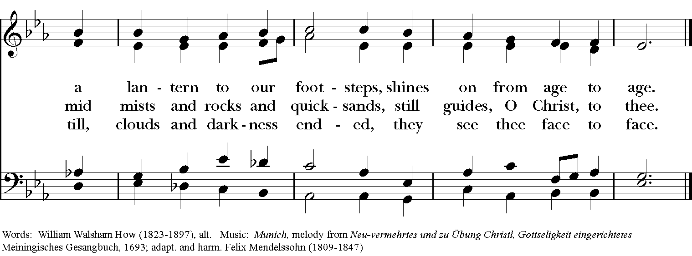

Thank you for your spiritual presence with us this morning!
Although we're physically apart, we are united in prayer, worship, and holy love!

Rector: The Rev. Maggie Leidheiser-Stoddard
Deacon: The Rev. Dr. Rick Incorvati
Organist/Choirmaster: Dr. Chris Durrenberger
Lectors: Ron Dowling & Jesse Leidheiser-Stoddard
Singers: Liz Wheeler, Joy Carter, Ed Hasecke, Fred Bartenstein
Technology: Jon Leidheiser-Stoddard
Slideshow: Ed Hasecke
Parish Administrator: Kelly Zeller
Coffee Hour Host: Ron Dowling

