MORNING PRAYER for July 19th, 2020 at 9 am: Seventh Sunday after Pentecost
Note: We invite you to light a candle on your table or home altar before worship begins.

God is Spirit, and those who worship must worship in spirit and in truth. John 4:24

The Invitatory & Psalter BCP p. 81

Lord, open our lips.
And our mouth shall proclaim your praise.
Glory to the Father, and to the Son, and to the Holy Spirit:
as it was in the beginning, is now, and will be for ever. Amen.

Invitatory Psalm Psalm 67:1-5 Deus misereatur from Enriching Our Worship

O God, be merciful to us and bless us, *
show us the light of your countenance and come to us.
Let your ways be known upon earth, *
your saving health among all nations.
Let the peoples praise you, O God; *
let all the peoples praise you.
Let the nations be glad and sing for joy, *
for you judge the peoples with equity and guide all the nations upon earth.
Let the peoples praise you, O God; *
let all the peoples praise you.

The Psalm Appointed 139:1-11, 22-23 Domine, probasti BCP p. 794

1 Lord, you have searched me out and known me; *
you know my sitting down and my rising up; you discern my thoughts from afar.
2 You trace my journeys and my resting-places *
and are acquainted with all my ways.
3 Indeed, there is not a word on my lips, *
but you, O Lord, know it altogether.
4 You press upon me behind and before *
and lay your hand upon me.
5 Such knowledge is too wonderful for me; *
it is so high that I cannot attain to it.
6 Where can I go then from your Spirit? *
where can I flee from your presence?
7 If I climb up to heaven, you are there; *
if I make the grave my bed, you are there also.
8 If I take the wings of the morning *
and dwell in the uttermost parts of the sea,
9 Even there your hand will lead me *
and your right hand hold me fast.
10 If I say, “Surely the darkness will cover me, *
and the light around me turn to night,”
11 Darkness is not dark to you; the night is as bright as the day; *
darkness and light to you are both alike.
22 Search me out, O God, and know my heart; *
try me and know my restless thoughts.
23 Look well whether there be any wickedness in me *
and lead me in the way that is everlasting.
Glory to the Father, and to the Son, and to the Holy Spirit:
as it was in the beginning, is now, and will be for ever. Amen.

Sequence Hymn: “We are climbing Jacob’s ladder”

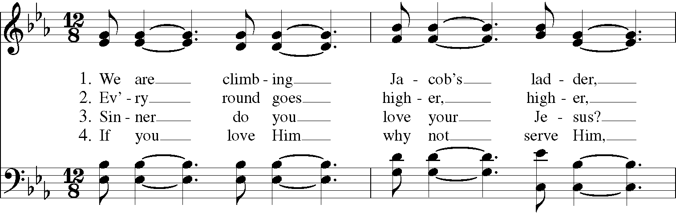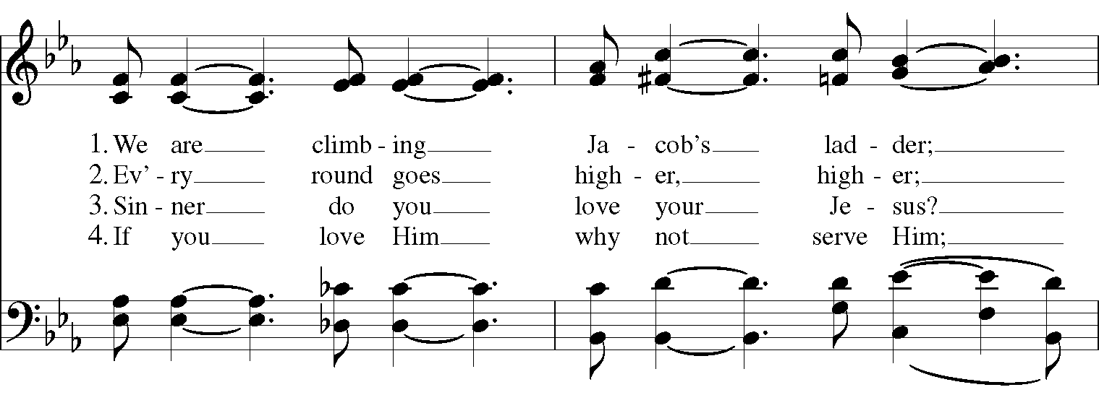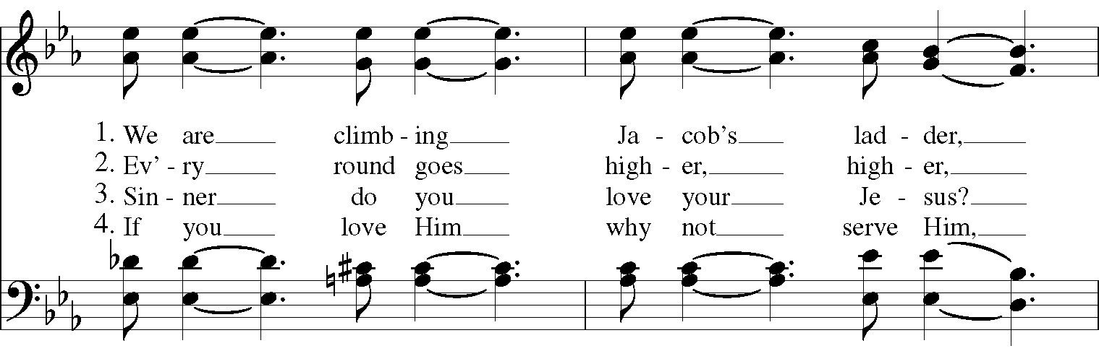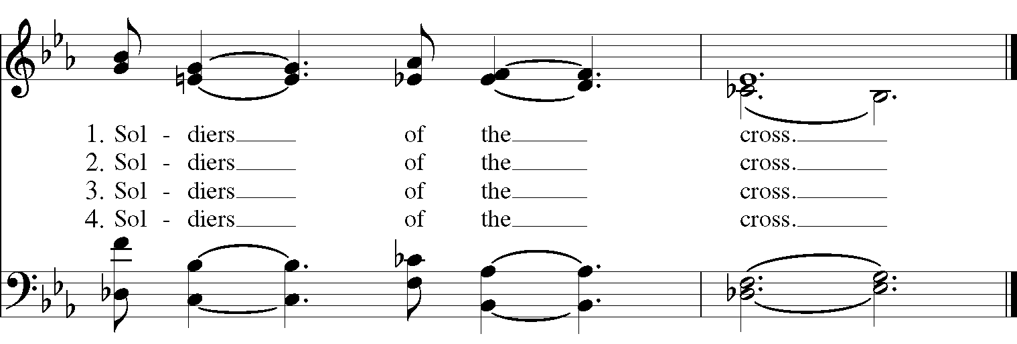

The Lessons & Canticles

A reading from the 28th chapter of the Book of Genesis. (Genesis 28:10-19a)
Jacob left Beer-sheba and went toward Haran. He came to a certain place and stayed there for the night, because the sun had set. Taking one of the stones of the place, he put it under his head and lay down in that place. And he dreamed that there was a ladder set up on the earth, the top of it reaching to heaven; and the angels of God were ascending and descending on it. And the Lord stood beside him and said, “I am the Lord, the God of Abraham your father and the God of Isaac; the land on which you lie I will give to you and to your offspring; and your offspring shall be like the dust of the earth, and you shall spread abroad to the west and to the east and to the north and to the south; and all the families of the earth shall be blessed in you and in your offspring. Know that I am with you and will keep you wherever you go, and will bring you back to this land; for I will not leave you until I have done what I have promised you.” Then Jacob woke from his sleep and said, “Surely the Lord is in this place—and I did not know it!” And he was afraid, and said, “How awesome is this place! This is none other than the house of God, and this is the gate of heaven.”
So Jacob rose early in the morning, and he took the stone that he had put under his head and set it up for a pillar and poured oil on the top of it. He called that place Bethel.
The Word of the Lord. Thanks be to God.

Canticle D: A Song of the Wilderness Isaiah 35:1-7,10 from Enriching Our Worship

The wilderness and the dry land shall be glad, *
the desert shall rejoice and blossom;
It shall blossom abundantly, *
and rejoice with joy and singing.
They shall see the glory of the Lord, *
the majesty of our God.
Strengthen the weary hands, *
and make firm the feeble knees.
Say to the anxious, “Be strong, do not fear! *
Here is your God, coming with judgment to save you.”
Then shall the eyes of the blind be opened, *
and the ears of the deaf be unstopped.
Then shall the lame leap like a deer, *
and the tongue of the speechless sing for joy.
For waters shall break forth in the wilderness *
and streams in the desert;
The burning sand shall become a pool *
and the thirsty ground, springs of water.
The ransomed of God shall return with singing, *
with everlasting joy upon their heads.
Joy and gladness shall be theirs, *
and sorrow and sighing shall flee away.
Glory to the Father, and to the Son, and to the Holy Spirit:
as it was in the beginning, is now, and will be for ever. Amen.

A reading from the 8th chapter of Saint Paul's Letter to the Romans. (Romans 8:12-25)

Brothers and sisters, we are debtors, not to the flesh, to live according to the flesh-- for if you live according to the flesh, you will die; but if by the Spirit you put to death the deeds of the body, you will live. For all who are led by the Spirit of God are children of God. For you did not receive a spirit of slavery to fall back into fear, but you have received a spirit of adoption. When we cry, “Abba! Father!” it is that very Spirit bearing witness with our spirit that we are children of God, and if children, then heirs, heirs of God and joint heirs with Christ-- if, in fact, we suffer with him so that we may also be glorified with him.
I consider that the sufferings of this present time are not worth comparing with the glory about to be revealed to us. For the creation waits with eager longing for the revealing of the children of God; for the creation was subjected to futility, not of its own will but by the will of the one who subjected it, in hope that the creation itself will be set free from its bondage to decay and will obtain the freedom of the glory of the children of God. We know that the whole creation has been groaning in labor pains until now; and not only the creation, but we ourselves, who have the first fruits of the Spirit, groan inwardly while we wait for adoption, the redemption of our bodies. For in hope we were saved. Now hope that is seen is not hope. For who hopes for what is seen? But if we hope for what we do not see, we wait for it with patience.
The Word of the Lord. Thanks be to God.

Canticle 15: The Song of Mary Magnificat Luke 1:46-55 BCP p. 91-92

My soul proclaims the greatness of the Lord, my spirit rejoices in God my Savior; *
for he has looked with favor on his lowly servant.
From this day all generations will call me blessed: *
the Almighty has done great things for me, and holy is his Name.
He has mercy on those who fear him *
in every generation.
He has shown the strength of his arm, *
he has scattered the proud in their conceit.
He has cast down the mighty from their thrones, *
and has lifted up the lowly.
He has filled the hungry with good things, *
and the rich he has sent away empty.
He has come to the help of his servant Israel, *
for he has remembered his promise of mercy,
The promise he made to our fathers, *
to Abraham and his children for ever.
Glory to the Father, and to the Son, and to the Holy Spirit: *
as it was in the beginning, is now, and will be for ever. Amen.

A reading from the Holy Gospel of our Lord and Savior Jesus Christ, according to Matthew.
Glory to you, Lord Christ. (Matthew 13:24-30, 36-43)

Jesus put before the crowd another parable: “The kingdom of heaven may be compared to someone who sowed good seed in his field; but while everybody was asleep, an enemy came and sowed weeds among the wheat, and then went away. So when the plants came up and bore grain, then the weeds appeared as well. And the slaves of the householder came and said to him, ‘Master, did you not sow good seed in your field? Where, then, did these weeds come from?’ He answered, ‘An enemy has done this.’ The slaves said to him, ‘Then do you want us to go and gather them?’ But he replied, ‘No; for in gathering the weeds you would uproot the wheat along with them. Let both of them grow together until the harvest; and at harvest time I will tell the reapers, Collect the weeds first and bind them in bundles to be burned, but gather the wheat into my barn.’”
Then he left the crowds and went into the house. And his disciples approached him, saying, “Explain to us the parable of the weeds of the field.” He answered, “The one who sows the good seed is the Son of Man; the field is the world, and the good seed are the children of the kingdom; the weeds are the children of the evil one, and the enemy who sowed them is the devil; the harvest is the end of the age, and the reapers are angels. Just as the weeds are collected and burned up with fire, so will it be at the end of the age. The Son of Man will send his angels, and they will collect out of his kingdom all causes of sin and all evildoers, and they will throw them into the furnace of fire, where there will be weeping and gnashing of teeth. Then the righteous will shine like the sun in the kingdom of their Father. Let anyone with ears listen!”
The Gospel of the Lord. Praise to you, Lord Christ.
A reflection on the Scripture is offered.

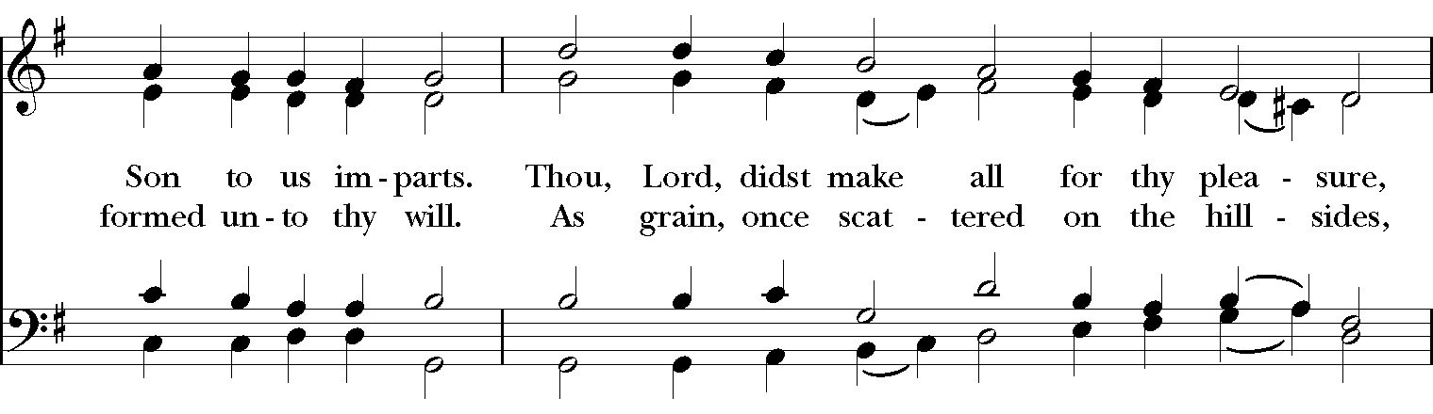
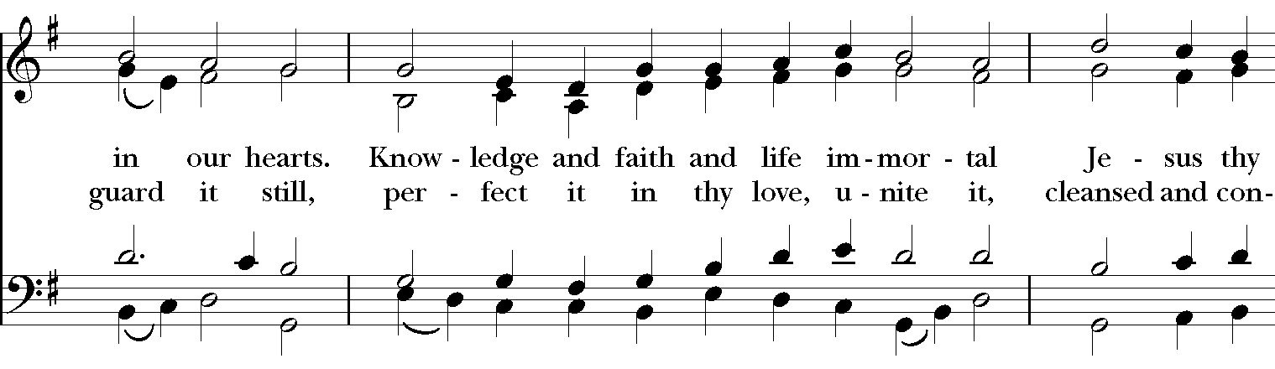
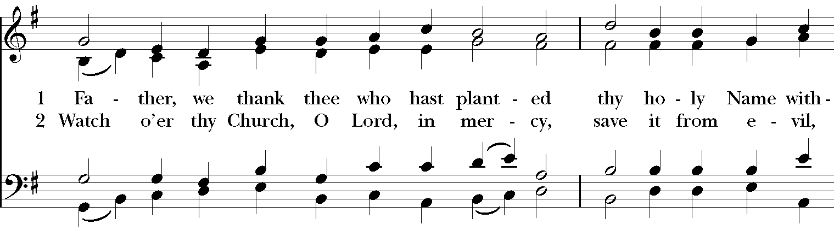
Sequence Hymn: #302 “Father, we thank thee who hast planted”
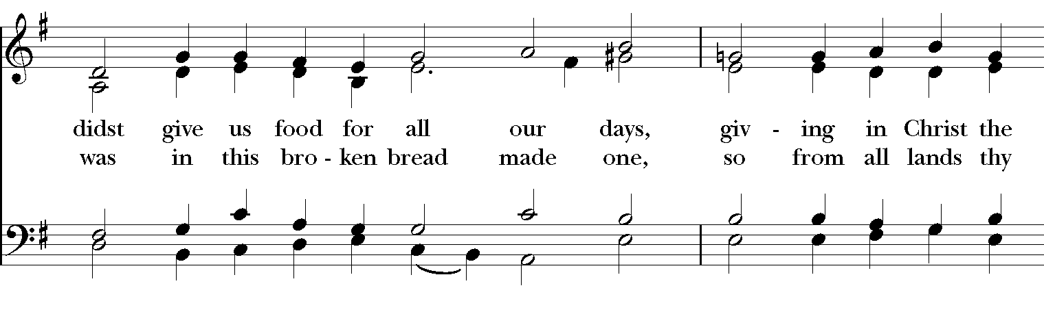
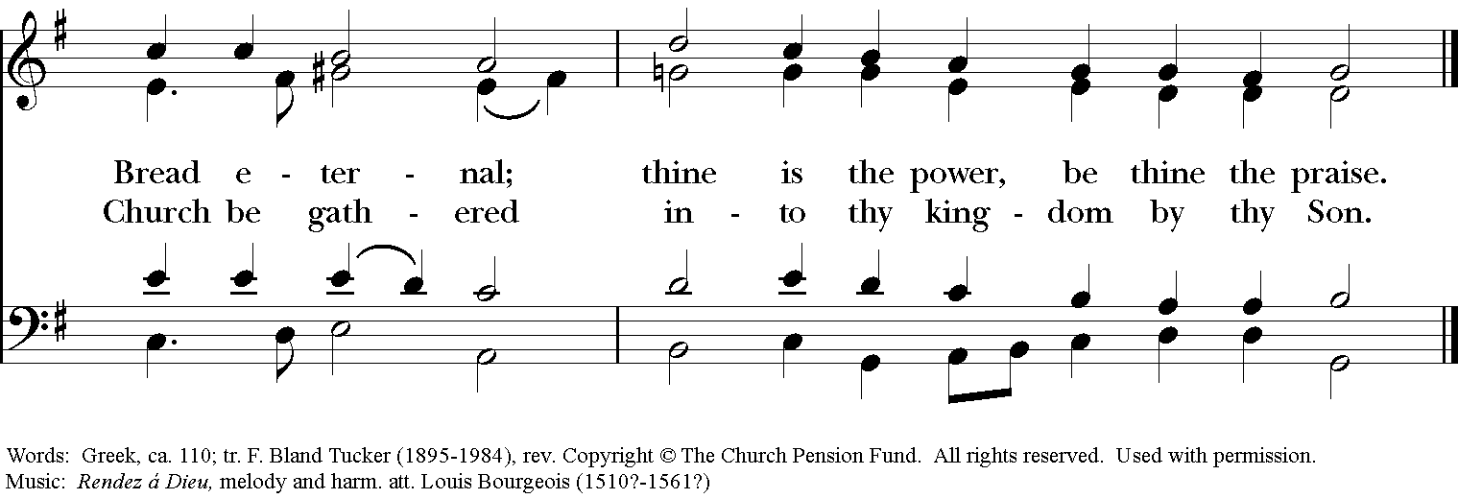

Parting Blessing for the Brooks Hedstrom Family

The church is a family.
United by the common recognition of Jesus Christ as our Savior,
we are all siblings in Christ.
And, for a time, Christ Episcopal Church is our home.
Like every human family,
our church family is formed and reformed over time:
as members are born, as they die,
as members are adopted into our family,
and as they leave our congregation for a new home, in a different place.
For a time, Mark, Dar, and Silas have lived with us.
We have shared with each other good times and bad,
we have shared each other's joys and sorrows,
we have lightened each other's heavy loads.
Together we have laughed and cried,
together we have worshiped and praised God,
together we have lived.

Eternal God, you are the strength and protector of your people.
We humbly place into your hands
our dear sister Dar, and our dear brothers Mark and Silas,
who are about to leave us.
We send them forth as messengers of salvation and peace,
marked with the sign of the cross.
Keep and preserve them, O Lord,
in all health and safety, both of body and soul;
and guide their steps, that they may be always in your light.
This we ask through Jesus Christ our Lord. Amen.

The Apostles’ Creed
I believe in God, the Father almighty,
creator of heaven and earth;
I believe in Jesus Christ, his only Son, our Lord.
He was conceived by the power of the Holy Spirit
and born of the Virgin Mary.
He suffered under Pontius Pilate,
was crucified, died, and was buried.
He descended to the dead.
On the third day he rose again.
He ascended into heaven,
and is seated at the right hand of the Father.
He will come again to judge the living and the dead.
I believe in the Holy Spirit,
the holy catholic Church,
the communion of saints,
the forgiveness of sins
the resurrection of the body,
and the life everlasting. Amen.

The Prayers BCP p. 97-98
The Lord be with you.
And also with you.
Let us pray.

Our Father, who art in heaven,
hallowed be thy Name,
thy kingdom come,
thy will be done,
on earth as it is in heaven.
Give us this day our daily bread.
And forgive us our trespasses,
as we forgive those
who trespass against us.
And lead us not into temptation,
but deliver us from evil.
For thine is the kingdom,
and the power, and the glory,
for ever and ever. Amen.

Save your people, Lord, and bless your inheritance;
Govern and uphold them, now and always.
Day by day we bless you;
We praise your name for ever.
Lord, keep us from all sin today;
Have mercy upon us, Lord, have mercy.
Lord, show us your love and mercy;
For we put our trust in you.
In you, Lord, is our hope;
And we shall never hope in vain.

The Collect of the Day
Almighty God, the fountain of all wisdom, you know our necessities before we ask and our ignorance in asking: Have compassion on our weakness, and mercifully give us those things which for our unworthiness we dare not, and for our blindness we cannot ask; through the worthiness of your Son Jesus Christ our Lord, who lives and reigns with you and the Holy Spirit, one God, now and for ever. Amen.

A Prayer for Mission
O God, you have made of one blood all the peoples of the earth, and sent your blessed Son to preach peace to those who are far off and to those who are near: Grant that people everywhere may seek after you and find you; bring the nations into your fold; pour out your Spirit upon all flesh; and hasten the coming of your kingdom; through Jesus Christ our Lord. Amen.

An Act of Spiritual Communion (for times when we cannot celebrate Holy Eucharist together)

In union, Lord Jesus, with the faithful gathered at every altar of your Church --
in places where your blessed Body and Blood are offered this day,
and in places (like our parish) where your people
now fast from the Holy Eucharist out of love for one another --
we offer you praise and thanksgiving,
for the Creation and all the blessings of this life,
for the redemption won for us by your life, death, and resurrection,
for the means of grace and the hope of glory.

On this day, O Lord, we offer particular gratitude for the blessings of our own lives ...
[share your blessings, aloud or silently]

We are members of your holy, glorious, and blessed Body, O Lord Christ.
We believe that you are truly present in the Holy Sacrament,
and, since we cannot at this time receive communion,
we each entreat you with these words:
I pray you, Lord, to come into my heart.
I unite myself with you and embrace you
with all my heart, my soul, and my mind.
Let nothing separate me from you;
let me serve you in this life until, by your grace,
I come to your glorious kingdom and unending peace. Amen.

Come Lord Jesus, and dwell in our hearts in the fullness of your strength;
be our wisdom and guide us in right pathways;
conform our lives and actions to the image of your holiness;
and, in the power of your gracious might,
rule over every hostile power that threatens or disturbs the growth of your kingdom;
who with God our Creator,
and the Holy Spirit our Sanctifier,
lives and reigns,
one God,
in glory everlasting. Amen.

And now may the peace of God, which passes all understanding,
keep our hearts and minds in the knowledge and love of God,
and of God's Son Jesus Christ our Lord;
and the blessing of our Triune God,
the Creator, the Redeemer, and the Sanctifier, This is an appropriate time to
be with us now and always. Amen. make the sign of the cross.

Let us bless the Lord. Alleluia, alleluia!
Thanks be to God. Alleluia, alleluia!

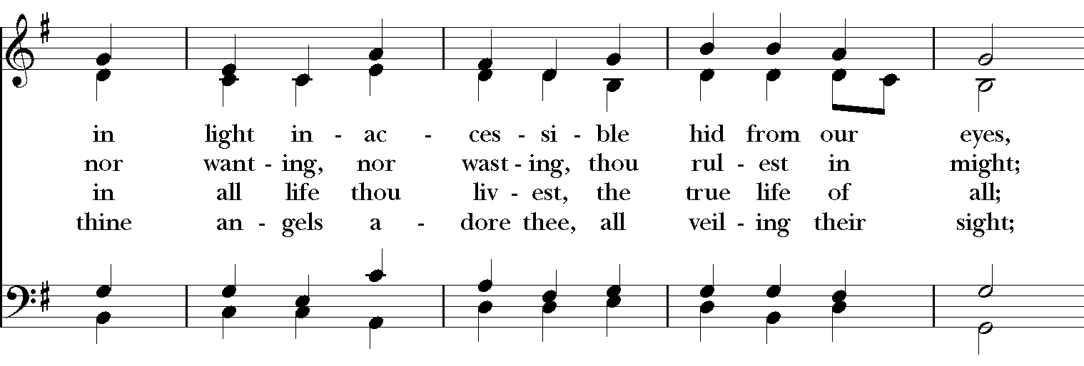
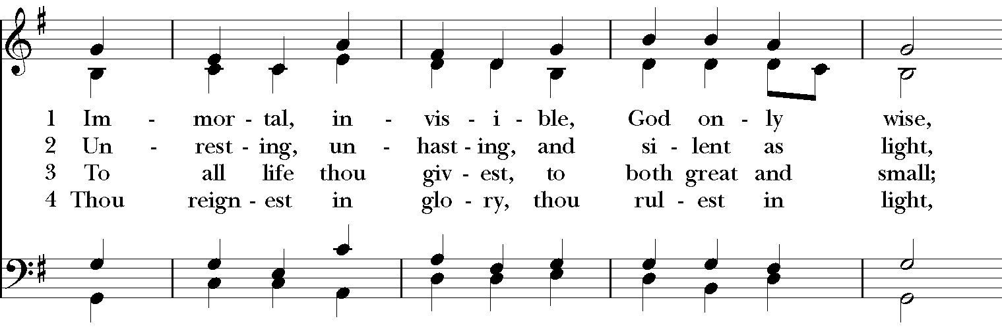
Closing Hymn: # 423 “Immortal, invisible, God only wise”
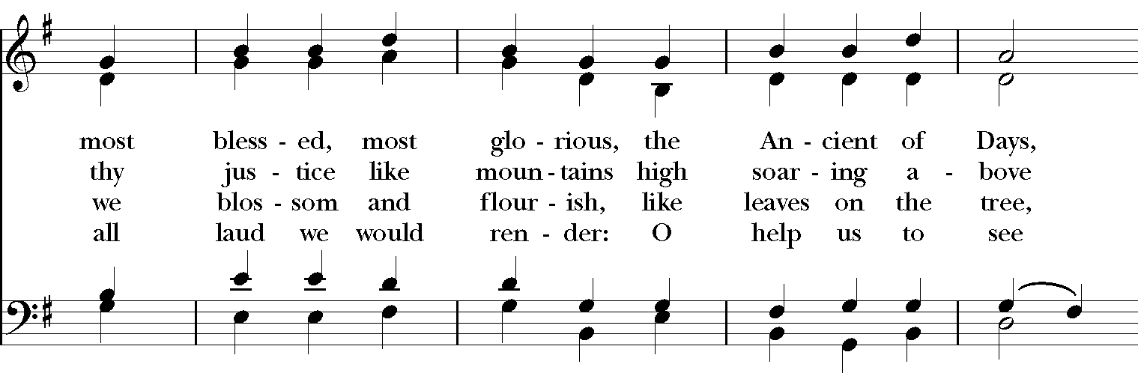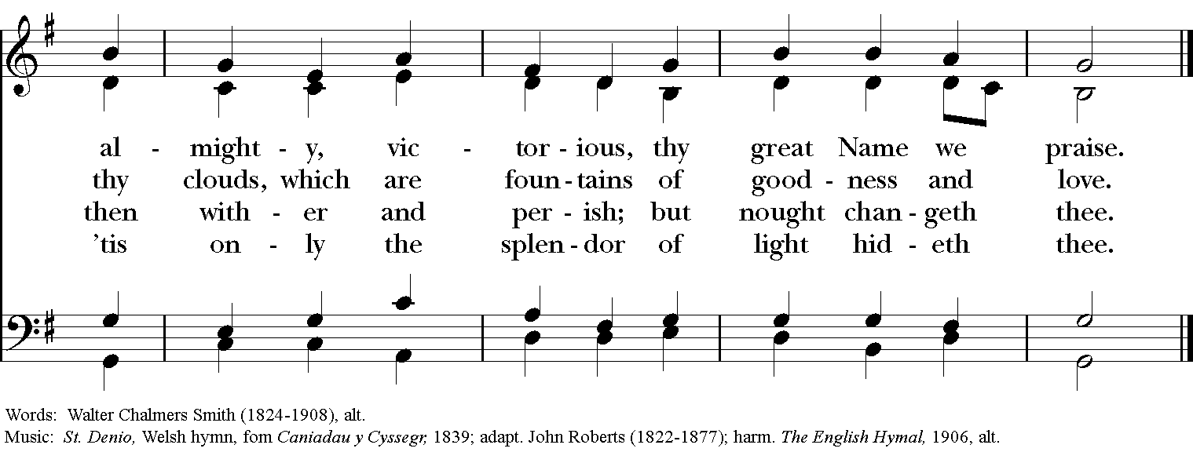

Thank you for your spiritual presence with us this morning!
Although we're physically apart, we are united in prayer, worship, and holy love!

Rector: The Rev. Maggie Leidheiser-Stoddard
Deacon: The Rev. Dr. Rick Incorvati
Organist/Choirmaster: Dr. Chris Durrenberger
Lector: Keith Doubt
Singers: Liz Wheeler, Joy Carter, Ed Hasecke, Fred Bartenstein
Technology: Jon Leidheiser-Stoddard
Slideshow: Ed Hasecke
Parish Administrator: Kelly Zeller
Coffee Hour Host: TBA

