MORNING PRAYER for July 26th, 2020 at 9 am: Eighth Sunday after Pentecost
Note: We invite you to light a candle on your table or home altar before worship begins.

God is Spirit, and those who worship must worship in spirit and in truth. John 4:24

The Invitatory & Psalter BCP p. 81

Lord, open our lips.
And our mouth shall proclaim your praise.
Glory to the Father, and to the Son, and to the Holy Spirit:
as it was in the beginning, is now, and will be for ever. Amen.

Invitatory Psalm Psalm 67:1-5 Deus misereatur from Enriching Our Worship

O God, be merciful to us and bless us, *
show us the light of your countenance and come to us.
Let your ways be known upon earth, *
your saving health among all nations.
Let the peoples praise you, O God; *
let all the peoples praise you.
Let the nations be glad and sing for joy, *
for you judge the peoples with equity and guide all the nations upon earth.
Let the peoples praise you, O God; *
let all the peoples praise you.

Psalm Appointed 105:1-11, 45b Confitemini Domino BCP p. 738

1 Give thanks to the Lord and call upon his Name; *
make known his deeds among the peoples.
2 Sing to him, sing praises to him, *
and speak of all his marvelous works.
3 Glory in his holy Name; *
let the hearts of those who seek the Lord rejoice.
4 Search for the Lord and his strength; *
continually seek his face.
5 Remember the marvels he has done, *
his wonders and the judgments of his mouth,
6 O offspring of Abraham his servant, *
O children of Jacob his chosen.
7 He is the Lord our God; *
his judgments prevail in all the world.
8 He has always been mindful of his covenant, *
the promise he made for a thousand generations:
9 The covenant he made with Abraham, *
the oath that he swore to Isaac,
10 Which he established as a statute for Jacob, *
an everlasting covenant for Israel,
11 Saying, "To you will I give the land of Canaan *
to be your allotted inheritance."
45b Hallelujah!
Glory to the Father, and to the Son, and to the Holy Spirit:
as it was in the beginning, is now, and will be for ever. Amen.

Sequence Hymn: #390 “Praise to the Lord, the Almighty”
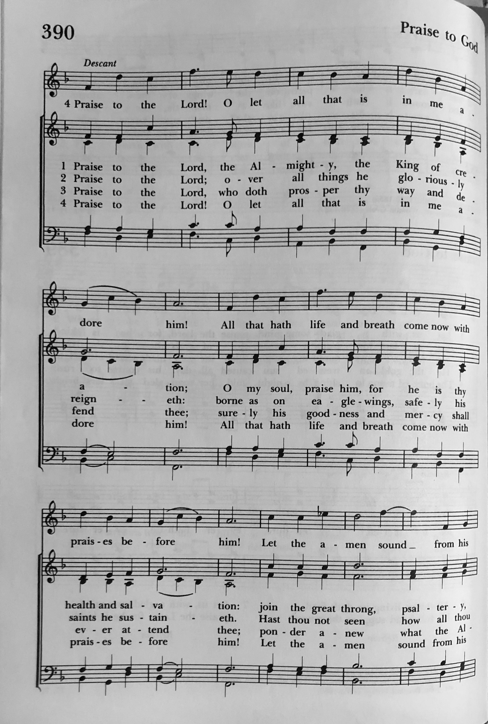

The Lessons & Canticles

A reading from the 29th chapter of the Book of Genesis. (Genesis 29:15-28)
Laban said to Jacob, “Because you are my kinsman, should you therefore serve me for nothing? Tell me, what shall your wages be?” Now Laban had two daughters; the name of the elder was Leah, and the name of the younger was Rachel. Leah’s eyes were lovely, and Rachel was graceful and beautiful. Jacob loved Rachel; so he said, “I will serve you seven years for your younger daughter Rachel.” Laban said, “It is better that I give her to you than that I should give her to any other man; stay with me.” So Jacob served seven years for Rachel, and they seemed to him but a few days because of the love he had for her.
Then Jacob said to Laban, “Give me my wife that I may go in to her, for my time is completed.” So Laban gathered together all the people of the place, and made a feast. But in the evening he took his daughter Leah and brought her to Jacob; and he went in to her. (Laban gave his maid Zilpah to his daughter Leah to be her maid.) When morning came, it was Leah! And Jacob said to Laban, “What is this you have done to me? Did I not serve with you for Rachel? Why then have you deceived me?” Laban said, “This is not done in our country—giving the younger before the firstborn. Complete the week of this one, and we will give you the other also in return for serving me another seven years.” Jacob did so, and completed her week; then Laban gave him his daughter Rachel as a wife.
The Word of the Lord. Thanks be to God.
Canticle 11: The 3rd Song of Isaiah Surge, illuminare Isaiah 60:1-3, 11a, 14c, 18-19
BCP p. 87-88
Arise, shine, for your light has come, *
and the glory of the Lord has dawned upon you.
For behold, darkness covers the land; *
deep gloom enshrouds the peoples.
But over you the Lord will rise, *
and his glory will appear upon you.
Nations will stream to your light, *
and kings to the brightness of your dawning.
Your gates will always be open; *
by day or night they will never be shut.
They will call you, The City of the Lord, *
The Zion of the Holy One of Israel.
Violence will no more be heard in your land, *
ruin or destruction within your borders.
You will call your walls, Salvation, *
and all your portals, Praise.
The sun will no more be your light by day; *
by night you will not need the brightness of the moon.
The Lord will be your everlasting light, *
and your God will be your glory.
Glory to the Father, and to the Son, and to the Holy Spirit: *
as it was in the beginning, is now, and will be for ever. Amen.

A reading from the 8th chapter of Saint Paul's Letter to the Romans. (Romans 8:26-39)

The Spirit helps us in our weakness; for we do not know how to pray as we ought, but that very Spirit intercedes with sighs too deep for words. And God, who searches the heart, knows what is the mind of the Spirit, because the Spirit intercedes for the saints according to the will of God.
We know that all things work together for good for those who love God, who are called according to his purpose. For those whom he foreknew he also predestined to be conformed to the image of his Son, in order that he might be the firstborn within a large family. And those whom he predestined he also called; and those whom he called he also justified; and those whom he justified he also glorified.
What then are we to say about these things? If God is for us, who is against us? He who did not withhold his own Son, but gave him up for all of us, will he not with him also give us everything else? Who will bring any charge against God's elect? It is God who justifies. Who is to condemn? It is Christ Jesus, who died, yes, who was raised, who is at the right hand of God, who indeed intercedes for us. Who will separate us from the love of Christ? Will hardship, or distress, or persecution, or famine, or nakedness, or peril, or sword? As it is written,
“For your sake we are being killed all day long;
we are accounted as sheep to be slaughtered.”
No, in all these things we are more than conquerors through him who loved us. For I am convinced that neither death, nor life, nor angels, nor rulers, nor things present, nor things to come, nor powers, nor height, nor depth, nor anything else in all creation, will be able to separate us from the love of God in Christ Jesus our Lord.
The Word of the Lord. Thanks be to God.
Canticle N: A Song of God’s Love 1 John 4:7-11 from Enriching our Worship

Beloved, let us love one another, *
for love is of God.
Whoever does not love does not know God, *
for God is Love.
In this the love of God was revealed among us, *
that God sent his only Son into the world, so that we might live through Jesus Christ.
In this is love, not that we loved God but that God loved us *
and sent his Son that sins might be forgiven.
Beloved, since God loved us so much, *
we ought also to love one another.
For if we love one another, God abides in us, *
and God’s love will be perfected in us.
Glory to the Father, and to the Son, and to the Holy Spirit: *
as it was in the beginning, is now, and will be for ever. Amen.

A reading from the Holy Gospel of our Lord and Savior Jesus Christ, according to Matthew.
Glory to you, Lord Christ. (Matthew 13:31-33, 44-52)

Jesus put before the crowds another parable: “The kingdom of heaven is like a mustard seed that someone took and sowed in his field; it is the smallest of all the seeds, but when it has grown it is the greatest of shrubs and becomes a tree, so that the birds of the air come and make nests in its branches.”
He told them another parable: “The kingdom of heaven is like yeast that a woman took and mixed in with three measures of flour until all of it was leavened.”
“The kingdom of heaven is like treasure hidden in a field, which someone found and hid; then in his joy he goes and sells all that he has and buys that field.
“Again, the kingdom of heaven is like a merchant in search of fine pearls; on finding one pearl of great value, he went and sold all that he had and bought it.
“Again, the kingdom of heaven is like a net that was thrown into the sea and caught fish of every kind; when it was full, they drew it ashore, sat down, and put the good into baskets but threw out the bad. So it will be at the end of the age. The angels will come out and separate the evil from the righteous and throw them into the furnace of fire, where there will be weeping and gnashing of teeth.
“Have you understood all this?” They answered, “Yes.” And he said to them, “Therefore every scribe who has been trained for the kingdom of heaven is like the master of a household who brings out of his treasure what is new and what is old.”
The Gospel of the Lord. Praise to you, Lord Christ.
A reflection on the Scripture is offered.

Sequence Hymn: #488 “Be thou my vision”
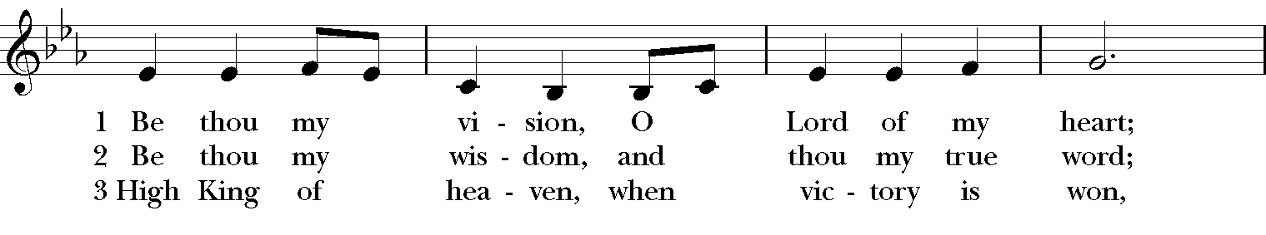

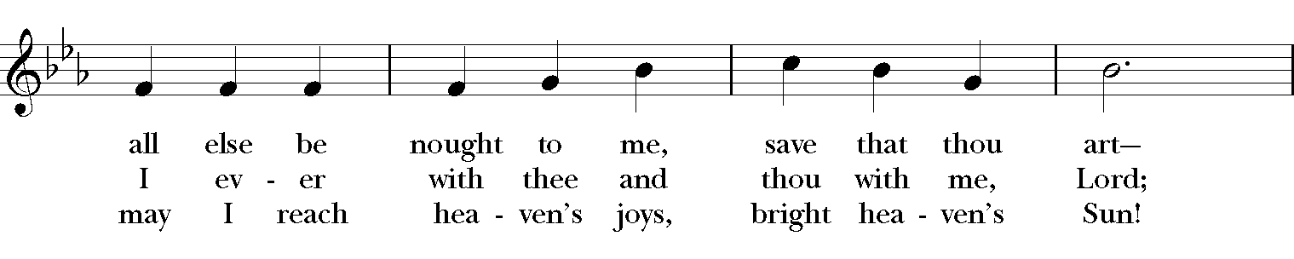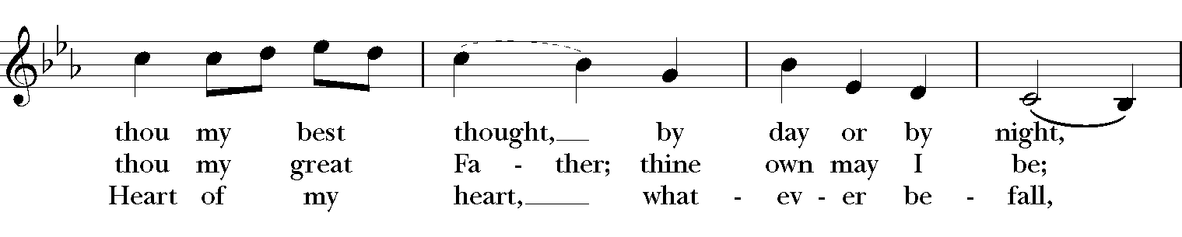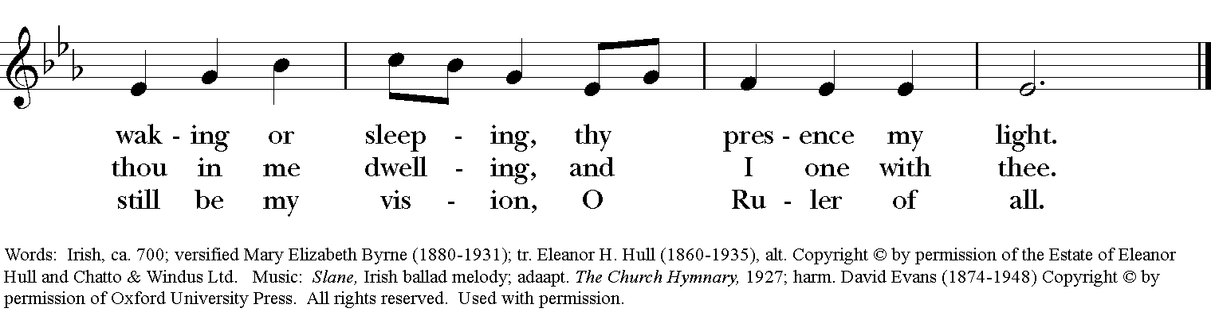

The Apostles’ Creed
I believe in God, the Father almighty,
creator of heaven and earth;
I believe in Jesus Christ, his only Son, our Lord.
He was conceived by the power of the Holy Spirit
and born of the Virgin Mary.
He suffered under Pontius Pilate,
was crucified, died, and was buried.
He descended to the dead.
On the third day he rose again.
He ascended into heaven,
and is seated at the right hand of the Father.
He will come again to judge the living and the dead.
I believe in the Holy Spirit,
the holy catholic Church,
the communion of saints,
the forgiveness of sins
the resurrection of the body,
and the life everlasting. Amen.

The Prayers BCP p. 97-98
The Lord be with you.
And also with you.
Let us pray.

Our Father, who art in heaven,
hallowed be thy Name,
thy kingdom come,
thy will be done,
on earth as it is in heaven.
Give us this day our daily bread.
And forgive us our trespasses,
as we forgive those
who trespass against us.
And lead us not into temptation,
but deliver us from evil.
For thine is the kingdom,
and the power, and the glory,
for ever and ever. Amen.

Save your people, Lord, and bless your inheritance;
Govern and uphold them, now and always.
Day by day we bless you;
We praise your name for ever.
Lord, keep us from all sin today;
Have mercy upon us, Lord, have mercy.
Lord, show us your love and mercy;
For we put our trust in you.
In you, Lord, is our hope;
And we shall never hope in vain.

The Collect of the Day
O God, the protector of all who trust in you, without whom nothing is strong, nothing is holy: Increase and multiply upon us your mercy; that, with you as our ruler and guide, we may so pass through things temporal, that we lose not the things eternal; through Jesus Christ our Lord, who lives and reigns with you and the Holy Spirit, one God, for ever and ever. Amen.

A Prayer for Mission
O God, you have made of one blood all the peoples of the earth, and sent your blessed Son to preach peace to those who are far off and to those who are near: Grant that people everywhere may seek after you and find you; bring the nations into your fold; pour out your Spirit upon all flesh; and hasten the coming of your kingdom; through Jesus Christ our Lord. Amen.

An Act of Spiritual Communion (for times when we cannot celebrate Holy Eucharist together)

In union, Lord Jesus, with the faithful gathered at every altar of your Church --
in places where your blessed Body and Blood are offered this day,
and in places (like our parish) where your people
now fast from the Holy Eucharist out of love for one another --
we offer you praise and thanksgiving,
for the Creation and all the blessings of this life,
for the redemption won for us by your life, death, and resurrection,
for the means of grace and the hope of glory.

On this day, O Lord, we offer particular gratitude for the blessings of our own lives ...
[share your blessings, aloud or silently]

We are members of your holy, glorious, and blessed Body, O Lord Christ.
We believe that you are truly present in the Holy Sacrament,
and, since we cannot at this time receive communion,
we each entreat you with these words:
I pray you, Lord, to come into my heart.
I unite myself with you and embrace you
with all my heart, my soul, and my mind.
Let nothing separate me from you;
let me serve you in this life until, by your grace,
I come to your glorious kingdom and unending peace. Amen.

Come Lord Jesus, and dwell in our hearts in the fullness of your strength;
be our wisdom and guide us in right pathways;
conform our lives and actions to the image of your holiness;
and, in the power of your gracious might,
rule over every hostile power that threatens or disturbs the growth of your kingdom;
who with God our Creator,
and the Holy Spirit our Sanctifier,
lives and reigns,
one God,
in glory everlasting. Amen.

And now may the peace of God, which passes all understanding,
keep our hearts and minds in the knowledge and love of God,
and of God's Son Jesus Christ our Lord;
and the blessing of our Triune God,
the Creator, the Redeemer, and the Sanctifier, This is an appropriate time to
be with us now and always. Amen. make the sign of the cross.

Let us bless the Lord. Alleluia, alleluia!
Thanks be to God. Alleluia, alleluia!

Closing Hymn: # 615 “Thy kingdom come! on bended knee”

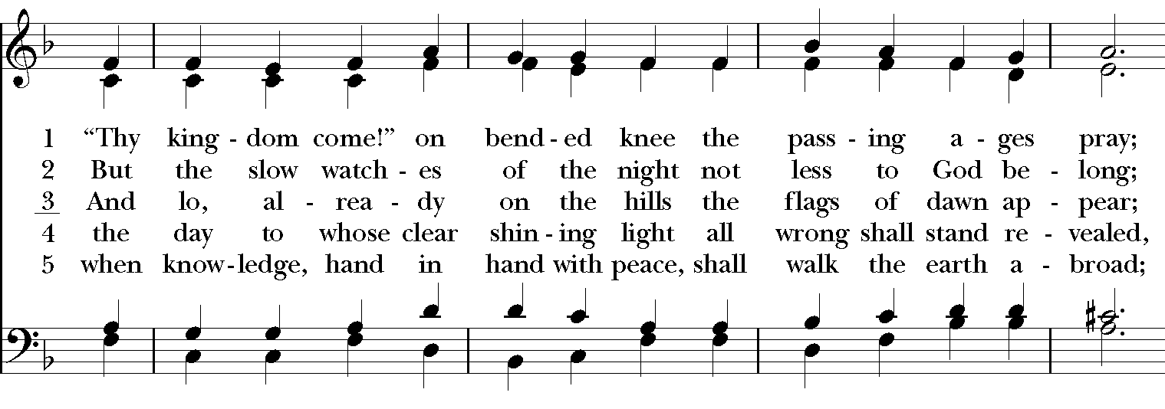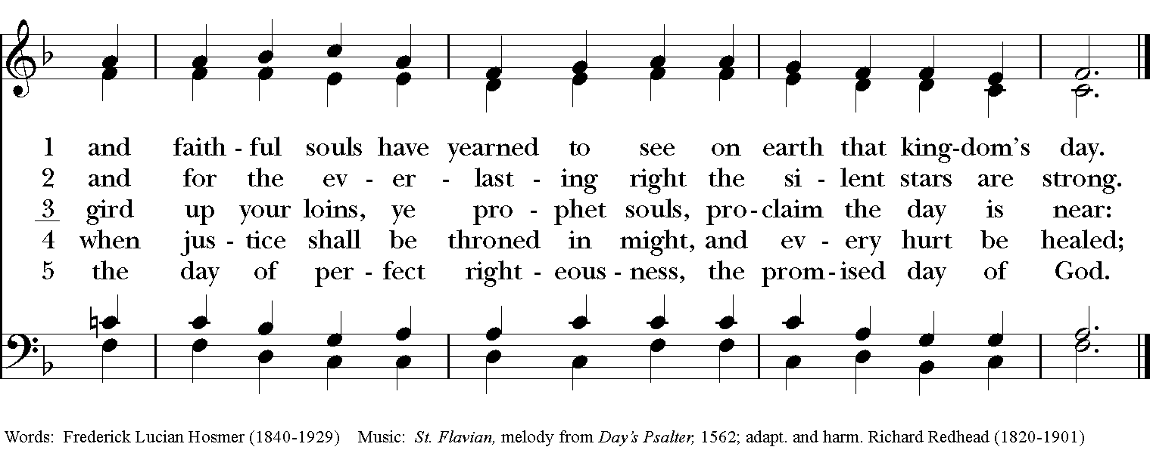

Thank you for your spiritual presence with us this morning!
Although we're physically apart, we are united in prayer, worship, and holy love!

Rector: The Rev. Maggie Leidheiser-Stoddard
Deacon: The Rev. Dr. Rick Incorvati
Organist/Choirmaster: Dr. Chris Durrenberger
Lectors: Fred Bartenstein, Jesse Leidheiser-Stoddard
Singers: Liz Wheeler, Joy Carter, Ed Hasecke, Fred Bartenstein
Technology: Jon Leidheiser-Stoddard
Slideshow: Ed Hasecke
Parish Administrator: Kelly Zeller
Coffee Hour Host: TBA

