MORNING PRAYER for July 5th, 2020 at 9 am: Fifth Sunday after Pentecost
Note: We invite you to light a candle on your table or home altar before worship begins.

God is Spirit, and those who worship must worship in spirit and in truth. John 4:24

The Invitatory & Psalter BCP p. 81

Lord, open our lips.
And our mouth shall proclaim your praise.
Glory to the Father, and to the Son, and to the Holy Spirit:
as it was in the beginning, is now, and will be for ever. Amen.

Invitatory Psalm Psalm 67:1-5 Deus misereatur from Enriching Our Worship

O God, be merciful to us and bless us, *
show us the light of your countenance and come to us.
Let your ways be known upon earth, *
your saving health among all nations.
Let the peoples praise you, O God; *
let all the peoples praise you.
Let the nations be glad and sing for joy, *
for you judge the peoples with equity and guide all the nations upon earth.
Let the peoples praise you, O God; *
let all the peoples praise you.

The Scriptural Hymn Appointed Song of Solomon 2:8-13

The voice of my beloved!
Look, he comes,
leaping upon the mountains,
bounding over the hills.
My beloved is like a gazelle
or a young stag.
Look, there he stands
behind our wall,
gazing in at the windows,
looking through the lattice.
My beloved speaks and says to me:
"Arise, my love, my fair one, and come away;
for now the winter is past,
the rain is over and gone.
The flowers appear on the earth;
the time of singing has come,
and the voice of the turtledove
is heard in our land.
The fig tree puts forth its figs,
and the vines are in blossom; they give forth fragrance.
Arise, my love, my fair one,
and come away."
Glory to the Father, and to the Son, and to the Holy Spirit:
as it was in the beginning, is now, and will be for ever. Amen.

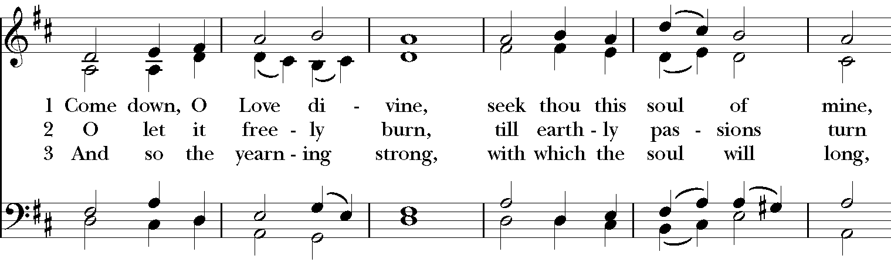
Sequence Hymn: #516 “Come down, O Love divine”

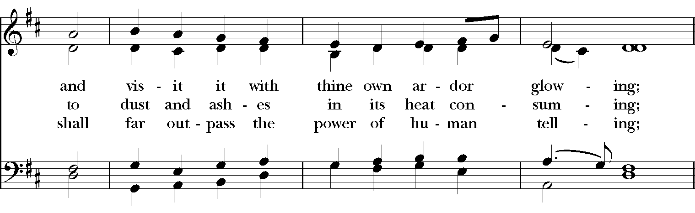

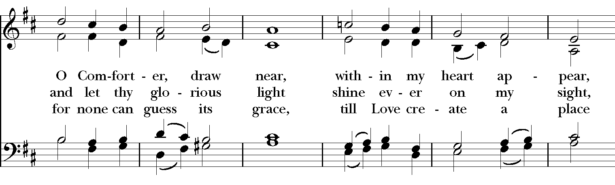

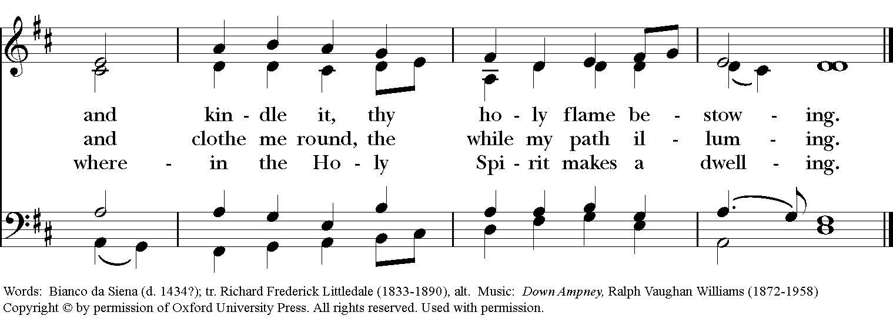

The Lessons & Canticles

A reading from the 24th chapter of the Book of Genesis. (Genesis 24:34-38, 42-49, 58-67)
The servant said to Laban, “I am Abraham’s servant. The Lord has greatly blessed my master, and he has become wealthy; he has given him flocks and herds, silver and gold, male and female slaves, camels and donkeys. And Sarah my master’s wife bore a son to my master when she was old; and he has given him all that he has. My master made me swear, saying, ‘You shall not take a wife for my son from the daughters of the Canaanites, in whose land I live; but you shall go to my father’s house, to my kindred, and get a wife for my son.’
“I came today to the spring, and said, ‘O Lord, the God of my master Abraham, if now you will only make successful the way I am going! I am standing here by the spring of water; let the young woman who comes out to draw, to whom I shall say, “Please give me a little water from your jar to drink,” and who will say to me, “Drink, and I will draw for your camels also” —let her be the woman whom the Lord has appointed for my master’s son.’
“Before I had finished speaking in my heart, there was Rebekah coming out with her water jar on her shoulder; and she went down to the spring, and drew. I said to her, ‘Please let me drink.’ She quickly let down her jar from her shoulder, and said, ‘Drink, and I will also water your camels.’ So I drank, and she also watered the camels. Then I asked her, ‘Whose daughter are you?’ She said, ‘The daughter of Bethuel, Nahor’s son, whom Milcah bore to him.’ So I put the ring on her nose, and the bracelets on her arms. Then I bowed my head and worshiped the Lord, and blessed the Lord, the God of my master Abraham, who had led me by the right way to obtain the daughter of my master’s kinsman for his son. Now then, if you will deal loyally and truly with my master, tell me; and if not, tell me, so that I may turn either to the right hand or to the left.”
And they called Rebekah, and said to her, “Will you go with this man?” She said, “I will.” So they sent away their sister Rebekah and her nurse along with Abraham’s servant and his men. And they blessed Rebekah and said to her, “May you, our sister, become thousands of myriads; may your offspring gain possession of the gates of their foes.” Then Rebekah and her maids rose up, mounted the camels, and followed the man; thus the servant took Rebekah, and went his way. Now Isaac had come from Beer-lahai-roi, and was settled in the Negeb. Isaac went out in the evening to walk in the field; and looking up, he saw camels coming. And Rebekah looked up, and when she saw Isaac, she slipped quickly from the camel, and said to the servant, “Who is the man over there, walking in the field to meet us?” The servant said, “It is my master.” So she took her veil and covered herself. And the servant told Isaac all the things that he had done. Then Isaac brought her into his mother Sarah’s tent. He took Rebekah, and she became his wife; and he loved her. So Isaac was comforted after his mother’s death.
The Word of the Lord. Thanks be to God.
Canticle B: A Song of Pilgrimage Priusquam errarem Ecclesiasticus 51:13-16,20b-22
from Enriching Our Worship
Before I ventured forth, even while I was very young, *
I sought wisdom openly in my prayer.
In the forecourts of the temple I asked for her, *
and I will seek her to the end.
From first blossom to early fruit, *
she has been the delight of my heart.
My foot has kept firmly to the true path, *
diligently from my youth have I pursued her.
I inclined my ear a little and received her; *
I found for myself much wisdom and became adept in her.
To the one who gives me wisdom will I give glory, *
for I have resolved to live according to her way.
From the beginning I gained courage from her, *
therefore I will not be forsaken.
In my inmost being I have been stirred to seek her, *
therefore have I gained a good possession.
As my reward the Almighty has given me the gift of language,*
and with it will I offer praise to God. AMEN.

A reading from the 7th chapter of Saint Paul's Letter to the Romans. (Romans 7:15-25a)

I do not understand my own actions. For I do not do what I want, but I do the very thing I hate. Now if I do what I do not want, I agree that the law is good. But in fact it is no longer I that do it, but sin that dwells within me. For I know that nothing good dwells within me, that is, in my flesh. I can will what is right, but I cannot do it. For I do not do the good I want, but the evil I do not want is what I do. Now if I do what I do not want, it is no longer I that do it, but sin that dwells within me.
So I find it to be a law that when I want to do what is good, evil lies close at hand. For I delight in the law of God in my inmost self, but I see in my members another law at war with the law of my mind, making me captive to the law of sin that dwells in my members. Wretched man that I am! Who will rescue me from this body of death? Thanks be to God through Jesus Christ our Lord!
The Word of the Lord. Thanks be to God.
Canticle 9: The 1st Song of Isaiah Ecce, Deus (Isaiah 12:2-6) BCP p.86

Surely, it is God who saves me; *
I will trust in him and not be afraid.
For the Lord is my stronghold and my sure defense, *
and he will be my Savior.
Therefore you shall draw water with rejoicing *
from the springs of salvation.
And on that day you shall say, *
Give thanks to the Lord and call upon his Name;
Make his deeds known among the peoples; *
see that they remember that his Name is exalted.
Sing the praises of the Lord, for he has done great things, *
and this is known in all the world.
Cry aloud, inhabitants of Zion, ring out your joy, *
for the great one in the midst of you is the Holy One of Israel.
Glory to the Father, and to the Son, and to the Holy Spirit: *
as it was in the beginning, is now, and will be for ever. Amen.

A reading from the Holy Gospel of our Lord and Savior Jesus Christ, according to Matthew.
Glory to you, Lord Christ. (Matthew 11:16-19, 25-30)

Jesus said to the crowd, “To what will I compare this generation? It is like children sitting in the marketplaces and calling to one another,

‘We played the flute for you, and you did not dance; we wailed, and you did not mourn.’

For John came neither eating nor drinking, and they say, ‘He has a demon’; the Son of Man came eating and drinking, and they say, ‘Look, a glutton and a drunkard, a friend of tax collectors and sinners!’ Yet wisdom is vindicated by her deeds.”

At that time Jesus said, “I thank you, Father, Lord of heaven and earth, because you have hidden these things from the wise and the intelligent and have revealed them to infants; yes, Father, for such was your gracious will. All things have been handed over to me by my Father; and no one knows the Son except the Father, and no one knows the Father except the Son and anyone to whom the Son chooses to reveal him.

“Come to me, all you that are weary and are carrying heavy burdens, and I will give you rest. Take my yoke upon you, and learn from me; for I am gentle and humble in heart, and you will find rest for your souls. For my yoke is easy, and my burden is light.”

The Gospel of the Lord. Praise to you, Lord Christ.
A reflection on the Scripture is offered.

Sequence Hymn: #184 “Blessed Assurance”

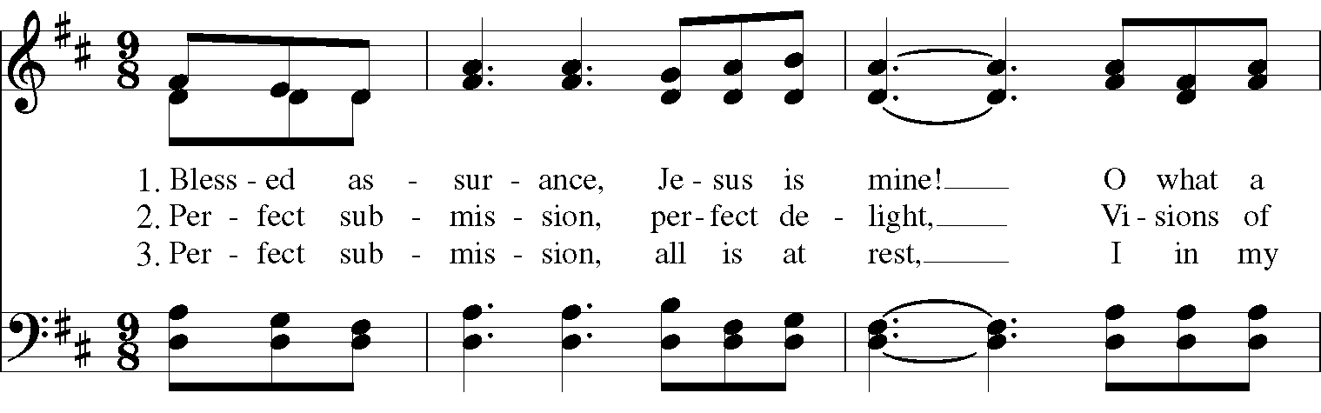

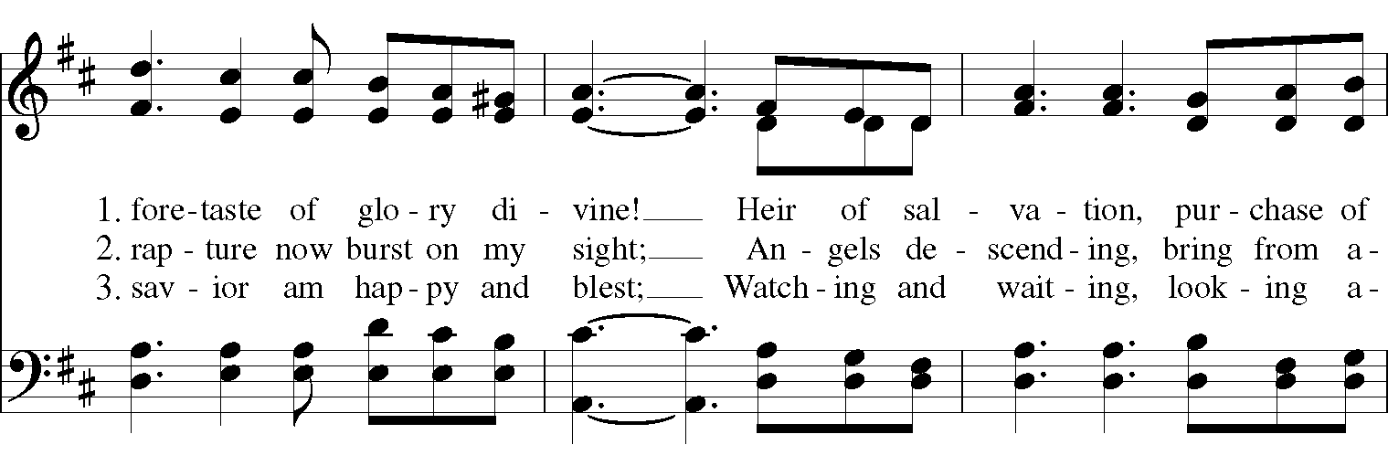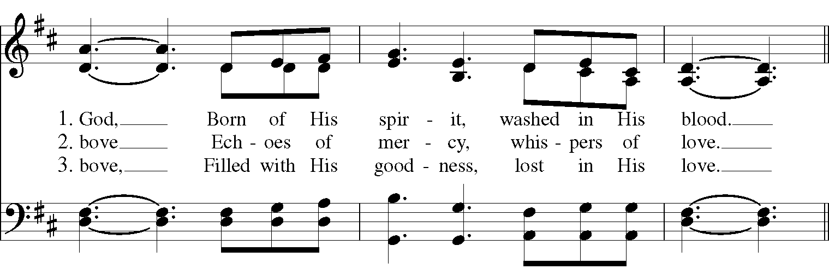

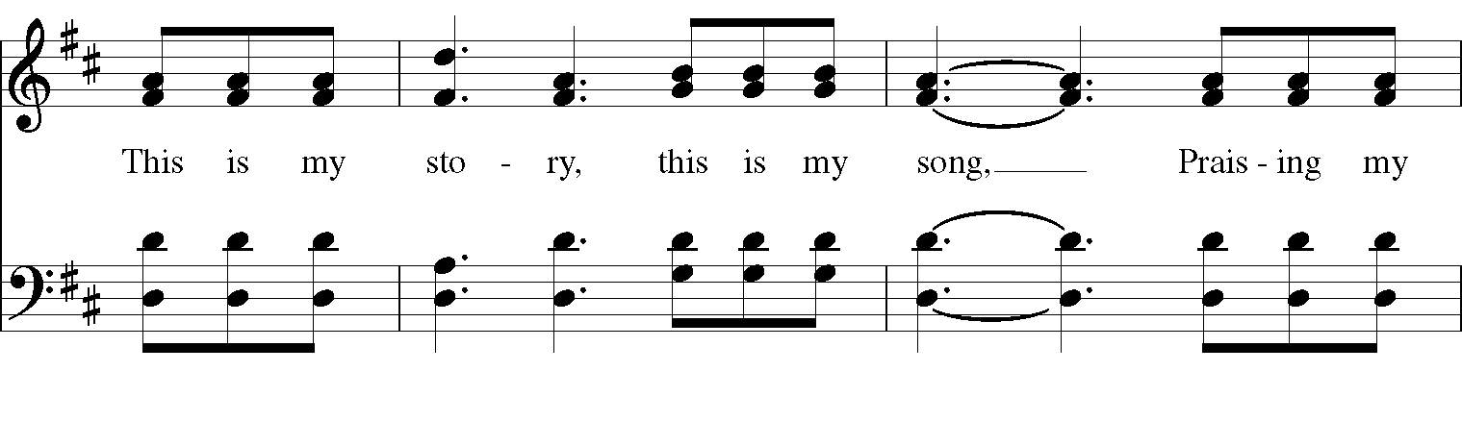
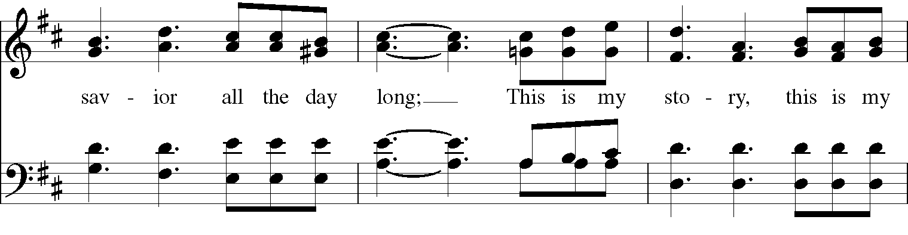
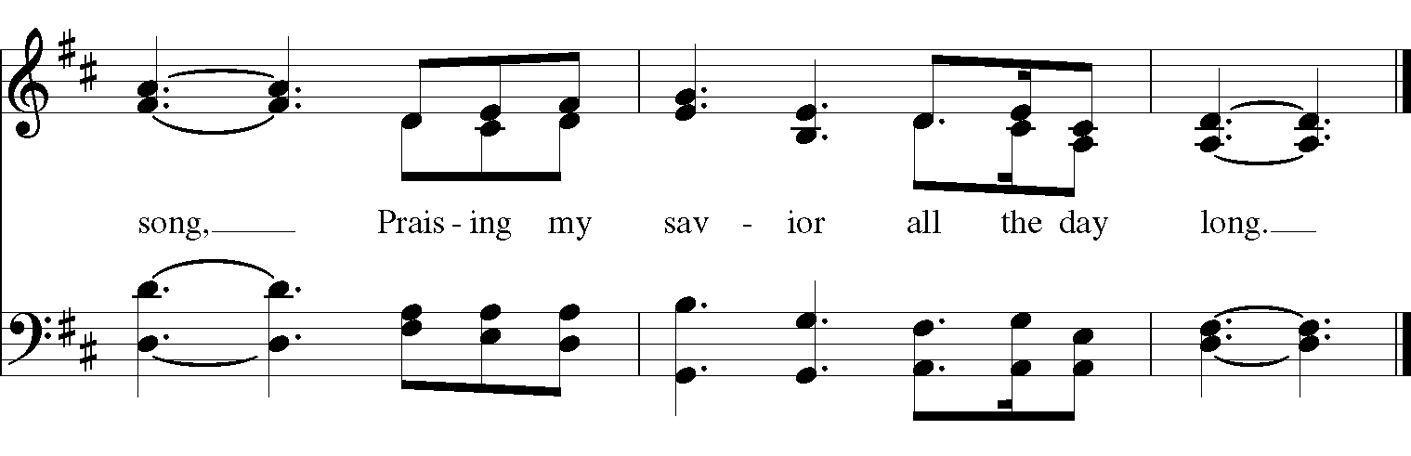

The Apostles’ Creed
I believe in God, the Father almighty,
creator of heaven and earth;
I believe in Jesus Christ, his only Son, our Lord.
He was conceived by the power of the Holy Spirit
and born of the Virgin Mary.
He suffered under Pontius Pilate,
was crucified, died, and was buried.
He descended to the dead.
On the third day he rose again.
He ascended into heaven,
and is seated at the right hand of the Father.
He will come again to judge the living and the dead.
I believe in the Holy Spirit,
the holy catholic Church,
the communion of saints,
the forgiveness of sins
the resurrection of the body,
and the life everlasting. Amen.

The Prayers BCP p. 97-98
The Lord be with you.
And also with you.
Let us pray.

Our Father, who art in heaven,
hallowed be thy Name,
thy kingdom come,
thy will be done,
on earth as it is in heaven.
Give us this day our daily bread.
And forgive us our trespasses,
as we forgive those
who trespass against us.
And lead us not into temptation,
but deliver us from evil.
For thine is the kingdom,
and the power, and the glory,
for ever and ever. Amen.

Save your people, Lord, and bless your inheritance;
Govern and uphold them, now and always.
Day by day we bless you;
We praise your name for ever.
Lord, keep us from all sin today;
Have mercy upon us, Lord, have mercy.
Lord, show us your love and mercy;
For we put our trust in you.
In you, Lord, is our hope;
And we shall never hope in vain.

The Collect of the Day
O God, you have taught us to keep all your commandments by loving you and our neighbor: Grant us the grace of your Holy Spirit, that we may be devoted to you with our whole heart, and united to one another with pure affection; through Jesus Christ our Lord, who lives and reigns with you and the Holy Spirit, one God, for ever and ever. Amen.

A Prayer for Mission
O God, you have made of one blood all the peoples of the earth, and sent your blessed Son to preach peace to those who are far off and to those who are near: Grant that people everywhere may seek after you and find you; bring the nations into your fold; pour out your Spirit upon all flesh; and hasten the coming of your kingdom; through Jesus Christ our Lord. Amen.

An Act of Spiritual Communion (for times when we cannot celebrate Holy Eucharist together)

In union, Lord Jesus, with the faithful gathered at every altar of your Church --
in places where your blessed Body and Blood are offered this day,
and in places (like our parish) where your people
now fast from the Holy Eucharist out of love for one another --
we offer you praise and thanksgiving,
for the Creation and all the blessings of this life,
for the redemption won for us by your life, death, and resurrection,
for the means of grace and the hope of glory.

On this day, O Lord, we offer particular gratitude for the blessings of our own lives ...
[share your blessings, aloud or silently]

We are members of your holy, glorious, and blessed Body, O Lord Christ.
We believe that you are truly present in the Holy Sacrament,
and, since we cannot at this time receive communion,
we each entreat you with these words:
I pray you, Lord, to come into my heart.
I unite myself with you and embrace you
with all my heart, my soul, and my mind.
Let nothing separate me from you;
let me serve you in this life until, by your grace,
I come to your glorious kingdom and unending peace. Amen.

Come Lord Jesus, and dwell in our hearts in the fullness of your strength;
be our wisdom and guide us in right pathways;
conform our lives and actions to the image of your holiness;
and, in the power of your gracious might,
rule over every hostile power that threatens or disturbs the growth of your kingdom;
who with God our Creator,
and the Holy Spirit our Sanctifier,
lives and reigns,
one God,
in glory everlasting. Amen.

And now may the peace of God, which passes all understanding,
keep our hearts and minds in the knowledge and love of God,
and of God's Son Jesus Christ our Lord;
and the blessing of our Triune God,
the Creator, the Redeemer, and the Sanctifier, This is an appropriate time to
be with us now and always. Amen. make the sign of the cross.

Let us bless the Lord. Alleluia, alleluia!
Thanks be to God. Alleluia, alleluia!

Closing Hymn: # 719 “O beautiful for spacious skies"

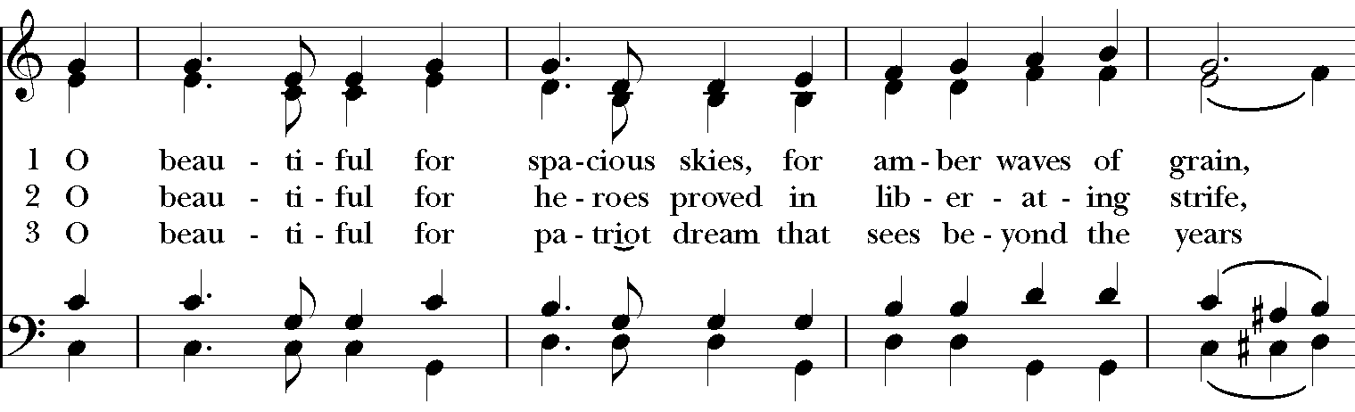
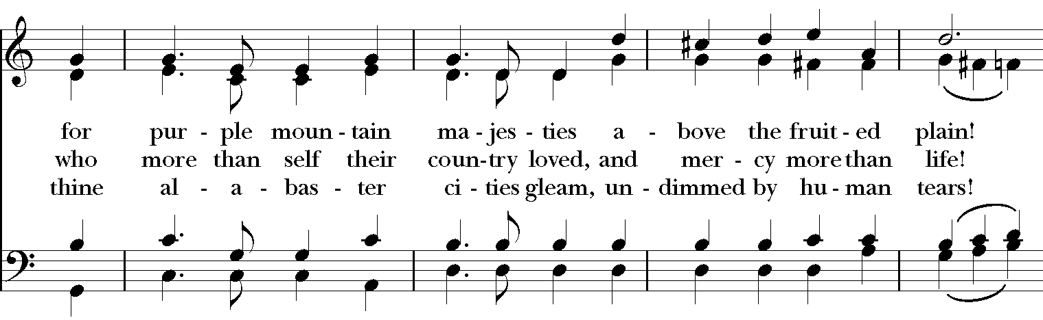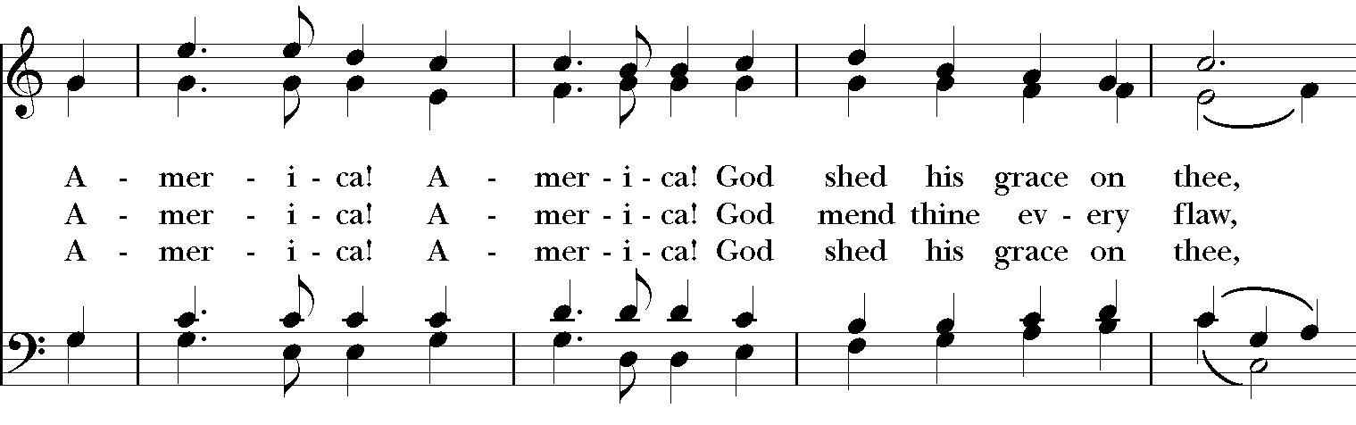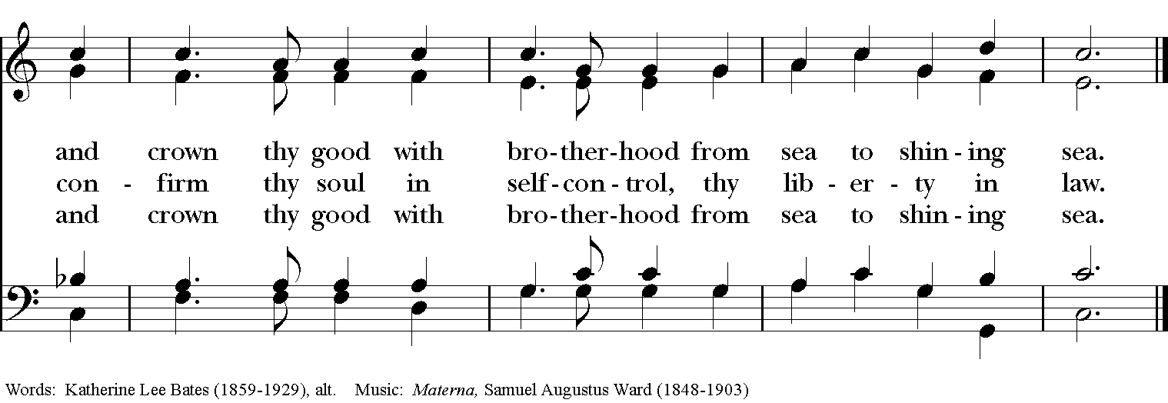

Thank you for your spiritual presence with us this morning!
Although we're physically apart, we are united in prayer, worship, and holy love!

Rector: The Rev. Maggie Leidheiser-Stoddard
Deacon: The Rev. Dr. Rick Incorvati
Organist/Choirmaster: Dr. Chris Durrenberger
Lector: Anne Strothman
Singers: Liz Wheeler, Joy Carter, Ed Hasecke, Fred Bartenstein
Technology: Jon Leidheiser-Stoddard
Slideshow: Ed Hasecke
Parish Administrator: Kelly Zeller
Coffee Hour Host: TBA

