Christ Episcopal Church in Springfield, Ohio
Service of the Word
Second Sunday of Easter: April 11th, 2021 at 9 am

Prelude:

Opening Hymn: “Good Christians all, rejoice and sing!” Hymnal 205
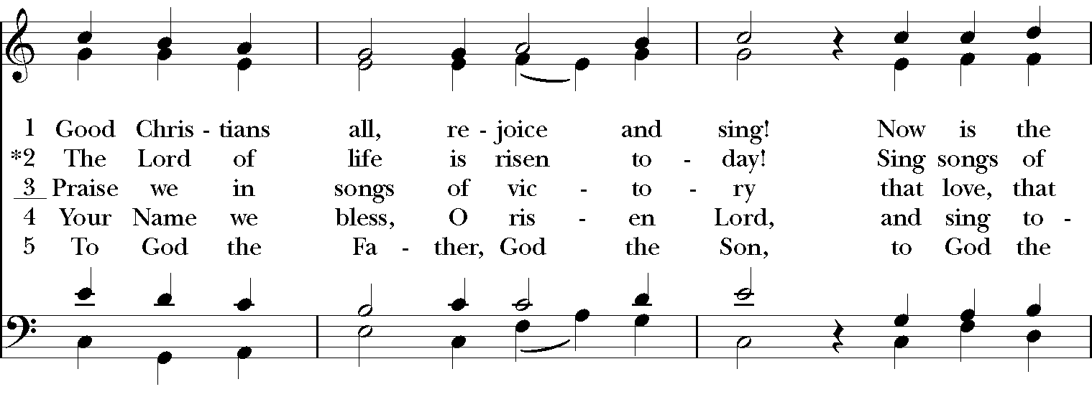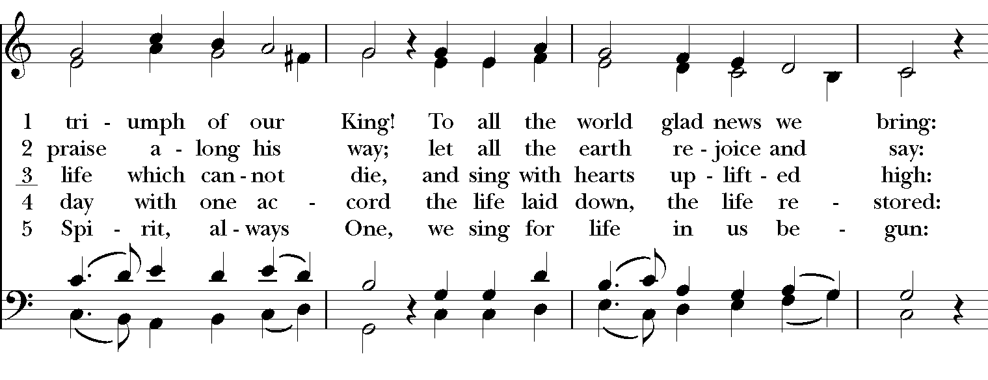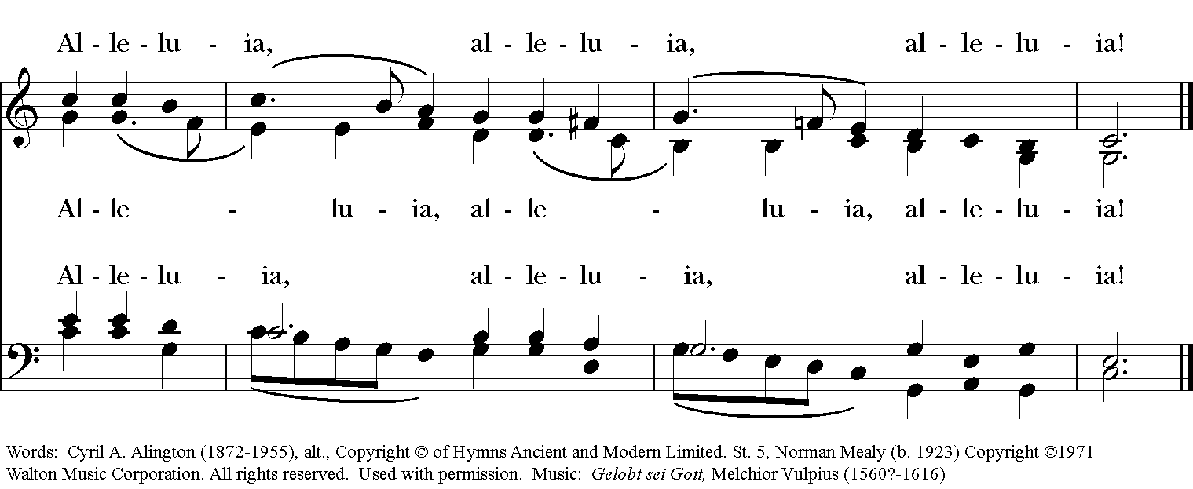

Celebrant: Alleluia! Christ has risen!
People: The Lord is risen indeed. Alleluia!

The Collect of the Day
Celebrant: The Lord be with you.
People: And also with you.
Celebrant: Let us pray.
Almighty and everlasting God, who in the Paschal mystery established the new covenant of reconciliation: Grant that all who have been reborn into the fellowship of Christ's Body may show forth in their lives what they profess by their faith; through Jesus Christ our Lord, who lives and reigns with you and the Holy Spirit, one God, for ever and ever. Amen.

The Lessons

The First Reading: Acts 4:32-35

Now the whole group of those who believed were of one heart and soul, and no one claimed private ownership of any possessions, but everything they owned was held in common. With great power the apostles gave their testimony to the resurrection of the Lord Jesus, and great grace was upon them all. There was not a needy person among them, for as many as owned lands or houses sold them and brought the proceeds of what was sold. They laid it at the apostles' feet, and it was distributed to each as any had need.
Lector: The Word of the Lord.
People: Thanks be to God.

*PSALM: 133 Ecce, quam bonum!
1 Oh, how good and pleasant it is, *
when brethren live together in unity!
2 It is like fine oil upon the head *
that runs down upon the beard,
3 Upon the beard of Aaron, *
and runs down upon the collar of his robe.
4 It is like the dew of Hermon *
that falls upon the hills of Zion.
5 For there the Lord has ordained the blessing: *
life for evermore.

THE SECOND LESSON 1 John 1:1-2:2
We declare to you what was from the beginning, what we have heard, what we have seen with our eyes, what we have looked at and touched with our hands, concerning the word of life-- this life was revealed, and we have seen it and testify to it, and declare to you the eternal life that was with the Father and was revealed to us-- we declare to you what we have seen and heard so that you also may have fellowship with us; and truly our fellowship is with the Father and with his Son Jesus Christ. We are writing these things so that our joy may be complete.
This is the message we have heard from him and proclaim to you, that God is light and in him there is no darkness at all. If we say that we have fellowship with him while we are walking in darkness, we lie and do not do what is true; but if we walk in the light as he himself is in the light, we have fellowship with one another, and the blood of Jesus his Son cleanses us from all sin. If we say that we have no sin, we deceive ourselves, and the truth is not in us. If we confess our sins, he who is faithful and just will forgive us our sins and cleanse us from all unrighteousness. If we say that we have not sinned, we make him a liar, and his word is not in us.
My little children, I am writing these things to you so that you may not sin. But if anyone does sin, we have an advocate with the Father, Jesus Christ the righteous; and he is the atoning sacrifice for our sins, and not for ours only but also for the sins of the whole world.
Lector: The Word of the Lord.
People: Thanks be to God.
Sequence Hymn: “I want to walk as a child of the light” Hymnal 490
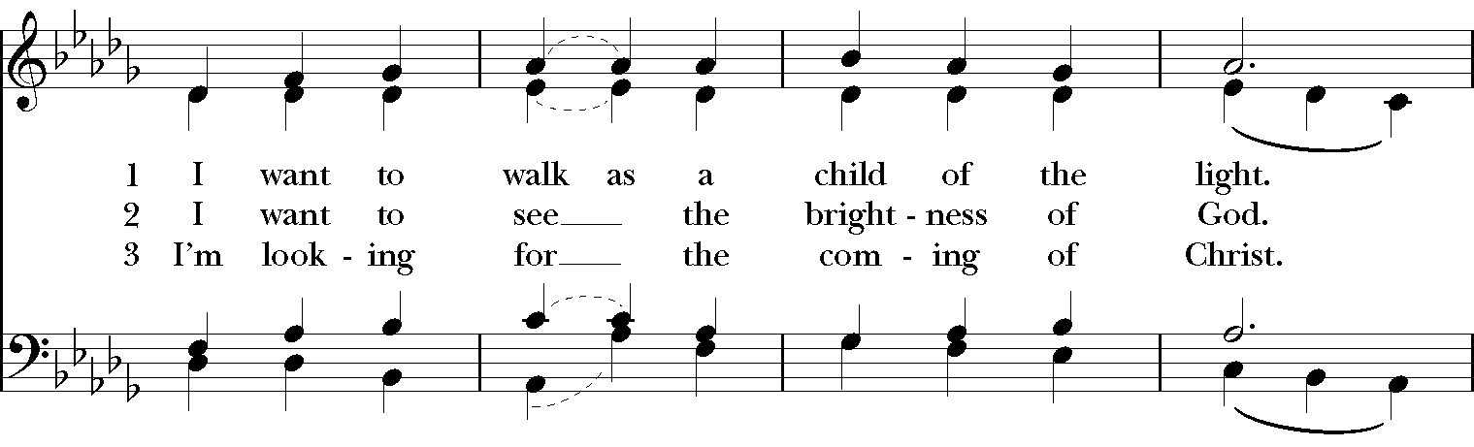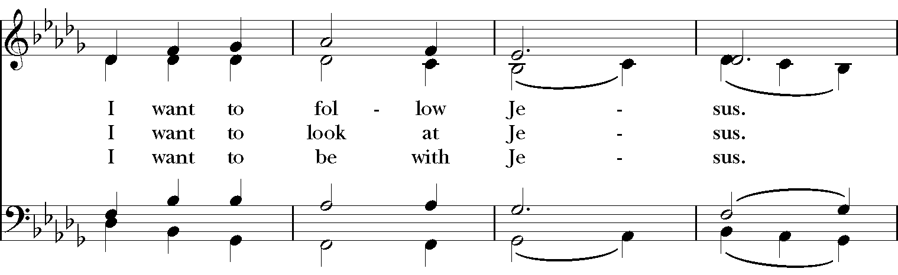

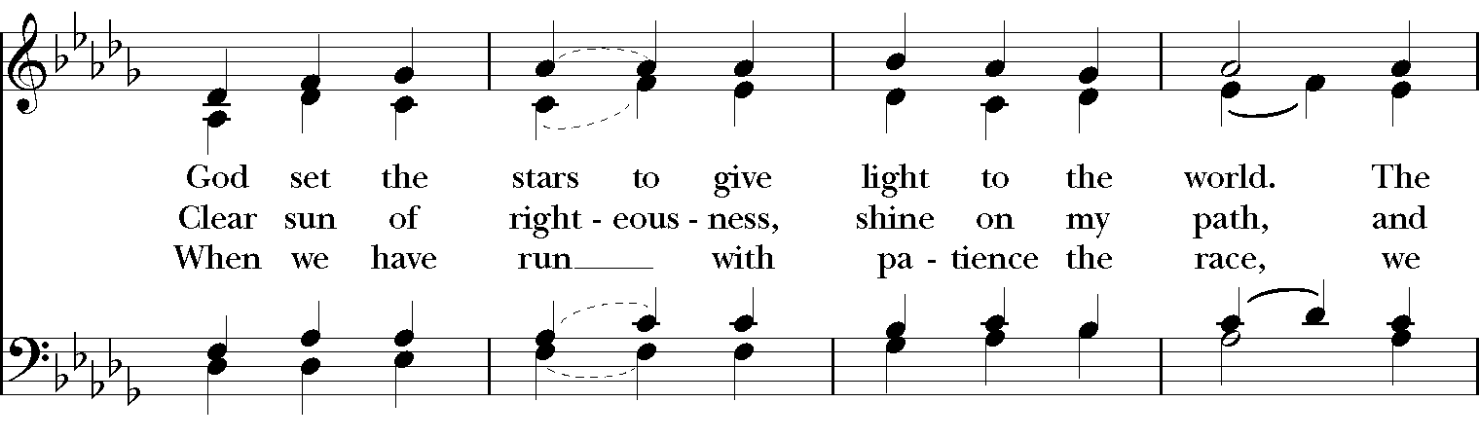

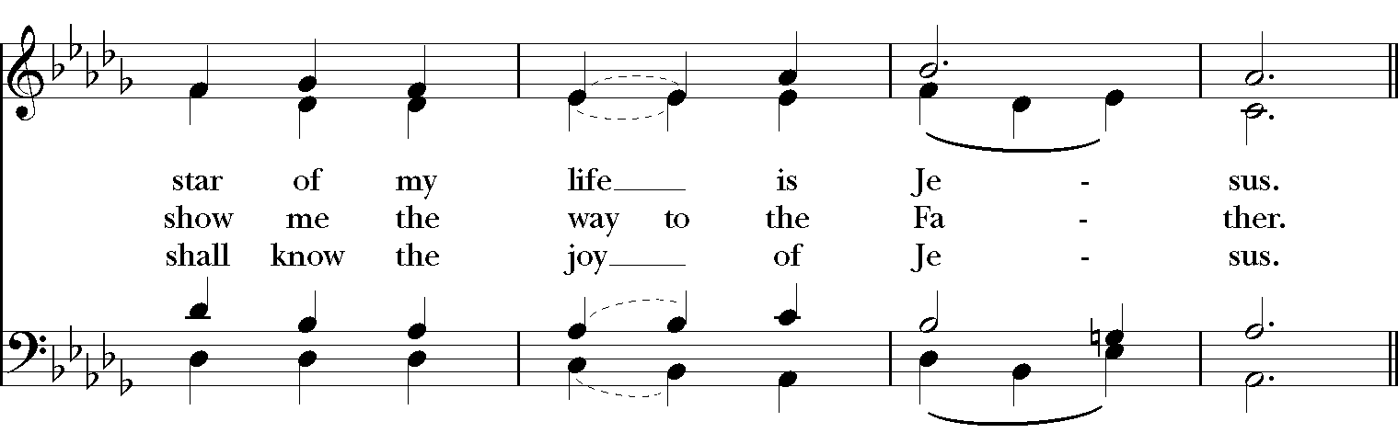
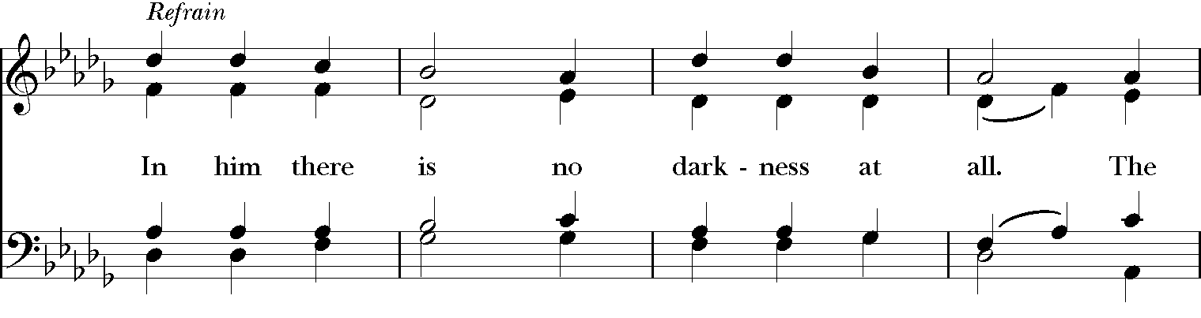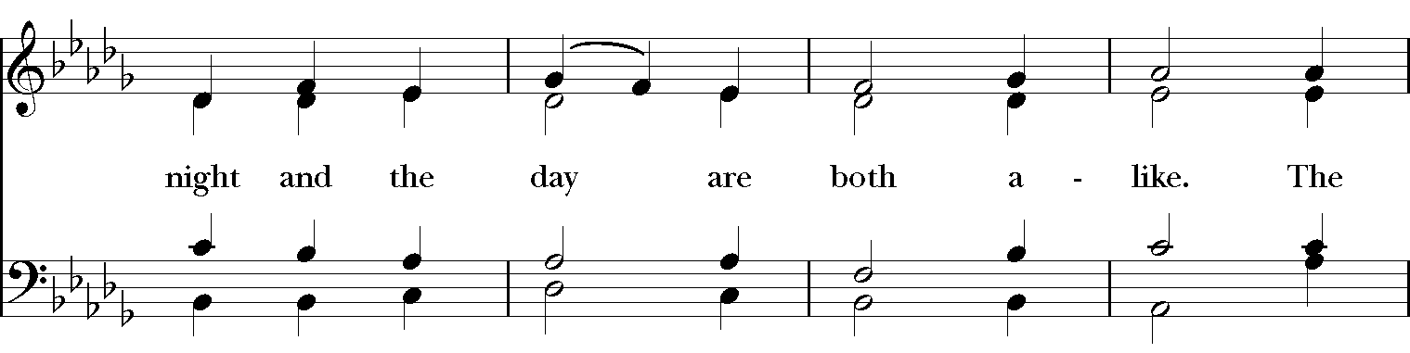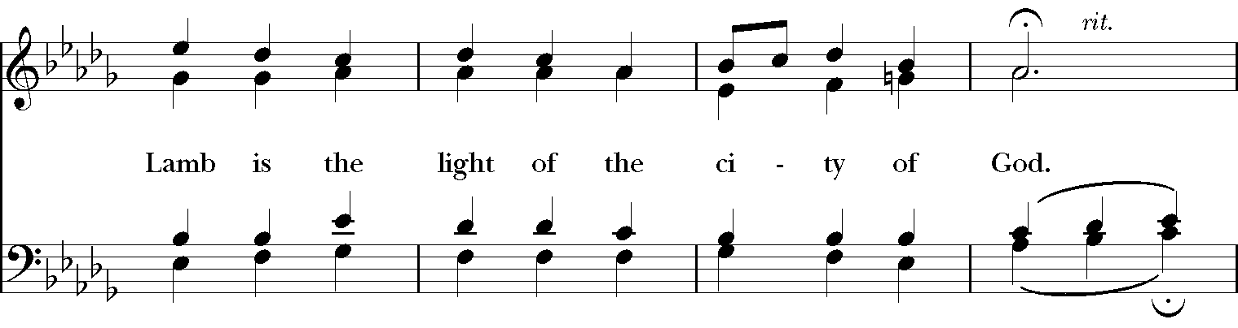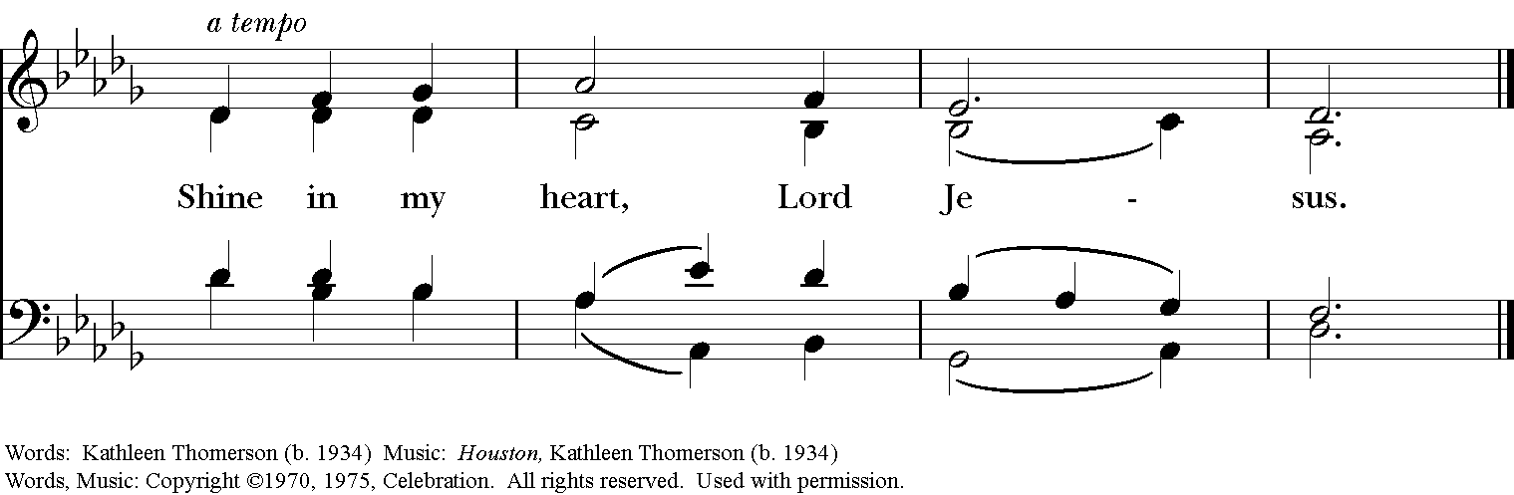

Gospel
Deacon: The Holy Gospel of our Lord Jesus Christ according to John (John 20:19-31).
People: Glory to you, Lord Christ.
When it was evening on that day, the first day of the week, and the doors of the house where the disciples had met were locked for fear of the Jews, Jesus came and stood among them and said, "Peace be with you." After he said this, he showed them his hands and his side. Then the disciples rejoiced when they saw the Lord. Jesus said to them again, "Peace be with you. As the Father has sent me, so I send you." When he had said this, he breathed on them and said to them, "Receive the Holy Spirit. If you forgive the sins of any, they are forgiven them; if you retain the sins of any, they are retained."
But Thomas (who was called the Twin), one of the twelve, was not with them when Jesus came. So the other disciples told him, "We have seen the Lord." But he said to them, "Unless I see the mark of the nails in his hands, and put my finger in the mark of the nails and my hand in his side, I will not believe."
A week later his disciples were again in the house, and Thomas was with them. Although the doors were shut, Jesus came and stood among them and said, "Peace be with you." Then he said to Thomas, "Put your finger here and see my hands. Reach out your hand and put it in my side. Do not doubt but believe." Thomas answered him, "My Lord and my God!" Jesus said to him, "Have you believed because you have seen me? Blessed are those who have not seen and yet have come to believe."
Now Jesus did many other signs in the presence of his disciples, which are not written in this book. But these are written so that you may come to believe that Jesus is the Messiah, the Son of God, and that through believing you may have life in his name.
Deacon: The Gospel of the Lord.
People: Praise to you, Lord Christ.

Sermon The Rev. Rick Incorvati

The Nicene Creed
We believe in one God, the Father, the Almighty,
maker of heaven and earth, of all that is, seen and unseen.
We believe in one Lord, Jesus Christ, the only Son of God,
eternally begotten of the Father, God from God,
Light from Light, true God from true God,
begotten, not made, of one Being with the Father.
Through him all things were made.
For us and for our salvation he came down from heaven,
by the power of the Holy Spirit he became incarnate from the Virgin Mary,
and was made man.
For our sake he was crucified under Pontius Pilate;
he suffered death and was buried.
On the third day he rose again in accordance with the Scriptures;
he ascended into heaven and is seated at the right hand of the Father.
He will come again in glory to judge the living and the dead, and his kingdom will have no end.
We believe in the Holy Spirit, the Lord, the giver of life,
who proceeds from the Father, and the Son.
who with the Father and the Son is worshiped and glorified,
who has spoken through the Prophets.
We believe in one holy catholic and apostolic Church.
We acknowledge one baptism for the forgiveness of sins.
We look for the resurrection of the dead, and the life of the world to come. Amen.

The Prayers of the People

In peace, we pray to you Lord God. Congregational responses are in bold.

Silence

Blessed are you eternal God,
to be praised and glorified forever.

Hear us as we pray for the unity of the Church.
May we all be one, that the world may come to know you.

Grant that every member of the Church may truly and humbly serve you,
that the life of Christ may be revealed in us.
We remember those who have died.
Into your hands we commend them.
We praise you for all your saints who have entered eternal glory.
May we also come to share your heavenly kingdom.

Have compassion on those who suffer from sickness, grief or trouble, especially Faye, Chris, Laura, Bonnie, Alice, Diana, James, Joy, Jane, Joni, Kim, Bobby, Sarah, Traudie, Lexie, and Keith.
In your presence may they find strength.

Look with kindness on our homes and families, and all who celebrate birthdays and anniversaries this week, especially Ann, David, Gretchen, Richard, Alice, Carter, Gabe, Kay, and Ian.
Grant that your love may grow in our hearts.

Make us alive to the needs of our community, and bless the holy work of Clark County Literacy Coalition, Episcopal Community Ministries, Second Harvest Food Bank, and Interfaith Hospitality Network.
Help us to share one another’s joys and burdens.

Inspire and lead those who hold authority in the nations of the world.
Guide us and all people in the way of justice and peace.

For Justin, Archbishop of Canterbury; Michael, our Presiding Bishop; Ken, our Diocesan Bishop; Lee Anne, our priest; Rick, our deacon; and all who minister in Christ, that they may be firmly rooted in your truth and love.
Inspire us and give us courage to proclaim your Gospel of Resurrection.

*THE COLLECT FOR PEACE
Grant, O God, that your holy and life-giving Spirit may so move every human heart, that barriers which divide us may crumble, suspicions disappear, and hatreds cease; that our divisions being healed, we may live in justice and peace; through Jesus Christ our Lord. Amen.

Deacon: Let us confess our sins against God and our neighbor.
All: Most merciful God, we confess that we have sinned against you in thought, word, and deed, by what we have done, and by what we have left undone. We have not loved you with our whole heart; we have not loved our neighbors as ourselves. We are truly sorry and we humbly repent. For the sake of your Son Jesus Christ, have mercy on us and forgive us; that we may delight in your will, and walk in your ways, to the glory of your Name. Amen.

Priest: Almighty God, have mercy on you, forgive you all your sins through our Lord Jesus Christ, strengthen you in all goodness, and by the power of the Holy Spirit keep you in eternal life. Amen.

And now, as our Savior Christ has taught us, we are bold to say:
Our Father, who art in heaven, hallowed be thy Name,
thy kingdom come, thy will be done, on earth as it is in heaven.
Give us this day our daily bread.
And forgive us our trespasses, as we forgive those who trespass against us.
And lead us not into temptation, but deliver us from evil.
For thine is the kingdom, and the power, and the glory, for ever and ever. Amen

CLOSING HYMN: “We walk by faith, not by sight” Hymnal 209
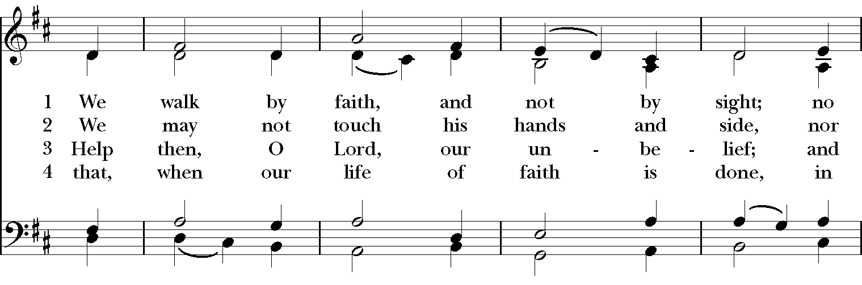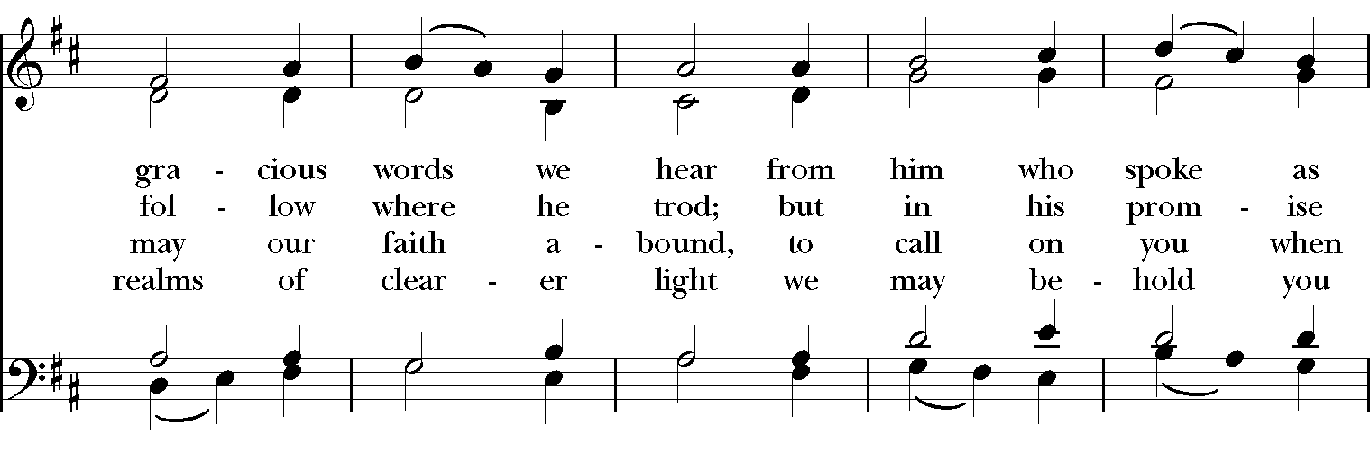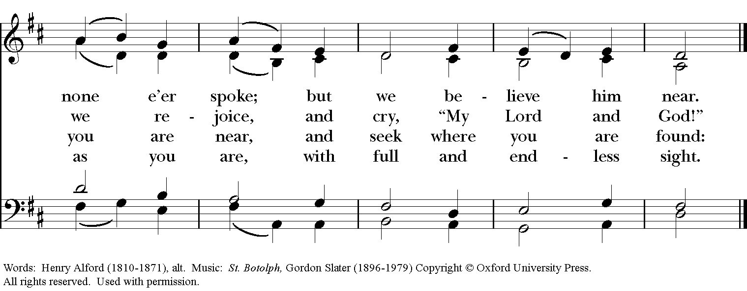

*THE BLESSING
The God of peace, who brought again from the dead our Lord Jesus Christ, the great Shepherd of the sheep, through the blood of the everlasting covenant, make you perfect in every good work to do his will, working in you that which is well-pleasing in his sight; and the blessing of God Almighty, the Father, the Son, and the Holy Spirit, be among you, and remain with you always. Amen.

*THE DISMISSAL Deacon: Go in peace to love and serve the Lord. Alleluia, alleluia!
People: Thanks be to God. Alleluia, alleluia!

POSTLUDE:

Easter Flowers
Memorials and Thanksgivings

In memory of Don and Dorothy Wiegel by Julie Wiegel Brust

In memory of Dariel Fahnestock, Russ and Audriel Mumford and Bernice Harbaugh from Keith & Carol Harbaugh and Linda & Larry Hupp & families.

In thanksgiving for family by Joann Albright

In memory of Ben Schwartz and Dr. Dennis Sullivan by Sally Schwartz and family and Ava Sullivan and family.

In memory of Helen Krott, Paul Krott, William T. Hicks, Bettie Hicks, and John Hicks by Bill and Gretchen Hicks

In memory of Evelyn Stinnett Reed and in thanksgiving for Don and Charlotte and Babs by Fred Reed

In loving memory of William G. Vasileff by Marj. Vasileff

In memory of Henry W. Roberts by Martha Chaney

In memory of Ronald and Lois St. Martin by Anne Strothman

In memory of Bernice Schmidt, Larry and Jane Sharp by Steve and Denise Sharp

In memory of Jim Beardsell by Anita Beardsell

In memory of Mike Fields by Sue Allender

In memory of Lynn Rigsbee and Norm Silliman

Thank you for your spiritual presence with us this morning!
Although we're physically apart, we are united in prayer, worship, and holy love!
Priest-In-Charge: The Rev. Dr. Canon Lee Anne Reat
Deacon: The Rev. Dr. Rick Incorvati
Music Director: Dr. Chris Durrenberger
Lector: Sarah Schubert
Singers: Liz Wheeler, Joy Carter, Ed Hasecke, Chris Oldstone-Moore
Technology: Steve Ide
Slideshow: Ed Hasecke
Parish Administrator and Program Coordinator: Kelly Zeller

