Christ Episcopal Church in Springfield, Ohio
Service of the Word
Fourth Sunday of Easter: April 25th, 2021 at 9 am

PRELUDE:

OPENING HYMN: “All hail the power of Jesus’ name!” Hymnal 450
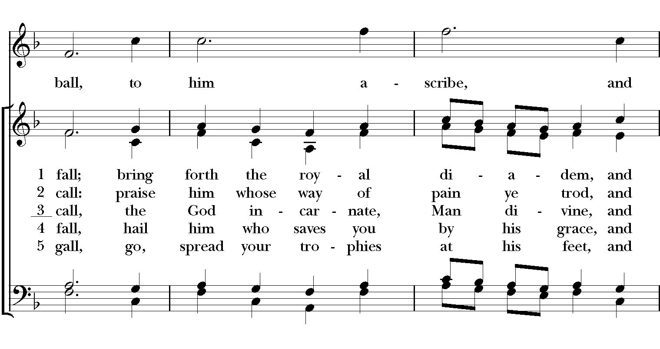
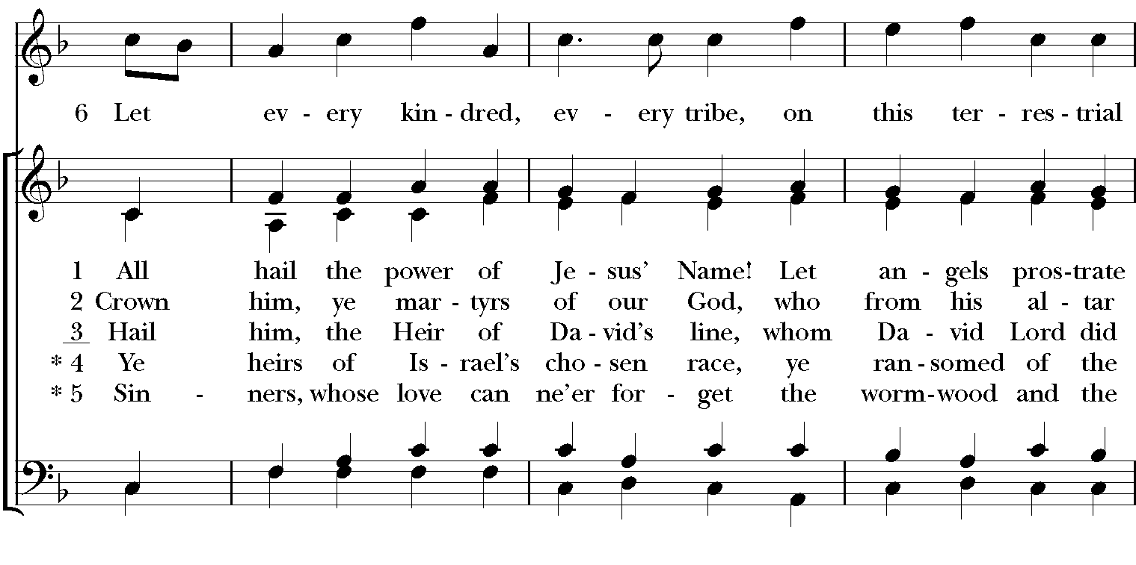

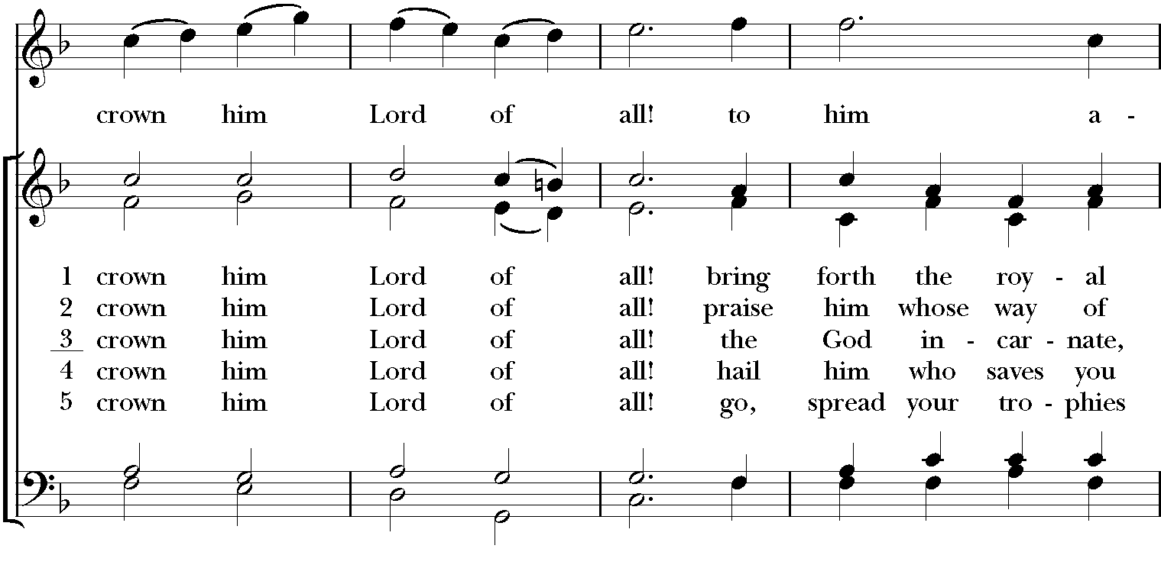

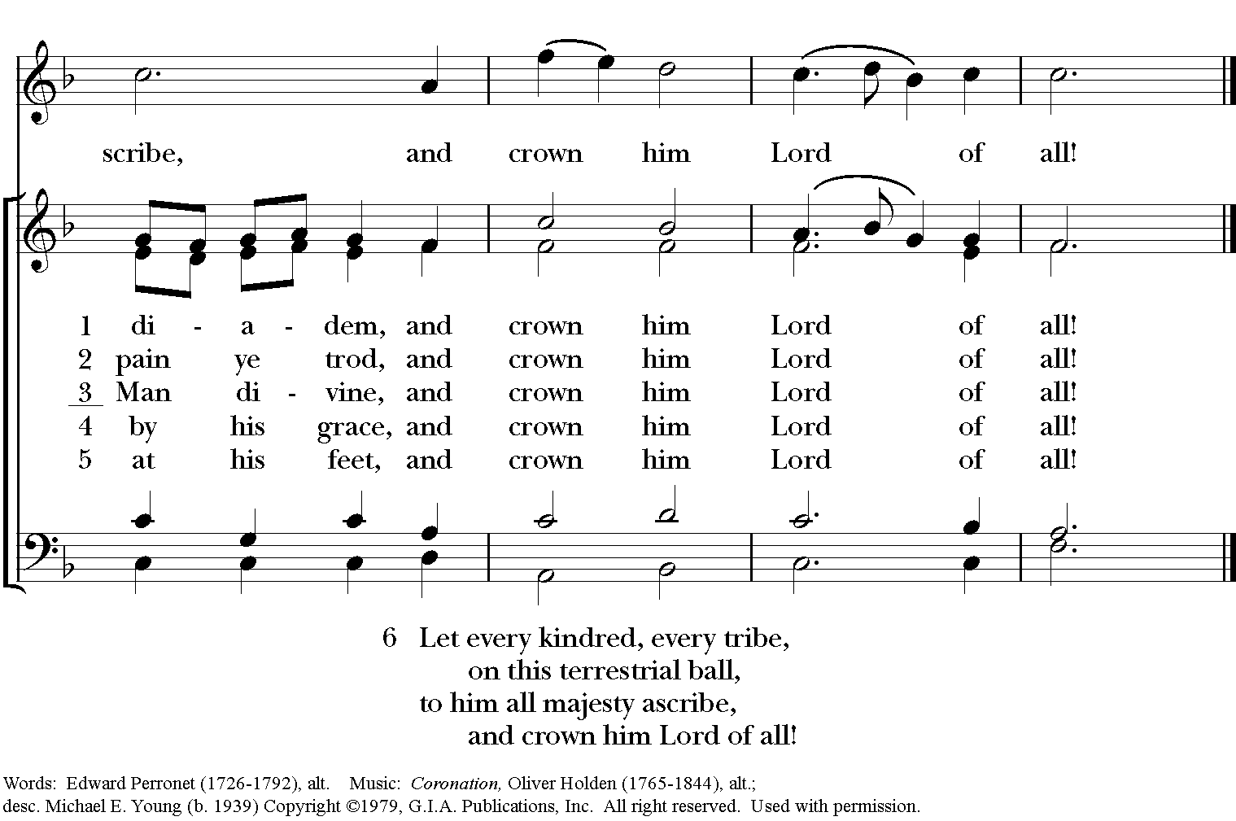

Celebrant: Alleluia! Christ has risen!
People: The Lord is risen indeed. Alleluia!

The Collect of the Day
Celebrant: The Lord be with you.
People: And also with you.
Celebrant: Let us pray.
O God, whose Son Jesus is the good shepherd of your people: Grant that when we hear his voice we may know him who calls us each by name, and follow where he leads; who, with you and the Holy Spirit, lives and reigns, one God, for ever and ever. Amen.

The Lessons

THE FIRST READING Acts 4:5-12
The rulers, elders, and scribes assembled in Jerusalem, with Annas the high priest, Caiaphas, John, and Alexander, and all who were of the high-priestly family. When they had made the prisoners stand in their midst, they inquired, "By what power or by what name did you do this?" Then Peter, filled with the Holy Spirit, said to them, "Rulers of the people and elders, if we are questioned today because of a good deed done to someone who was sick and are asked how this man has been healed, let it be known to all of you, and to all the people of Israel, that this man is standing before you in good health by the name of Jesus Christ of Nazareth, whom you crucified, whom God raised from the dead. This Jesus is
`the stone that was rejected by you, the builders;
it has become the cornerstone.'
There is salvation in no one else, for there is no other name under heaven given among mortals by which we must be saved."
Lector: The Word of the Lord.
People: Thanks be to God.

*PSALM: 23 Dominus regit me
1 The Lord is my shepherd; *
I shall not be in want.
2 He makes me lie down in green pastures *
and leads me beside still waters.
3 He revives my soul *
and guides me along right pathways for his Name's sake.
4 Though I walk through the valley of the shadow of death, I shall fear no evil; *
for you are with me; your rod and your staff, they comfort me.
5 You spread a table before me in the presence of those who trouble me; *
you have anointed my head with oil, and my cup is running over.
6 Surely your goodness and mercy shall follow me all the days of my life,
and I will dwell in the house of the Lord for ever.

THE SECOND LESSON 1 John 3:16-24
We know love by this, that he laid down his life for us-- and we ought to lay down our lives for one another. How does God's love abide in anyone who has the world's goods and sees a brother or sister in need and yet refuses help?

Little children, let us love, not in word or speech, but in truth and action. And by this we will know that we are from the truth and will reassure our hearts before him whenever our hearts condemn us; for God is greater than our hearts, and he knows everything. Beloved, if our hearts do not condemn us, we have boldness before God; and we receive from him whatever we ask, because we obey his commandments and do what pleases him.

And this is his commandment, that we should believe in the name of his Son Jesus Christ and love one another, just as he has commanded us. All who obey his commandments abide in him, and he abides in them. And by this we know that he abides in us, by the Spirit that he has given us.
Lector: The Word of the Lord.
People: Thanks be to God.
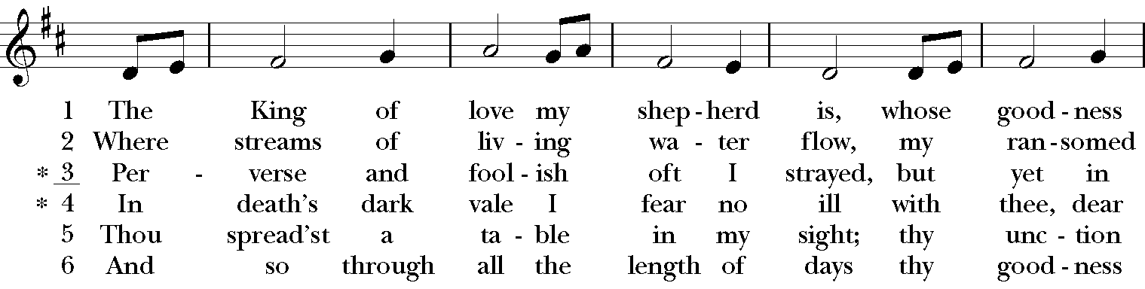
SEQUENCE HYMN: “The King of love my shepherd is” Hymnal 645

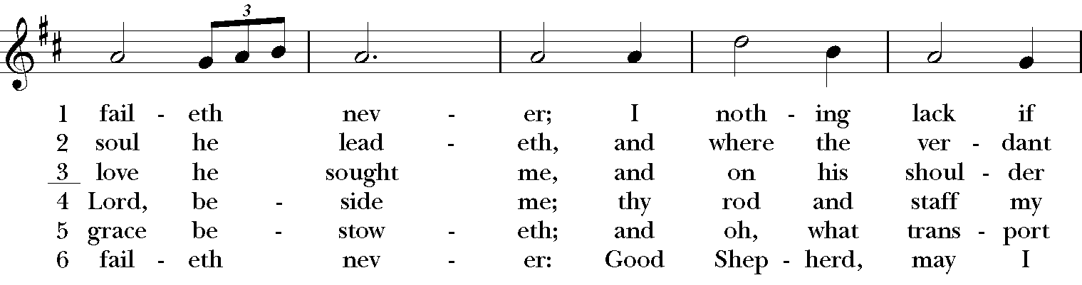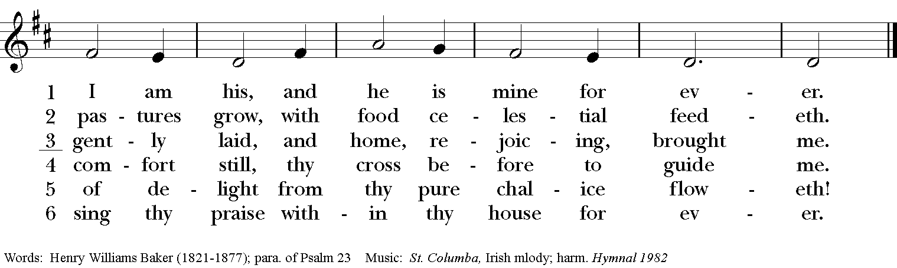

Gospel
Deacon: The Holy Gospel of our Lord Jesus Christ according to John (John 10:11-18).
People: Glory to you, Lord Christ.
Jesus said, “I am the good shepherd. The good shepherd lays down his life for the sheep. The hired hand, who is not the shepherd and does not own the sheep, sees the wolf coming and leaves the sheep and runs away—and the wolf snatches them and scatters them. The hired hand runs away because a hired hand does not care for the sheep. I am the good shepherd. I know my own and my own know me, just as the Father knows me and I know the Father. And I lay down my life for the sheep. I have other sheep that do not belong to this fold. I must bring them also, and they will listen to my voice. So there will be one flock, one shepherd. For this reason the Father loves me, because I lay down my life in order to take it up again. No one takes it from me, but I lay it down of my own accord. I have power to lay it down, and I have power to take it up again. I have received this command from my Father.”
Deacon: The Gospel of the Lord.
People: Praise to you, Lord Christ.

Sermon The Rev. Canon Lee Anne Reat

The Nicene Creed
We believe in one God, the Father, the Almighty,
maker of heaven and earth, of all that is, seen and unseen.
We believe in one Lord, Jesus Christ, the only Son of God,
eternally begotten of the Father, God from God,
Light from Light, true God from true God,
begotten, not made, of one Being with the Father.
Through him all things were made.
For us and for our salvation he came down from heaven,
by the power of the Holy Spirit he became incarnate from the Virgin Mary,
and was made man.
For our sake he was crucified under Pontius Pilate;
he suffered death and was buried.
On the third day he rose again in accordance with the Scriptures;
he ascended into heaven and is seated at the right hand of the Father.
He will come again in glory to judge the living and the dead, and his kingdom will have no end.
We believe in the Holy Spirit, the Lord, the giver of life,
who proceeds from the Father, and the Son.
who with the Father and the Son is worshiped and glorified,
who has spoken through the Prophets.
We believe in one holy catholic and apostolic Church.
We acknowledge one baptism for the forgiveness of sins.
We look for the resurrection of the dead, and the life of the world to come. Amen.

The Prayers of the People

In peace, we pray to you Lord God. Congregational responses are in bold.

Silence

Blessed are you eternal God,
to be praised and glorified forever.

Hear us as we pray for the unity of the Church.
May we all be one, that the world may come to know you.

Grant that every member of the Church may truly and humbly serve you,
that the life of Christ may be revealed in us.

We remember those who have died.
Into your hands we commend them.
We praise you for all your saints who have entered eternal glory.
May we also come to share your heavenly kingdom.

Have compassion on those who suffer from sickness, grief or trouble, especially Charlene, Laura, Faye, Chris, Laura, Bonnie, Alice, Diana, James, Joy, Jane, Joni, Kim, Bobby, Sarah, Traudie, Lexie, and Keith.
In your presence may they find strength.

Look with kindness on our homes and families, and all who celebrate birthdays this week, especially Rand.
Grant that your love may grow in our hearts.

Make us alive to the needs of our community, and bless the holy work of Rainbow Table, Springfield Promise Neighborhood, Springfield Peace Center, and Partners in Ministry in Liberia.
Help us to share one another’s joys and burdens.

Inspire and lead those who hold authority in the nations of the world.
Guide us and all people in the way of justice and peace.

For Justin, Archbishop of Canterbury; Michael, our Presiding Bishop; Ken, our Diocesan Bishop; Lee Anne, our priest; Bruce our supply priest; Rick, our deacon; and all who minister in Christ, that they may be firmly rooted in your truth and love.
Inspire us and give us courage to proclaim your Gospel of Resurrection.

*THE COLLECT FOR PEACE
Grant, O God, that your holy and life-giving Spirit may so move every human heart, that barriers which divide us may crumble, suspicions disappear, and hatreds cease; that our divisions being healed, we may live in justice and peace; through Jesus Christ our Lord. Amen.

Deacon: Let us confess our sins against God and our neighbor.
All: Most merciful God, we confess that we have sinned against you in thought, word, and deed, by what we have done, and by what we have left undone. We have not loved you with our whole heart; we have not loved our neighbors as ourselves. We are truly sorry and we humbly repent. For the sake of your Son Jesus Christ, have mercy on us and forgive us; that we may delight in your will, and walk in your ways, to the glory of your Name. Amen.

Priest: Almighty God, have mercy on you, forgive you all your sins through our Lord Jesus Christ, strengthen you in all goodness, and by the power of the Holy Spirit keep you in eternal life. Amen.

And now, as our Savior Christ has taught us, we are bold to say:
Our Father, who art in heaven, hallowed be thy Name,
thy kingdom come, thy will be done, on earth as it is in heaven.
Give us this day our daily bread.
And forgive us our trespasses, as we forgive those who trespass against us.
And lead us not into temptation, but deliver us from evil.
For thine is the kingdom, and the power, and the glory, for ever and ever. Amen

CLOSING HYMN: “Joyful, joyful, we adore thee” Hymnal 376
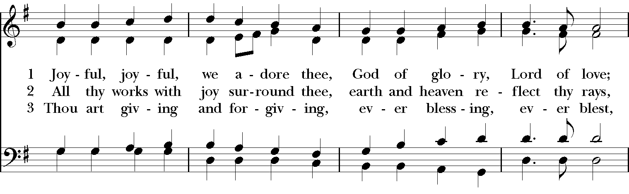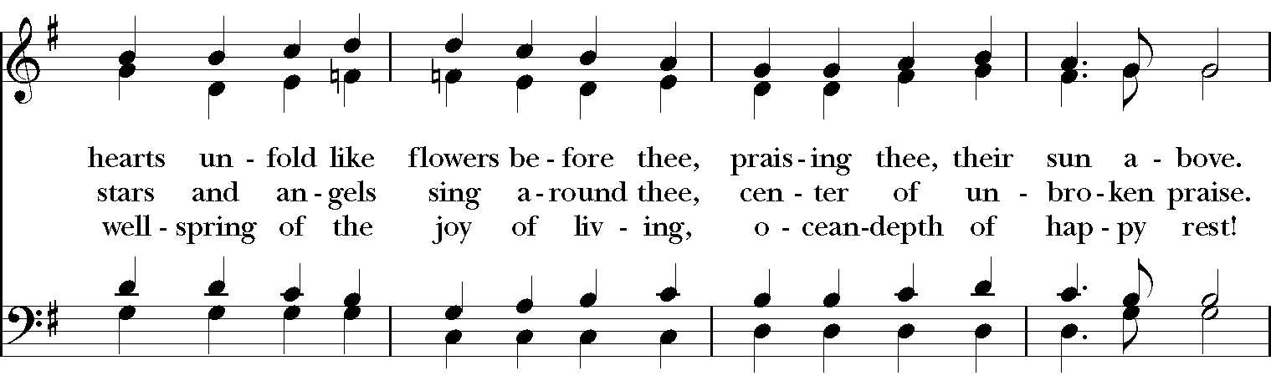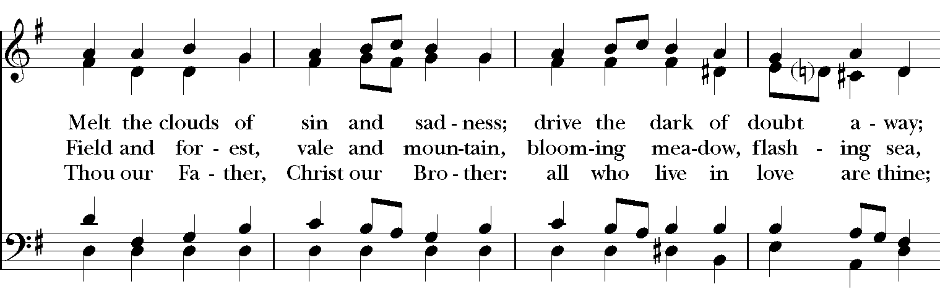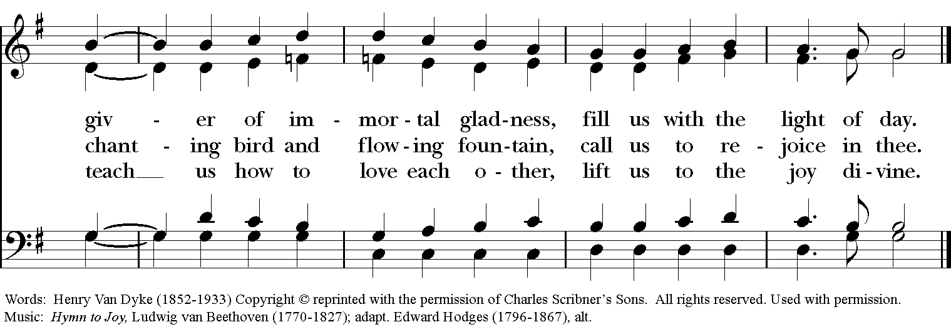

*THE BLESSING
The God of peace, who brought again from the dead our Lord Jesus Christ, the great Shepherd of the sheep, through the blood of the everlasting covenant, make you perfect in every good work to do his will, working in you that which is well-pleasing in his sight; and the blessing of God Almighty, the Father, the Son, and the Holy Spirit, be among you, and remain with you always. Amen.

*THE DISMISSAL Deacon: Go in peace to love and serve the Lord. Alleluia, alleluia!
People: Thanks be to God. Alleluia, alleluia!

POSTLUDE:

Thank you for your spiritual presence with us this morning!
Although we're physically apart, we are united in prayer, worship, and holy love!
Priest-In-Charge: The Rev. Dr. Canon Lee Anne Reat
Deacon: The Rev. Dr. Rick Incorvati
Music Director: Dr. Chris Durrenberger
Lector: Keith Doubt
Singers: Liz Wheeler, Joy Carter, Ed Hasecke, Chris Oldstone-Moore
Technology: Steve Ide
Slideshow: Ed Hasecke
Parish Administrator and Program Coordinator: Kelly Zeller

