Christ Episcopal Church in Springfield, Ohio
Service of the Word
Eleventh Sunday after Pentecost: August 8th, 2021 at 9 am

PRELUDE: “Jerusalem, My Happy Home” - Land of Rest/arr. Callahan

OPENING HYMN: “Spirit Divine, attend our prayers” Hymnal 509
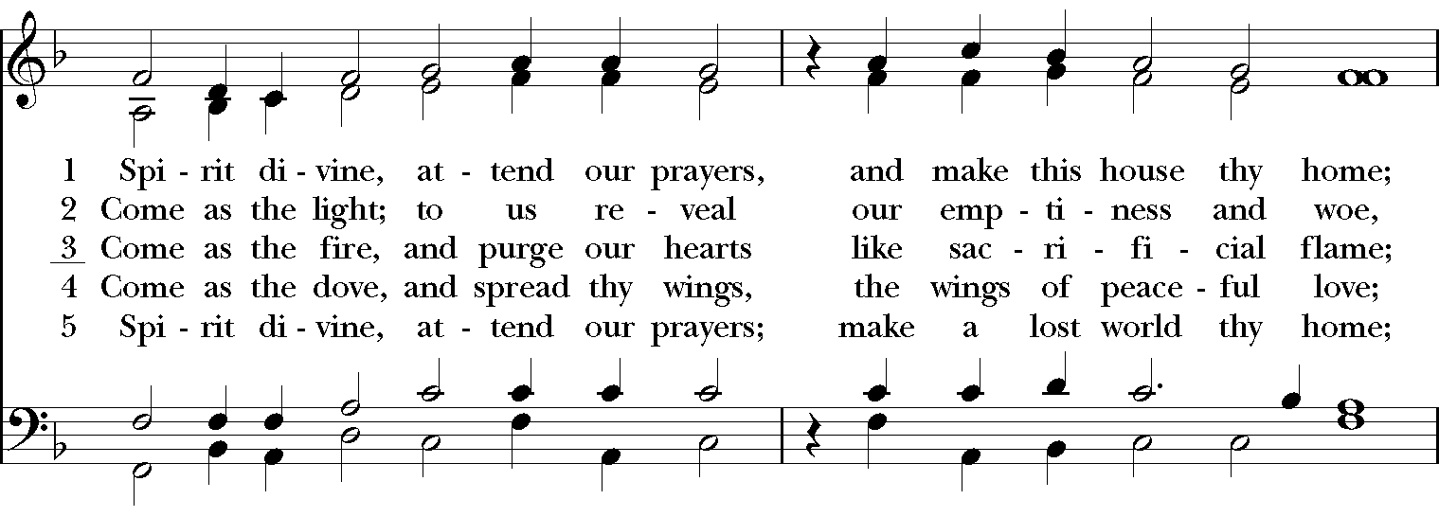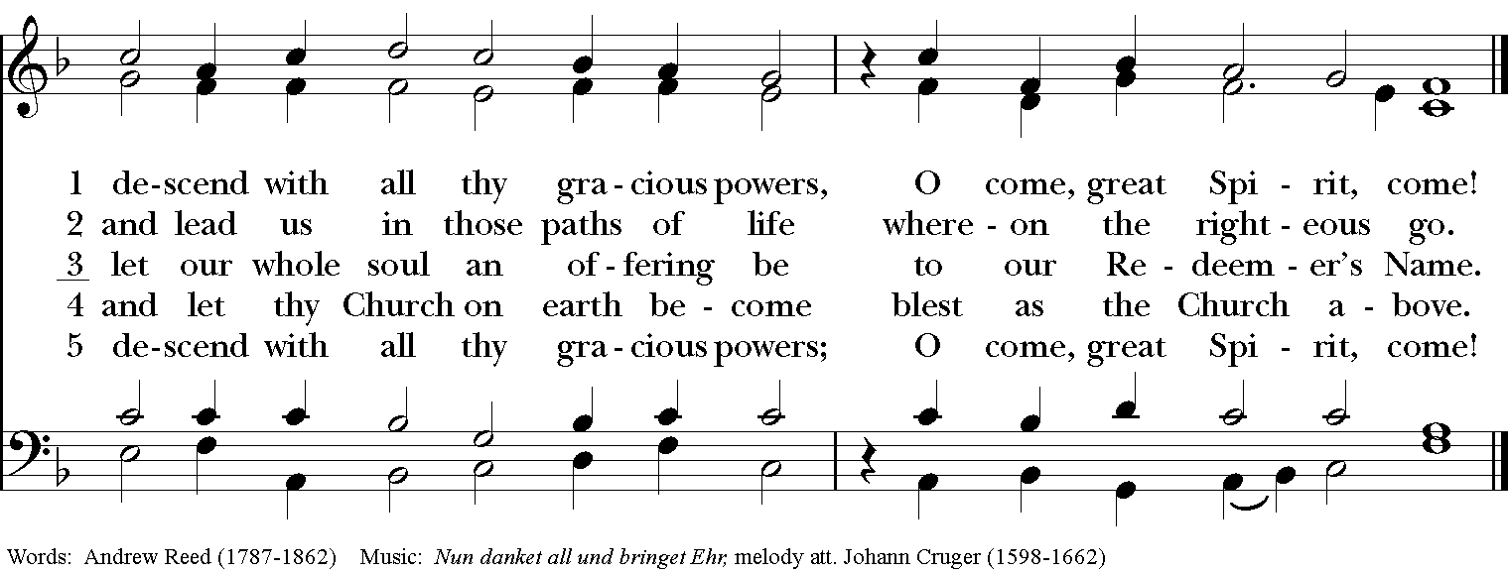

Celebrant: Blessed be God: Father, Son, and Holy Spirit.
People: And blessed be his kingdom, now and for ever. Amen.

The Collect of the Day
Celebrant: The Lord be with you.
People: And also with you.
Celebrant: Let us pray.
Grant to us, Lord, we pray, the spirit to think and do always those things that are right, that we, who cannot exist without you, may by you be enabled to live according to your will; through Jesus Christ our Lord, who lives and reigns with you and the Holy Spirit, one God, for ever and ever. Amen.

THE LESSONS

THE FIRST READING 1 King 19:4-8
Elijah went a day’s journey into the wilderness, and came and sat down under a solitary broom tree. He asked that he might die: “It is enough; now, O Lord, take away my life, for I am no better than my ancestors.” Then he lay down under the broom tree and fell asleep. Suddenly an angel touched him and said to him, “Get up and eat.” He looked, and there at his head was a cake baked on hot stones, and a jar of water. He ate and drank, and lay down again. The angel of the Lord came a second time, touched him, and said, “Get up and eat, otherwise the journey will be too much for you.” He got up, and ate and drank; then he went in the strength of that food forty days and forty nights to Horeb the mount of God.
Lector: The Word of the Lord.
People: Thanks be to God.
PSALM 34:1-8 Benedicam Dominum
1 I will bless the Lord at all times; *
his praise shall ever be in my mouth.
2 I will glory in the Lord; *
let the humble hear and rejoice.
3 Proclaim with me the greatness of the Lord; *
let us exalt his Name together.
4 I sought the Lord, and he answered me *
and delivered me out of all my terror.
5 Look upon him and be radiant, *
and let not your faces be ashamed.
6 I called in my affliction and the Lord heard me *
and saved me from all my troubles.
7 The angel of the Lord encompasses those who fear him, *
and he will deliver them.
8 Taste and see that the Lord is good; *
happy are they who trust in him!

THE SECOND LESSON Ephesians 4:25-5:2
Putting away falsehood, let all of us speak the truth to our neighbors, for we are members of one another. Be angry but do not sin; do not let the sun go down on your anger, and do not make room for the devil. Thieves must give up stealing; rather let them labor and work honestly with their own hands, so as to have something to share with the needy. Let no evil talk come out of your mouths, but only what is useful for building up, as there is need, so that your words may give grace to those who hear. And do not grieve the Holy Spirit of God, with which you were marked with a seal for the day of redemption. Put away from you all bitterness and wrath and anger and wrangling and slander, together with all malice, and be kind to one another, tenderhearted, forgiving one another, as God in Christ has forgiven you. Therefore be imitators of God, as beloved children, and live in love, as Christ loved us and gave himself up for us, a fragrant offering and sacrifice to God.
Lector: The Word of the Lord.
People: Thanks be to God.
SQUENCE HYMN: “God is Love” Hymnal 577
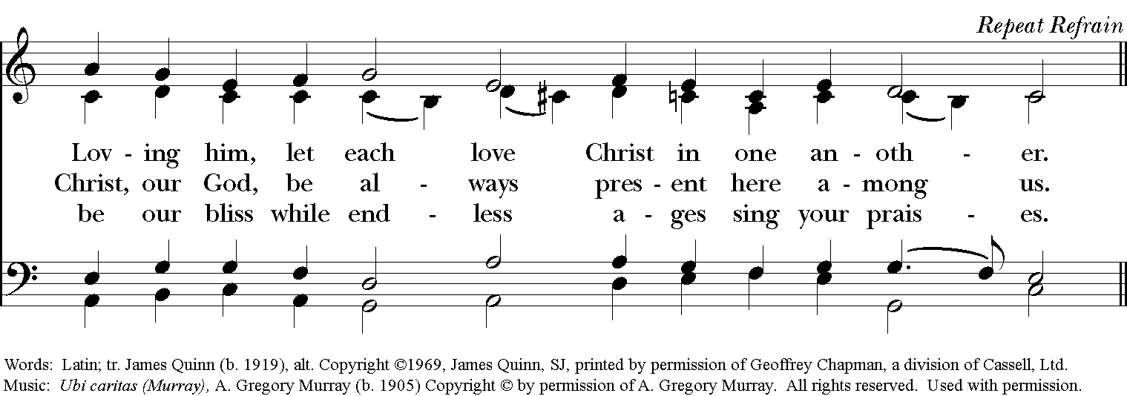
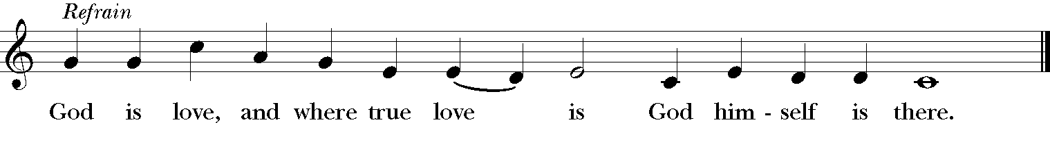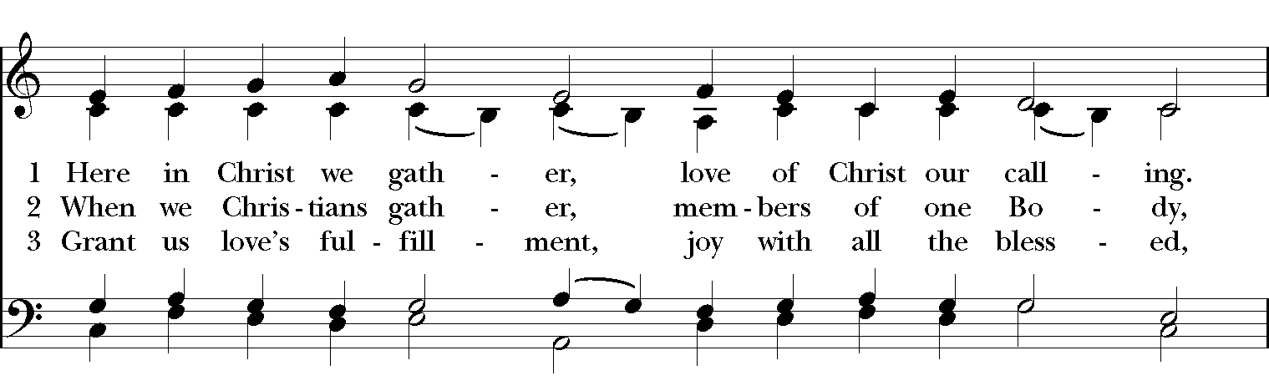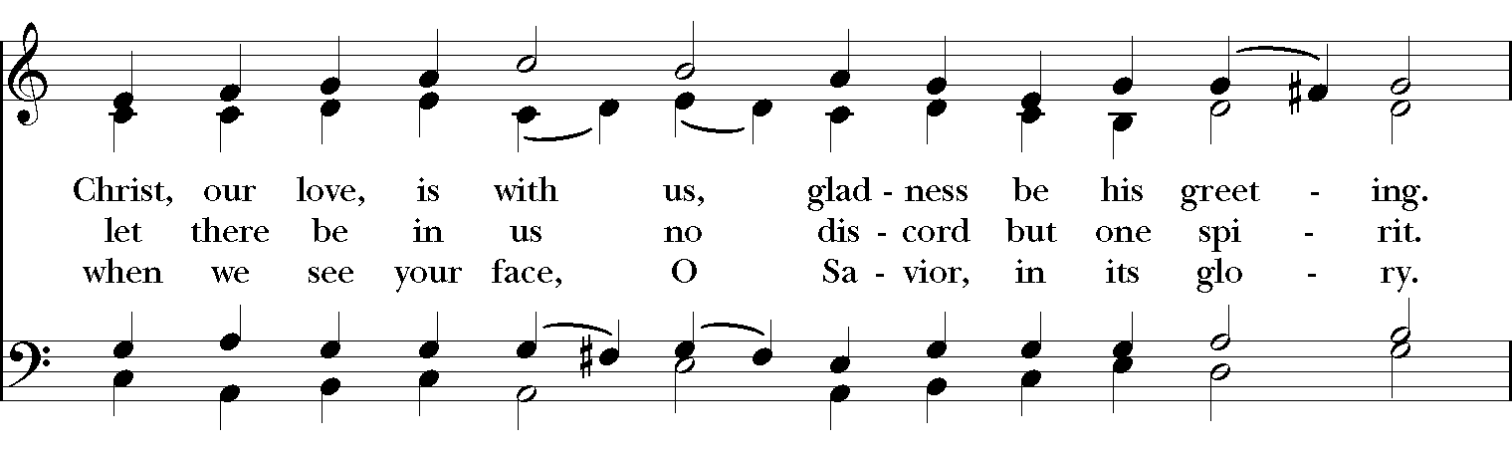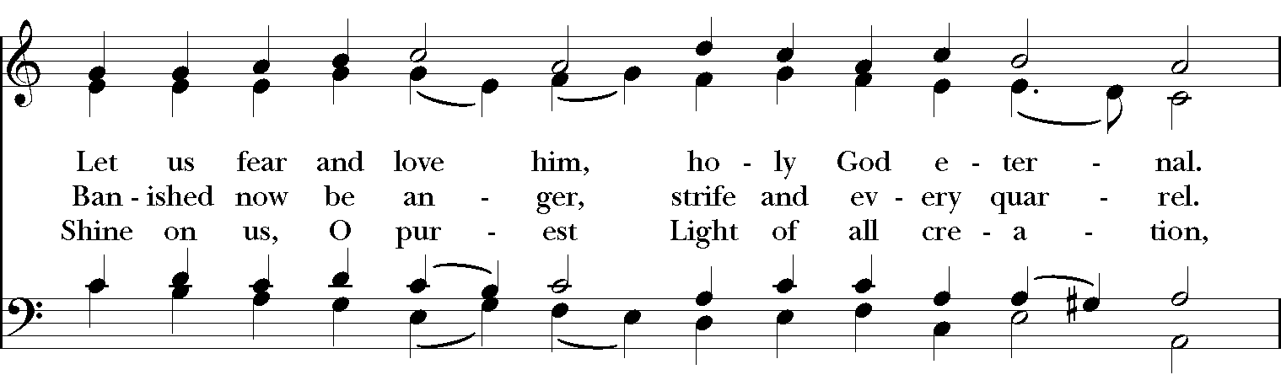

GOSPEL
Celebrant: The Holy Gospel of our Lord Jesus Christ according to John (John 6:35, 41-51).
People: Glory to you, Lord Christ.
Jesus said, “I am the bread of life. Whoever comes to me will never be hungry, and whoever believes in me will never be thirsty.”
Then the Jews began to complain about him because he said, “I am the bread that came down from heaven.” They were saying, “Is not this Jesus, the son of Joseph, whose father and mother we know? How can he now say, ‘I have come down from heaven’?” Jesus answered them, “Do not complain among yourselves. No one can come to me unless drawn by the Father who sent me; and I will raise that person up on the last day. It is written in the prophets, ‘And they shall all be taught by God.’ Everyone who has heard and learned from the Father comes to me. Not that anyone has seen the Father except the one who is from God; he has seen the Father. Very truly, I tell you, whoever believes has eternal life. I am the bread of life. Your ancestors ate the manna in the wilderness, and they died. This is the bread that comes down from heaven, so that one may eat of it and not die. I am the living bread that came down from heaven. Whoever eats of this bread will live forever; and the bread that I will give for the life of the world is my flesh.”
Celebrant: The Gospel of the Lord.
People: Praise to you, Lord Christ.

Sermon The Rev. Canon Dr. Lee Anne Reat

The Nicene Creed
We believe in one God, the Father, the Almighty,
maker of heaven and earth, of all that is, seen and unseen.
We believe in one Lord, Jesus Christ, the only Son of God,
eternally begotten of the Father, God from God,
Light from Light, true God from true God,
begotten, not made, of one Being with the Father.
Through him all things were made.
For us and for our salvation he came down from heaven,
by the power of the Holy Spirit he became incarnate from the Virgin Mary,
and was made man.
For our sake he was crucified under Pontius Pilate;
he suffered death and was buried.
On the third day he rose again in accordance with the Scriptures;
he ascended into heaven and is seated at the right hand of the Father.
He will come again in glory to judge the living and the dead, and his kingdom will have no end.
We believe in the Holy Spirit, the Lord, the giver of life,
who proceeds from the Father, and the Son.
who with the Father and the Son is worshiped and glorified,
who has spoken through the Prophets.
We believe in one holy catholic and apostolic Church.
We acknowledge one baptism for the forgiveness of sins.
We look for the resurrection of the dead, and the life of the world to come. Amen.

THE PRAYERS OF THE PEOPLE

In peace, we pray to you Lord God. Congregational responses are in bold.

Silence

Let us pray. Founder of our faith, we ask your guidance for the Church, for its unity, and for the work it does in the world. Give grace to its leaders, especially Justin, archbishop of Canterbury; Michael, our Presiding Bishop; George, our Provisional Bishop; Lee Anne, our priest; and all the members of this parish.
R: Let your priests be clothed with righteousness; let your faithful people sing for joy.

Ruler over the nations, we pray for this country and its leaders in an unsettling time. Grant wisdom to all who serve in positions of leadership throughout the world.
R: For dominion belongs to the Lord, and he rules over the nations.

Lord of the harvest, we offer thanks for the beauty and abundance of this season. May we consider how best to tend the Earth and to share what You have given us, so that all may eat and be satisfied by your goodness. We pray for the ministries this church supports, especially Springfield Farmer’s Market, Project Woman, Children’s Defense Fund Freedom Schools, The YMCA, and Jefferson St. Oasis Garden.
R: He covers the heavens with clouds, and prepares rain for the earth;
He makes grass grow upon the mountains, and green plants to serve humankind.

Giver of every good gift, we pray for those celebrating birthdays this week, especially Josh, Nick, Dana, and Marilyn, and anniversaries, David & Kathleen.
R: Let the righteous be glad and rejoice before God; Let them also be merry and joyful.

Great Physician, we pray for healing and comfort for all those in need or pain, especially Leigh, Charlene, Faye, Chris, Bonnie, Alice, Diana, James, Joy, Jane, Joni, Kim, Bobby, Sarah, Traudie, Lexie, and Keith. May they remember that You are with them and those who care for them.
R: Surely you behold trouble and misery; you see it and take it into your own hand.
The helpless commit themselves to you; for you are the helper of orphans.

Just Judge, we ask your aid for all those in trouble, bringing before You prisoners and captives, refugees and the oppressed. We pray for those most vulnerable throughout the world, especially women and children.
R: Let justice roll down like waters, and righteousness like an ever-flowing stream.

Lord over life and death, we pray for all who have died, asking light and peace for them and those who mourn.
R: Precious in the sight of the Lord is the death of his servant.

*THE COLLECT FOR PEACE
Grant, O God, that your holy and life-giving Spirit may so move every human heart, that barriers which divide us may crumble, suspicions disappear, and hatreds cease; that our divisions being healed, we may live in justice and peace; through Jesus Christ our Lord. Amen.

THE CONFESSION AND ABSOLUTION
Priest: Let us confess our sins against God and our neighbor.
All: Most merciful God, we confess that we have sinned against you in thought, word, and deed, by what we have done, and by what we have left undone. We have not loved you with our whole heart; we have not loved our neighbors as ourselves. We are truly sorry and we humbly repent. For the sake of your Son Jesus Christ, have mercy on us and forgive us; that we may delight in your will, and walk in your ways, to the glory of your Name. Amen.

Priest: Almighty God, have mercy on you, forgive you all your sins through our Lord Jesus Christ, strengthen you in all goodness, and by the power of the Holy Spirit keep you in eternal life. Amen.

And now, as our Savior Christ has taught us, we are bold to say:
Our Father, who art in heaven, hallowed be thy Name,
thy kingdom come, thy will be done, on earth as it is in heaven.
Give us this day our daily bread.
And forgive us our trespasses, as we forgive those who trespass against us.
And lead us not into temptation, but deliver us from evil.
For thine is the kingdom, and the power, and the glory, for ever and ever. Amen

CLOSING HYMN: “Father, we thank thee who has planted” Hymnal 302
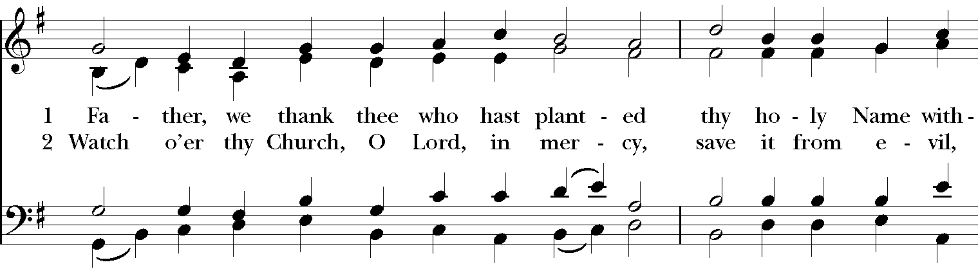
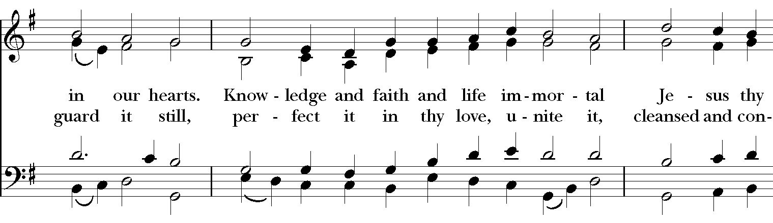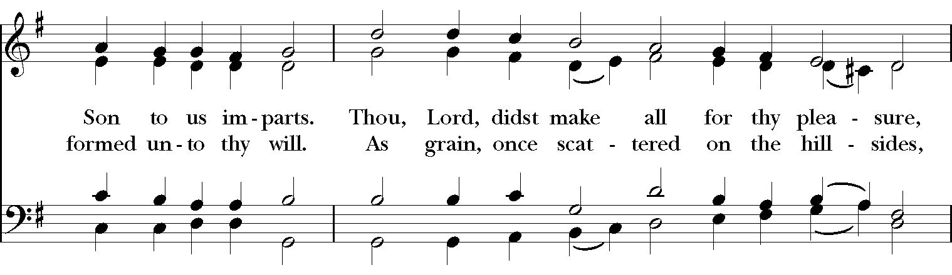
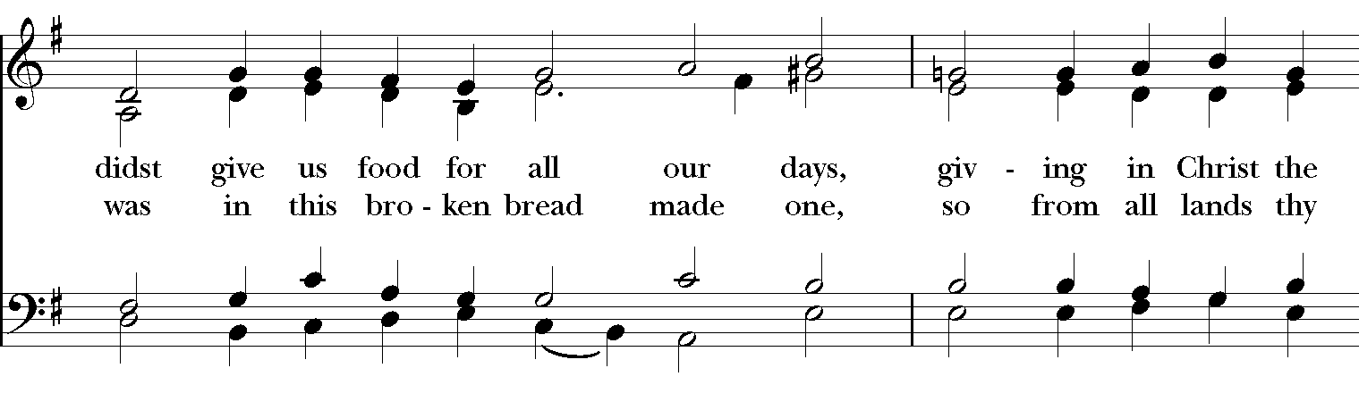
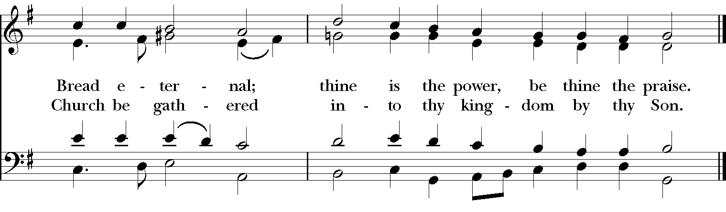
*THE BLESSING
Christ who has nourished us with himself the living bread, make you one in praise and love, and raise you up at the last day; and the blessing God Almighty, the Father, the Son, and the Holy Spirit, be among you, and remain with you always. Amen.

ANNOUNCEMENTS

*THE DISMISSAL Celebrant: Go in peace to love and serve the Lord.
People: Thanks be to God.

POSTLUDE: “Adagio cantabile“ from sonata in C Minor “Pathétique“ – Beethoven

Thank you for your spiritual presence with us this morning!
Although we're physically apart, we are united in prayer, worship, and holy love!
Priest-In-Charge: The Rev. Dr. Canon Lee Anne Reat
Music Director: Dr. Chris Durrenberger
Lector: Keith Doubt
Singers: Liz Wheeler, Joy Carter, Basil Fett, Chris Oldstone-Moore, and Fred Bartenstein
Technology: Steve Ide
Slideshow: Ed Hasecke
Parish Administrator and Program Coordinator: Kelly Zeller

