Christ Episcopal Church in Springfield, Ohio
Service of the Word
Fourth Sunday of Advent: December 20th, 2020 at 9 am

Prelude:

The Lighting of the Advent wreath
Priest: People of God: awake! The day is coming soon when we shall see God face to face. As God’s children, we remember the ways and the works of God. We are called out of darkness to walk in the light of God’s coming. Lord, make us one as we walk with Christ today and for ever. Amen.

Opening Hymn: “Blest be the King whose coming” Hymnal 74

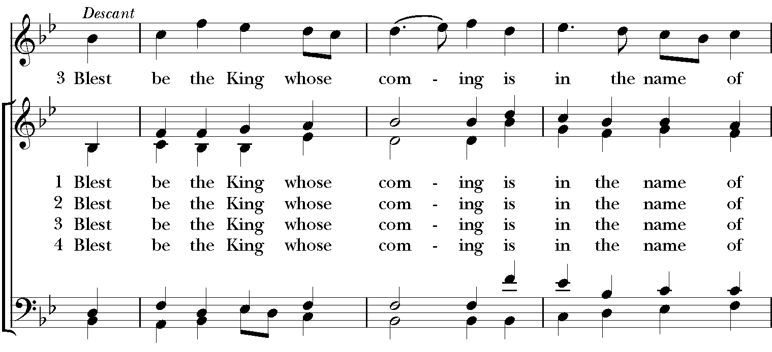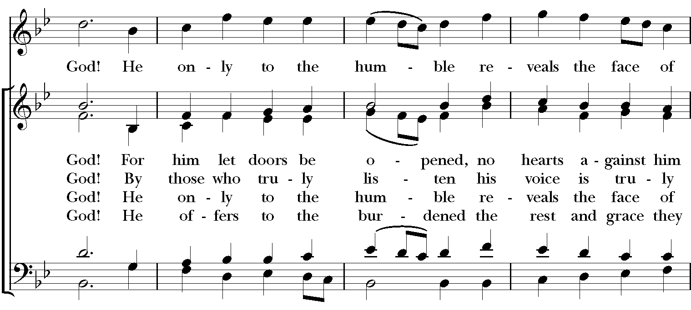

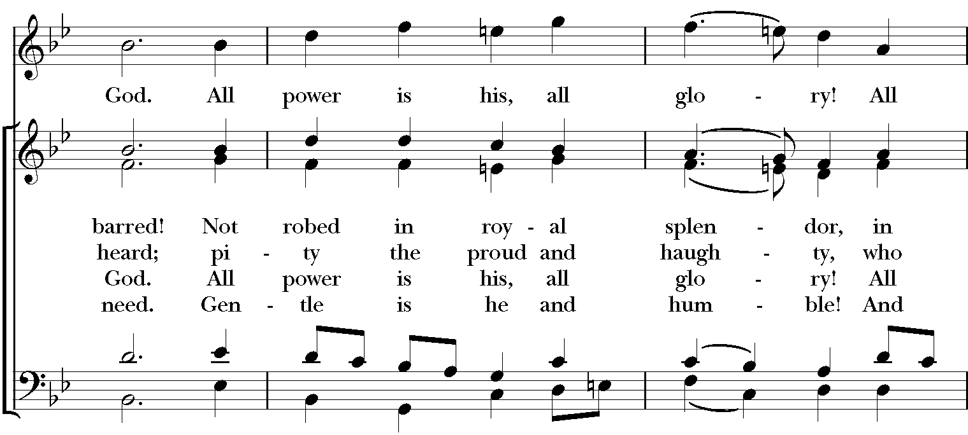
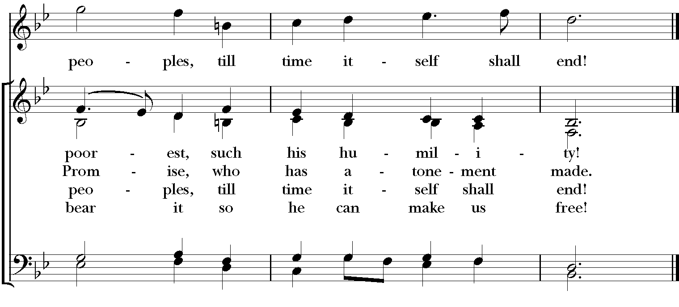
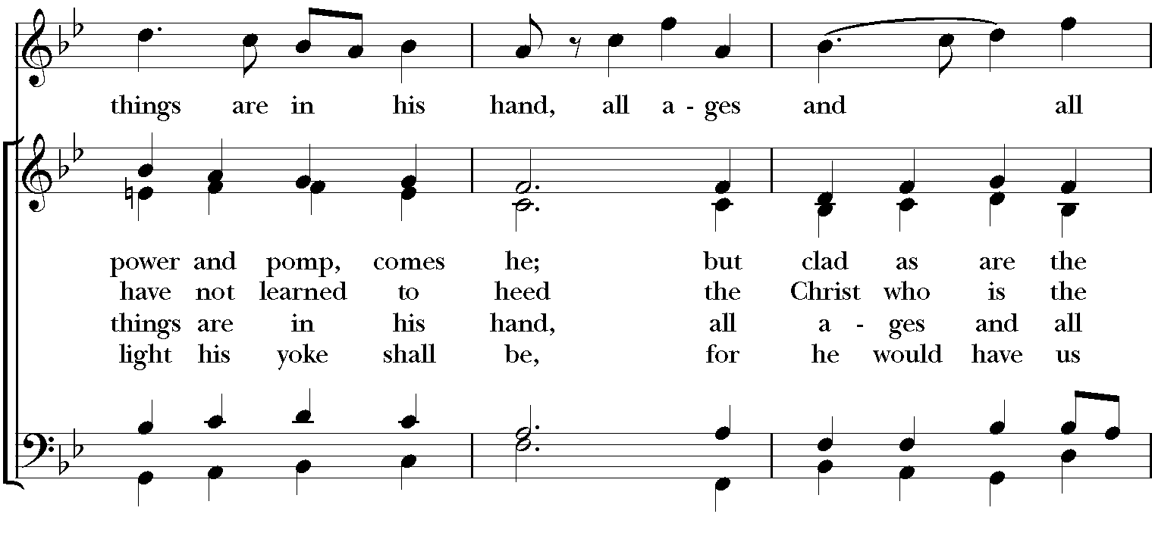

Celebrant: Blessed be God: Father, Son, and Holy Spirit.
People: And blessed be God’s kingdom, now and for ever. Amen.
Celebrant: Lord, have mercy.
People: Christ, have mercy.
Celebrant: Lord, have mercy.

The Collect of the Day
Celebrant: The Lord be with you.
People: And also with you.
Celebrant: Let us pray.
Purify our conscience, Almighty God, by your daily visitation, that your Son Jesus Christ, at his coming, may find in us a mansion prepared for himself; who lives and reigns with you, in the unity of the Holy Spirit, one God, now and for ever. Amen.

The Lessons

The First Reading: 2 Samuel 7:1-11, 16
When the king was settled in his house, and the Lord had given him rest from all his enemies around him, the king said to the prophet Nathan, "See now, I am living in a house of cedar, but the ark of God stays in a tent." Nathan said to the king, "Go, do all that you have in mind; for the Lord is with you."

But that same night the word of the Lord came to Nathan: Go and tell my servant David: Thus says the Lord: Are you the one to build me a house to live in? I have not lived in a house since the day I brought up the people of Israel from Egypt to this day, but I have been moving about in a tent and a tabernacle. Wherever I have moved about among all the people of Israel, did I ever speak a word with any of the tribal leaders of Israel, whom I commanded to shepherd my people Israel, saying, "Why have you not built me a house of cedar?" Now therefore thus you shall say to my servant David: Thus says the Lord of hosts: I took you from the pasture, from following the sheep to be prince over my people Israel; and I have been with you wherever you went, and have cut off all your enemies from before you; and I will make for you a great name, like the name of the great ones of the earth. And I will appoint a place for my people Israel and will plant them, so that they may live in their own place, and be disturbed no more; and evildoers shall afflict them no more, as formerly, from the time that I appointed judges over my people Israel; and I will give you rest from all your enemies. Moreover the Lord declares to you that the Lord will make you a house. Your house and your kingdom shall be made sure forever before me; your throne shall be established forever.
Reader: The Word of the Lord.
People: Thanks be to God.

Psalm 89:1-4, 19-26 Misericordias Domini
1 Your love, O Lord, for ever will I sing; *
from age to age my mouth will proclaim your faithfulness.
2 For I am persuaded that your love is established for ever; *
you have set your faithfulness firmly in the heavens.
3 "I have made a covenant with my chosen one; *
I have sworn an oath to David my servant:
4 'I will establish your line for ever, *
and preserve your throne for all generations.'
19 You spoke once in a vision and said to your faithful people: *
I have set the crown upon a warrior and have exalted one chosen out of the people.
20 I have found David my servant; *
with my holy oil have I anointed him.
21 My hand will hold him fast *
and my arm will make him strong.
22 No enemy shall deceive him, *
nor any wicked man bring him down.
23 I will crush his foes before him *
and strike down those who hate him.
24 My faithfulness and love shall be with him, *
and he shall be victorious through my Name.
25 I shall make his dominion extend *
from the Great Sea to the River.
26 He will say to me, 'You are my Father, *
my God, and the rock of my salvation.'

Second Lesson: Romans 16:25-27
Now to God who is able to strengthen you according to my gospel and the proclamation of Jesus Christ, according to the revelation of the mystery that was kept secret for long ages but is now disclosed, and through the prophetic writings is made known to all the Gentiles, according to the command of the eternal God, to bring about the obedience of faith-- to the only wise God, through Jesus Christ, to whom be the glory forever! Amen.
Reader: The Word of the Lord.
People: Thanks be to God.

Sequence Hymn: “The angel Gabriel from heaven came” Hymnal 265

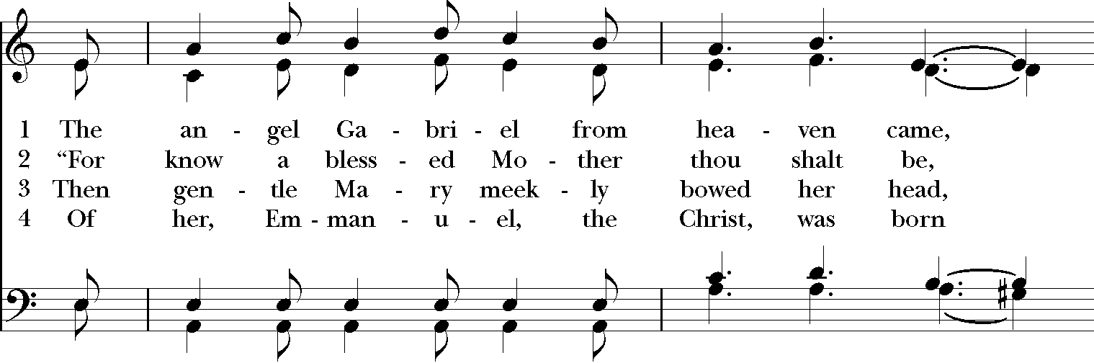

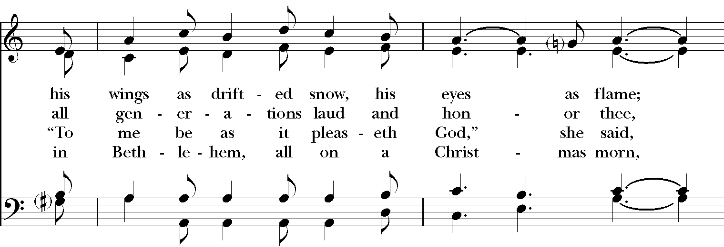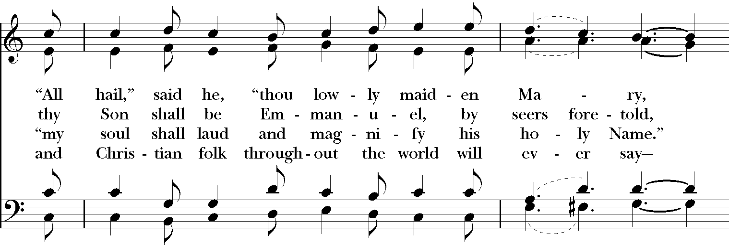

Gospel
Deacon: The Holy Gospel According to Luke (1:26-38)
People: Glory to you, Lord Christ.
In the sixth month the angel Gabriel was sent by God to a town in Galilee called Nazareth, to a virgin engaged to a man whose name was Joseph, of the house of David. The virgin’s name was Mary. And he came to her and said, “Greetings, favored one! The Lord is with you.” But she was much perplexed by his words and pondered what sort of greeting this might be. The angel said to her, “Do not be afraid, Mary, for you have found favor with God. And now, you will conceive in your womb and bear a son, and you will name him Jesus. He will be great, and will be called the Son of the Most High, and the Lord God will give to him the throne of his ancestor David. He will reign over the house of Jacob forever, and of his kingdom there will be no end.” Mary said to the angel, “How can this be, since I am a virgin?” The angel said to her, “The Holy Spirit will come upon you, and the power of the Most High will overshadow you; therefore the child to be born will be holy; he will be called Son of God. And now, your relative Elizabeth in her old age has also conceived a son; and this is the sixth month for her who was said to be barren. For nothing will be impossible with God.” Then Mary said, “Here am I, the servant of the Lord; let it be with me according to your word.” Then the angel departed from her.
Deacon: The Gospel of the Lord.
People: Praise to you, Lord Christ.

Sermon The Rev. Canon Dr. Lee Anne Reat

The Nicene Creed
We believe in one God,
the Father, the Almighty,
the maker of heaven and earth,
of all that is, seen and unseen.
We believe in one Lord, Jesus Christ,
the only Son of God,
eternally begotten of the Father,
God from God, Light from Light,
true God from true God,
begotten, not made,
of one Being with the Father.
Through him all things were made.
For us and for our salvation
he came down from heaven:
by the power of the Holy Spirit
he became incarnate from the Virgin Mary,
and was made man.
For our sake he was crucified under Pontius Pilate;
he suffered death and was buried.
On the third day he rose again
in accordance with the Scriptures;
He ascended into heaven
and is seated on the right hand of the Father.
He will come again in glory to judge the living and the dead,
and his kingdom will have no end.
We believe in the Holy Spirit, the Lord, the giver of life,
who proceeds from the Father and the Son.
With the Father and the Son he is worshiped and glorified.
He has spoken through the Prophets.
We believe in one holy catholic and apostolic Church.
We acknowledge one baptism for the forgiveness of sins.
We look for the resurrection of the dead,
and the life of the world to come. Amen.

The Prayers of the People
In peace, we pray to you Lord God.

Silence
Let us pray. Lord Jesus Christ, you came and dwelt among us, showing us the glory of the Father. Let that glory be manifest in our churches. Give us the will to be united as You prayed we would be.
R: Lord Jesus, come and dwell within all churches.
Lord Jesus Christ, you came and dwelt among us, serving others and not seeking your own glory. Inspire church leaders, that they may be examples of willing service. Bless Justin, Archbishop of Canterbury; Michael, our Presiding Bishop; Lee Anne, our priest, and Rick, our deacon.
R: Lord Jesus, come and dwell among all church leaders

Lord Jesus Christ, you came and dwelt among us, giving us an example of true power, which lies in holiness. Direct government leaders into wise decisions that will bring forth righteousness. Give the leaders of the nation wisdom and hearts for peace.
R: Lord Jesus, come and dwell in all government leaders.

Lord Jesus Christ, you came and dwelt among us, choosing the company of the poor, the homeless, the hungry, and the sick, of widows and orphans, and of sinners. Help us to reach out in lovingkindness to those who are in any need or trouble. We pray for the ministries this church supports, especially Clark County Literacy Coalition, Episcopal Community Ministries, Second Harvest Food Bank, and Interfaith Hospitality Network.
R: Lord Jesus, come and dwell in our acts of mercy.

Lord Jesus Christ, you came and dwelt among us, taking on our flesh, and inhabiting both the pains and the joys of this life. We celebrate with those who have birthdays, especially Marilyn, Chris, and Leeza and anniversaries this week, especially Scott & Lisa.
R: Lord Jesus, come and dwell in our moments of joy.

Lord Jesus Christ, you came and dwelt among us, taking sickness and suffering into your own hands and transforming them. Have mercy on those who suffer in body, mind, or spirit. We pray especially for Chris, Dodi, Laura, Bonnie, Alice, Diana, James, Joy, Jane, Joni, Kim, Bobby, Ruth, Sarah, Traudie, Lexie, Norm, and Keith. Give special grace and power to all those who spend this holiday working with the sick and the dying.
R: Lord Jesus, come and dwell in our dis-ease and make us whole.

Lord Jesus Christ, you came and dwelt among us, weeping at the death of those whom you loved. Comfort all those who have lost loved ones, and bless those departed.
R: Lord Jesus, come and dwell in our memories of those whom we have lost. Grant peace and light to those who have died.

*THE COLLECT FOR PEACE
Grant, O God, that your holy and life-giving Spirit may so move every human heart, that barriers which divide us may crumble, suspicions disappear, and hatreds cease; that our divisions being healed, we may live in justice and peace; through Jesus Christ our Lord. Amen.

Deacon: Let us confess our sins against God and our neighbor.
All: Most merciful God, we confess that we have sinned against you in thought, word, and deed, by what we have done, and by what we have left undone. We have not loved you with our whole heart; we have not loved our neighbors as ourselves. We are truly sorry and we humbly repent. For the sake of your Son Jesus Christ, have mercy on us and forgive us; that we may delight in your will, and walk in your ways, to the glory of your Name. Amen.

Priest: Almighty God, have mercy on you, forgive you all your sins through our Lord Jesus Christ, strengthen you in all goodness, and by the power of the Holy Spirit keep you in eternal life. Amen.

And now, as our Savior Christ has taught us, we are bold to say:
Our Father, who art in heaven, hallowed be thy Name,
thy kingdom come, thy will be done, on earth as it is in heaven.
Give us this day our daily bread.
And forgive us our trespasses, as we forgive those who trespass against us.
And lead us not into temptation, but deliver us from evil.
For thine is the kingdom, and the power, and the glory, for ever and ever. Amen.

Closing Hymn: “Rejoice! rejoice, believers” Hymnal 68

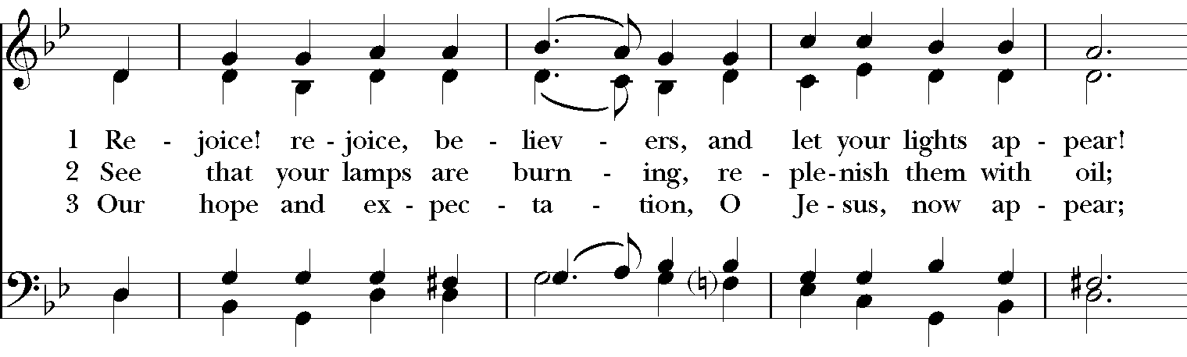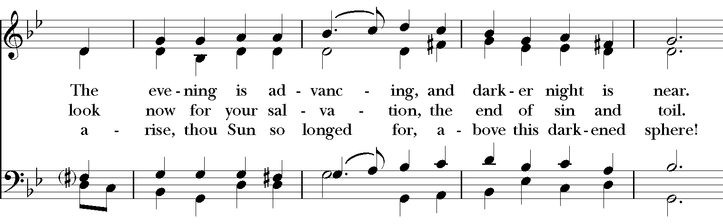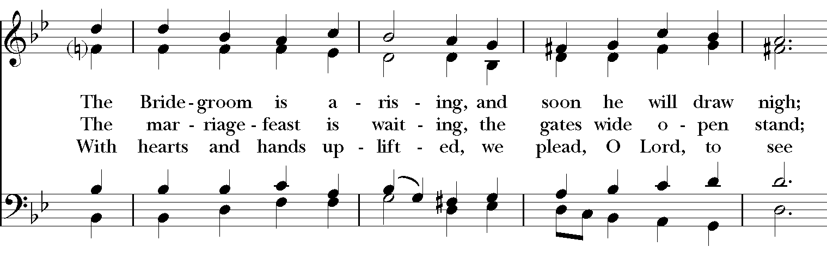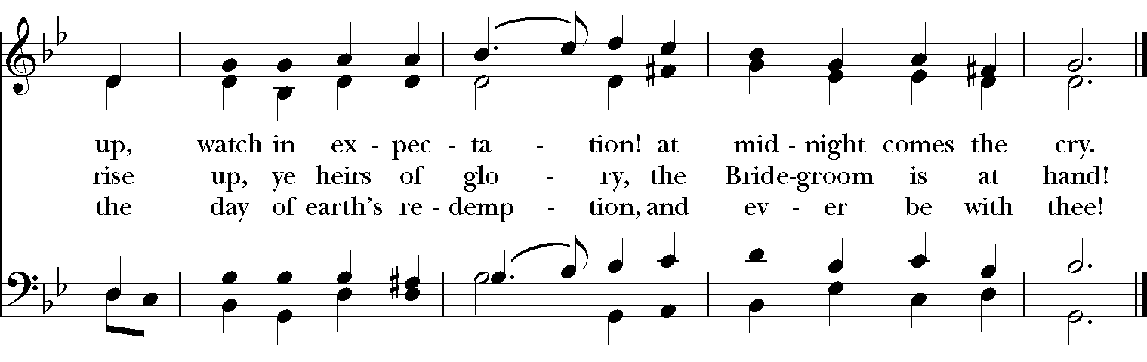
Blessing
May the Sun of Righteousness shine upon you and scatter the darkness from before your path; and the blessing of God Almighty, the Father, the Son, and the Holy Spirit, be among you, and remain with you always. Amen.

Announcements

Dismissal
Deacon: Go in peace to love and serve the Lord.
People: Thanks be to God!

Postlude:

Thank you for your spiritual presence with us this morning!
Although we're physically apart, we are united in prayer, worship, and holy love!
Priest-In-Charge: The Rev. Dr. Canon Lee Anne Reat
Deacon: The Rev. Dr. Rick Incorvati
Music Director: Dr. Chris Durrenberger
Lector: Anne Strothman
Acolyte: Bill Yeazell
Singers: Liz Wheeler, Joy Carter, Ed Hasecke, Chris Oldstone-Moore
Technology: Steve Ide
Slideshow: Ed Hasecke
Parish Administrator and Program Coordinator: Kelly Zeller
Coffee Hour Host: Linda Mortensen

