Christ Episcopal Church in Springfield, Ohio
Service of the Word
Second Sunday of Advent: December 6th, 2020 at 9 am

Prelude:

The lighting of the Advent wreath
Priest: People of God: awake! The day is coming soon when we shall see God face to face. As God’s children, we remember the ways and the works of God. We are called out of darkness to walk in the light of God’s coming. Lord, make us one as we walk with Christ today and for ever. Amen.

Opening Hymn: “O come, O come, Emmanuel” Hymnal 56 vs. 1, 4, 5, 6, & 7

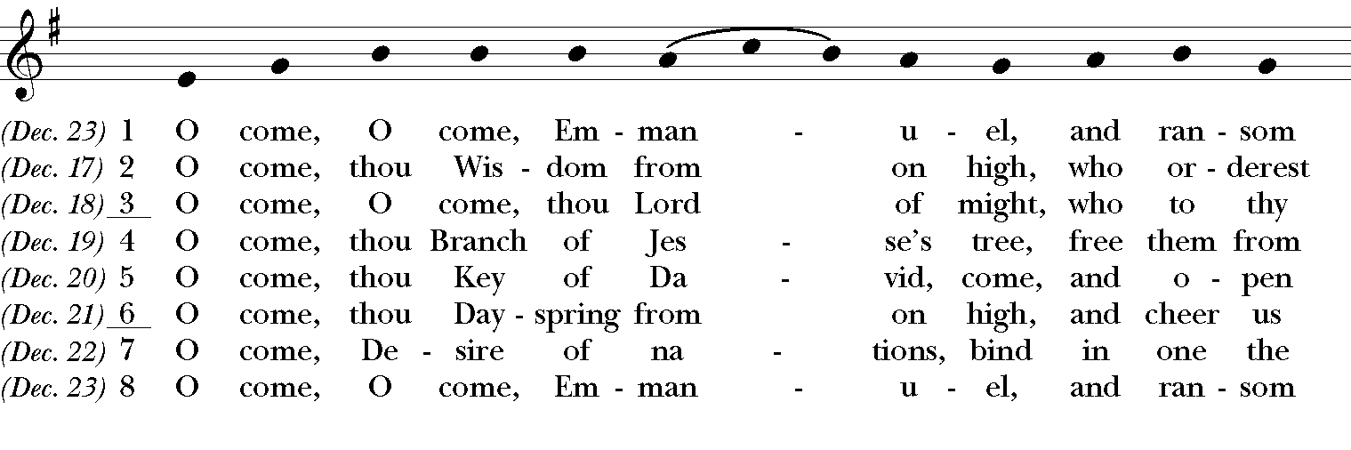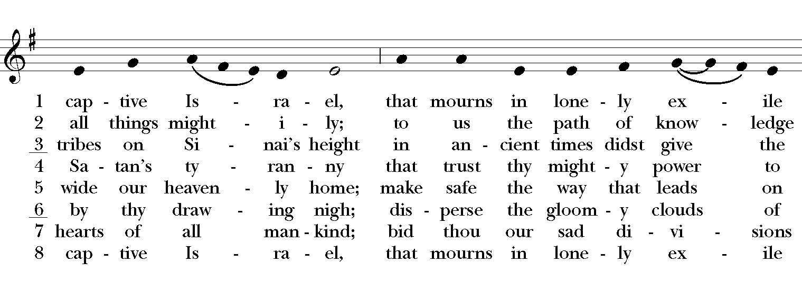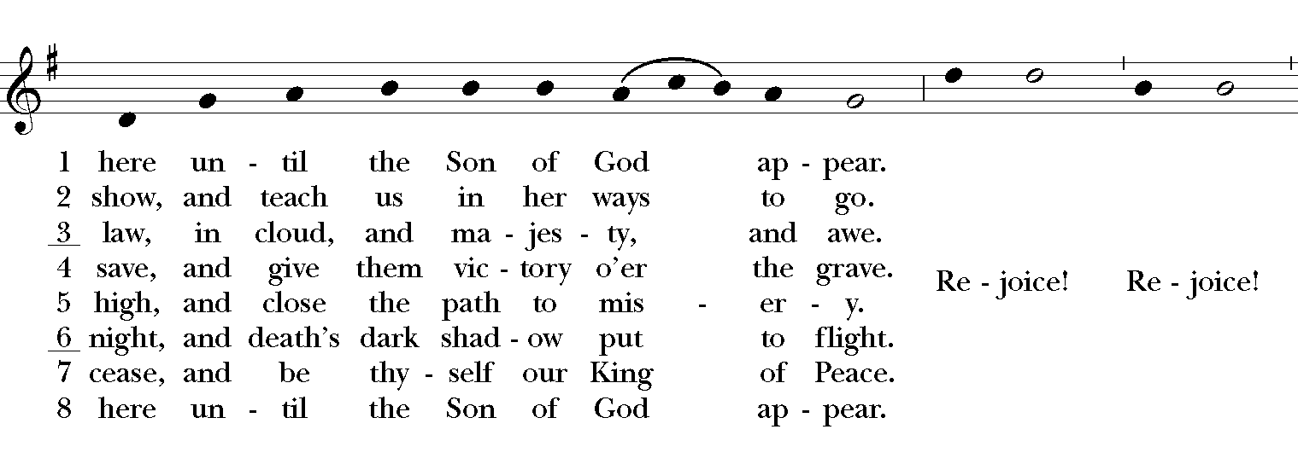

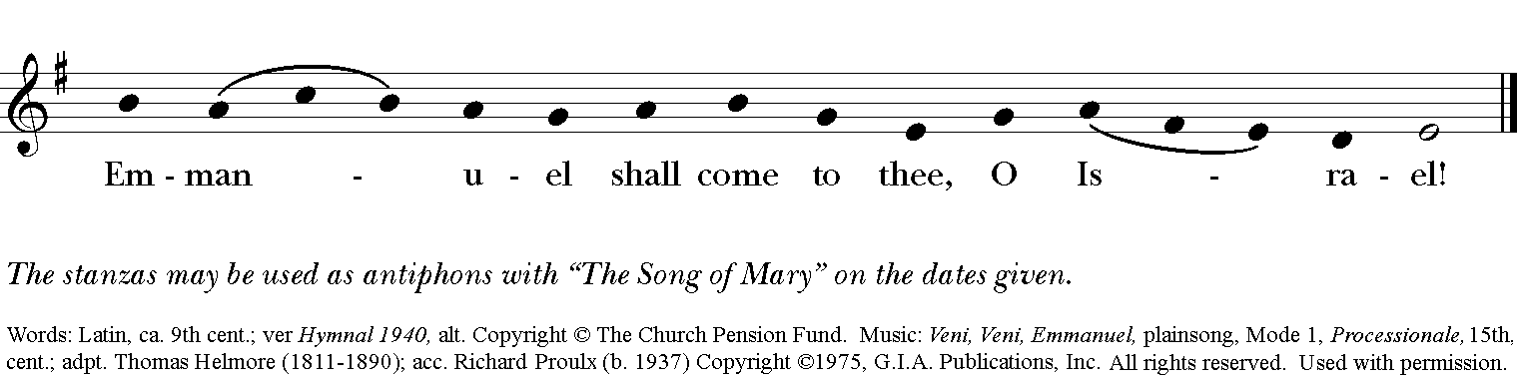

Celebrant: Blessed be God: Father, Son, and Holy Spirit.
People: And blessed be God’s kingdom, now and for ever. Amen.
Celebrant: Lord, have mercy.
People: Christ, have mercy.
Celebrant: Lord, have mercy.

The Collect of the Day
Celebrant: The Lord be with you.
People: And also with you.
Celebrant: Let us pray.
Merciful God, who sent your messengers the prophets to preach repentance and prepare the way for our salvation: Give us grace to heed their warnings and forsake our sins, that we may greet with joy the coming of Jesus Christ our Redeemer; who lives and reigns with you and the Holy Spirit, one God, now and for ever.Amen.

The Lessons

The First Reading: Isaiah 40:1-11
Comfort, O comfort my people,
says your God.
Speak tenderly to Jerusalem,
and cry to her
that she has served her term,
that her penalty is paid,
that she has received from the Lord's hand
double for all her sins.
A voice cries out:
“In the wilderness prepare the way of the Lord,
make straight in the desert a highway for our God.
Every valley shall be lifted up,
and every mountain and hill be made low;
the uneven ground shall become level,
and the rough places a plain.
Then the glory of the Lord shall be revealed,
and all people shall see it together,
for the mouth of the Lord has spoken.”
A voice says, “Cry out!”
And I said, “What shall I cry?”
All people are grass,
their constancy is like the flower of the field.
The grass withers, the flower fades,
when the breath of the Lord blows upon it;
surely the people are grass.
The grass withers, the flower fades;
but the word of our God will stand for ever.
Get you up to a high mountain,
O Zion, herald of good tidings;
lift up your voice with strength,
O Jerusalem, herald of good tidings,
lift it up, do not fear;
say to the cities of Judah,
“Here is your God!”
See, the Lord God comes with might,
and his arm rules for him;
his reward is with him,
and his recompense before him.
He will feed his flock like a shepherd;
he will gather the lambs in his arms,
and carry them in his bosom,
and gently lead the mother sheep.
Reader: The Word of the Lord.
People: Thanks be to God.

Psalm 85:1-2, 8-13 Benedixisti, Domine

1 You have been gracious to your land, O Lord, *
you have restored the good fortune of Jacob.
2 You have forgiven the iniquity of your people *
and blotted out all their sins.
8 I will listen to what the Lord God is saying, *
for he is speaking peace to his faithful people
and to those who turn their hearts to him.
9 Truly, his salvation is very near to those who fear him, *
that his glory may dwell in our land.
10 Mercy and truth have met together; *
righteousness and peace have kissed each other.
11 Truth shall spring up from the earth, *
and righteousness shall look down from heaven.
12 The Lord will indeed grant prosperity, *
and our land will yield its increase.
13 Righteousness shall go before him, *
and peace shall be a pathway for his feet.

Second Lesson: 2 Peter 3:8-15a
Do not ignore this one fact, beloved, that with the Lord one day is like a thousand years, and a thousand years are like one day. The Lord is not slow about his promise, as some think of slowness, but is patient with you, not wanting any to perish, but all to come to repentance. But the day of the Lord will come like a thief, and then the heavens will pass away with a loud noise, and the elements will be dissolved with fire, and the earth and everything that is done on it will be disclosed.

Since all these things are to be dissolved in this way, what sort of persons ought you to be in leading lives of holiness and godliness, waiting for and hastening the coming of the day of God, because of which the heavens will be set ablaze and dissolved, and the elements will melt with fire? But, in accordance with his promise, we wait for new heavens and a new earth, where righteousness is at home.

Therefore, beloved, while you are waiting for these things, strive to be found by him at peace, without spot or blemish; and regard the patience of our Lord as salvation.
Reader: The Word of the Lord.
People: Thanks be to God.

Sequence Hymn: “ Comfort, comfort ye my people” Hymnal 67
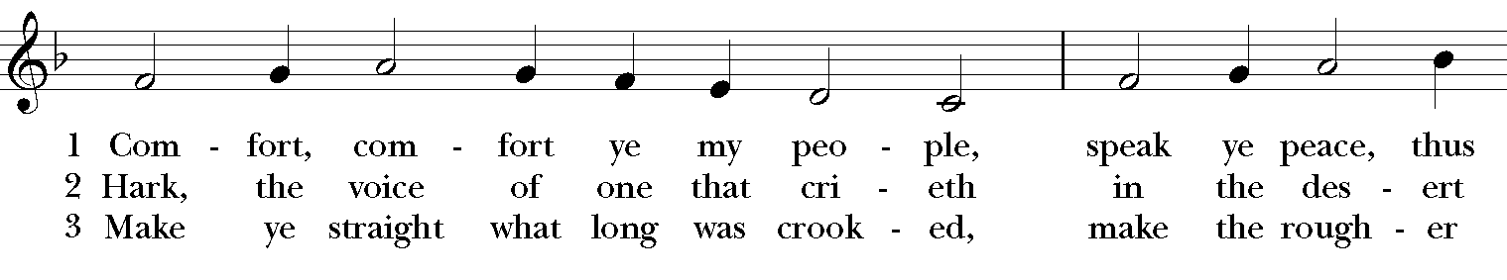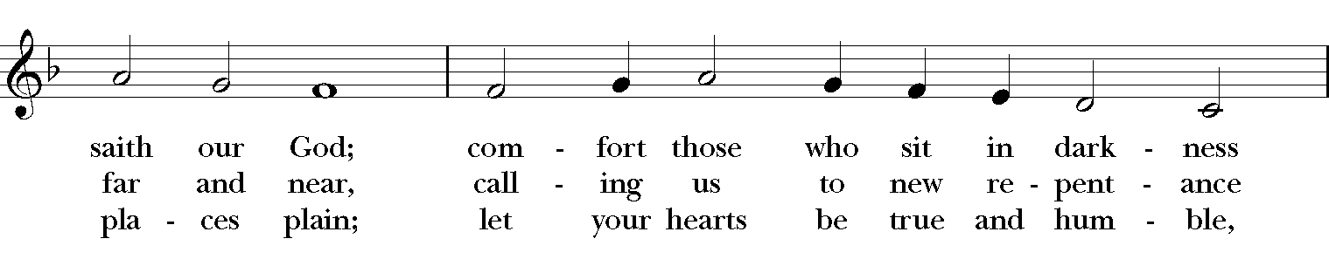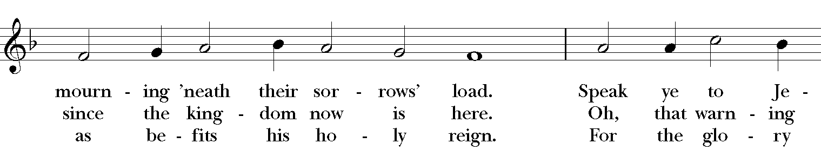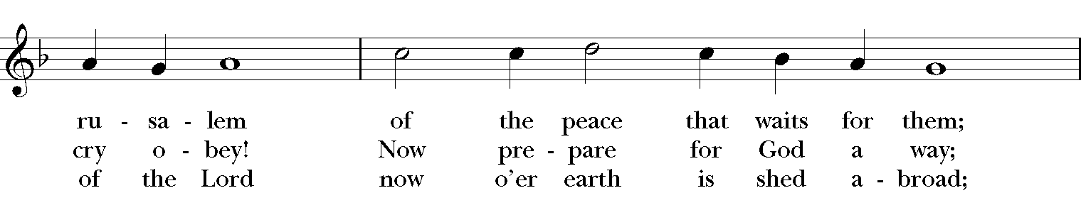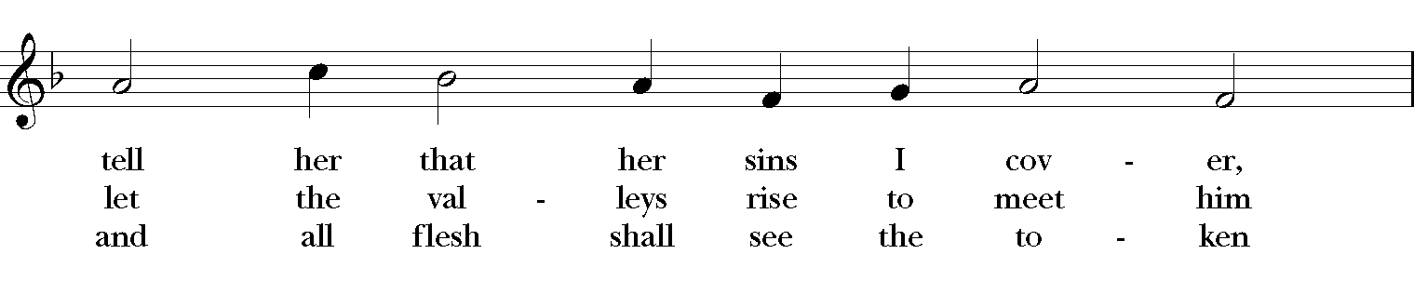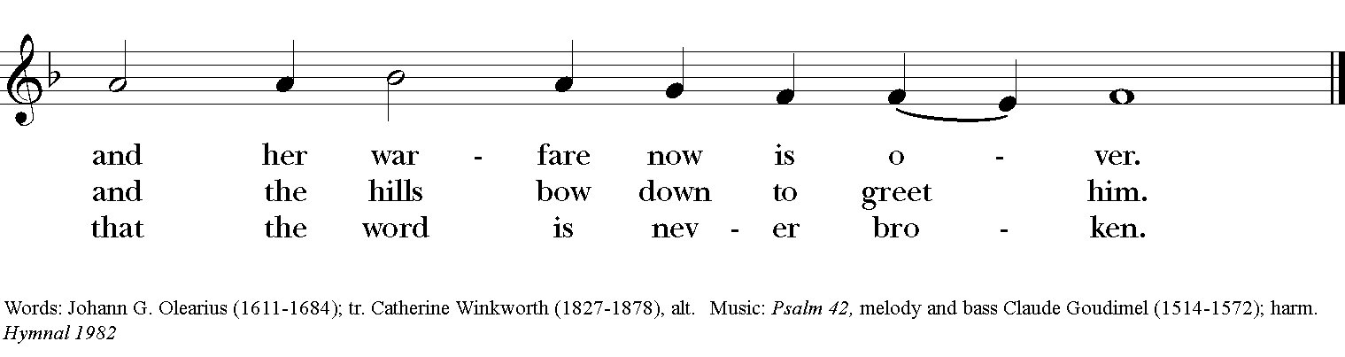

Gospel
Deacon: The Holy Gospel According to Mark (1:1-8)
People: Glory to you, Lord Christ.
The beginning of the good news of Jesus Christ, the Son of God.
As it is written in the prophet Isaiah,
“See, I am sending my messenger ahead of you,
who will prepare your way;
the voice of one crying out in the wilderness:
‘Prepare the way of the Lord,
make his paths straight,’”

John the baptizer appeared in the wilderness, proclaiming a baptism of repentance for the forgiveness of sins. And people from the whole Judean countryside and all the people of Jerusalem w ere going out to him, and were baptized by him in the river Jordan, confessing their sins. Now John was clothed with camel’s hair, with a leather belt around his waist, and he ate locusts and wild honey. He proclaimed, “The one who is more powerful than I is coming after me; I am not worthy to stoop down and untie the thong of his sandals. I have baptized you with water; but he will baptize you with the Holy Spirit.”
Deacon: The Gospel of the Lord.
People: Praise to you, Lord Christ.

Sermon The Rev. Canon Dr. Lee Anne Reat
The Nicene Creed
We believe in one God,
the Father, the Almighty,
the maker of heaven and earth,
of all that is, seen and unseen.
We believe in one Lord, Jesus Christ,
the only Son of God,
eternally begotten of the Father,
God from God, Light from Light,
true God from true God,
begotten, not made,
of one Being with the Father.
Through him all things were made.
For us and for our salvation
he came down from heaven:
by the power of the Holy Spirit
he became incarnate from the Virgin Mary,
and was made man.
For our sake he was crucified under Pontius Pilate;
he suffered death and was buried.
On the third day he rose again
in accordance with the Scriptures;
He ascended into heaven
and is seated on the right hand of the Father.
He will come again in glory to judge the living and the dead,
and his kingdom will have no end.
We believe in the Holy Spirit, the Lord, the giver of life,
who proceeds from the Father and the Son.
With the Father and the Son he is worshiped and glorified.
He has spoken through the Prophets.
We believe in one holy catholic and apostolic Church.
We acknowledge one baptism for the forgiveness of sins.
We look for the resurrection of the dead,
and the life of the world to come. Amen.

The Prayers of the People
In peace, we pray to you Lord God.

Silence
Let us pray. Lord Jesus Christ, you came and dwelt among us, showing us the glory of the Father. Let that glory be manifest in our churches. Give us the will to be united as You prayed we would be.
R: Lord Jesus, come and dwell within all churches.
Lord Jesus Christ, you came and dwelt among us, serving others and not seeking your own glory. Inspire church leaders, that they may be examples of willing service. Bless Justin, Archbishop of Canterbury; Michael, our Presiding Bishop; Lee Anne, our priest, and Rick, our deacon.
R: Lord Jesus, come and dwell among all church leaders

Lord Jesus Christ, you came and dwelt among us, giving us an example of true power, which lies in holiness. Direct government leaders into wise decisions that will bring forth righteousness. Give the leaders of the nation wisdom and hearts for peace.
R: Lord Jesus, come and dwell in all government leaders.

Lord Jesus Christ, you came and dwelt among us, choosing the company of the poor, the homeless, the hungry, and the sick, of widows and orphans, and of sinners. Help us to reach out in lovingkindness to those who are in any need or trouble. We pray for the ministries this church supports, especially Rainbow Table, Springfield Promise Neighborhood, Springfield Peace Center, and Partners in Ministry in Liberia.
R: Lord Jesus, come and dwell in our acts of mercy.

Lord Jesus Christ, you came and dwelt among us, taking on our flesh, and inhabiting both the pains and the joys of this life. We celebrate with those who have birthdays, especially Al, Peng, Fred, Doug, Anita, Sam, Blake, Bryce, and Liz, and anniversaries this week.
R: Lord Jesus, come and dwell in our moments of joy.

Lord Jesus Christ, you came and dwelt among us, taking sickness and suffering into your own hands and transforming them. Have mercy on those who suffer in body, mind, or spirit. We pray especially for Julie, Chris, Dodi, Laura, Bonnie, Alice, Diana, James, Joy, Jane, Joni, Kim, Bobby, Ruth, Sarah, Traudie, Lexie, Norm, and Keith. Give special grace and power to all those who spend this holiday working with the sick and the dying.
R: Lord Jesus, come and dwell in our dis-ease and make us whole.

Lord Jesus Christ, you came and dwelt among us, weeping at the death of those whom you loved. Comfort all those who have lost loved ones, and bless those departed.
R: Lord Jesus, come and dwell in our memories of those whom we have lost. Grant peace and light to those who have died.

*THE COLLECT FOR PEACE
Grant, O God, that your holy and life-giving Spirit may so move every human heart, that barriers which divide us may crumble, suspicions disappear, and hatreds cease; that our divisions being healed, we may live in justice and peace; through Jesus Christ our Lord. Amen.

Deacon: Let us confess our sins against God and our neighbor.
All: Most merciful God, we confess that we have sinned against you in thought, word, and deed, by what we have done, and by what we have left undone. We have not loved you with our whole heart; we have not loved our neighbors as ourselves. We are truly sorry and we humbly repent. For the sake of your Son Jesus Christ, have mercy on us and forgive us; that we may delight in your will, and walk in your ways, to the glory of your Name. Amen.

Priest: Almighty God, have mercy on you, forgive you all your sins through our Lord Jesus Christ, strengthen you in all goodness, and by the power of the Holy Spirit keep you in eternal life. Amen.

And now, as our Savior Christ has taught us, we are bold to say:
Our Father, who art in heaven, hallowed be thy Name,
thy kingdom come, thy will be done, on earth as it is in heaven.
Give us this day our daily bread.
And forgive us our trespasses, as we forgive those who trespass against us.
And lead us not into temptation, but deliver us from evil.
For thine is the kingdom, and the power, and the glory, for ever and ever. Amen.

Closing Hymn: “Prepare the way, O Zion” Hymnal 65

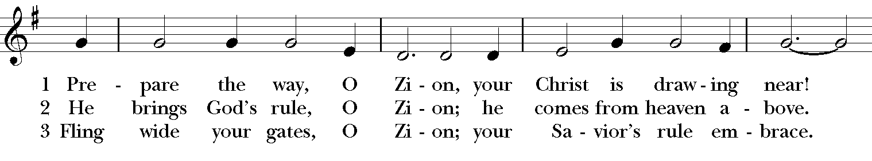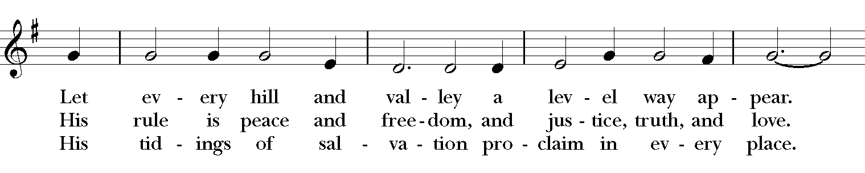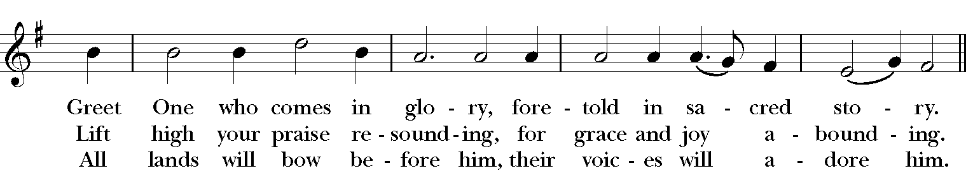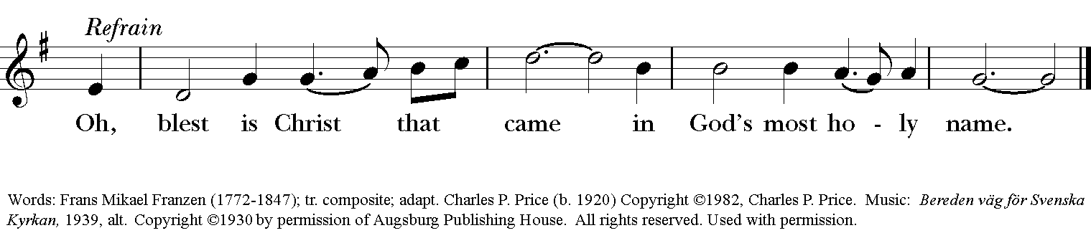

Blessing
May the Sun of Righteousness shine upon you and scatter the darkness from before your path; and the blessing of God Almighty, the Father, the Son, and the Holy Spirit, be among you, and remain with you always. Amen.”

Announcements

Dismissal
Deacon: Go in peace to love and serve the Lord.
People: Thanks be to God!
Postlude:
Thank you for your spiritual presence with us this morning!
Although we're physically apart, we are united in prayer, worship, and holy love!
Priest-In-Charge: The Rev. Dr. Canon Lee Anne Reat
Deacon: The Rev. Dr. Rick Incorvati
Music Director: Dr. Chris Durrenberger
Lector: Diane Rode
Singers: Liz Wheeler, Joy Carter, Ed Hasecke, Chris Oldstone-Moore
Technology: Steve Ide
Slideshow: Ed Hasecke
Parish Administrator and Program Coordinator: Kelly Zeller
Coffee Hour Host: Fred Bartenstein

