Christ Episcopal Church in Springfield, Ohio
Service of the Word
Last Sunday after Epiphany: February 14th, 2021 at 9 am

Prelude: “My Jesus, I Love Thee” -Gordon/arr. Lloyd Larson

Opening Hymn: “Alleluia, sing to Jesus” Hymn 460
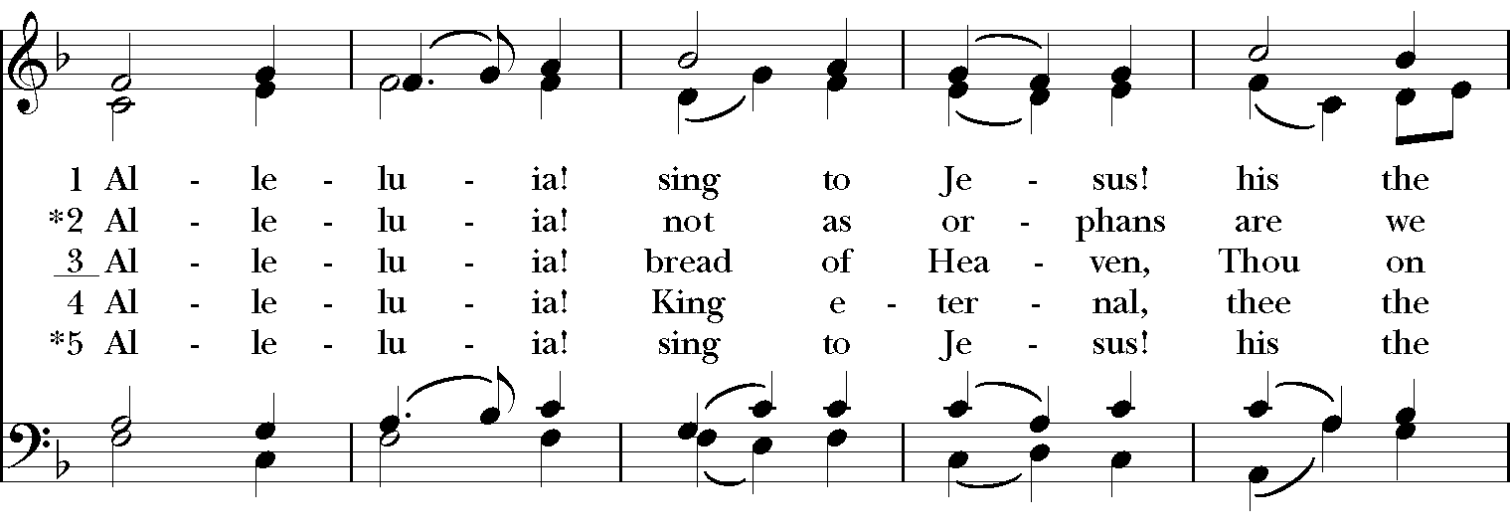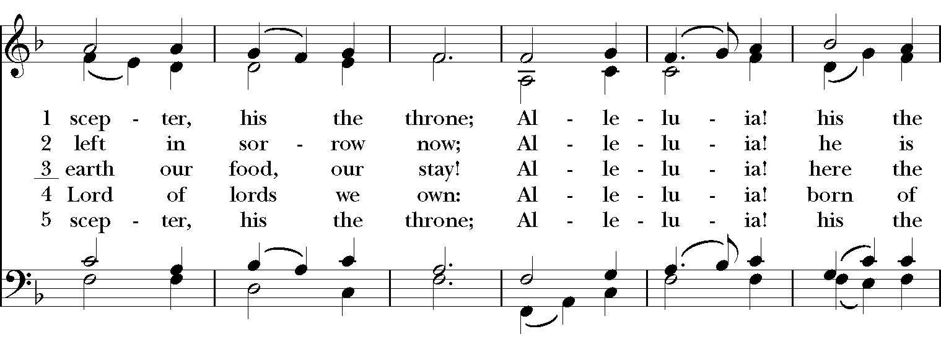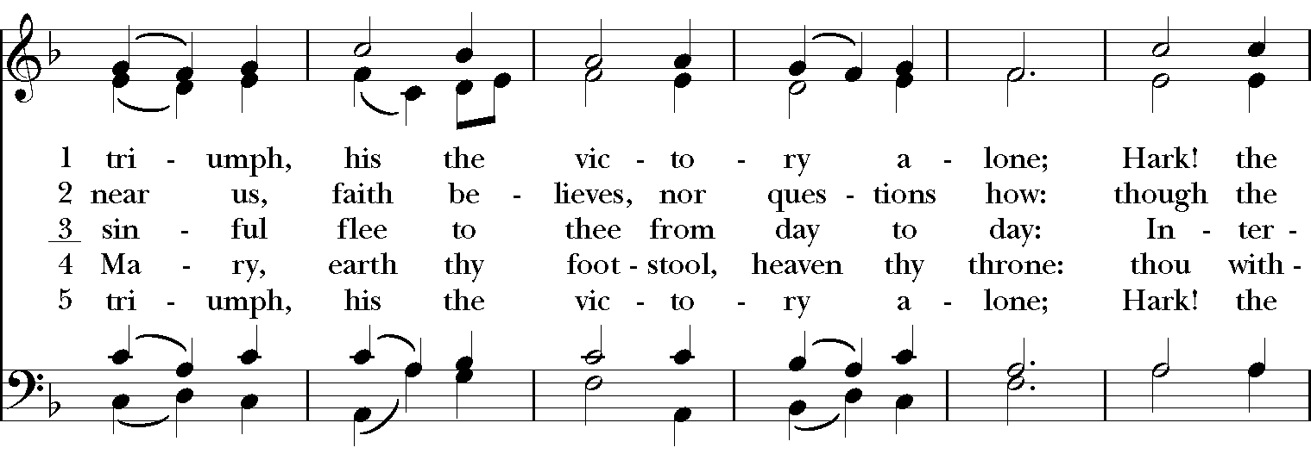

Celebrant: Blessed be God: Father, Son, and Holy Spirit.
People: And blessed be God’s kingdom, now and for ever. Amen.
Celebrant: Lord, have mercy.
People: Christ, have mercy.
Celebrant: Lord, have mercy.

The Collect of the Day
Celebrant: The Lord be with you.
People: And also with you.
Celebrant: Let us pray.
O God, who before the passion of your only-begotten Son revealed his glory upon the holy mountain: Grant to us that we, beholding by faith the light of his countenance, may be strengthened to bear our cross, and be changed into his likeness from glory to glory; through Jesus Christ our Lord, who lives and reigns with you and the Holy Spirit, one God, for ever and ever. Amen.

The Lessons
The First Reading: 2 Kings 2:1-12
When the Lord was about to take Elijah up to heaven by a whirlwind, Elijah and Elisha were on their way from Gilgal. Elijah said to Elisha, “Stay here; for the Lord has sent me as far as Bethel.” But Elisha said, “As the Lord lives, and as you yourself live, I will not leave you.” So they went down to Bethel. The company of prophets who were in Bethel came out to Elisha, and said to him, “Do you know that today the Lord will take your master away from you?” And he said, “Yes, I know; keep silent.”
Elijah said to him, “Elisha, stay here; for the Lord has sent me to Jericho.” But he said, “As the Lord lives, and as you yourself live, I will not leave you.” So they came to Jericho. The company of prophets who were at Jericho drew near to Elisha, and said to him, “Do you know that today the Lord will take your master away from you?” And he answered, “Yes, I know; be silent.”
Then Elijah said to him, “Stay here; for the Lord has sent me to the Jordan.” But he said, “As the Lord lives, and as you yourself live, I will not leave you.” So the two of them went on. Fifty men of the company of prophets also went, and stood at some distance from them, as they both were standing by the Jordan. Then Elijah took his mantle and rolled it up, and struck the water; the water was parted to the one side and to the other, until the two of them crossed on dry ground.
When they had crossed, Elijah said to Elisha, “Tell me what I may do for you, before I am taken from you.” Elisha said, “Please let me inherit a double share of your spirit.” He responded, “You have asked a hard thing; yet, if you see me as I am being taken from you, it will be granted you; if not, it will not.” As they continued walking and talking, a chariot of fire and horses of fire separated the two of them, and Elijah ascended in a whirlwind into heaven. Elisha kept watching and crying out, “Father, father! The chariots of Israel and its horsemen!” But when he could no longer see him, he grasped his own clothes and tore them in two pieces.
Reader: The Word of the Lord.
People: Thanks be to God.

Psalm 50:1-6 Deus deorum
1 The Lord, the God of gods, has spoken; *
he has called the earth from the rising of the sun to its setting.
2 Out of Zion, perfect in its beauty, *
God reveals himself in glory.
3 Our God will come and will not keep silence; *
before him there is a consuming flame, and round about him a raging storm.
4 He calls the heavens and the earth from above *
to witness the judgment of his people.
5 "Gather before me my loyal followers, *
those who have made a covenant with me and sealed it with sacrifice."
6 Let the heavens declare the rightness of his cause; *
for God himself is judge.

Second Lesson: 2 Corinthians 4:3-6
Even if our gospel is veiled, it is veiled to those who are perishing. In their case the god of this world has blinded the minds of the unbelievers, to keep them from seeing the light of the gospel of the glory of Christ, who is the image of God. For we do not proclaim ourselves; we proclaim Jesus Christ as Lord and ourselves as your slaves for Jesus’ sake. For it is the God who said, “Let light shine out of darkness,” who has shone in our hearts to give the light of the knowledge of the glory of God in the face of Jesus Christ.
Reader: The Word of the Lord.
People: Thanks be to God.
Sequence Hymn: “I have decided to follow Jesus” Hymnal LEVAS II 136
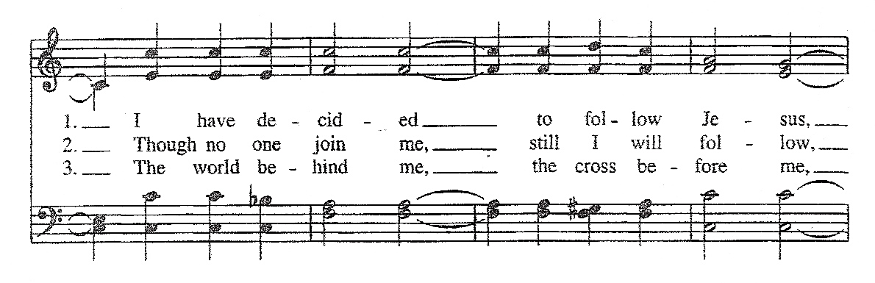
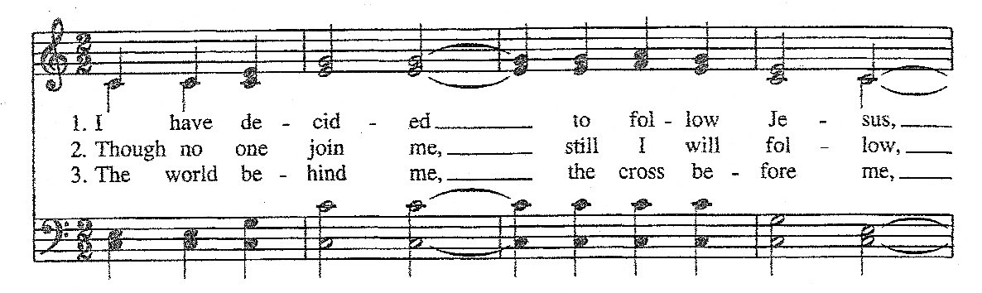

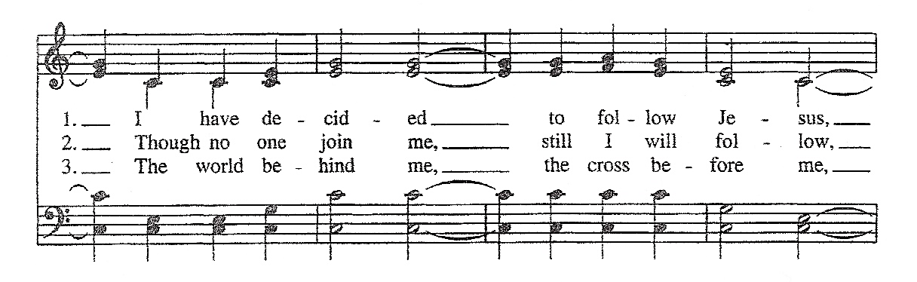

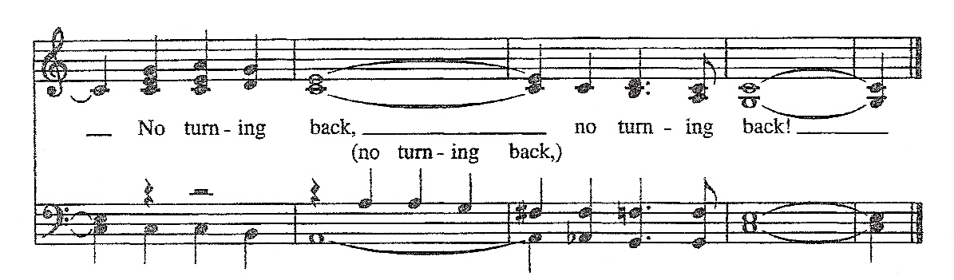

Gospel
Deacon: The Holy Gospel According to Mark (9:2-9)
People: Glory to you, Lord Christ
Jesus took with him Peter and James and John, and led them up a high mountain apart, by themselves. And he was transfigured before them, and his clothes became dazzling white, such as no one on earth could bleach them. And there appeared to them Elijah with Moses, who were talking with Jesus. Then Peter said to Jesus, “Rabbi, it is good for us to be here; let us make three dwellings, one for you, one for Moses, and one for Elijah.” He did not know what to say, for they were terrified. Then a cloud overshadowed them, and from the cloud there came a voice, “This is my Son, the Beloved; listen to him!” Suddenly when they looked around, they saw no one with them any more, but only Jesus.
As they were coming down the mountain, he ordered them to tell no one about what they had seen, until after the Son of Man had risen from the dead.
Deacon: The Gospel of the Lord.
People: Praise to you, Lord Christ.

Sermon The Rev. Canon Dr. Lee Anne Reat

The Nicene Creed
We believe in one God,
the Father, the Almighty,
the maker of heaven and earth,
of all that is, seen and unseen.
We believe in one Lord, Jesus Christ,
the only Son of God,
eternally begotten of the Father,
God from God, Light from Light,
true God from true God,
begotten, not made,
of one Being with the Father.
Through him all things were made.
For us and for our salvation
he came down from heaven:
by the power of the Holy Spirit
he became incarnate from the Virgin Mary,
and was made man.
For our sake he was crucified under Pontius Pilate;
he suffered death and was buried.
On the third day he rose again
in accordance with the Scriptures;
He ascended into heaven
and is seated on the right hand of the Father.
He will come again in glory to judge the living and the dead,
and his kingdom will have no end.
We believe in the Holy Spirit, the Lord, the giver of life,
who proceeds from the Father and the Son.
With the Father and the Son he is worshiped and glorified.
He has spoken through the Prophets.
We believe in one holy catholic and apostolic Church.
We acknowledge one baptism for the forgiveness of sins.
We look for the resurrection of the dead,
and the life of the world to come. Amen.

The Prayers of the People

In peace, we pray to you Lord God.

Silence

Dear Jesus, you came to bring light and love into the world. Your light shines in the darkness of these winter days and nights. May we also shine brightly.

Light of the World, we ask your light upon the Church and its servants. Enlighten Justin, Archbishop of Canterbury; Michael, our Presiding Bishop; Ken, our Bishop; Lee Anne, our priest; and Rick, our deacon. Grant light to each member and guest of this parish. Grant special light to those celebrating birthdays this week especially, Chris, David, and Charlene, and anniversaries this week especially, Fred and Babs.
May your light be reflected in the Church’s mission and unity.

Light of Life, we pray for your light to shine on the nations of the world and their leaders. Enlighten our president, members of Congress, and local authorities. Give them hearts for justice and peace.
May your light be reflected in the governments of our world.

Light of the World, you have called us to be salt and light in our broken world. Enlighten us in our service and our various ministries, especially Clark County Literacy Coalition, Episcopal Community Ministries, Second Harvest Food Bank, and Interfaith Hospitality Network.
May your light be reflected in our works of mercy.

Light of Life, your grace shines in our times of sickness and trouble. Shine on those who suffer in body, mind, or spirit, especially Faye, Chris, Laura, Bonnie, Alice, Diana, James, Joy, Jane, Joni, Kim, Bobby, Sarah, Traudie, Lexie, and Keith.
May your light be reflected in our seasons of pain and difficulty.

Light of the World, you shine in the darkness, and the darkness does not overcome your light. We pray for that eternal light to shine on all who have died and to ease the grief of those who mourn their departing.
May your light be reflected in our loss and grief.

*THE COLLECT FOR PEACE
Grant, O God, that your holy and life-giving Spirit may so move every human heart, that barriers which divide us may crumble, suspicions disappear, and hatreds cease; that our divisions being healed, we may live in justice and peace; through Jesus Christ our Lord. Amen.

Deacon: Let us confess our sins against God and our neighbor.
All: Most merciful God, we confess that we have sinned against you in thought, word, and deed, by what we have done, and by what we have left undone. We have not loved you with our whole heart; we have not loved our neighbors as ourselves. We are truly sorry and we humbly repent. For the sake of your Son Jesus Christ, have mercy on us and forgive us; that we may delight in your will, and walk in your ways, to the glory of your Name. Amen.

Priest: Almighty God, have mercy on you, forgive you all your sins through our Lord Jesus Christ, strengthen you in all goodness, and by the power of the Holy Spirit keep you in eternal life. Amen.

And now, as our Savior Christ has taught us, we are bold to say:
Our Father, who art in heaven, hallowed be thy Name,
thy kingdom come, thy will be done, on earth as it is in heaven.
Give us this day our daily bread.
And forgive us our trespasses, as we forgive those who trespass against us.
And lead us not into temptation, but deliver us from evil.
For thine is the kingdom, and the power, and the glory, for ever and ever. Amen.

Closing Hymn: “Ye watchers and ye Holy ones” Hymnal 618
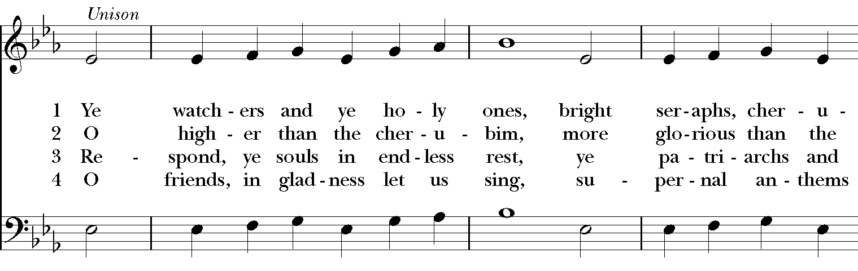
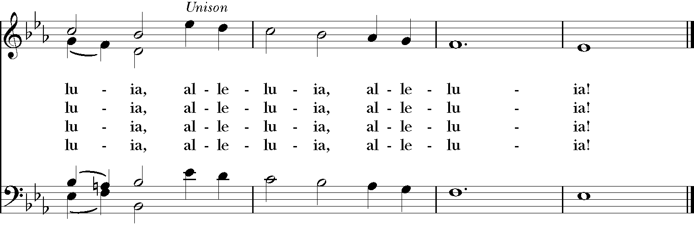
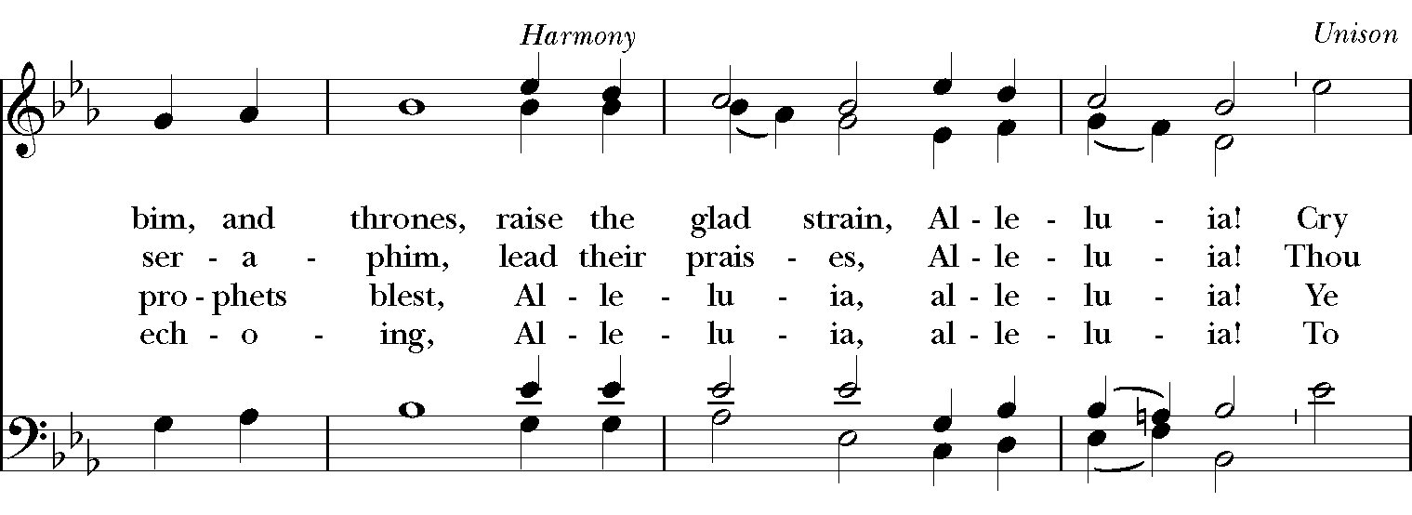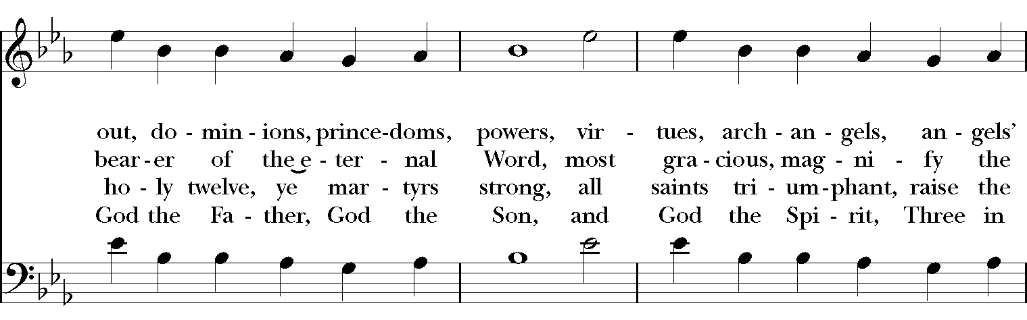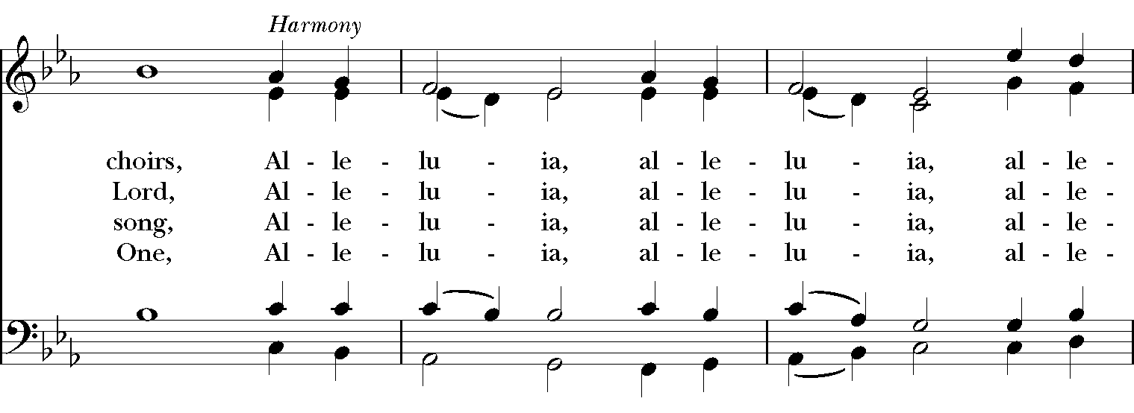

Blessing
May Christ, the Son of God, be manifest in you, that your lives may be a light to the world; and the blessing of God Almighty, the Father, the Son and the Holy Spirit, be among you and remain with you always. Amen
Announcements

Dismissal
Deacon: Go in peace to love and serve the Lord.
People: Thanks be to God!

Postlude: “The Glory of God in Nature” -Beethoven

Thank you for your spiritual presence with us this morning!
Although we're physically apart, we are united in prayer, worship, and holy love!
Priest-In-Charge: The Rev. Dr. Canon Lee Anne Reat
Deacon: The Rev. Dr. Rick Incorvati
Music Director: Dr. Chris Durrenberger
Lector: Liz Wheeler
Singers: Liz Wheeler, Joy Carter, Ed Hasecke, Fred Bartenstein
Technology: Steve Ide
Slideshow: Ed Hasecke
Parish Administrator and Program Coordinator: Kelly Zeller
Coffee Hour Host: Linda Mortensen

