Christ Episcopal Church in Springfield, Ohio
Service of the Word
First Sunday in Lent: February 21st, 2021 at 9 am

Prelude: Improvisation on “Pange Lingua” - Plainsong, Mode 3/arr. Callahan

Opening Hymn: “Forty days and forty nights” Hymn 150
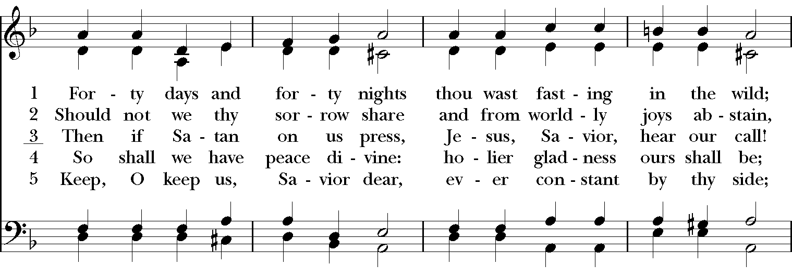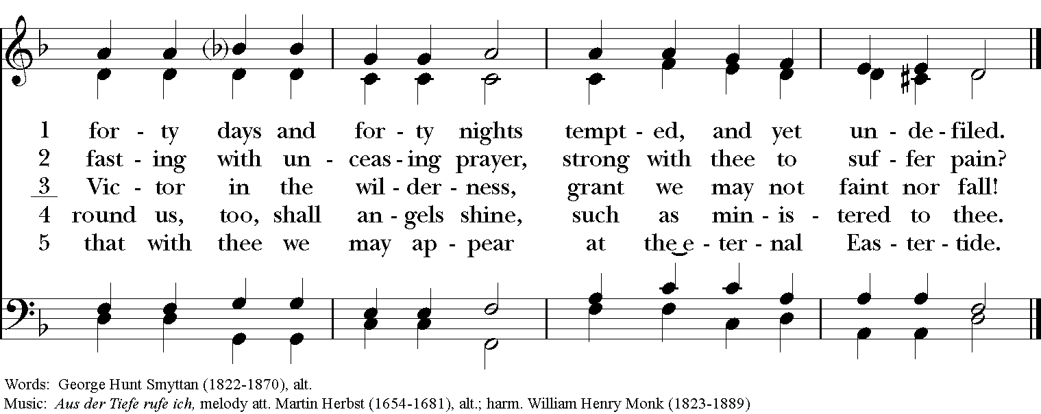

Celebrant: Bless the Lord who forgives all our sins;
People: His mercy endures for ever.
Celebrant: Lord, have mercy.
People: Christ, have mercy.
Celebrant: Lord, have mercy.

The Collect of the Day
Celebrant: The Lord be with you.
People: And also with you.
Celebrant: Let us pray.
Almighty God, whose blessed Son was led by the Spirit to be tempted by Satan: Come quickly to help us who are assaulted by many temptations; and, as you know the weaknesses of each of us, let each one find you mighty to save; through Jesus Christ your Son our Lord, who lives and reigns with you and the Holy Spirit, one God, now and for ever. Amen.

The Lessons

The First Reading: Genesis 9:8-17
God said to Noah and to his sons with him, “As for me, I am establishing my covenant with you and your descendants after you, and with every living creature that is with you, the birds, the domestic animals, and every animal of the earth with you, as many as came out of the ark. I establish my covenant with you, that never again shall all flesh be cut off by the waters of a flood, and never again shall there be a flood to destroy the earth.” God said, “This is the sign of the covenant that I make between me and you and every living creature that is with you, for all future generations: I have set my bow in the clouds, and it shall be a sign of the covenant between me and the earth. When I bring clouds over the earth and the bow is seen in the clouds, I will remember my covenant that is between me and you and every living creature of all flesh; and the waters shall never again become a flood to destroy all flesh. When the bow is in the clouds, I will see it and remember the everlasting covenant between God and every living creature of all flesh that is on the earth.” God said to Noah, “This is the sign of the covenant that I have established between me and all flesh that is on the earth.”
Reader: The Word of the Lord.
People: Thanks be to God.

Psalm 25:1-9 Ad te, Domine, levavi

1 To you, O Lord, I lift up my soul; my God, I put my trust in you; *
let me not be humiliated, nor let my enemies triumph over me.
2 Let none who look to you be put to shame; *
let the treacherous be disappointed in their schemes.
3 Show me your ways, O Lord, *
and teach me your paths.
4 Lead me in your truth and teach me, *
for you are the God of my salvation; in you have I trusted all the day long.
5 Remember, O Lord, your compassion and love, *
for they are from everlasting.
6 Remember not the sins of my youth and my transgressions; *
remember me according to your love and for the sake of your goodness, O Lord.
7 Gracious and upright is the Lord; *
therefore he teaches sinners in his way.
8 He guides the humble in doing right *
and teaches his way to the lowly.
9 All the paths of the Lord are love and faithfulness *
to those who keep his covenant and his testimonies.

Second Lesson: 1 Peter 3:18-22
Christ also suffered for sins once for all, the righteous for the unrighteous, in order to bring you to God. He was put to death in the flesh, but made alive in the spirit, in which also he went and made a proclamation to the spirits in prison, who in former times did not obey, when God waited patiently in the days of Noah, during the building of the ark, in which a few, that is, eight persons, were saved through water. And baptism, which this prefigured, now saves you-- not as a removal of dirt from the body, but as an appeal to God for a good conscience, through the resurrection of Jesus Christ, who has gone into heaven and is at the right hand of God, with angels, authorities, and powers made subject to him.
Reader: The Word of the Lord.
People: Thanks be to God.
Sequence Hymn: “Precious Lord, take my hand” Hymnal LEVAS II 106
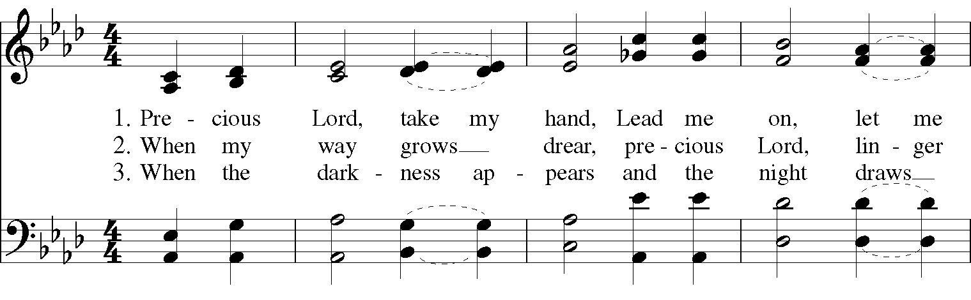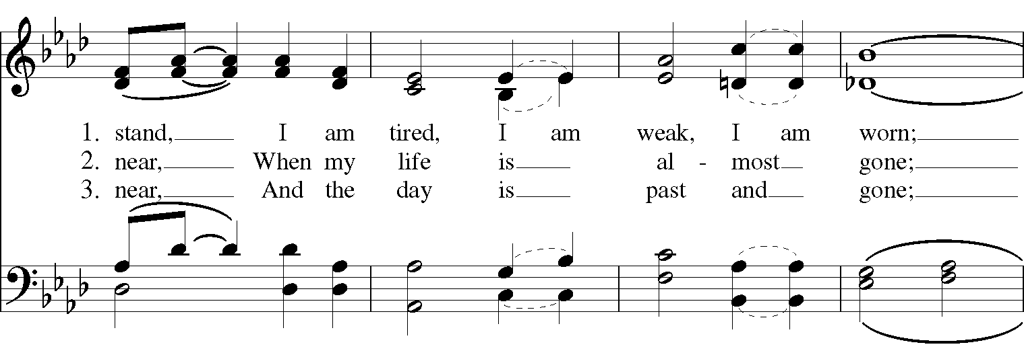
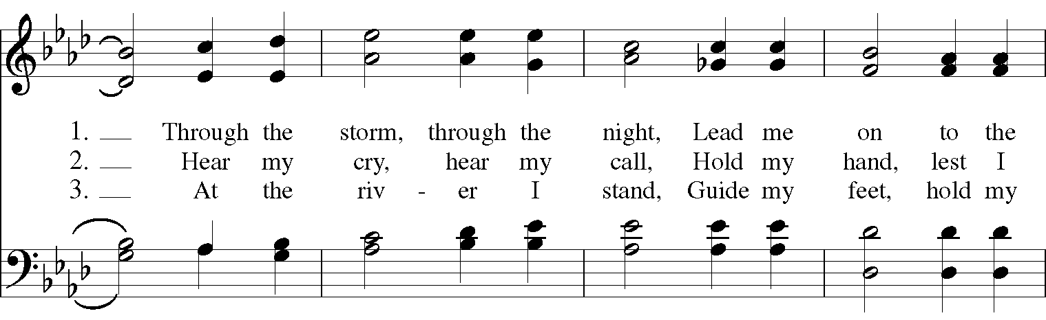

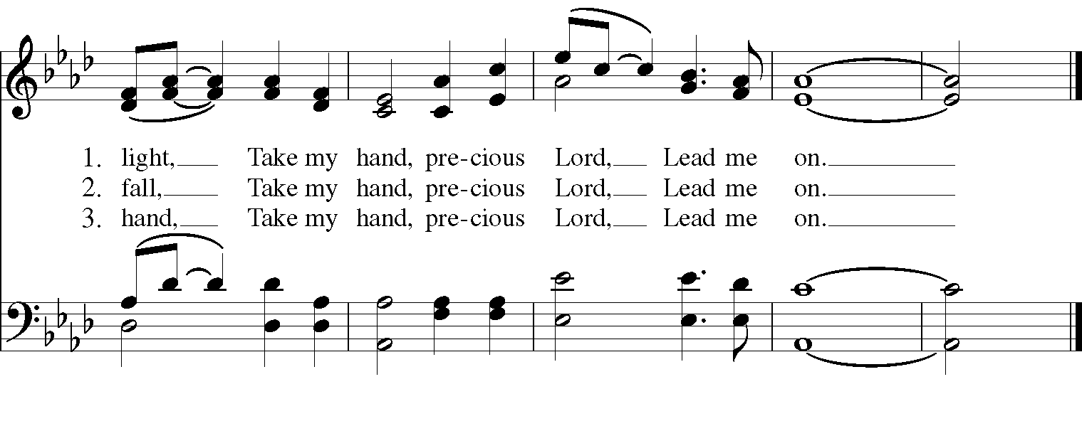
Gospel
Deacon: The Holy Gospel According to Mark (1:9-15)
People: Glory to you, Lord Christ.
In those days Jesus came from Nazareth of Galilee and was baptized by John in the Jordan. And just as he was coming up out of the water, he saw the heavens torn apart and the Spirit descending like a dove on him. And a voice came from heaven, “You are my Son, the Beloved; with you I am well pleased.”

And the Spirit immediately drove him out into the wilderness. He was in the wilderness forty days, tempted by Satan; and he was with the wild beasts; and the angels waited on him.
Now after John was arrested, Jesus came to Galilee, proclaiming the good news of God, and saying, “The time is fulfilled, and the kingdom of God has come near; repent, and believe in the good news.”
Deacon: The Gospel of the Lord.
People: Praise to you, Lord Christ.

Sermon The Rev. Canon Dr. Lee Anne Reat

The Nicene Creed
We believe in one God,
the Father, the Almighty,
the maker of heaven and earth,
of all that is, seen and unseen.
We believe in one Lord, Jesus Christ,
the only Son of God,
eternally begotten of the Father,
God from God, Light from Light,
true God from true God,
begotten, not made,
of one Being with the Father.
Through him all things were made.
For us and for our salvation
he came down from heaven:
by the power of the Holy Spirit
he became incarnate from the Virgin Mary,
and was made man.
For our sake he was crucified under Pontius Pilate;
he suffered death and was buried.
On the third day he rose again
in accordance with the Scriptures;
He ascended into heaven
and is seated on the right hand of the Father.
He will come again in glory to judge the living and the dead,
and his kingdom will have no end.
We believe in the Holy Spirit, the Lord, the giver of life,
who proceeds from the Father and the Son.
With the Father and the Son he is worshiped and glorified.
He has spoken through the Prophets.
We believe in one holy catholic and apostolic Church.
We acknowledge one baptism for the forgiveness of sins.
We look for the resurrection of the dead,
and the life of the world to come. Amen.

The Prayers of the People

In peace, we pray to you Lord God.

Silence

Let us offer prayers to God who has made us a new creation in Christ, saying "Lord, have mercy."

For this parish community, that we may grow in holiness together as we prepare for the Paschal season.
Lord, have mercy.

For Justin, Archbishop of Canterbury; Michael, our Presiding Bishop; Ken, our Diocesan Bishop; Lee Anne, our priest; Rick, our deacon; and all who minister in Christ, that they may be firmly rooted in your truth and love.
Lord, have mercy.

For all the peoples of the earth and for their leaders, that we may move ever closer to your holy reign of peace, dignity, and abundant life for all.
Lord, have mercy.

For the holy work being done through and around us, in ministries such as Springfield Farmer’s Market, Project Woman, Children’s Defense Fund Freedom School, The YMCA, and Jefferson St. Oasis Garden, that fruits of love and mercy may be borne continually.
Lord, have mercy.

For all who are sick, afflicted, oppressed, or in need, especially Faye, Chris, Laura, Bonnie, Alice, Diana, James, Joy, Jane, Joni, Kim, Bobby, Sarah, Traudie, Lexie, and Keith, that they may be upheld by your Spirit and restored to wholeness.
Lord, have mercy.

For those celebrating birthdays and anniversaries, especially Nancy, Heather, and Judy; Denny & Sharon, Mark & Judy that they may rejoice always in you.
Lord, have mercy.

For those who have fallen asleep in Christ, for all the departed, and for those who grieve.
Lord, have mercy.

*THE COLLECT FOR PEACE
Grant, O God, that your holy and life-giving Spirit may so move every human heart, that barriers which divide us may crumble, suspicions disappear, and hatreds cease; that our divisions being healed, we may live in justice and peace; through Jesus Christ our Lord. Amen.

Deacon: Let us confess our sins against God and our neighbor.
All: Most merciful God, we confess that we have sinned against you in thought, word, and deed, by what we have done, and by what we have left undone. We have not loved you with our whole heart; we have not loved our neighbors as ourselves. We are truly sorry and we humbly repent. For the sake of your Son Jesus Christ, have mercy on us and forgive us; that we may delight in your will, and walk in your ways, to the glory of your Name. Amen.

Priest: Almighty God, have mercy on you, forgive you all your sins through our Lord Jesus Christ, strengthen you in all goodness, and by the power of the Holy Spirit keep you in eternal life. Amen.

And now, as our Savior Christ has taught us, we are bold to say:
Our Father, who art in heaven, hallowed be thy Name,
thy kingdom come, thy will be done, on earth as it is in heaven.
Give us this day our daily bread.
And forgive us our trespasses, as we forgive those who trespass against us.
And lead us not into temptation, but deliver us from evil.
For thine is the kingdom, and the power, and the glory, for ever and ever. Amen.

Closing Hymn: “O love, how deep, how broad, how high” Hymnal 448 vs. 1-3
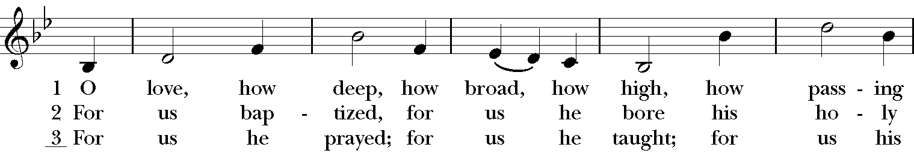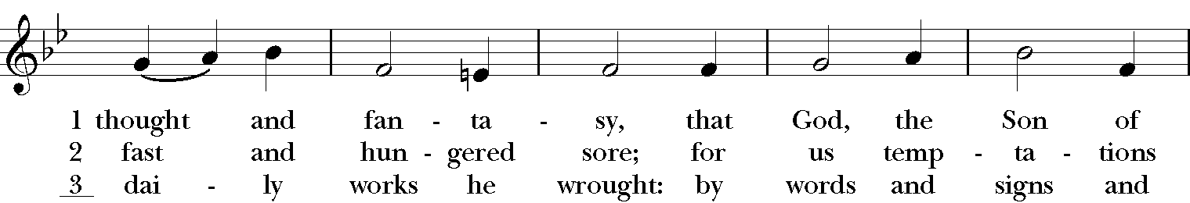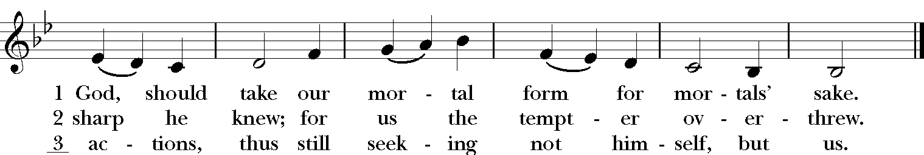

Blessing
Grant, Almighty God, that your people may recognize their weakness and put their whole trust in your strength, so that they may rejoice for ever in the protection of your loving providence; through Christ our Lord, and the blessing of God Almighty, the Father, the Son and the Holy Spirit, be among you and remain with you always. Amen.

Announcements

Dismissal
Deacon: Go in peace to love and serve the Lord.
People: Thanks be to God!

Postlude: Gymnopédie #1 - Erik Satie

Thank you for your spiritual presence with us this morning!
Although we're physically apart, we are united in prayer, worship, and holy love!
Priest-In-Charge: The Rev. Dr. Canon Lee Anne Reat
Deacon: The Rev. Dr. Rick Incorvati
Music Director: Dr. Chris Durrenberger
Lector: Anne Strothman
Singers: Liz Wheeler, Joy Carter, Ed Hasecke, Chris Oldstone-Moore
Technology: Steve Ide
Slideshow: Ed Hasecke
Parish Administrator and Program Coordinator: Kelly Zeller
Coffee Hour Host: Ron Dowling

