Christ Episcopal Church in Springfield, Ohio
Service of the Word
Second Sunday in Lent: February 28th, 2021 at 9 am

Prelude: Meditation on “Hamburg” - Mason/arr. Callahan

Opening Hymn: “When I survey the Wondrous Cross” Hymn 474
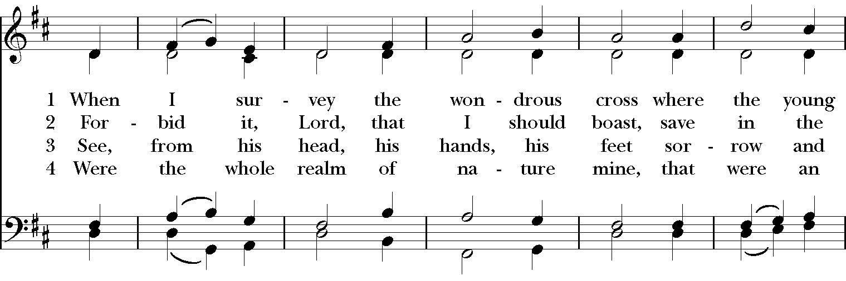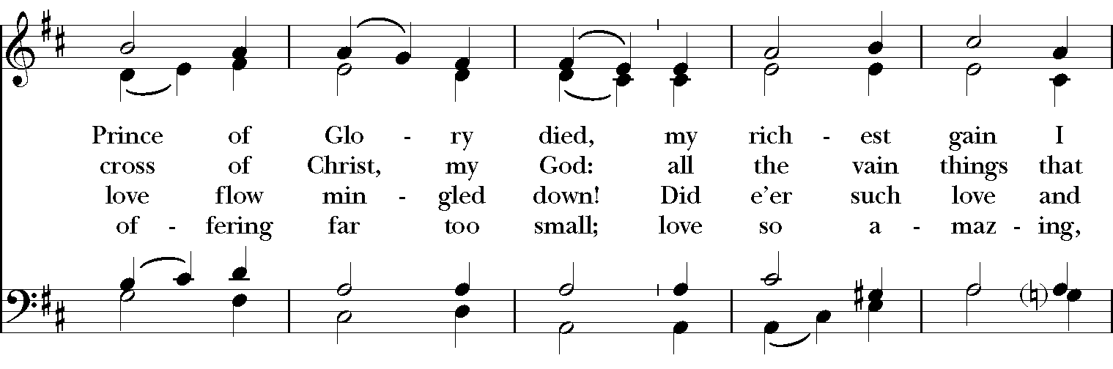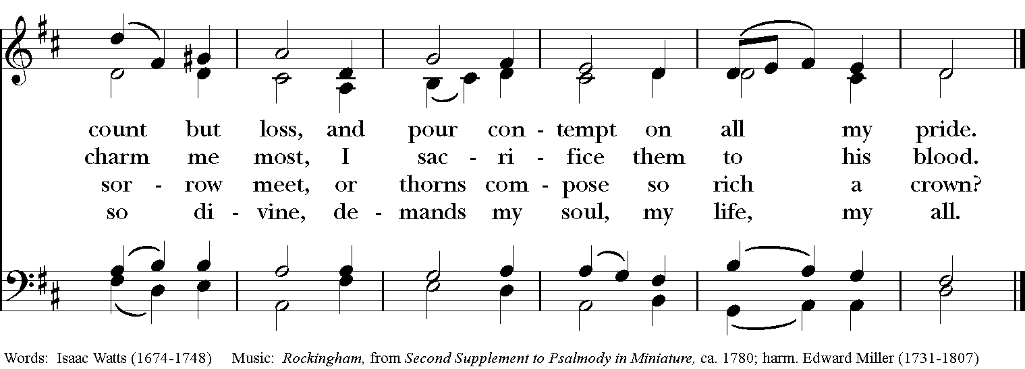

Celebrant: Bless the Lord who forgives all our sins;
People: His mercy endures for ever.
Celebrant: Lord, have mercy.
People: Christ, have mercy.
Celebrant: Lord, have mercy.

The Collect of the Day
Celebrant: The Lord be with you.
People: And also with you.
Celebrant: Let us pray.
O God, whose glory it is always to have mercy: Be gracious to all who have gone astray from your ways, and bring them again with penitent hearts and steadfast faith to embrace and hold fast the unchangeable truth of your Word, Jesus Christ your Son; who with you and the Holy Spirit lives and reigns, one God, for ever and ever. Amen.

The Lessons

The First Reading: Genesis 17:1-7, 15-16
When Abram was ninety-nine years old, the Lord appeared to Abram, and said to him, “I am God Almighty; walk before me, and be blameless. And I will make my covenant between me and you, and will make you exceedingly numerous.” Then Abram fell on his face; and God said to him, “As for me, this is my covenant with you: You shall be the ancestor of a multitude of nations. No longer shall your name be Abram, but your name shall be Abraham; for I have made you the ancestor of a multitude of nations. I will make you exceedingly fruitful; and I will make nations of you, and kings shall come from you. I will establish my covenant between me and you, and your offspring after you throughout their generations, for an everlasting covenant, to be God to you and to your offspring after you.

God said to Abraham, “As for Sarai your wife, you shall not call her Sarai, but Sarah shall be her name. I will bless her, and moreover I will give you a son by her. I will bless her, and she shall give rise to nations; kings of peoples shall come from her.”
Reader: The Word of the Lord.
People: Thanks be to God.

Psalm 22:22-30 Deus, Deus meus

22 Praise the Lord, you that fear him; *
stand in awe of him, O offspring of Israel; all you of Jacob's line, give glory.
23 For he does not despise nor abhor the poor in their poverty;
neither does he hide his face from them; *
but when they cry to him he hears them.
24 My praise is of him in the great assembly; *
I will perform my vows in the presence of those who worship him.
25 The poor shall eat and be satisfied, and those who seek the Lord shall praise him: *
"May your heart live for ever!"
26 All the ends of the earth shall remember and turn to the Lord, *
and all the families of the nations shall bow before him.
27 For kingship belongs to the Lord; *
he rules over the nations.
28 To him alone all who sleep in the earth bow down in worship; *
all who go down to the dust fall before him.
29 My soul shall live for him; my descendants shall serve him; *
they shall be known as the Lord's for ever.
30 They shall come and make known to a people yet unborn *
the saving deeds that he has done.

Second Lesson: Romans 4:13-25
For the promise that he would inherit the world did not come to Abraham or to his descendants through the law but through the righteousness of faith. If it is the adherents of the law who are to be the heirs, faith is null and the promise is void. For the law brings wrath; but where there is no law, neither is there violation.
For this reason it depends on faith, in order that the promise may rest on grace and be guaranteed to all his descendants, not only to the adherents of the law but also to those who share the faith of Abraham (for he is the father of all of us, as it is written, “I have made you the father of many nations”) —in the presence of the God in whom he believed, who gives life to the dead and calls into existence the things that do not exist. Hoping against hope, he believed that he would become “the father of many nations,” according to what was said, “So numerous shall your descendants be.” He did not weaken in faith when he considered his own body, which was already as good as dead (for he was about a hundred years old), or when he considered the barrenness of Sarah’s womb. No distrust made him waver concerning the promise of God, but he grew strong in his faith as he gave glory to God, being fully convinced that God was able to do what he had promised. Therefore his faith “was reckoned to him as righteousness.” Now the words, “it was reckoned to him,” were written not for his sake alone, but for ours also. It will be reckoned to us who believe in him who raised Jesus our Lord from the dead, who was handed over to death for our trespasses and was raised for our justification.
Reader: The Word of the Lord.
People: Thanks be to God.
Sequence Hymn: “ If I have wounded any soul today” Hymnal LEVAS II 176
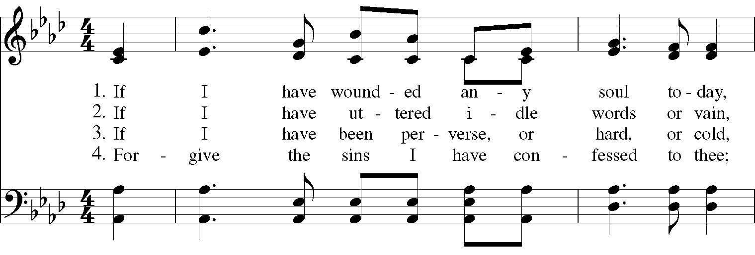

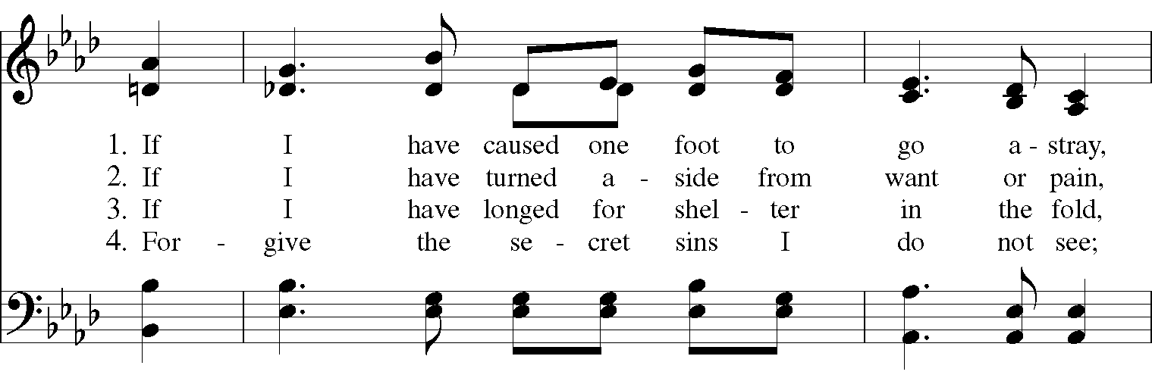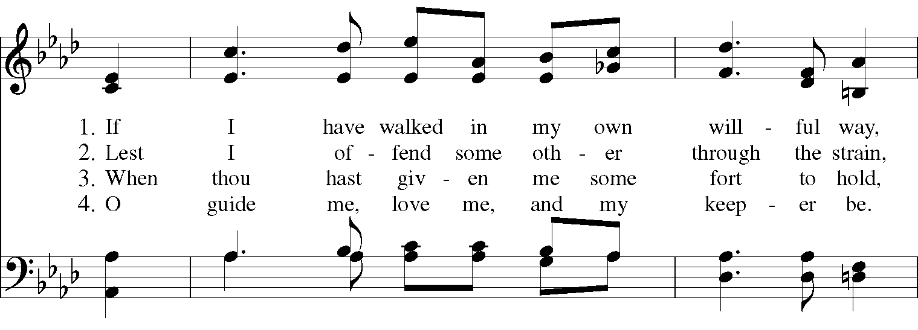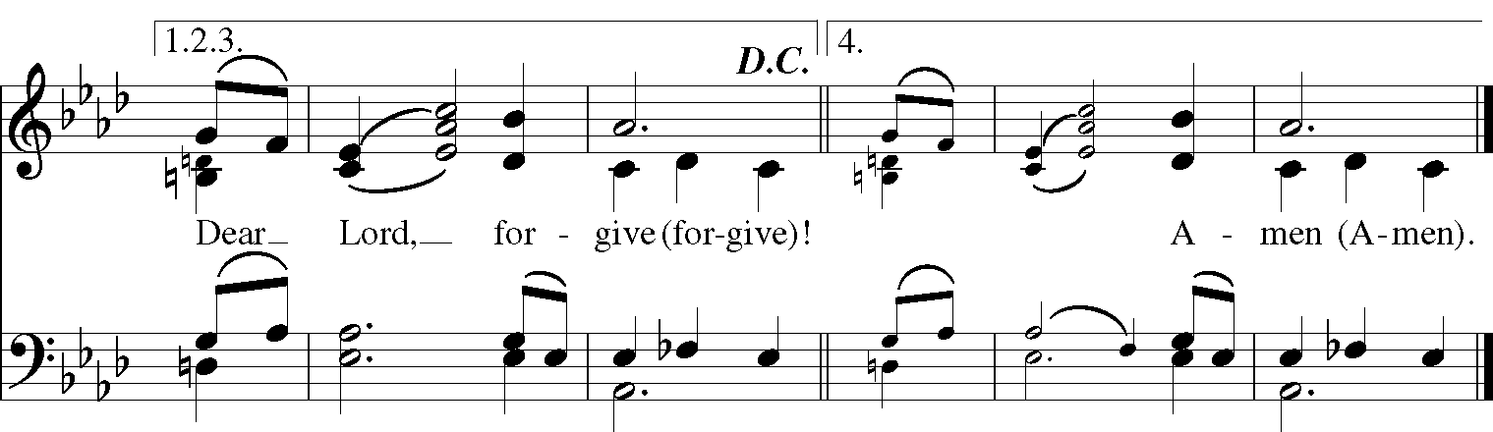
Gospel
Deacon: The Holy Gospel According to Mark (8:31-38)
People: Glory to you, Lord Christ.
Jesus began to teach his disciples that the Son of Man must undergo great suffering, and be rejected by the elders, the chief priests, and the scribes, and be killed, and after three days rise again. He said all this quite openly. And Peter took him aside and began to rebuke him. But turning and looking at his disciples, he rebuked Peter and said, “Get behind me, Satan! For you are setting your mind not on divine things but on human things.”
He called the crowd with his disciples, and said to them, “If any want to become my followers, let them deny themselves and take up their cross and follow me. For those who want to save their life will lose it, and those who lose their life for my sake, and for the sake of the gospel, will save it. For what will it profit them to gain the whole world and forfeit their life? Indeed, what can they give in return for their life? Those who are ashamed of me and of my words in this adulterous and sinful generation, of them the Son of Man will also be ashamed when he comes in the glory of his Father with the holy angels.”
Deacon: The Gospel of the Lord.
People: Praise to you, Lord Christ.
Sermon The Rev. Canon Dr. Lee Anne Reat

The Nicene Creed
We believe in one God,
the Father, the Almighty,
the maker of heaven and earth,
of all that is, seen and unseen.
We believe in one Lord, Jesus Christ,
the only Son of God,
eternally begotten of the Father,
God from God, Light from Light,
true God from true God,
begotten, not made,
of one Being with the Father.
Through him all things were made.
For us and for our salvation
he came down from heaven:
by the power of the Holy Spirit
he became incarnate from the Virgin Mary,
and was made man.
For our sake he was crucified under Pontius Pilate;
he suffered death and was buried.
On the third day he rose again
in accordance with the Scriptures;
He ascended into heaven
and is seated on the right hand of the Father.
He will come again in glory to judge the living and the dead,
and his kingdom will have no end.
We believe in the Holy Spirit, the Lord, the giver of life,
who proceeds from the Father and the Son.
With the Father and the Son he is worshiped and glorified.
He has spoken through the Prophets.
We believe in one holy catholic and apostolic Church.
We acknowledge one baptism for the forgiveness of sins.
We look for the resurrection of the dead,
and the life of the world to come. Amen.

The Prayers of the People

In peace, we pray to you Lord God.

Silence

Let us offer prayers to God who has made us a new creation in Christ, saying "Lord, have mercy."

For this parish community, that we may grow in holiness together as we prepare for the Paschal season.
Lord, have mercy.

For Justin, Archbishop of Canterbury; Michael, our Presiding Bishop; Ken, our Diocesan Bishop; Lee Anne, our priest; Rick, our deacon; and all who minister in Christ, that they may be firmly rooted in your truth and love.
Lord, have mercy.

For all the peoples of the earth and for their leaders, that we may move ever closer to your holy reign of peace, dignity, and abundant life for all.
Lord, have mercy.

For the holy work being done through and around us, in ministries such as Rainbow table, Springfield Promise Neighborhood, Springfield Peace Center, and Partners in Ministry in Liberia, that fruits of love and mercy may be borne continually.
Lord, have mercy.

For all who are sick, afflicted, oppressed, or in need, especially Faye, Chris, Laura, Bonnie, Alice, Diana, James, Joy, Jane, Joni, Kim, Bobby, Sarah, Traudie, Lexie, and Keith, that they may be upheld by your Spirit and restored to wholeness.

Lord, have mercy.
For those celebrating birthdays and anniversaries, especially Alan, Rick, Joann, Keith, Stacy, and Cheryl that they may rejoice always in you.
Lord, have mercy.

For those who have fallen asleep in Christ, for all the departed, and for those who grieve.
Lord, have mercy.

*THE COLLECT FOR PEACE
Grant, O God, that your holy and life-giving Spirit may so move every human heart, that barriers which divide us may crumble, suspicions disappear, and hatreds cease; that our divisions being healed, we may live in justice and peace; through Jesus Christ our Lord. Amen.

Deacon: Let us confess our sins against God and our neighbor.
All: Most merciful God, we confess that we have sinned against you in thought, word, and deed, by what we have done, and by what we have left undone. We have not loved you with our whole heart; we have not loved our neighbors as ourselves. We are truly sorry and we humbly repent. For the sake of your Son Jesus Christ, have mercy on us and forgive us; that we may delight in your will, and walk in your ways, to the glory of your Name. Amen.

Priest: Almighty God, have mercy on you, forgive you all your sins through our Lord Jesus Christ, strengthen you in all goodness, and by the power of the Holy Spirit keep you in eternal life. Amen.

And now, as our Savior Christ has taught us, we are bold to say:
Our Father, who art in heaven, hallowed be thy Name,
thy kingdom come, thy will be done, on earth as it is in heaven.
Give us this day our daily bread.
And forgive us our trespasses, as we forgive those who trespass against us.
And lead us not into temptation, but deliver us from evil.
For thine is the kingdom, and the power, and the glory, for ever and ever. Amen.
Closing Hymn: “At the name of Jesus” Hymnal 435 vs. 1-4
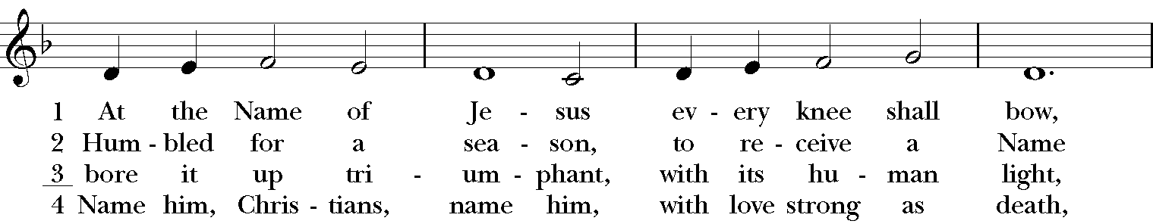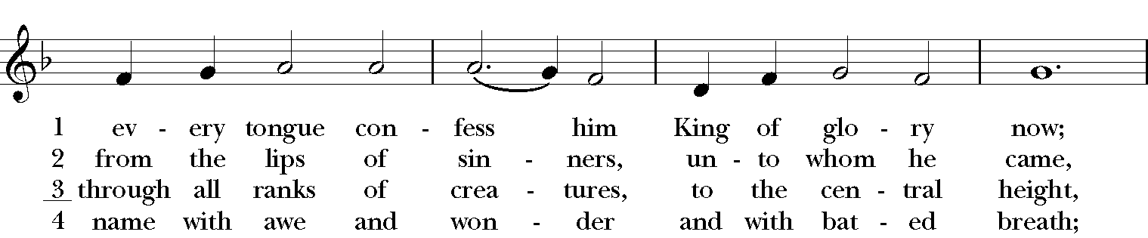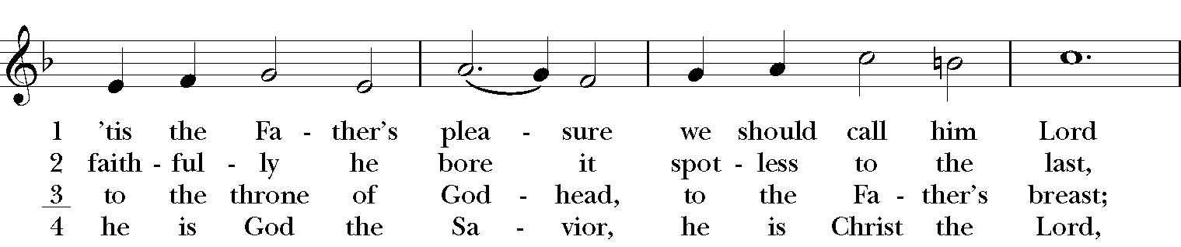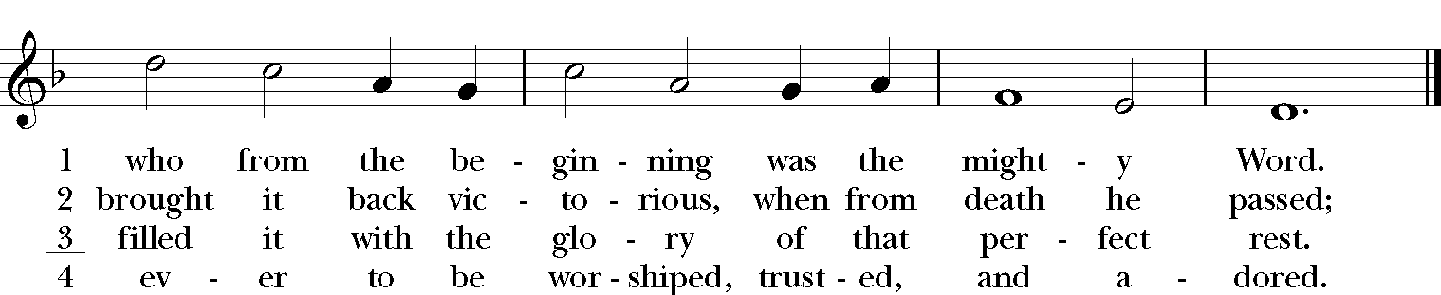

Blessing
Keep this your family, Lord, with your never-failing mercy, that relying solely on the help of your heavenly grace, they may be upheld by your divine protection; through Christ our Lord, and the blessing of God Almighty, the Father, the Son and the Holy Spirit, be among you and remain with you always. Amen.

Announcements

Dismissal
Deacon: Go in peace to love and serve the Lord.
People: Thanks be to God!

Postlude: Gnossienne #2 - Erik Satie

Thank you for your spiritual presence with us this morning!
Although we're physically apart, we are united in prayer, worship, and holy love!
Priest-In-Charge: The Rev. Dr. Canon Lee Anne Reat
Deacon: The Rev. Dr. Rick Incorvati
Music Director: Dr. Chris Durrenberger
Lector: Sarah Schubert
Singers: Liz Wheeler, Joy Carter, Ed Hasecke, Chris Oldstone-Moore
Technology: Steve Ide
Slideshow: Ed Hasecke
Parish Administrator and Program Coordinator: Kelly Zeller
Coffee Hour Host: Fred Bartenstein

