Christ Episcopal Church in Springfield, Ohio
Service of the Word
Fifth Sunday after Epiphany: February 7th, 2021 at 9 am

Prelude: “Do with me as Thy Goodness Prompts Thee” J.S. Bach

Opening Hymn: “O Food to Pilgrims Given” Hymn 309
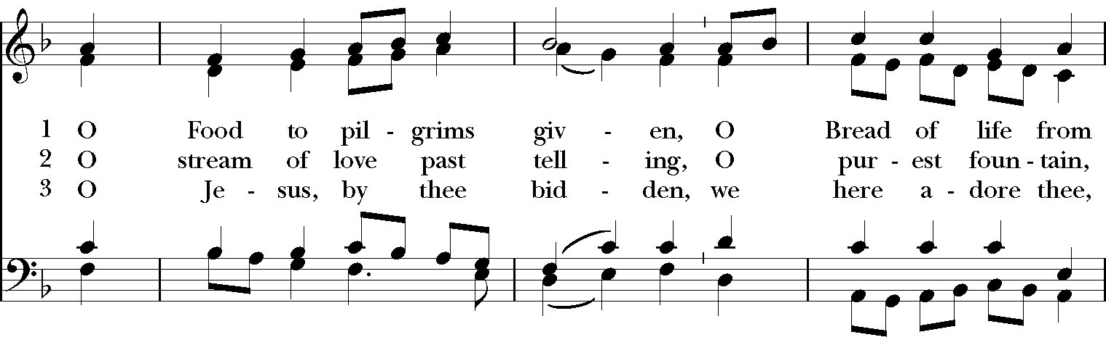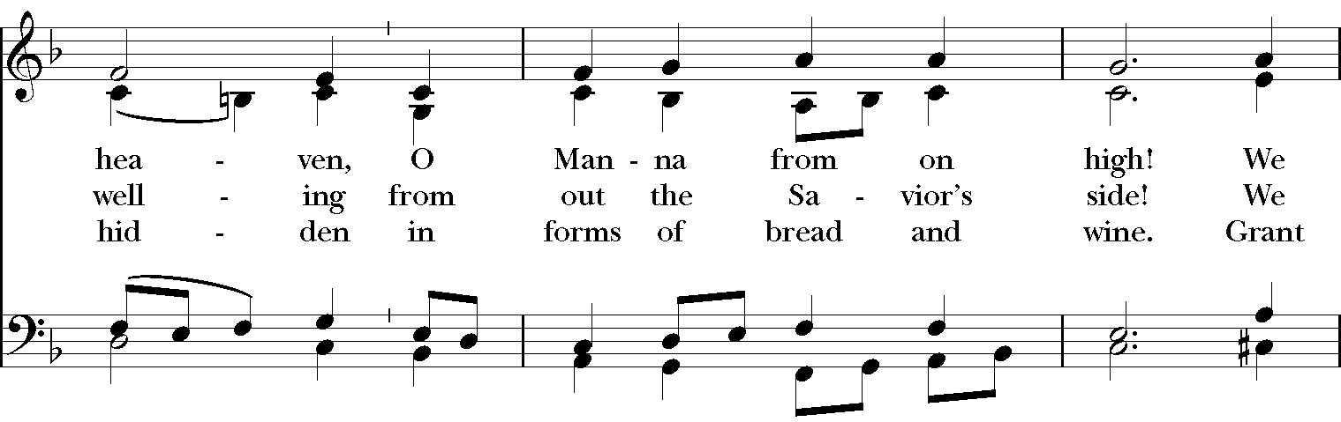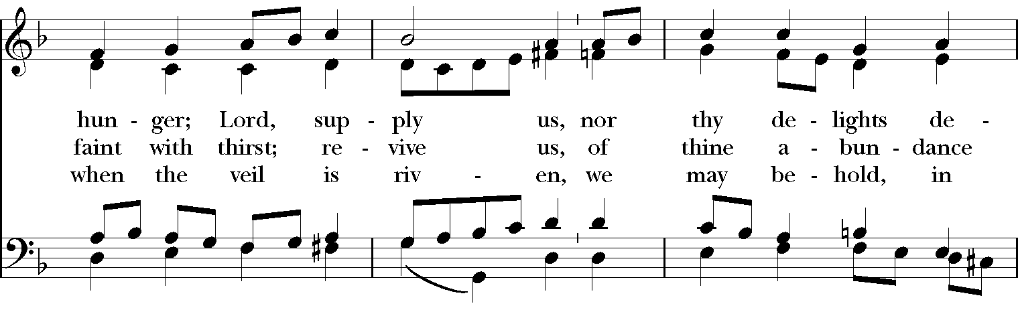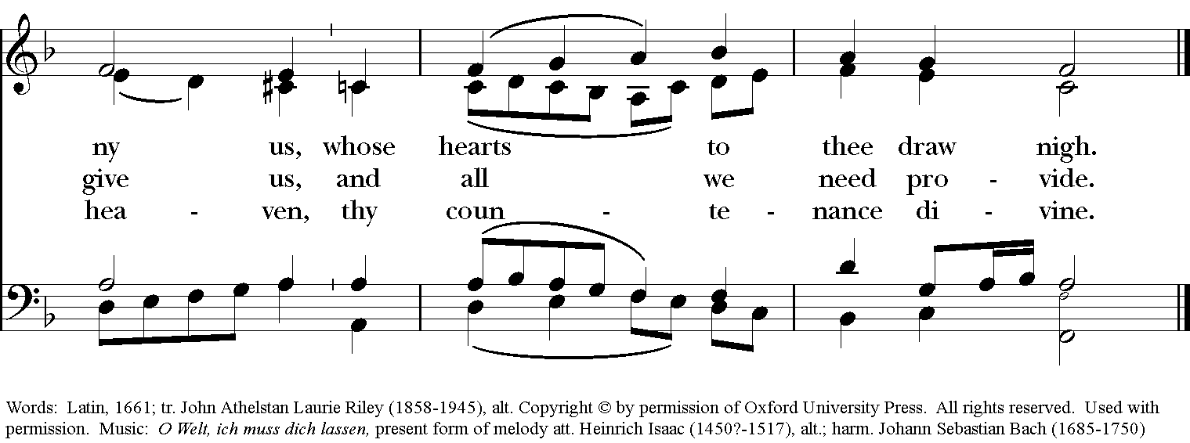

Celebrant: Blessed be God: Father, Son, and Holy Spirit.
People: And blessed be God’s kingdom, now and for ever. Amen.
Celebrant: Lord, have mercy.
People: Christ, have mercy.
Celebrant: Lord, have mercy.

The Collect of the Day
Celebrant: The Lord be with you.
People: And also with you.
Celebrant: Let us pray.
Set us free, O God, from the bondage of our sins, and give us the liberty of that abundant life which you have made known to us in your Son our Savior Jesus Christ; who lives and reigns with you, in the unity of the Holy Spirit, one God, now and for ever. Amen.

The Lessons
The First Reading: Isaiah 40:21-31
Have you not known? Have you not heard?
Has it not been told you from the beginning?
Have you not understood from the foundations of the earth?
It is he who sits above the circle of the earth,
and its inhabitants are like grasshoppers;
who stretches out the heavens like a curtain,
and spreads them like a tent to live in;
who brings princes to naught,
and makes the rulers of the earth as nothing.
Scarcely are they planted, scarcely sown,
scarcely has their stem taken root in the earth,
when he blows upon them, and they wither,
and the tempest carries them off like stubble.
To whom then will you compare me,
or who is my equal? says the Holy One.
Lift up your eyes on high and see:
Who created these?
He who brings out their host and numbers them,
calling them all by name;
because he is great in strength,
mighty in power,
not one is missing.
Why do you say, O Jacob,
and speak, O Israel,
"My way is hidden from the Lord,
and my right is disregarded by my God"?
Have you not known? Have you not heard?
The Lord is the everlasting God,
the Creator of the ends of the earth.
He does not faint or grow weary;
his understanding is unsearchable.
He gives power to the faint,
and strengthens the powerless.
Even youths will faint and be weary,
and the young will fall exhausted;
but those who wait for the Lord shall renew their strength,
they shall mount up with wings like eagles,
they shall run and not be weary,
they shall walk and not faint.
Reader: The Word of the Lord.
People: Thanks be to God.
Psalm 147:1-12, 21c Laudate Dominum
1 Hallelujah!
How good it is to sing praises to our God! *
how pleasant it is to honor him with praise!
2 The Lord rebuilds Jerusalem; *
he gathers the exiles of Israel.
3 He heals the brokenhearted *
and binds up their wounds.
4 He counts the number of the stars *
and calls them all by their names.
5 Great is our Lord and mighty in power; *
there is no limit to his wisdom.
6 The Lord lifts up the lowly, *
but casts the wicked to the ground.
7 Sing to the Lord with thanksgiving; *
make music to our God upon the harp.
8 He covers the heavens with clouds *
and prepares rain for the earth;
9 He makes grass to grow upon the mountains *
and green plants to serve mankind.
10 He provides food for flocks and herds *
and for the young ravens when they cry.
11 He is not impressed by the might of a horse; *
he has no pleasure in the strength of a man;
12 But the Lord has pleasure in those who fear him, *
in those who await his gracious favor.
21 Hallelujah!

Second Lesson: 1 Corinthians 9:16-23
If I proclaim the gospel, this gives me no ground for boasting, for an obligation is laid on me, and woe to me if I do not proclaim the gospel! For if I do this of my own will, I have a reward; but if not of my own will, I am entrusted with a commission. What then is my reward? Just this: that in my proclamation I may make the gospel free of charge, so as not to make full use of my rights in the gospel.
For though I am free with respect to all, I have made myself a slave to all, so that I might win more of them. To the Jews I became as a Jew, in order to win Jews. To those under the law I became as one under the law (though I myself am not under the law) so that I might win those under the law. To those outside the law I became as one outside the law (though I am not free from God's law but am under Christ's law) so that I might win those outside the law. To the weak I became weak, so that I might win the weak. I have become all things to all people, that I might by all means save some. I do it all for the sake of the gospel, so that I may share in its blessings.
Reader: The Word of the Lord.
People: Thanks be to God.
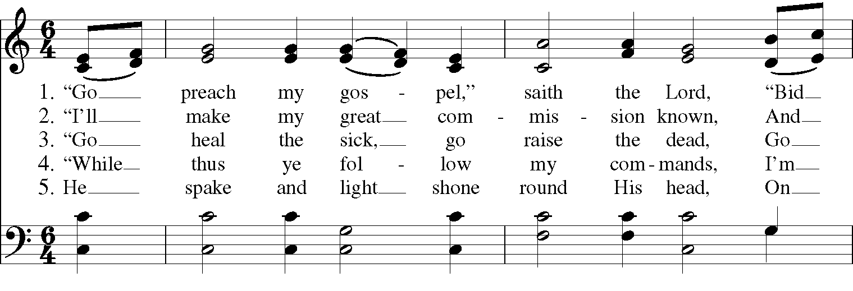
Sequence Hymn: “Go Preach my Gospel” Hymnal LEVAS II 161

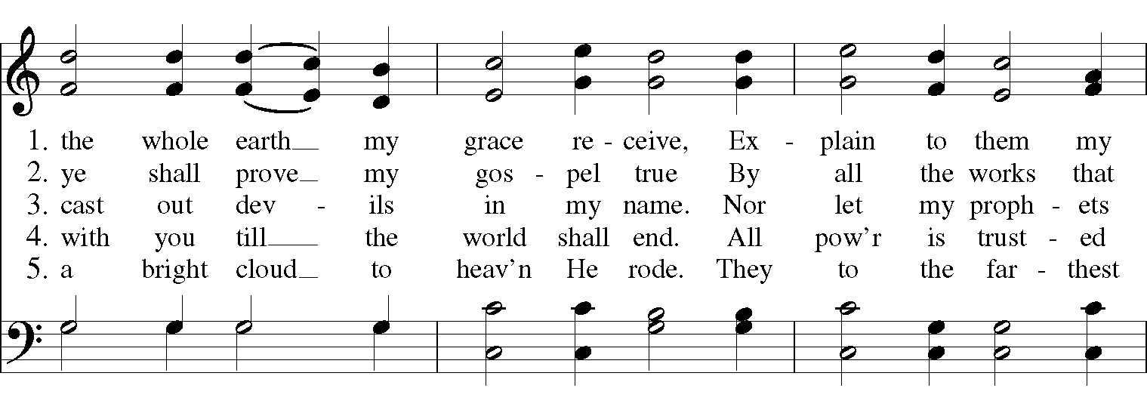

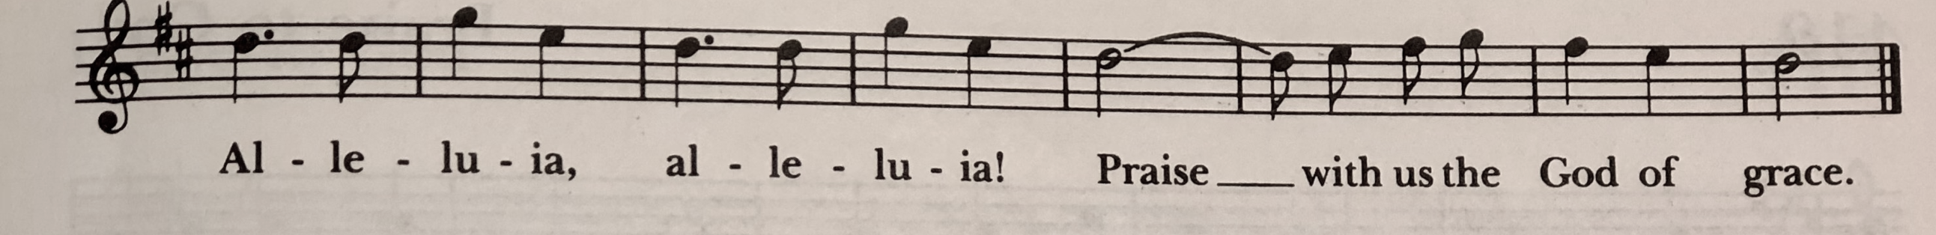

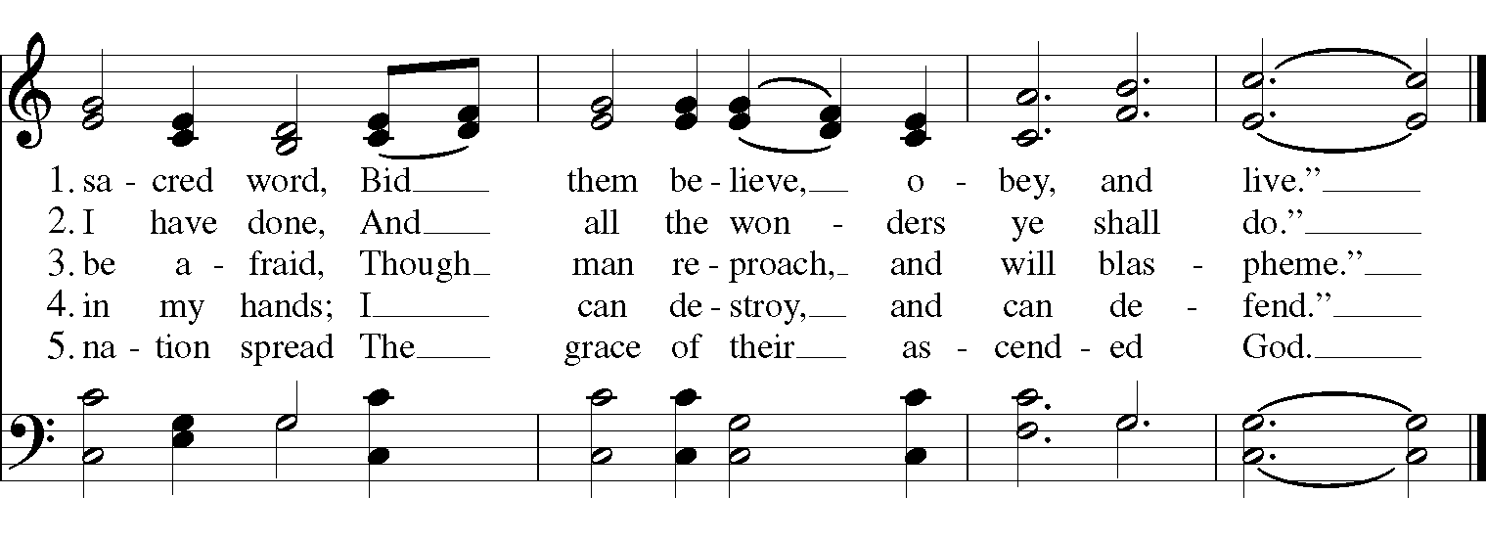

Gospel
Deacon: The Holy Gospel According to Mark (1:29-39)
People: Glory to you, Lord Christ.
After Jesus and his disciples left the synagogue, they entered the house of Simon and Andrew, with James and John. Now Simon’s mother-in-law was in bed with a fever, and they told him about her at once. He came and took her by the hand and lifted her up. Then the fever left her, and she began to serve them.

That evening, at sundown, they brought to him all who were sick or possessed with demons. And the whole city was gathered around the door. And he cured many who were sick with various diseases, and cast out many demons; and he would not permit the demons to speak, because they knew him. In the morning, while it was still very dark, he got up and went out to a deserted place, and there he prayed. And Simon and his companions hunted for him. When they found him, they said to him, “Everyone is searching for you.” He answered, “Let us go on to the neighboring towns, so that I may proclaim the message there also; for that is what I came out to do.” And he went throughout Galilee, proclaiming the message in their synagogues and casting out demons.
Deacon: The Gospel of the Lord.
People: Praise to you, Lord Christ.

Sermon The Rev. Canon Dr. Lee Anne Reat

The Nicene Creed
We believe in one God,
the Father, the Almighty,
the maker of heaven and earth,
of all that is, seen and unseen.
We believe in one Lord, Jesus Christ,
the only Son of God,
eternally begotten of the Father,
God from God, Light from Light,
true God from true God,
begotten, not made,
of one Being with the Father.
Through him all things were made.
For us and for our salvation
he came down from heaven:
by the power of the Holy Spirit
he became incarnate from the Virgin Mary,
and was made man.
For our sake he was crucified under Pontius Pilate;
he suffered death and was buried.
On the third day he rose again
in accordance with the Scriptures;
He ascended into heaven
and is seated on the right hand of the Father.
He will come again in glory to judge the living and the dead,
and his kingdom will have no end.
We believe in the Holy Spirit, the Lord, the giver of life,
who proceeds from the Father and the Son.
With the Father and the Son he is worshiped and glorified.
He has spoken through the Prophets.
We believe in one holy catholic and apostolic Church.
We acknowledge one baptism for the forgiveness of sins.
We look for the resurrection of the dead,
and the life of the world to come. Amen.

The Prayers of the People

In peace, we pray to you Lord God.

Silence

Dear Jesus, you came to bring light and love into the world. Your light shines in the darkness of these winter days and nights. May we also shine brightly.

Light of the World, we ask your light upon the Church and its servants. Enlighten Justin, Archbishop of Canterbury; Michael, our Presiding Bishop; Ken, our Bishop; Lee Anne, our priest; and Rick, our deacon. Grant light to each member and guest of this parish. Grant special light to those celebrating birthdays and anniversaries this week especially, Joni, Cameron, Joe, Walt, and Fred.
May your light be reflected in the Church’s mission and unity.

Light of Life, we pray for your light to shine on the nations of the world and their leaders. Enlighten our president, members of Congress, and local authorities. Give them hearts for justice and peace.
May your light be reflected in the governments of our world.

Light of the World, you have called us to be salt and light in our broken world. Enlighten us in our service and our various ministries, especially Children’s Rescue Center/The Ark, Christ Church Food Pantry, The Fuller Center for Housing, and Safe Harbor House.
May your light be reflected in our works of mercy.

Light of Life, your grace shines in our times of sickness and trouble. Shine on those who suffer in body, mind, or spirit, especially Faye, Chris, Laura, Bonnie, Alice, Diana, James, Joy, Jane, Joni, Kim, Bobby, Sarah, Traudie, Lexie, and Keith.
May your light be reflected in our seasons of pain and difficulty.

Light of the World, you shine in the darkness, and the darkness does not overcome your light. We pray for that eternal light to shine on all who have died and to ease the grief of those who mourn their departing.
May your light be reflected in our loss and grief.

*THE COLLECT FOR PEACE
Grant, O God, that your holy and life-giving Spirit may so move every human heart, that barriers which divide us may crumble, suspicions disappear, and hatreds cease; that our divisions being healed, we may live in justice and peace; through Jesus Christ our Lord. Amen.

Deacon: Let us confess our sins against God and our neighbor.
All: Most merciful God, we confess that we have sinned against you in thought, word, and deed, by what we have done, and by what we have left undone. We have not loved you with our whole heart; we have not loved our neighbors as ourselves. We are truly sorry and we humbly repent. For the sake of your Son Jesus Christ, have mercy on us and forgive us; that we may delight in your will, and walk in your ways, to the glory of your Name. Amen.

Priest: Almighty God, have mercy on you, forgive you all your sins through our Lord Jesus Christ, strengthen you in all goodness, and by the power of the Holy Spirit keep you in eternal life. Amen.

And now, as our Savior Christ has taught us, we are bold to say:
Our Father, who art in heaven, hallowed be thy Name,
thy kingdom come, thy will be done, on earth as it is in heaven.
Give us this day our daily bread.
And forgive us our trespasses, as we forgive those who trespass against us.
And lead us not into temptation, but deliver us from evil.
For thine is the kingdom, and the power, and the glory, for ever and ever. Amen.

Closing Hymn: “Dear Lord and Father of Mankind” Hymnal 652
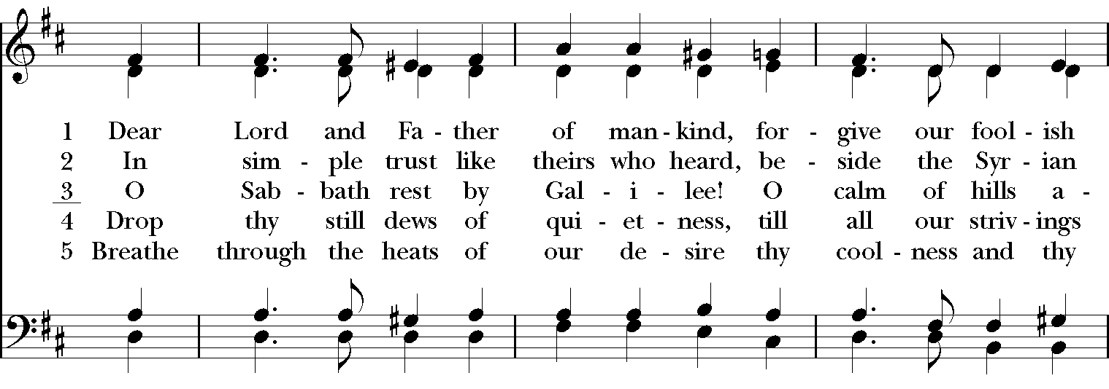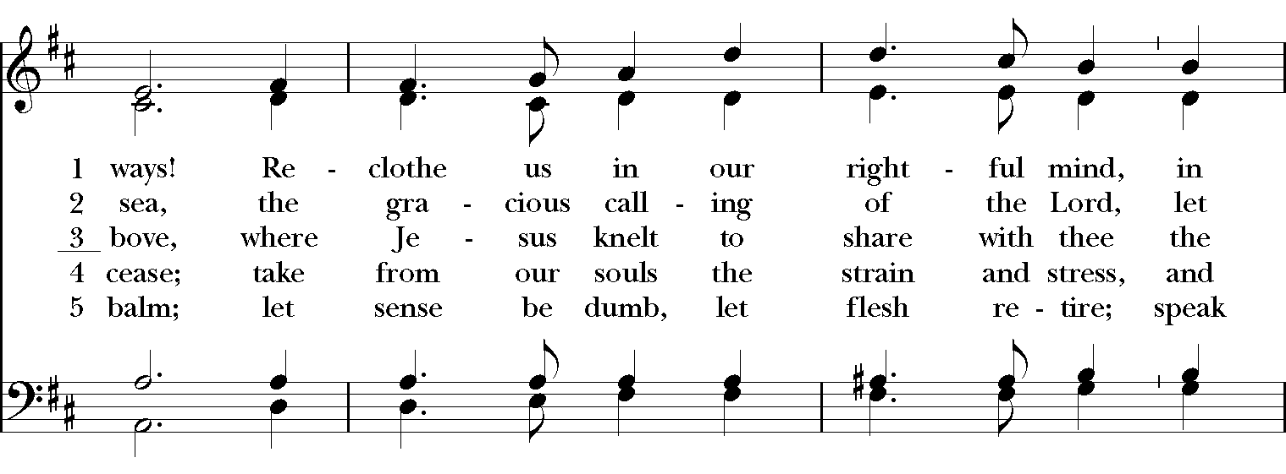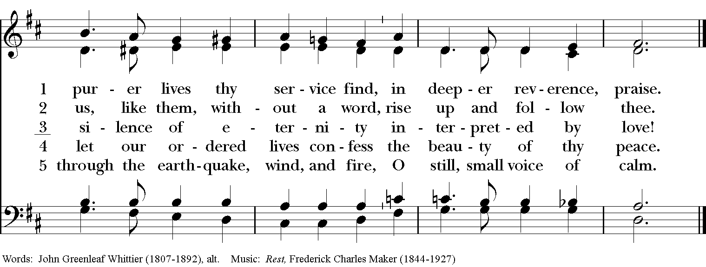

Blessing
May Christ, the Son of God, be manifest in you, that your lives may be a light to the world; and the blessing of God Almighty, the Father, the Son and the Holy Spirit, be among you and remain with you always. Amen.

Announcements

Dismissal
Deacon: Go in peace to love and serve the Lord.
People: Thanks be to God!

Postlude: “Aria” from Goldberg Variations-J.S. Bach

Thank you for your spiritual presence with us this morning!
Although we're physically apart, we are united in prayer, worship, and holy love!
Priest-In-Charge: The Rev. Dr. Canon Lee Anne Reat
Deacon: The Rev. Dr. Rick Incorvati
Music Director: Dr. Chris Durrenberger
Lector: Diane Rode
Singers: Liz Wheeler, Joy Carter, Ed Hasecke, Chris Oldstone-Moore
Technology: Steve Ide
Slideshow: Ed Hasecke
Parish Administrator and Program Coordinator: Kelly Zeller
Coffee Hour Host: Fred Bartenstein

