Christ Episcopal Church in Springfield, Ohio
Service of the Word
First Sunday after Epiphany: The Baptism of our Lord
January 10th, 2021 at 9 am

Prelude:

Opening Hymn: Deep River Hymn 8 LEVII
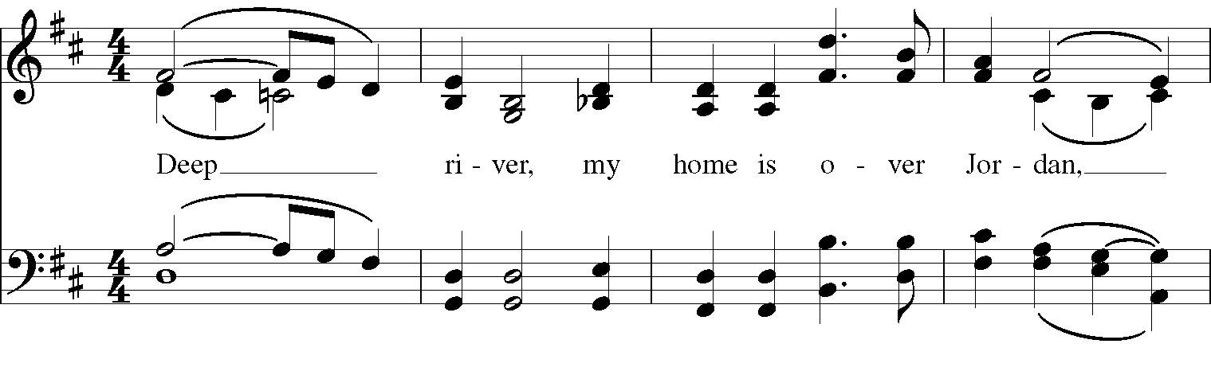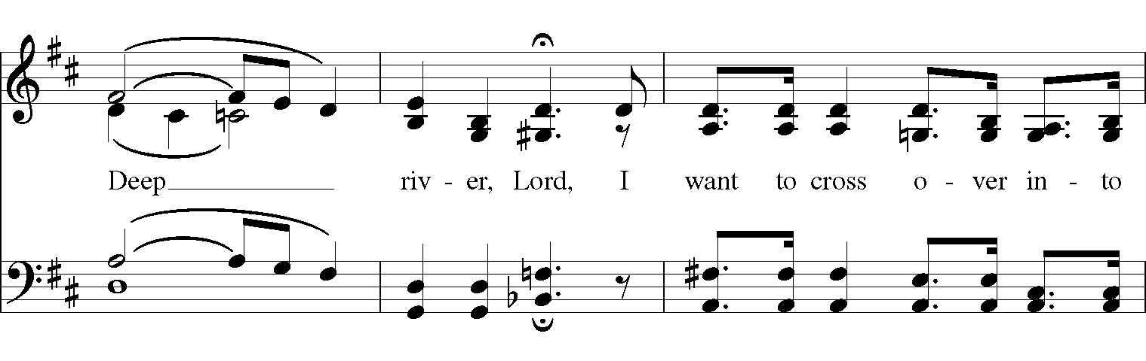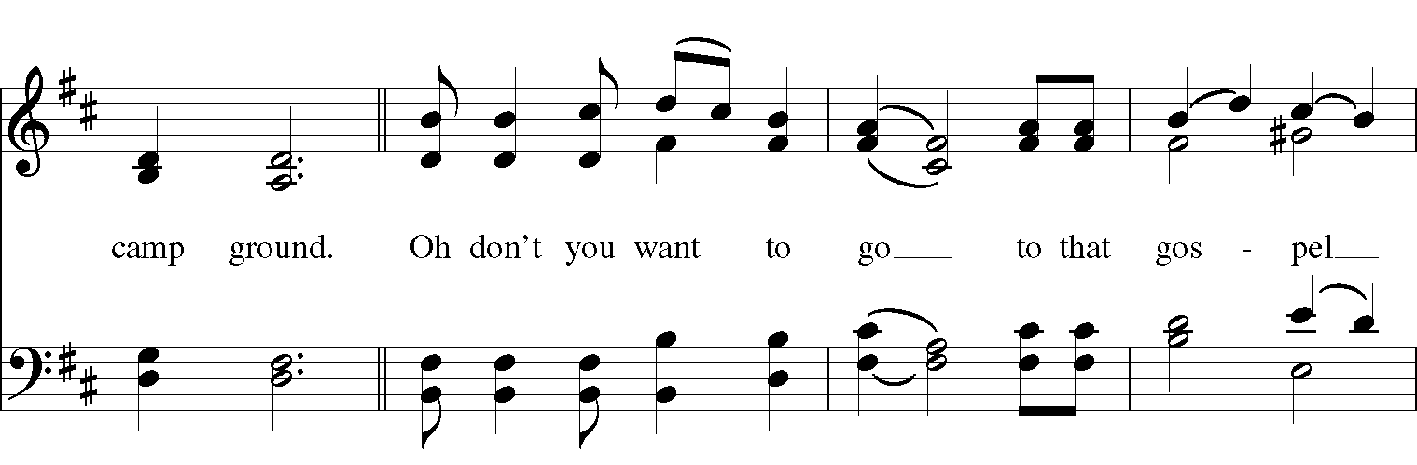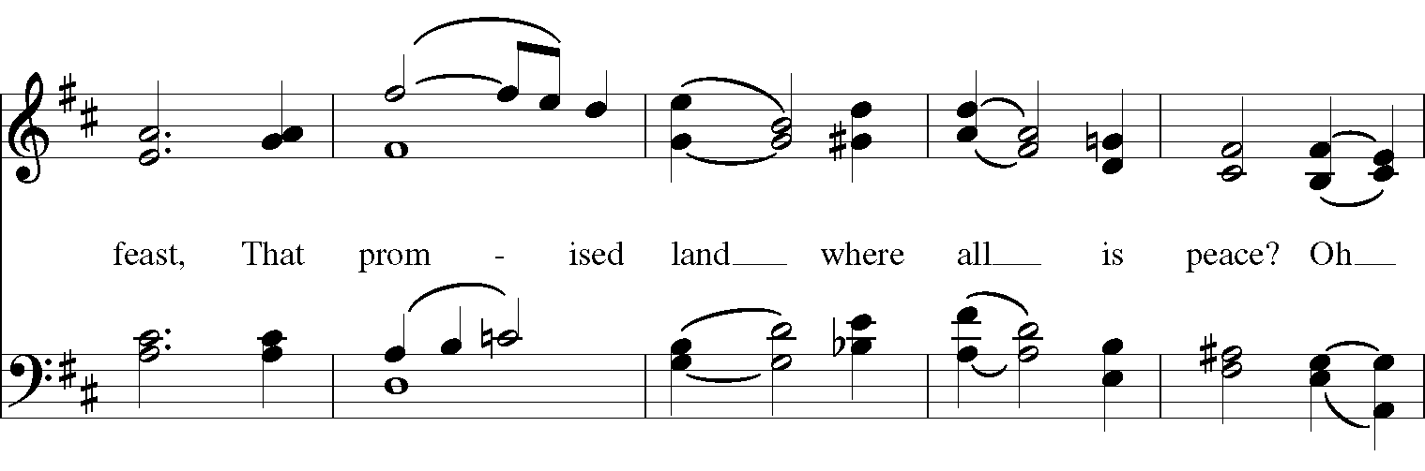

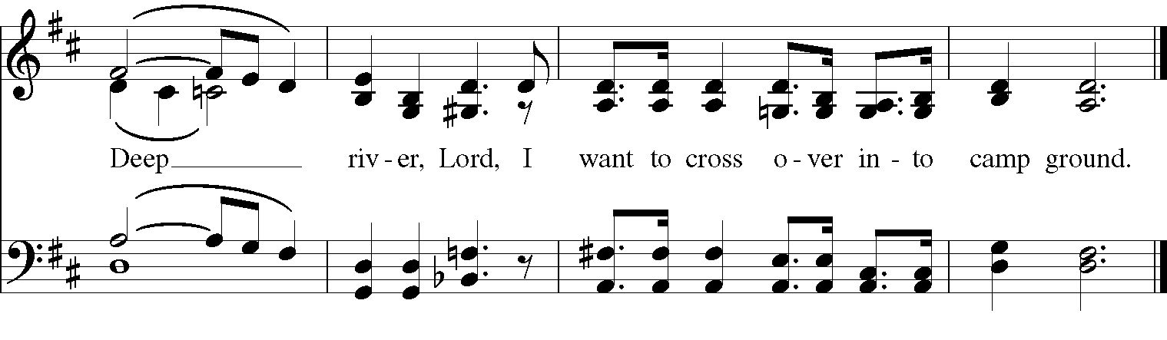
Celebrant: Blessed be God: Father, Son, and Holy Spirit.
People: And blessed be God’s kingdom, now and for ever. Amen.
Celebrant: Lord, have mercy.
People: Christ, have mercy.
Celebrant: Lord, have mercy.

The Collect of the Day
Celebrant: The Lord be with you.
People: And also with you.
Celebrant: Let us pray.
Father in heaven, who at the baptism of Jesus in the River Jordan proclaimed him your beloved Son and anointed him with the Holy Spirit: Grant that all who are baptized into his Name may keep the covenant they have made, and boldly confess him as Lord and Savior; who with you and the Holy Spirit lives and reigns, one God, in glory everlasting. Amen.

The Lessons
The First Reading: Genesis 1:1-5
In the beginning when God created the heavens and the earth, the earth was a formless void and darkness covered the face of the deep, while a wind from God swept over the face of the waters. Then God said, “Let there be light”; and there was light. And God saw that the light was good; and God separated the light from the darkness. God called the light Day, and the darkness he called Night. And there was evening and there was morning, the first day.
Reader: The Word of the Lord.
People: Thanks be to God.

Psalm 29 Afferte Domino
1 Ascribe to the Lord, you gods, *
ascribe to the Lord glory and strength.
2 Ascribe to the Lord the glory due his Name; *
worship the Lord in the beauty of holiness.
3 The voice of the Lord is upon the waters; the God of glory thunders; *
the Lord is upon the mighty waters.
4 The voice of the Lord is a powerful voice; *
the voice of the Lord is a voice of splendor.
5 The voice of the Lord breaks the cedar trees; *
the Lord breaks the cedars of Lebanon;
6 He makes Lebanon skip like a calf, *
and Mount Hermon like a young wild ox.
7 The voice of the Lord splits the flames of fire;
the voice of the Lord shakes the wilderness; *
the Lord shakes the wilderness of Kadesh.
8 The voice of the Lord makes the oak trees writhe *
and strips the forests bare.
9 And in the temple of the Lord *
all are crying, "Glory!"
10 The Lord sits enthroned above the flood; *
the Lord sits enthroned as King for evermore.
11 The Lord shall give strength to his people; *
the Lord shall give his people the blessing of peace.

Second Lesson: Acts 19:1-7
While Apollos was in Corinth, Paul passed through the interior regions and came to Ephesus, where he found some disciples. He said to them, “Did you receive the Holy Spirit when you became believers?” They replied, “No, we have not even heard that there is a Holy Spirit.” Then he said, “Into what then were you baptized?” They answered, “Into John’s baptism.” Paul said, “John baptized with the baptism of repentance, telling the people to believe in the one who was to come after him, that is, in Jesus.” On hearing this, they were baptized in the name of the Lord Jesus. When Paul had laid his hands on them, the Holy Spirit came upon them, and they spoke in tongues and prophesied— altogether there were about twelve of them.
Reader: The Word of the Lord.
People: Thanks be to God.
Sequence Hymn: Like the murmur of the dove’s song Hymnal 513
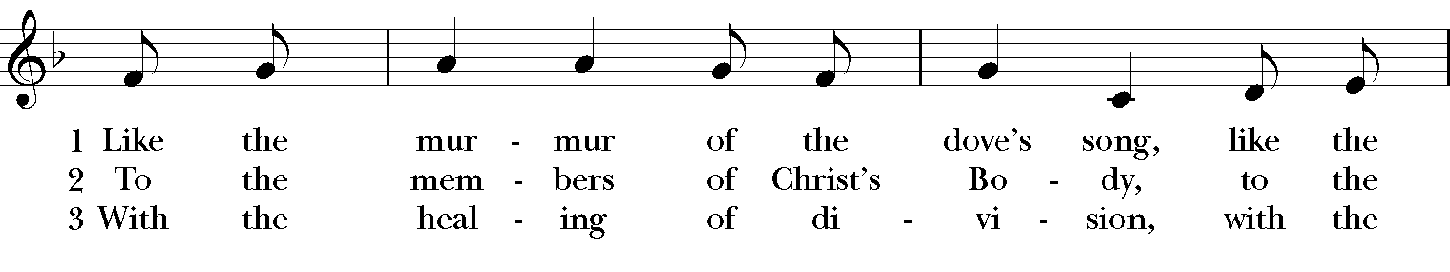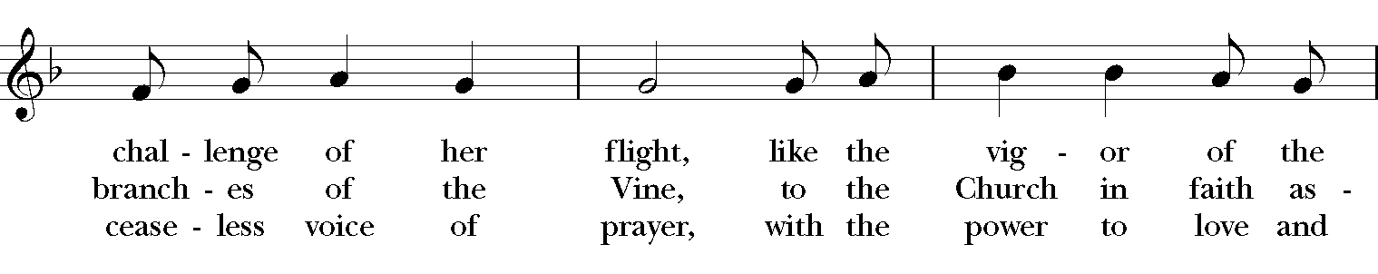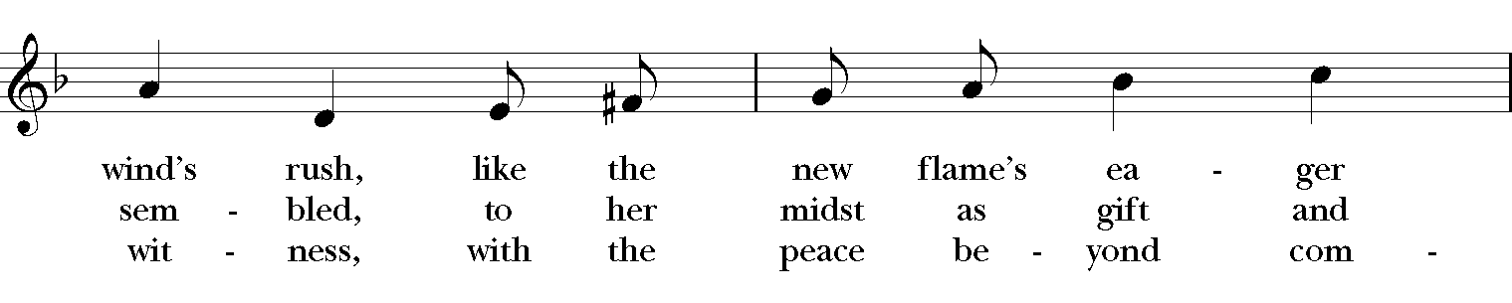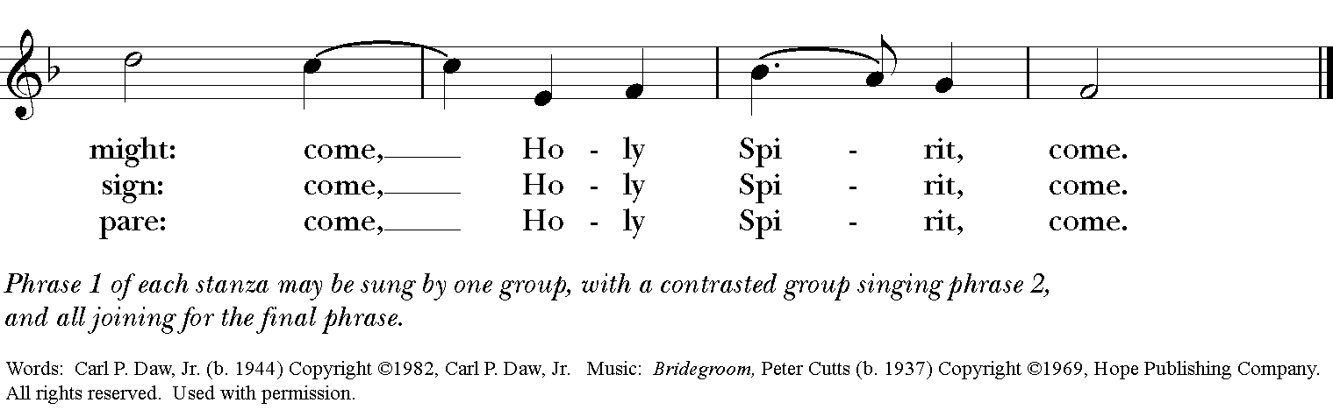

Gospel
Deacon: The Holy Gospel According to Mark (1:4-11)
People: Glory to you, Lord Christ.
John the baptizer appeared in the wilderness, proclaiming a baptism of repentance for the forgiveness of sins. And people from the whole Judean countryside and all the people of Jerusalem were going out to him, and were baptized by him in the river Jordan, confessing their sins. Now John was clothed with camel’s hair, with a leather belt around his waist, and he ate locusts and wild honey. He proclaimed, “The one who is more powerful than I is coming after me; I am not worthy to stoop down and untie the thong of his sandals. I have baptized you with water; but he will baptize you with the Holy Spirit.”
In those days Jesus came from Nazareth of Galilee and was baptized by John in the Jordan. And just as he was coming up out of the water, he saw the heavens torn apart and the Spirit descending like a dove on him. And a voice came from heaven, “You are my Son, the Beloved; with you I am well pleased.”
Deacon: The Gospel of the Lord.
People: Praise to you, Lord Christ.

Sermon The Rev. Canon Dr. Lee Anne Reat

The Renewal of Baptismal Vows

Celebrant: Do you reaffirm your renunciation of evil and renew your commitment to Jesus Christ?
People: I do.

Celebrant: Do you believe in God the Father?
People: I believe in God, the Father almighty, creator of heaven and earth.
Celebrant: Do you believe in Jesus Christ, the Son of God?
People: I believe in Jesus Christ, his only Son, our Lord.
He was conceived by the power of the Holy Spirit and born of the Virgin Mary. He suffered under Pontius Pilate, was crucified, died, and was buried. He descended to the dead. On the third day he rose again. He ascended into heaven, and is seated at the right hand of the Father. He will come again to judge the living and the dead.

Celebrant: Do you believe in God the Holy Spirit?
People: I believe in the Holy Spirit, the holy catholic Church, the communion of saints, the forgiveness of sins, the resurrection of the body, and the life everlasting.

Celebrant: Will you continue in the apostles’ teaching and fellowship, in the breaking of bread, and in the prayers ?
People: I will, with God’s help.

Celebrant: Will you persevere in resisting evil, and, whenever you fall into sin, repent and return to the Lord?
People: I will, with God’s help.

Celebrant: Will you proclaim by word and example the Good News of God in Christ?
People: I will, with God’s help.

Celebrant: Will you seek and serve Christ in all persons, loving your neighbor as yourself?
People: I will, with God’s help.

Celebrant: Will you strive for justice and peace among all people, and respect the dignity of every human being?
People: I will, with God’s help.
The Celebrant concludes the Renewal of Vows as follows
May Almighty God, the Father of our Lord Jesus Christ, who has given us a new birth by water and the Holy Spirit, and bestowed upon us the forgiveness of sins, keep us in eternal life by his grace, in Christ Jesus our Lord. Amen.
The Prayers of the People

In peace, we pray to you Lord God.

Silence

Dear Jesus, you came to bring light and love into the world. Your light shines in the darkness of these winter days and nights. May we also shine brightly.

Light of the World, we ask your light upon the Church and its servants. Enlighten Justin, Archbishop of Canterbury; Michael, our Presiding Bishop; Ken, our Bishop; Lee Anne, our priest; and Rick, our deacon. Grant light to each member and guest of this parish. Grant special light to those celebrating birthdays and anniversaries this week especially, Carol and Martha.
May your light be reflected in the Church’s mission and unity.

Light of Life, we pray for your light to shine on the nations of the world and their leaders. Enlighten our president, members of Congress, and local authorities. Give them hearts for justice and peace.
May your light be reflected in the governments of our world.

Light of the World, you have called us to be salt and light in our broken world. Enlighten us in our service and our various ministries, especially Children’s Rescue Center/ The Ark, Christ Church Food Pantry, The Fuller Center for Housing, and Safe Harbor House.
May your light be reflected in our works of mercy.

Light of Life, your grace shines in our times of sickness and trouble. Shine on those who suffer in body, mind, or spirit, especially Joan, Chris, Laura, Bonnie, Alice, Diana, James, Joy, Jane, Joni, Kim, Bobby, Sarah, Traudie, Lexie, Norm, and Keith.
May your light be reflected in our seasons of pain and difficulty.

Light of the World, you shine in the darkness, and the darkness does not overcome your light. We pray for that eternal light to shine on all who have died and to ease the grief of those who mourn their departing.
May your light be reflected in our loss and grief.

*THE COLLECT FOR PEACE
Grant, O God, that your holy and life-giving Spirit may so move every human heart, that barriers which divide us may crumble, suspicions disappear, and hatreds cease; that our divisions being healed, we may live in justice and peace; through Jesus Christ our Lord. Amen.

Deacon: Let us confess our sins against God and our neighbor.
All: Most merciful God, we confess that we have sinned against you in thought, word, and deed, by what we have done, and by what we have left undone. We have not loved you with our whole heart; we have not loved our neighbors as ourselves. We are truly sorry and we humbly repent. For the sake of your Son Jesus Christ, have mercy on us and forgive us; that we may delight in your will, and walk in your ways, to the glory of your Name. Amen.

Priest: Almighty God, have mercy on you, forgive you all your sins through our Lord Jesus Christ, strengthen you in all goodness, and by the power of the Holy Spirit keep you in eternal life. Amen.

And now, as our Savior Christ has taught us, we are bold to say:
Our Father, who art in heaven, hallowed be thy Name,
thy kingdom come, thy will be done, on earth as it is in heaven.
Give us this day our daily bread.
And forgive us our trespasses, as we forgive those who trespass against us.
And lead us not into temptation, but deliver us from evil.
For thine is the kingdom, and the power, and the glory, for ever and ever. Amen.
Closing Hymn: Christ, when for us you were baptized Hymnal 121
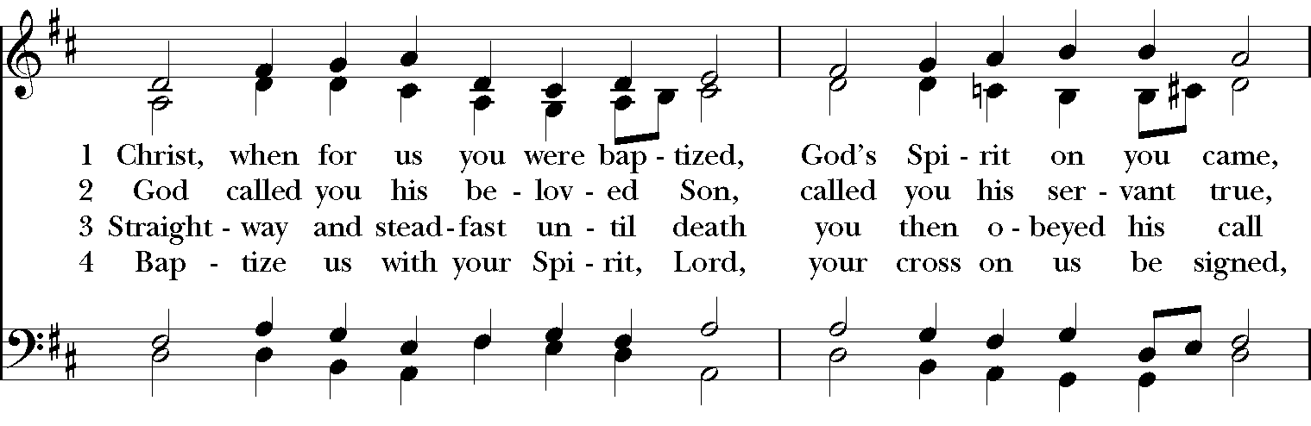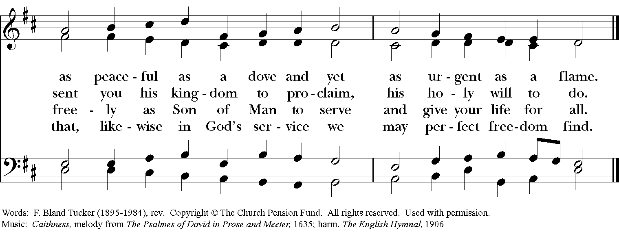

Blessing
May Christ, who by his Incarnation gathered into one things earthly and heavenly, fill you with his joy and peace; and the blessing of God Almighty, the Father, the Son, and the Holy Spirit, be among you, and remain with you always. Amen

Announcements

Dismissal
Deacon: Go in peace to love and serve the Lord.
People: Thanks be to God!

Postlude:

Thank you for your spiritual presence with us this morning!
Although we're physically apart, we are united in prayer, worship, and holy love!
Priest-In-Charge: The Rev. Dr. Canon Lee Anne Reat
Deacon: The Rev. Dr. Rick Incorvati
Music Director: Dr. Chris Durrenberger
Lector: Keith Doubt
Singers: Liz Wheeler, Joy Carter, Ed Hasecke, Ed Hasecke
Technology: Steve Ide
Slideshow: Ed Hasecke
Parish Administrator and Program Coordinator: Kelly Zeller
Coffee Hour Host: Linda Mortensen

