Christ Episcopal Church in Springfield, Ohio
Service of the Word
Third Sunday after Epiphany: January 24th, 2021 at 9 am

Prelude: “Come Down, O Love Divine“ - Down Ampney/arr. Callahan

Opening Hymn: Come down, O Love divine Hymn 516
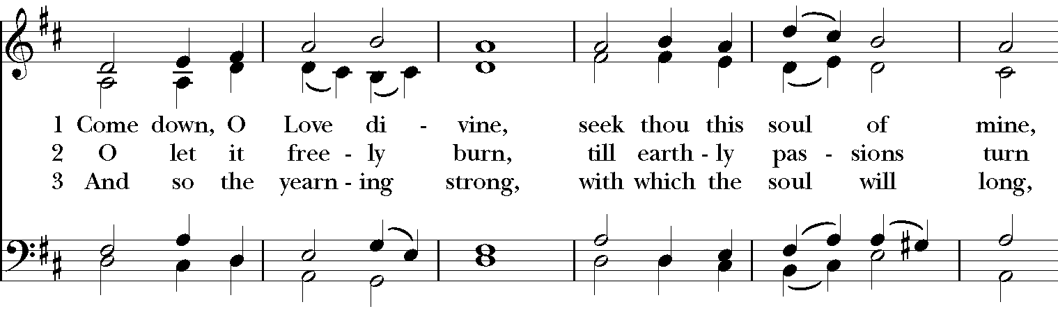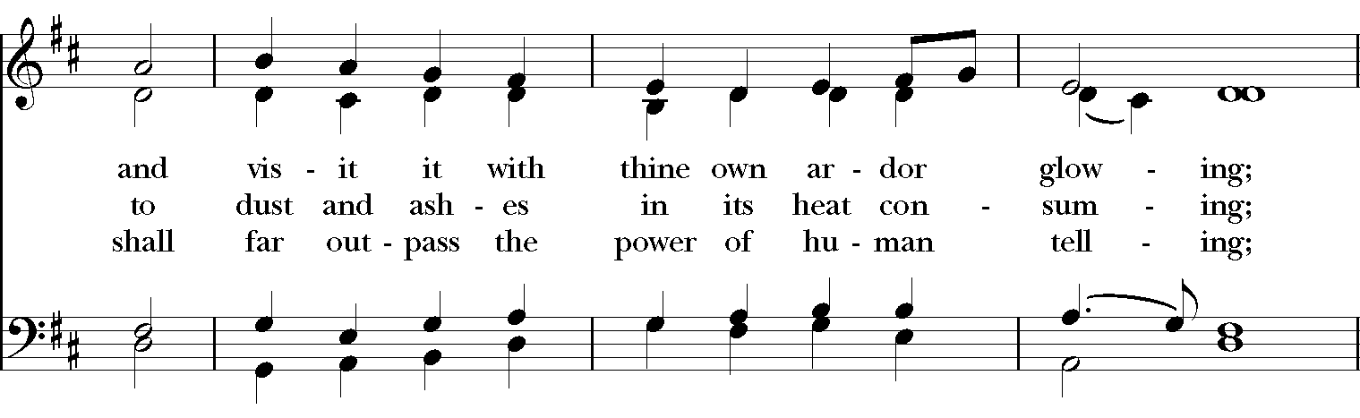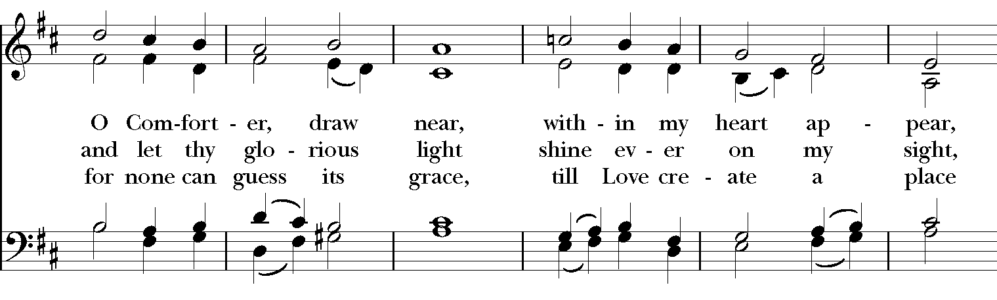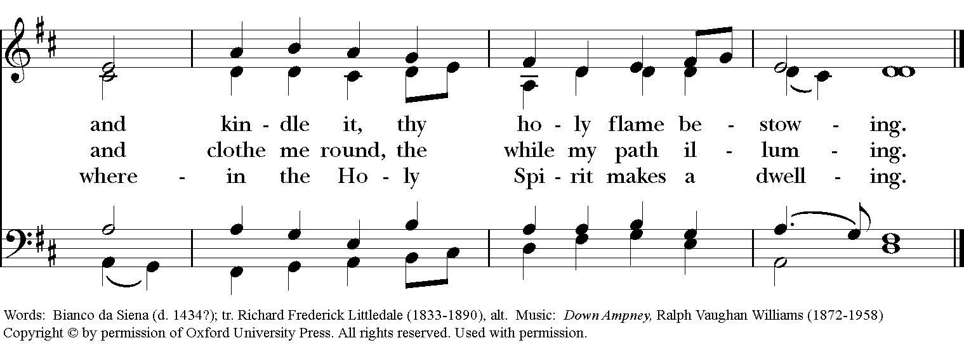

Celebrant: Blessed be God: Father, Son, and Holy Spirit.
People: And blessed be God’s kingdom, now and for ever. Amen.
Celebrant: Lord, have mercy.
People: Christ, have mercy.
Celebrant: Lord, have mercy.

The Collect of the Day
Celebrant: The Lord be with you.
People: And also with you.
Celebrant: Let us pray.
Give us grace, O Lord, to answer readily the call of our Savior Jesus Christ and proclaim to all people the Good News of his salvation, that we and the whole world may perceive the glory of his marvelous works; who lives and reigns with you and the Holy Spirit, one God, for ever and ever. Amen.

The Lessons
The First Reading: Jonah 3:1-5, 10
The word of the Lord came to Jonah a second time, saying, “Get up, go to Nineveh, that great city, and proclaim to it the message that I tell you.” So Jonah set out and went to Nineveh, according to the word of the Lord. Now Nineveh was an exceedingly large city, a three days' walk across. Jonah began to go into the city, going a day's walk. And he cried out, “Forty days more, and Nineveh shall be overthrown!” And the people of Nineveh believed God; they proclaimed a fast, and everyone, great and small, put on sackcloth.

When God saw what they did, how they turned from their evil ways, God changed his mind about the calamity that he had said he would bring upon them; and he did not do it.
Reader: The Word of the Lord.
People: Thanks be to God.

Psalm 62:6-14 Nonne Deo?
6 For God alone my soul in silence waits; *
truly, my hope is in him.
7 He alone is my rock and my salvation, *
my stronghold, so that I shall not be shaken.
8 In God is my safety and my honor; *
God is my strong rock and my refuge.
9 Put your trust in him always, O people, *
pour out your hearts before him, for God is our refuge.
10 Those of high degree are but a fleeting breath, *
even those of low estate cannot be trusted.
11 On the scales they are lighter than a breath, *
all of them together.
12 Put no trust in extortion; in robbery take no empty pride; *
though wealth increase, set not your heart upon it.
13 God has spoken once, twice have I heard it, *
that power belongs to God.
14 Steadfast love is yours, O Lord, *
for you repay everyone according to his deeds.

Second Lesson: 1 Corinthians 7:29-31
I mean, brothers and sisters, the appointed time has grown short; from now on, let even those who have wives be as though they had none, and those who mourn as though they were not mourning, and those who rejoice as though they were not rejoicing, and those who buy as though they had no possessions, and those who deal with the world as though they had no dealings with it. For the present form of this world is passing away.
Reader: The Word of the Lord.
People: Thanks be to God.
Sequence Hymn: Just as I am Hymnal 693
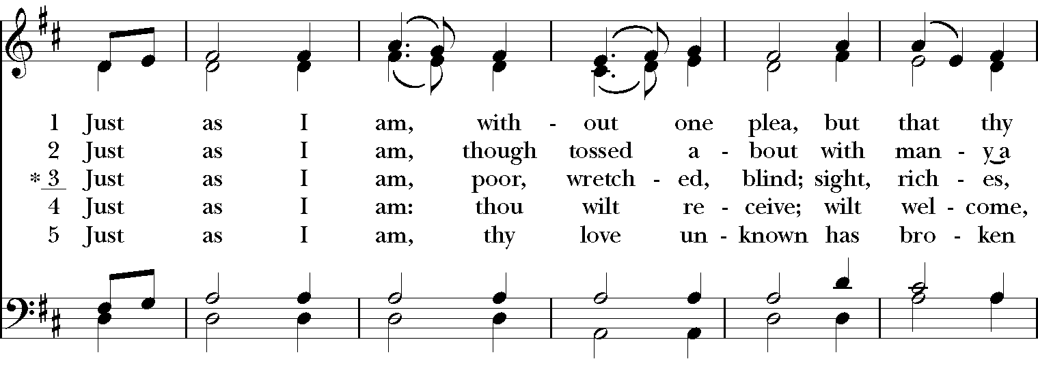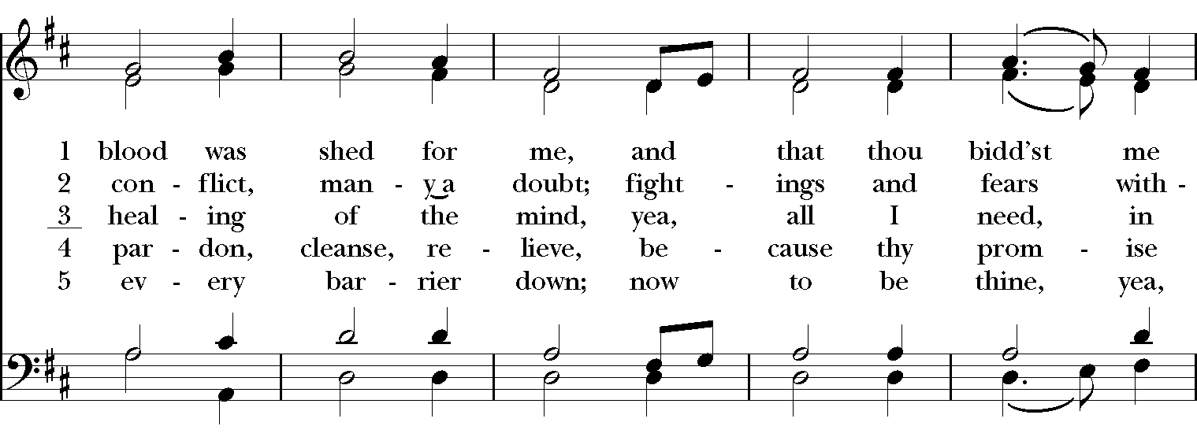

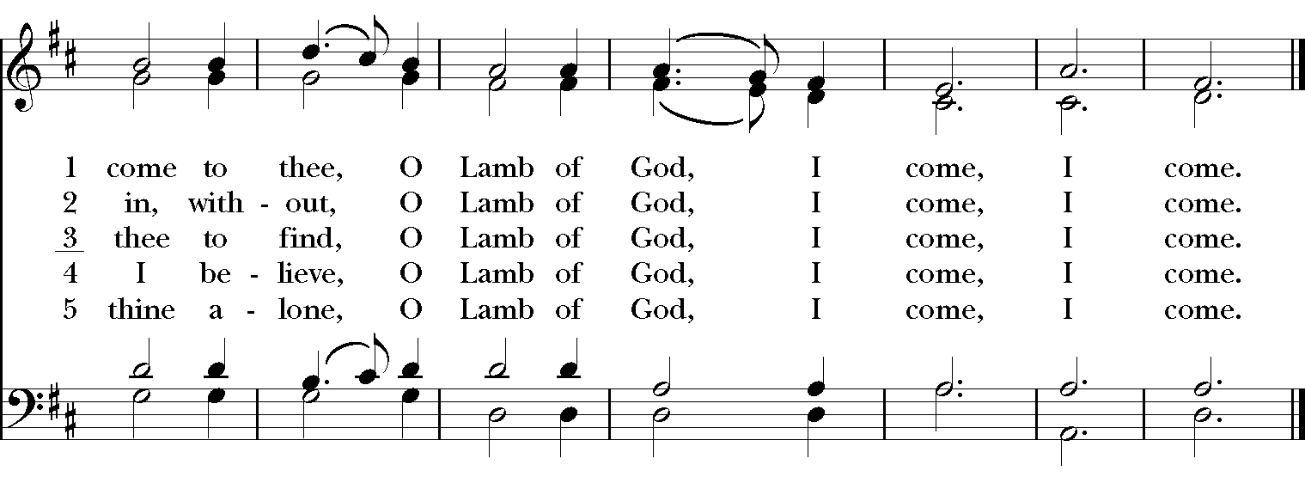

Gospel
Deacon: The Holy Gospel According to Mark (1:14-20)
People: Glory to you, Lord Christ.
After John was arrested, Jesus came to Galilee, proclaiming the good news of God, and saying, “The time is fulfilled, and the kingdom of God has come near; repent, and believe in the good news.”
As Jesus passed along the Sea of Galilee, he saw Simon and his brother Andrew casting a net into the sea—for they were fishermen. And Jesus said to them, “Follow me and I will make you fish for people.” And immediately they left their nets and followed him. As he went a little farther, he saw James son of Zebedee and his brother John, who were in their boat mending the nets. Immediately he called them; and they left their father Zebedee in the boat with the hired men, and followed him.
Deacon: The Gospel of the Lord.
People: Praise to you, Lord Christ.

Sermon The Rev. Canon Dr. Lee Anne Reat

The Nicene Creed
We believe in one God,
the Father, the Almighty,
the maker of heaven and earth,
of all that is, seen and unseen.
We believe in one Lord, Jesus Christ,
the only Son of God,
eternally begotten of the Father,
God from God, Light from Light,
true God from true God,
begotten, not made,
of one Being with the Father.
Through him all things were made.
For us and for our salvation
he came down from heaven:
by the power of the Holy Spirit
he became incarnate from the Virgin Mary,
and was made man.
For our sake he was crucified under Pontius Pilate;
he suffered death and was buried.
On the third day he rose again
in accordance with the Scriptures;
He ascended into heaven
and is seated on the right hand of the Father.
He will come again in glory to judge the living and the dead,
and his kingdom will have no end.
We believe in the Holy Spirit, the Lord, the giver of life,
who proceeds from the Father and the Son.
With the Father and the Son he is worshiped and glorified.
He has spoken through the Prophets.
We believe in one holy catholic and apostolic Church.
We acknowledge one baptism for the forgiveness of sins.
We look for the resurrection of the dead,
and the life of the world to come. Amen.

The Prayers of the People

In peace, we pray to you Lord God.

Silence

Dear Jesus, you came to bring light and love into the world. Your light shines in the darkness of these winter days and nights. May we also shine brightly.

Light of the World, we ask your light upon the Church and its servants. Enlighten Justin, Archbishop of Canterbury; Michael, our Presiding Bishop; Ken, our Bishop; Lee Anne, our priest; and Rick, our deacon. Grant light to each member and guest of this parish. Grant special light to those celebrating birthdays this week especially, Denise, Steve, and anniversaries this week, Mandy & Jimmy.
May your light be reflected in the Church’s mission and unity.

Light of Life, we pray for your light to shine on the nations of the world and their leaders. Enlighten our president, members of Congress, and local authorities. Give them hearts for justice and peace.
May your light be reflected in the governments of our world.

Light of the World, you have called us to be salt and light in our broken world. Enlighten us in our service and our various ministries, especially Springfield Farmer’s Market, Project Woman, Children’s Defense Fund Freedom School, The YMCA, and Jefferson St. Oasis Garden.
May your light be reflected in our works of mercy.

Light of Life, your grace shines in our times of sickness and trouble. Shine on those who suffer in body, mind, or spirit, especially Faye, Chris, Laura, Bonnie, Alice, Diana, James, Joy, Jane, Joni, Kim, Bobby, Sarah, Traudie, Lexie, and Keith.
May your light be reflected in our seasons of pain and difficulty.

Light of the World, you shine in the darkness, and the darkness does not overcome your light. We pray for that eternal light to shine on all who have died, especially Norm and Brenda and to ease the grief of those who mourn their departing.
May your light be reflected in our loss and grief.

*THE COLLECT FOR PEACE
Grant, O God, that your holy and life-giving Spirit may so move every human heart, that barriers which divide us may crumble, suspicions disappear, and hatreds cease; that our divisions being healed, we may live in justice and peace; through Jesus Christ our Lord. Amen.

Deacon: Let us confess our sins against God and our neighbor.
All: Most merciful God, we confess that we have sinned against you in thought, word, and deed, by what we have done, and by what we have left undone. We have not loved you with our whole heart; we have not loved our neighbors as ourselves. We are truly sorry and we humbly repent. For the sake of your Son Jesus Christ, have mercy on us and forgive us; that we may delight in your will, and walk in your ways, to the glory of your Name. Amen.

Priest: Almighty God, have mercy on you, forgive you all your sins through our Lord Jesus Christ, strengthen you in all goodness, and by the power of the Holy Spirit keep you in eternal life. Amen.

And now, as our Savior Christ has taught us, we are bold to say:
Our Father, who art in heaven, hallowed be thy Name,
thy kingdom come, thy will be done, on earth as it is in heaven.
Give us this day our daily bread.
And forgive us our trespasses, as we forgive those who trespass against us.
And lead us not into temptation, but deliver us from evil.
For thine is the kingdom, and the power, and the glory, for ever and ever. Amen.

Closing Hymn: Lead on, O King eternal Hymnal 555
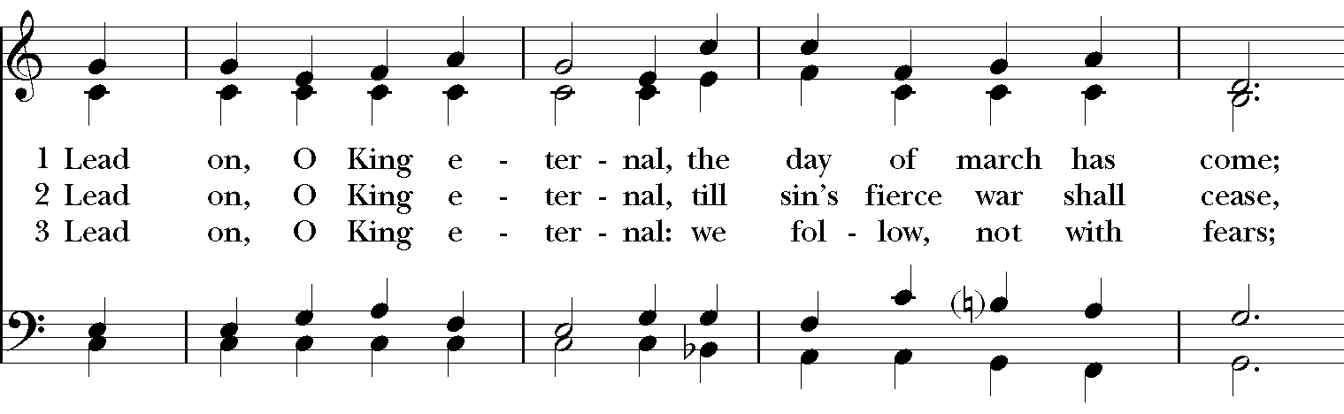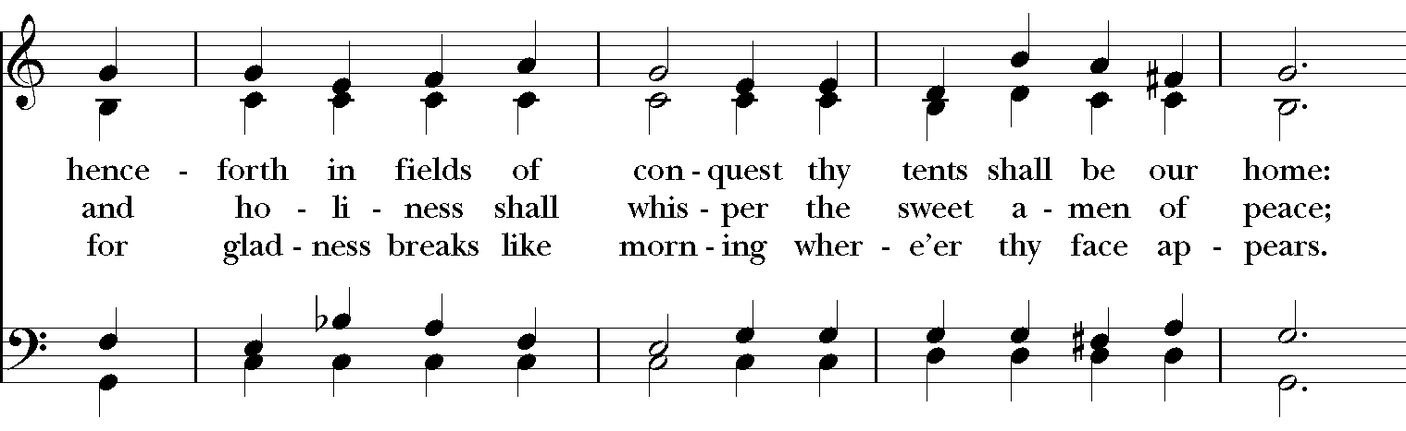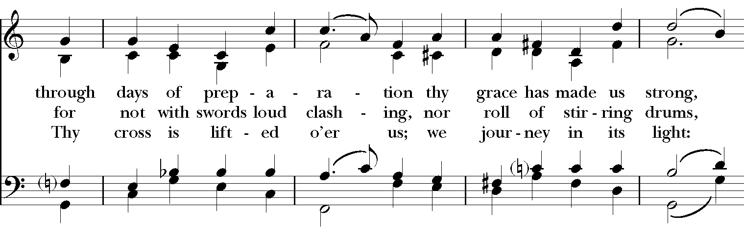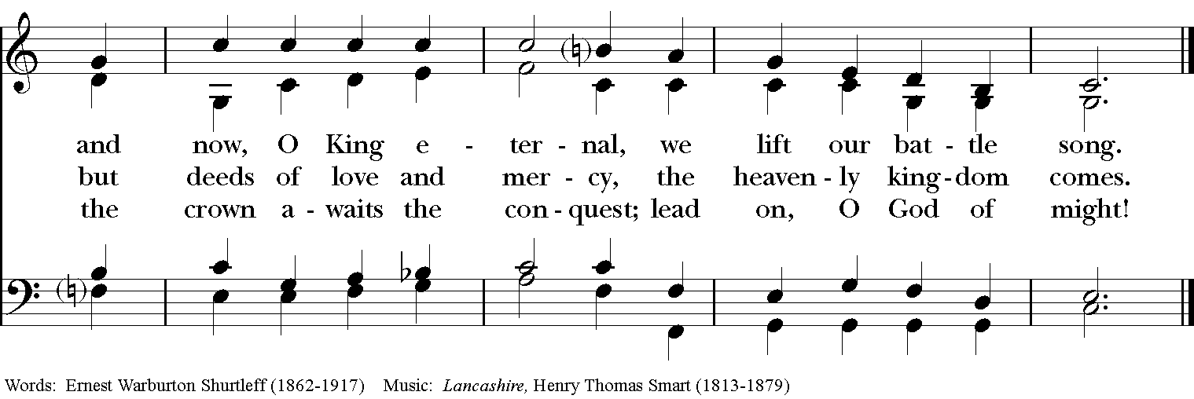

Blessing
May Christ, the Son of God, be manifest in you, that your lives may be a light to the world; and the blessing of God Almighty, the Father, the Son and the Holy Spirit, be among you and remain with you always. Amen.

Announcements

Dismissal
Deacon: Go in peace to love and serve the Lord.
People: Thanks be to God!

Postlude: “To a Wild Rose” from 10 Woodland Sketches Op. 51 - MacDowell

Thank you for your spiritual presence with us this morning!
Although we're physically apart, we are united in prayer, worship, and holy love!
Priest-In-Charge: The Rev. Dr. Canon Lee Anne Reat
Deacon: The Rev. Dr. Rick Incorvati
Music Director: Dr. Chris Durrenberger
Lector: Liz Wheeler
Singers: Liz Wheeler, Joy Carter, Ed Hasecke, Chris Oldstone-Moore
Technology: Steve Ide
Slideshow: Ed Hasecke
Parish Administrator and Program Coordinator: Kelly Zeller
Coffee Hour Host: Ron Dowling

