Christ Episcopal Church in Springfield, Ohio
Service of the Word
Fourth Sunday after Epiphany: January 31st, 2021 at 9 am

Prelude:

Opening Hymn: Blessed Jesus, at Thy word Hymn 440
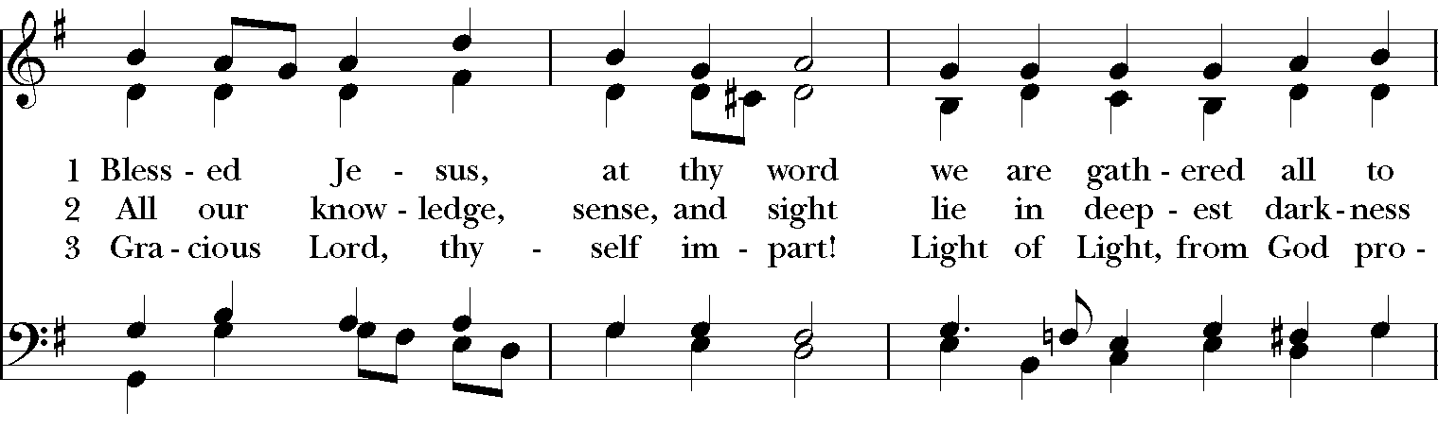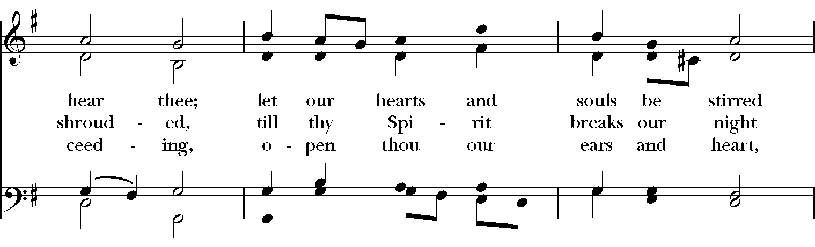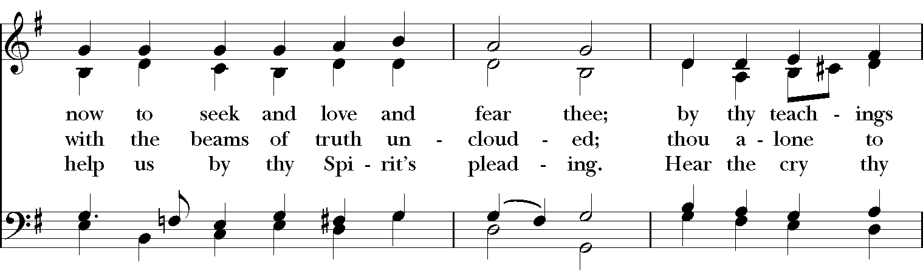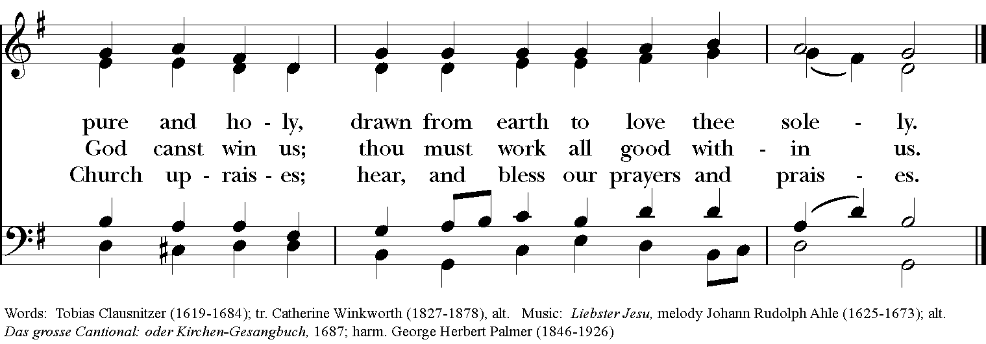

Celebrant: Blessed be God: Father, Son, and Holy Spirit.
People: And blessed be God’s kingdom, now and for ever. Amen.
Celebrant: Lord, have mercy.
People: Christ, have mercy.
Celebrant: Lord, have mercy.

The Collect of the Day
Celebrant: The Lord be with you.
People: And also with you.
Celebrant: Let us pray.
Almighty and everlasting God, you govern all things both in heaven and on earth: Mercifully hear the supplications of your people, and in our time grant us your peace; through Jesus Christ our Lord, who lives and reigns with you and the Holy Spirit, one God, for ever and ever. Amen.

The Lessons
The First Reading: Deuteronomy 18:15-20
Moses said: The Lord your God will raise up for you a prophet like me from among your own people; you shall heed such a prophet. This is what you requested of the Lord your God at Horeb on the day of the assembly when you said: “If I hear the voice of the Lord my God any more, or ever again see this great fire, I will die.” Then the Lord replied to me: “They are right in what they have said. I will raise up for them a prophet like you from among their own people; I will put my words in the mouth of the prophet, who shall speak to them everything that I command. Anyone who does not heed the words that the prophet shall speak in my name, I myself will hold accountable. But any prophet who speaks in the name of other gods, or who presumes to speak in my name a word that I have not commanded the prophet to speak—that prophet shall die.”
Reader: The Word of the Lord.
People: Thanks be to God.

Psalm 111 Confitebor tibi
1 Hallelujah!
I will give thanks to the Lord with my whole heart, *
in the assembly of the upright, in the congregation.
2 Great are the deeds of the Lord! *
they are studied by all who delight in them.
3 His work is full of majesty and splendor, *
and his righteousness endures for ever.
4 He makes his marvelous works to be remembered; *
the Lord is gracious and full of compassion.
5 He gives food to those who fear him; *
he is ever mindful of his covenant.
6 He has shown his people the power of his works *
in giving them the lands of the nations.
7 The works of his hands are faithfulness and justice; *
all his commandments are sure.
8 They stand fast for ever and ever, *
because they are done in truth and equity.
9 He sent redemption to his people; he commanded his covenant for ever; *
holy and awesome is his Name.
10 The fear of the Lord is the beginning of wisdom; *
those who act accordingly have a good understanding; his praise endures for ever.

Second Lesson: 1 Corinthians 8:1-13
Now concerning food sacrificed to idols: we know that “all of us possess knowledge.” Knowledge puffs up, but love builds up. Anyone who claims to know something does not yet have the necessary knowledge; but anyone who loves God is known by him.

Hence, as to the eating of food offered to idols, we know that “no idol in the world really exists,” and that “there is no God but one.” Indeed, even though there may be so-called gods in heaven or on earth—as in fact there are many gods and many lords— yet for us there is one God, the Father, from whom are all things and for whom we exist, and one Lord, Jesus Christ, through whom are all things and through whom we exist.

It is not everyone, however, who has this knowledge. Since some have become so accustomed to idols until now, they still think of the food they eat as food offered to an idol; and their conscience, being weak, is defiled. “Food will not bring us close to God.” We are no worse off if we do not eat, and no better off if we do. But take care that this liberty of yours does not somehow become a stumbling block to the weak. For if others see you, who possess knowledge, eating in the temple of an idol, might they not, since their conscience is weak, be encouraged to the point of eating food sacrificed to idols? So by your knowledge those weak believers for whom Christ died are destroyed. But when you thus sin against members of your family, and wound their conscience when it is weak, you sin against Christ. Therefore, if food is a cause of their falling, I will never eat meat, so that I may not cause one of them to fall.
Reader: The Word of the Lord.
People: Thanks be to God.
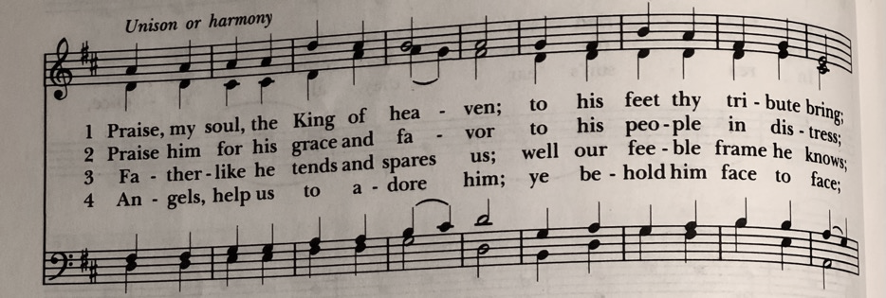
Sequence Hymn: Praise my soul, the King of Heaven Hymnal 410

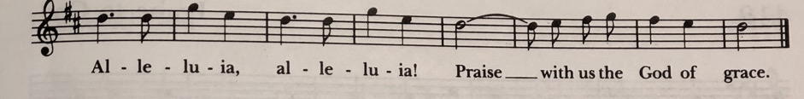
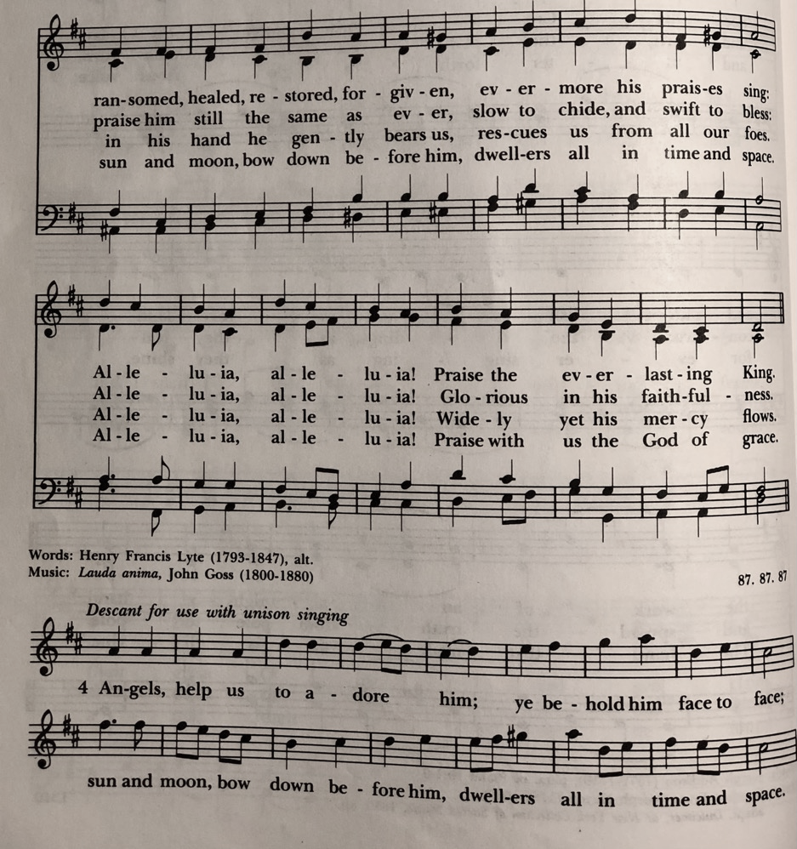

Gospel
Deacon: The Holy Gospel According to Mark (1:21-28)
People: Glory to you, Lord Christ.
Jesus and his disciples went to Capernaum; and when the sabbath came, he entered the synagogue and taught. They were astounded at his teaching, for he taught them as one having authority, and not as the scribes. Just then there was in their synagogue a man with an unclean spirit, and he cried out, “What have you to do with us, Jesus of Nazareth? Have you come to destroy us? I know who you are, the Holy One of God.” But Jesus rebuked him, saying, “Be silent, and come out of him!” And the unclean spirit, convulsing him and crying with a loud voice, came out of him. They were all amazed, and they kept on asking one another, “What is this? A new teaching—with authority! He commands even the unclean spirits, and they obey him.” At once his fame began to spread throughout the surrounding region of Galilee.
Deacon: The Gospel of the Lord.
People: Praise to you, Lord Christ.

Sermon The Rev. Canon Dr. Lee Anne Reat

The Nicene Creed
We believe in one God,
the Father, the Almighty,
the maker of heaven and earth,
of all that is, seen and unseen.
We believe in one Lord, Jesus Christ,
the only Son of God,
eternally begotten of the Father,
God from God, Light from Light,
true God from true God,
begotten, not made,
of one Being with the Father.
Through him all things were made.
For us and for our salvation
he came down from heaven:
by the power of the Holy Spirit
he became incarnate from the Virgin Mary,
and was made man.
For our sake he was crucified under Pontius Pilate;
he suffered death and was buried.
On the third day he rose again
in accordance with the Scriptures;
He ascended into heaven
and is seated on the right hand of the Father.
He will come again in glory to judge the living and the dead,
and his kingdom will have no end.
We believe in the Holy Spirit, the Lord, the giver of life,
who proceeds from the Father and the Son.
With the Father and the Son he is worshiped and glorified.
He has spoken through the Prophets.
We believe in one holy catholic and apostolic Church.
We acknowledge one baptism for the forgiveness of sins.
We look for the resurrection of the dead,
and the life of the world to come. Amen.

The Prayers of the People

In peace, we pray to you Lord God.

Silence

Dear Jesus, you came to bring light and love into the world. Your light shines in the darkness of these winter days and nights. May we also shine brightly.

Light of the World, we ask your light upon the Church and its servants. Enlighten Justin, Archbishop of Canterbury; Michael, our Presiding Bishop; Ken, our Bishop; Lee Anne, our priest; and Rick, our deacon. Grant light to each member and guest of this parish. Grant special light to those celebrating birthdays and anniversaries this week especially, Karen, Jack, Kathi, Vijay, and Jenna.
May your light be reflected in the Church’s mission and unity.

Light of Life, we pray for your light to shine on the nations of the world and their leaders. Enlighten our president, members of Congress, and local authorities. Give them hearts for justice and peace.
May your light be reflected in the governments of our world.

Light of the World, you have called us to be salt and light in our broken world. Enlighten us in our service and our various ministries, especially Rainbow Table, Springfield Promise Neighborhood, Springfield Peace Center, and Partners in Ministry in Liberia.
May your light be reflected in our works of mercy.

Light of Life, your grace shines in our times of sickness and trouble. Shine on those who suffer in body, mind, or spirit, especially Faye, Chris, Laura, Bonnie, Alice, Diana, James, Joy, Jane, Joni, Kim, Bobby, Sarah, Traudie, Lexie, and Keith.
May your light be reflected in our seasons of pain and difficulty.

Light of the World, you shine in the darkness, and the darkness does not overcome your light. We pray for that eternal light to shine on all who have died and to ease the grief of those who mourn their departing.
May your light be reflected in our loss and grief.

*THE COLLECT FOR PEACE
Grant, O God, that your holy and life-giving Spirit may so move every human heart, that barriers which divide us may crumble, suspicions disappear, and hatreds cease; that our divisions being healed, we may live in justice and peace; through Jesus Christ our Lord. Amen.

Deacon: Let us confess our sins against God and our neighbor.
All: Most merciful God, we confess that we have sinned against you in thought, word, and deed, by what we have done, and by what we have left undone. We have not loved you with our whole heart; we have not loved our neighbors as ourselves. We are truly sorry and we humbly repent. For the sake of your Son Jesus Christ, have mercy on us and forgive us; that we may delight in your will, and walk in your ways, to the glory of your Name. Amen.

Priest: Almighty God, have mercy on you, forgive you all your sins through our Lord Jesus Christ, strengthen you in all goodness, and by the power of the Holy Spirit keep you in eternal life. Amen.

And now, as our Savior Christ has taught us, we are bold to say:
Our Father, who art in heaven, hallowed be thy Name,
thy kingdom come, thy will be done, on earth as it is in heaven.
Give us this day our daily bread.
And forgive us our trespasses, as we forgive those who trespass against us.
And lead us not into temptation, but deliver us from evil.
For thine is the kingdom, and the power, and the glory, for ever and ever. Amen.
Closing Hymn: Christ is the world’s true light Hymnal 542
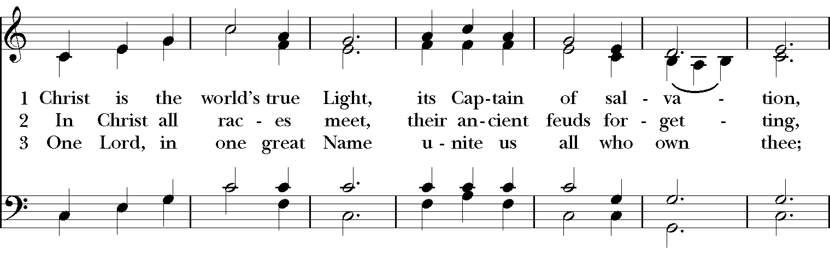
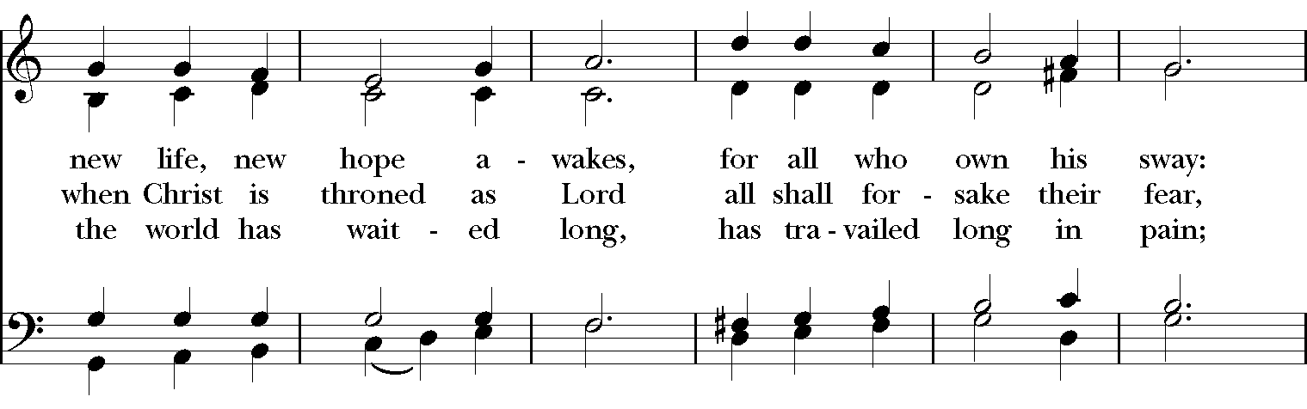
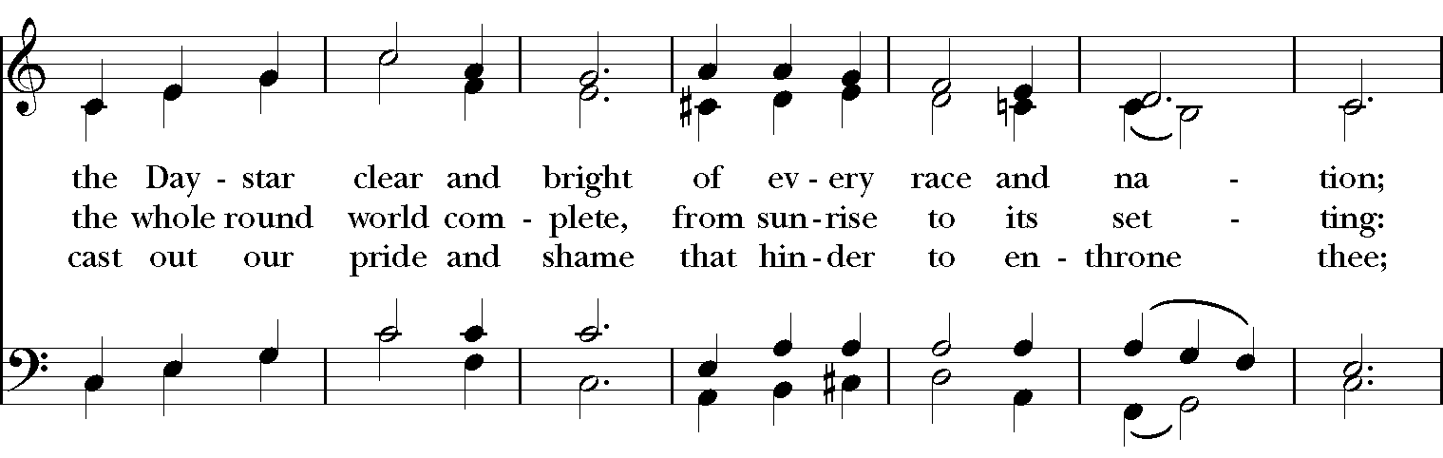

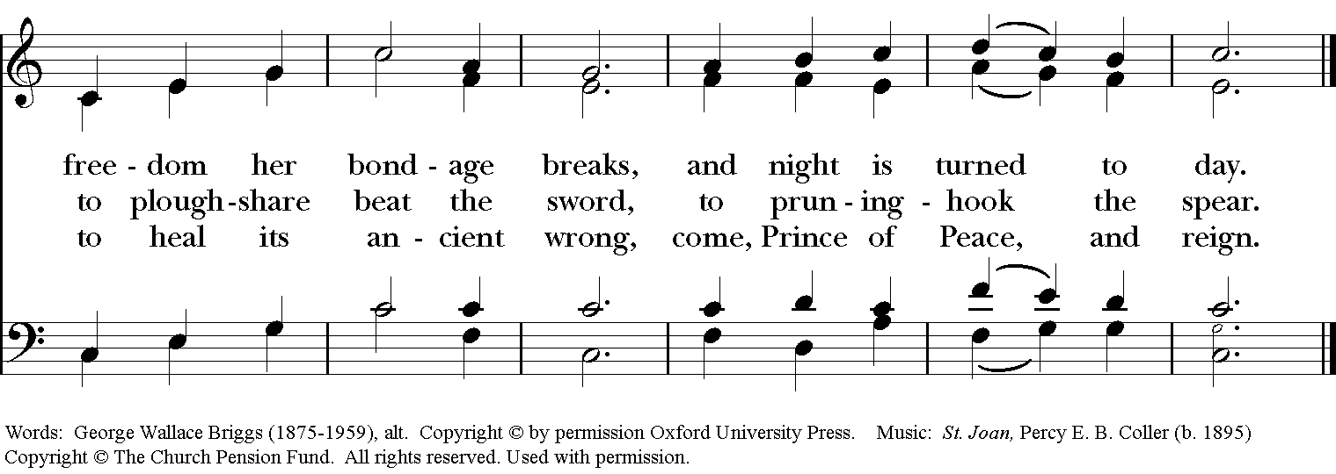

Blessing
May Christ, the Son of God, be manifest in you, that your lives may be a light to the world; and the blessing of God Almighty, the Father, the Son and the Holy Spirit, be among you and remain with you always. Amen.

Announcements

Dismissal
Deacon: Go in peace to love and serve the Lord.
People: Thanks be to God!

Postlude:

Thank you for your spiritual presence with us this morning!
Although we're physically apart, we are united in prayer, worship, and holy love!
Priest-In-Charge: The Rev. Dr. Canon Lee Anne Reat
Deacon: The Rev. Dr. Rick Incorvati
Music Director: Dr. Chris Durrenberger
Lector: Anne Strothman
Singers: Liz Wheeler, Joy Carter, Ed Hasecke, Fred Bartenstein
Technology: Steve Ide
Slideshow: Ed Hasecke
Parish Administrator and Program Coordinator: Kelly Zeller
Coffee Hour Host: Linda Mortensen

