Christ Episcopal Church in Springfield, Ohio
Service of the Word
Second Sunday after Christmas: January 3rd, 2021 at 9 am

Prelude: "We Three Kings of Orient Are" by John Henry Hopkins, Jr. ~ Joy Carter and Jeff Carter

Opening Hymn: “Angels we have heard on high” Hymn 96
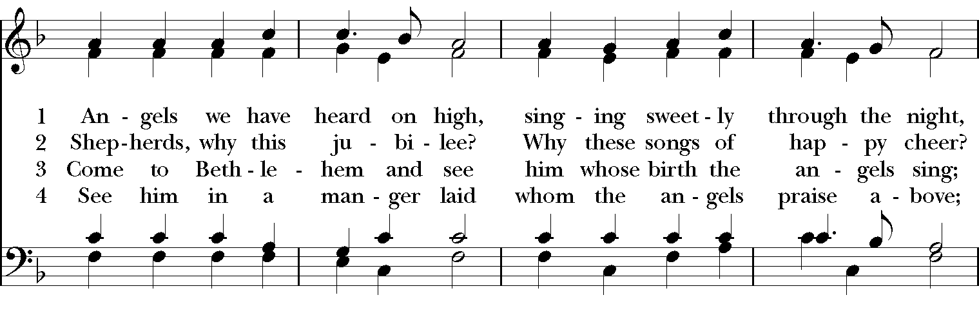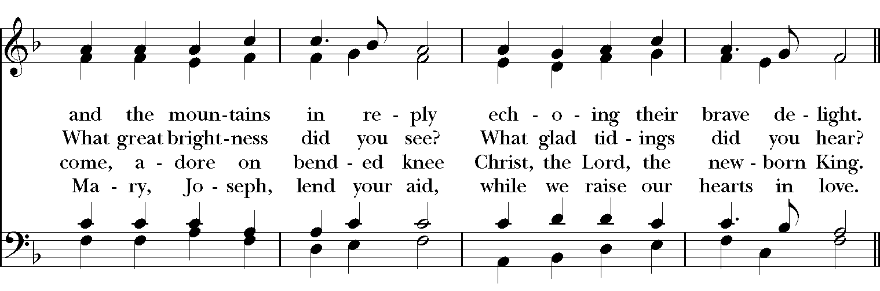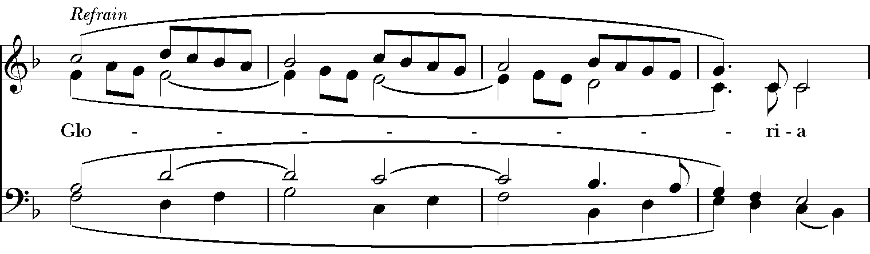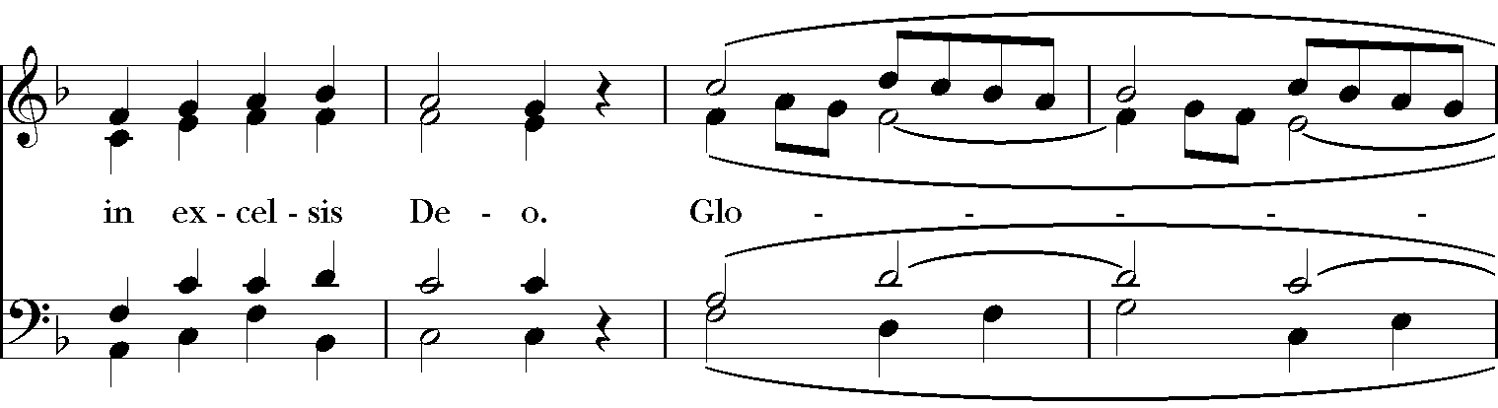

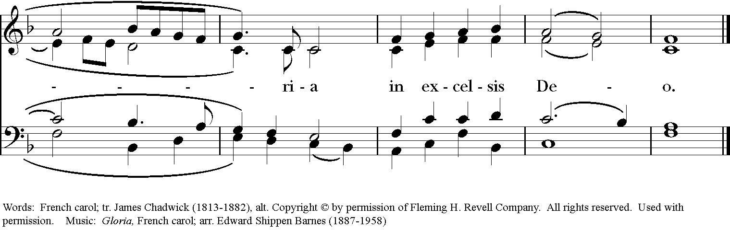

Celebrant: Blessed be God: Father, Son, and Holy Spirit.
People: And blessed be God’s kingdom, now and for ever. Amen.

Gloria:
Glory to God in the highest,
and peace to God’s people on earth.
Lord God, heavenly King,
almighty God and Father,
we worship you, we give you thanks,
we praise you for your glory.
Lord Jesus Christ, only Son of the Father,
Lord God, Lamb of God,
you take away the sin of the world:
have mercy on us;
you are seated at the right hand of the Father:
receive our prayer.
For you alone are the Holy One,
you alone are the Lord,
you alone are the Most High,
Jesus Christ,
with the Holy Spirit,
in the glory of God the Father. Amen.

The Collect of the Day
Celebrant: The Lord be with you.
People: And also with you.
Celebrant: Let us pray.
O God, who wonderfully created, and yet more wonderfully restored, the dignity of human nature: Grant that we may share the divine life of him who humbled himself to share our humanity, your Son Jesus Christ; who lives and reigns with you, in the unity of the Holy Spirit, one God, for ever and ever. Amen.

The Lessons

The First Reading: Jeremiah 31:7-14
Thus says the Lord:
Sing aloud with gladness for Jacob,
and raise shouts for the chief of the nations;
proclaim, give praise, and say,
"Save, O Lord, your people,
the remnant of Israel."
See, I am going to bring them from the land of the north,
and gather them from the farthest parts of the earth,
among them the blind and the lame, those with child and
those in labor, together;
a great company, they shall return here.
With weeping they shall come,
and with consolations I will lead them back,
I will let them walk by brooks of water,
in a straight path in which they shall not stumble;
for I have become a father to Israel,
and Ephraim is my firstborn.
Hear the word of the Lord, O nations,
and declare it in the coastlands far away;
say, "He who scattered Israel will gather him,
and will keep him as a shepherd a flock."
For the Lord has ransomed Jacob,
and has redeemed him from hands too strong for him.
They shall come and sing aloud on the height of Zion,
and they shall be radiant over the goodness of the Lord,
over the grain, the wine, and the oil,
and over the young of the flock and the herd;
their life shall become like a watered garden,
and they shall never languish again.
Then shall the young women rejoice in the dance,
and the young men and the old shall be merry.
I will turn their mourning into joy,
I will comfort them, and give them gladness for sorrow.
I will give the priests their fill of fatness,
and my people shall be satisfied with my bounty, says the Lord.
Reader: The Word of the Lord.
People: Thanks be to God.

Psalm 84 Quam dilecta!
1 How dear to me is your dwelling, O Lord of hosts! *
My soul has a desire and longing for the courts of the Lord;
my heart and my flesh rejoice in the living God.
2 The sparrow has found her a house
and the swallow a nest where she may lay her young; *
by the side of your altars, O Lord of hosts, my King and my God.
3 Happy are they who dwell in your house! *
they will always be praising you.
4 Happy are the people whose strength is in you! *
whose hearts are set on the pilgrims' way.
5 Those who go through the desolate valley will find it a place of springs, *
for the early rains have covered it with pools of water.
6 They will climb from height to height, *
and the God of gods will reveal himself in Zion.
7 Lord God of hosts, hear my prayer; *
hearken, O God of Jacob.
8 Behold our defender, O God; *
and look upon the face of your Anointed.
9 For one day in your courts is better than a thousand in my own room, *
and to stand at the threshold of the house of my God
than to dwell in the tents of the wicked.
10 For the Lord God is both sun and shield; *
he will give grace and glory;
11 No good thing will the Lord withhold *
from those who walk with integrity.
12 O Lord of hosts, *
happy are they who put their trust in you!

Second Lesson: Ephesians 1:3-6, 15-19a
Blessed be the God and Father of our Lord Jesus Christ, who has blessed us in Christ with every spiritual blessing in the heavenly places, just as he chose us in Christ before the foundation of the world to be holy and blameless before him in love. He destined us for adoption as his children through Jesus Christ, according to the good pleasure of his will, to the praise of his glorious grace that he freely bestowed on us in the Beloved.
I have heard of your faith in the Lord Jesus and your love toward all the saints, and for this reason I do not cease to give thanks for you as I remember you in my prayers. I pray that the God of our Lord Jesus Christ, the Father of glory, may give you a spirit of wisdom and revelation as you come to know him, so that, with the eyes of your heart enlightened, you may know what is the hope to which he has called you, what are the riches of his glorious inheritance among the saints, and what is the immeasurable greatness of his power for us who believe.
Reader: The Word of the Lord.
People: Thanks be to God.

Sequence Hymn: “Lo, how a Rose e’er blooming” Hymnal 81

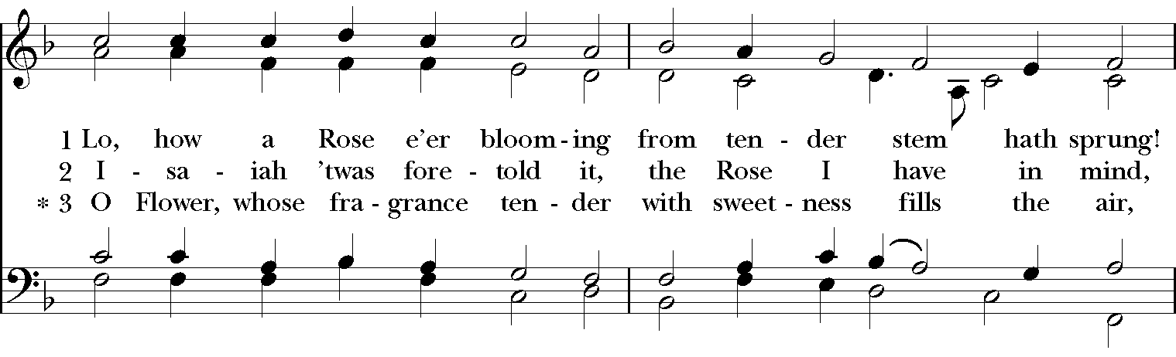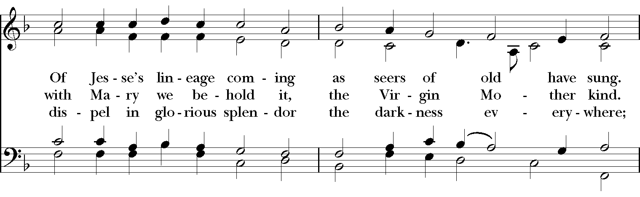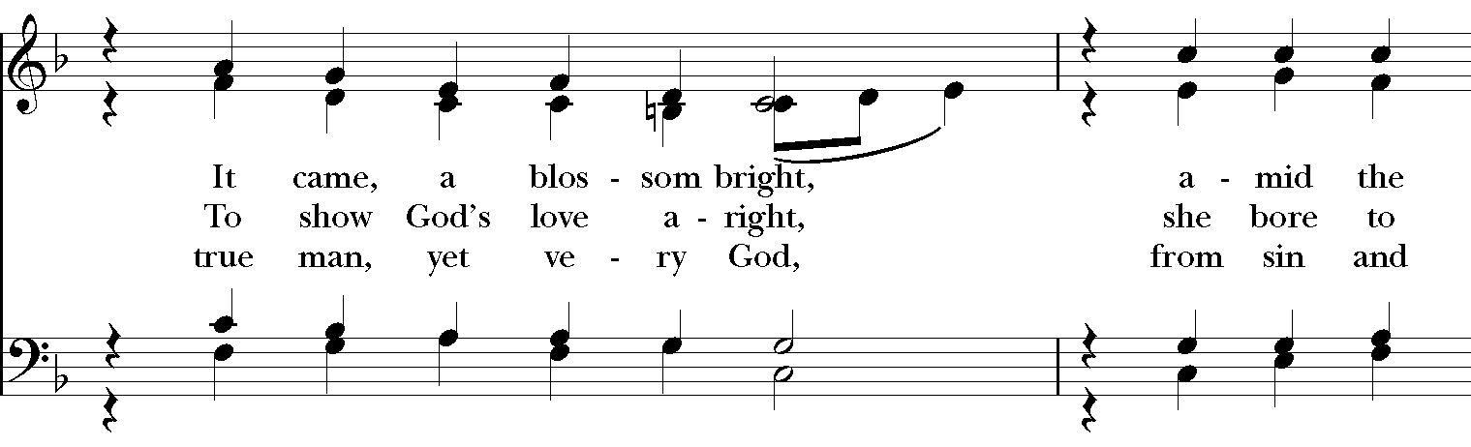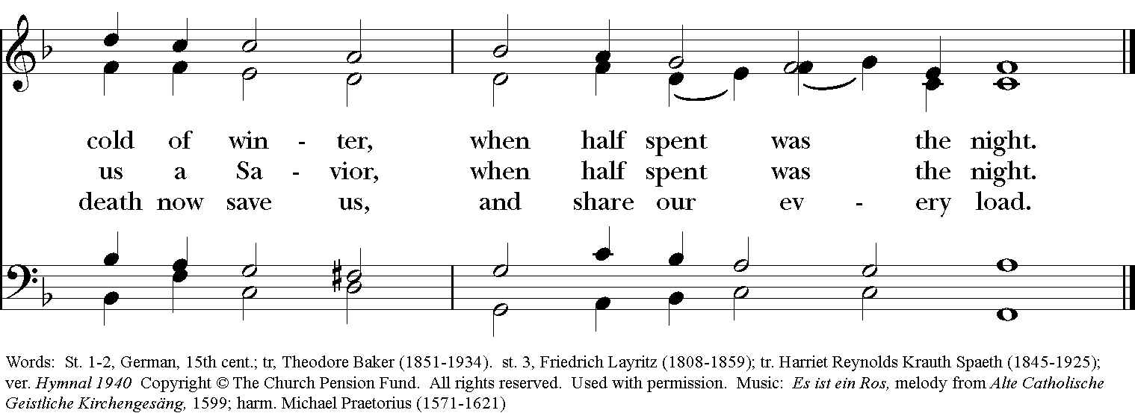

Gospel
Deacon: The Holy Gospel According to Matthew (2:13-15, 19-23)
People: Glory to you, Lord Christ.
After the wise men had left, an angel of the Lord appeared to Joseph in a dream and said, "Get up, take the child and his mother, and flee to Egypt, and remain there until I tell you; for Herod is about to search for the child, to destroy him." Then Joseph got up, took the child and his mother by night, and went to Egypt, and remained there until the death of Herod. This was to fulfill what had been spoken by the Lord through the prophet, "Out of Egypt I have called my son."
When Herod died, an angel of the Lord suddenly appeared in a dream to Joseph in Egypt and said, "Get up, take the child and his mother, and go to the land of Israel, for those who were seeking the child's life are dead." Then Joseph got up, took the child and his mother, and went to the land of Israel. But when he heard that Archelaus was ruling over Judea in place of his father Herod, he was afraid to go there. And after being warned in a dream, he went away to the district of Galilee. There he made his home in a town called Nazareth, so that what had been spoken through the prophets might be fulfilled, "He will be called a Nazorean."
Deacon: The Gospel of the Lord.
People: Praise to you, Lord Christ.

Sermon The Rev. Canon Dr. Lee Anne Reat

The Nicene Creed
We believe in one God,
the Father, the Almighty,
the maker of heaven and earth,
of all that is, seen and unseen.
We believe in one Lord, Jesus Christ,
the only Son of God,
eternally begotten of the Father,
God from God, Light from Light,
true God from true God,
begotten, not made,
of one Being with the Father.
Through him all things were made.
For us and for our salvation
he came down from heaven:
by the power of the Holy Spirit
he became incarnate from the Virgin Mary,
and was made man.
For our sake he was crucified under Pontius Pilate;
he suffered death and was buried.
On the third day he rose again
in accordance with the Scriptures;
He ascended into heaven
and is seated on the right hand of the Father.
He will come again in glory to judge the living and the dead,
and his kingdom will have no end.
We believe in the Holy Spirit, the Lord, the giver of life,
who proceeds from the Father and the Son.
With the Father and the Son he is worshiped and glorified.
He has spoken through the Prophets.
We believe in one holy catholic and apostolic Church.
We acknowledge one baptism for the forgiveness of sins.
We look for the resurrection of the dead,
and the life of the world to come. Amen.

The Prayers of the People

In peace, we pray to you Lord God.

Silence
Let us pray to God, who came among us in the birth of Jesus:
Gracious God, as a star rose, and drew people from great distances to Bethlehem that they might greet the Christ-child; Draw us, your Church, and all of your people to you – that we might be the Church and the People who you call us to be.
Lord, in your mercy,
Hear our prayer.

As you gave Mary your Holy Spirit, filling her with the delight of your Presence; Fill us with your Spirit, and renew our lives.
Lord, in your mercy,
Hear our prayer.

As Gentiles streamed to Jesus’ Light, and Kings to the brightness of his rising; Draw our nation, our President, and all in authority, to His brightness. Bless Justin, Archbishop of Canterbury; Michael, our Presiding Bishop; Ken, our Bishop; Lee Anne, our priest, and Rick, our deacon.
Lord, in your mercy,
Hear our prayer.

As angels sang ‘glorias’ to you and proclaimed peace on earth, and goodwill among all peoples; Bring us your peace, and bring an end to terror and strife.
Lord, in your mercy,
Hear our prayer.
As shepherds were drawn away from their flocks by night; Draw those who do not know you yet to the knowledge and love of you.
Lord, in your mercy,
Hear our prayer.

As Jesus was born in a manger, because there was no room for them in the inn; Be especially present with those who have nowhere to lay their heads, those who are vulnerable, and those who are hungry. Especially, Rainbow Table, Springfield Promise Neighborhood, Springfield Peace Center, and Partners in Ministry in Liberia.
Lord, in your mercy,
Hear our prayer.

As the Holy Family gathered together in Bethlehem, and traveled together to far off lands; Bless all families, especially the families of our parish, and protect those who travel. We celebrate with those who have birthdays, especially Margaret, Graham, Audrey, and Emily and anniversaries this week.
Lord, in your mercy,
Hear our prayer.

As your son came to proclaim the forgiveness of sins, and the gift of Life Eternal; Give to the departed, especially Ruth Bayley, eternal rest and let Light perpetual shine on them.
Lord, in your mercy,
Hear our prayer.

Let us pray for our own needs and those of others, especially Judy, Lynn, Joan, Chris, Dodi, Laura, Bonnie, Alice, Diana, James, Joy, Jane, Joni, Kim, Bobby, Ruth, Sarah, Traudie, Lexie, Norm, and Keith.
Lord, in your mercy,
Hear our prayer.

O Lord our God, may the Light and Hope of this season, and of your Son’s Incarnation, reassure our hearts that you are among us, that you hear our prayer, and that you will be with us always, even to the end of the age. In the name of Jesus of Nazareth we pray. Amen.

Deacon: Let us confess our sins against God and our neighbor.
All: Most merciful God, we confess that we have sinned against you in thought, word, and deed, by what we have done, and by what we have left undone. We have not loved you with our whole heart; we have not loved our neighbors as ourselves. We are truly sorry and we humbly repent. For the sake of your Son Jesus Christ, have mercy on us and forgive us; that we may delight in your will, and walk in your ways, to the glory of your Name. Amen.

Priest: Almighty God, have mercy on you, forgive you all your sins through our Lord Jesus Christ, strengthen you in all goodness, and by the power of the Holy Spirit keep you in eternal life. Amen.

And now, as our Savior Christ has taught us, we are bold to say:
Our Father, who art in heaven, hallowed be thy Name,
thy kingdom come, thy will be done, on earth as it is in heaven.
Give us this day our daily bread.
And forgive us our trespasses, as we forgive those who trespass against us.
And lead us not into temptation, but deliver us from evil.
For thine is the kingdom, and the power, and the glory, for ever and ever. Amen.

Closing Hymn: “Go tell it on the mountain” Hymnal 99

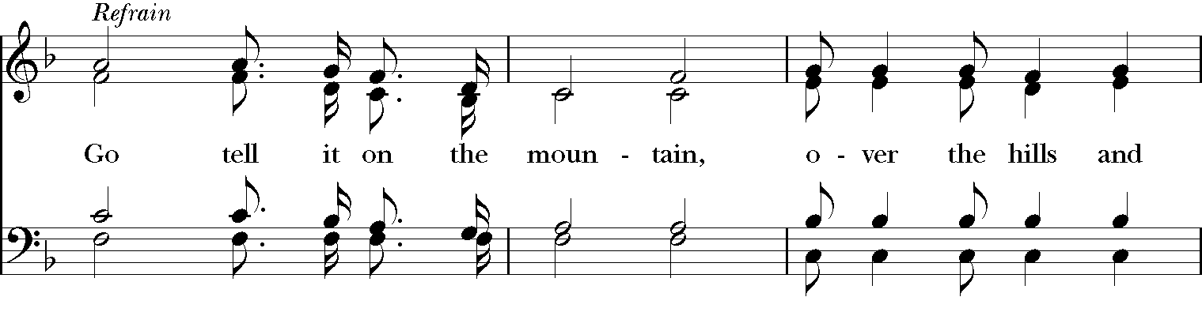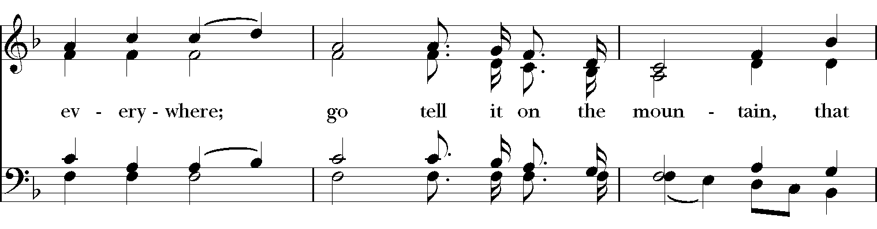
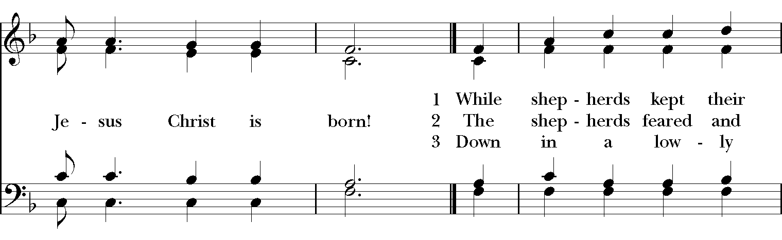
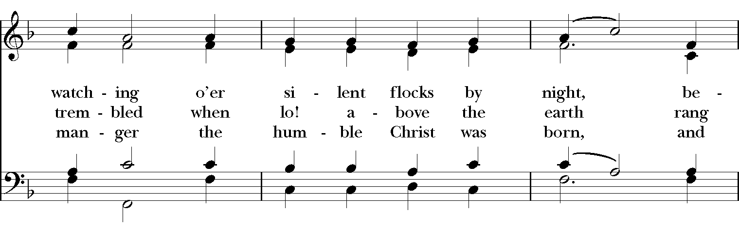

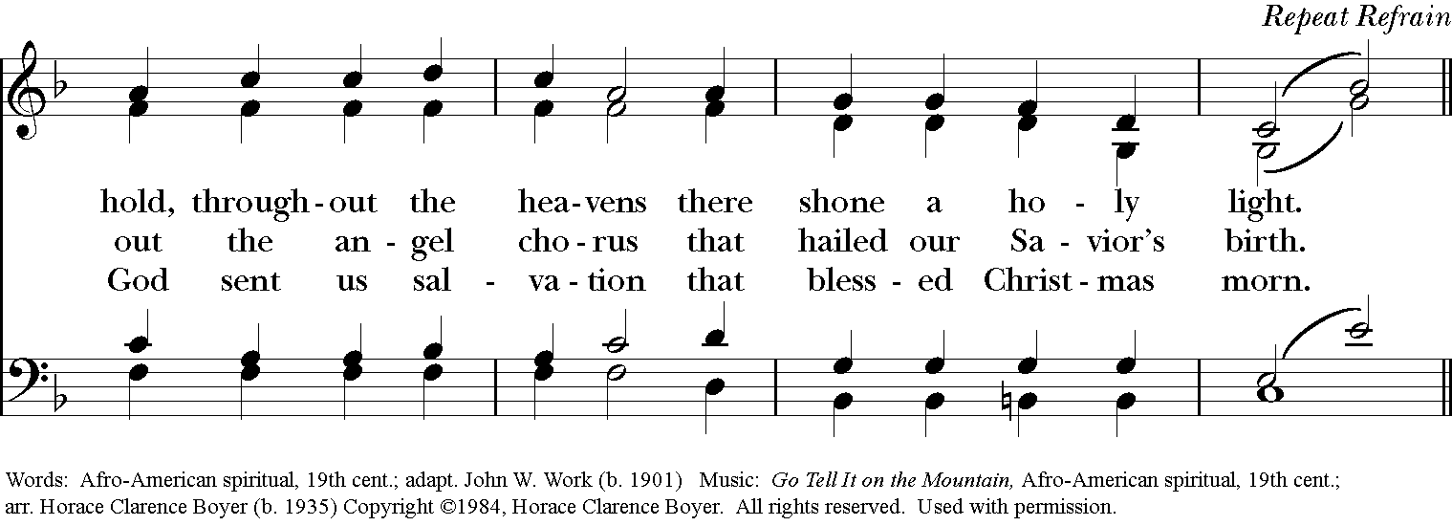

Blessing
May Christ, who by his Incarnation gathered into one things earthly and heavenly, fill you with his joy and peace; and the blessing of God Almighty, the Father, the Son, and the Holy Spirit, be among you, and remain with you always. Amen

Announcements

Dismissal
Deacon: Go in peace to love and serve the Lord.
People: Thanks be to God!

Postlude: "Mary Did You Know?" by Mark Lowry and Buddy Greene ~ Joy Carter and
Jeff Carter

Thank you for your spiritual presence with us this morning!
Although we're physically apart, we are united in prayer, worship, and holy love!
Priest-In-Charge: The Rev. Dr. Canon Lee Anne Reat
Deacon: The Rev. Dr. Rick Incorvati
Music Director: Dr. Chris Durrenberger
Guest Musicians: Joy Carter and Jeff Carter
Lectors: Steve Schlather
Singers: Liz Wheeler, Joy Carter, Ed Hasecke, Fred Bartenstein
Technology: Steve Ide
Slideshow: Ed Hasecke
Parish Administrator and Program Coordinator: Kelly Zeller
Coffee Hour Host: Ron Dowling

