Christ Episcopal Church in Springfield, Ohio
Service of the Word
Ninth Sunday after Pentecost: July 25th, 2021 at 9 am

PRELUDE: “O Morning Star, How Fair and Bright” - Wie Schön Leuchtet/arr. Held

OPENING HYMN: “Take my life, and let it be ” Hymnal 707
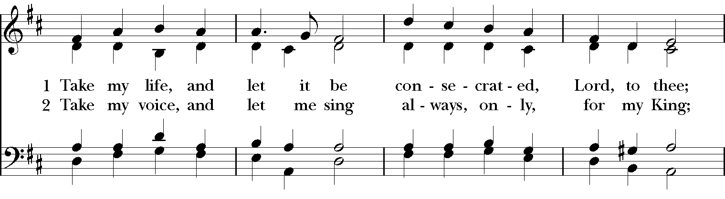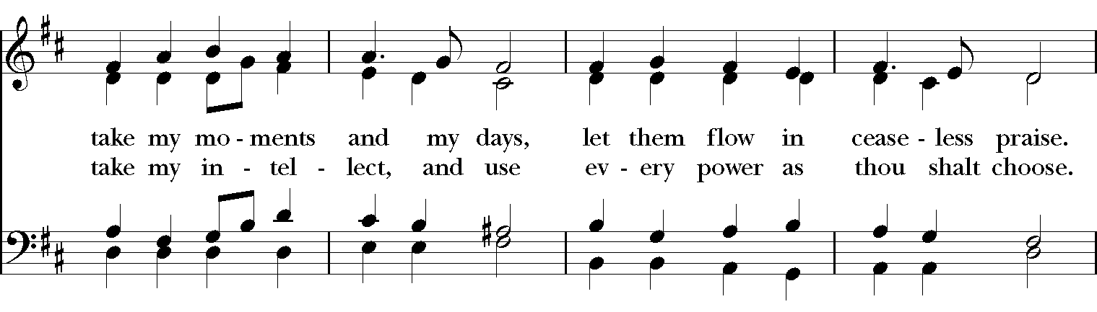
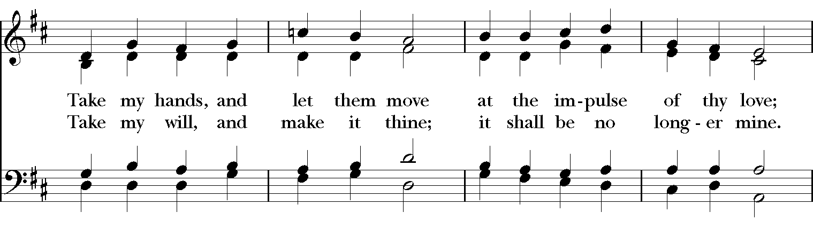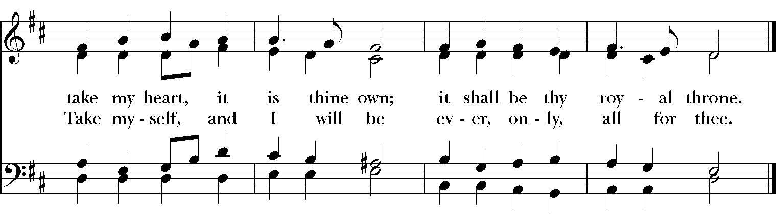

Celebrant: Blessed be God: Father, Son, and Holy Spirit.
People: And blessed be his kingdom, now and for ever. Amen.

The Collect of the Day
Celebrant: The Lord be with you.
People: And also with you.
Celebrant: Let us pray.
O God, the protector of all who trust in you, without whom nothing is strong, nothing is holy: Increase and multiply upon us your mercy; that, with you as our ruler and guide, we may so pass through things temporal, that we lose not the things eternal; through Jesus Christ our Lord, who lives and reigns with you and the Holy Spirit, one God, for ever and ever. Amen.

THE LESSONS

THE FIRST READING 2 Samuel 11:1-15
In the spring of the year, the time when kings go out to battle, David sent Joab with his officers and all Israel with him; they ravaged the Ammonites, and besieged Rabbah. But David remained at Jerusalem.

It happened, late one afternoon, when David rose from his couch and was walking about on the roof of the king’s house, that he saw from the roof a woman bathing; the woman was very beautiful. David sent someone to inquire about the woman. It was reported, “This is Bathsheba daughter of Eliam, the wife of Uriah the Hittite.” So David sent messengers to get her, and she came to him, and he lay with her. (Now she was purifying herself after her period.) Then she returned to her house. The woman conceived; and she sent and told David, “I am pregnant.”
So David sent word to Joab, “Send me Uriah the Hittite.” And Joab sent Uriah to David. When Uriah came to him, David asked how Joab and the people fared, and how the war was going. Then David said to Uriah, “Go down to your house, and wash your feet.” Uriah went out of the king’s house, and there followed him a present from the king. But Uriah slept at the entrance of the king’s house with all the servants of his lord, and did not go down to his house. When they told David, “Uriah did not go down to his house,” David said to Uriah, “You have just come from a journey. Why did you not go down to your house?” Uriah said to David, “The ark and Israel and Judah remain in booths; and my lord Joab and the servants of my lord are camping in the open field; shall I then go to my house, to eat and to drink, and to lie with my wife? As you live, and as your soul lives, I will not do such a thing.” Then David said to Uriah, “Remain here today also, and tomorrow I will send you back.” So Uriah remained in Jerusalem that day. On the next day, David invited him to eat and drink in his presence and made him drunk; and in the evening he went out to lie on his couch with the servants of his lord, but he did not go down to his house.

In the morning David wrote a letter to Joab, and sent it by the hand of Uriah. In the letter he wrote, “Set Uriah in the forefront of the hardest fighting, and then draw back from him, so that he may be struck down and die.”
Lector: The Word of the Lord.
People: Thanks be to God.

PSALM 14 Dixit insipiens
1 The fool has said in his heart, "There is no God." *
All are corrupt and commit abominable acts; there is none who does any good.
2 The Lord looks down from heaven upon us all, *
to see if there is any who is wise, if there is one who seeks after God.
3 Every one has proved faithless; all alike have turned bad; *
there is none who does good; no, not one.
4 Have they no knowledge, all those evildoers *
who eat up my people like bread and do not call upon the Lord?
5 See how they tremble with fear, *
because God is in the company of the righteous.
6 Their aim is to confound the plans of the afflicted, *
but the Lord is their refuge.
7 Oh, that Israel's deliverance would come out of Zion! *
when the Lord restores the fortunes of his people, Jacob will rejoice and Israel be glad.

THE SECOND LESSON Ephesians 3:14-21
I bow my knees before the Father, from whom every family in heaven and on earth takes its name. I pray that, according to the riches of his glory, he may grant that you may be strengthened in your inner being with power through his Spirit, and that Christ may dwell in your hearts through faith, as you are being rooted and grounded in love. I pray that you may have the power to comprehend, with all the saints, what is the breadth and length and height and depth, and to know the love of Christ that surpasses knowledge, so that you may be filled with all the fullness of God.

Now to him who by the power at work within us is able to accomplish abundantly far more than all we can ask or imagine, to him be glory in the church and in Christ Jesus to all generations, forever and ever. Amen.
Lector: The Word of the Lord.
People: Thanks be to God.
SEQUENCE HYMN: “The church’s one foundation” Hymnal 525
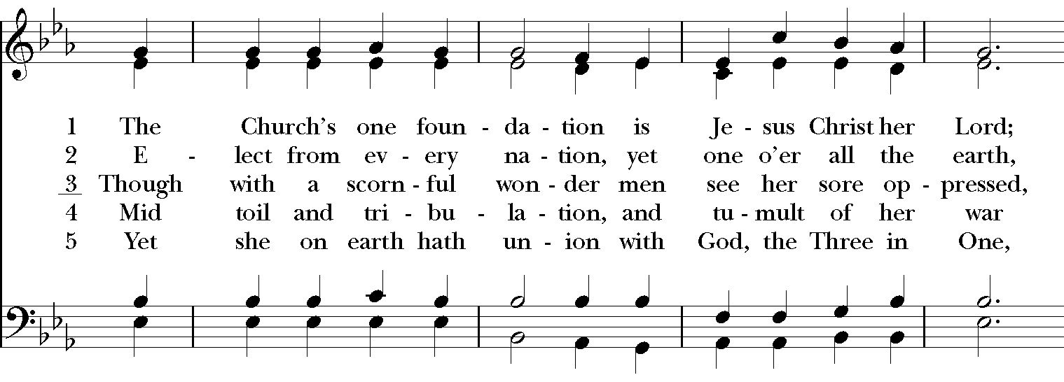
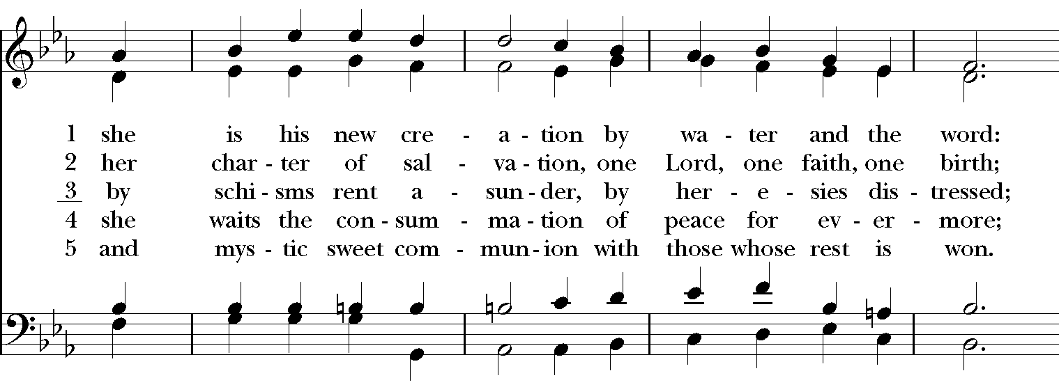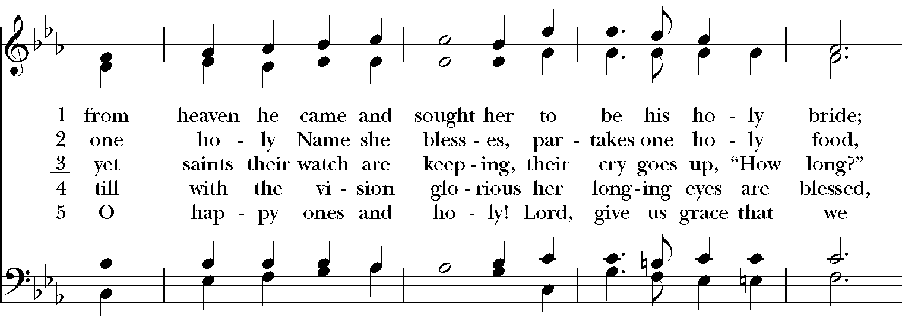
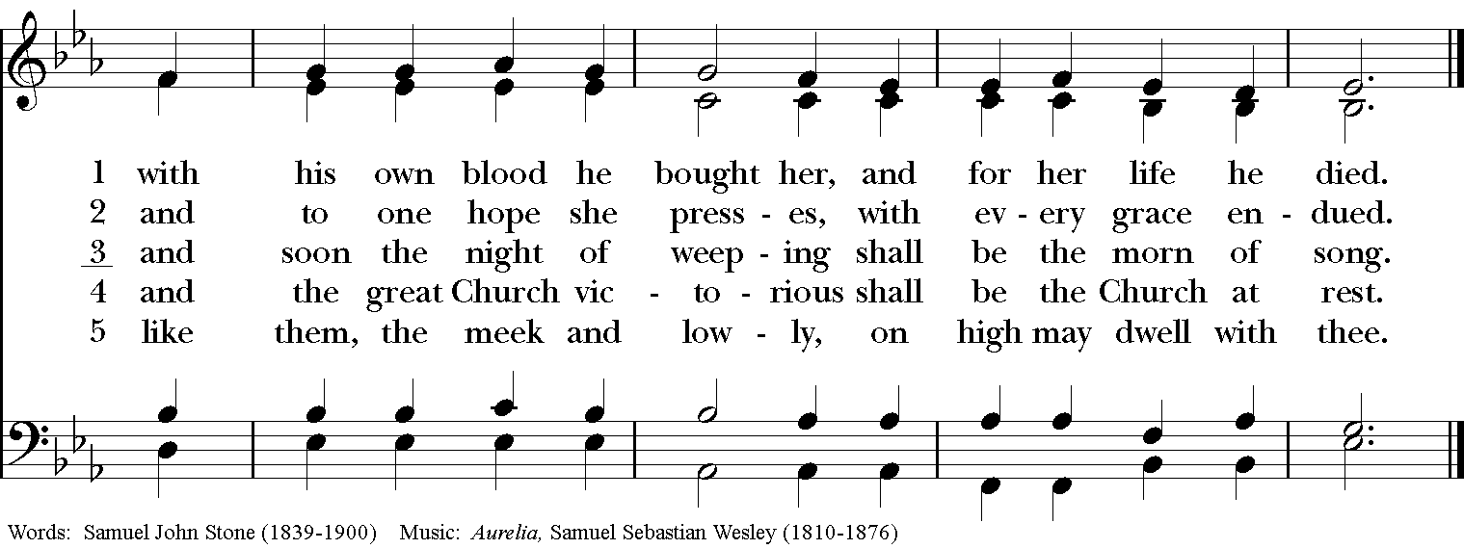

GOSPEL
Deacon: The Holy Gospel of our Lord Jesus Christ according to John (John 6:1-21).
People: Glory to you, Lord Christ.
Deacon: The Gospel of the Lord. Jesus went to the other side of the Sea of Galilee, also called the Sea of Tiberias. A large crowd kept following him, because they saw the signs that he was doing for the sick. Jesus went up the mountain and sat down there with his disciples. Now the Passover, the festival of the Jews, was near. When he looked up and saw a large crowd coming toward him, Jesus said to Philip, “Where are we to buy bread for these people to eat?” He said this to test him, for he himself knew what he was going to do. Philip answered him, “Six months’ wages would not buy enough bread for each of them to get a little.” One of his disciples, Andrew, Simon Peter’s brother, said to him, “There is a boy here who has five barley loaves and two fish. But what are they among so many people?” Jesus said, “Make the people sit down.” Now there was a great deal of grass in the place; so they sat down, about five thousand in all. Then Jesus took the loaves, and when he had given thanks, he distributed them to those who were seated; so also the fish, as much as they wanted. When they were satisfied, he told his disciples, “Gather up the fragments left over, so that nothing may be lost.” So they gathered them up, and from the fragments of the five barley loaves, left by those who had eaten, they filled twelve baskets. When the people saw the sign that he had done, they began to say, “This is indeed the prophet who is to come into the world.”

When Jesus realized that they were about to come and take him by force to make him king, he withdrew again to the mountain by himself.

When evening came, his disciples went down to the sea, got into a boat, and started across the sea to Capernaum. It was now dark, and Jesus had not yet come to them. The sea became rough because a strong wind was blowing. When they had rowed about three or four miles, they saw Jesus walking on the sea and coming near the boat, and they were terrified. But he said to them, “It is I; do not be afraid.” Then they wanted to take him into the boat, and immediately the boat reached the land toward which they were going.
Deacon: The Gospel of the Lord.
People: Praise to you, Lord Christ.

Sermon The Rev. Rick Incorvati

The Nicene Creed
We believe in one God, the Father, the Almighty,
maker of heaven and earth, of all that is, seen and unseen.
We believe in one Lord, Jesus Christ, the only Son of God,
eternally begotten of the Father, God from God,
Light from Light, true God from true God,
begotten, not made, of one Being with the Father.
Through him all things were made.
For us and for our salvation he came down from heaven,
by the power of the Holy Spirit he became incarnate from the Virgin Mary,
and was made man.
For our sake he was crucified under Pontius Pilate;
he suffered death and was buried.
On the third day he rose again in accordance with the Scriptures;
he ascended into heaven and is seated at the right hand of the Father.
He will come again in glory to judge the living and the dead, and his kingdom will have no end.
We believe in the Holy Spirit, the Lord, the giver of life,
who proceeds from the Father, and the Son.
who with the Father and the Son is worshiped and glorified,
who has spoken through the Prophets.
We believe in one holy catholic and apostolic Church.
We acknowledge one baptism for the forgiveness of sins.
We look for the resurrection of the dead, and the life of the world to come. Amen.

THE PRAYERS OF THE PEOPLE

In peace, we pray to you Lord God. Congregational responses are in bold.

Silence

Let us pray. Founder of our faith, we ask your guidance for the Church, for its unity, and for the work it does in the world. Give grace to its leaders, especially Justin, archbishop of Canterbury; Michael, our Presiding Bishop; George, our Provisional Bishop; Lee Anne, our priest; Rick, our deacon; and all the members of this parish.
R: Let your priests be clothed with righteousness; let your faithful people sing for joy.

Ruler over the nations, we pray for this country and its leaders in an unsettling time. Grant wisdom to all who serve in positions of leadership throughout the world.
R: For dominion belongs to the Lord, and he rules over the nations.

Lord of the harvest, we offer thanks for the beauty and abundance of this season. May we consider how best to tend the Earth and to share what You have given us, so that all may eat and be satisfied by your goodness. We pray for the ministries this church supports, especially Children’s Rescue Center/The Ark, Christ Church Food Pantry, The Fuller Center for Housing, and Safe Harbor House.
R: He covers the heavens with clouds, and prepares rain for the earth;
He makes grass grow upon the mountains, and green plants to serve humankind.

Giver of every good gift, we pray for those celebrating birthdays this week, especially Rick, Jake, Cash, Michael, Owen, and Benjamin.
R: Let the righteous be glad and rejoice before God; Let them also be merry and joyful.

Great Physician, we pray for healing and comfort for all those in need or pain, especially Leigh, Charlene, Faye, Chris, Bonnie, Alice, Diana, James, Joy, Jane, Joni, Kim, Bobby, Sarah, Traudie, Lexie, and Keith. May they remember that You are with them and those who care for them.
R: Surely you behold trouble and misery; you see it and take it into your own hand.
The helpless commit themselves to you; for you are the helper of orphans.

Just Judge, we ask your aid for all those in trouble, bringing before You prisoners and captives, refugees and the oppressed. We pray for those most vulnerable throughout the world, especially women and children.
R: Let justice roll down like waters, and righteousness like an ever-flowing stream.

Lord over life and death, we pray for all who have died, especially Betty Jo Rode asking light and peace for them and those who mourn.
R: Precious in the sight of the Lord is the death of his servant.

*THE COLLECT FOR PEACE
Grant, O God, that your holy and life-giving Spirit may so move every human heart, that barriers which divide us may crumble, suspicions disappear, and hatreds cease; that our divisions being healed, we may live in justice and peace; through Jesus Christ our Lord. Amen.

THE CONFESSION AND ABSOLUTION
Deacon: Let us confess our sins against God and our neighbor.
All: Most merciful God, we confess that we have sinned against you in thought, word, and deed, by what we have done, and by what we have left undone. We have not loved you with our whole heart; we have not loved our neighbors as ourselves. We are truly sorry and we humbly repent. For the sake of your Son Jesus Christ, have mercy on us and forgive us; that we may delight in your will, and walk in your ways, to the glory of your Name. Amen.

Priest: Almighty God, have mercy on you, forgive you all your sins through our Lord Jesus Christ, strengthen you in all goodness, and by the power of the Holy Spirit keep you in eternal life. Amen.

And now, as our Savior Christ has taught us, we are bold to say:
Our Father, who art in heaven, hallowed be thy Name,
thy kingdom come, thy will be done, on earth as it is in heaven.
Give us this day our daily bread.
And forgive us our trespasses, as we forgive those who trespass against us.
And lead us not into temptation, but deliver us from evil.
For thine is the kingdom, and the power, and the glory, for ever and ever. Amen

CLOSING HYMN: “Shepherd of souls, refresh and bless” Hymnal 343
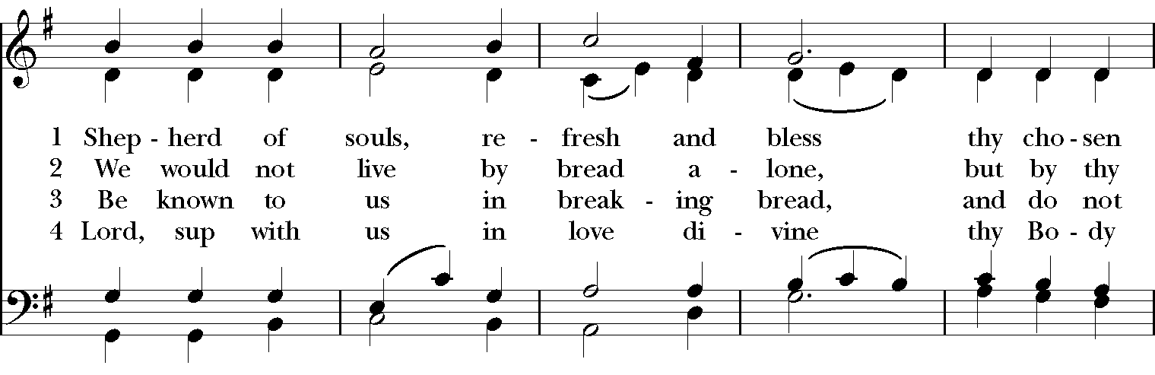
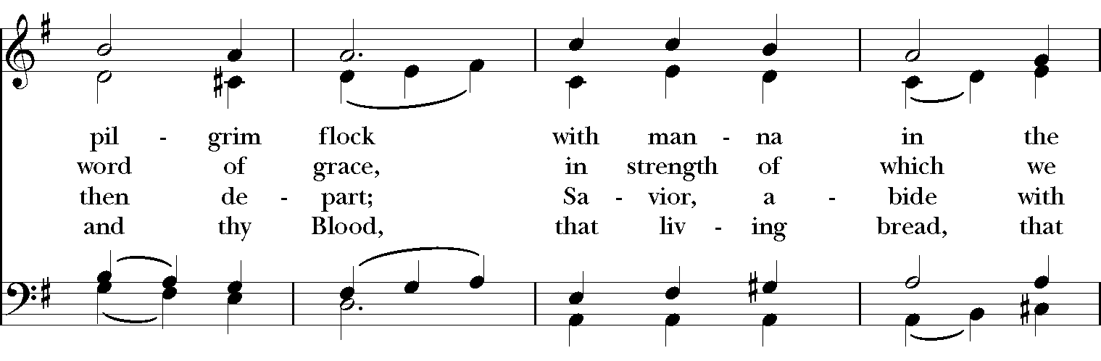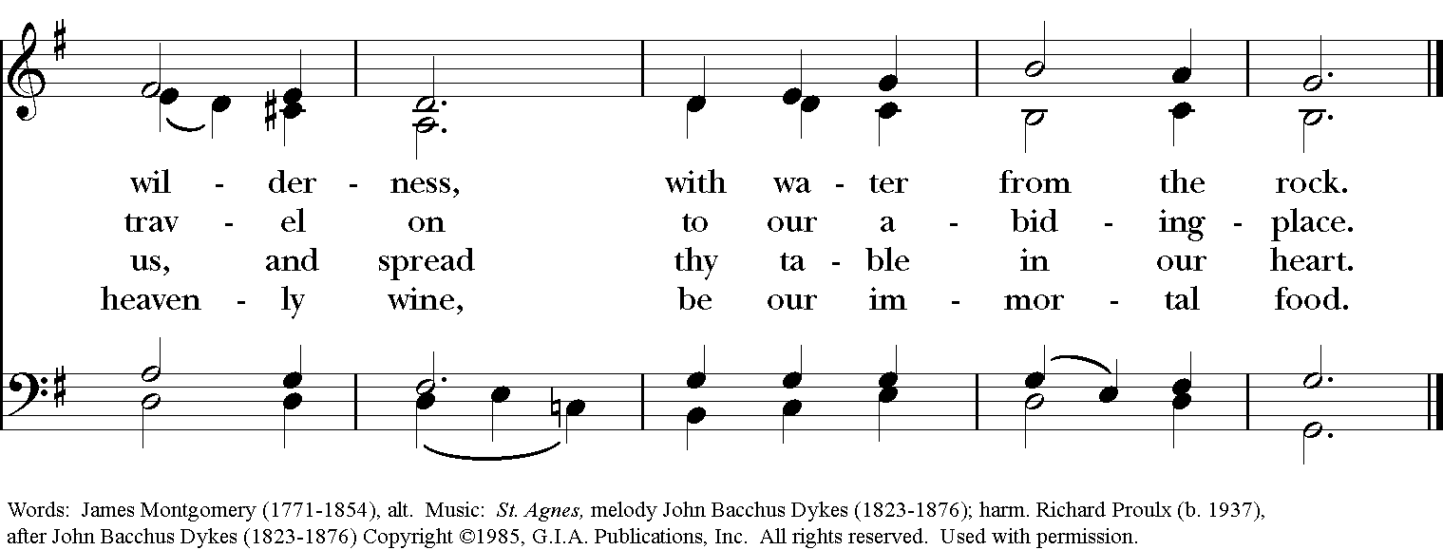

*THE BLESSING
Christ who has nourished us with himself the living bread, make you one in praise and love, and raise you up at the last day; and the blessing God Almighty, the Father, the Son, and the Holy Spirit, be among you, and remain with you always. Amen.

*THE DISMISSAL Deacon: Go in peace to love and serve the Lord.
People: Thanks be to God.

POSTLUDE: “Sarabande” from English Suite No. 1 in F Major - J.S. Bach

Thank you for your spiritual presence with us this morning!
Although we're physically apart, we are united in prayer, worship, and holy love!
Priest-In-Charge: The Rev. Dr. Canon Lee Anne Reat
Deacon: The Rev. Dr. Rick Incorvati
Music Director: Dr. Chris Durrenberger
Lector: Liz Wheeler
Singers: Liz Wheeler, Joy Carter, Basil Fett, Chris Oldstone-Moore, and Fred Bartenstein
Technology: Steve Ide
Slideshow: Ed Hasecke
Parish Administrator and Program Coordinator: Kelly Zeller

