Christ Episcopal Church in Springfield, Ohio
Service of the Word
Sixth Sunday after Pentecost: July 4th, 2021 at 9 am

PRELUDE: Prelude on “O Beautiful for Spacious Skies” - Materna/arr. Callahan

OPENING HYMN: “Come down, O Love Divine Hymnal 516
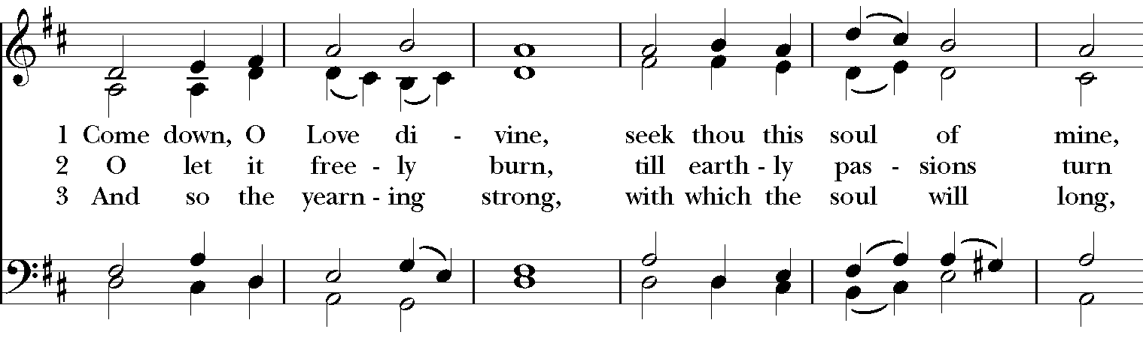

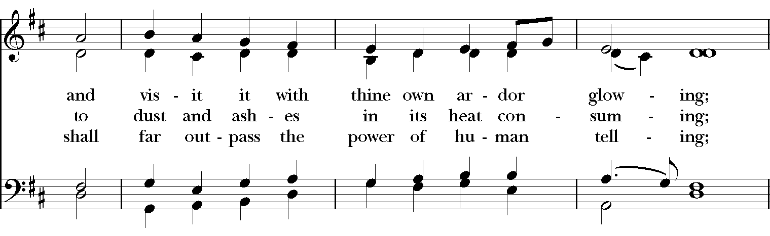

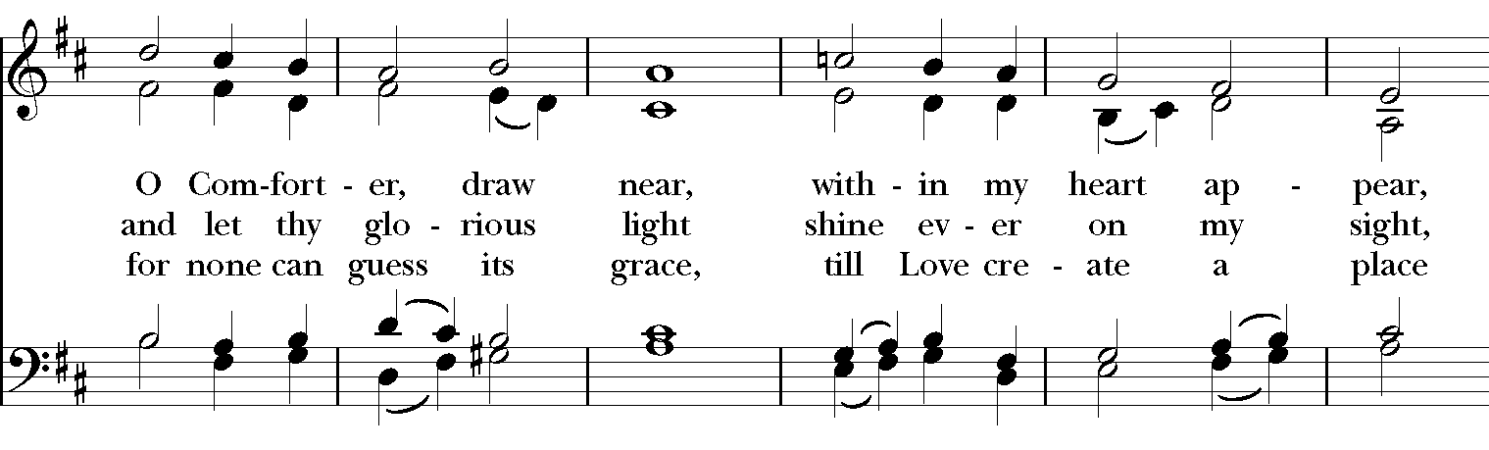

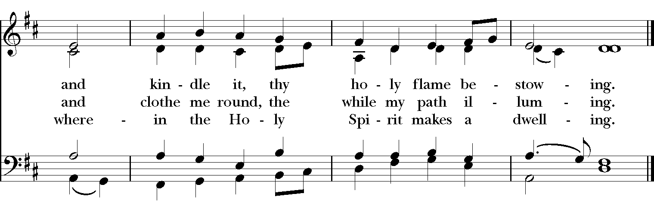

Celebrant: Blessed be God: Father, Son, and Holy Spirit.
People: And blessed be his kingdom, now and for ever. Amen.

The Collect of the Day
Celebrant: The Lord be with you.
People: And also with you.
Celebrant: Let us pray.
O God, you have taught us to keep all your commandments by loving you and our neighbor: Grant us the grace of your Holy Spirit, that we may be devoted to you with our whole heart, and united to one another with pure affection; through Jesus Christ our Lord, who lives and reigns with you and the Holy Spirit, one God, for ever and ever. Amen.

THE LESSONS

THE FIRST READING Ezekiel 2:1-5

The Lord said to me: O mortal, stand up on your feet, and I will speak with you. And when he spoke to me, a spirit entered into me and set me on my feet; and I heard him speaking to me. He said to me, Mortal, I am sending you to the people of Israel, to a nation of rebels who have rebelled against me; they and their ancestors have transgressed against me to this very day. The descendants are impudent and stubborn. I am sending you to them, and you shall say to them, “Thus says the Lord God.” Whether they hear or refuse to hear (for they are a rebellious house), they shall know that there has been a prophet among them.
Lector: The Word of the Lord.
People: Thanks be to God.

Psalm 123 Ad te levavi oculos meos
1 To you I lift up my eyes, *
to you enthroned in the heavens.
2 As the eyes of servants look to the hand of their masters, *
and the eyes of a maid to the hand of her mistress,
3 So our eyes look to the Lord our God, *
until he show us his mercy.
4 Have mercy upon us, O Lord, have mercy, *
for we have had more than enough of contempt,
5 Too much of the scorn of the indolent rich, *
and of the derision of the proud.

THE SECOND LESSON 2 Corinthians 12:2-10
I know a person in Christ who fourteen years ago was caught up to the third heaven—whether in the body or out of the body I do not know; God knows. And I know that such a person—whether in the body or out of the body I do not know; God knows— was caught up into Paradise and heard things that are not to be told, that no mortal is permitted to repeat. On behalf of such a one I will boast, but on my own behalf I will not boast, except of my weaknesses. But if I wish to boast, I will not be a fool, for I will be speaking the truth. But I refrain from it, so that no one may think better of me than what is seen in me or heard from me, even considering the exceptional character of the revelations. Therefore, to keep me from being too elated, a thorn was given me in the flesh, a messenger of Satan to torment me, to keep me from being too elated. Three times I appealed to the Lord about this, that it would leave me, but he said to me, “My grace is sufficient for you, for power is made perfect in weakness.” So, I will boast all the more gladly of my weaknesses, so that the power of Christ may dwell in me. Therefore I am content with weaknesses, insults, hardships, persecutions, and calamities for the sake of Christ; for whenever I am weak, then I am strong.
Lector: The Word of the Lord.
People: Thanks be to God.

SEQUENCE HYMN: Blessed Assurance Hymnal 184
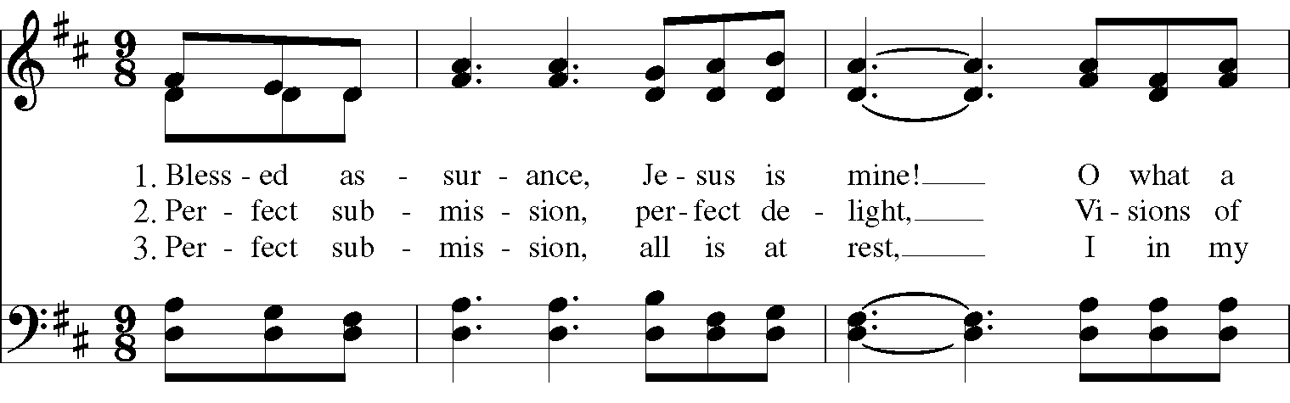

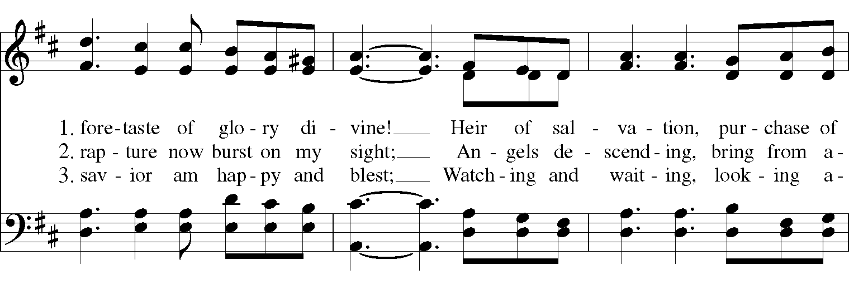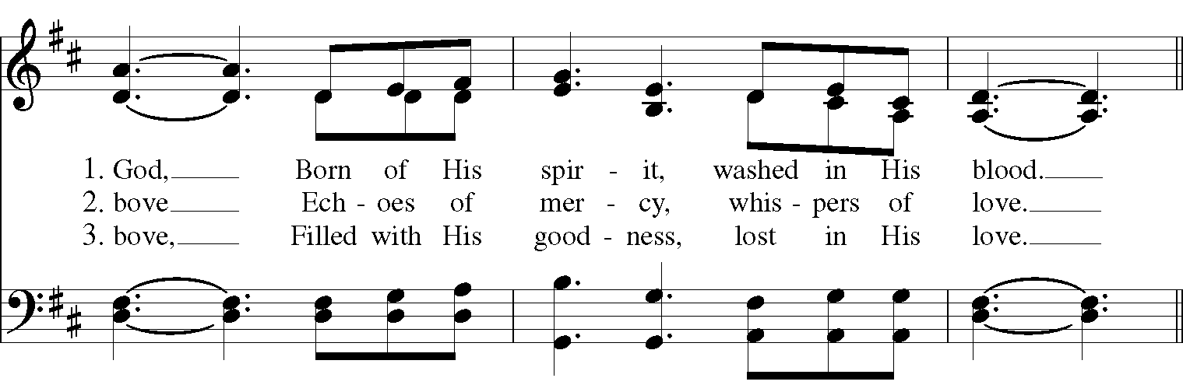
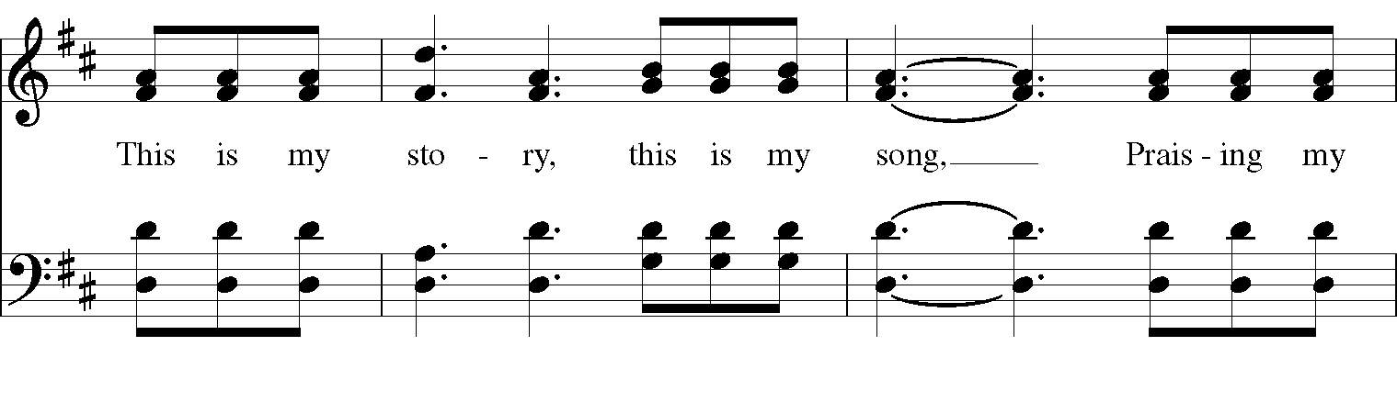
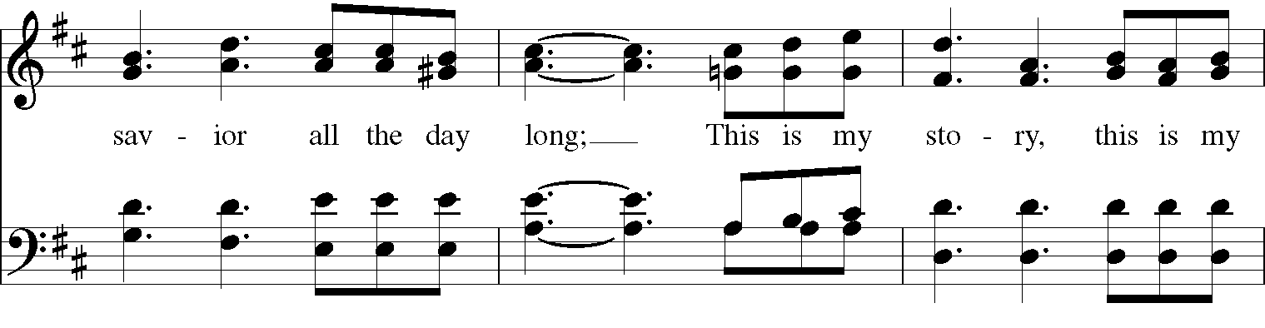
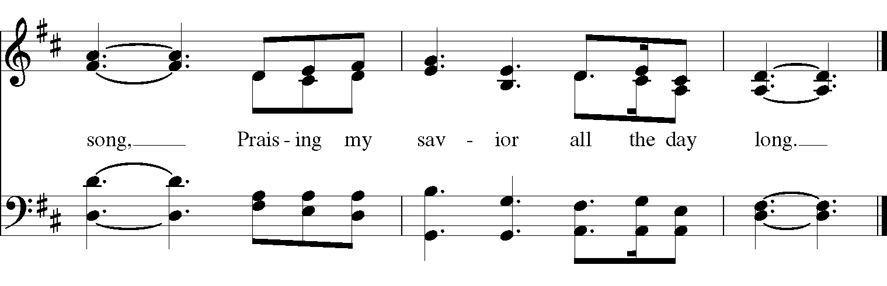

The Apostles’ Creed
I believe in God, the Father almighty,
creator of heaven and earth;
I believe in Jesus Christ, his only Son, our Lord.
He was conceived by the power of the Holy Spirit
GOSPEL
Deacon: The Holy Gospel of our Lord Jesus Christ according to Mark (Mark 6:1-13).
People: Glory to you, Lord Christ
Jesus came to his hometown, and his disciples followed him. On the sabbath he began to teach in the synagogue, and many who heard him were astounded. They said, “Where did this man get all this? What is this wisdom that has been given to him? What deeds of power are being done by his hands! Is not this the carpenter, the son of Mary and brother of James and Joses and Judas and Simon, and are not his sisters here with us?” And they took offense at him. Then Jesus said to them, “Prophets are not without honor, except in their hometown, and among their own kin, and in their own house.” And he could do no deed of power there, except that he laid his hands on a few sick people and cured them. And he was amazed at their unbelief.

Then he went about among the villages teaching. He called the twelve and began to send them out two by two, and gave them authority over the unclean spirits. He ordered them to take nothing for their journey except a staff; no bread, no bag, no money in their belts; but to wear sandals and not to put on two tunics. He said to them, “Wherever you enter a house, stay there until you leave the place. If any place will not welcome you and they refuse to hear you, as you leave, shake off the dust that is on your feet as a testimony against them.” So they went out and proclaimed that all should repent. They cast out many demons, and anointed with oil many who were sick and cured them.
Deacon: The Gospel of the Lord.
People: Praise to you, Lord Christ.

Sermon The Rev. Canon Dr. Lee Anne Reat

The Nicene Creed
We believe in one God, the Father, the Almighty,
maker of heaven and earth, of all that is, seen and unseen.
We believe in one Lord, Jesus Christ, the only Son of God,
eternally begotten of the Father, God from God,
Light from Light, true God from true God,
begotten, not made, of one Being with the Father.
Through him all things were made.
For us and for our salvation he came down from heaven,
by the power of the Holy Spirit he became incarnate from the Virgin Mary,
and was made man.
For our sake he was crucified under Pontius Pilate;
he suffered death and was buried.
On the third day he rose again in accordance with the Scriptures;
he ascended into heaven and is seated at the right hand of the Father.
He will come again in glory to judge the living and the dead, and his kingdom will have no end.
We believe in the Holy Spirit, the Lord, the giver of life,
who proceeds from the Father, and the Son.
who with the Father and the Son is worshiped and glorified,
who has spoken through the Prophets.
We believe in one holy catholic and apostolic Church.
We acknowledge one baptism for the forgiveness of sins.
We look for the resurrection of the dead, and the life of the world to come. Amen.

The Prayers of the People

In peace, we pray to you Lord God. Congregational responses are in bold.

Silence

Let us pray. Founder of our faith, we ask your guidance for the Church, for its unity, and for the work it does in the world. Give grace to its leaders, especially Justin, archbishop of Canterbury; Michael, our Presiding Bishop; Ken, our Diocesan Bishop; Lee Anne, our priest; Rick, our deacon; and all the members of this parish.
R: Let your priests be clothed with righteousness; let your faithful people sing for joy.

Ruler over the nations, we pray for this country and its leaders in an unsettling time. Grant wisdom to all who serve in positions of leadership throughout the world.
R: For dominion belongs to the Lord, and he rules over the nations.

Lord of the harvest, we offer thanks for the beauty and abundance of this season. May we consider how best to tend the Earth and to share what You have given us, so that all may eat and be satisfied by your goodness. We pray for the ministries this church supports, especially Clark County Literacy Coalition, Episcopal Community Ministries, Second Harvest Food Bank, and Interfaith Hospitality Network.
R: He covers the heavens with clouds, and prepares rain for the earth;
He makes grass grow upon the mountains, and green plants to serve humankind.

Giver of every good gift, we pray for those celebrating birthdays this week, especially David, Sue, Anne R., Anne, Cathy, and Leon; anniversaries Audra & Eman, Lori & Rand, and Ron & John.
R: Let the righteous be glad and rejoice before God; Let them also be merry and joyful.

Great Physician, we pray for healing and comfort for all those in need or pain, especially Leigh, Charlene, Faye, Chris, Bonnie, Alice, Diana, James, Joy, Jane, Joni, Kim, Bobby, Sarah, Traudie, Lexie, and Keith. May they remember that You are with them and those who care for them.
R: Surely you behold trouble and misery; you see it and take it into your own hand.
The helpless commit themselves to you; for you are the helper of orphans.

Just Judge, we ask your aid for all those in trouble, bringing before You prisoners and captives, refugees and the oppressed. We pray for those most vulnerable throughout the world, especially women and children.
R: Let justice roll down like waters, and righteousness like an ever-flowing stream.

Lord over life and death, we pray for all who have died, asking light and peace for them and those who mourn.
R: Precious in the sight of the Lord is the death of his servant.

*THE COLLECT FOR PEACE
Grant, O God, that your holy and life-giving Spirit may so move every human heart, that barriers which divide us may crumble, suspicions disappear, and hatreds cease; that our divisions being healed, we may live in justice and peace; through Jesus Christ our Lord. Amen.

THE CONFESSION AND ABSOLUTION
Deacon: Let us confess our sins against God and our neighbor.
All: Most merciful God, we confess that we have sinned against you in thought, word, and deed, by what we have done, and by what we have left undone. We have not loved you with our whole heart; we have not loved our neighbors as ourselves. We are truly sorry and we humbly repent. For the sake of your Son Jesus Christ, have mercy on us and forgive us; that we may delight in your will, and walk in your ways, to the glory of your Name. Amen.

Priest: Almighty God, have mercy on you, forgive you all your sins through our Lord Jesus Christ, strengthen you in all goodness, and by the power of the Holy Spirit keep you in eternal life. Amen.

And now, as our Savior Christ has taught us, we are bold to say:
Our Father, who art in heaven, hallowed be thy Name,
thy kingdom come, thy will be done, on earth as it is in heaven.
Give us this day our daily bread.
And forgive us our trespasses, as we forgive those who trespass against us.
And lead us not into temptation, but deliver us from evil.
For thine is the kingdom, and the power, and the glory, for ever and ever. Amen

CLOSING HYMN: “O beautiful for spacious skies” Hymnal 719
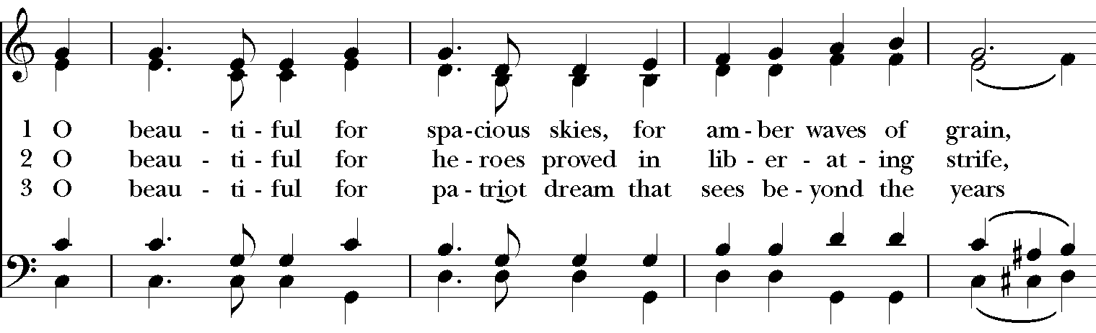
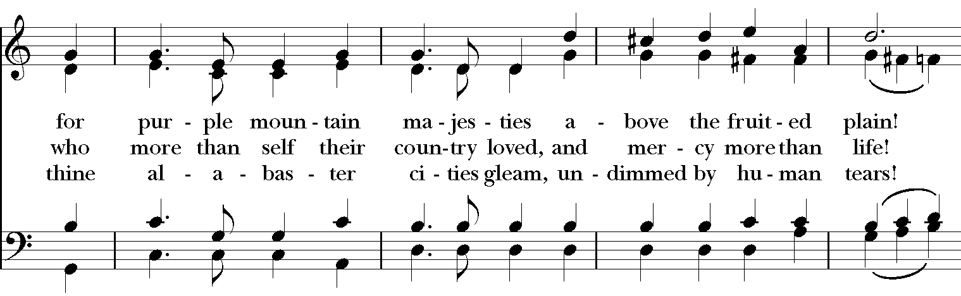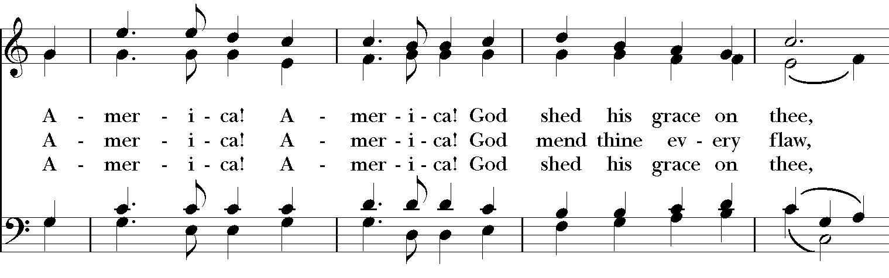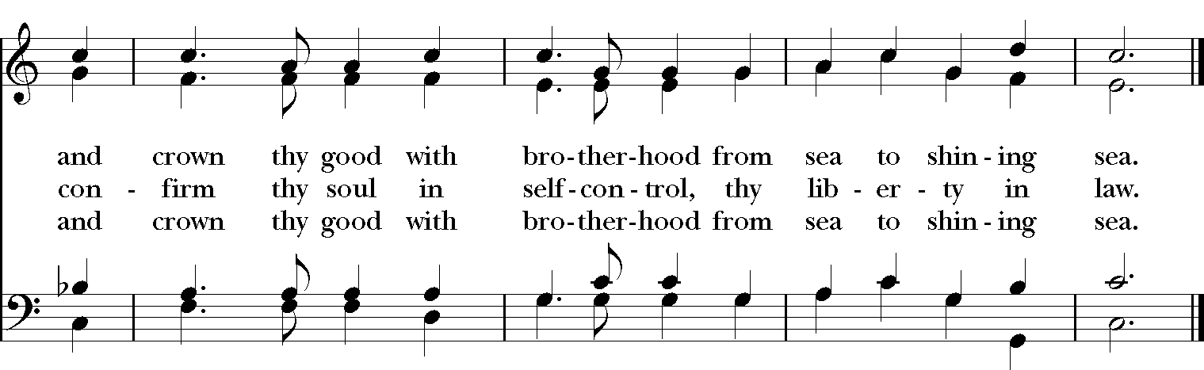

*THE BLESSING
Christ who has nourished us with himself the living bread, make you one in praise and love, and raise you up at the last day; and the blessing God Almighty, the Father, the Son, and the Holy Spirit, be among you, and remain with you always. Amen.

*THE DISMISSAL Deacon: Go in peace to love and serve the Lord.
People: Thanks be to God.

POSTLUDE: “Tis the Gift to be Simple” - Simple Gifts/arr. Callahan

Thank you for your spiritual presence with us this morning!
Although we're physically apart, we are united in prayer, worship, and holy love!
Priest-In-Charge: The Rev. Dr. Canon Lee Anne Reat
Deacon: The Rev. Dr. Rick Incorvati
Music Director: Dr. Chris Durrenberger
Lector: Keith Doubt
Singers: Liz Wheeler, Joy Carter, Basil Fett, Chris Oldstone-Moore, and Fred Bartenstein
Technology: Steve Ide
Slideshow: Ed Hasecke
Parish Administrator and Program Coordinator: Kelly Zeller

