Christ Episcopal Church in Springfield, Ohio
Service of the Word
Fourth Sunday in Lent: March 14th, 2021 at 9 am

Prelude:

Opening Hymn: “What wondrous love is this” Hymnal 439
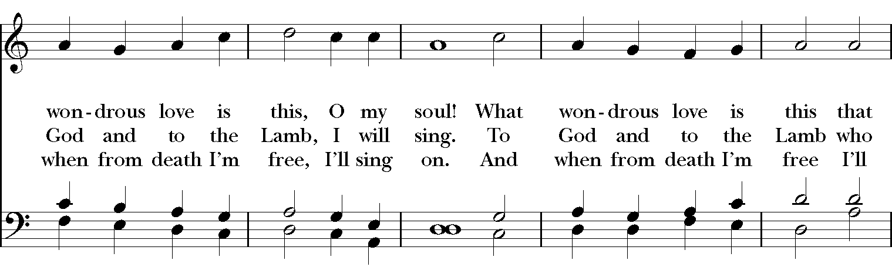
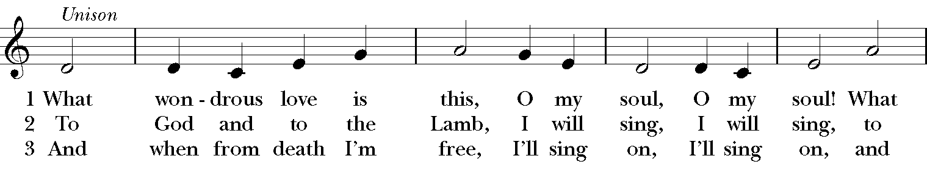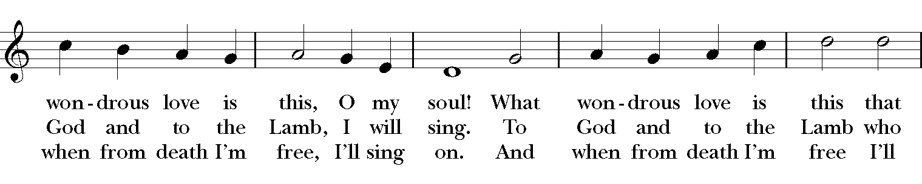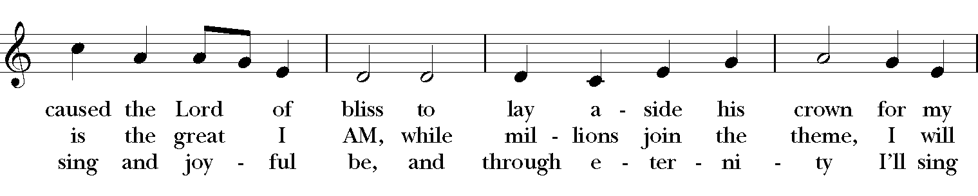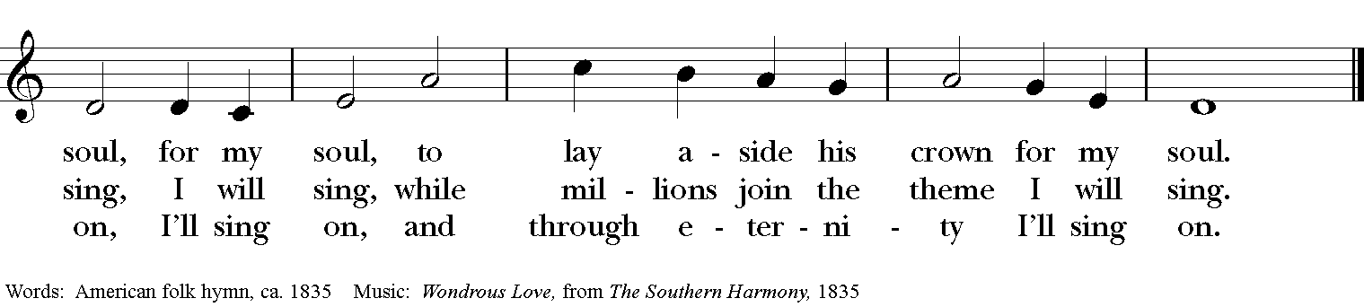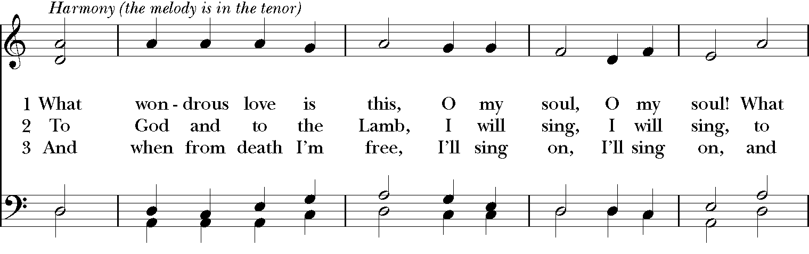
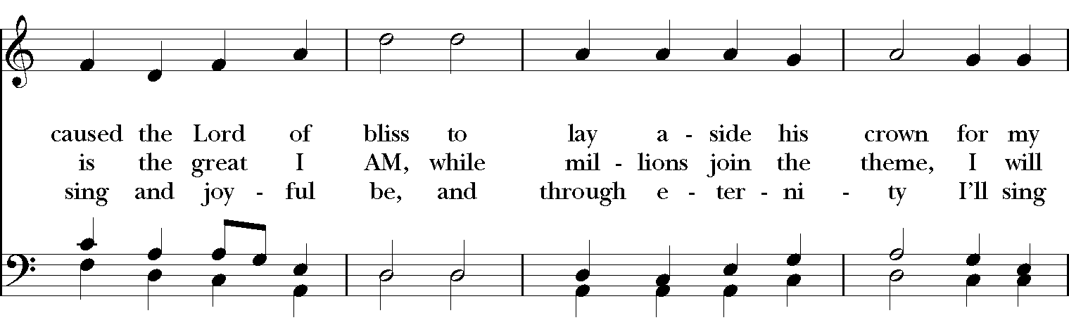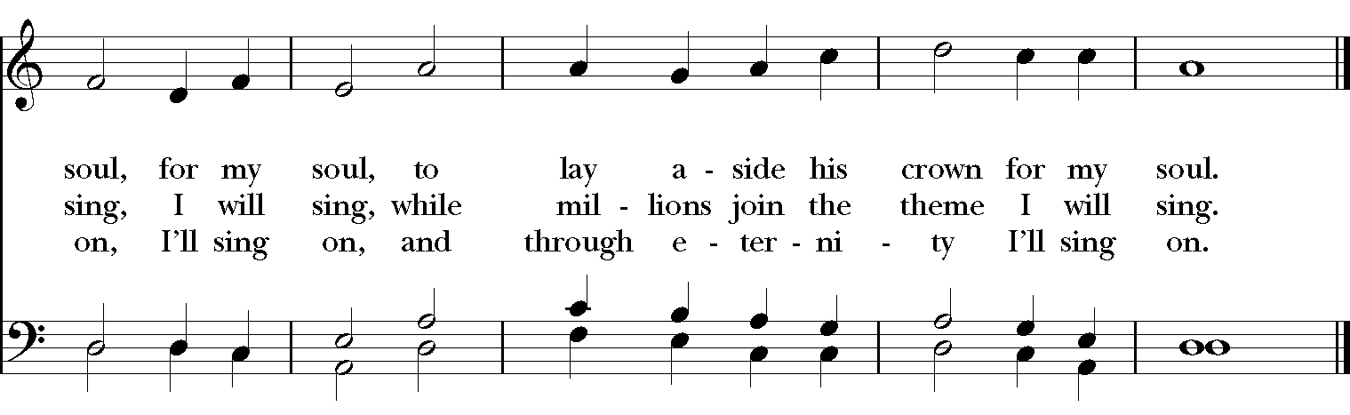
Celebrant: Bless the Lord who forgives all our sins;
People: His mercy endures for ever.
Celebrant: Lord, have mercy.
People: Christ, have mercy.
Celebrant: Lord, have mercy.

The Collect of the Day
Celebrant: The Lord be with you.
People: And also with you.
Celebrant: Let us pray.
Gracious Father, whose blessed Son Jesus Christ came down from heaven to be the true bread which gives life to the world: Evermore give us this bread, that he may live in us, and we in him; who lives and reigns with you and the Holy Spirit, one God, now and for ever. Amen.
The Lessons

The First Reading: Numbers 21:4-9
From Mount Hor the Israelites set out by the way to the Red Sea, to go around the land of Edom; but the people became impatient on the way. The people spoke against God and against Moses, “Why have you brought us up out of Egypt to die in the wilderness? For there is no food and no water, and we detest this miserable food.” Then the Lord sent poisonous serpents among the people, and they bit the people, so that many Israelites died. The people came to Moses and said, “We have sinned by speaking against the Lord and against you; pray to the Lord to take away the serpents from us.” So Moses prayed for the people. And the Lord said to Moses, “Make a poisonous serpent, and set it on a pole; and everyone who is bitten shall look at it and live.” So Moses made a serpent of bronze, and put it upon a pole; and whenever a serpent bit someone, that person would look at the serpent of bronze and live.
Reader: The Word of the Lord.
People: Thanks be to God.

Psalm 107:1-3, 17-22 Confitemini Domino
1 Give thanks to the Lord, for he is good, *
and his mercy endures for ever.
2 Let all those whom the Lord has redeemed proclaim *
that he redeemed them from the hand of the foe.
3 He gathered them out of the lands; *
from the east and from the west, from the north and from the south.
17 Some were fools and took to rebellious ways; *
they were afflicted because of their sins.
18 They abhorred all manner of food *
and drew near to death's door.
19 Then they cried to the Lord in their trouble, *
and he delivered them from their distress.
20 He sent forth his word and healed them *
and saved them from the grave.
21 Let them give thanks to the Lord for his mercy *
and the wonders he does for his children.
22 Let them offer a sacrifice of thanksgiving *
and tell of his acts with shouts of joy.

Second Lesson: Ephesians 2:1-10
You were dead through the trespasses and sins in which you once lived, following the course of this world, following the ruler of the power of the air, the spirit that is now at work among those who are disobedient. All of us once lived among them in the passions of our flesh, following the desires of flesh and senses, and we were by nature children of wrath, like everyone else. But God, who is rich in mercy, out of the great love with which he loved us even when we were dead through our trespasses, made us alive together with Christ-- by grace you have been saved-- and raised us up with him and seated us with him in the heavenly places in Christ Jesus, so that in the ages to come he might show the immeasurable riches of his grace in kindness toward us in Christ Jesus. For by grace you have been saved through faith, and this is not your own doing; it is the gift of God-- not the result of works, so that no one may boast. For we are what he has made us, created in Christ Jesus for good works, which God prepared beforehand to be our way of life.
Reader: The Word of the Lord.
People: Thanks be to God.
Sequence Hymn: “My song is love unknown” Hymnal 458 (vs. 1,2,7)
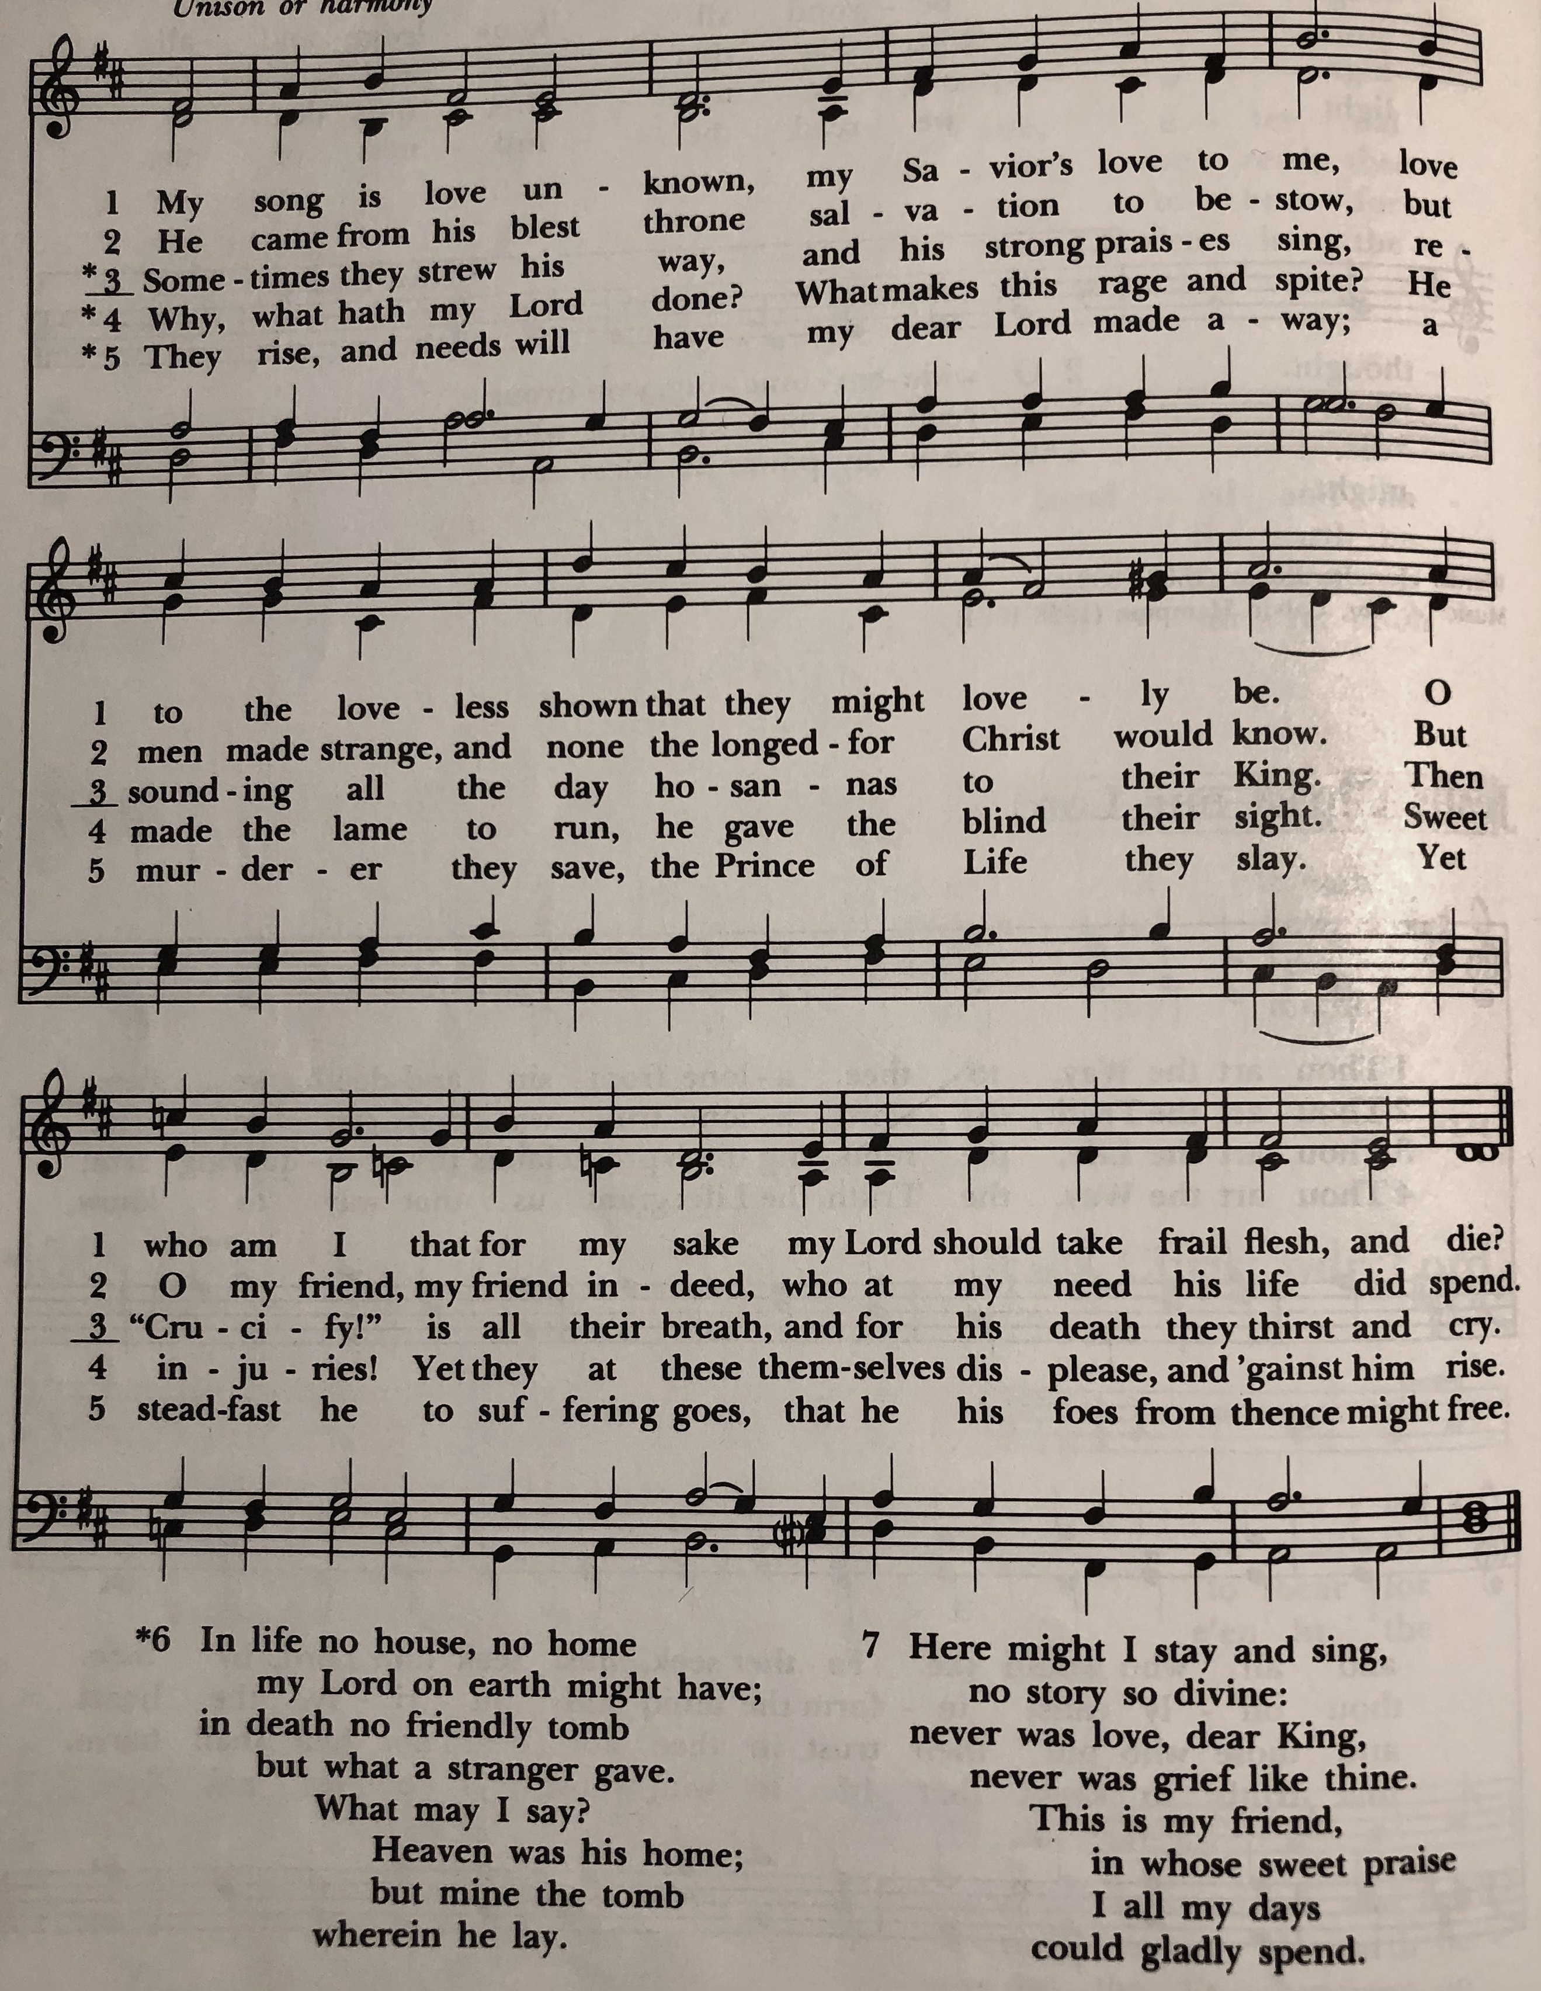

Gospel
Deacon: The Holy Gospel According to John (3:14-21)
People: Glory to you, Lord Christ.
Jesus said, “Just as Moses lifted up the serpent in the wilderness, so must the Son of Man be lifted up, that whoever believes in him may have eternal life.

“For God so loved the world that he gave his only Son, so that everyone who believes in him may not perish but may have eternal life.

“Indeed, God did not send the Son into the world to condemn the world, but in order that the world might be saved through him. Those who believe in him are not condemned; but those who do not believe are condemned already, because they have not believed in the name of the only Son of God. And this is the judgment, that the light has come into the world, and people loved darkness rather than light because their deeds were evil. For all who do evil hate the light and do not come to the light, so that their deeds may not be exposed. But those who do what is true come to the light, so that it may be clearly seen that their deeds have been done in God.”
Deacon: The Gospel of the Lord.
People: Praise to you, Lord Christ.

Sermon The Rev. Canon Dr. Lee Anne Reat

The Nicene Creed
We believe in one God,
the Father, the Almighty,
the maker of heaven and earth,
of all that is, seen and unseen.
We believe in one Lord, Jesus Christ,
the only Son of God,
eternally begotten of the Father,
God from God, Light from Light,
true God from true God,
begotten, not made,
of one Being with the Father.
Through him all things were made.
For us and for our salvation
he came down from heaven:
by the power of the Holy Spirit
he became incarnate from the Virgin Mary,
and was made man.
For our sake he was crucified under Pontius Pilate;
he suffered death and was buried.
On the third day he rose again
in accordance with the Scriptures;
He ascended into heaven
and is seated on the right hand of the Father.
He will come again in glory to judge the living and the dead,
and his kingdom will have no end.
We believe in the Holy Spirit, the Lord, the giver of life,
who proceeds from the Father and the Son.
With the Father and the Son he is worshiped and glorified.
He has spoken through the Prophets.
We believe in one holy catholic and apostolic Church.
We acknowledge one baptism for the forgiveness of sins.
We look for the resurrection of the dead,
and the life of the world to come. Amen.

The Prayers of the People

In peace, we pray to you Lord God.

Silence

Let us offer prayers to God who has made us a new creation in Christ, saying "Lord, have mercy."

For this parish community, that we may grow in holiness together as we prepare for the Paschal season.
Lord, have mercy.

For Justin, Archbishop of Canterbury; Michael, our Presiding Bishop; Ken, our Diocesan Bishop; Lee Anne, our priest; Rick, our deacon; and all who minister in Christ, that they may be firmly rooted in your truth and love.
Lord, have mercy.

For all the peoples of the earth and for their leaders, that we may move ever closer to your holy reign of peace, dignity, and abundant life for all.
Lord, have mercy.

For the holy work being done through and around us, in ministries such as Clark County Literacy Coalition, Episcopal Community Ministries, Second Harvest Food Bank, and Interfaith Hospitality Network, that fruits of love and mercy may be borne continually.
Lord, have mercy.

For all who are sick, afflicted, oppressed, or in need, especially Faye, Chris, Laura, Bonnie, Alice, Diana, James, Joy, Jane, Joni, Kim, Bobby, Sarah, Traudie, Lexie, and Keith, that they may be upheld by your Spirit and restored to wholeness.
Lord, have mercy.

For those celebrating birthdays, especially Wayne, Elisabeth, Deb, Babs, Olivia, and Ian, and anniversaries especially, Wayne & Deb that they may rejoice always in you.
Lord, have mercy.

For those who have fallen asleep in Christ, for all the departed, and for those who grieve.
Lord, have mercy.

*THE COLLECT FOR PEACE
Grant, O God, that your holy and life-giving Spirit may so move every human heart, that barriers which divide us may crumble, suspicions disappear, and hatreds cease; that our divisions being healed, we may live in justice and peace; through Jesus Christ our Lord. Amen.

Deacon: Let us confess our sins against God and our neighbor.
All: Most merciful God, we confess that we have sinned against you in thought, word, and deed, by what we have done, and by what we have left undone. We have not loved you with our whole heart; we have not loved our neighbors as ourselves. We are truly sorry and we humbly repent. For the sake of your Son Jesus Christ, have mercy on us and forgive us; that we may delight in your will, and walk in your ways, to the glory of your Name. Amen.

Priest: Almighty God, have mercy on you, forgive you all your sins through our Lord Jesus Christ, strengthen you in all goodness, and by the power of the Holy Spirit keep you in eternal life. Amen.

And now, as our Savior Christ has taught us, we are bold to say:
Our Father, who art in heaven, hallowed be thy Name,
thy kingdom come, thy will be done, on earth as it is in heaven.
Give us this day our daily bread.
And forgive us our trespasses, as we forgive those who trespass against us.
And lead us not into temptation, but deliver us from evil.
For thine is the kingdom, and the power, and the glory, for ever and ever. Amen.

Closing Hymn: “Savior, like a shepherd lead us” Hymnal 708
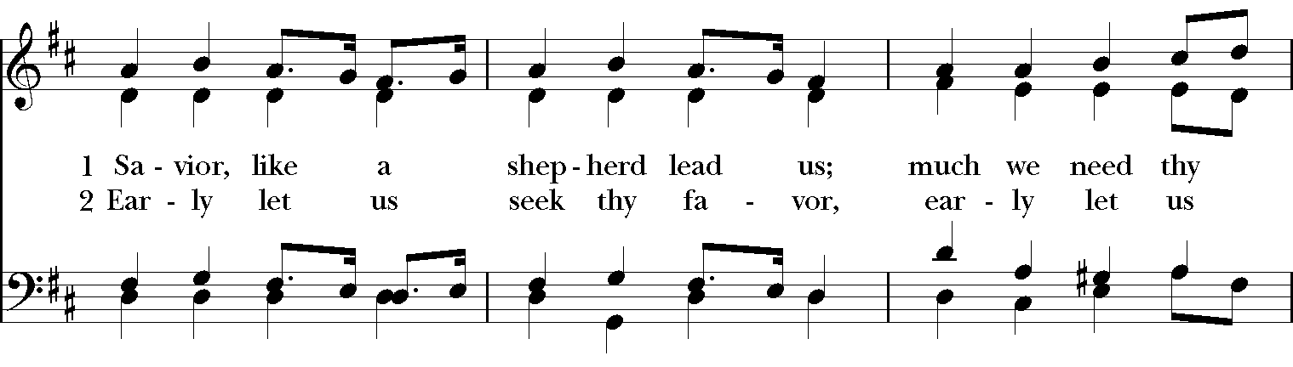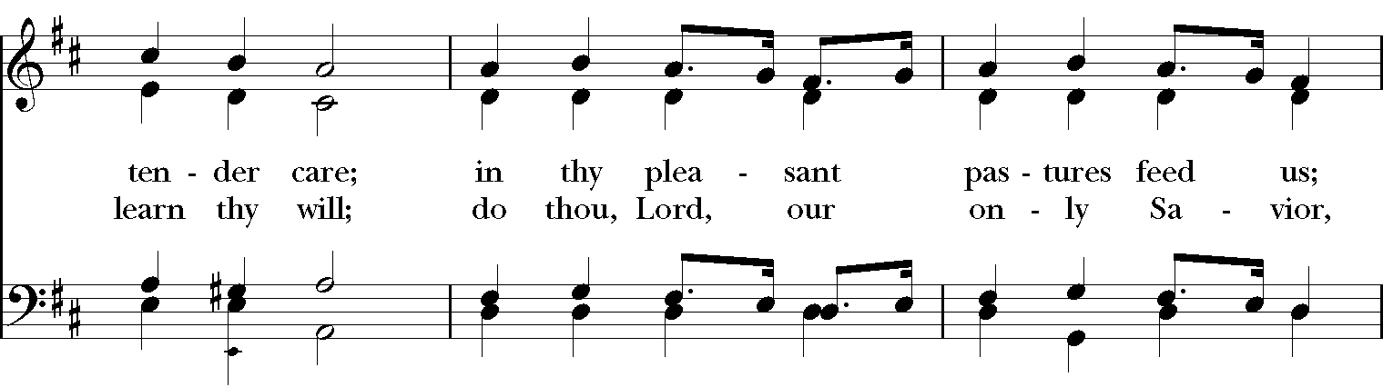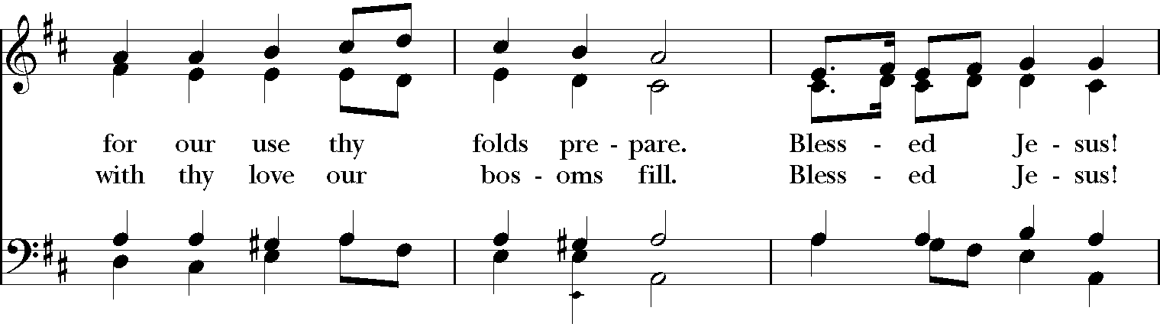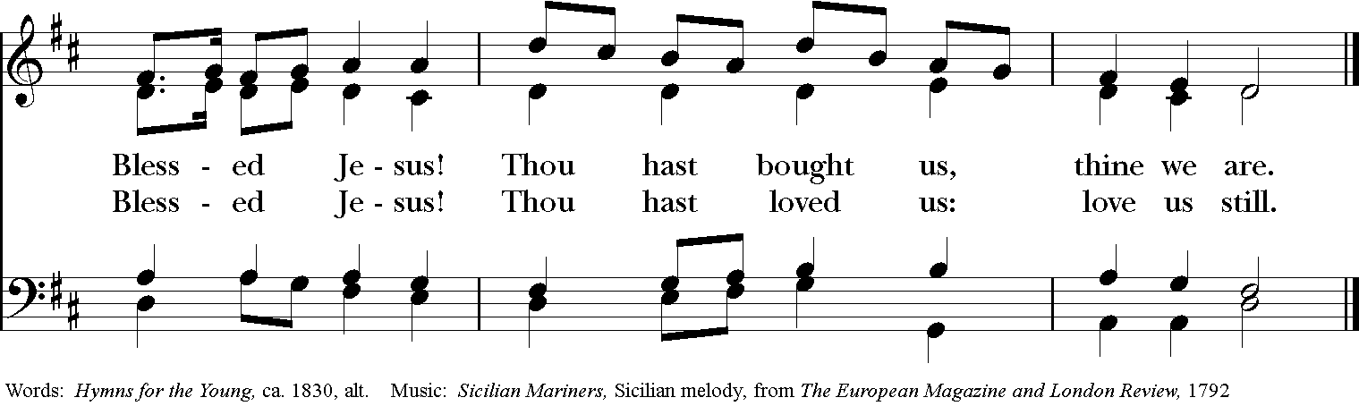

Blessing
Look down in mercy. Lord on your people who kneel before you; and grant that those whom you have nourished by your Word and Sacraments may bring forth fruit worthy of repentance: through Christ our Lord, and the blessing of God Almighty, the Father, the Son and the Holy Spirit, be among you and remain with you always. Amen.

Announcements

Dismissal
Deacon: Go in peace to love and serve the Lord.
People: Thanks be to God!

Postlude:

Thank you for your spiritual presence with us this morning!
Although we're physically apart, we are united in prayer, worship, and holy love!
Priest-In-Charge: The Rev. Dr. Canon Lee Anne Reat
Deacon: The Rev. Dr. Rick Incorvati
Music Director: Dr. Chris Durrenberger
Lector: Keith Doubt
Singers: Liz Wheeler, Joy Carter, Ed Hasecke, Fred Bartenstein
Technology: Steve Ide
Slideshow: Ed Hasecke
Parish Administrator and Program Coordinator: Kelly Zeller
Coffee Hour Host: Ron Dowling

