Christ Episcopal Church in Springfield, Ohio
Service of the Word
Fifth Sunday in Lent: March 21st, 2021 at 9 am

Prelude:

Opening Hymn: “Lord, who throughout these forty days” Hymnal 142
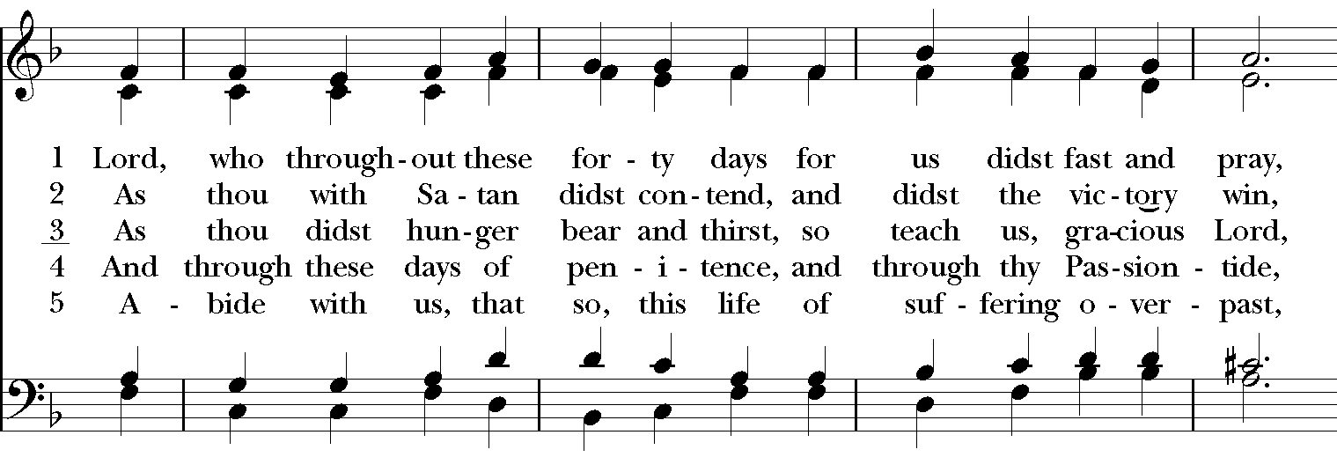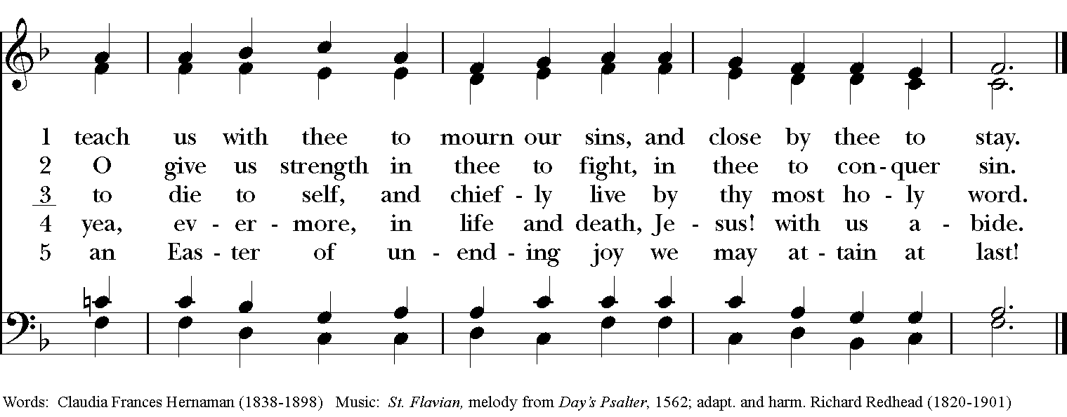
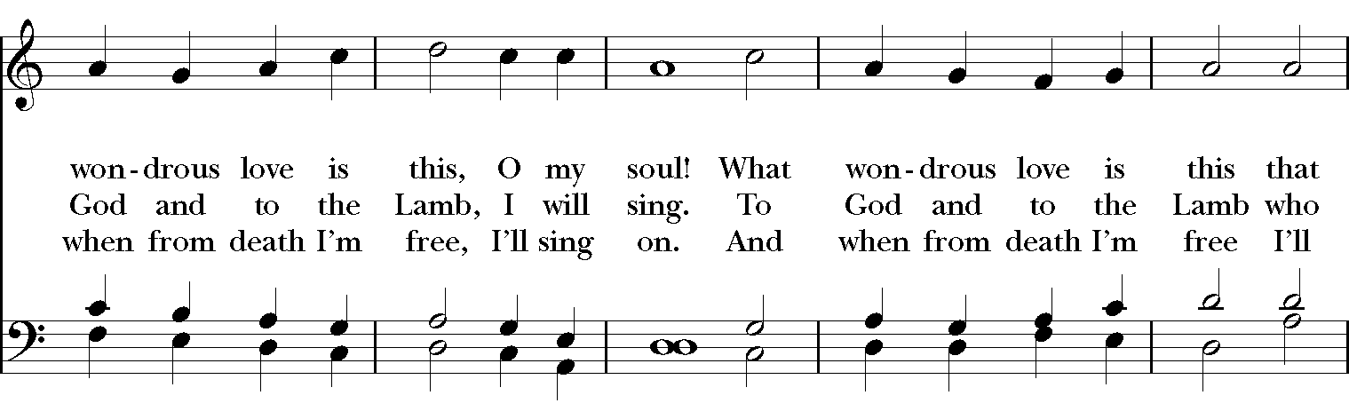
Celebrant: Bless the Lord who forgives all our sins;
People: His mercy endures for ever.
Celebrant: Lord, have mercy.
People: Christ, have mercy.
Celebrant: Lord, have mercy.

The Collect of the Day
Celebrant: The Lord be with you.
People: And also with you.
Celebrant: Let us pray.
Almighty God, you alone can bring into order the unruly wills and affections of sinners: Grant your people grace to love what you command and desire what you promise; that, among the swift and varied changes of the world, our hearts may surely there be fixed where true joys are to be found; through Jesus Christ our Lord, who lives and reigns with you and the Holy Spirit, one God, now and for ever. Amen.
The Lessons

The First Reading: Jeremiah 31:31-34
The days are surely coming, says the Lord, when I will make a new covenant with the house of Israel and the house of Judah. It will not be like the covenant that I made with their ancestors when I took them by the hand to bring them out of the land of Egypt—a covenant that they broke, though I was their husband, says the Lord. But this is the covenant that I will make with the house of Israel after those days, says the Lord: I will put my law within them, and I will write it on their hearts; and I will be their God, and they shall be my people. No longer shall they teach one another, or say to each other, “Know the Lord,” for they shall all know me, from the least of them to the greatest, says the Lord; for I will forgive their iniquity, and remember their sin no more.
Reader: The Word of the Lord.
People: Thanks be to God.

Psalm 51:1-13 Miserere mei, Deus
1 Have mercy on me, O God, according to your loving-kindness; *
in your great compassion blot out my offenses.
2 Wash me through and through from my wickedness *
and cleanse me from my sin.
3 For I know my transgressions, *
and my sin is ever before me.
4 Against you only have I sinned *
and done what is evil in your sight.
5 And so you are justified when you speak *
and upright in your judgment.
6 Indeed, I have been wicked from my birth, *
a sinner from my mother's womb.
7 For behold, you look for truth deep within me, *
and will make me understand wisdom secretly.
8 Purge me from my sin, and I shall be pure; *
wash me, and I shall be clean indeed.
9 Make me hear of joy and gladness, *
that the body you have broken may rejoice.
10 Hide your face from my sins *
and blot out all my iniquities.
11 Create in me a clean heart, O God, *
and renew a right spirit within me.
12 Cast me not away from your presence *
and take not your holy Spirit from me.
13 Give me the joy of your saving help again *
and sustain me with your bountiful Spirit.

Second Lesson: Hebrews 5:5-10
Christ did not glorify himself in becoming a high priest, but was appointed by the one who said to him,
“You are my Son,
today I have begotten you”;
as he says also in another place,
“You are a priest forever,
according to the order of Melchizedek.”

In the days of his flesh, Jesus offered up prayers and supplications, with loud cries and tears, to the one who was able to save him from death, and he was heard because of his reverent submission. Although he was a Son, he learned obedience through what he suffered; and having been made perfect, he became the source of eternal salvation for all who obey him, having been designated by God a high priest according to the order of Melchizedek.
Reader: The Word of the Lord.
People: Thanks be to God.
Sequence Hymn: “Hail thou once despised Jesus” Hymnal 495
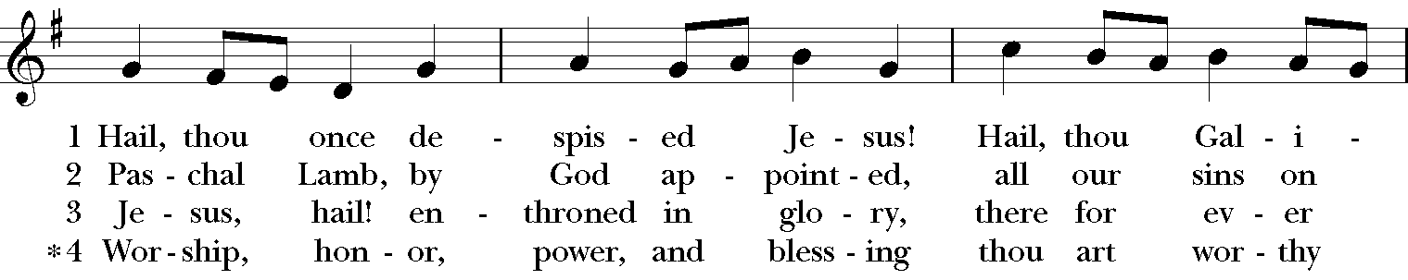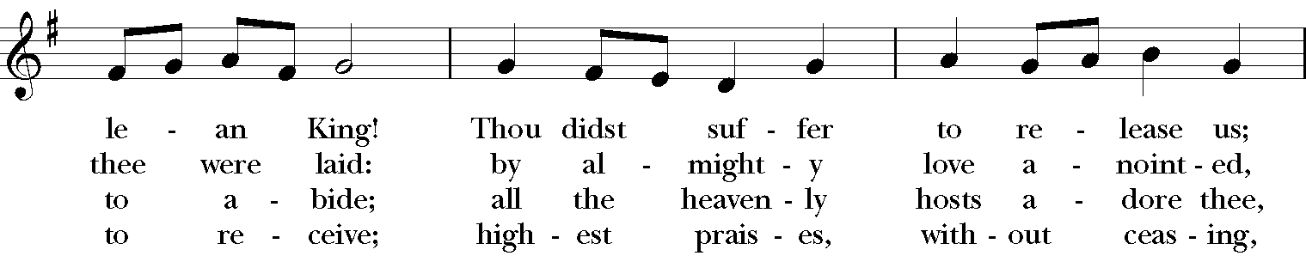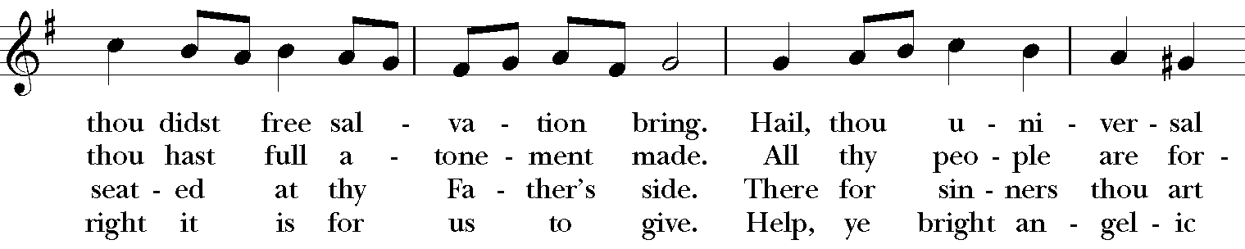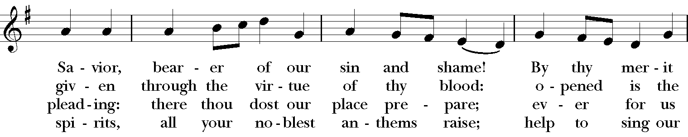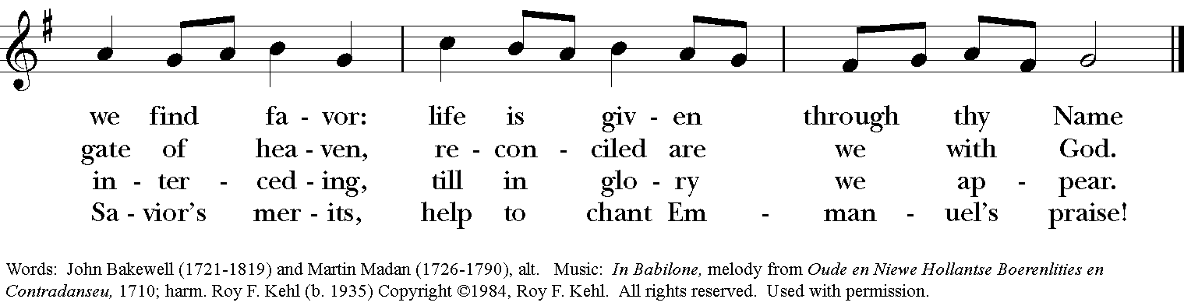

Gospel
Deacon: The Holy Gospel According to John (12:20-33)
People: Glory to you, Lord Christ.
Now among those who went up to worship at the festival were some Greeks. They came to Philip, who was from Bethsaida in Galilee, and said to him, “Sir, we wish to see Jesus.” Philip went and told Andrew; then Andrew and Philip went and told Jesus. Jesus answered them, “The hour has come for the Son of Man to be glorified. Very truly, I tell you, unless a grain of wheat falls into the earth and dies, it remains just a single grain; but if it dies, it bears much fruit. Those who love their life lose it, and those who hate their life in this world will keep it for eternal life. Whoever serves me must follow me, and where I am, there will my servant be also. Whoever serves me, the Father will honor.
“Now my soul is troubled. And what should I say—‘Father, save me from this hour’? No, it is for this reason that I have come to this hour. Father, glorify your name.” Then a voice came from heaven, “I have glorified it, and I will glorify it again.” The crowd standing there heard it and said that it was thunder. Others said, “An angel has spoken to him.” Jesus answered, “This voice has come for your sake, not for mine. Now is the judgment of this world; now the ruler of this world will be driven out. And I, when I am lifted up from the earth, will draw all people to myself.” He said this to indicate the kind of death he was to die.
Deacon: The Gospel of the Lord.
People: Praise to you, Lord Christ.

Sermon The Rev. Canon Dr. Lee Anne Reat

The Nicene Creed
We believe in one God,
the Father, the Almighty,
the maker of heaven and earth,
of all that is, seen and unseen.
We believe in one Lord, Jesus Christ,
the only Son of God,
eternally begotten of the Father,
God from God, Light from Light,
true God from true God,
begotten, not made,
of one Being with the Father.
Through him all things were made.
For us and for our salvation
he came down from heaven:
by the power of the Holy Spirit
he became incarnate from the Virgin Mary,
and was made man.
For our sake he was crucified under Pontius Pilate;
he suffered death and was buried.
On the third day he rose again
in accordance with the Scriptures;
He ascended into heaven
and is seated on the right hand of the Father.
He will come again in glory to judge the living and the dead,
and his kingdom will have no end.
We believe in the Holy Spirit, the Lord, the giver of life,
who proceeds from the Father and the Son.
With the Father and the Son he is worshiped and glorified.
He has spoken through the Prophets.
We believe in one holy catholic and apostolic Church.
We acknowledge one baptism for the forgiveness of sins.
We look for the resurrection of the dead,
and the life of the world to come. Amen.

The Prayers of the People

In peace, we pray to you Lord God.

Silence

Let us offer prayers to God who has made us a new creation in Christ, saying "Lord, have mercy."

For this parish community, that we may grow in holiness together as we prepare for the Paschal season.
Lord, have mercy.

For Justin, Archbishop of Canterbury; Michael, our Presiding Bishop; Ken, our Diocesan Bishop; Lee Anne, our priest; Rick, our deacon; and all who minister in Christ, that they may be firmly rooted in your truth and love.
Lord, have mercy.

For all the peoples of the earth and for their leaders, that we may move ever closer to your holy reign of peace, dignity, and abundant life for all.
Lord, have mercy.

For the holy work being done through and around us, in ministries such as Springfield Farmer’s Market, Project Woman, Children’s Defense Fund Freedom Schools, The YMCA, and Jefferson ST. Oasis Garden, that fruits of love and mercy may be borne continually.
Lord, have mercy.

For all who are sick, afflicted, oppressed, or in need, especially Faye, Chris, Laura, Bonnie, Alice, Diana, James, Joy, Jane, Joni, Kim, Bobby, Sarah, Traudie, Lexie, and Keith, that they may be upheld by your Spirit and restored to wholeness.
Lord, have mercy.

For those celebrating birthdays, especially Traudie, Jennifer, and Lori, and anniversaries especially, Ted & Wendy that they may rejoice always in you.
Lord, have mercy.

For those who have fallen asleep in Christ, for all the departed, and for those who grieve.
Lord, have mercy.

*THE COLLECT FOR PEACE
Grant, O God, that your holy and life-giving Spirit may so move every human heart, that barriers which divide us may crumble, suspicions disappear, and hatreds cease; that our divisions being healed, we may live in justice and peace; through Jesus Christ our Lord. Amen.

Deacon: Let us confess our sins against God and our neighbor.
All: Most merciful God, we confess that we have sinned against you in thought, word, and deed, by what we have done, and by what we have left undone. We have not loved you with our whole heart; we have not loved our neighbors as ourselves. We are truly sorry and we humbly repent. For the sake of your Son Jesus Christ, have mercy on us and forgive us; that we may delight in your will, and walk in your ways, to the glory of your Name. Amen.

Priest: Almighty God, have mercy on you, forgive you all your sins through our Lord Jesus Christ, strengthen you in all goodness, and by the power of the Holy Spirit keep you in eternal life. Amen.

And now, as our Savior Christ has taught us, we are bold to say:
Our Father, who art in heaven, hallowed be thy Name,
thy kingdom come, thy will be done, on earth as it is in heaven.
Give us this day our daily bread.
And forgive us our trespasses, as we forgive those who trespass against us.
And lead us not into temptation, but deliver us from evil.
For thine is the kingdom, and the power, and the glory, for ever and ever. Amen
Closing Hymn: “In the cross of Christ” Hymnal 441 vs. 1-4
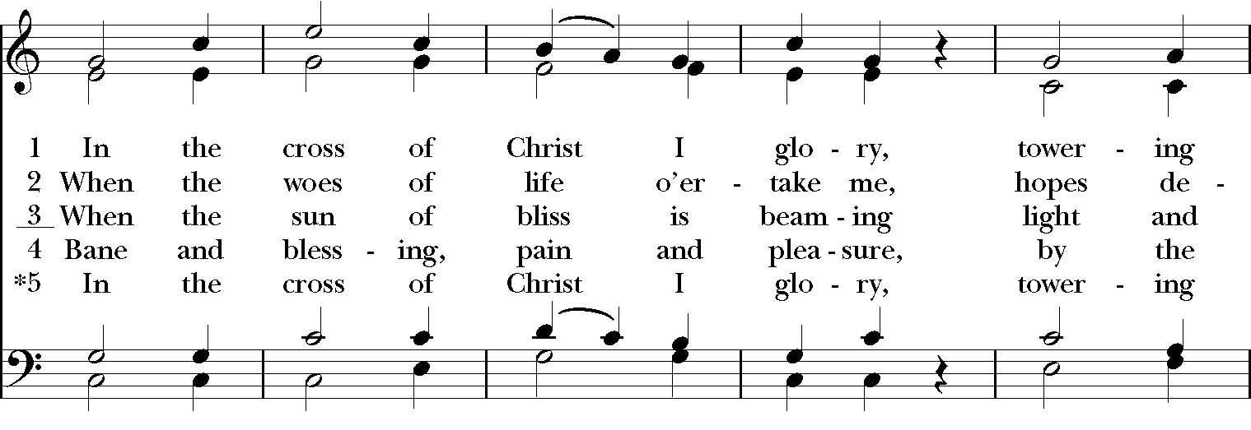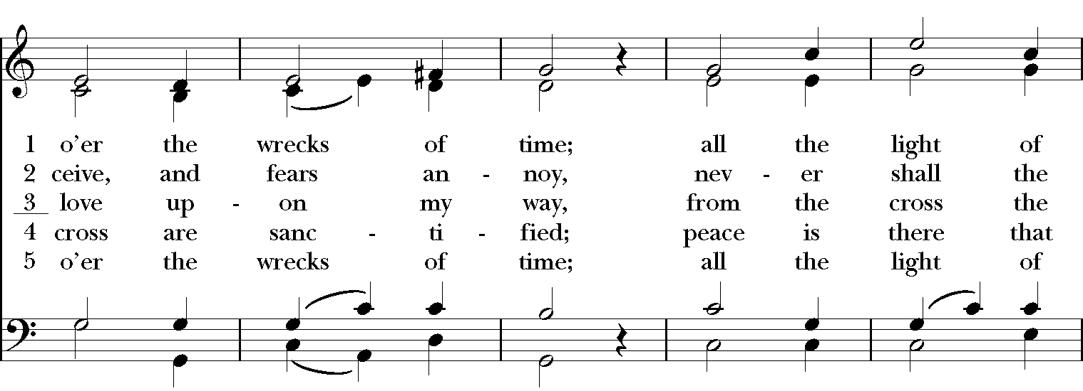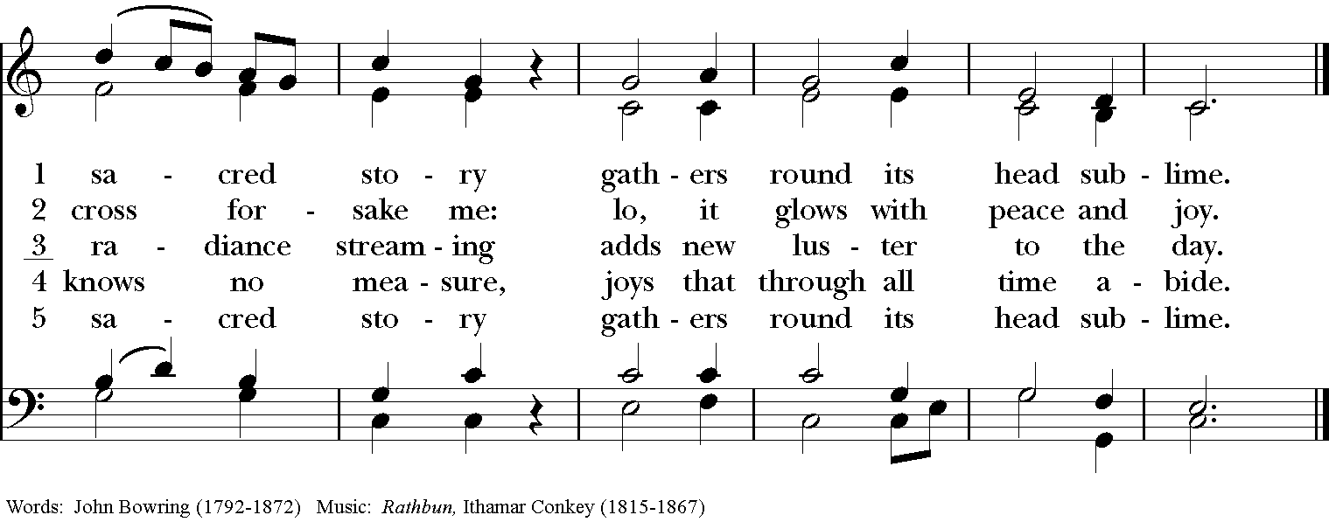

Blessing
Look down in mercy. Lord on your people who kneel before you; and grant that those whom you have nourished by your Word and Sacraments may bring forth fruit worthy of repentance: through Christ our Lord, and the blessing of God Almighty, the Father, the Son and the Holy Spirit, be among you and remain with you always. Amen.

Announcements

Dismissal
Deacon: Go in peace to love and serve the Lord.
People: Thanks be to God!

Postlude:

Thank you for your spiritual presence with us this morning!
Although we're physically apart, we are united in prayer, worship, and holy love!
Priest-In-Charge: The Rev. Dr. Canon Lee Anne Reat
Deacon: The Rev. Dr. Rick Incorvati
Music Director: Dr. Chris Durrenberger
Lector: Diane Rode
Singers: Liz Wheeler, Joy Carter, Ed Hasecke, Fred Bartenstein
Technology: Steve Ide
Slideshow: Ed Hasecke
Parish Administrator and Program Coordinator: Kelly Zeller
Coffee Hour Host: Fred Bartenstein

