Christ Episcopal Church in Springfield, Ohio
Service of the Word
Sunday of the Passion: Palm Sunday
March 28th, 2021 at 9 am

THE LITURGY OF THE PALMS

Celebrant: Blessed is the King who comes in the name of the Lord.
People: Peace in heaven and glory in the highest.

Celebrant: Let us pray
Assist us mercifully with your help, O Lord God of our
salvation, that we may enter with joy upon the contemplation
of those mighty acts, whereby you have given us life and
immortality; through Jesus Christ our Lord. Amen.
Mark 11:1-11a
When they were approaching Jerusalem, at Bethphage and Bethany, near the Mount of Olives, Jesus sent two of his disciples and said to them, “Go into the village ahead of you, and immediately as you enter it, you will find tied there a colt that has never been ridden; untie it and bring it. If anyone says to you, ‘Why are you doing this?’ just say this, ‘The Lord needs it and will send it back here immediately.’” They went away and found a colt tied near a door, outside in the street. As they were untying it, some of the bystanders said to them, “What are you doing, untying the colt?” They told them what Jesus had said; and they allowed them to take it. Then they brought the colt to Jesus and threw their cloaks on it; and he sat on it. Many people spread their cloaks on the road, and others spread leafy branches that they had cut in the fields. Then those who went ahead and those who followed were shouting,
“Hosanna!
Blessed is the one who comes in the name of the Lord!
Blessed is the coming kingdom of our ancestor David!
Hosanna in the highest heaven!”
Then he entered Jerusalem and went into the temple; and when he had looked around at everything, as it was already late, he went out to Bethany with the twelve.
Celebrant: The Lord be with you.
People: And also with you.
Celebrant: Let us give thanks to the Lord our God.
People: It is right to give him thanks and praise.
It is right to praise you, Almighty God, for the acts of love by which you have redeemed us through your Son Jesus Christ our Lord. On this day he entered the holy city of Jerusalem triumph, and was proclaimed as King of kings by those who spread their garments and branches of palm along his way. Let these branches be for us signs of his victory, and grant that we who bear them in his name may ever hail him as our King, and follow him in the way that leads to eternal life; who lives and reigns in glory with you and the Holy Spirit, now and for ever. Amen.
Celebrant: Blessed is he who comes in the name of the Lord.
People: Hosanna in the highest.

Opening Hymn: “All glory, laud, and honor” Hymnal 154
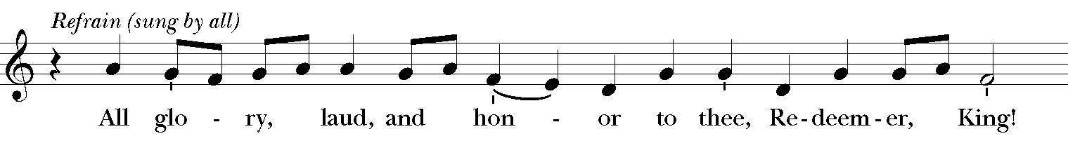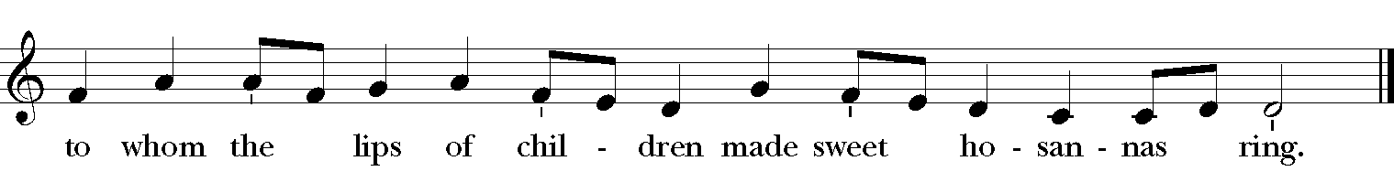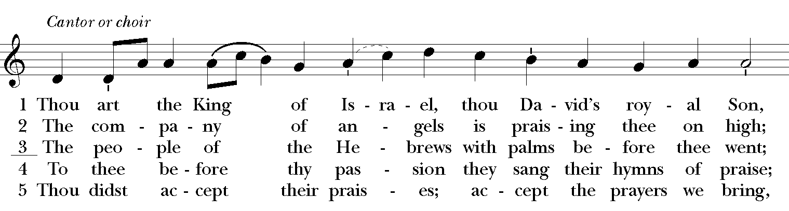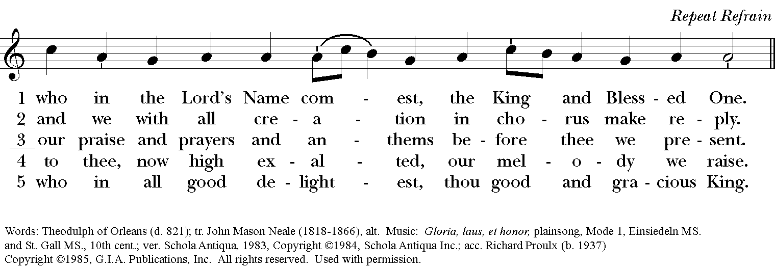

The Collect of the Day
Celebrant: The Lord be with you.
People: And also with you.
Celebrant: Let us pray.
Almighty and everliving God, in your tender love for the human race you sent your Son our Savior Jesus Christ to take upon him our nature, and to suffer death upon the cross, giving us the example of his great humility: Mercifully grant that we may walk in the way of his suffering, and also share in his resurrection; through Jesus Christ our Lord, who lives and reigns with you and the Holy Spirit, one God, for ever and ever. Amen.

The Lessons

THE FIRST LESSON Isaiah 45:21-25

Declare and present your case;
let them take counsel together!
Who told this long ago?
Who declared it of old?
Was it not I, the Lord?
There is no other god besides me,
a righteous God and a Savior;
there is no one besides me.
Turn to me and be saved,
all the ends of the earth!
For I am God, and there is no other.
By myself I have sworn,
from my mouth has gone forth in righteousness
a word that shall not return:
‘To me every knee shall bow,
every tongue shall swear.’
Only in the Lord, it shall be said of me,
are righteousness and strength;
all who were incensed against him
shall come to him and be ashamed.
In the Lord all the offspring of Israel
shall triumph and glory.
Reader: The Word of the Lord.
People: Thanks be to God.

*PSALM: 22:1-11
1 My God, my God, why have you forsaken me? *
and are so far from my cry and from the words of my distress?
2 O my God, I cry in the daytime, but you do not answer; *
by night as well, but I find no rest.
3 Yet you are the Holy One, *
enthroned upon the praises of Israel.
4 Our forefathers put their trust in you; *
they trusted, and you delivered them.
5 They cried out to you and were delivered; *
they trusted in you and were not put to shame.
6 But as for me, I am a worm and no man, *
scorned by all and despised by the people.
7 All who see me laugh me to scorn; *
they curl their lips and wag their heads, saying,
8 "He trusted in the LORD; let him deliver him; *
let him rescue him, if he delights in him."
9 Yet you are he who took me out of the womb, *
and kept me safe upon my mother's breast.
10 I have been entrusted to you ever since I was born; *
you were my God when I was still in my mother's womb.
11 Be not far from me, for trouble is near, *
and there is none to help.

Second Lesson: Philippians 2:5-11
Let the same mind be in you that was in Christ Jesus,
who, though he was in the form of God,
did not regard equality with God
as something to be exploited,
but emptied himself,
taking the form of a slave,
being born in human likeness.
And being found in human form,
he humbled himself
and became obedient to the point of death--
even death on a cross.
Therefore God also highly exalted him
and gave him the name
that is above every name,
so that at the name of Jesus
every knee should bend,
in heaven and on earth and under the earth,
and every tongue should confess
that Jesus Christ is Lord,
to the glory of God the Father.
Reader: The Word of the Lord.
People: Thanks be to God.
Sequence Hymn: “Let thy Blood in mercy poured” Hymnal 313
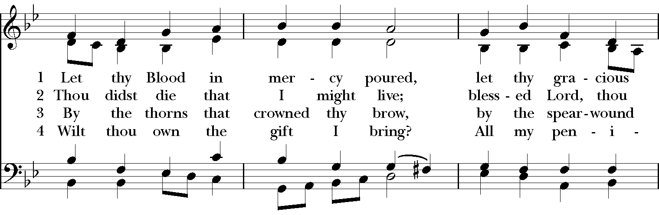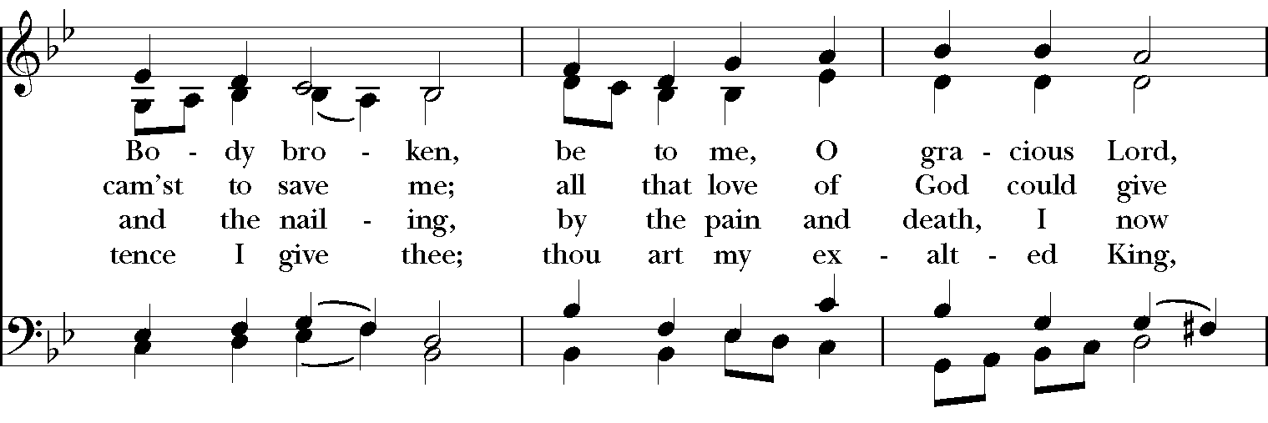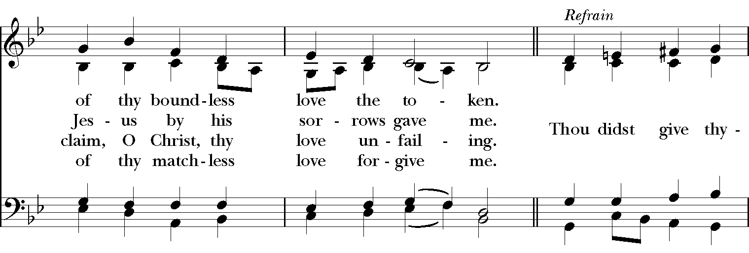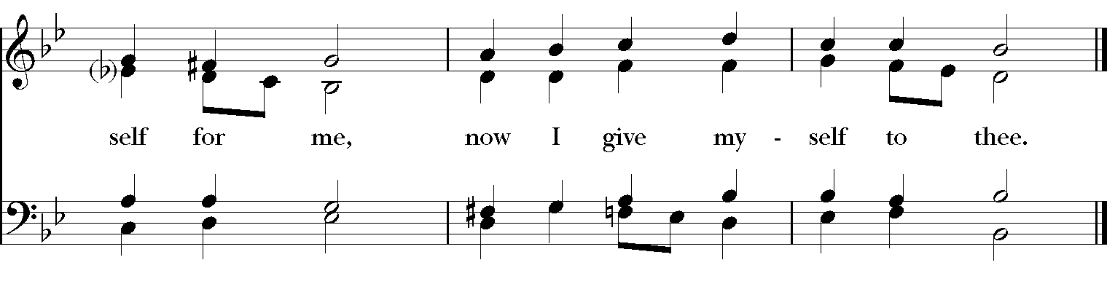

*THE READING OF THE PASSION

The Passion of our Lord Jesus Christ according to Mark (14:32-15:47)
They went to a place called Gethsemane; and he said to his disciples, “Sit here while I pray.” He took with him Peter and James and John, and began to be distressed and agitated. And he said to them, “I am deeply grieved, even to death; remain here, and keep awake.” And going a little farther, he threw himself on the ground and prayed that, if it were possible, the hour might pass from him. He said, “Abba, Father, for you all things are possible; remove this cup from me; yet, not what I want, but what you want.” He came and found them sleeping; and he said to Peter, “Simon, are you asleep? Could you not keep awake one hour? Keep awake and pray that you may not come into the time of trial; the spirit indeed is willing, but the flesh is weak.” And again he went away and prayed, saying the same words. And once more he came and found them sleeping, for their eyes were very heavy; and they did not know what to say to him. He came a third time and said to them, “Are you still sleeping and taking your rest? Enough! The hour has come; the Son of Man is betrayed into the hands of sinners. Get up, let us be going. See, my betrayer is at hand.”
Immediately, while he was still speaking, Judas, one of the twelve, arrived; and with him there was a crowd with swords and clubs, from the chief priests, the scribes, and the elders. Now the betrayer had given them a sign, saying, “The one I will kiss is the man; arrest him and lead him away under guard.” So when he came, he went up to him at once and said, “Rabbi!” and kissed him. Then they laid hands on him and arrested him. But one of those who stood near drew his sword and struck the slave of the high priest, cutting off his ear. Then Jesus said to them, “Have you come out with swords and clubs to arrest me as though I were a bandit? Day after day I was with you in the temple teaching, and you did not arrest me. But let the scriptures be fulfilled.” All of them deserted him and fled.
A certain young man was following him, wearing nothing but a linen cloth. They caught hold of him, but he left the linen cloth and ran off naked.
They took Jesus to the high priest; and all the chief priests, the elders, and the scribes were assembled. Peter had followed him at a distance, right into the courtyard of the high priest; and he was sitting with the guards, warming himself at the fire. Now the chief priests and the whole council were looking for testimony against Jesus to put him to death; but they found none. For many gave false testimony against him, and their testimony did not agree. Some stood up and gave false testimony against him, saying, “We heard him say, ‘I will destroy this temple that is made with hands, and in three days I will build another, not made with hands.’” But even on this point their testimony did not agree. Then the high priest stood up before them and asked Jesus, “Have you no answer? What is it that they testify against you?” But he was silent and did not answer. Again the high priest asked him, “Are you the Messiah, the Son of the Blessed One?” Jesus said, “I am; and
‘you will see the Son of Man
seated at the right hand of the Power,’
and ‘coming with the clouds of heaven.’”
Then the high priest tore his clothes and said, “Why do we still need witnesses? You have heard his blasphemy! What is your decision?” All of them condemned him as deserving death. Some began to spit on him, to blindfold him, and to strike him, saying to him, “Prophesy!” The guards also took him over and beat him.
While Peter was below in the courtyard, one of the servant-girls of the high priest came by. When she saw Peter warming himself, she stared at him and said, “You also were with Jesus, the man from Nazareth.” But he denied it, saying, “I do not know or understand what you are talking about.” And he went out into the forecourt. Then the cock crowed. And the servant-girl, on seeing him, began again to say to the bystanders, “This man is one of them.” But again he denied it. Then after a little while the bystanders again said to Peter, “Certainly you are one of them; for you are a Galilean.” But he began to curse, and he swore an oath, “I do not know this man you are talking about.” At that moment the cock crowed for the second time. Then Peter remembered that Jesus had said to him, “Before the cock crows twice, you will deny me three times.” And he broke down and wept.
As soon as it was morning, the chief priests held a consultation with the elders and scribes and the whole council. They bound Jesus, led him away, and handed him over to Pilate. Pilate asked him, “Are you the King of the Jews?” He answered him, “You say so.” Then the chief priests accused him of many things. Pilate asked him again, “Have you no answer? See how many charges they bring against you.” But Jesus made no further reply, so that Pilate was amazed.
Now at the festival he used to release a prisoner for them, anyone for whom they asked. Now a man called Barabbas was in prison with the rebels who had committed murder during the insurrection. So the crowd came and began to ask Pilate to do for them according to his custom. Then he answered them, “Do you want me to release for you the King of the Jews?” For he realized that it was out of jealousy that the chief priests had handed him over. But the chief priests stirred up the crowd to have him release Barabbas for them instead. Pilate spoke to them again, “Then what do you wish me to do with the man you call the King of the Jews?” They shouted back, “Crucify him!” Pilate asked them, “Why, what evil has he done?” But they shouted all the more, “Crucify him!” So Pilate, wishing to satisfy the crowd, released Barabbas for them; and after flogging Jesus, he handed him over to be crucified.
Then the soldiers led him into the courtyard of the palace (that is, the governor’s headquarters); and they called together the whole cohort. And they clothed him in a purple cloak; and after twisting some thorns into a crown, they put it on him. And they began saluting him, “Hail, King of the Jews!” They struck his head with a reed, spat upon him, and knelt down in homage to him. After mocking him, they stripped him of the purple cloak and put his own clothes on him. Then they led him out to crucify him.
They compelled a passer-by, who was coming in from the country, to carry his cross; it was Simon of Cyrene, the father of Alexander and Rufus. Then they brought Jesus to the place called Golgotha (which means the place of a skull). And they offered him wine mixed with myrrh; but he did not take it. And they crucified him, and divided his clothes among them, casting lots to decide what each should take.
It was nine o’clock in the morning when they crucified him. The inscription of the charge against him read, “The King of the Jews.” And with him they crucified two bandits, one on his right and one on his left. Those who passed by derided him, shaking their heads and saying, “Aha! You who would destroy the temple and build it in three days, save yourself, and come down from the cross!” In the same way the chief priests, along with the scribes, were also mocking him among themselves and saying, “He saved others; he cannot save himself. Let the Messiah, the King of Israel, come down from the cross now, so that we may see and believe.” Those who were crucified with him also taunted him.
When it was noon, darkness came over the whole land until three in the afternoon. At three o’clock Jesus cried out with a loud voice, “Eloi, Eloi, lema sabachthani?” which means, “My God, my God, why have you forsaken me?” When some of the bystanders heard it, they said, “Listen, he is calling for Elijah.” And someone ran, filled a sponge with sour wine, put it on a stick, and gave it to him to drink, saying, “Wait, let us see whether Elijah will come to take him down.” Then Jesus gave a loud cry and breathed his last. And the curtain of the temple was torn in two, from top to bottom. Now when the centurion, who stood facing him, saw that in this way he breathed his last, he said, “Truly this man was God’s Son!”
There were also women looking on from a distance; among them were Mary Magdalene, and Mary the mother of James the younger and of Joses, and Salome. These used to follow him and provided for him when he was in Galilee; and there were many other women who had come up with him to Jerusalem.
When evening had come, and since it was the day of Preparation, that is, the day before the sabbath, Joseph of Arimathea, a respected member of the council, who was also himself waiting expectantly for the kingdom of God, went boldly to Pilate and asked for the body of Jesus. Then Pilate wondered if he were already dead; and summoning the centurion, he asked him whether he had been dead for some time. When he learned from the centurion that he was dead, he granted the body to Joseph. Then Joseph bought a linen cloth, and taking down the body, wrapped it in the linen cloth, and laid it in a tomb that had been hewn out of the rock. He then rolled a stone against the door of the tomb. Mary Magdalene and Mary the mother of Joses saw where the body was laid.

The Prayers of the People

In peace, we pray to you Lord God.

Silence

Let us offer prayers to God who has made us a new creation in Christ, saying "Lord, have mercy."
For this parish community, that we may grow in holiness together as we prepare for the Paschal season.
Lord, have mercy.

For Justin, Archbishop of Canterbury; Michael, our Presiding Bishop; Ken, our Diocesan Bishop; Lee Anne, our priest; Rick, our deacon; and all who minister in Christ, that they may be firmly rooted in your truth and love.
Lord, have mercy.

For all the peoples of the earth and for their leaders, that we may move ever closer to your holy reign of peace, dignity, and abundant life for all.
Lord, have mercy.

For the holy work being done through and around us, in ministries such as Rainbow Table, Springfield Promise Neighborhood, Springfield Peace Center, and Partners in Ministry in Liberia, that fruits of love and mercy may be borne continually.
Lord, have mercy.

For all who are sick, afflicted, oppressed, or in need, especially Faye, Chris, Laura, Bonnie, Alice, Diana, James, Joy, Jane, Joni, Kim, Bobby, Sarah, Traudie, Lexie, and Keith, that they may be upheld by your Spirit and restored to wholeness.
Lord, have mercy.

For those celebrating birthdays, especially Wade and Vivian that they may rejoice always in you.
Lord, have mercy.

For those who have fallen asleep in Christ, for all the departed, and for those who grieve.
Lord, have mercy.

*THE COLLECT FOR PEACE
Grant, O God, that your holy and life-giving Spirit may so move every human heart, that barriers which divide us may crumble, suspicions disappear, and hatreds cease; that our divisions being healed, we may live in justice and peace; through Jesus Christ our Lord. Amen.
Deacon: Let us confess our sins against God and our neighbor.
All: Most merciful God, we confess that we have sinned against you in thought, word, and deed, by what we have done, and by what we have left undone. We have not loved you with our whole heart; we have not loved our neighbors as ourselves. We are truly sorry and we humbly repent. For the sake of your Son Jesus Christ, have mercy on us and forgive us; that we may delight in your will, and walk in your ways, to the glory of your Name. Amen.

Priest: Almighty God, have mercy on you, forgive you all your sins through our Lord Jesus Christ, strengthen you in all goodness, and by the power of the Holy Spirit keep you in eternal life. Amen.

And now, as our Savior Christ has taught us, we are bold to say:
Our Father, who art in heaven, hallowed be thy Name,
thy kingdom come, thy will be done, on earth as it is in heaven.
Give us this day our daily bread.
And forgive us our trespasses, as we forgive those who trespass against us.
And lead us not into temptation, but deliver us from evil.
For thine is the kingdom, and the power, and the glory, for ever and ever. Amen
Closing Hymn: “Ride on, ride on, in majesty” Hymnal 156
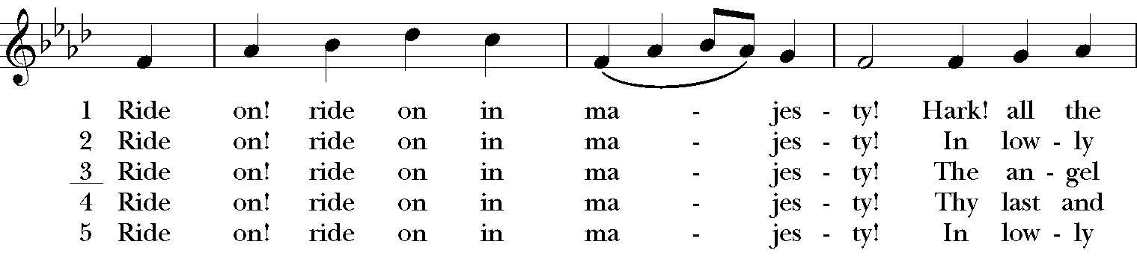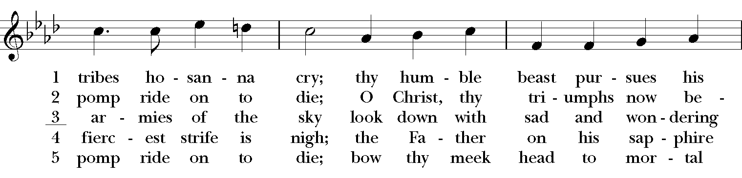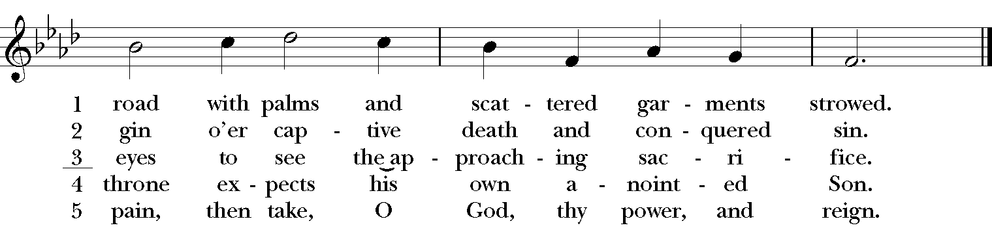

Blessing
Almighty God, we pray you graciously to behold this your family, for whom our Lord Jesus Christ was willing to be betrayed, and given into the hands of sinners, and to suffer death upon the cross; who lives and reigns for ever and ever. Amen.

Announcements

Dismissal
Deacon: Go in peace to love and serve the Lord.
People: Thanks be to God!

Postlude: "When Jesus Left His Father's Throne" – Kingsfold/arr. David Schelat

Thank you for your spiritual presence with us this morning!
Although we're physically apart, we are united in prayer, worship, and holy love!
Priest-In-Charge: The Rev. Dr. Canon Lee Anne Reat
Deacon: The Rev. Dr. Rick Incorvati
Music Director: Dr. Chris Durrenberger
Lector: Liz Wheeler
Narrator: The Rev. Dr. Rick Incorvati
Jesus: Fred Bartenstein
Male Leader: Kent Brooks
Female Leader: Anne Strothman
Peter: Liz Wheeler
Pilate: Amanda Hayden
Judas: Sarah Schubert
Singers: Liz Wheeler, Joy Carter, Ed Hasecke, Fred Bartenstein
Technology: Steve Ide
Slideshow: Ed Hasecke
Parish Administrator and Program Coordinator: Kelly Zeller

