Christ Episcopal Church in Springfield, Ohio
Service of the Word
Third Sunday in Lent: March 7th, 2021 at 9 am

Prelude:

Opening Hymn: “Eternal Lord of love, behold your church” Hymnal 149
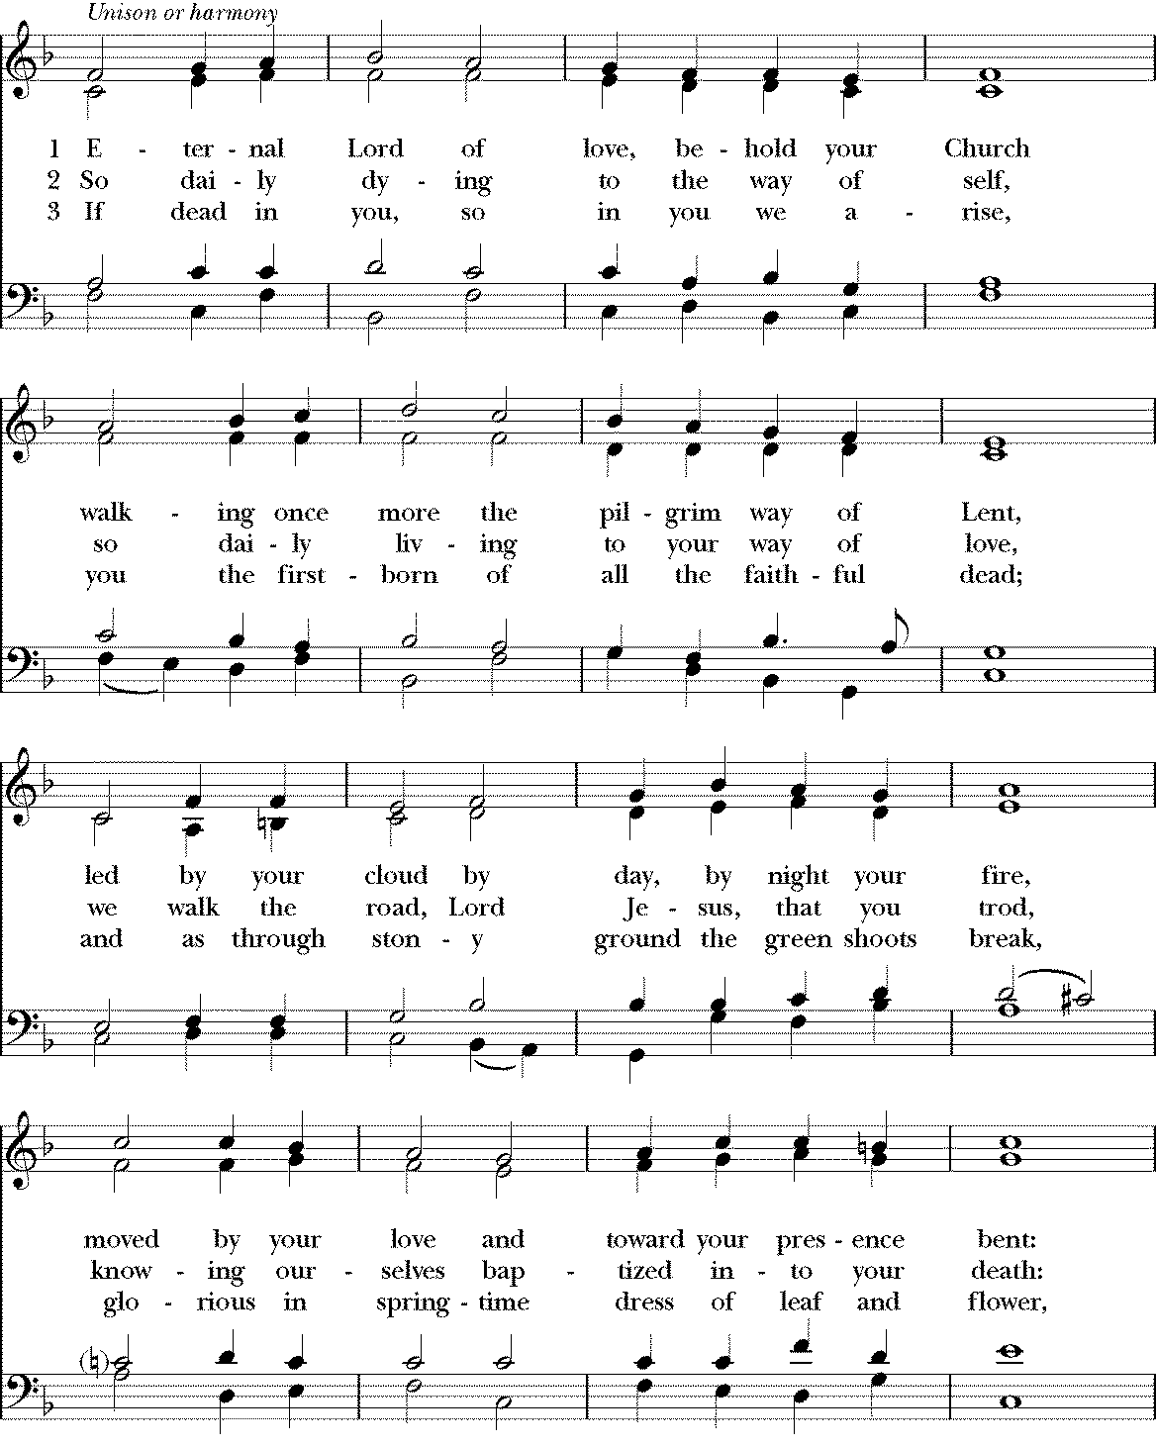

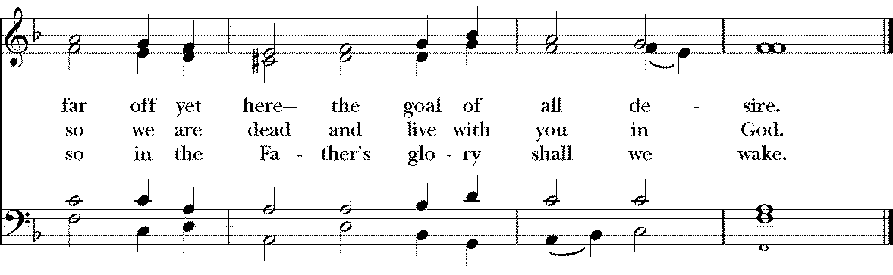

Celebrant: Bless the Lord who forgives all our sins;
People: His mercy endures for ever.
Celebrant: Lord, have mercy.
People: Christ, have mercy.
Celebrant: Lord, have mercy.

The Collect of the Day
Celebrant: The Lord be with you.
People: And also with you.
Celebrant: Let us pray.
Almighty God, you know that we have no power in ourselves to help ourselves: Keep us both outwardly in our bodies and inwardly in our souls, that we may be defended from all adversities which may happen to the body, and from all evil thoughts which may assault and hurt the soul; through Jesus Christ our Lord, who lives and reigns with you and the Holy Spirit, one God, for ever and ever. Amen.

The Lessons

The First Reading: Exodus 20:1-17
Then God spoke all these words:
I am the Lord your God, who brought you out of the land of Egypt, out of the house of slavery; you shall have no other gods before me.
You shall not make for yourself an idol, whether in the form of anything that is in heaven above, or that is on the earth beneath, or that is in the water under the earth. You shall not bow down to them or worship them; for I the Lord your God am a jealous God, punishing children for the iniquity of parents, to the third and the fourth generation of those who reject me, but showing steadfast love to the thousandth generation of those who love me and keep my commandments.
You shall not make wrongful use of the name of the Lord your God, for the Lord will not acquit anyone who misuses his name.
Remember the sabbath day, and keep it holy. For six days you shall labour and do all your work. But the seventh day is a sabbath to the Lord your God; you shall not do any work—you, your son or your daughter, your male or female slave, your livestock, or the alien resident in your towns. For in six days the Lord made heaven and earth, the sea, and all that is in them, but rested the seventh day; therefore the Lord blessed the sabbath day and consecrated it.
Honor your father and your mother, so that your days may be long in the land that the Lord your God is giving you.
You shall not murder.
You shall not commit adultery.
You shall not steal.
You shall not bear false witness against your neighbor.
You shall not covet your neighbor’s house; you shall not covet your neighbor’s wife, or male or female slave, or ox, or donkey, or anything that belongs to your neighbor.
Reader: The Word of the Lord.
People: Thanks be to God.

Psalm 19 Caeli enarrant

1 The heavens declare the glory of God, *
and the firmament shows his handiwork.
2 One day tells its tale to another, *
and one night imparts knowledge to another.
3 Although they have no words or language, *
and their voices are not heard,
4 Their sound has gone out into all lands, *
and their message to the ends of the world.
5 In the deep has he set a pavilion for the sun; *
it comes forth like a bridegroom out of his chamber;
it rejoices like a champion to run its course.
6 It goes forth from the uttermost edge of the heavens
and runs about to the end of it again; *
nothing is hidden from its burning heat.
7 The law of the Lord is perfect and revives the soul; *
the testimony of the Lord is sure and gives wisdom to the innocent.
8 The statutes of the Lord are just and rejoice the heart; *
the commandment of the Lord is clear and gives light to the eyes.
9 The fear of the Lord is clean and endures for ever; *
the judgments of the Lord are true and righteous altogether.
10 More to be desired are they than gold, more than much fine gold, *
sweeter far than honey, than honey in the comb.
11 By them also is your servant enlightened, *
and in keeping them there is great reward.
12 Who can tell how often he offends? *
cleanse me from my secret faults.
13 Above all, keep your servant from presumptuous sins;
let them not get dominion over me; *
then shall I be whole and sound, and innocent of a great offense.
14 Let the words of my mouth and the meditation
of my heart be acceptable in your sight, *
O Lord, my strength and my redeemer.

Second Lesson: 1 Corinthians 1:18-25
The message about the cross is foolishness to those who are perishing, but to us who are being saved it is the power of God. For it is written,

“I will destroy the wisdom of the wise,
and the discernment of the discerning I will thwart.”

Where is the one who is wise? Where is the scribe? Where is the debater of this age? Has not God made foolish the wisdom of the world? For since, in the wisdom of God, the world did not know God through wisdom, God decided, through the foolishness of our proclamation, to save those who believe. For Jews demand signs and Greeks desire wisdom, but we proclaim Christ crucified, a stumbling block to Jews and foolishness to Gentiles, but to those who are the called, both Jews and Greeks, Christ the power of God and the wisdom of God. For God’s foolishness is wiser than human wisdom, and God’s weakness is stronger than human strength.
Reader: The Word of the Lord.
People: Thanks be to God.
Sequence Hymn: “Beneath the cross of Jesus” Hymnal 498
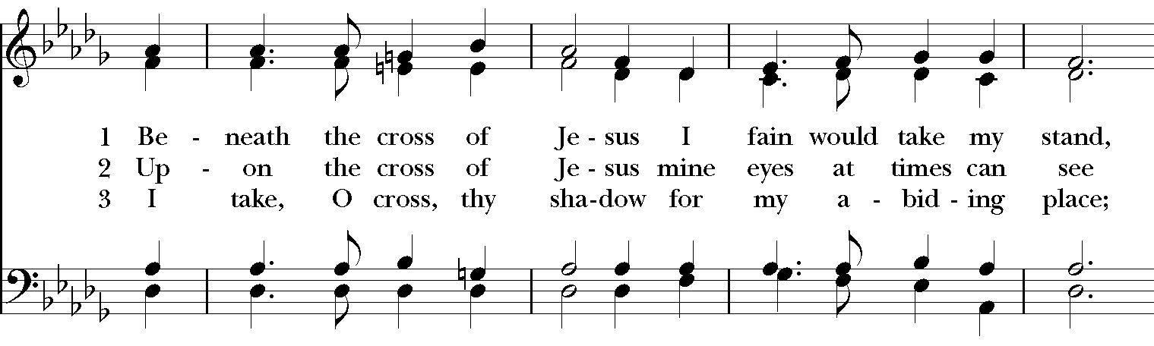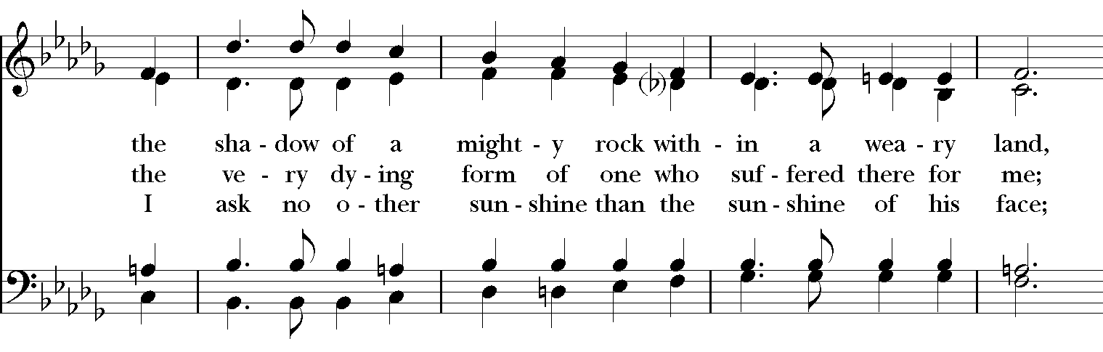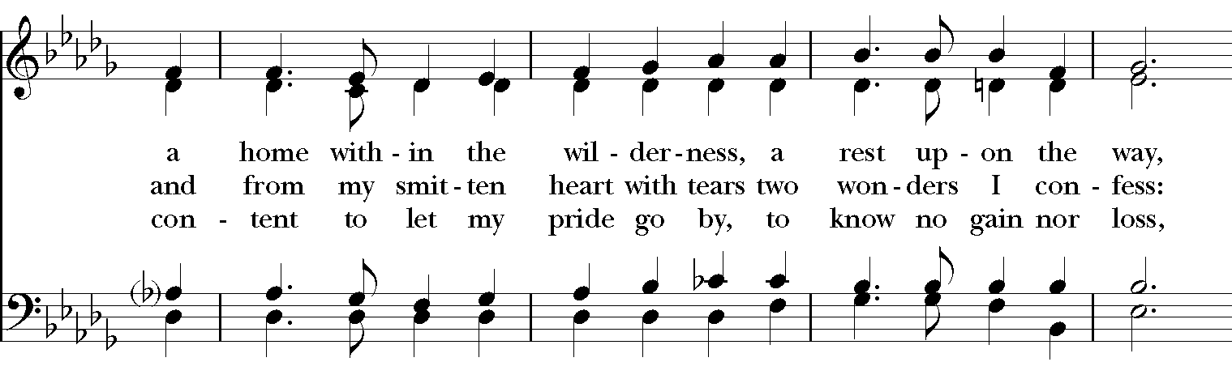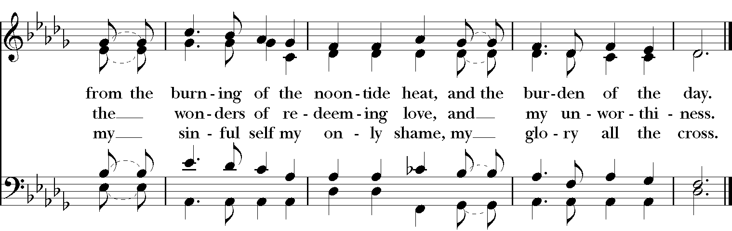
Gospel
Deacon: The Holy Gospel According to John (2:13-22)
People: Glory to you, Lord Christ.
The Passover of the Jews was near, and Jesus went up to Jerusalem. In the temple he found people selling cattle, sheep, and doves, and the money changers seated at their tables. Making a whip of cords, he drove all of them out of the temple, both the sheep and the cattle. He also poured out the coins of the money changers and overturned their tables. He told those who were selling the doves, “Take these things out of here! Stop making my Father’s house a marketplace!” His disciples remembered that it was written, “Zeal for your house will consume me.” The Jews then said to him, “What sign can you show us for doing this?” Jesus answered them, “Destroy this temple, and in three days I will raise it up.” The Jews then said, “This temple has been under construction for forty-six years, and will you raise it up in three days?” But he was speaking of the temple of his body. After he was raised from the dead, his disciples remembered that he had said this; and they believed the scripture and the word that Jesus had spoken.
Deacon: The Gospel of the Lord.
People: Praise to you, Lord Christ.

Sermon The Rev. Canon Dr. Lee Anne Reat

The Nicene Creed
We believe in one God,
the Father, the Almighty,
the maker of heaven and earth,
of all that is, seen and unseen.
We believe in one Lord, Jesus Christ,
the only Son of God,
eternally begotten of the Father,
God from God, Light from Light,
true God from true God,
begotten, not made,
of one Being with the Father.
Through him all things were made.
For us and for our salvation
he came down from heaven:
by the power of the Holy Spirit
he became incarnate from the Virgin Mary,
and was made man.
For our sake he was crucified under Pontius Pilate;
he suffered death and was buried.
On the third day he rose again
in accordance with the Scriptures;
He ascended into heaven
and is seated on the right hand of the Father.
He will come again in glory to judge the living and the dead,
and his kingdom will have no end.
We believe in the Holy Spirit, the Lord, the giver of life,
who proceeds from the Father and the Son.
With the Father and the Son he is worshiped and glorified.
He has spoken through the Prophets.
We believe in one holy catholic and apostolic Church.
We acknowledge one baptism for the forgiveness of sins.
We look for the resurrection of the dead,
and the life of the world to come. Amen.

The Prayers of the People

In peace, we pray to you Lord God.

Silence

Let us offer prayers to God who has made us a new creation in Christ, saying "Lord, have mercy."

For this parish community, that we may grow in holiness together as we prepare for the Paschal season.
Lord, have mercy.

For Justin, Archbishop of Canterbury; Michael, our Presiding Bishop; Ken, our Diocesan Bishop; Lee Anne, our priest; Rick, our deacon; and all who minister in Christ, that they may be firmly rooted in your truth and love.
Lord, have mercy.

For all the peoples of the earth and for their leaders, that we may move ever closer to your holy reign of peace, dignity, and abundant life for all.
Lord, have mercy.

For the holy work being done through and around us, in ministries such as Children’s Rescue Center/The Ark, Christ Church Food Pantry, The Fuller Center for Housing, and Safe Harbor House, that fruits of love and mercy may be borne continually.
Lord, have mercy.

For all who are sick, afflicted, oppressed, or in need, especially Faye, Chris, Laura, Bonnie, Alice, Diana, James, Joy, Jane, Joni, Kim, Bobby, Sarah, Traudie, Lexie, and Keith, that they may be upheld by your Spirit and restored to wholeness.

Lord, have mercy.

For those celebrating birthdays and anniversaries, especially Bailey and Judy that they may rejoice always in you.
Lord, have mercy.

For those who have fallen asleep in Christ, for all the departed, and for those who grieve.
Lord, have mercy.

*THE COLLECT FOR PEACE
Grant, O God, that your holy and life-giving Spirit may so move every human heart, that barriers which divide us may crumble, suspicions disappear, and hatreds cease; that our divisions being healed, we may live in justice and peace; through Jesus Christ our Lord. Amen.

Deacon: Let us confess our sins against God and our neighbor.
All: Most merciful God, we confess that we have sinned against you in thought, word, and deed, by what we have done, and by what we have left undone. We have not loved you with our whole heart; we have not loved our neighbors as ourselves. We are truly sorry and we humbly repent. For the sake of your Son Jesus Christ, have mercy on us and forgive us; that we may delight in your will, and walk in your ways, to the glory of your Name. Amen.

Priest: Almighty God, have mercy on you, forgive you all your sins through our Lord Jesus Christ, strengthen you in all goodness, and by the power of the Holy Spirit keep you in eternal life. Amen.
And now, as our Savior Christ has taught us, we are bold to say:
Our Father, who art in heaven, hallowed be thy Name,
thy kingdom come, thy will be done, on earth as it is in heaven.
Give us this day our daily bread.
And forgive us our trespasses, as we forgive those who trespass against us.
And lead us not into temptation, but deliver us from evil.
For thine is the kingdom, and the power, and the glory, for ever and ever. Amen.
Closing Hymn: “God of grace and God of glory Hymnal 594
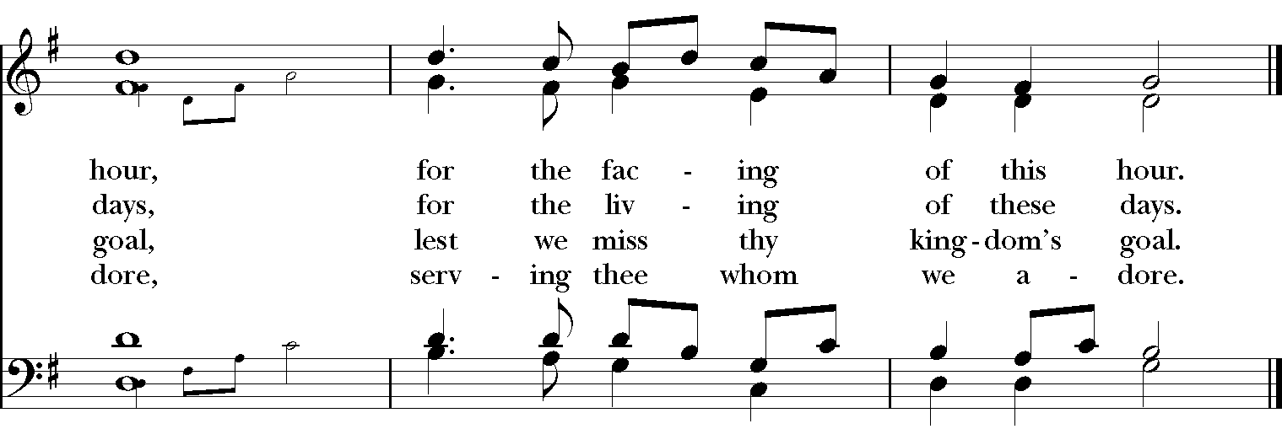
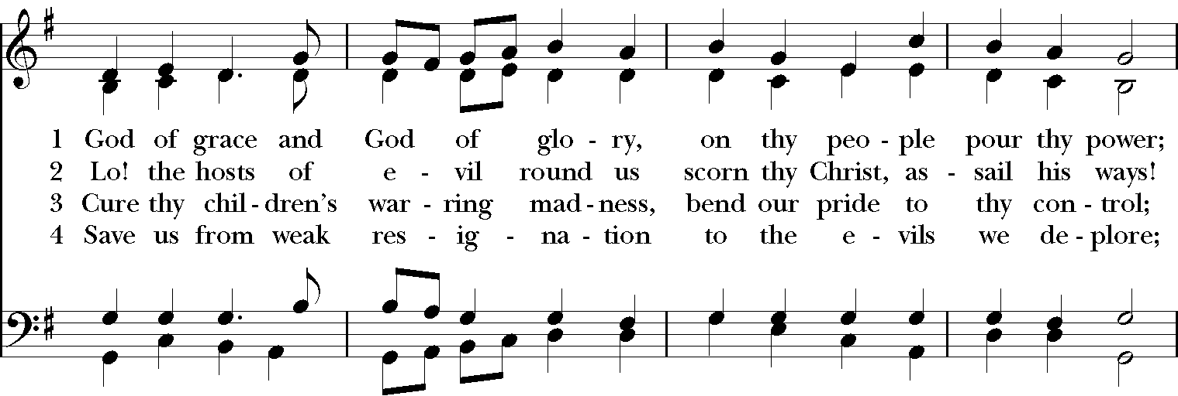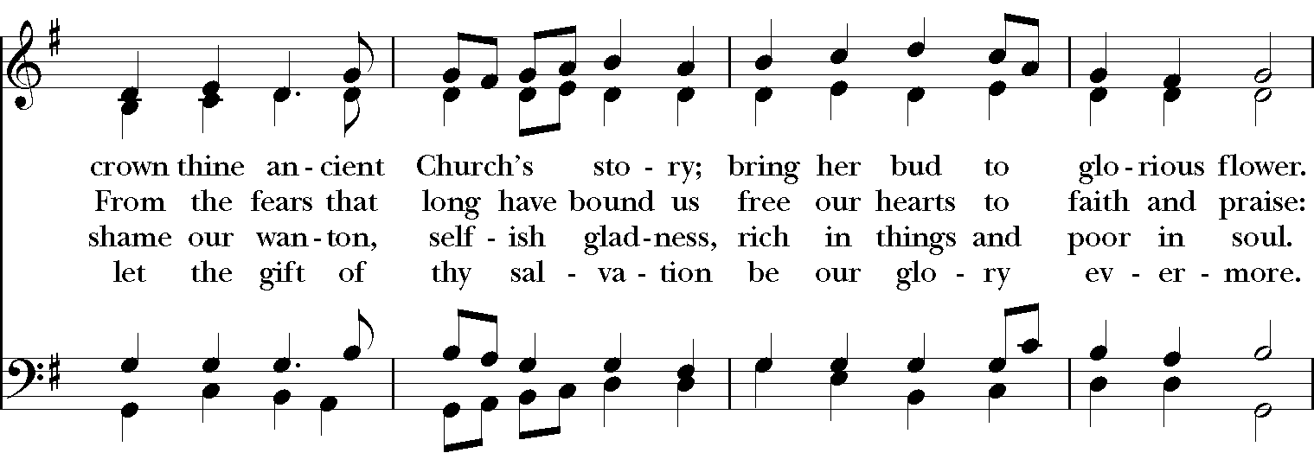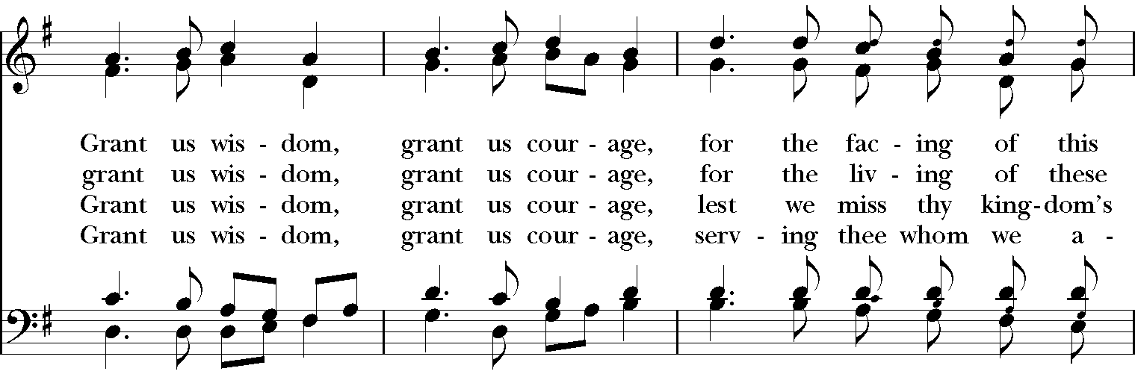

Blessing
Look mercifully on this your family, Almighty God, that by your great good ness they may be governed and preserved evermore; through Christ our Lord, and the blessing of God Almighty, the Father, the Son and the Holy Spirit, be among you and remain with you always. Amen.

Announcements

Dismissal
Deacon: Go in peace to love and serve the Lord.
People: Thanks be to God!

Postlude:

Thank you for your spiritual presence with us this morning!
Although we're physically apart, we are united in prayer, worship, and holy love!
Priest-In-Charge: The Rev. Dr. Canon Lee Anne Reat
Deacon: The Rev. Dr. Rick Incorvati
Music Director: Dr. Chris Durrenberger
Lector: Fred Bartenstein
Singers: Liz Wheeler, Joy Carter, Ed Hasecke, Fred Bartenstein
Technology: Steve Ide
Slideshow: Ed Hasecke
Parish Administrator and Program Coordinator: Kelly Zeller
Coffee Hour Host: Linda Mortensen

