Christ Episcopal Church in Springfield, Ohio
Service of the Word
Seventh Sunday of Easter: May 16th, 2021 at 9 am

PRELUDE:

OPENING HYMN: “Awake, arise, lift up your voice” Hymnal 212
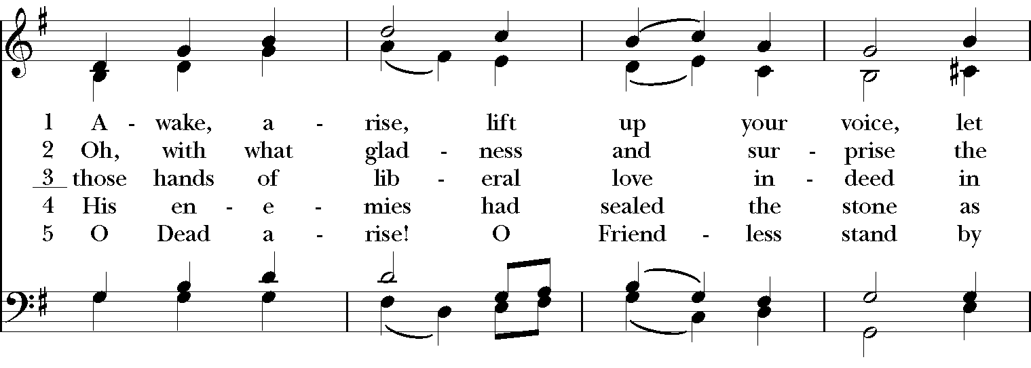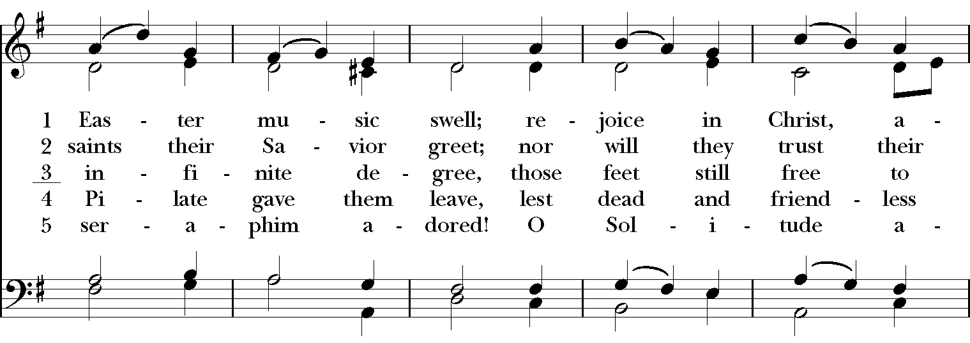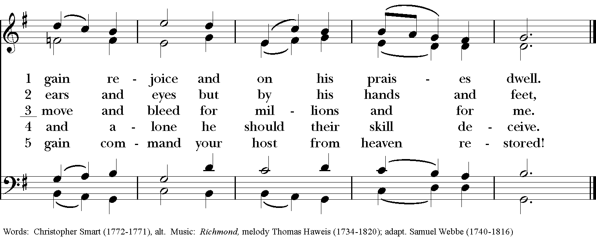
Celebrant: Alleluia! Christ has risen!
People: The Lord is risen indeed. Alleluia!

The Collect of the Day
Celebrant: The Lord be with you.
People: And also with you.
Celebrant: Let us pray.
O God, the King of glory, you have exalted your only Son Jesus Christ with great triumph to your kingdom in heaven: Do not leave us comfortless, but send us your Holy Spirit to strengthen us, and exalt us to that place where our Savior Christ has gone before; who lives and reigns with you and the Holy Spirit, one God, in glory everlasting. Amen.

The Lessons

THE FIRST READING Acts 1:15-17, 21-26
In those days Peter stood up among the believers (together the crowd numbered about one hundred twenty persons) and said, "Friends, the scripture had to be fulfilled, which the Holy Spirit through David foretold concerning Judas, who became a guide for those who arrested Jesus-- for he was numbered among us and was allotted his share in this ministry. So one of the men who have accompanied us during all the time that the Lord Jesus went in and out among us, beginning from the baptism of John until the day when he was taken up from us-- one of these must become a witness with us to his resurrection." So they proposed two, Joseph called Barsabbas, who was also known as Justus, and Matthias. Then they prayed and said, "Lord, you know everyone's heart. Show us which one of these two you have chosen to take the place in this ministry and apostleship from which Judas turned aside to go to his own place." And they cast lots for them, and the lot fell on Matthias; and he was added to the eleven apostles.
Lector: The Word of the Lord.
People: Thanks be to God.

*PSALM: 1 Beatus vir qui non abiit
1 Happy are they who have not walked in the counsel of the wicked, *
nor lingered in the way of sinners, nor sat in the seats of the scornful!
2 Their delight is in the law of the Lord, *
and they meditate on his law day and night.
3 They are like trees planted by streams of water,
bearing fruit in due season, with leaves that do not wither; *
everything they do shall prosper.
4 It is not so with the wicked; *
they are like chaff which the wind blows away.
5 Therefore the wicked shall not stand upright when judgment comes, *
nor the sinner in the council of the righteous.
6 For the Lord knows the way of the righteous, *
but the way of the wicked is doomed.

THE SECOND LESSON 1 John 5:9-13
If we receive human testimony, the testimony of God is greater; for this is the testimony of God that he has testified to his Son. Those who believe in the Son of God have the testimony in their hearts. Those who do not believe in God have made him a liar by not believing in the testimony that God has given concerning his Son. And this is the testimony: God gave us eternal life, and this life is in his Son. Whoever has the Son has life; whoever does not have the Son of God does not have life.

I write these things to you who believe in the name of the Son of God, so that you may know that you have eternal life.
Lector: The Word of the Lord.
People: Thanks be to God.

SEQUENCE HYMN: “Father, we thank thee who hast planted” Hymnal 302
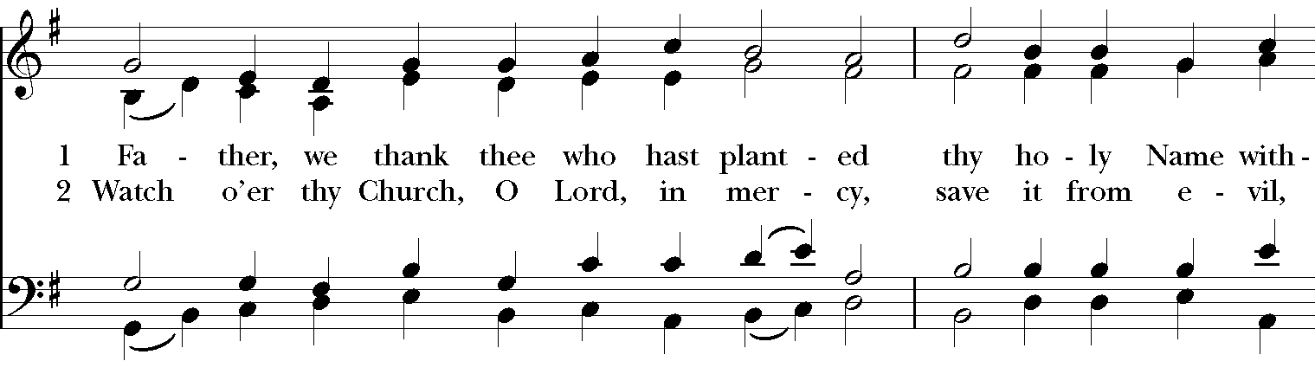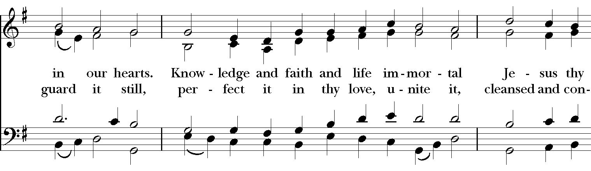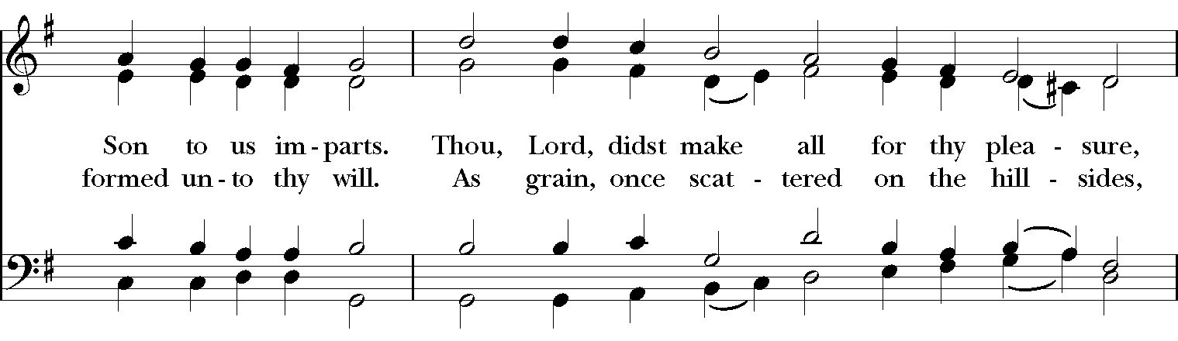
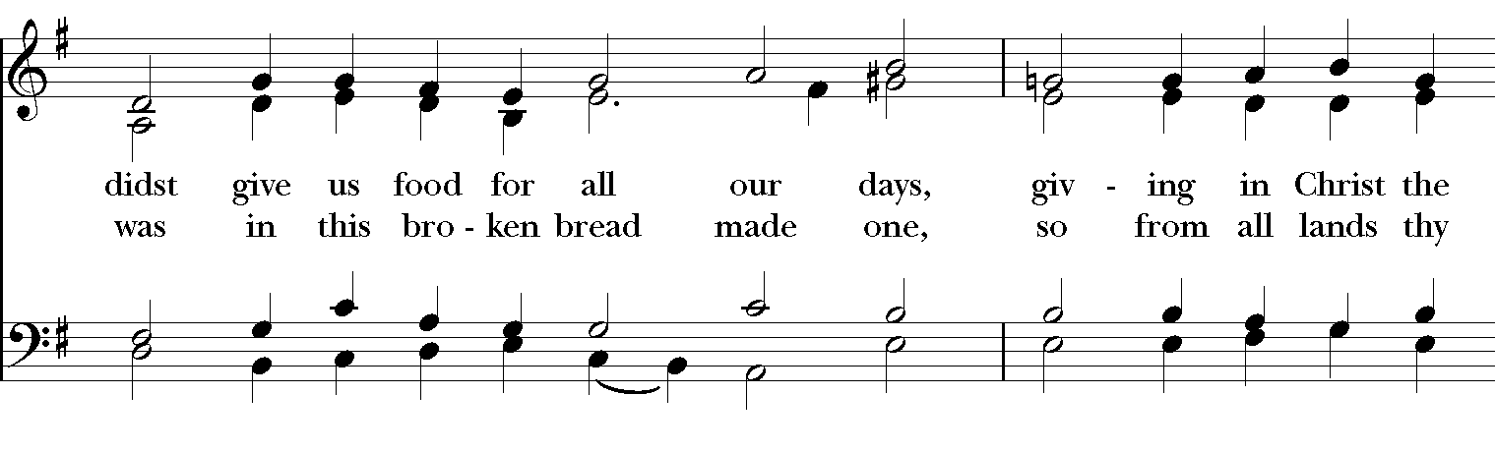

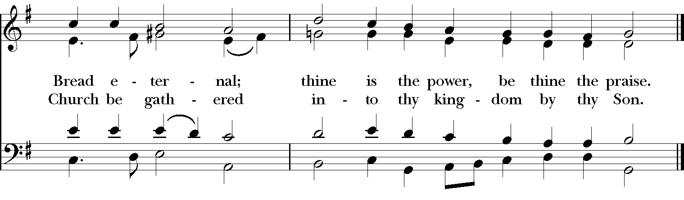
Gospel
Deacon: The Holy Gospel of our Lord Jesus Christ according to John (John 17:6-19).
People: Glory to you, Lord Christ.
Jesus prayed for his disciples, “I have made your name known to those whom you gave me from the world. They were yours, and you gave them to me, and they have kept your word. Now they know that everything you have given me is from you; for the words that you gave to me I have given to them, and they have received them and know in truth that I came from you; and they have believed that you sent me. I am asking on their behalf; I am not asking on behalf of the world, but on behalf of those whom you gave me, because they are yours. All mine are yours, and yours are mine; and I have been glorified in them. And now I am no longer in the world, but they are in the world, and I am coming to you. Holy Father, protect them in your name that you have given me, so that they may be one, as we are one. While I was with them, I protected them in your name that you have given me. I guarded them, and not one of them was lost except the one destined to be lost, so that the scripture might be fulfilled. But now I am coming to you, and I speak these things in the world so that they may have my joy made complete in themselves. I have given them your word, and the world has hated them because they do not belong to the world, just as I do not belong to the world. I am not asking you to take them out of the world, but I ask you to protect them from the evil one. They do not belong to the world, just as I do not belong to the world. Sanctify them in the truth; your word is truth. As you have sent me into the world, so I have sent them into the world. And for their sakes I sanctify myself, so that they also may be sanctified in truth.”
Deacon: The Gospel of the Lord.
People: Praise to you, Lord Christ.

Sermon The Rev. Canon Dr. Lee Anne Reat

The Nicene Creed
We believe in one God, the Father, the Almighty,
maker of heaven and earth, of all that is, seen and unseen.
We believe in one Lord, Jesus Christ, the only Son of God,
eternally begotten of the Father, God from God,
Light from Light, true God from true God,
begotten, not made, of one Being with the Father.
Through him all things were made.
For us and for our salvation he came down from heaven,
by the power of the Holy Spirit he became incarnate from the Virgin Mary,
and was made man.
For our sake he was crucified under Pontius Pilate;
he suffered death and was buried.
On the third day he rose again in accordance with the Scriptures;
he ascended into heaven and is seated at the right hand of the Father.
He will come again in glory to judge the living and the dead, and his kingdom will have no end.
We believe in the Holy Spirit, the Lord, the giver of life,
who proceeds from the Father, and the Son.
who with the Father and the Son is worshiped and glorified,
who has spoken through the Prophets.
We believe in one holy catholic and apostolic Church.
We acknowledge one baptism for the forgiveness of sins.
We look for the resurrection of the dead, and the life of the world to come. Amen.

The Prayers of the People

In peace, we pray to you Lord God. Congregational responses are in bold.

Silence

Blessed are you eternal God,
to be praised and glorified forever.

Hear us as we pray for the unity of the Church.
May we all be one, that the world may come to know you.

Grant that every member of the Church may truly and humbly serve you,
that the life of Christ may be revealed in us.

We remember those who have died.
Into your hands we commend them.
We praise you for all your saints who have entered eternal glory.
May we also come to share your heavenly kingdom.

Have compassion on those who suffer from sickness, grief or trouble, especially Charlene, Laura, Faye, Chris, Laura, Bonnie, Alice, Diana, James, Joy, Jane, Joni, Kim, Bobby, Sarah, Traudie, Lexie, and Keith.
In your presence may they find strength.

Look with kindness on our homes and families, and all who celebrate birthdays this week, especially Logan, Ross, Hollis, Eman, Ron, Daphne, Marj, and Zoe, and anniversaries Chris & Ping.
Grant that your love may grow in our hearts.

Make us alive to the needs of our community, and bless the holy work of Springfield Farmer’s Market, Project Woman, Children’s Defense Fund Freedom School, The YMCA, and Jefferson St. Oasis Garden.
Help us to share one another’s joys and burdens.

Inspire and lead those who hold authority in the nations of the world.
Guide us and all people in the way of justice and peace.

For Justin, Archbishop of Canterbury; Michael, our Presiding Bishop; Ken, our Diocesan Bishop; Lee Anne, our priest; Rick, our deacon; and all who minister in Christ, that they may be firmly rooted in your truth and love.
Inspire us and give us courage to proclaim your Gospel of Resurrection.

*THE COLLECT FOR PEACE
Grant, O God, that your holy and life-giving Spirit may so move every human heart, that barriers which divide us may crumble, suspicions disappear, and hatreds cease; that our divisions being healed, we may live in justice and peace; through Jesus Christ our Lord. Amen.
Deacon: Let us confess our sins against God and our neighbor.
All: Most merciful God, we confess that we have sinned against you in thought, word, and deed, by what we have done, and by what we have left undone. We have not loved you with our whole heart; we have not loved our neighbors as ourselves. We are truly sorry and we humbly repent. For the sake of your Son Jesus Christ, have mercy on us and forgive us; that we may delight in your will, and walk in your ways, to the glory of your Name. Amen.

Priest: Almighty God, have mercy on you, forgive you all your sins through our Lord Jesus Christ, strengthen you in all goodness, and by the power of the Holy Spirit keep you in eternal life. Amen.

And now, as our Savior Christ has taught us, we are bold to say:
Our Father, who art in heaven, hallowed be thy Name,
thy kingdom come, thy will be done, on earth as it is in heaven.
Give us this day our daily bread.
And forgive us our trespasses, as we forgive those who trespass against us.
And lead us not into temptation, but deliver us from evil.
For thine is the kingdom, and the power, and the glory, for ever and ever. Amen

CLOSING HYMN: “Jesus Shall reign where’er the sun” Hymnal 544
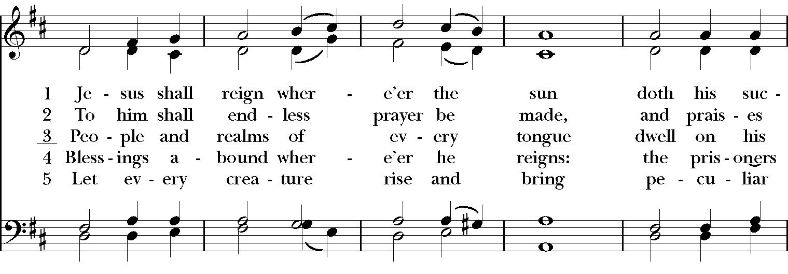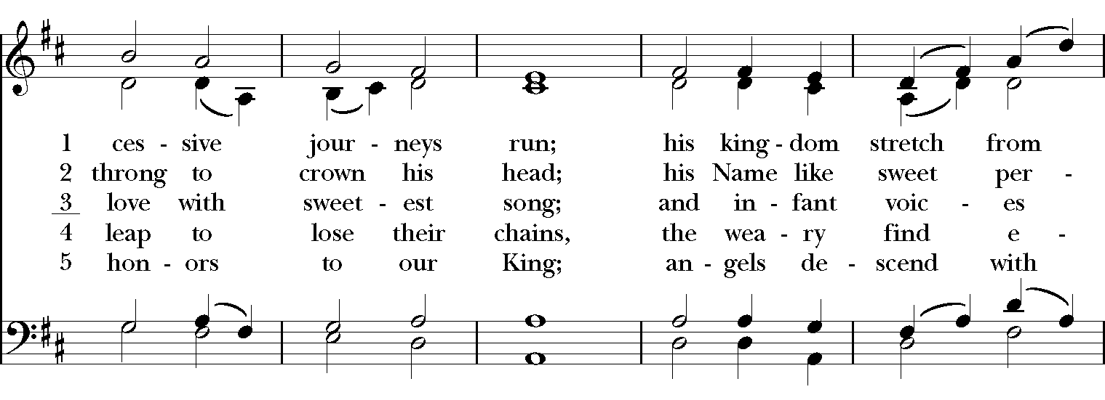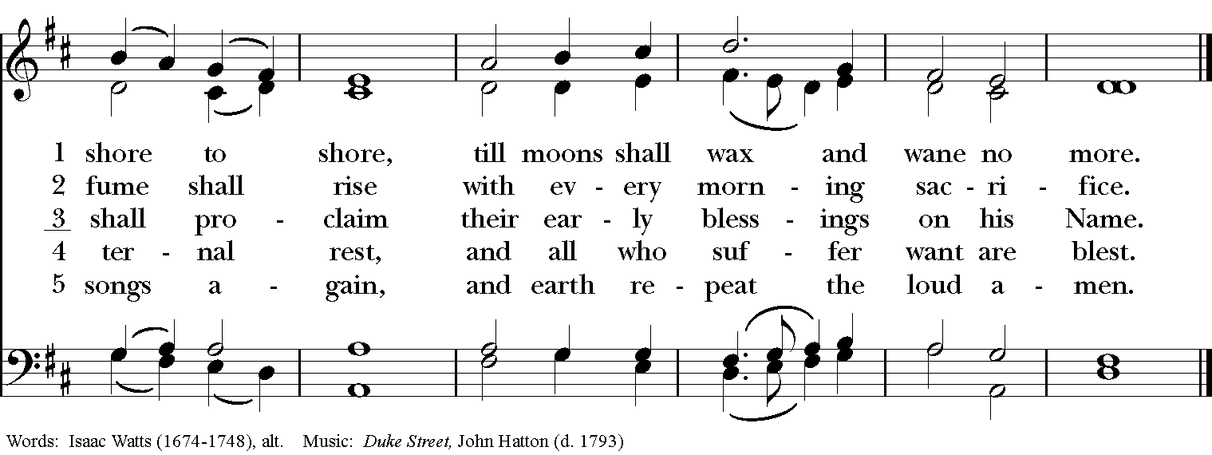

*THE BLESSING
The God of peace, who brought again from the dead our Lord Jesus Christ, the great Shepherd of the sheep, through the blood of the everlasting covenant, make you perfect in every good work to do his will, working in you that which is well-pleasing in his sight; and the blessing of God Almighty, the Father, the Son, and the Holy Spirit, be among you, and remain with you always. Amen.

*THE DISMISSAL Deacon: Go in peace to love and serve the Lord. Alleluia, alleluia!
People: Thanks be to God. Alleluia, alleluia!

POSTLUDE:

Thank you for your spiritual presence with us this morning!
Although we're physically apart, we are united in prayer, worship, and holy love!
Priest-In-Charge: The Rev. Dr. Canon Lee Anne Reat
Deacon: The Rev. Dr. Rick Incorvati
Music Director: Dr. Chris Durrenberger
Lector: Ann Strothman
Singers: Liz Wheeler, Joy Carter, Ed Hasecke, Chris Oldstone-Moore
Technology: Steve Ide
Slideshow: Ed Hasecke
Parish Administrator and Program Coordinator: Kelly Zeller

