Christ Episcopal Church in Springfield, Ohio
Service of the Word
The Day of Pentecost: May 23rd, 2021 at 9 am

PRELUDE:

OPENING HYMN: “Hail thee, festival day!” Hymnal 225
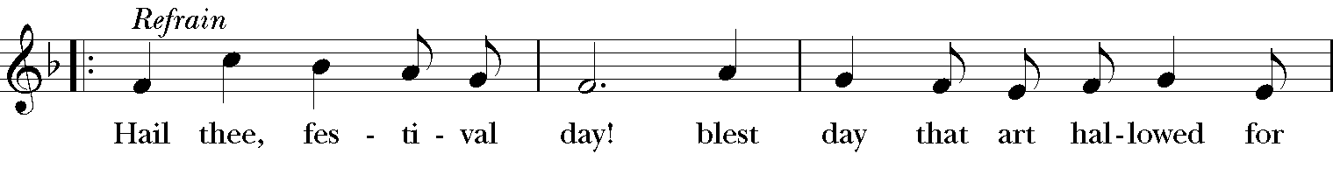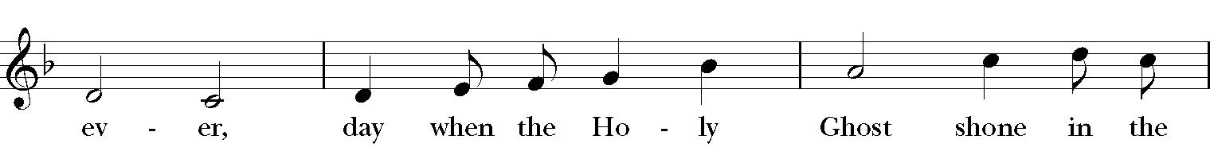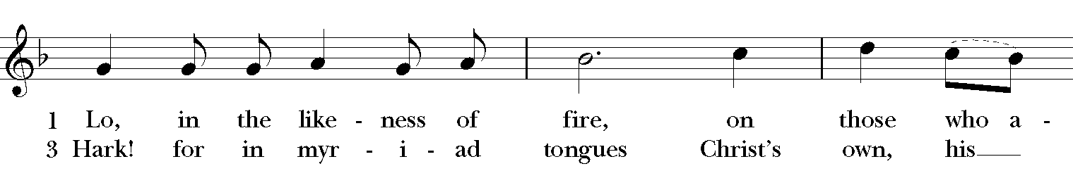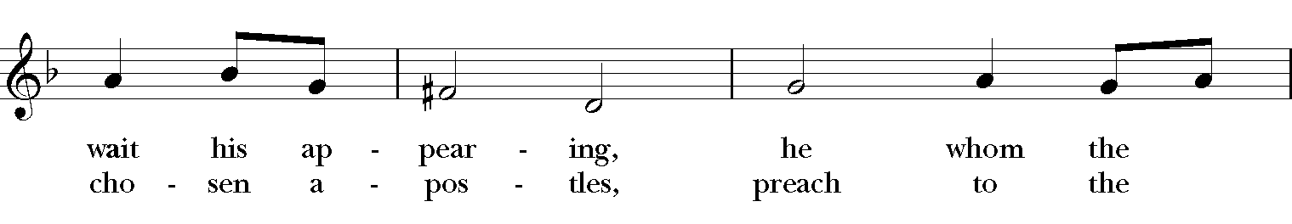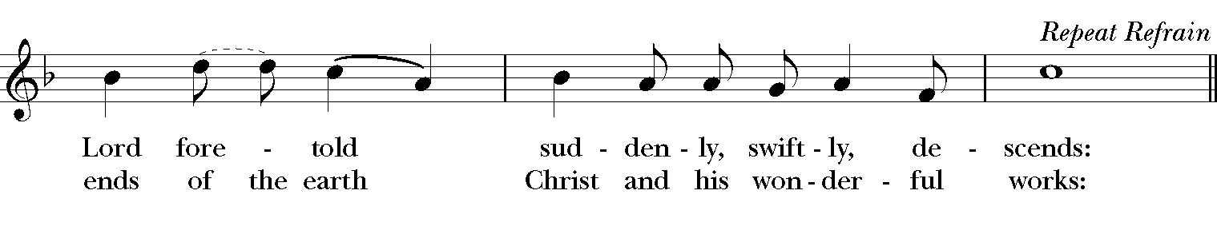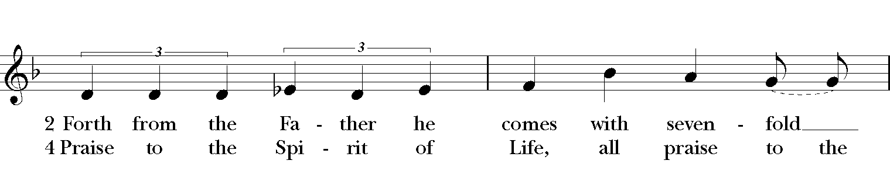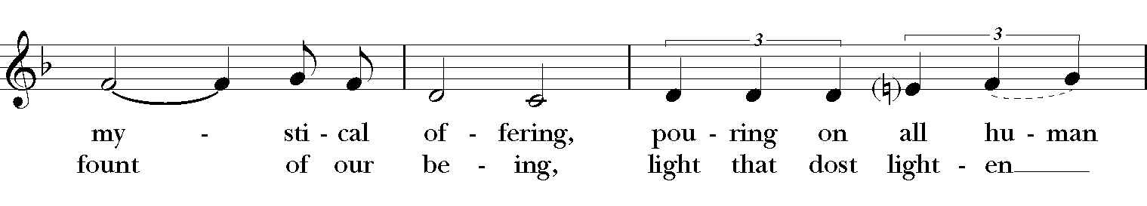
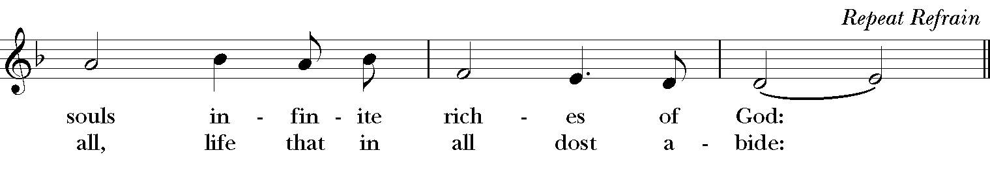

Celebrant: We are your Pentecost people, O God!
People: “When the day of Pentecost had come, they were all together in one place.”
Celebrant: Gather your people, as we, here, are gathered.
People: “Suddenly from heaven there came a sound like the rush of a violent wind.”
Celebrant: Blow through our fellowship with your strong Spirit-wind.
People: “And it filled the entire house where they were sitting.”
Celebrant: Fill your people, brim-full ... and beyond.
People: “Divided tongues, as of fire, appeared among them, and a tongue rested on each of them.”
Celebrant: Burn through this place with your bright Spirit-fire.
People: “All of them were filled with the Holy Spirit and began to speak ....”
Celebrant: Then we will be empowered to fan your Spirit’s hot fire.
People: Then it will burn through this world!
Celebrant: Through Jesus Christ, your Son, our Lord. He lives and reigns with you and the Holy Spirit, one God,
People: Now, and forever. Amen.

The Collect of the Day
Celebrant: The Lord be with you.
People: And also with you.
Celebrant: Let us pray.
Almighty God, on this day you opened the way of eternal life to every race and nation by the promised gift of your Holy Spirit: Shed abroad this gift throughout the world by the preaching of the Gospel, that it may reach to the ends of the earth; through Jesus Christ our Lord, who lives and reigns with you, in the unity of the Holy Spirit, one God, for ever and ever. Amen.

The Lessons

THE FIRST READING Acts 2:1-21
When the day of Pentecost had come, the disciples were all together in one place. And suddenly from heaven there came a sound like the rush of a violent wind, and it filled the entire house where they were sitting. Divided tongues, as of fire, appeared among them, and a tongue rested on each of them. All of them were filled with the Holy Spirit and began to speak in other languages, as the Spirit gave them ability.
Now there were devout Jews from every nation under heaven living in Jerusalem. And at this sound the crowd gathered and was bewildered, because each one heard them speaking in the native language of each. Amazed and astonished, they asked, "Are not all these who are speaking Galileans? And how is it that we hear, each of us, in our own native language? Parthians, Medes, Elamites, and residents of Mesopotamia, Judea and Cappadocia, Pontus and Asia, Phrygia and Pamphylia, Egypt and the parts of Libya belonging to Cyrene, and visitors from Rome, both Jews and proselytes, Cretans and Arabs-- in our own languages we hear them speaking about God's deeds of power." All were amazed and perplexed, saying to one another, "What does this mean?" But others sneered and said, "They are filled with new wine."
But Peter, standing with the eleven, raised his voice and addressed them, "Men of Judea and all who live in Jerusalem, let this be known to you, and listen to what I say. Indeed, these are not drunk, as you suppose, for it is only nine o'clock in the morning. No, this is what was spoken through the prophet Joel:
`In the last days it will be, God declares,
that I will pour out my Spirit upon all flesh,
and your sons and your daughters shall prophesy,
and your young men shall see visions,
and your old men shall dream dreams.
Even upon my slaves, both men and women,
in those days I will pour out my Spirit;
and they shall prophesy.
And I will show portents in the heaven above
and signs on the earth below,
blood, and fire, and smoky mist.
The sun shall be turned to darkness
and the moon to blood,
before the coming of the Lord's great and glorious day.
Then everyone who calls on the name of the Lord shall be saved.' "
Lector: The Word of the Lord.
People: Thanks be to God.

*PSALM: 104:25-35,37 Benedic, anima mea
25 O Lord, how manifold are your works! *
in wisdom you have made them all; the earth is full of your creatures.
26 Yonder is the great and wide sea with its living things too many to number, *
creatures both small and great.
27 There move the ships, and there is that Leviathan, *
which you have made for the sport of it.
28 All of them look to you *
to give them their food in due season.
29 You give it to them; they gather it; *
you open your hand, and they are filled with good things.
30 You hide your face, and they are terrified; *
you take away their breath, and they die and return to their dust.
31 You send forth your Spirit, and they are created; *
and so you renew the face of the earth.
32 May the glory of the Lord endure for ever; *
may the Lord rejoice in all his works.
33 He looks at the earth and it trembles; *
he touches the mountains and they smoke.
34 I will sing to the Lord as long as I live; *
I will praise my God while I have my being.
35 May these words of mine please him; *
I will rejoice in the Lord.
37 Bless the Lord, O my soul. *
Hallelujah!

THE SECOND LESSON Romans 8:22-27
We know that the whole creation has been groaning in labor pains until now; and not only the creation, but we ourselves, who have the first fruits of the Spirit, groan inwardly while we wait for adoption, the redemption of our bodies. For in hope we were saved. Now hope that is seen is not hope. For who hopes for what is seen? But if we hope for what we do not see, we wait for it with patience.

Likewise the Spirit helps us in our weakness; for we do not know how to pray as we ought, but that very Spirit intercedes with sighs too deep for words. And God, who searches the heart, knows what is the mind of the Spirit, because the Spirit intercedes for the saints according to the will of God.
Lector: The Word of the Lord.
People: Thanks be to God.

SEQUENCE HYMN: “Come, Holy Spirit, heavenly Dove” Hymnal 510
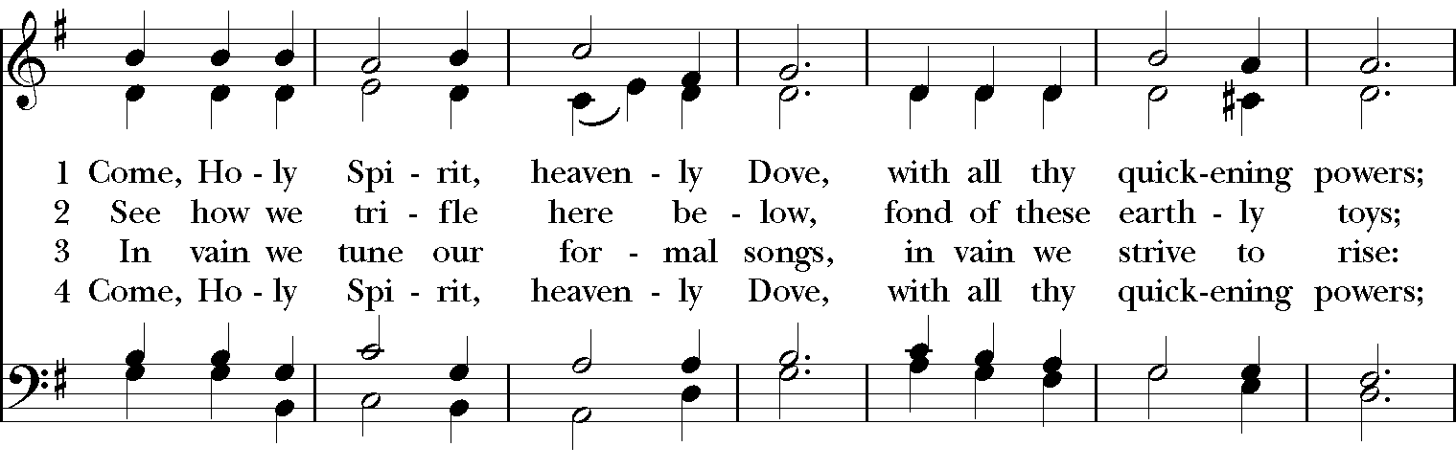

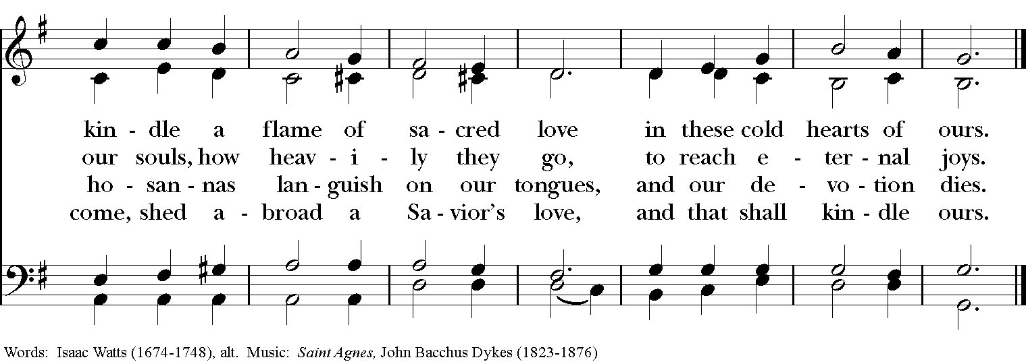

Gospel
Deacon: The Holy Gospel of our Lord Jesus Christ according to John (John 15:26-27; 16:4b-15).
People: Glory to you, Lord Christ.
Jesus said to his disciples, ”When the Advocate comes, whom I will send to you from the Father, the Spirit of truth who comes from the Father, he will testify on my behalf. You also are to testify because you have been with me from the beginning.
“I did not say these things to you from the beginning, because I was with you. But now I am going to him who sent me; yet none of you asks me, ‘Where are you going?’ But because I have said these things to you, sorrow has filled your hearts. Nevertheless I tell you the truth: it is to your advantage that I go away, for if I do not go away, the Advocate will not come to you; but if I go, I will send him to you. And when he comes, he will prove the world wrong about sin and righteousness and judgment: about sin, because they do not believe in me; about righteousness, because I am going to the Father and you will see me no longer; about judgment, because the ruler of this world has been condemned.

“I still have many things to say to you, but you cannot bear them now. When the Spirit of truth comes, he will guide you into all the truth; for he will not speak on his own, but will speak whatever he hears, and he will declare to you the things that are to come. He will glorify me, because he will take what is mine and declare it to you. All that the Father has is mine. For this reason I said that he will take what is mine and declare it to you.
Deacon: The Gospel of the Lord.
People: Praise to you, Lord Christ.

Sermon The Rev. Canon Dr. Lee Anne Reat

THE RENEWAL OF BAPTISMAL VOWS
Celebrant: Do you reaffirm your renunciation of evil and renew your commitment to Jesus Christ?
People: I do.

Celebrant: Do you believe in God the Father?
People: I believe in God, the Father almighty, creator of heaven and earth.
Celebrant: Do you believe in Jesus Christ, the Son of God?
People: I believe in Jesus Christ, his only Son, our Lord.
He was conceived by the power of the Holy Spirit
and born of the Virgin Mary.
He suffered under Pontius Pilate,
was crucified, died, and was buried.
He descended to the dead.
On the third day he rose again.
He ascended into heaven,
and is seated at the right hand of the Father.
He will come again to judge the living and the dead.

Celebrant: Do you believe in God the Holy Spirit?
People: I believe in the Holy Spirit,
the holy catholic Church,
the communion of saints,
the forgiveness of sins,
the resurrection of the body,
and the life everlasting.

Celebrant: Will you continue in the apostles' teaching and fellowship, in the breaking of bread, and in the prayers?
People: I will, with God's help.

Celebrant: Will you persevere in resisting evil, and, whenever you fall into sin, repent and return to the Lord?
People: I will, with God's help.

Celebrant: Will you proclaim by word and example the Good News of God in Christ?
People: I will, with God's help.

Celebrant: Will you seek and serve Christ in all persons, loving your neighbor as yourself?
People: I will, with God's help.

Celebrant | : Will you strive for justice and peace among all people, and respect the dignity  of every human being?
People: | I will, with God's help.
Celebrant: May Almighty God, the Father of our Lord Jesus Christ, who
has given us a new birth by water and the Holy Spirit, and bestowed upon us the forgiveness of sins, keep us in eternal life by his grace, in Christ Jesus our Lord. Amen.

THE PRAYERS OF THE PEOPLE

In peace, we pray to you Lord God. Congregational responses are in bold.

Silence

Let us pray. Founder of our faith, we ask your guidance for the Church, for its unity, and for the work it does in the world. Give grace to its leaders, especially Justin, archbishop of Canterbury; Michael, our Presiding Bishop; Ken, our Diocesan Bishop; Lee Anne, our priest; Rick, our deacon; and all the members of this parish.
R: Let your priests be clothed with righteousness; let your faithful people sing for joy.

Ruler over the nations, we pray for this country and its leaders in an unsettling time. Grant wisdom to all who serve in positions of leadership throughout the world.
R: For dominion belongs to the Lord, and he rules over the nations.

Lord of the harvest, we offer thanks for the beauty and abundance of this season. May we consider how best to tend the Earth and to share what You have given us, so that all may eat and be satisfied by your goodness. We pray for the ministries this church supports, especially Rainbow Table, Springfield Promise Neighborhood, Springfield Peace Center, and Partners in Ministry in Liberia.
R: He covers the heavens with clouds, and prepares rain for the earth;
He makes grass grow upon the mountains, and green plants to serve humankind.

Giver of every good gift and we pray for those celebrating birthdays this week, especially Taylor, Charlotte, Scott, and anniversaries Rick & Jeanie and Scott & Cathy.
R: Let the righteous be glad and rejoice before God; Let them also be merry and joyful.

Great Physician, we pray for healing and comfort for all those in need or pain, especially Charlene, Faye, Chris, Bonnie, Alice, Diana, James, Joy, Jane, Joni, Kim, Bobby, Sarah, Traudie, Lexie, and Keith. May they remember that You are with them and those who care for them.
R: Surely you behold trouble and misery; you see it and take it into your own hand.
The helpless commit themselves to you; for you are the helper of orphans.

Just Judge, we ask your aid for all those in trouble, bringing before You prisoners and captives, refugees and the oppressed. We pray for those most vulnerable throughout the world, especially women and children.
R: Let justice roll down like waters, and righteousness like an ever-flowing stream.

Lord over life and death, we pray for all who have died, asking light and peace for them and those who mourn.
R: Precious in the sight of the Lord is the death of his servant.
*THE COLLECT FOR PEACE
Grant, O God, that your holy and life-giving Spirit may so move every human heart, that barriers which divide us may crumble, suspicions disappear, and hatreds cease; that our divisions being healed, we may live in justice and peace; through Jesus Christ our Lord. Amen.

Deacon: Let us confess our sins against God and our neighbor.
All: Most merciful God, we confess that we have sinned against you in thought, word, and deed, by what we have done, and by what we have left undone. We have not loved you with our whole heart; we have not loved our neighbors as ourselves. We are truly sorry and we humbly repent. For the sake of your Son Jesus Christ, have mercy on us and forgive us; that we may delight in your will, and walk in your ways, to the glory of your Name. Amen.

Priest: Almighty God, have mercy on you, forgive you all your sins through our Lord Jesus Christ, strengthen you in all goodness, and by the power of the Holy Spirit keep you in eternal life. Amen.

And now, as our Savior Christ has taught us, we are bold to say:
Our Father, who art in heaven, hallowed be thy Name,
thy kingdom come, thy will be done, on earth as it is in heaven.
Give us this day our daily bread.
And forgive us our trespasses, as we forgive those who trespass against us.
And lead us not into temptation, but deliver us from evil.
For thine is the kingdom, and the power, and the glory, for ever and ever. Amen

CLOSING HYMN: “Come down, O Love divine” Hymnal 516
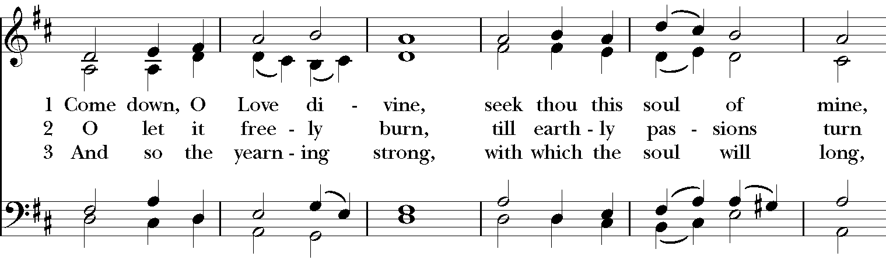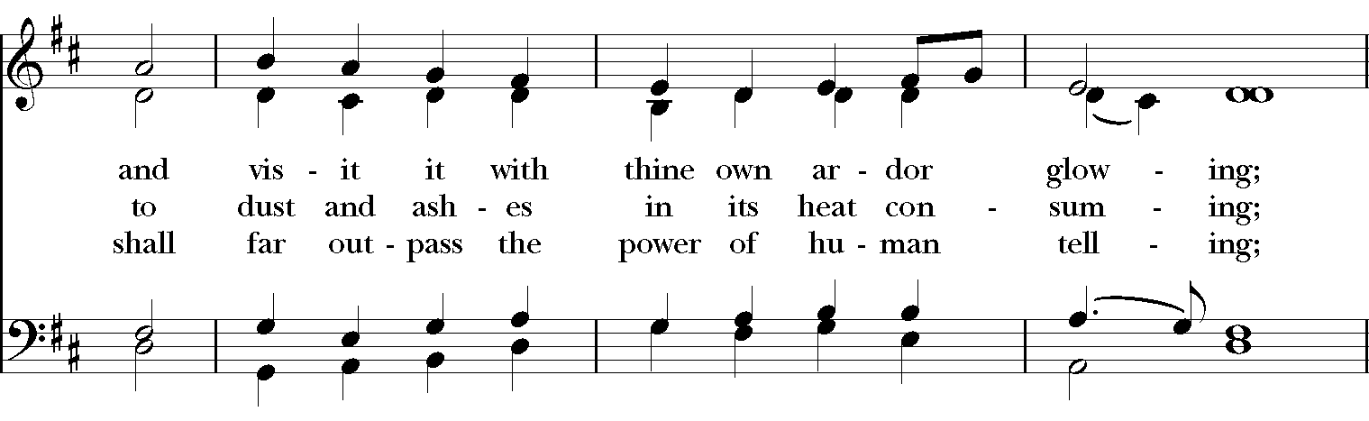
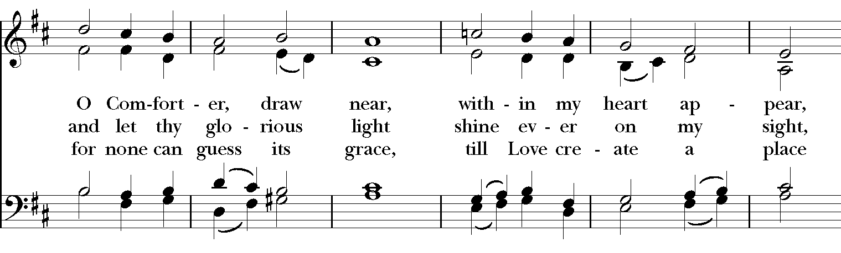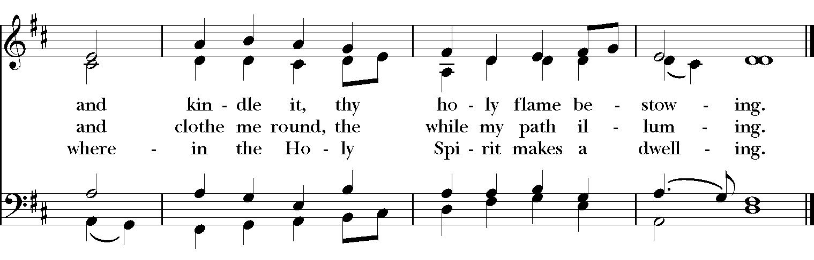
*THE BLESSING
May Almighty God, who enlightened the minds of the disciples by pouring out upon them the Holy Spirit, make you rich with his blessing, that you may abound more and more in that Spirit for ever. Amen.
May God, who sent the Holy Spirit as a flame of fire that rested upon the heads of the disciples, burn out all evil from your hearts, and make them shine with the pure light of his presence. Amen.
May God, who by the Holy Spirit caused those of many tongues to proclaim Jesus as Lord, strengthen your faith and send you out to bear witness to him in word and deed.
Amen.
And the blessing of God Almighty, the Father, the Son, and the Holy Spirit, be upon you and remain with you for ever. Amen.
*THE DISMISSAL Deacon: Go in peace to love and serve the Lord. Alleluia, alleluia!
People: Thanks be to God. Alleluia, alleluia!

POSTLUDE:

Thank you for your spiritual presence with us this morning!
Although we're physically apart, we are united in prayer, worship, and holy love!
Priest-In-Charge: The Rev. Dr. Canon Lee Anne Reat
Deacon: The Rev. Dr. Rick Incorvati
Music Director: Dr. Chris Durrenberger
Lector: Sarah Schubert
Singers: Liz Wheeler, Joy Carter, Chris Oldstone-Moore, Fred Bartenstein, Basil Fett
Technology: Steve Ide
Slideshow: Ed Hasecke
Parish Administrator and Program Coordinator: Kelly Zeller

