Christ Episcopal Church in Springfield, Ohio
Service of the Word
Fifth Sunday of Easter: May 2nd, 2021 at 9 am

PRELUDE:

OPENING HYMN: “Christ is alive!” Hymnal 182
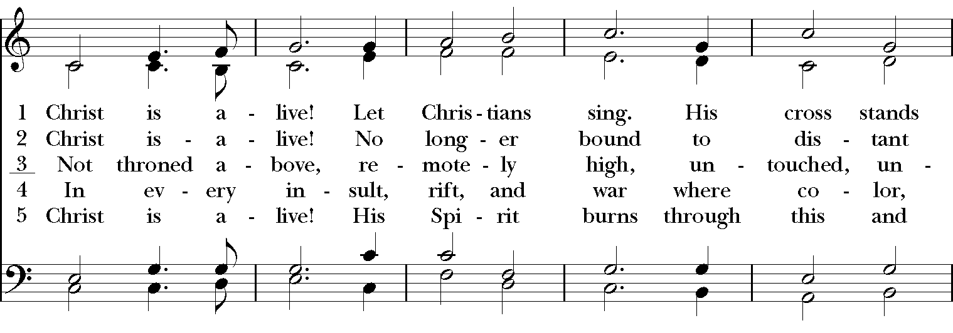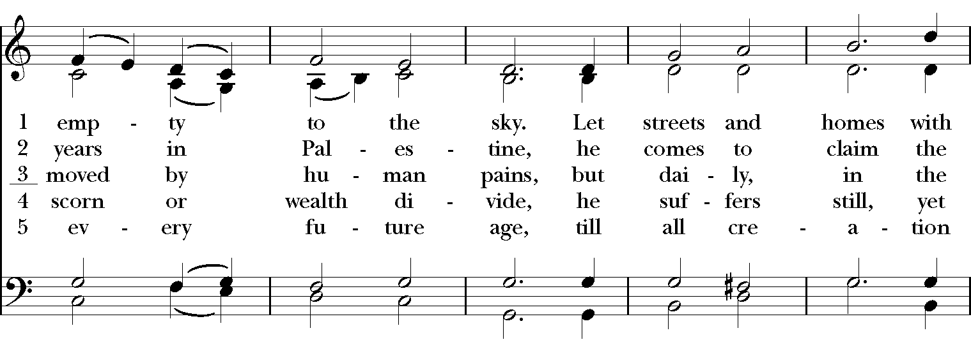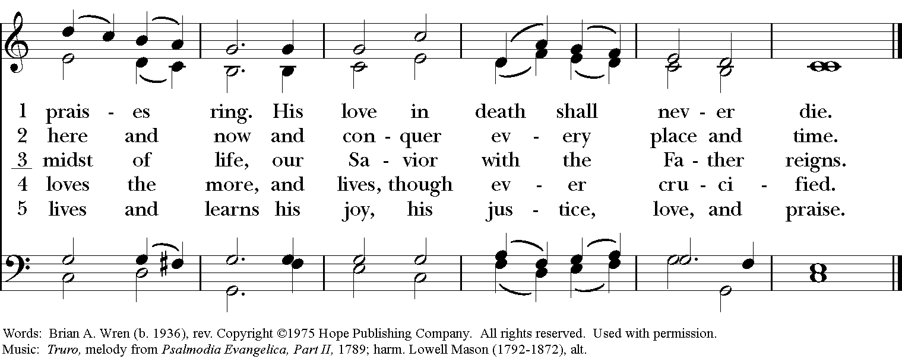
Celebrant: Alleluia! Christ has risen!
People: The Lord is risen indeed. Alleluia!

The Collect of the Day
Celebrant: The Lord be with you.
People: And also with you.
Celebrant: Let us pray.
Almighty God, whom truly to know is everlasting life: Grant us so perfectly to know your Son Jesus Christ to be the way, the truth, and the life, that we may steadfastly follow his steps in the way that leads to eternal life; through Jesus Christ your Son our Lord, who lives and reigns with you, in the unity of the Holy Spirit, one God, for ever and ever. Amen.

The Lessons

THE FIRST READING Acts 8:26-40
An angel of the Lord said to Philip, “Get up and go toward the south to the road that goes down from Jerusalem to Gaza.” (This is a wilderness road.) So he got up and went. Now there was an Ethiopian eunuch, a court official of the Candace, queen of the Ethiopians, in charge of her entire treasury. He had come to Jerusalem to worship and was returning home; seated in his chariot, he was reading the prophet Isaiah. Then the Spirit said to Philip, “Go over to this chariot and join it.” So Philip ran up to it and heard him reading the prophet Isaiah. He asked, “Do you understand what you are reading?” He replied, “How can I, unless someone guides me?” And he invited Philip to get in and sit beside him. Now the passage of the scripture that he was reading was this:
“Like a sheep he was led to the slaughter,
and like a lamb silent before its shearer,
so he does not open his mouth.
In his humiliation justice was denied him.
Who can describe his generation?
For his life is taken away from the earth.”

The eunuch asked Philip, “About whom, may I ask you, does the prophet say this, about himself or about someone else?” Then Philip began to speak, and starting with this scripture, he proclaimed to him the good news about Jesus. As they were going along the road, they came to some water; and the eunuch said, “Look, here is water! What is to prevent me from being baptized?” He commanded the chariot to stop, and both of them, Philip and the eunuch, went down into the water, and Philip baptized him. When they came up out of the water, the Spirit of the Lord snatched Philip away; the eunuch saw him no more, and went on his way rejoicing. But Philip found himself at Azotus, and as he was passing through the region, he proclaimed the good news to all the towns until he came to Caesarea.
Lector: The Word of the Lord.
People: Thanks be to God.

*PSALM: 22:24-30 Deus, Deus meus
24 My praise is of him in the great assembly; *
I will perform my vows in the presence of those who worship him.
25 The poor shall eat and be satisfied, and those who seek the Lord shall praise him: *
"May your heart live for ever!"
26 All the ends of the earth shall remember and turn to the Lord, *
and all the families of the nations shall bow before him.
27 For kingship belongs to the Lord; *
he rules over the nations.
28 To him alone all who sleep in the earth bow down in worship; *
all who go down to the dust fall before him.
29 My soul shall live for him; my descendants shall serve him; *
they shall be known as the Lord's for ever.
30 They shall come and make known to a people yet unborn *
the saving deeds that he has done.

THE SECOND LESSON 1 John 4:7-21
Beloved, let us love one another, because love is from God; everyone who loves is born of God and knows God. Whoever does not love does not know God, for God is love. God's love was revealed among us in this way: God sent his only Son into the world so that we might live through him. In this is love, not that we loved God but that he loved us and sent his Son to be the atoning sacrifice for our sins. Beloved, since God loved us so much, we also ought to love one another. No one has ever seen God; if we love one another, God lives in us, and his love is perfected in us.
By this we know that we abide in him and he in us, because he has given us of his Spirit. And we have seen and do testify that the Father has sent his Son as the Savior of the world. God abides in those who confess that Jesus is the Son of God, and they abide in God. So we have known and believe the love that God has for us.
God is love, and those who abide in love abide in God, and God abides in them. Love has been perfected among us in this: that we may have boldness on the day of judgment, because as he is, so are we in this world. There is no fear in love, but perfect love casts out fear; for fear has to do with punishment, and whoever fears has not reached perfection in love. We love because he first loved us. Those who say, "I love God," and hate their brothers or sisters, are liars; for those who do not love a brother or sister whom they have seen, cannot love God whom they have not seen. The commandment we have from him is this: those who love God must love their brothers and sisters also.
Lector: The Word of the Lord.
People: Thanks be to God.
SEQUENCE HYMN: “Abide in me fast falls the eventide” Hymnal 662
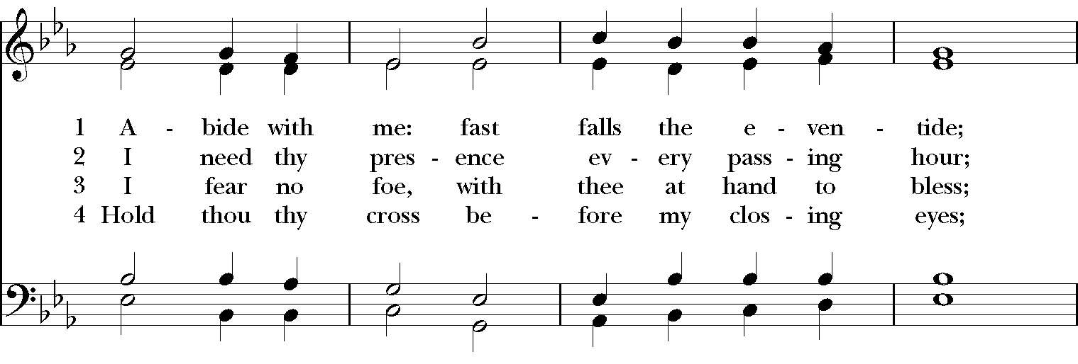

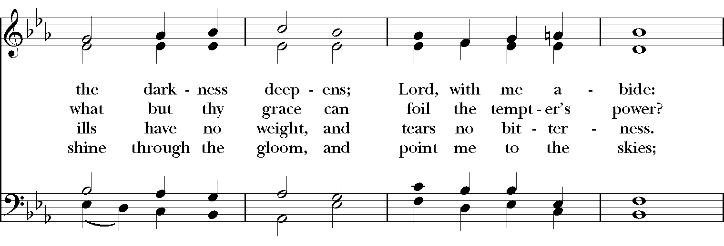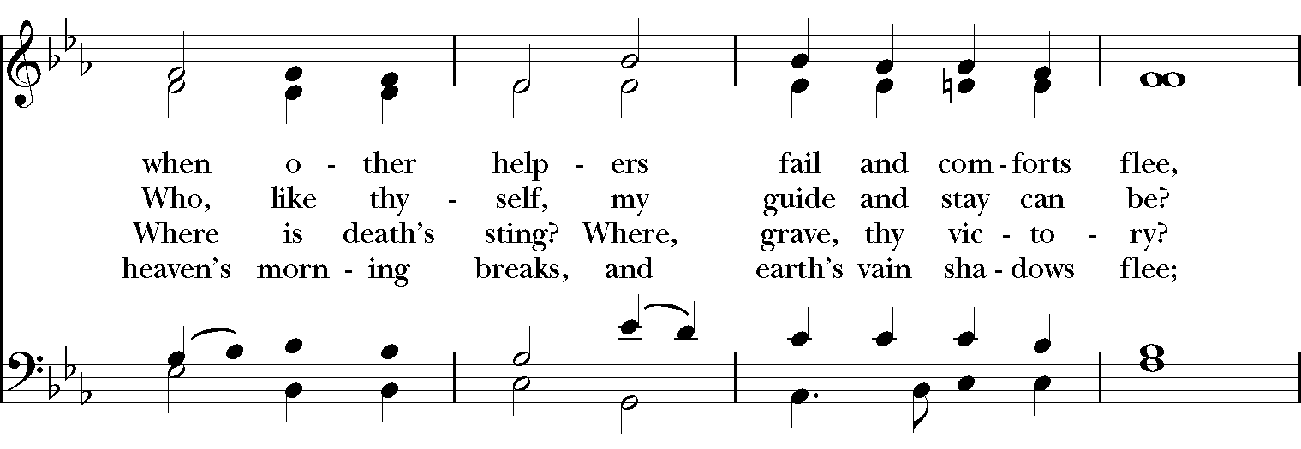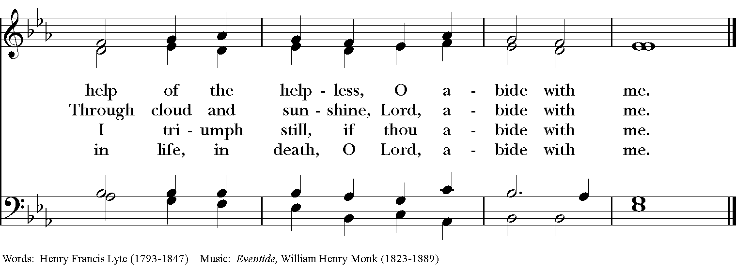
Gospel
Deacon: The Holy Gospel of our Lord Jesus Christ according to John (John 15:1-8).
People: Glory to you, Lord Christ.
Jesus said to his disciples, ”I am the true vine, and my Father is the vinegrower. He removes every branch in me that bears no fruit. Every branch that bears fruit he prunes to make it bear more fruit. You have already been cleansed by the word that I have spoken to you. Abide in me as I abide in you. Just as the branch cannot bear fruit by itself unless it abides in the vine, neither can you unless you abide in me. I am the vine, you are the branches. Those who abide in me and I in them bear much fruit, because apart from me you can do nothing. Whoever does not abide in me is thrown away like a branch and withers; such branches are gathered, thrown into the fire, and burned. If you abide in me, and my words abide in you, ask for whatever you wish, and it will be done for you. My Father is glorified by this, that you bear much fruit and become my disciples.”
Deacon: The Gospel of the Lord.
People: Praise to you, Lord Christ.

Sermon The Rev. Dr. Daniel M. Linnenberg

The Nicene Creed
We believe in one God, the Father, the Almighty,
maker of heaven and earth, of all that is, seen and unseen.
We believe in one Lord, Jesus Christ, the only Son of God,
eternally begotten of the Father, God from God,
Light from Light, true God from true God,
begotten, not made, of one Being with the Father.
Through him all things were made.
For us and for our salvation he came down from heaven,
by the power of the Holy Spirit he became incarnate from the Virgin Mary,
and was made man.
For our sake he was crucified under Pontius Pilate;
he suffered death and was buried.
On the third day he rose again in accordance with the Scriptures;
he ascended into heaven and is seated at the right hand of the Father.
He will come again in glory to judge the living and the dead, and his kingdom will have no end.
We believe in the Holy Spirit, the Lord, the giver of life,
who proceeds from the Father, and the Son.
who with the Father and the Son is worshiped and glorified,
who has spoken through the Prophets.
We believe in one holy catholic and apostolic Church.
We acknowledge one baptism for the forgiveness of sins.
We look for the resurrection of the dead, and the life of the world to come. Amen.

The Prayers of the People

In peace, we pray to you Lord God. Congregational responses are in bold.

Silence

Blessed are you eternal God,
to be praised and glorified forever.

Hear us as we pray for the unity of the Church.
May we all be one, that the world may come to know you.

Grant that every member of the Church may truly and humbly serve you,
that the life of Christ may be revealed in us.

We remember those who have died.
Into your hands we commend them.
We praise you for all your saints who have entered eternal glory.
May we also come to share your heavenly kingdom.

Have compassion on those who suffer from sickness, grief or trouble, especially Charlene, Laura, Faye, Chris, Laura, Bonnie, Alice, Diana, James, Joy, Jane, Joni, Kim, Bobby, Sarah, Traudie, Lexie, and Keith.
In your presence may they find strength.

Look with kindness on our homes and families, and all who celebrate birthdays this week, especially Bobbi, Peg, and Ben.
Grant that your love may grow in our hearts.

Make us alive to the needs of our community, and bless the holy work of Children’s Rescue Center/The Ark, Christ Church Food Pantry, The Fuller Center for Housing, and Safe Harbor House.
Help us to share one another’s joys and burdens.

Inspire and lead those who hold authority in the nations of the world.
Guide us and all people in the way of justice and peace.

For Justin, Archbishop of Canterbury; Michael, our Presiding Bishop; Ken, our Diocesan Bishop; Lee Anne, our priest; Daniel our supply priest; Rick, our deacon; and all who minister in Christ, that they may be firmly rooted in your truth and love.
Inspire us and give us courage to proclaim your Gospel of Resurrection.

*THE COLLECT FOR PEACE
Grant, O God, that your holy and life-giving Spirit may so move every human heart, that barriers which divide us may crumble, suspicions disappear, and hatreds cease; that our divisions being healed, we may live in justice and peace; through Jesus Christ our Lord. Amen.

Deacon: Let us confess our sins against God and our neighbor.
All: Most merciful God, we confess that we have sinned against you in thought, word, and deed, by what we have done, and by what we have left undone. We have not loved you with our whole heart; we have not loved our neighbors as ourselves. We are truly sorry and we humbly repent. For the sake of your Son Jesus Christ, have mercy on us and forgive us; that we may delight in your will, and walk in your ways, to the glory of your Name. Amen.

Priest: Almighty God, have mercy on you, forgive you all your sins through our Lord Jesus Christ, strengthen you in all goodness, and by the power of the Holy Spirit keep you in eternal life. Amen.

And now, as our Savior Christ has taught us, we are bold to say:
Our Father, who art in heaven, hallowed be thy Name,
thy kingdom come, thy will be done, on earth as it is in heaven.
Give us this day our daily bread.
And forgive us our trespasses, as we forgive those who trespass against us.
And lead us not into temptation, but deliver us from evil.
For thine is the kingdom, and the power, and the glory, for ever and ever. Amen

CLOSING HYMN: “O Christ, the Word Incarnate” Hymnal 632
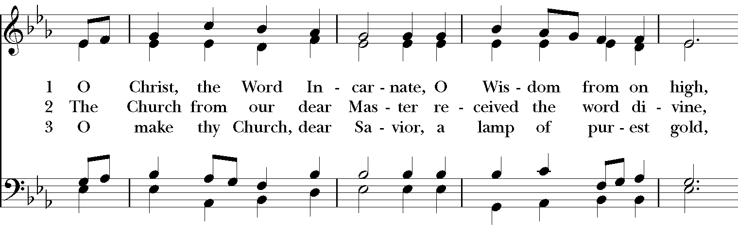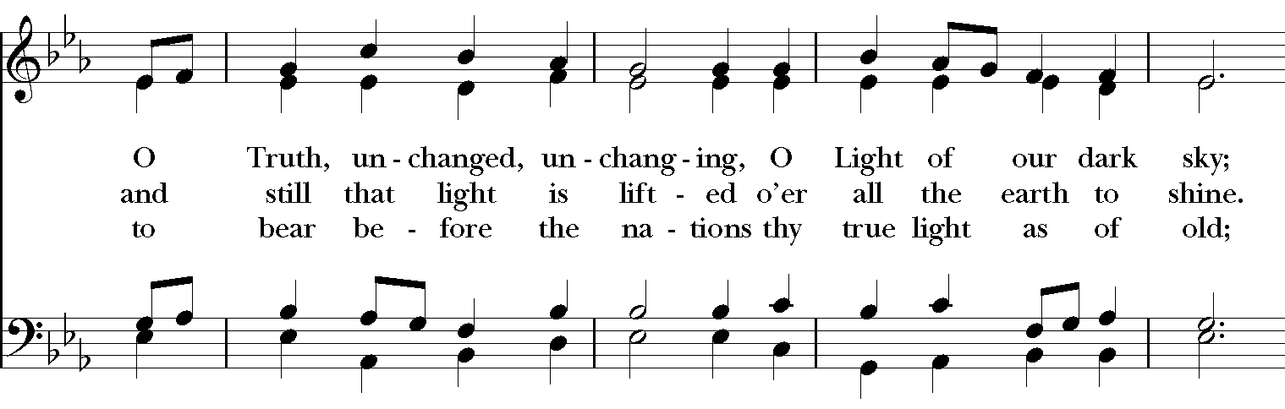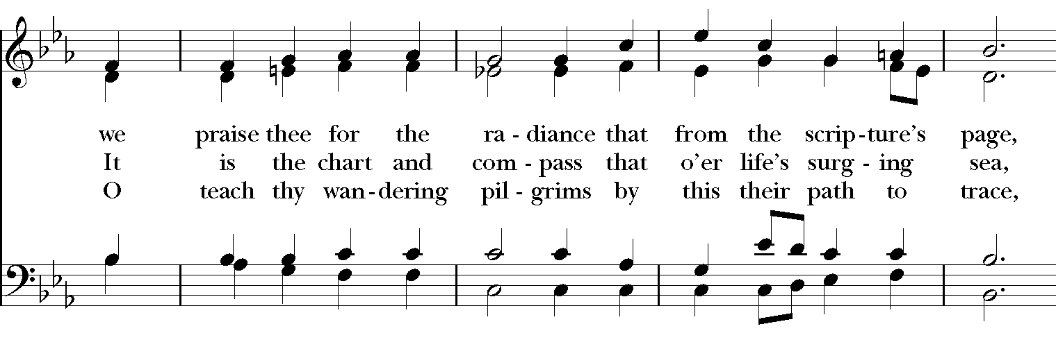

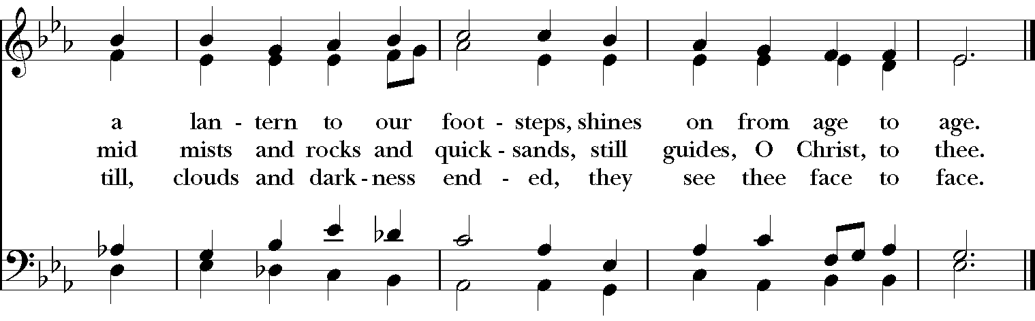

*THE BLESSING
The God of peace, who brought again from the dead our Lord Jesus Christ, the great Shepherd of the sheep, through the blood of the everlasting covenant, make you perfect in every good work to do his will, working in you that which is well-pleasing in his sight; and the blessing of God Almighty, the Father, the Son, and the Holy Spirit, be among you, and remain with you always. Amen.

*THE DISMISSAL Deacon: Go in peace to love and serve the Lord. Alleluia, alleluia!
People: Thanks be to God. Alleluia, alleluia!

POSTLUDE:

Thank you for your spiritual presence with us this morning!
Although we're physically apart, we are united in prayer, worship, and holy love!
Priest-In-Charge: The Rev. Dr. Canon Lee Anne Reat
Supply Priest: The Rev. Dr. Daniel M. Linnenberg
Deacon: The Rev. Dr. Rick Incorvati
Music Director: Dr. Chris Durrenberger
Lector: Diane Rode
Singers: Liz Wheeler, Joy Carter, Ed Hasecke, Chris Oldstone-Moore
Technology: Steve Ide
Slideshow: Ed Hasecke
Parish Administrator and Program Coordinator: Kelly Zeller

