Christ Episcopal Church in Springfield, Ohio
Service of the Word
Sixth Sunday of Easter: May 9th, 2021 at 9 am

PRELUDE:

OPENING HYMN: “Now the green blade riseth” Hymnal 204
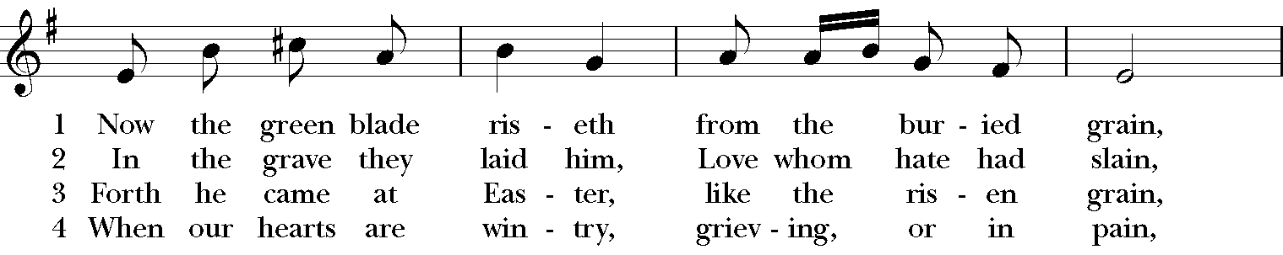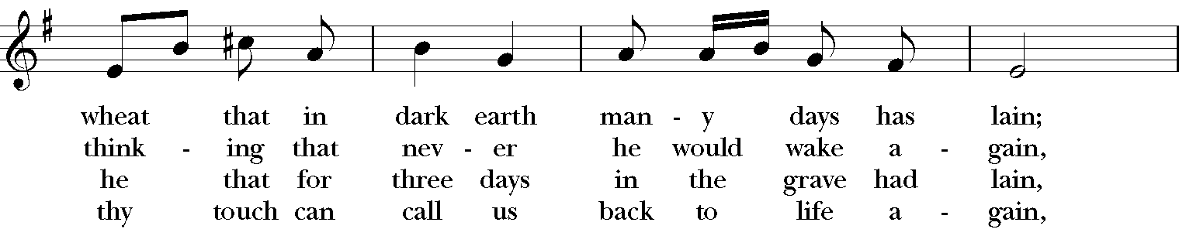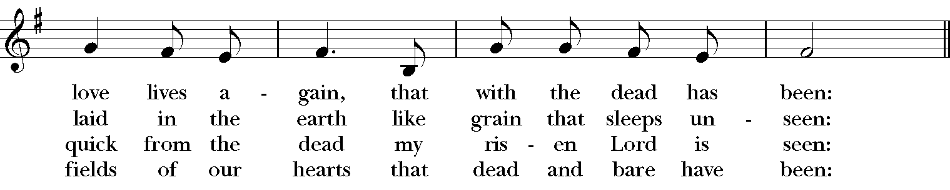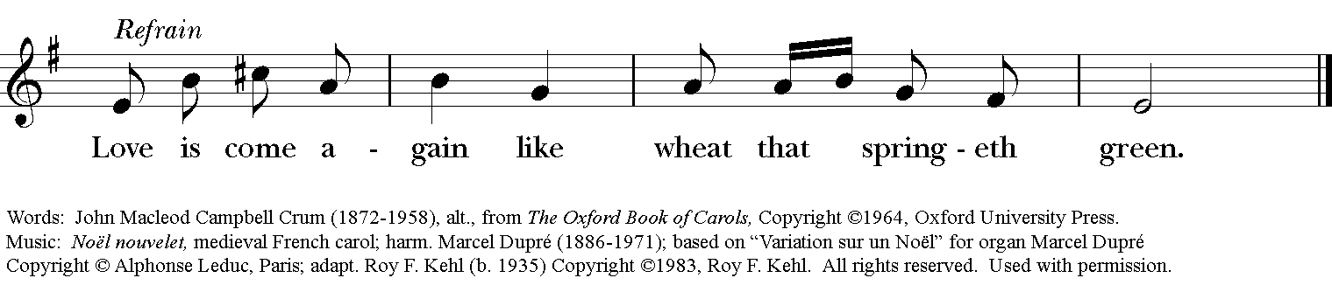

Celebrant: Alleluia! Christ has risen!
People: The Lord is risen indeed. Alleluia!

The Collect of the Day
Celebrant: The Lord be with you.
People: And also with you.
Celebrant: Let us pray.
O God, you have prepared for those who love you such good things as surpass our understanding: Pour into our hearts such love towards you, that we, loving you in all things and above all things, may obtain your promises, which exceed all that we can desire; through Jesus Christ our Lord, who lives and reigns with you and the Holy Spirit, one God, for ever and ever. Amen.

The Lessons

THE FIRST READING Acts 10:44-48
While Peter was still speaking, the Holy Spirit fell upon all who heard the word. The circumcised believers who had come with Peter were astounded that the gift of the Holy Spirit had been poured out even on the Gentiles, for they heard them speaking in tongues and extolling God. Then Peter said, "Can anyone withhold the water for baptizing these people who have received the Holy Spirit just as we have?" So he ordered them to be baptized in the name of Jesus Christ. Then they invited him to stay for several days.
Lector: The Word of the Lord.
People: Thanks be to God.

*PSALM: 98 Cantate Domino
1 Sing to the Lord a new song, *
for he has done marvelous things.
2 With his right hand and his holy arm *
has he won for himself the victory.
3 The Lord has made known his victory; *
his righteousness has he openly shown in the sight of the nations.
4 He remembers his mercy and faithfulness to the house of Israel, *
and all the ends of the earth have seen the victory of our God.
5 Shout with joy to the Lord, all you lands; *
lift up your voice, rejoice, and sing.
6 Sing to the Lord with the harp, *
with the harp and the voice of song.
7 With trumpets and the sound of the horn *
shout with joy before the King, the Lord.
8 Let the sea make a noise and all that is in it, *
the lands and those who dwell therein.
9 Let the rivers clap their hands, *
and let the hills ring out with joy before the Lord, when he comes to judge the earth.
10 In righteousness shall he judge the world *
and the peoples with equity.

THE SECOND LESSON 1 John 5:1-6
Everyone who believes that Jesus is the Christ has been born of God, and everyone who loves the parent loves the child. By this we know that we love the children of God, when we love God and obey his commandments. For the love of God is this, that we obey his commandments. And his commandments are not burdensome, for whatever is born of God conquers the world. And this is the victory that conquers the world, our faith. Who is it that conquers the world but the one who believes that Jesus is the Son of God?
This is the one who came by water and blood, Jesus Christ, not with the water only but with the water and the blood. And the Spirit is the one that testifies, for the Spirit is the truth.
Lector: The Word of the Lord.
People: Thanks be to God.
SEQUENCE HYMN: “The Church’s one foundation” Hymnal 525
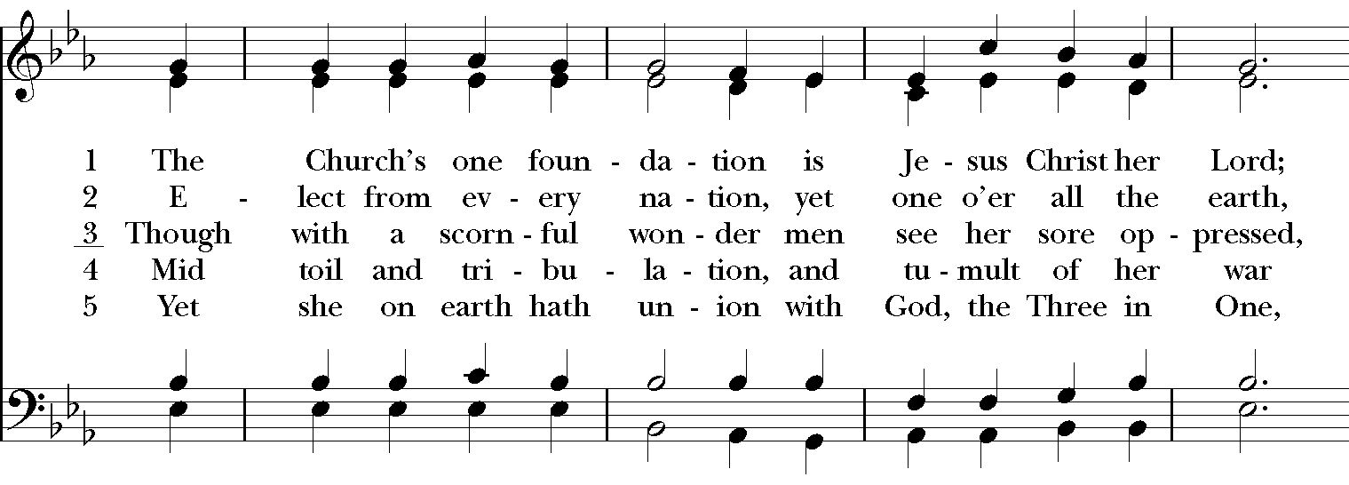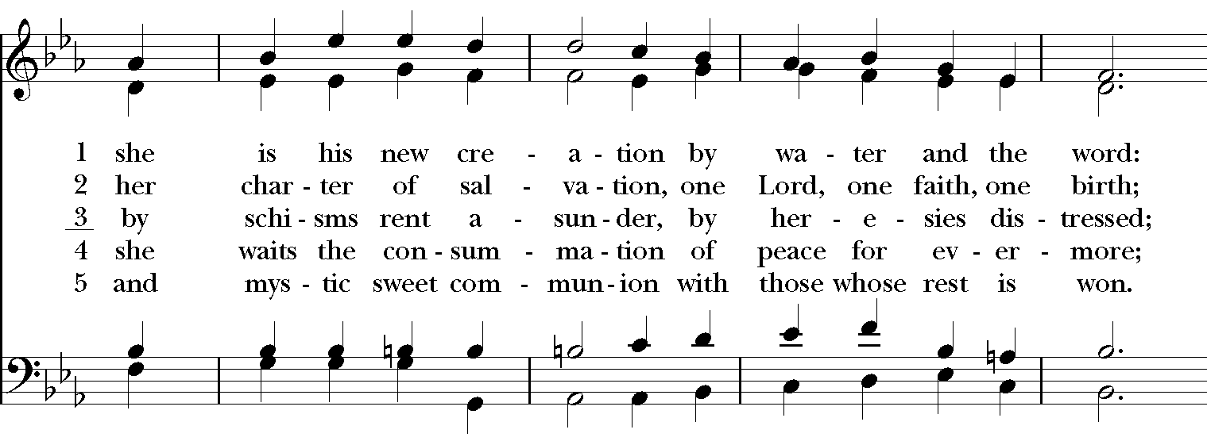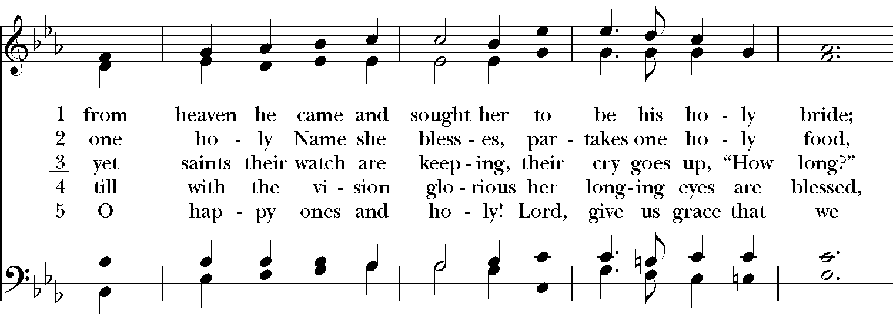
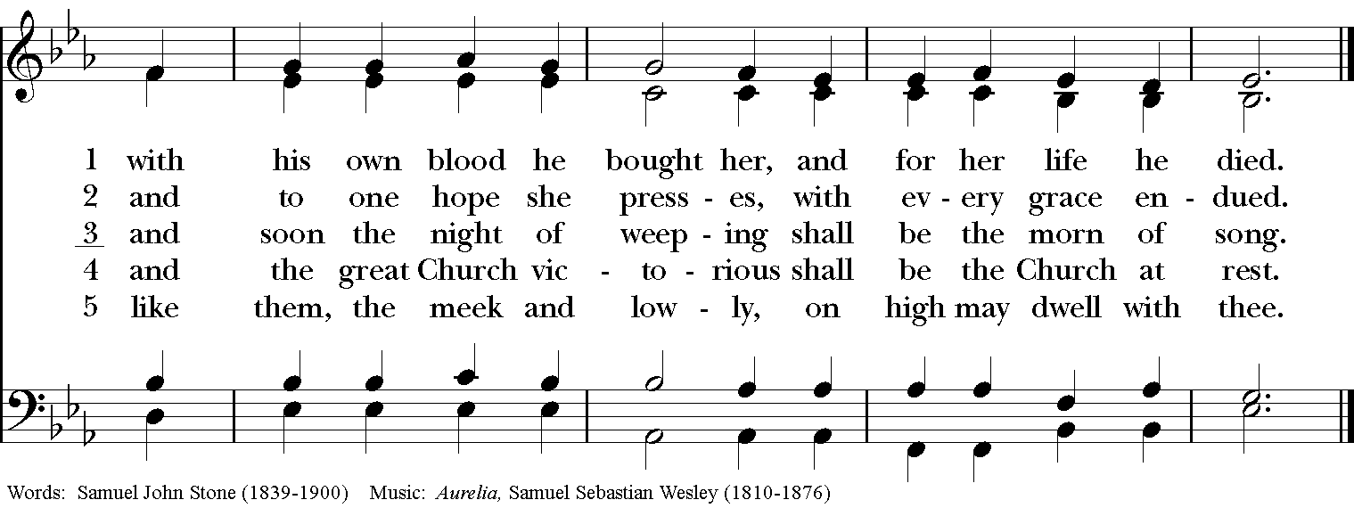

Gospel
Deacon: The Holy Gospel of our Lord Jesus Christ according to John (John 15:9-17).
People: Glory to you, Lord Christ.
Jesus said to his disciples, “As the Father has loved me, so I have loved you; abide in my love. If you keep my commandments, you will abide in my love, just as I have kept my Father’s commandments and abide in his love. I have said these things to you so that my joy may be in you, and that your joy may be complete.

“This is my commandment, that you love one another as I have loved you. No one has greater love than this, to lay down one’s life for one’s friends. You are my friends if you do what I command you. I do not call you servants any longer, because the servant does not know what the master is doing; but I have called you friends, because I have made known to you everything that I have heard from my Father. You did not choose me but I chose you. And I appointed you to go and bear fruit, fruit that will last, so that the Father will give you whatever you ask him in my name. I am giving you these commands so that you may love one another.”
Deacon: The Gospel of the Lord.
People: Praise to you, Lord Christ.

Sermon The Rev. Canon Dr. Lee Anne Reat

The Nicene Creed
We believe in one God, the Father, the Almighty,
maker of heaven and earth, of all that is, seen and unseen.
We believe in one Lord, Jesus Christ, the only Son of God,
eternally begotten of the Father, God from God,
Light from Light, true God from true God,
begotten, not made, of one Being with the Father.
Through him all things were made.
For us and for our salvation he came down from heaven,
by the power of the Holy Spirit he became incarnate from the Virgin Mary,
and was made man.
For our sake he was crucified under Pontius Pilate;
he suffered death and was buried.
On the third day he rose again in accordance with the Scriptures;
he ascended into heaven and is seated at the right hand of the Father.
He will come again in glory to judge the living and the dead, and his kingdom will have no end.
We believe in the Holy Spirit, the Lord, the giver of life,
who proceeds from the Father, and the Son.
who with the Father and the Son is worshiped and glorified,
who has spoken through the Prophets.
We believe in one holy catholic and apostolic Church.
We acknowledge one baptism for the forgiveness of sins.
We look for the resurrection of the dead, and the life of the world to come. Amen.

The Prayers of the People

In peace, we pray to you Lord God. Congregational responses are in bold.

Silence

Blessed are you eternal God,
to be praised and glorified forever.

Hear us as we pray for the unity of the Church.
May we all be one, that the world may come to know you.

Grant that every member of the Church may truly and humbly serve you,
that the life of Christ may be revealed in us.

We remember those who have died.
Into your hands we commend them.
We praise you for all your saints who have entered eternal glory.
May we also come to share your heavenly kingdom.

Have compassion on those who suffer from sickness, grief or trouble, especially Charlene, Laura, Faye, Chris, Laura, Bonnie, Alice, Diana, James, Joy, Jane, Joni, Kim, Bobby, Sarah, Traudie, Lexie, and Keith.
In your presence may they find strength.

Look with kindness on our homes and families, and all who celebrate birthdays this week, especially Sarah, Susie, Dodi, and Katie, and anniversaries Bill & Gretchen.
Grant that your love may grow in our hearts.

Make us alive to the needs of our community, and bless the holy work of Clark County Literacy Coalition, Episcopal Community Ministries, Second Harvest Food Bank, and Interfaith Hospitality Network.
Help us to share one another’s joys and burdens.

Inspire and lead those who hold authority in the nations of the world.
Guide us and all people in the way of justice and peace.

For Justin, Archbishop of Canterbury; Michael, our Presiding Bishop; Ken, our Diocesan Bishop; Lee Anne, our priest; Rick, our deacon; and all who minister in Christ, that they may be firmly rooted in your truth and love.
Inspire us and give us courage to proclaim your Gospel of Resurrection.

*THE COLLECT FOR PEACE
Grant, O God, that your holy and life-giving Spirit may so move every human heart, that barriers which divide us may crumble, suspicions disappear, and hatreds cease; that our divisions being healed, we may live in justice and peace; through Jesus Christ our Lord. Amen.

Deacon: Let us confess our sins against God and our neighbor.
All: Most merciful God, we confess that we have sinned against you in thought, word, and deed, by what we have done, and by what we have left undone. We have not loved you with our whole heart; we have not loved our neighbors as ourselves. We are truly sorry and we humbly repent. For the sake of your Son Jesus Christ, have mercy on us and forgive us; that we may delight in your will, and walk in your ways, to the glory of your Name. Amen.

Priest: Almighty God, have mercy on you, forgive you all your sins through our Lord Jesus Christ, strengthen you in all goodness, and by the power of the Holy Spirit keep you in eternal life. Amen.

And now, as our Savior Christ has taught us, we are bold to say:
Our Father, who art in heaven, hallowed be thy Name,
thy kingdom come, thy will be done, on earth as it is in heaven.
Give us this day our daily bread.
And forgive us our trespasses, as we forgive those who trespass against us.
And lead us not into temptation, but deliver us from evil.
For thine is the kingdom, and the power, and the glory, for ever and ever. Amen

CLOSING HYMN: “All creatures of our God and King” Hymnal 400
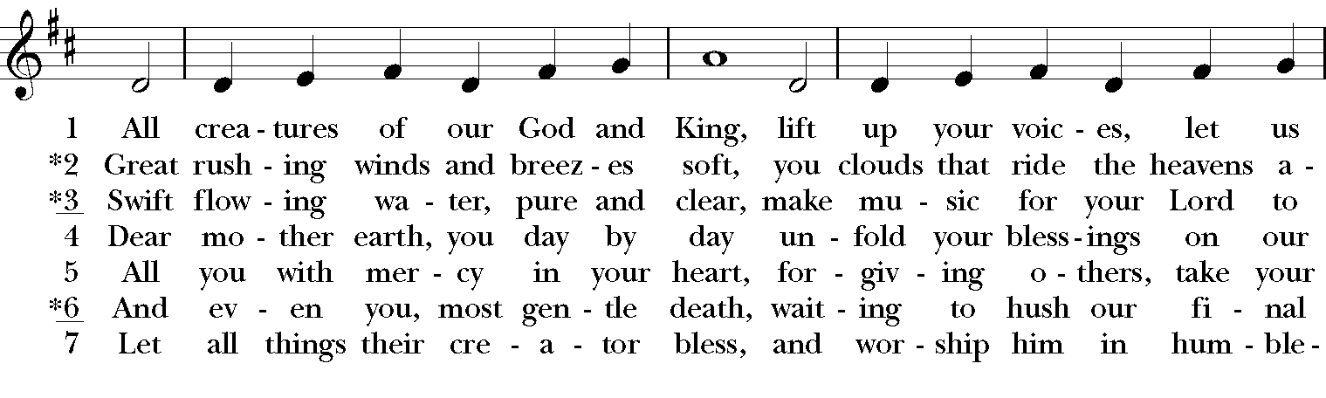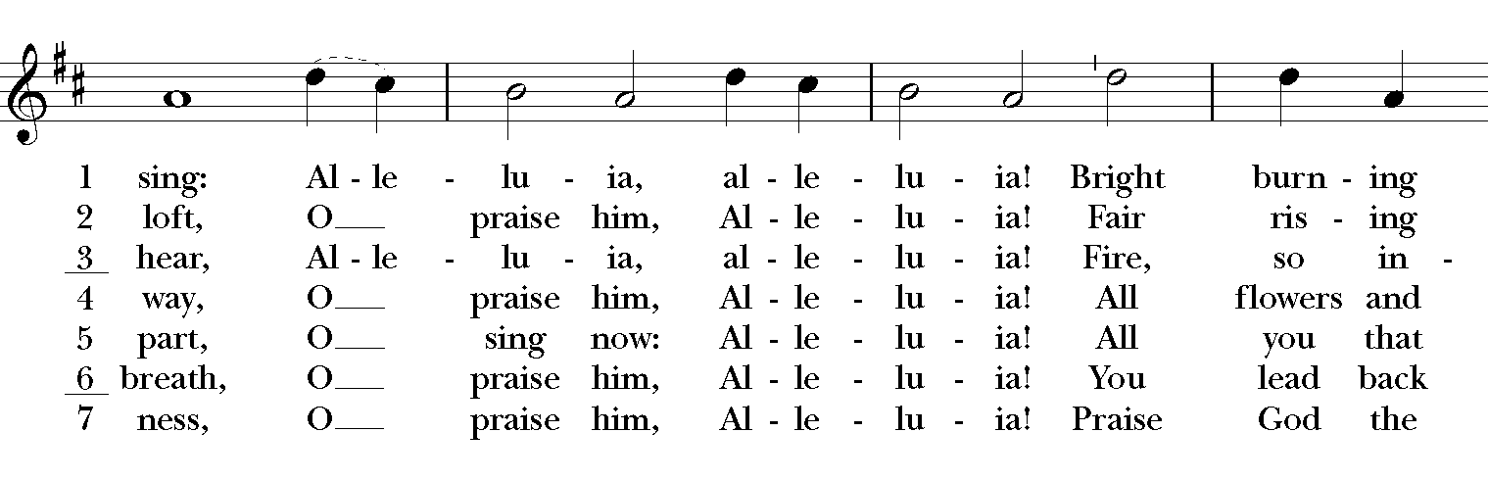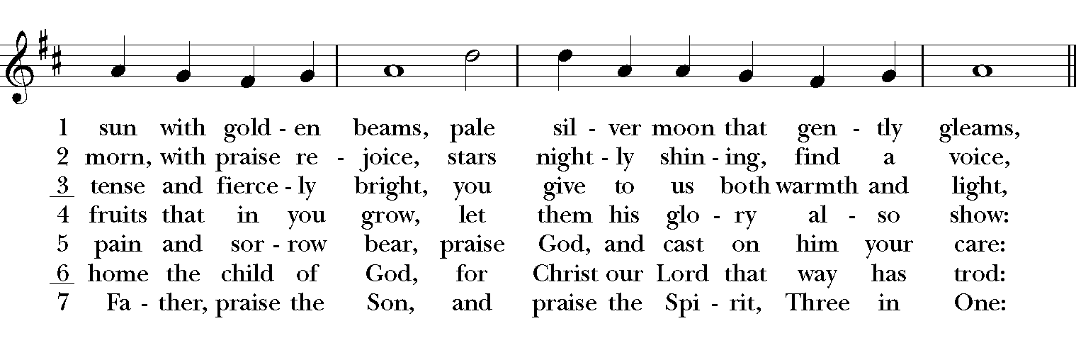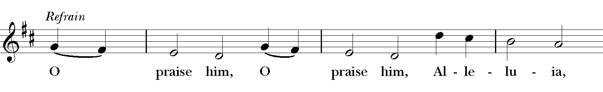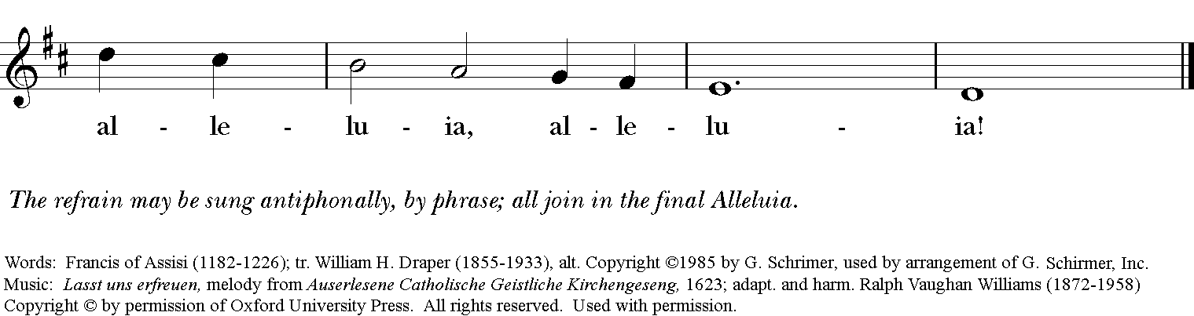

*THE BLESSING
The God of peace, who brought again from the dead our Lord Jesus Christ, the great Shepherd of the sheep, through the blood of the everlasting covenant, make you perfect in every good work to do his will, working in you that which is well-pleasing in his sight; and the blessing of God Almighty, the Father, the Son, and the Holy Spirit, be among you, and remain with you always. Amen.

*THE DISMISSAL Deacon: Go in peace to love and serve the Lord. Alleluia, alleluia!
People: Thanks be to God. Alleluia, alleluia!

POSTLUDE:

Thank you for your spiritual presence with us this morning!
Although we're physically apart, we are united in prayer, worship, and holy love!
Priest-In-Charge: The Rev. Dr. Canon Lee Anne Reat
Deacon: The Rev. Dr. Rick Incorvati
Music Director: Dr. Chris Durrenberger
Lector: Liz Wheeler
Singers: Liz Wheeler, Joy Carter, Ed Hasecke, Chris Oldstone-Moore
Technology: Steve Ide
Slideshow: Ed Hasecke
Parish Administrator and Program Coordinator: Kelly Zeller

