**Christ Episcopal Church in Springfield, Ohio**

**Service of the Word**

**November 1st, 2020 at 9 am: All Saints Sunday**

*Note: We invite you to light a candle on your table or home altar before worship begins.*

**Prelude:**

**Opening Hymn: “For all the saints” Hymnal 287 vs.1, 4, 5, 6, & 8**

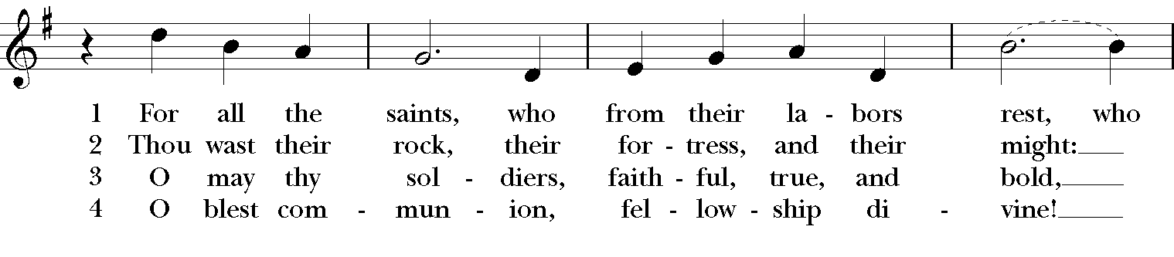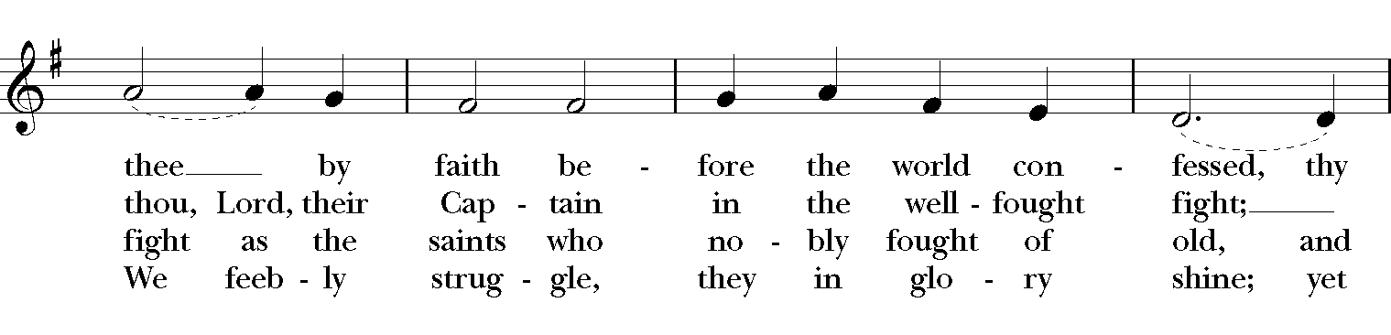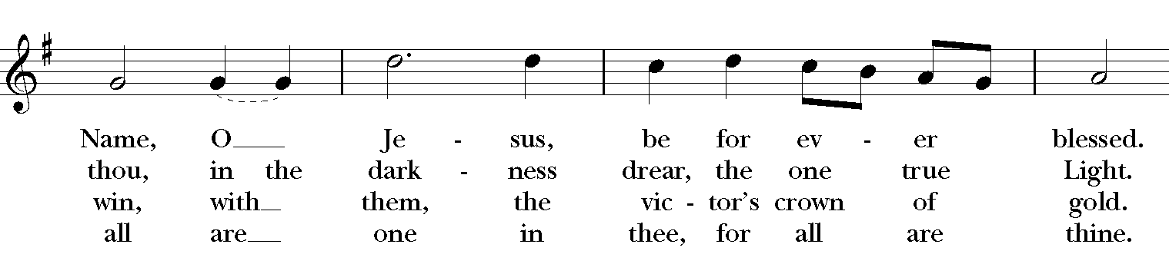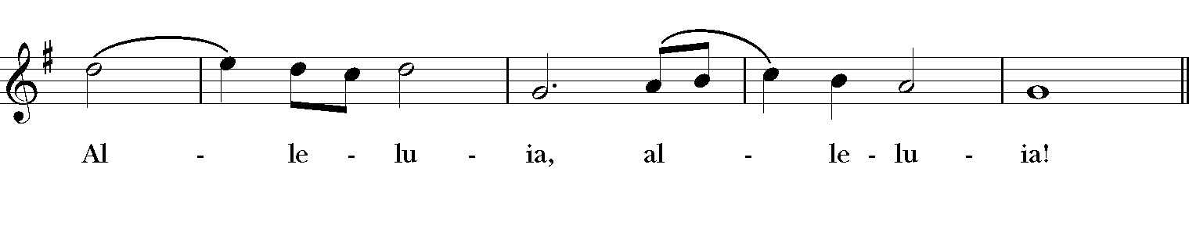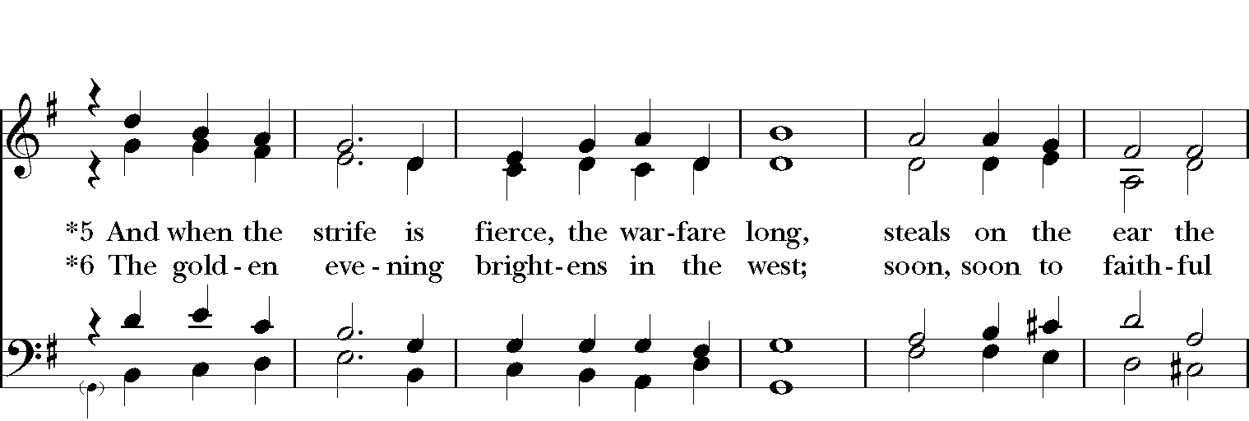

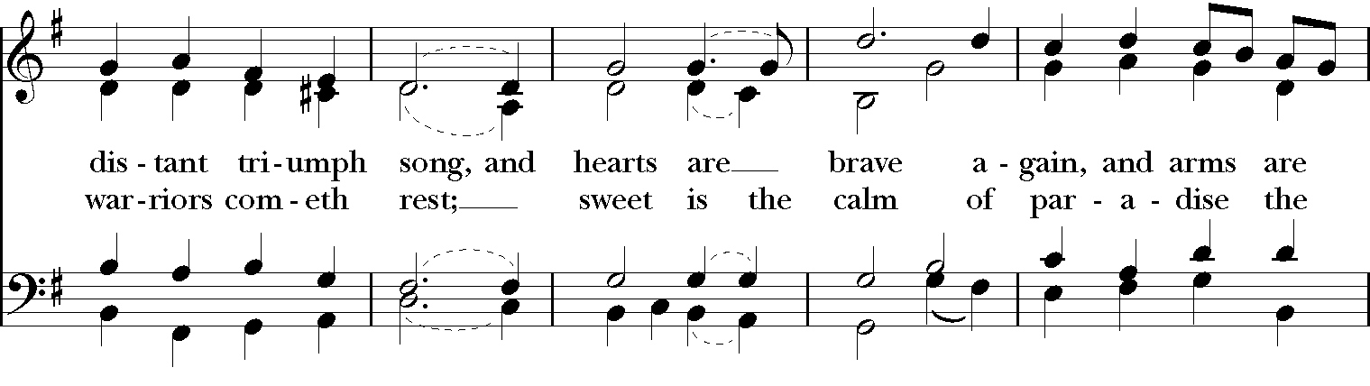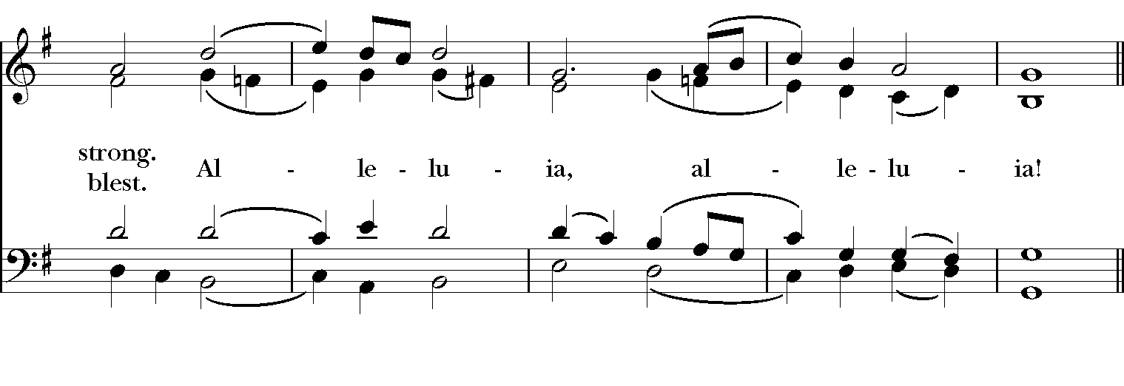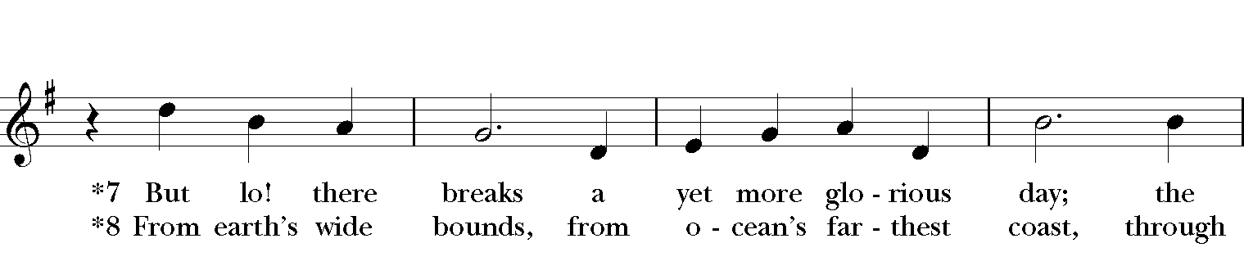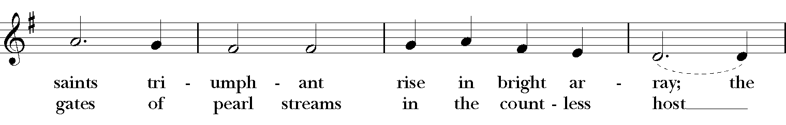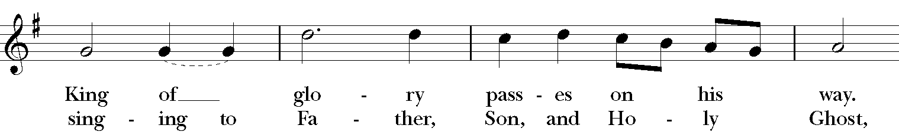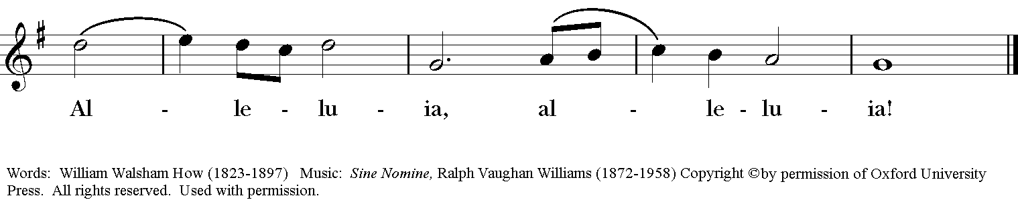

*Celebrant:* Blessed be God: Father, Son, and Holy Spirit.  
***People:* And blessed be God’s kingdom, now and for ever. Amen.**

**Glory to God in the highest,**

**and peace to God’s people on earth.**

**Lord God, heavenly King,**

**almighty God and Father,**

**we worship you, we give you thanks,**

**we praise you for your glory.**

**Lord Jesus Christ, only Son of the Father,**

**Lord God, Lamb of God,**

**you take away the sin of the world:**

**have mercy on us;**

**you are seated at the right hand of the Father:**

**receive our prayer.**

**For you alone are the Holy One,**

**you alone are the Lord,**

**you alone are the Most High,**

**Jesus Christ,**

**with the Holy Spirit,**

**in the glory of God the Father. Amen.**

**The Collect of the Day**

*Celebrant:*The Lord be with you.

***People:* And also with you.**

*Celebrant:* Let us pray.

Almighty God, you have knit together your elect in one communion and fellowship in the mystical body of your Son Christ our Lord: Give us grace so to follow your blessed saints in all virtuous and godly living, that we may come to those ineffable joys that you have prepared for those who truly love you; through Jesus Christ our Lord, who with you and the Holy Spirit lives and reigns, one God, in glory everlasting. ***Amen****.*

**The Lessons**

The First Reading: Revelation 7:9-17

After this I, John, looked, and there was a great multitude that no one could count, from every nation, from all tribes and peoples and languages, standing before the throne and before the Lamb, robed in white, with palm branches in their hands. They cried out in a loud voice, saying,

### "Salvation belongs to our God who is seated on the throne, and to the Lamb!" And all the angels stood around the throne and around the elders and the four living creatures, and they fell on their faces before the throne and worshiped God, singing,

"Amen! Blessing and glory and wisdom   
and thanksgiving and honor and power and might   
be to our God forever and ever! Amen."

### Then one of the elders addressed me, saying, "Who are these, robed in white, and where have they come from?" I said to him, "Sir, you are the one that knows." Then he said to me, "These are they who have come out of the great ordeal; they have washed their robes and made them white in the blood of the Lamb.

"For this reason they are before the throne of God,

and worship him day and night within his temple,

and the one who is seated on the throne will shelter them.

They will hunger no more, and thirst no more;

the sun will not strike them, nor any scorching heat;

for the Lamb at the center of the throne will be their shepherd,

and he will guide them to springs of the water of life,

and God will wipe away every tear from their eyes."

*Reader:* The Word of the Lord.

*People:* **Thanks be to God.**

**Psalm 34:1-10, 22 *Benedicam Dominum***

**1 I will bless the Lord at all times; \*** his praise shall ever be in my mouth.

**2 I will glory in the Lord; \***   
 let the humble hear and rejoice.

**3 Proclaim with me the greatness of the Lord; \***   
 let us exalt his Name together.

**4 I sought the Lord, and he answered me \***   
 and delivered me out of all my terror.

**5 Look upon him and be radiant, \***   
 and let not your faces be ashamed.

**6 I called in my affliction and the Lord heard me \***   
 and saved me from all my troubles.

**7 The angel of the Lord encompasses those who fear him, \***   
 and he will deliver them.

**8 Taste and see that the Lord is good; \***   
 happy are they who trust in him!

**9 Fear the Lord, you that are his saints, \***   
 for those who fear him lack nothing.

**10 The young lions lack and suffer hunger, \***   
 but those who seek the Lord lack nothing that is good.

**22 The Lord ransoms the life of his servants, \***   
 and none will be punished who trust in him.

**Second Lesson: 1 John 3:1-3**

See what love the Father has given us, that we should be called children of God; and that is what we are. The reason the world does not know us is that it did not know him. Beloved, we are God's children now; what we will be has not yet been revealed. What we do know is this: when he is revealed, we will be like him, for we will see him as he is. And all who have this hope in him purify themselves, just as he is pure.

*Reader:* The Word of the Lord.

***People:* Thanks be to God.**

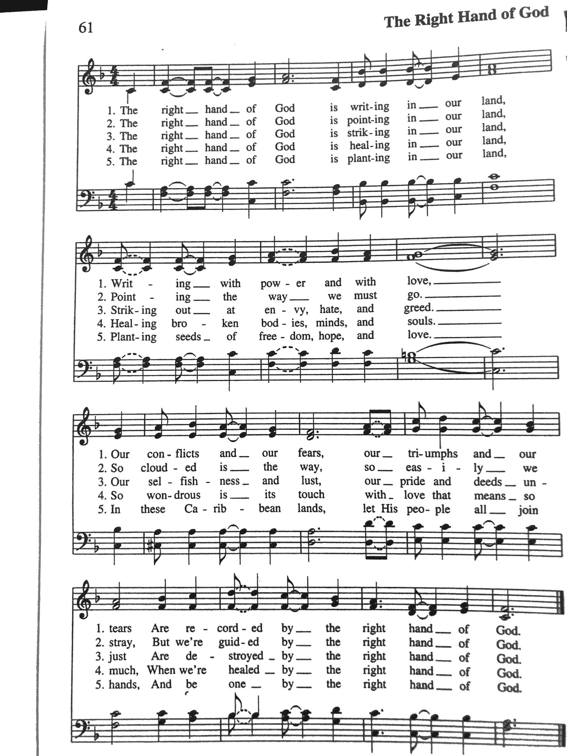**Sequence Hymn: “The Right Hand of God” Hymnal LEVAS II pg.61**

**Gospel**

*Deacon:* The Holy Gospel According to Matthew (5:1-12)

***People:* Glory to you, Lord Christ.**

When Jesus saw the crowds, he went up the mountain; and after he sat down, his disciples came to him. Then he began to speak, and taught them, saying:

"Blessed are the poor in spirit, for theirs is the kingdom of heaven.   
"Blessed are those who mourn, for they will be comforted.   
"Blessed are the meek, for they will inherit the earth.   
"Blessed are those who hunger and thirst for righteousness, for they will be filled.   
"Blessed are the merciful, for they will receive mercy.   
"Blessed are the pure in heart, for they will see God.   
"Blessed are the peacemakers, for they will be called children of God.  
"Blessed are those who are persecuted for righteousness' sake, for theirs is the kingdom of heaven.   
"Blessed are you when people revile you and persecute you and utter all kinds of evil against you falsely on my account. Rejoice and be glad, for your reward is great in heaven, for in the same way they persecuted the prophets who were before you."

*Deacon:* The Gospel of the Lord.

***People:* Praise to you, Lord Christ.**

*A reflection on the Scripture is offered by Rob Rue*

**THE RENEWAL OF BAPTISMAL VOWS**

Celebrant: Do you reaffirm your renunciation of evil and renew your commitment to Jesus Christ?

People: **I do**

Celebrant: Do you believe in God the Father?

People: **I believe in God, the Father almighty, creator of heaven and earth.**

Celebrant: Do you believe in Jesus Christ, the Son of God?

People: **I believe in Jesus Christ, his only Son, our Lord.**

**He was conceived by the power of the Holy Spirit and born of the Virgin Mary. He suffered under Pontius Pilate, was crucified, died, and was buried. He descended to the dead. On the third day he rose again. He ascended into heaven, and is seated at the right hand of the Father. He will come again to judge the living and the dead.**

Celebrant: Do you believe in God the Holy Spirit?

People: **I believe in the Holy Spirit, the holy catholic Church, the communion of saints, the forgiveness of sins, the resurrection of the body, and the life everlasting.**

Celebrant: Will you continue in the apostles’ teaching and fellowship, in the breaking of bread, and in the prayers?

People: **I will, with God’s help**.

Celebrant: Will you persevere in resisting evil, and, whenever you fall into sin, repent and return to the Lord?

People: **I will, with God’s help.**

Celebrant: Will you proclaim by word and example the Good News of God in Christ?

People: **I will, with God’s help.**

Celebrant: Will you seek and serve Christ in all persons, loving your neighbor as yourself?

People: **I will, with God’s help**.

Celebrant: Will you strive for justice and peace among all people, and respect the dignity of every human being?

People: **I will, with God’s help.**

Celebrant: May Almighty God, the Father of our Lord Jesus Christ, who has given us a new birth by water and the Holy Spirit, and bestowed upon us the forgiveness of sins, keep us in eternal life by his grace, in Christ Jesus our Lord. **Amen.**

**The Prayers of the People**

In peace, we pray to you Lord God.

*Silence*

Let us pray. Founder of our faith, we ask your guidance for the Church, for its unity, and for the work it does in the world. Give grace to its leaders, especially Justin, archbishop of Canterbury; Michael, our presiding bishop; Tom, our diocesan bishop; Lee Anne, our priest; Rick, our deacon; and all the members of this parish.

**R: *Let your priests be clothed with righteousness; let your faithful people sing for joy.***

Ruler over the nations, we pray for this country and its leaders in an unsettling time. Grant wisdom to all who serve in positions of leadership throughout the world.

**R: *For dominion belongs to the Lord, and he rules over the nations.***

Lord of the harvest, we offer thanks for the beauty and abundance of this season. May we consider how best to tend the Earth and to share what You have given us, so that all may eat and be satisfied by your goodness. We pray for the ministries this church supports, especially Springfield Farmer’s Market, Project Woman, Children’s Defense Fund Freedom Schools, The YMCA, and Jefferson St. Oasis Garden.

**R: *He covers the heavens with clouds, and prepares rain for the earth;  
 He makes grass grow upon the mountains, and green plants to serve humankind.***

Giver of every good gift, we pray for those celebrating birthdays this week, especially Rose, Becca, Barbara, and Marjy.

**R: *Let the righteous be glad and rejoice before God; Let them also be merry and joyful****.*

Great Physician, we pray for healing and comfort for all those in need or pain, especially Linda, Dodi, Laura, Bonnie, Alice, Joy, Diana, James, Joy, Jane, Joni, Kim, Bobby, Ruth, Sarah, Traudie, Lexie, Norm, and Keith. May they remember that You are with them and those who care for them.

**R: *Surely you behold trouble and misery; you see it and take it into your own hand.***

***The helpless commit themselves to you; for you are the helper of orphans.***

Just Judge, we ask your aid for all those in trouble, bringing before You prisoners and captives, refugees and the oppressed. We pray for those most vulnerable throughout the world, especially women and children.

**R: *Let justice roll down like waters, and righteousness like an ever-flowing stream.***

Lord over life and death, we pray for all who have died, asking light and peace for them and those who mourn.

**R: *Precious in the sight of the Lord is the death of his servant.***

As we celebrate the Feast of All Saints, we lift up to you the many saints of our lives, including…



Celebrant: O God, we praise and glorify your holy Name for all your servants who have finished their course in your faith and fear: for the blessed Virgin Mary; for the holy patriarchs, prophets, apostles, and martyrs; and for all your other righteous servants, known and unknown; and we pray that, encouraged by their examples, aided by their prayers, and strengthened by their fellowship, we also may be partakers of the inheritance of the saints in light; through the merits of your Son Jesus Christ our Lord. Amen.

We pray to you also for the forgiveness of our sins.

**Have mercy upon us, most merciful Father;  
in your compassion forgive us our sins,  
known and unknown,  
things done and left undone;  
and so uphold us by your Spirit**

**that we may live and serve you in newness of life,  
to the honor and glory of your Name;  
through Jesus Christ our Lord. Amen*.***

*Priest: Almighty God, have mercy on you, forgive you all your sins through our Lord Jesus Christ, strengthen you in all goodness, and by the power of the Holy Spirit keep you in eternal life.* ***Amen.***

And now, as our Savior Christ has taught us, we are bold to say:

**Our Father, who art in heaven, hallowed be thy Name,   
 thy kingdom come, thy will be done,  on earth as it is in heaven.   
Give us this day our daily bread.   
And forgive us our trespasses, as we forgive those who trespass against us.   
And lead us not into temptation, but deliver us from evil.   
For thine is the kingdom, and the power, and the glory,  for ever and ever. Amen.**

**Closing Hymn: “Ye servants of God” Hymnal 535**

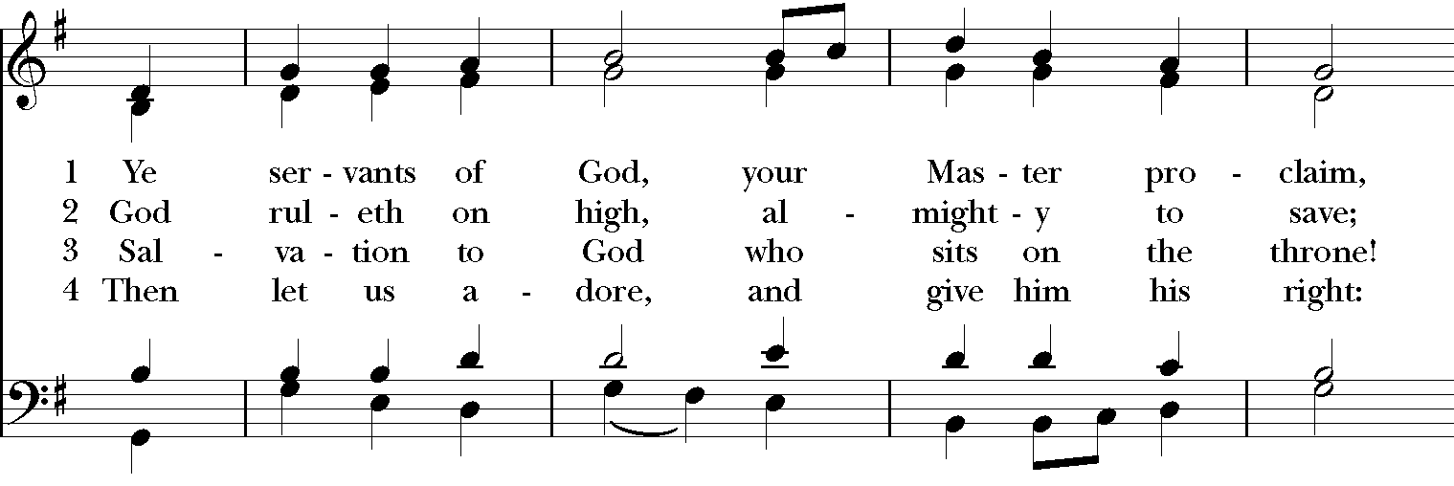

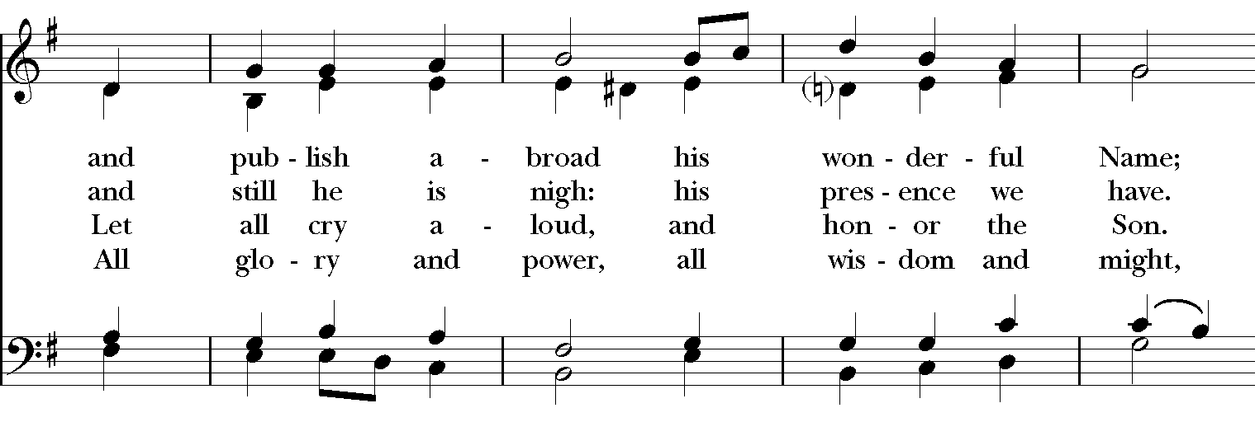

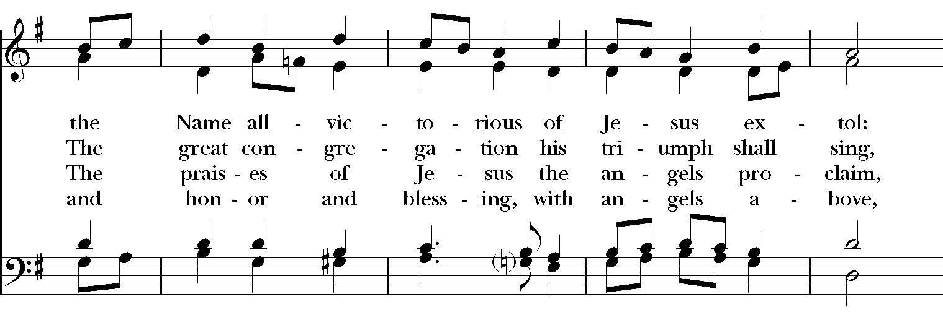

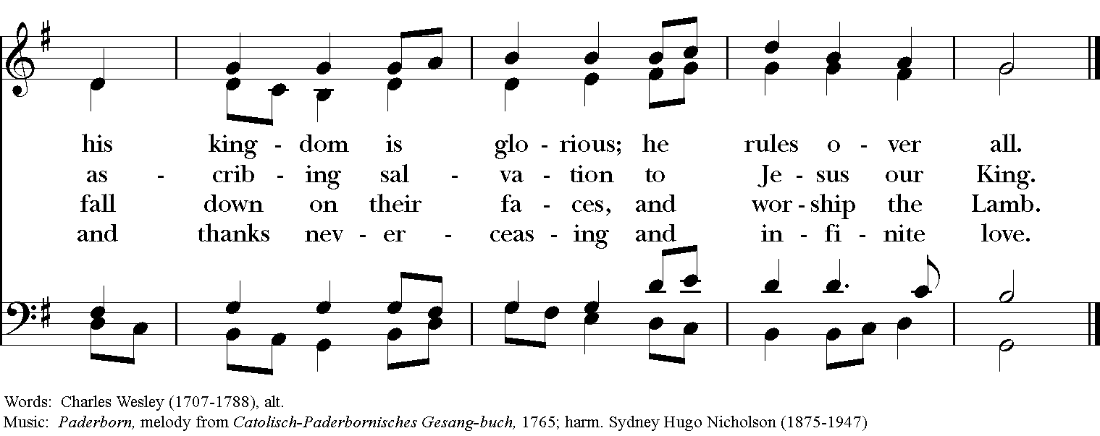

**Blessing**

May the Spirit of truth lead you into all truth, giving you grace to confess that Jesus Christ is Lord, and to proclaim the wonderful works of God; And the blessing of God Almighty, the

Father, the Son, and the Holy Spirit, be among you, and remain with you always. ***Amen.***

**Announcements**

**Dismissal**

*Deacon:* Go in peace to love and serve the Lord.

*People:* ***Thanks be to God!***

**Postlude: “Traumerei“ Opus 15, No. 7 - Schumann**

*Thank you for your spiritual presence with us this morning!*

*Although we're physically apart, we are united in prayer, worship, and holy love!*

Transition Priest-In-Charge: The Rev. Dr. Canon Lee Anne Reat

Deacon: The Rev. Dr. Rick Incorvati

Guest Speaker: Rob Rue

Music Director: Dr. Chris Durrenberger

Guest Organist: Kent Brooks

Lector: Anne Strothman

Singers: Liz Wheeler, Joy Carter, Ed Hasecke, Fred Bartenstein

Technology: Steve Ide

Slideshow: Ed Hasecke

Parish Administrator and Program Coordinator: Kelly Zeller

Coffee Hour Host: Fred Bartenstein