Christ Episcopal Church in Springfield, Ohio
Service of the Word
November 15th, 2020 at 9 am: Twenty-Fourth Sunday after Pentecost
Note: We invite you to light a candle on your table or home altar before worship begins.

Prelude:

Opening Hymn: “Open your ears, O faithful people” Hymnal 536

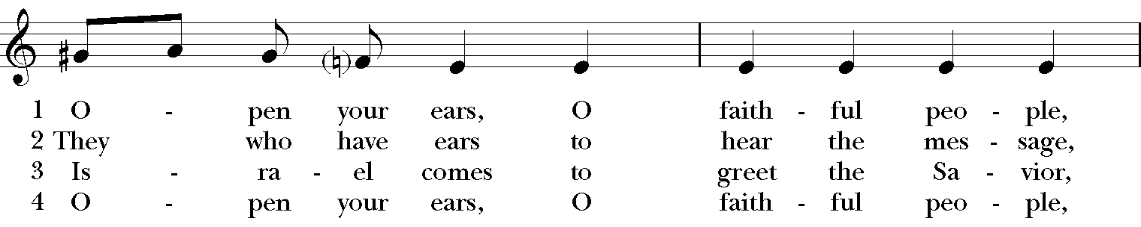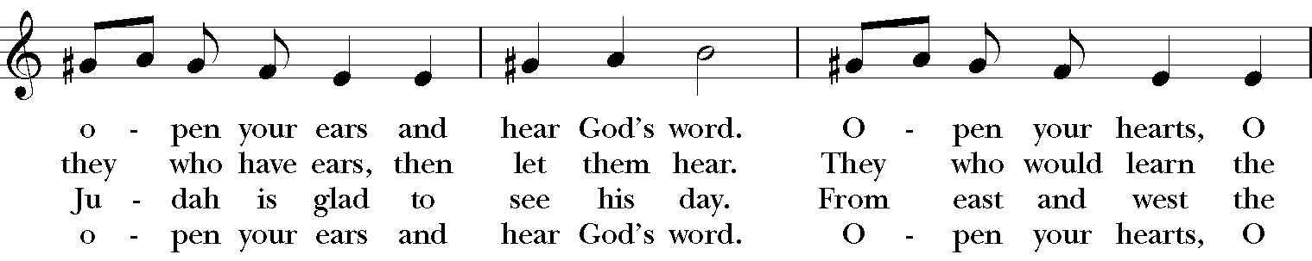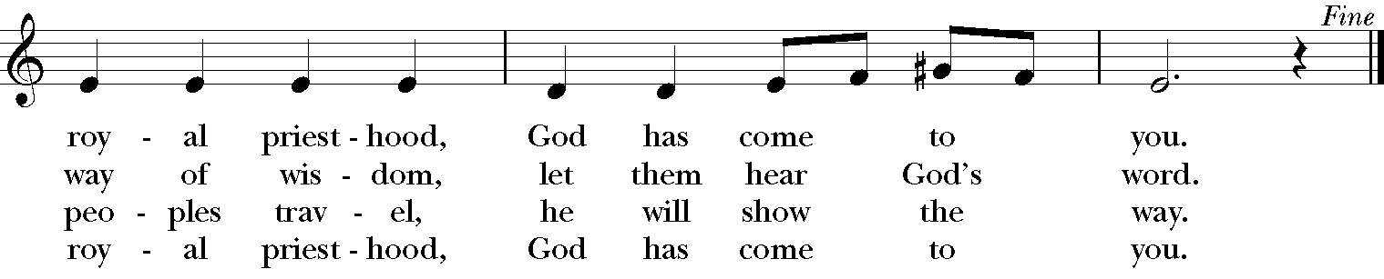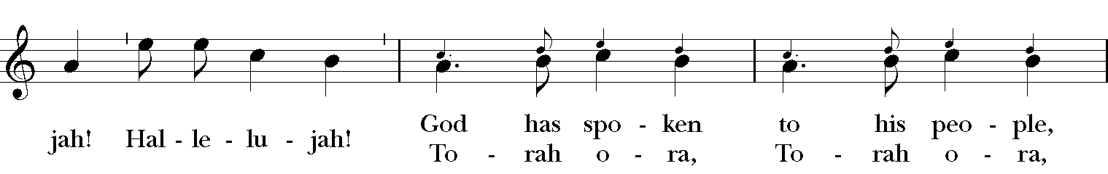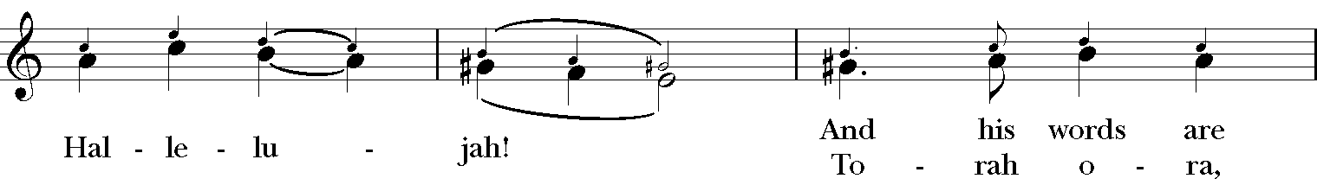

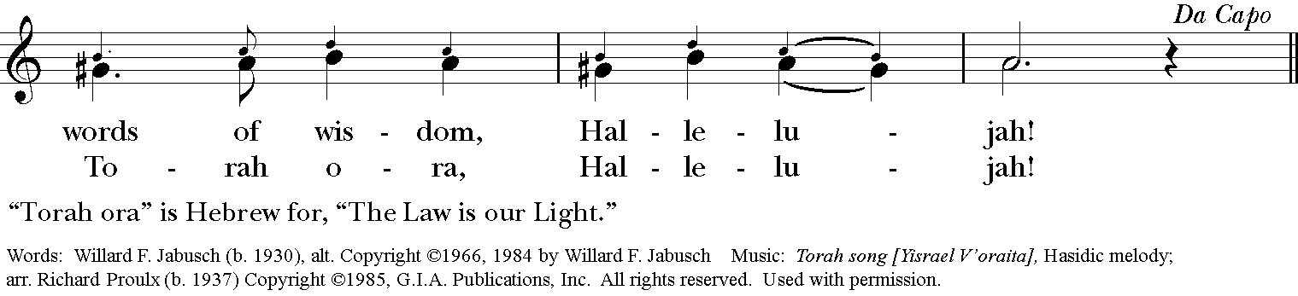

Celebrant: Blessed be God: Father, Son, and Holy Spirit.
People: And blessed be God’s kingdom, now and for ever. Amen.

Celebrant: Lord, have mercy.
People: Christ, have mercy.
Celebrant: Lord, have mercy.

The Collect of the Day

Celebrant: The Lord be with you.
People: And also with you.
Celebrant: Let us pray.
Blessed Lord, who caused all holy Scriptures to be written for our learning: Grant us so to hear them, read, mark, learn, and inwardly digest them, that we may embrace and ever hold fast the blessed hope of everlasting life, which you have given us in our Savior Jesus Christ; who lives and reigns with you and the Holy Spirit, one God, for ever and ever. Amen.

The Lessons

The First Reading: Judges 4:1-7
The Israelites again did what was evil in the sight of the Lord, after Ehud died. So the Lord sold them into the hand of King Jabin of Canaan, who reigned in Hazor; the commander of his army was Sisera, who lived in Harosheth-ha-goiim. Then the Israelites cried out to the Lord for help; for he had nine hundred chariots of iron, and had oppressed the Israelites cruelly twenty years.
At that time Deborah, a prophetess, wife of Lappidoth, was judging Israel. She used to sit under the palm of Deborah between Ramah and Bethel in the hill country of Ephraim; and the Israelites came up to her for judgment. She sent and summoned Barak son of Abinoam from Kedesh in Naphtali, and said to him, “The Lord, the God of Israel, commands you, ‘Go, take position at Mount Tabor, bringing ten thousand from the tribe of Naphtali and the tribe of Zebulun. I will draw out Sisera, the general of Jabin’s army, to meet you by the Wadi Kishon with his chariots and his troops; and I will give him into your hand.’”
Reader: The Word of the Lord.
People: Thanks be to God.

Psalm 123 Ad te levavi oculos meos

1 To you I lift up my eyes, *
to you enthroned in the heavens.
2 As the eyes of servants look to the hand of their masters, *
and the eyes of a maid to the hand of her mistress,
3 So our eyes look to the Lord our God, *
until he show us his mercy.
4 Have mercy upon us, O Lord, have mercy, *
for we have had more than enough of contempt,
5 Too much of the scorn of the indolent rich, *
and of the derision of the proud.

Second Lesson: 1 Thessalonians 5:1-11
Now concerning the times and the seasons, brothers and sisters, you do not need to have anything written to you. For you yourselves know very well that the day of the Lord will come like a thief in the night. When they say, “There is peace and security,” then sudden destruction will come upon them, as labor pains come upon a pregnant woman, and there will be no escape! But you, beloved, are not in darkness, for that day to surprise you like a thief; for you are all children of light and children of the day; we are not of the night or of darkness. So then let us not fall asleep as others do, but let us keep awake and be sober; for those who sleep at night, and those who are drunk get drunk at night. But since we belong to the day, let us be sober, and put on the breastplate of faith and love, and for a helmet the hope of salvation. For God has destined us not for wrath but for obtaining salvation through our Lord Jesus Christ, who died for us, so that whether we are awake or asleep we may live with him. Therefore encourage one another and build up each other, as indeed you are doing.
Reader: The Word of the Lord.
People: Thanks be to God.

Sequence Hymn: “Precious Lord, take my hand” Hymnal LEVAS II 106

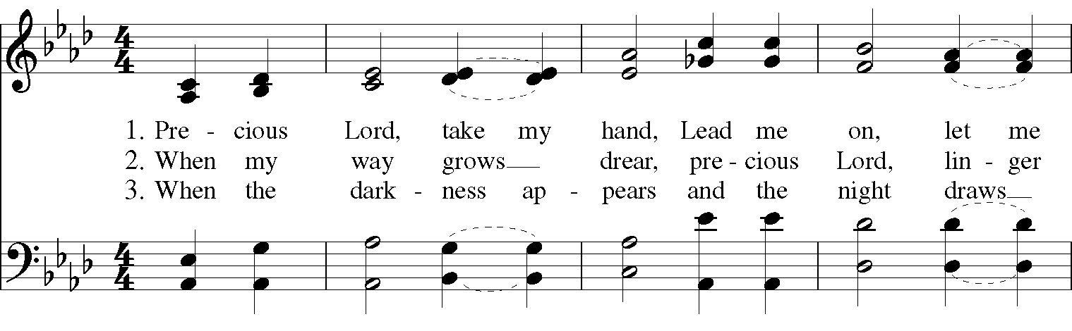

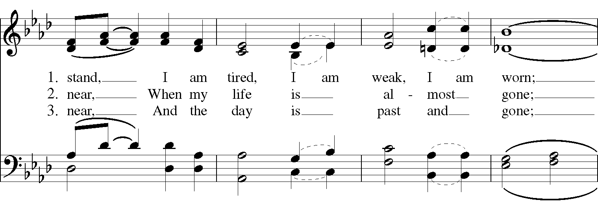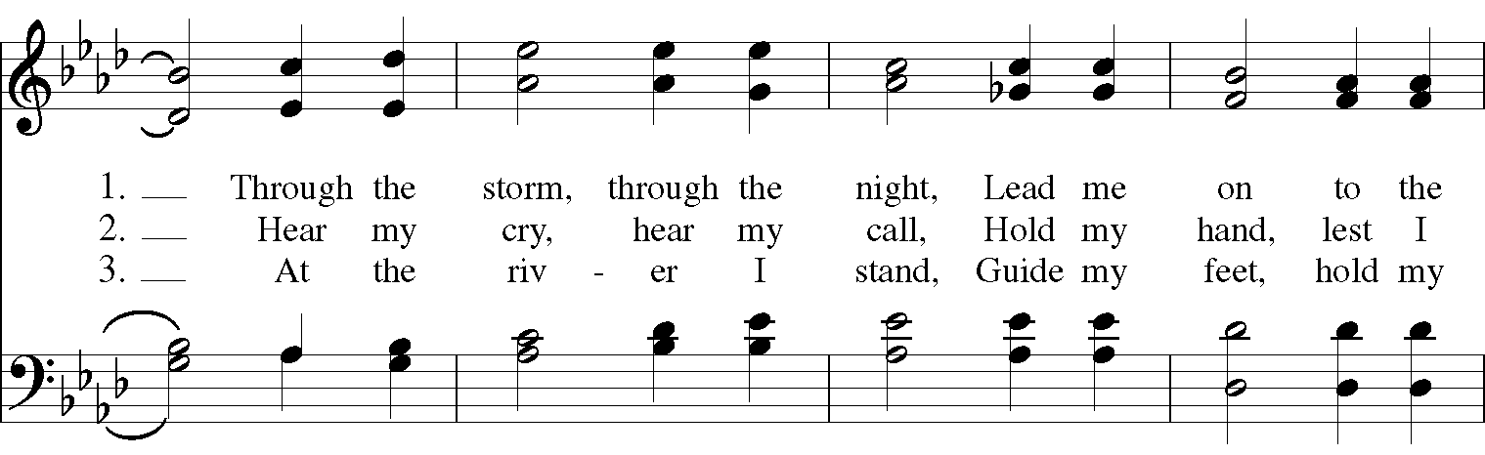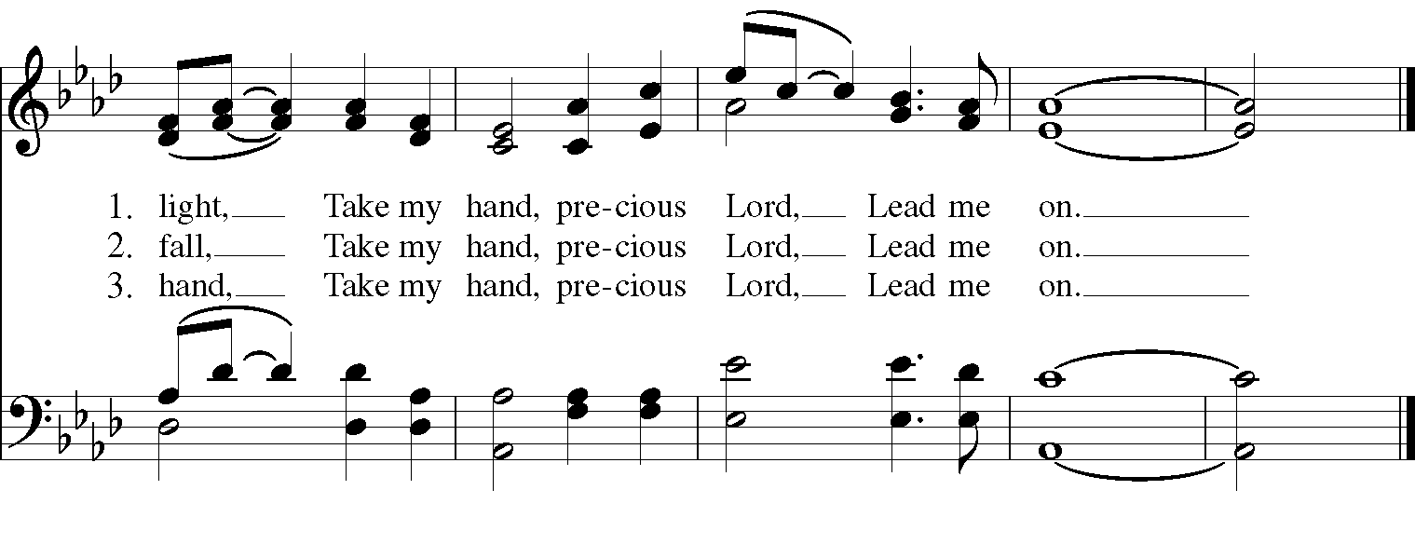
Gospel

Deacon: The Holy Gospel According to Matthew (25:14-30)
People: Glory to you, Lord Christ.
Jesus said, “It is as if a man, going on a journey, summoned his slaves and entrusted his property to them; to one he gave five talents, to another two, to another one, to each according to his ability. Then he went away. The one who had received the five talents went off at once and traded with them, and made five more talents. In the same way, the one who had the two talents made two more talents. But the one who had received the one talent went off and dug a hole in the ground and hid his master’s money. After a long time the master of those slaves came and settled accounts with them. Then the one who had received the five talents came forward, bringing five more talents, saying, ‘Master, you handed over to me five talents; see, I have made five more talents.’ His master said to him, ‘Well done, good and trustworthy slave; you have been trustworthy in a few things, I will put you in charge of many things; enter into the joy of your master.’ And the one with the two talents also came forward, saying, ‘Master, you handed over to me two talents; see, I have made two more talents.’ His master said to him, ‘Well done, good and trustworthy slave; you have been trustworthy in a few things, I will put you in charge of many things; enter into the joy of your master.’ Then the one who had received the one talent also came forward, saying, ‘Master, I knew that you were a harsh man, reaping where you did not sow, and gathering where you did not scatter seed; so I was afraid, and I went and hid your talent in the ground. Here you have what is yours.’ But his master replied, ‘You wicked and lazy slave! You knew, did you, that I reap where I did not sow, and gather where I did not scatter? Then you ought to have invested my money with the bankers, and on my return I would have received what was my own with interest. So take the talent from him, and give it to the one with the ten talents. For to all those who have, more will be given, and they will have an abundance; but from those who have nothing, even what they have will be taken away. As for this worthless slave, throw him into the outer darkness, where there will be weeping and gnashing of teeth.’”
Deacon: The Gospel of the Lord.
People: Praise to you, Lord Christ.

A reflection on the Scripture is offered by President Elfred Pinkard

The Nicene Creed
We believe in one God,
the Father, the Almighty,
the maker of heaven and earth,
of all that is, seen and unseen.
We believe in one Lord, Jesus Christ,
the only Son of God,
eternally begotten of the Father,
God from God, Light from Light,
true God from true God,
begotten, not made,
of one Being with the Father.
Through him all things were made.
For us and for our salvation
he came down from heaven:
by the power of the Holy Spirit
he became incarnate from the Virgin Mary,
and was made man.
For our sake he was crucified under Pontius Pilate;
he suffered death and was buried.
On the third day he rose again
in accordance with the Scriptures;
He ascended into heaven
and is seated on the right hand of the Father.
He will come again in glory to judge the living and the dead,
and his kingdom will have no end.
We believe in the Holy Spirit, the Lord, the giver of life,
who proceeds from the Father and the Son.
With the Father and the Son he is worshiped and glorified.
He has spoken through the Prophets.
We believe in one holy catholic and apostolic Church.
We acknowledge one baptism for the forgiveness of sins.
We look for the resurrection of the dead,
and the life of the world to come. Amen.

The Prayers of the People

In peace, we pray to you Lord God.

Silence

Let us pray. Founder of our faith, we ask your guidance for the Church, for its unity, and for the work it does in the world. Give grace to its leaders, especially Justin, archbishop of Canterbury; Michael, our presiding bishop; Tom, our diocesan bishop; Lee Anne, our priest; Rick, our deacon; and all the members of this parish.
R: Let your priests be clothed with righteousness; let your faithful people sing for joy.

Ruler over the nations, we pray for this country and its leaders in an unsettling time. Grant wisdom to all who serve in positions of leadership throughout the world.
R: For dominion belongs to the Lord, and he rules over the nations.

Lord of the harvest, we offer thanks for the beauty and abundance of this season. May we consider how best to tend the Earth and to share what You have given us, so that all may eat and be satisfied by your goodness. We pray for the ministries this church supports, especially Children’s Rescue Center/The Ark, Christ Church Food Pantry, The Fuller Center for Housing, and Safe Harbor House.
R: He covers the heavens with clouds, and prepares rain for the earth;
He makes grass grow upon the mountains, and green plants to serve humankind.

Giver of every good gift, we pray for those celebrating birthdays this week, especially Miles and Ava; and anniversaries Rick & Anne.
R: Let the righteous be glad and rejoice before God; Let them also be merry and joyful.

Great Physician, we pray for healing and comfort for all those in need or pain, especially Reilly, Chris, Judy, Susan, Linda, Dodi, Laura, Bonnie, Alice, Joy, Diana, James, Joy, Jane, Joni, Kim, Bobby, Ruth, Sarah, Traudie, Lexie, Norm, and Keith. May they remember that You are with them and those who care for them.
R: Surely you behold trouble and misery; you see it and take it into your own hand.
The helpless commit themselves to you; for you are the helper of orphans.

Just Judge, we ask your aid for all those in trouble, bringing before You prisoners and captives, refugees and the oppressed. We pray for those most vulnerable throughout the world, especially women and children.
R: Let justice roll down like waters, and righteousness like an ever-flowing stream.

Lord over life and death, we pray for all who have died, asking light and peace for them and those who mourn.
R: Precious in the sight of the Lord is the death of his servant.

We pray to you also for the forgiveness of our sins.
Have mercy upon us, most merciful Father;
in your compassion forgive us our sins,
known and unknown,
things done and left undone;
and so uphold us by your Spirit
that we may live and serve you in newness of life,
to the honor and glory of your Name;
through Jesus Christ our Lord. Amen.

Priest: Almighty God, have mercy on you, forgive you all your sins through our Lord Jesus Christ, strengthen you in all goodness, and by the power of the Holy Spirit keep you in eternal life. Amen.

And now, as our Savior Christ has taught us, we are bold to say:
Our Father, who art in heaven, hallowed be thy Name,
thy kingdom come, thy will be done, on earth as it is in heaven.
Give us this day our daily bread.
And forgive us our trespasses, as we forgive those who trespass against us.
And lead us not into temptation, but deliver us from evil.
For thine is the kingdom, and the power, and the glory, for ever and ever. Amen.

Closing Hymn: “O Jesus, I have promised” Hymnal 655

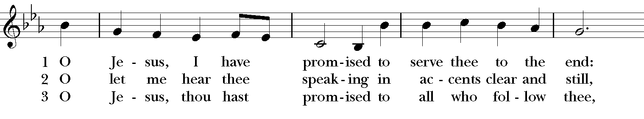

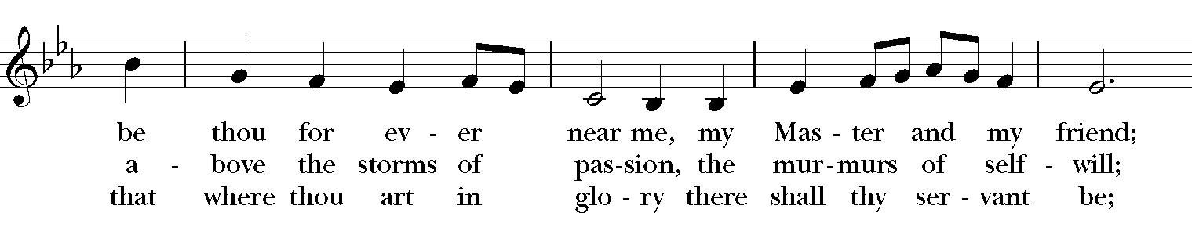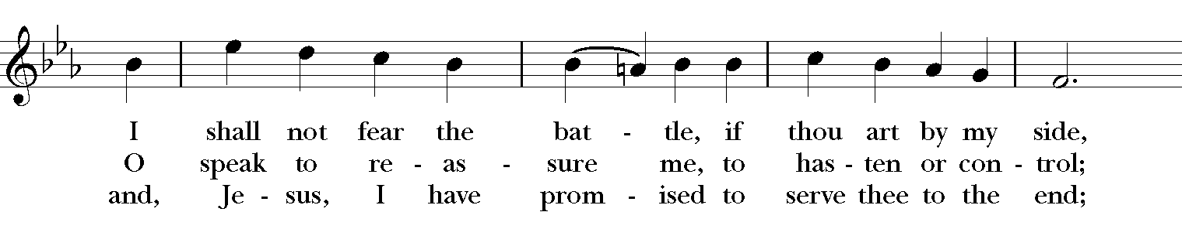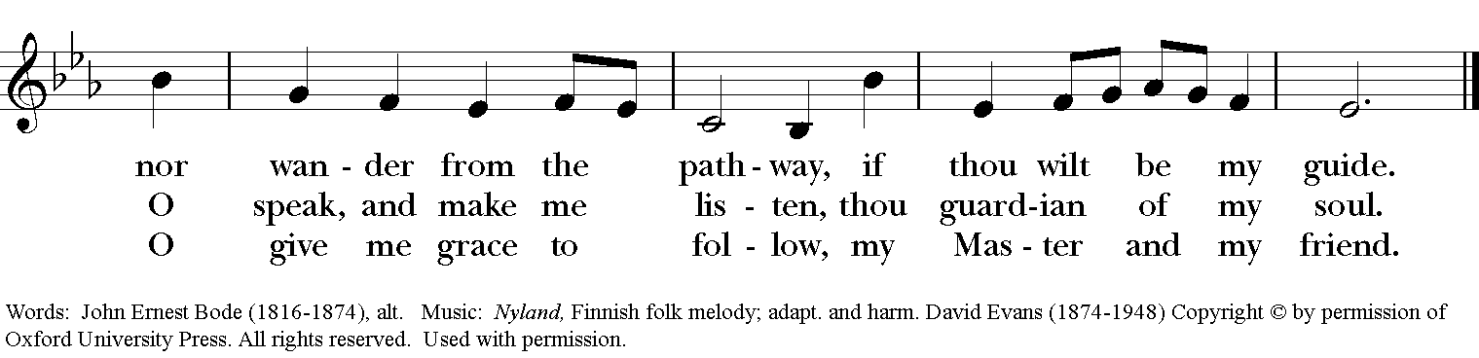

Blessing
May the Spirit of truth lead you into all truth, giving you grace to confess that Jesus Christ is Lord, and to proclaim the wonderful works of God; And the blessing of God Almighty, the
Father, the Son, and the Holy Spirit, be among you, and remain with you always. Amen.

Announcements

Dismissal
Deacon: Go in peace to love and serve the Lord.
People: Thanks be to God!
Postlude:
Thank you for your spiritual presence with us this morning!
Although we're physically apart, we are united in prayer, worship, and holy love!
Transition Priest-In-Charge: The Rev. Dr. Canon Lee Anne Reat
Deacon: The Rev. Dr. Rick Incorvati
Guest Speaker: Elfred Pinkard, President of Wilberforce University
Music Director: Dr. Chris Durrenberger
Guest Organist: Kent Brooks
Lector: Keith Doubt
Singers: Liz Wheeler, Joy Carter, Ed Hasecke, Chris Oldstone-Moore
Technology: Steve Ide
Slideshow: Ed Hasecke
Parish Administrator and Program Coordinator: Kelly Zeller
Coffee Hour Host: Fred Bartenstein

