Christ Episcopal Church in Springfield, Ohio
Service of the Word
The Last Sunday after Pentecost: Christ the King
November 22nd, 2020 at 9 am
Note: We invite you to light a candle on your table or home altar before worship begins.

Prelude:

Opening Hymn: “Crown him with many crowns” Hymnal 494

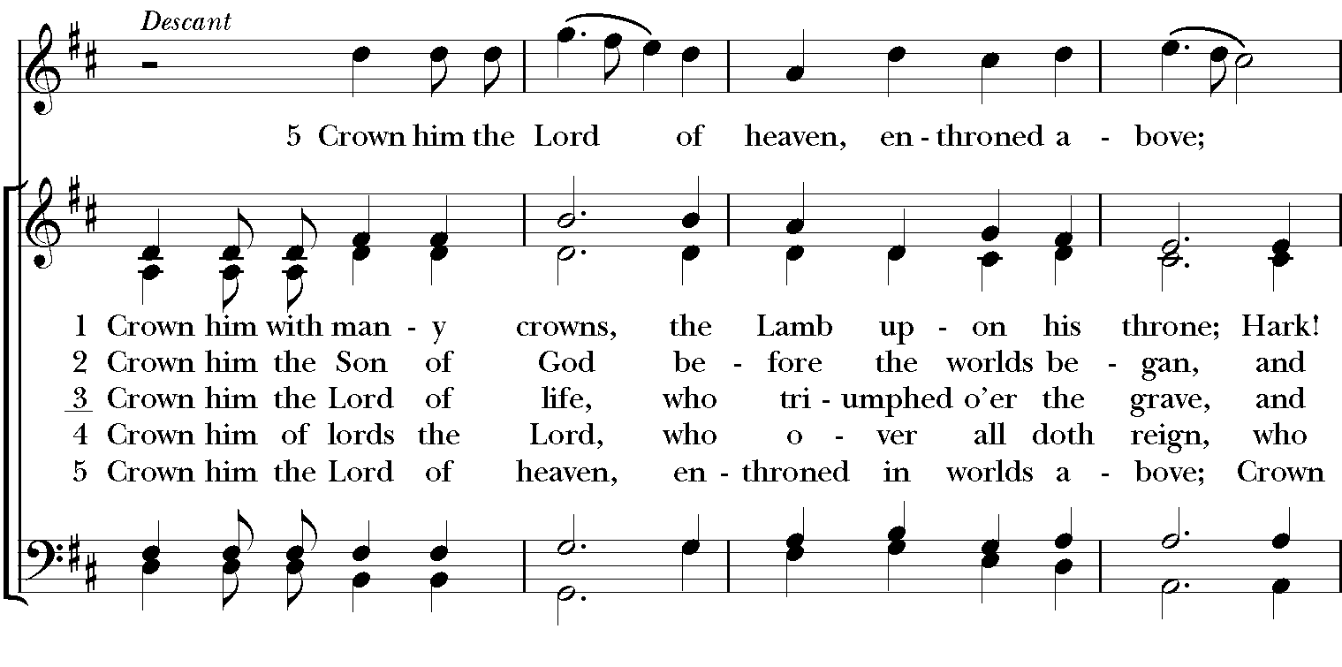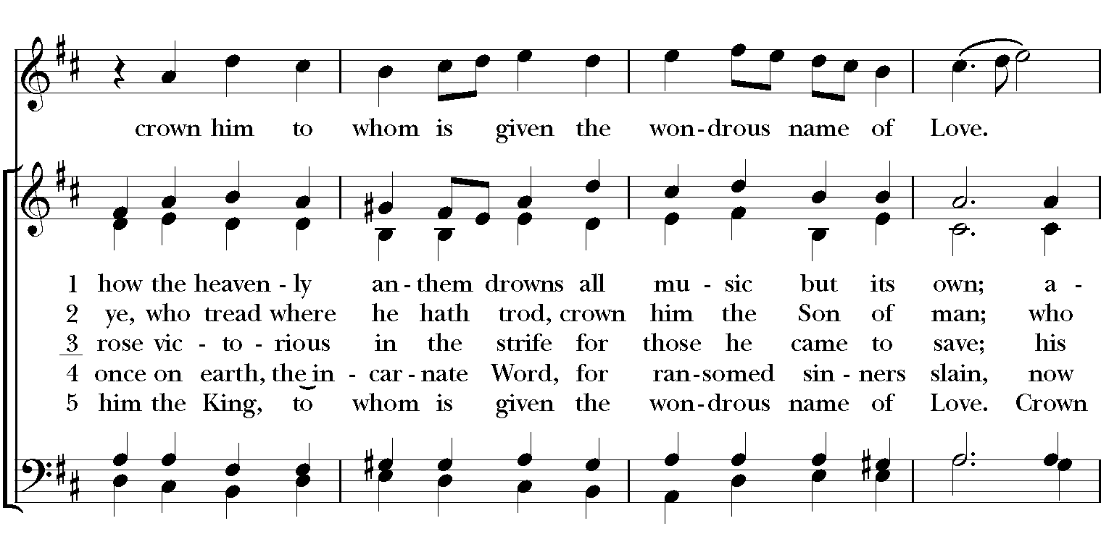

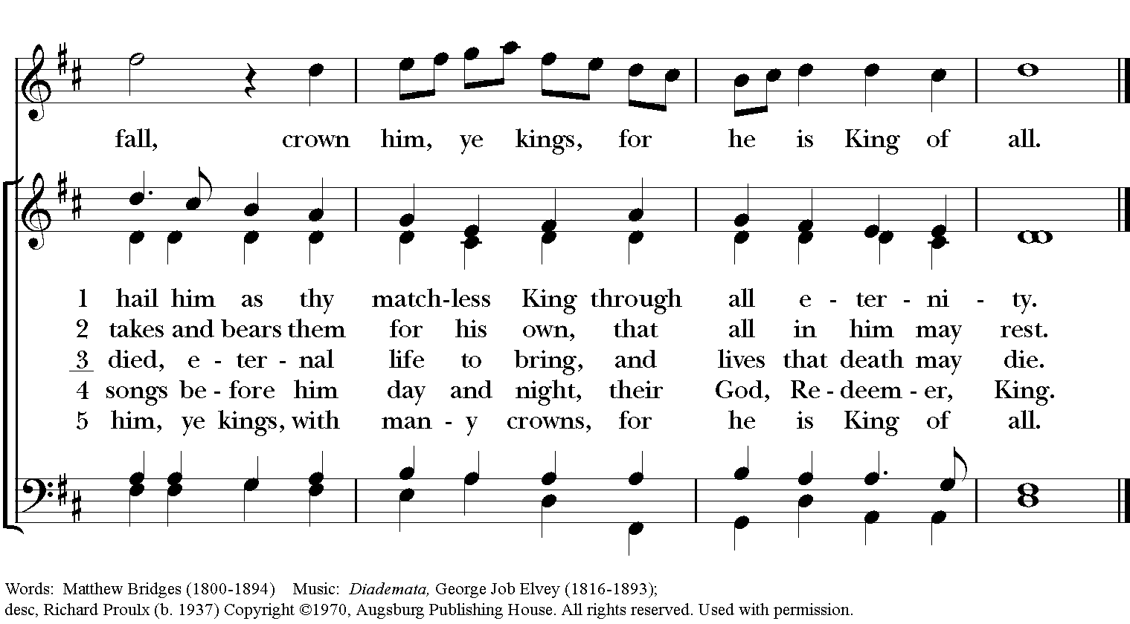
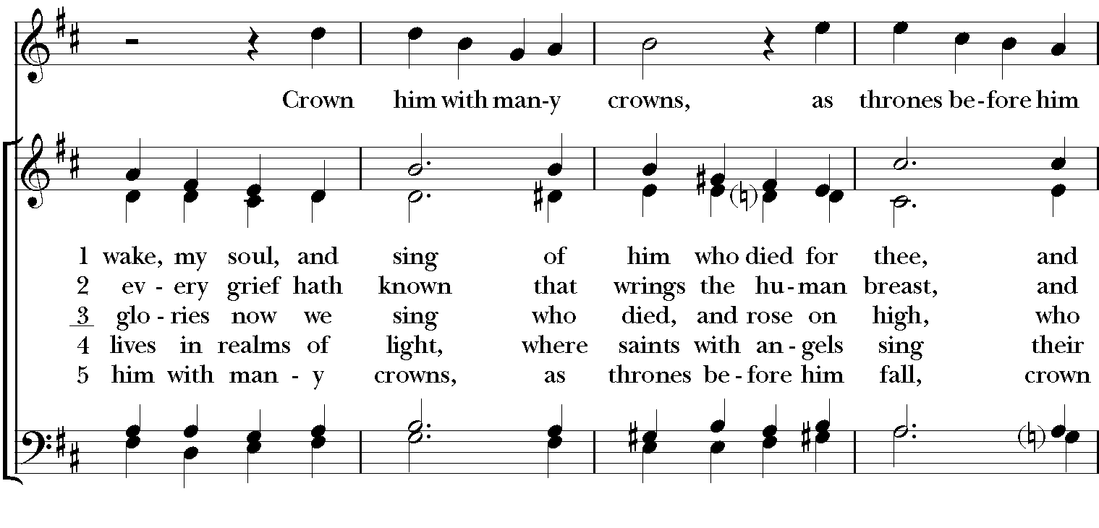

Celebrant: Blessed be God: Father, Son, and Holy Spirit.
People: And blessed be God’s kingdom, now and for ever. Amen.

Celebrant: Lord, have mercy.
People: Christ, have mercy.
Celebrant: Lord, have mercy.

The Collect of the Day

Celebrant: The Lord be with you.
People: And also with you.
Celebrant: Let us pray.
Almighty and everlasting God, whose will it is to restore all things in your well-beloved Son, the King of kings and Lord of lords: Mercifully grant that the peoples of the earth, divided and enslaved by sin, may be freed and brought together under his most gracious rule; who lives and reigns with you and the Holy Spirit, one God, now and for ever. Amen.
The Lessons

The First Reading: Ezekiel 34:11-16, 20-24
Thus says the Lord God: I myself will search for my sheep, and will seek them out. As shepherds seek out their flocks when they are among their scattered sheep, so I will seek out my sheep. I will rescue them from all the places to which they have been scattered on a day of clouds and thick darkness. I will bring them out from the peoples and gather them from the countries, and will bring them into their own land; and I will feed them on the mountains of Israel, by the watercourses, and in all the inhabited parts of the land. I will feed them with good pasture, and the mountain heights of Israel shall be their pasture; there they shall lie down in good grazing land, and they shall feed on rich pasture on the mountains of Israel. I myself will be the shepherd of my sheep, and I will make them lie down, says the Lord God. I will seek the lost, and I will bring back the strayed, and I will bind up the injured, and I will strengthen the weak, but the fat and the strong I will destroy. I will feed them with justice.

Therefore, thus says the Lord God to them: I myself will judge between the fat sheep and the lean sheep. Because you pushed with flank and shoulder, and butted at all the weak animals with your horns until you scattered them far and wide, I will save my flock, and they shall no longer be ravaged; and I will judge between sheep and sheep.

I will set up over them one shepherd, my servant David, and he shall feed them: he shall feed them and be their shepherd. And I, the Lord, will be their God, and my servant David shall be prince among them; I, the Lord, have spoken.
Reader: The Word of the Lord.
People: Thanks be to God.

Psalm 100 Jubilate Deo

1 Be joyful in the Lord, all you lands; *
serve the Lord with gladness and come before his presence with a song.
2 Know this: The Lord himself is God; *
he himself has made us, and we are his;
we are his people and the sheep of his pasture.
3 Enter his gates with thanksgiving; go into his courts with praise; *
give thanks to him and call upon his Name.
4 For the Lord is good; his mercy is everlasting; *
and his faithfulness endures from age to age.

Second Lesson: Ephesians 1:15-23
I have heard of your faith in the Lord Jesus and your love toward all the saints, and for this reason I do not cease to give thanks for you as I remember you in my prayers. I pray that the God of our Lord Jesus Christ, the Father of glory, may give you a spirit of wisdom and revelation as you come to know him, so that, with the eyes of your heart enlightened, you may know what is the hope to which he has called you, what are the riches of his glorious inheritance among the saints, and what is the immeasurable greatness of his power for us who believe, according to the working of his great power. God put this power to work in Christ when he raised him from the dead and seated him at his right hand in the heavenly places, far above all rule and authority and power and dominion, and above every name that is named, not only in this age but also in the age to come. And he has put all things under his feet and has made him the head over all things for the church, which is his body, the fullness of him who fills all in all.
Reader: The Word of the Lord.
People: Thanks be to God.

Sequence Hymn: “Go preach my Gospel” Hymnal LEVAS II 161

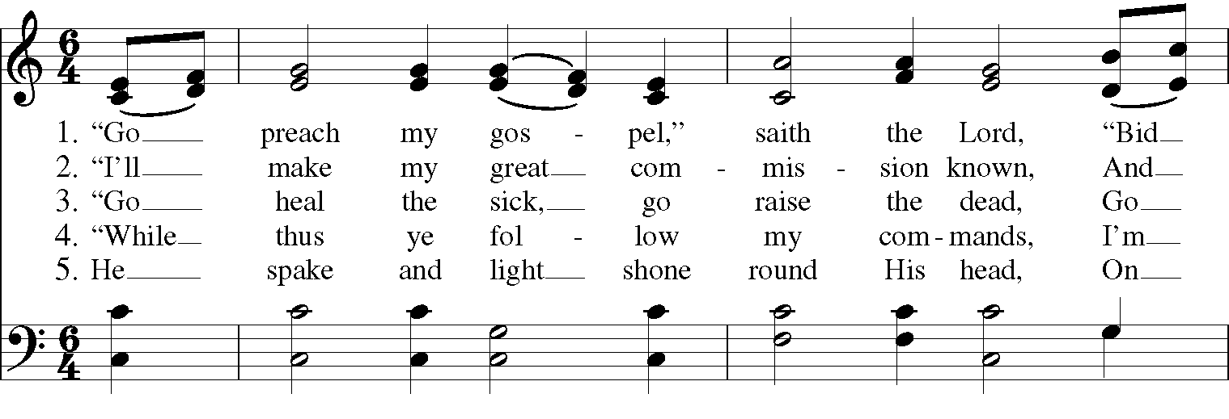
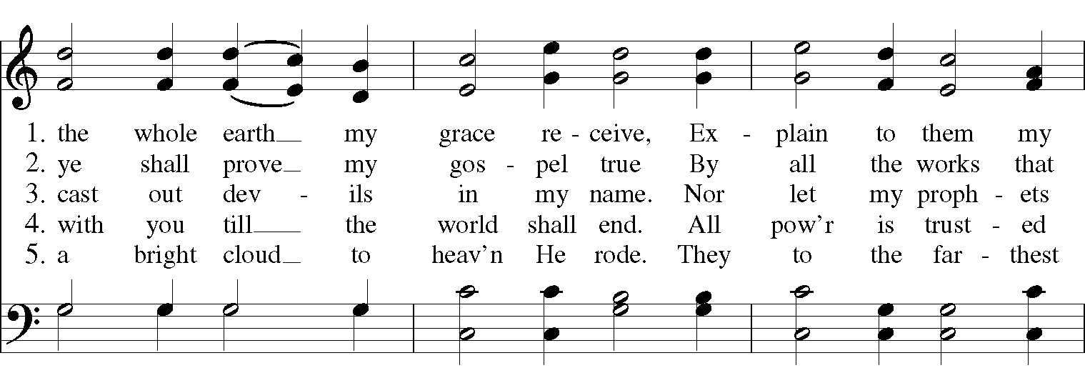

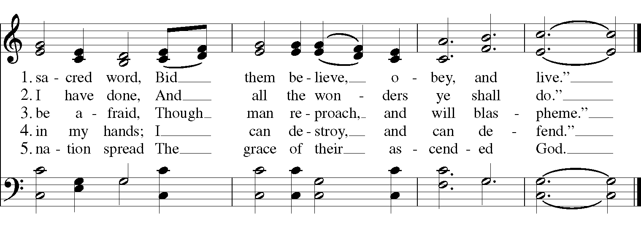

Gospel

Deacon: The Holy Gospel According to Matthew (25:31-46)
People: Glory to you, Lord Christ.
Jesus said, “When the Son of Man comes in his glory, and all the angels with him, then he will sit on the throne of his glory. All the nations will be gathered before him, and he will separate people one from another as a shepherd separates the sheep from the goats, and he will put the sheep at his right hand and the goats at the left. Then the king will say to those at his right hand, ‘Come, you that are blessed by my Father, inherit the kingdom prepared for you from the foundation of the world; for I was hungry and you gave me food, I was thirsty and you gave me something to drink, I was a stranger and you welcomed me, I was naked and you gave me clothing, I was sick and you took care of me, I was in prison and you visited me.’ Then the righteous will answer him, ‘Lord, when was it that we saw you hungry and gave you food, or thirsty and gave you something to drink? And when was it that we saw you a stranger and welcomed you, or naked and gave you clothing? And when was it that we saw you sick or in prison and visited you?’ And the king will answer them, ‘Truly I tell you, just as you did it to one of the least of these who are members of my family, you did it to me.’ Then he will say to those at his left hand, ‘You that are accursed, depart from me into the eternal fire prepared for the devil and his angels; for I was hungry and you gave me no food, I was thirsty and you gave me nothing to drink, I was a stranger and you did not welcome me, naked and you did not give me clothing, sick and in prison and you did not visit me.’ Then they also will answer, ‘Lord, when was it that we saw you hungry or thirsty or a stranger or naked or sick or in prison, and did not take care of you?’ Then he will answer them, ‘Truly I tell you, just as you did not do it to one of the least of these, you did not do it to me.’ And these will go away into eternal punishment, but the righteous into eternal life.”
Deacon: The Gospel of the Lord.
People: Praise to you, Lord Christ.

A reflection on the Scripture is offered by Pastor Carl Ruby

The Nicene Creed
We believe in one God,
the Father, the Almighty,
the maker of heaven and earth,
of all that is, seen and unseen.
We believe in one Lord, Jesus Christ,
the only Son of God,
eternally begotten of the Father,
God from God, Light from Light,
true God from true God,
begotten, not made,
of one Being with the Father.
Through him all things were made.
For us and for our salvation
he came down from heaven:
by the power of the Holy Spirit
he became incarnate from the Virgin Mary,
and was made man.
For our sake he was crucified under Pontius Pilate;
he suffered death and was buried.
On the third day he rose again
in accordance with the Scriptures;
He ascended into heaven
and is seated on the right hand of the Father.
He will come again in glory to judge the living and the dead,
and his kingdom will have no end.
We believe in the Holy Spirit, the Lord, the giver of life,
who proceeds from the Father and the Son.
With the Father and the Son he is worshiped and glorified.
He has spoken through the Prophets.
We believe in one holy catholic and apostolic Church.
We acknowledge one baptism for the forgiveness of sins.
We look for the resurrection of the dead,
and the life of the world to come. Amen.

The Prayers of the People

In peace, we pray to you Lord God.

Silence

Let us pray. Founder of our faith, we ask your guidance for the Church, for its unity, and for the work it does in the world. Give grace to its leaders, especially Justin, archbishop of Canterbury; Michael, our presiding bishop; Tom, our diocesan bishop; Lee Anne, our priest; Rick, our deacon; and all the members of this parish.
R: Let your priests be clothed with righteousness; let your faithful people sing for joy.

Ruler over the nations, we pray for this country and its leaders in an unsettling time. Grant wisdom to all who serve in positions of leadership throughout the world.
R: For dominion belongs to the Lord, and he rules over the nations.

Lord of the harvest, we offer thanks for the beauty and abundance of this season. May we consider how best to tend the Earth and to share what You have given us, so that all may eat and be satisfied by your goodness. We pray for the ministries this church supports, especially Clark County Literacy Coalition, Episcopal Community Ministries, Second Harvest Food Bank, and Interfaith Hospitality Network.
R: He covers the heavens with clouds, and prepares rain for the earth;
He makes grass grow upon the mountains, and green plants to serve humankind.

Giver of every good gift, we pray for those celebrating birthdays this week, especially Katrina, Donald, and Ed; and anniversaries Bob & Dawn and Richard & Joyce.
R: Let the righteous be glad and rejoice before God; Let them also be merry and joyful.

Great Physician, we pray for healing and comfort for all those in need or pain, especially Reilly, Chris, Susan, Linda, Dodi, Laura, Bonnie, Alice, Joy, Diana, James, Joy, Jane, Joni, Kim, Bobby, Ruth, Sarah, Traudie, Lexie, Norm, and Keith. May they remember that You are with them and those who care for them.
R: Surely you behold trouble and misery; you see it and take it into your own hand.
The helpless commit themselves to you; for you are the helper of orphans.

Just Judge, we ask your aid for all those in trouble, bringing before You prisoners and captives, refugees and the oppressed. We pray for those most vulnerable throughout the world, especially women and children.
R: Let justice roll down like waters, and righteousness like an ever-flowing stream.

Lord over life and death, we pray for all who have died, asking light and peace for them and those who mourn.
R: Precious in the sight of the Lord is the death of his servant.

We pray to you also for the forgiveness of our sins.
Have mercy upon us, most merciful Father;
in your compassion forgive us our sins,
known and unknown,
things done and left undone;
and so uphold us by your Spirit
that we may live and serve you in newness of life,
to the honor and glory of your Name;
through Jesus Christ our Lord. Amen.

Priest: Almighty God, have mercy on you, forgive you all your sins through our Lord Jesus Christ, strengthen you in all goodness, and by the power of the Holy Spirit keep you in eternal life. Amen.

And now, as our Savior Christ has taught us, we are bold to say:
Our Father, who art in heaven, hallowed be thy Name,
thy kingdom come, thy will be done, on earth as it is in heaven.
Give us this day our daily bread.
And forgive us our trespasses, as we forgive those who trespass against us.
And lead us not into temptation, but deliver us from evil.
For thine is the kingdom, and the power, and the glory, for ever and ever. Amen.
Closing Hymn: “Hail to the Lord’s Anointed” Hymnal 616

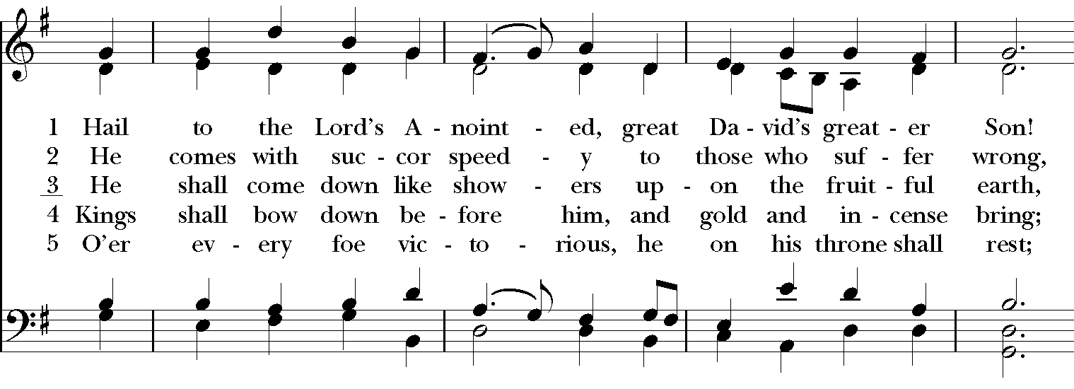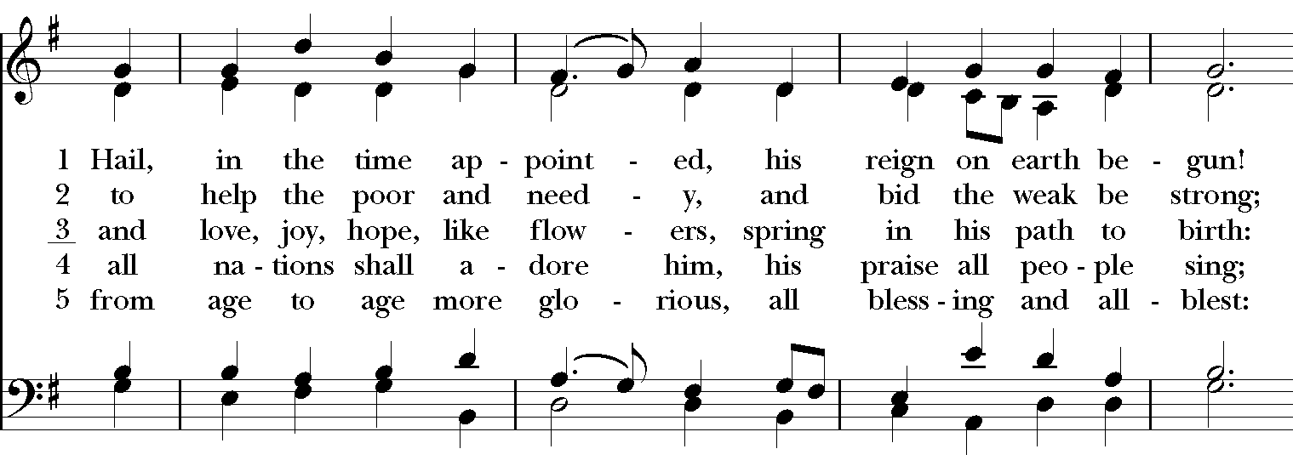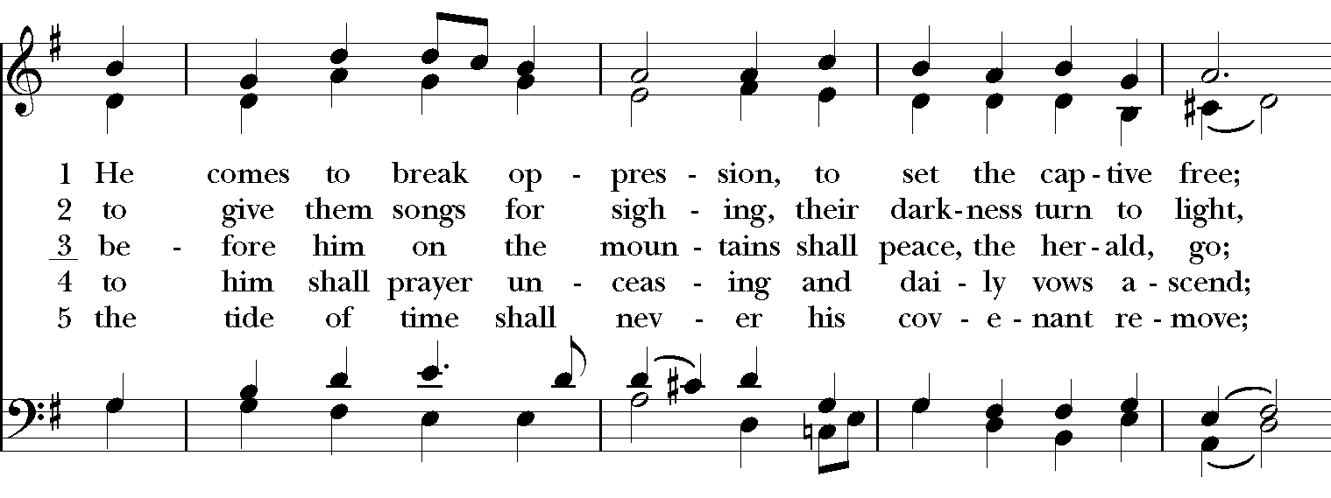
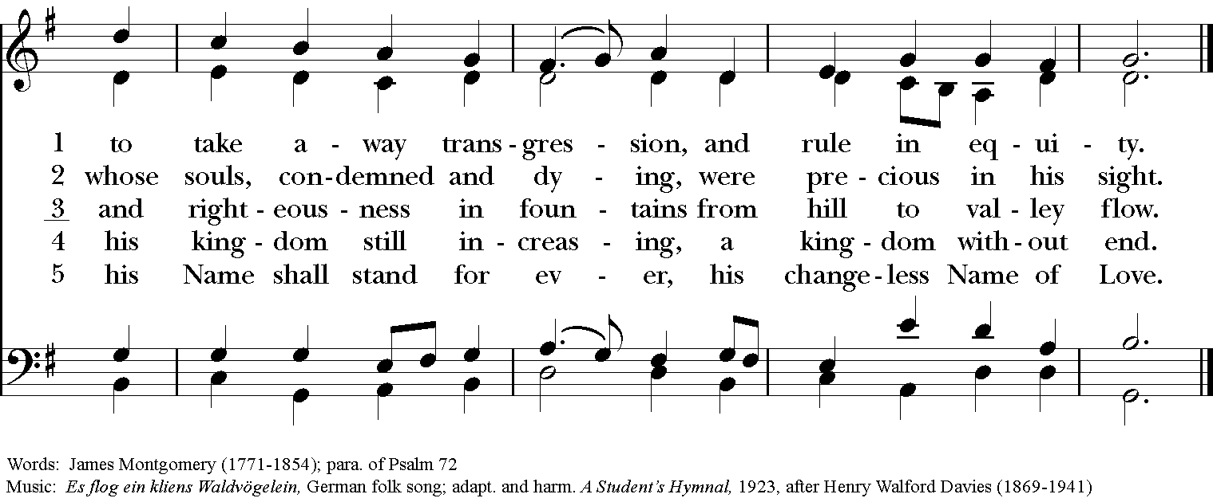

Blessing
May the Spirit of truth lead you into all truth, giving you grace to confess that Jesus Christ is Lord, and to proclaim the wonderful works of God; And the blessing of God Almighty, the
Father, the Son, and the Holy Spirit, be among you, and remain with you always. Amen.

Announcements

Blessing of the gifts and pledges

Dismissal
Deacon: Go in peace to love and serve the Lord.
People: Thanks be to God!
Postlude:
Thank you for your spiritual presence with us this morning!
Although we're physically apart, we are united in prayer, worship, and holy love!
Transition Priest-In-Charge: The Rev. Dr. Canon Lee Anne Reat
Deacon: The Rev. Dr. Rick Incorvati
Guest Speaker: Pastor Carl Ruby
Music Director: Dr. Chris Durrenberger
Guest Organist: Kent Brooks
Lector: Sarah Schubert
Singers: Liz Wheeler, Joy Carter, Ed Hasecke, Chris Oldstone-Moore
Technology: Steve Ide
Slideshow: Ed Hasecke
Parish Administrator and Program Coordinator: Kelly Zeller
Coffee Hour Host: Linda Mortensen

