Christ Episcopal Church in Springfield, Ohio
Service of the Word
First Sunday of Advent: November 29th, 2020 at 9 am

Prelude: “Lo, He Comes With Clouds Descending” - Helmsley/arr. Callahan

The Lighting of the Advent Wreath
Priest: People of God: awake! The day is coming soon when we shall see God face to face. As God’s children, we remember the ways and the works of God. We are called out of darkness to walk in the light of God’s coming. Lord, make us one as we walk with Christ today and for ever. Amen.

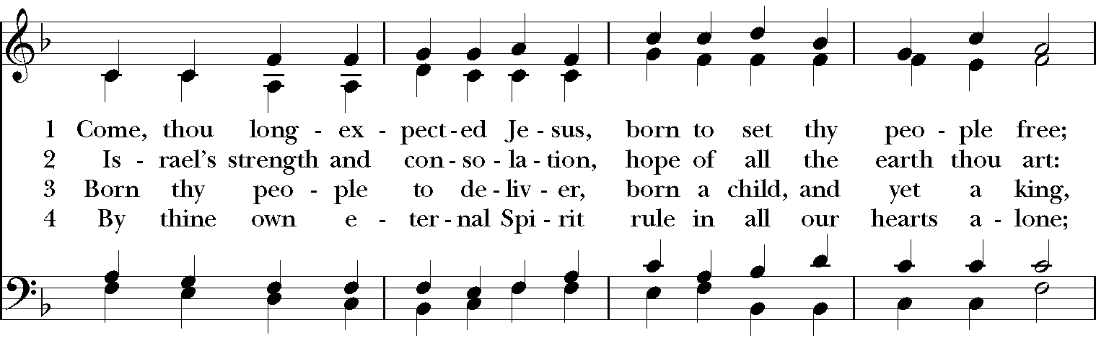
Opening Hymn: “Come, thou long expected Jesus” Hymnal 66

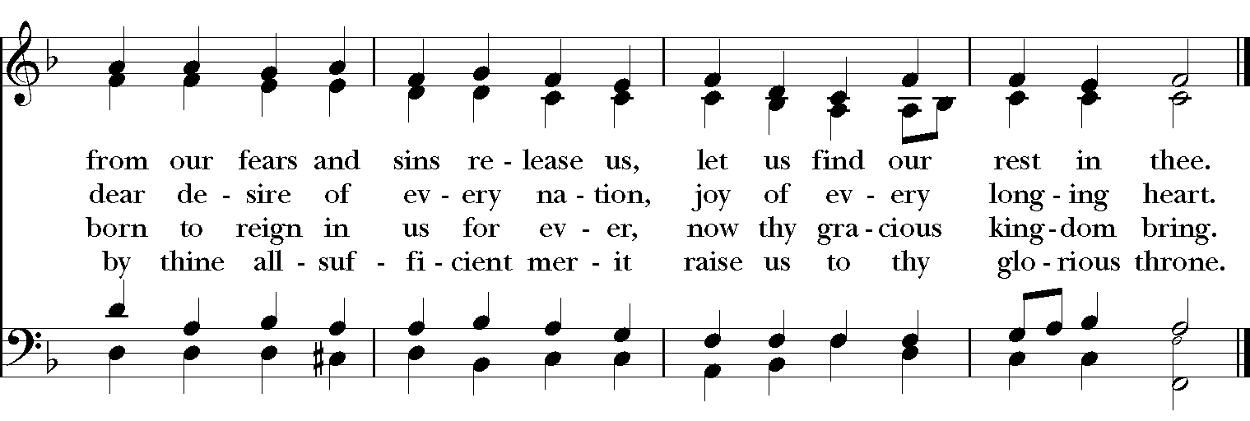

Celebrant: Blessed be God: Father, Son, and Holy Spirit.
People: And blessed be God’s kingdom, now and for ever. Amen.
Celebrant: Lord, have mercy.
People: Christ, have mercy.
Celebrant: Lord, have mercy.

The Collect of the Day
Celebrant: The Lord be with you.
People: And also with you.
Celebrant: Let us pray.
Almighty God, give us grace to cast away the works of darkness, and put on the armor of light, now in the time of this mortal life in which your Son Jesus Christ came to visit us in great humility; that in the last day, when he shall come again in his glorious majesty to judge both the living and the dead, we may rise to the life immortal; through him who lives and reigns with you and the Holy Spirit, one God, now and for ever. Amen.

The Lessons

The First Reading: Isaiah 64:1-9
O that you would tear open the heavens and come down,
so that the mountains would quake at your presence--
as when fire kindles brushwood
and the fire causes water to boil--
to make your name known to your adversaries,
so that the nations might tremble at your presence!
When you did awesome deeds that we did not expect,
you came down, the mountains quaked at your presence.
From ages past no one has heard,
no ear has perceived,
no eye has seen any God besides you,
who works for those who wait for him.
You meet those who gladly do right,
those who remember you in your ways.
But you were angry, and we sinned;
because you hid yourself we transgressed.
We have all become like one who is unclean,
and all our righteous deeds are like a filthy cloth.
We all fade like a leaf,
and our iniquities, like the wind, take us away.
There is no one who calls on your name,
or attempts to take hold of you;
for you have hidden your face from us,
and have delivered us into the hand of our iniquity.
Yet, O Lord, you are our Father;
we are the clay, and you are our potter;
we are all the work of your hand.
Do not be exceedingly angry, O Lord,
and do not remember iniquity forever.
Now consider, we are all your people.
Reader: The Word of the Lord.
People: Thanks be to God.

Psalm 80:1-7, 16-18 Qui regis Israel

1 Hear, O Shepherd of Israel, leading Joseph like a flock; *
shine forth, you that are enthroned upon the cherubim.
2 In the presence of Ephraim, Benjamin, and Manasseh, *
stir up your strength and come to help us.
3 Restore us, O God of hosts; *
show the light of your countenance, and we shall be saved.
4 O Lord God of hosts, *
how long will you be angered despite the prayers of your people?
5 You have fed them with the bread of tears; *
you have given them bowls of tears to drink.
6 You have made us the derision of our neighbors, *
and our enemies laugh us to scorn.
7 Restore us, O God of hosts; *
show the light of your countenance, and we shall be saved.
16 Let your hand be upon the man of your right hand, *
the son of man you have made so strong for yourself.
17 And so will we never turn away from you; *
give us life, that we may call upon your Name.
18 Restore us, O Lord God of hosts; *
show the light of your countenance, and we shall be saved.

Second Lesson: 1 Corinthians 1:3-9
Grace to you and peace from God our Father and the Lord Jesus Christ.
I give thanks to my God always for you because of the grace of God that has been given you in Christ Jesus, for in every way you have been enriched in him, in speech and knowledge of every kind-- just as the testimony of Christ has been strengthened among you-- so that you are not lacking in any spiritual gift as you wait for the revealing of our Lord Jesus Christ. He will also strengthen you to the end, so that you may be blameless on the day of our Lord Jesus Christ. God is faithful; by him you were called into the fellowship of his Son, Jesus Christ our Lord.
Reader: The Word of the Lord.
People: Thanks be to God.

Sequence Hymn: “Lo! He comes, with clouds descending” Hymnal 57
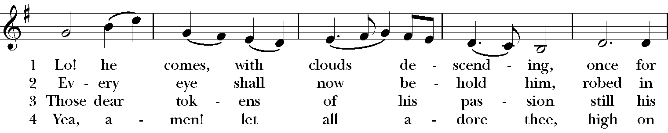

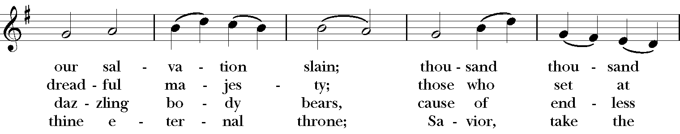
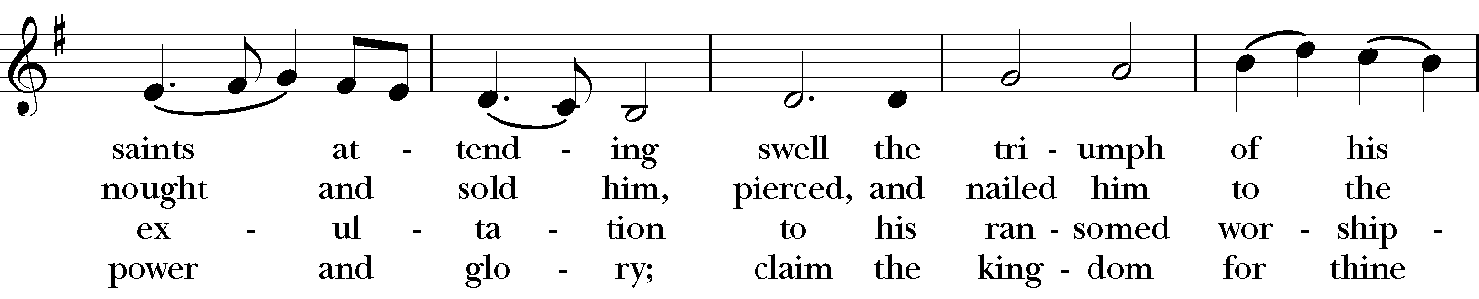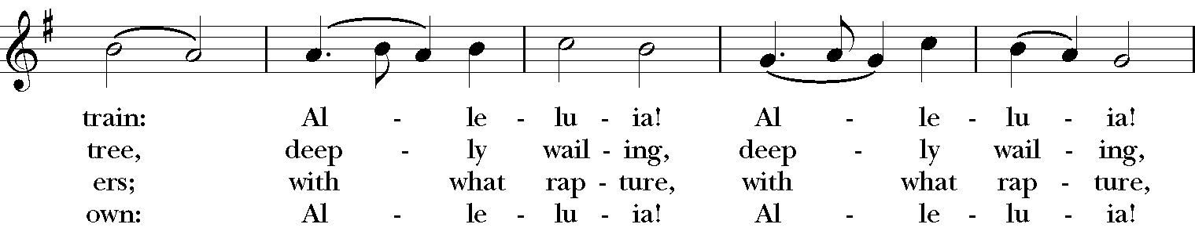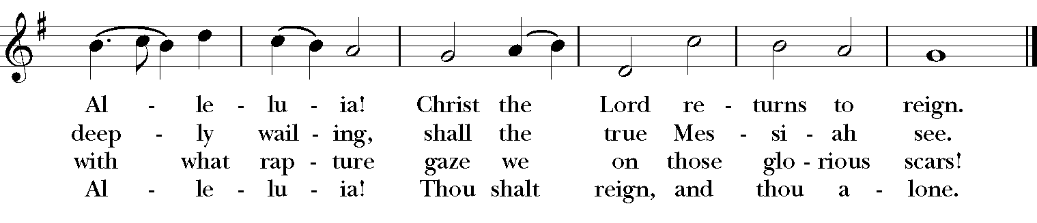
Gospel
Deacon: The Holy Gospel According to Mark (13:24-37)
People: Glory to you, Lord Christ.
Jesus said, “In those days, after that suffering,
the sun will be darkened,
and the moon will not give its light,
and the stars will be falling from heaven,
and the powers in the heavens will be shaken.
Then they will see ‘the Son of Man coming in clouds’ with great power and glory. Then he will send out the angels, and gather his elect from the four winds, from the ends of the earth to the ends of heaven.
“From the fig tree learn its lesson: as soon as its branch becomes tender and puts forth its leaves, you know that summer is near. So also, when you see these things taking place, you know that he is near, at the very gates. Truly I tell you, this generation will not pass away until all these things have taken place. Heaven and earth will pass away, but my words will not pass away.
“But about that day or hour no one knows, neither the angels in heaven, nor the Son, but only the Father. Beware, keep alert; for you do not know when the time will come. It is like a man going on a journey, when he leaves home and puts his slaves in charge, each with his work, and commands the doorkeeper to be on the watch. Therefore, keep awake—for you do not know when the master of the house will come, in the evening, or at midnight, or at cockcrow, or at dawn, or else he may find you asleep when he comes suddenly. And what I say to you I say to all: Keep awake.”
Deacon: The Gospel of the Lord.
People: Praise to you, Lord Christ.
Sermon The Rev. Canon Dr. Lee Anne Reat

The Nicene Creed
We believe in one God,
the Father, the Almighty,
the maker of heaven and earth,
of all that is, seen and unseen.
We believe in one Lord, Jesus Christ,
the only Son of God,
eternally begotten of the Father,
God from God, Light from Light,
true God from true God,
begotten, not made,
of one Being with the Father.
Through him all things were made.
For us and for our salvation
he came down from heaven:
by the power of the Holy Spirit
he became incarnate from the Virgin Mary,
and was made man.
For our sake he was crucified under Pontius Pilate;
he suffered death and was buried.
On the third day he rose again
in accordance with the Scriptures;
He ascended into heaven
and is seated on the right hand of the Father.
He will come again in glory to judge the living and the dead,
and his kingdom will have no end.
We believe in the Holy Spirit, the Lord, the giver of life,
who proceeds from the Father and the Son.
With the Father and the Son he is worshiped and glorified.
He has spoken through the Prophets.
We believe in one holy catholic and apostolic Church.
We acknowledge one baptism for the forgiveness of sins.
We look for the resurrection of the dead,
and the life of the world to come. Amen.

The Prayers of the People
In peace, we pray to you Lord God.

Silence
Let us pray. Lord Jesus Christ, you came and dwelt among us, showing us the glory of the Father. Let that glory be manifest in our churches. Give us the will to be united as You prayed we would be.
R: Lord Jesus, come and dwell within all churches.

Lord Jesus Christ, you came and dwelt among us, serving others and not seeking your own glory. Inspire church leaders, that they may be examples of willing service. Bless Justin, Archbishop of Canterbury; Michael, our Presiding Bishop; Thomas, our Bishop; Lee Anne, our priest, and Rick, our deacon.
R: Lord Jesus, come and dwell among all church leaders

Lord Jesus Christ, you came and dwelt among us, giving us an example of true power, which lies in holiness. Direct government leaders into wise decisions that will bring forth righteousness. Give the leaders of the nation wisdom and hearts for peace.
R: Lord Jesus, come and dwell in all government leaders.

Lord Jesus Christ, you came and dwelt among us, choosing the company of the poor, the homeless, the hungry, and the sick, of widows and orphans, and of sinners. Help us to reach out in lovingkindness to those who are in any need or trouble. We pray for the ministries this church supports, especially Springfield Farmer’s Market, Project Woman, Children’s Defense Fund Freedom Schools, The YMCA, and Jefferson St. Oasis Garden.
R: Lord Jesus, come and dwell in our acts of mercy.

Lord Jesus Christ, you came and dwelt among us, taking on our flesh, and inhabiting both the pains and the joys of this life. We celebrate with those who have birthdays, especially Pat and anniversaries this week.
R: Lord Jesus, come and dwell in our moments of joy.

Lord Jesus Christ, you came and dwelt among us, taking sickness and suffering into your own hands and transforming them. Have mercy on those who suffer in body, mind, or spirit. We pray especially for Julie, Reilly, Chris, Dodi, Laura, Bonnie, Alice, Joy, Diana, James, Joy, Jane, Joni, Kim, Bobby, Ruth, Sarah, Traudie, Lexie, Norm, and Keith. Give special grace and power to all those who spend this holiday working with the sick and the dying.
R: Lord Jesus, come and dwell in our dis-ease and make us whole.

Lord Jesus Christ, you came and dwelt among us, weeping at the death of those whom you loved. Comfort all those who have lost loved ones, and bless those departed.
R: Lord Jesus, come and dwell in our memories of those whom we have lost. Grant peace and light to those who have died.

*THE COLLECT FOR PEACE
Grant, O God, that your holy and life-giving Spirit may so move every human heart, that barriers which divide us may crumble, suspicions disappear, and hatreds cease; that our divisions being healed, we may live in justice and peace; through Jesus Christ our Lord. Amen.

Deacon: Let us confess our sins against God and our neighbor.
All: Most merciful God, we confess that we have sinned against you in thought, word, and deed, by what we have done, and by what we have left undone. We have not loved you with our whole heart; we have not loved our neighbors as ourselves. We are truly sorry and we humbly repent. For the sake of your Son Jesus Christ, have mercy on us and forgive us; that we may delight in your will, and walk in your ways, to the glory of your Name. Amen.

Priest: Almighty God, have mercy on you, forgive you all your sins through our Lord Jesus Christ, strengthen you in all goodness, and by the power of the Holy Spirit keep you in eternal life. Amen.

And now, as our Savior Christ has taught us, we are bold to say:
Our Father, who art in heaven, hallowed be thy Name,
thy kingdom come, thy will be done, on earth as it is in heaven.
Give us this day our daily bread.
And forgive us our trespasses, as we forgive those who trespass against us.
And lead us not into temptation, but deliver us from evil.
For thine is the kingdom, and the power, and the glory, for ever and ever. Amen.

Closing Hymn: “Sleepers, wake! A voice astounds us” Hymnal 61
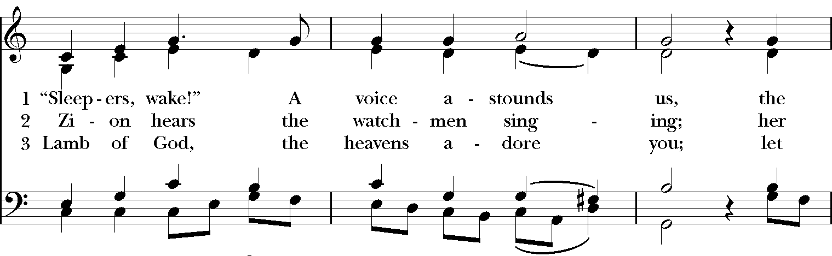

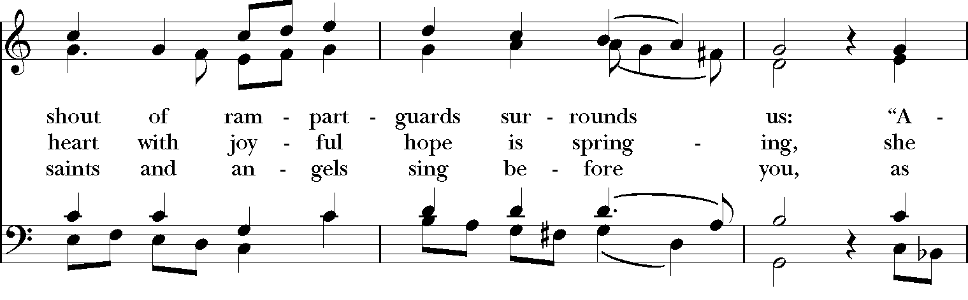
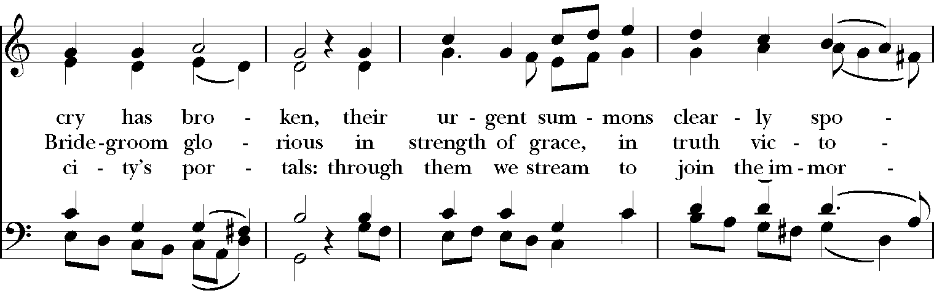
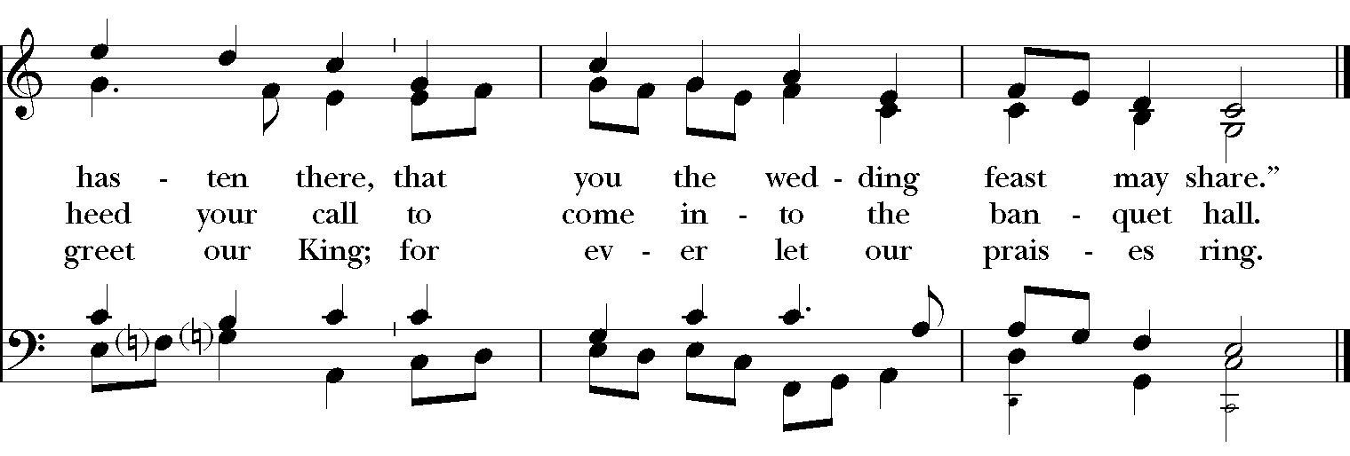
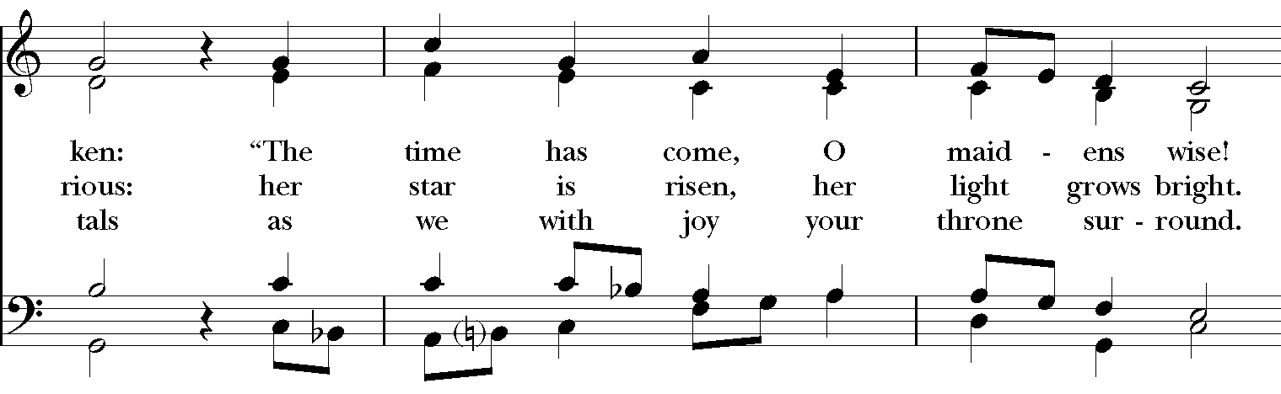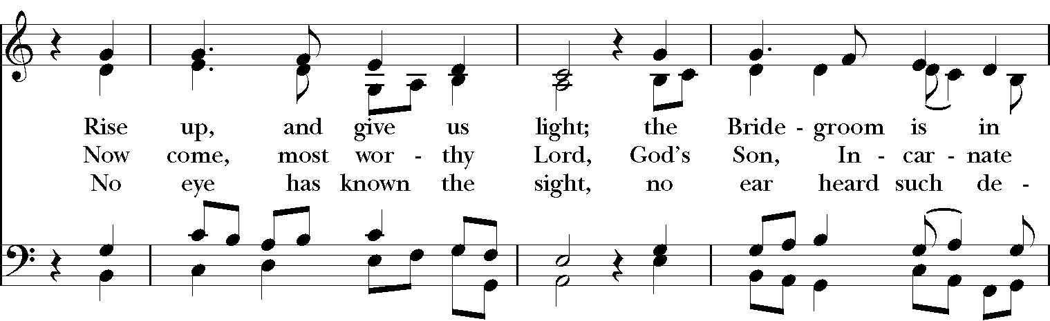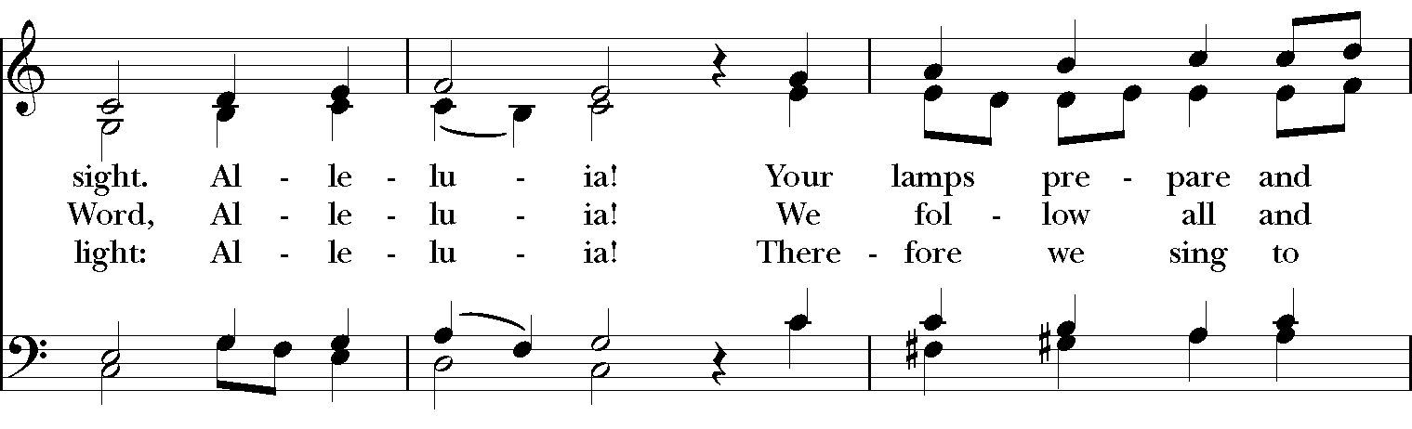

Blessing
May the Sun of Righteousness shine upon you and scatter the darkness from before your path; and the blessing of God Almighty, the Father, the Son, and the Holy Spirit, be among you, and remain with you always. Amen.”

Announcements

Dismissal
Deacon: Go in peace to love and serve the Lord.
People: Thanks be to God!

Postlude: Sonata in D minor K.9 – Scarlatti

Thank you for your spiritual presence with us this morning!
Although we're physically apart, we are united in prayer, worship, and holy love!
Transition Priest-In-Charge: The Rev. Dr. Canon Lee Anne Reat
Deacon: The Rev. Dr. Rick Incorvati
Music Director: Dr. Chris Durrenberger
Lector: Fred Bartenstein
Singers: Liz Wheeler, Joy Carter, Ed Hasecke, Fred Bartenstein
Technology: Steve Ide
Slideshow: Ed Hasecke
Parish Administrator and Program Coordinator: Kelly Zeller
Coffee Hour Host:

