Christ Episcopal Church in Springfield, Ohio
Service of the Word
November 8th, 2020 at 9 am: Twenty-Third Sunday after Pentecost
Note: We invite you to light a candle on your table or home altar before worship begins.

Prelude: “Jerusalem, My Happy Home” - Land of Rest/arr. Callahan

Opening Hymn: “Guide me, O thou great Jehovah” Hymnal 690
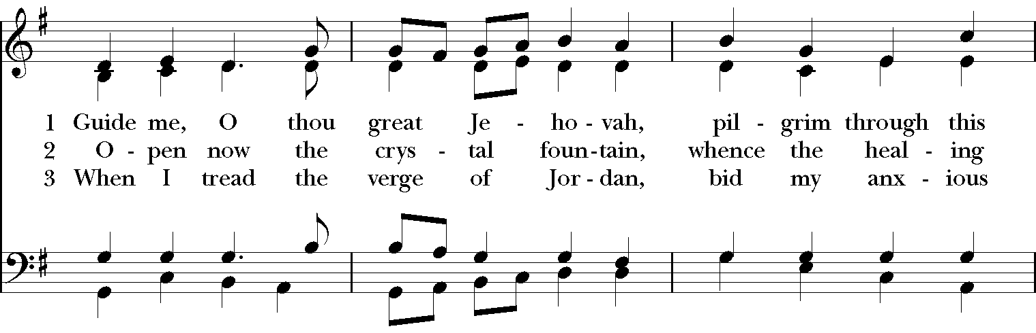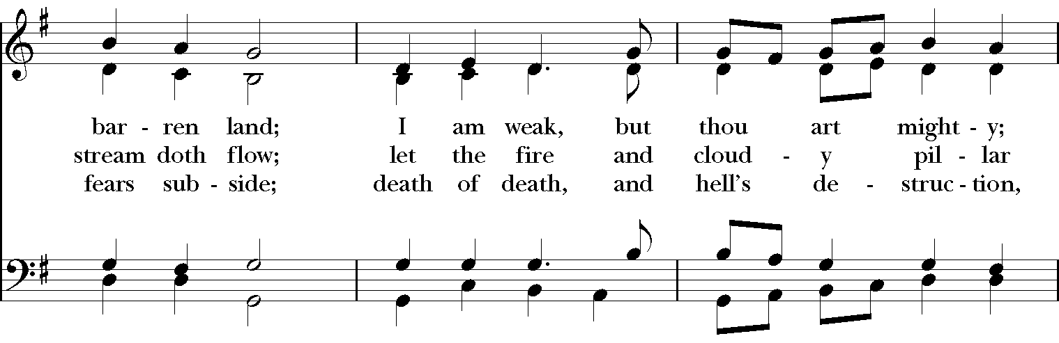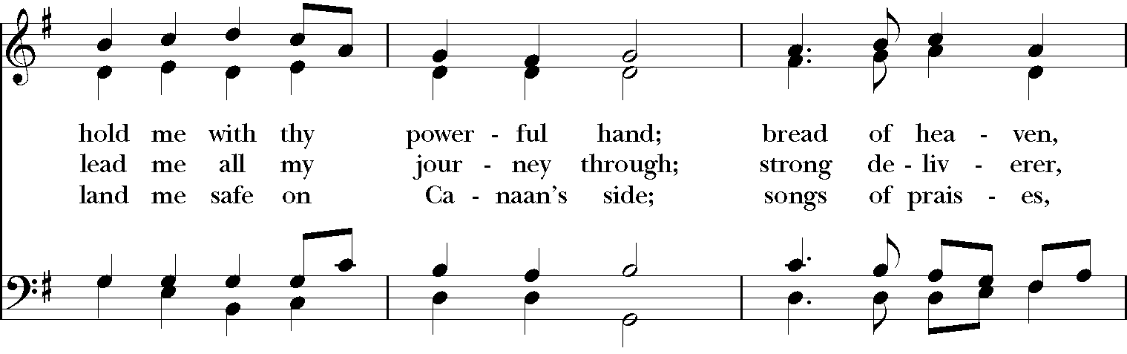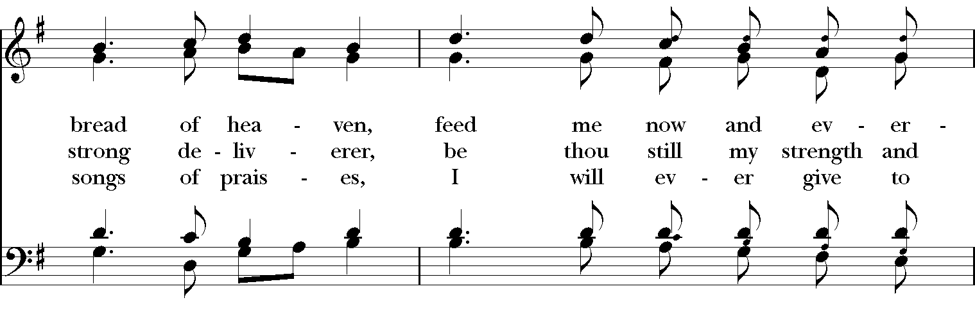
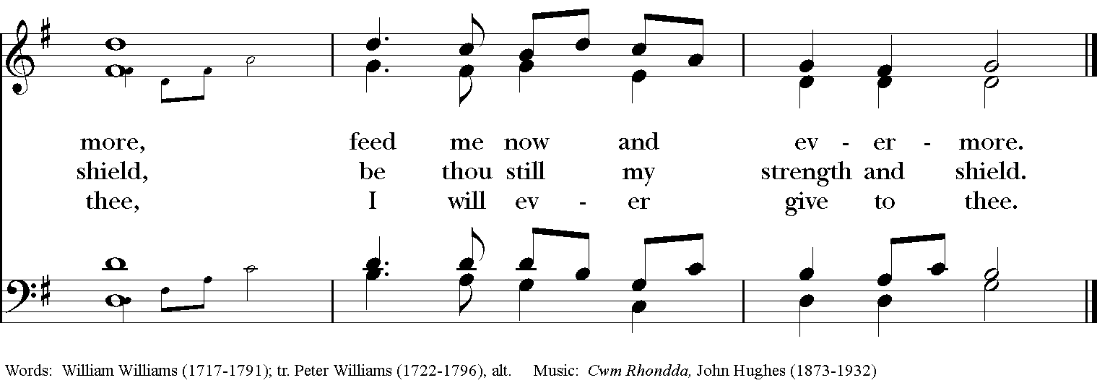

Celebrant: Blessed be God: Father, Son, and Holy Spirit.
People: And blessed be God’s kingdom, now and for ever. Amen.

Celebrant: Lord, have mercy.
People: Christ, have mercy.
Celebrant: Lord, have mercy.

The Collect of the Day

Celebrant: The Lord be with you.
People: And also with you.
Celebrant: Let us pray.
O God, whose blessed Son came into the world that he might destroy the works of the devil and make us children of God and heirs of eternal life: Grant that, having this hope, we may purify ourselves as he is pure; that, when he comes again with power and great glory, we may be made like him in his eternal and glorious kingdom; where he lives and reigns with you and the Holy Spirit, one God, for ever and ever. Amen.

The Lessons

The First Reading: Joshua 24:1-3a, 14-25
Joshua gathered all the tribes of Israel to Shechem, and summoned the elders, the heads, the judges, and the officers of Israel; and they presented themselves before God. And Joshua said to all the people, “Thus says the Lord, the God of Israel: Long ago your ancestors—Terah and his sons Abraham and Nahor—lived beyond the Euphrates and served other gods. Then I took your father Abraham from beyond the River and led him through all the land of Canaan and made his offspring many.

“Now therefore revere the Lord, and serve him in sincerity and in faithfulness; put away the gods that your ancestors served beyond the River and in Egypt, and serve the Lord. Now if you are unwilling to serve the Lord, choose this day whom you will serve, whether the gods your ancestors served in the region beyond the River or the gods of the Amorites in whose land you are living; but as for me and my household, we will serve the Lord.”
Then the people answered, “Far be it from us that we should forsake the Lord to serve other gods; for it is the Lord our God who brought us and our ancestors up from the land of Egypt, out of the house of slavery, and who did those great signs in our sight. He protected us along all the way that we went, and among all the peoples through whom we passed; and the Lord drove out before us all the peoples, the Amorites who lived in the land. Therefore we also will serve the Lord, for he is our God.”

But Joshua said to the people, “You cannot serve the Lord, for he is a holy God. He is a jealous God; he will not forgive your transgressions or your sins. If you forsake the Lord and serve foreign gods, then he will turn and do you harm, and consume you, after having done you good.” And the people said to Joshua, “No, we will serve the Lord!” Then Joshua said to the people, “You are witnesses against yourselves that you have chosen the Lord, to serve him.” And they said, “We are witnesses.” He said, “Then put away the foreign gods that are among you, and incline your hearts to the Lord, the God of Israel.” The people said to Joshua, “The Lord our God we will serve, and him we will obey.” So Joshua made a covenant with the people that day, and made statutes and ordinances for them at Shechem.
Reader: The Word of the Lord.
People: Thanks be to God.

Psalm 78:1-7
1 Hear my teaching, O my people; *
incline your ears to the words of my mouth.
2 I will open my mouth in a parable; *
I will declare the mysteries of ancient times.
3 That which we have heard and known, and what our forefathers have told us, *
we will not hide from their children.
4 We will recount to generations to come
the praiseworthy deeds and the power of the Lord, *
and the wonderful works he has done.
5 He gave his decrees to Jacob and established a law for Israel, *
which he commanded them to teach their children;
6 That the generations to come might know, and the children yet unborn; *
that they in their turn might tell it to their children;
7 So that they might put their trust in God, *
and not forget the deeds of God, but keep his commandments;

Second Lesson: 1 Thessalonians 4:13-18
We do not want you to be uninformed, brothers and sisters, about those who have died, so that you may not grieve as others do who have no hope. For since we believe that Jesus died and rose again, even so, through Jesus, God will bring with him those who have died. For this we declare to you by the word of the Lord, that we who are alive, who are left until the coming of the Lord, will by no means precede those who have died. For the Lord himself, with a cry of command, with the archangel's call and with the sound of God's trumpet, will descend from heaven, and the dead in Christ will rise first. Then we who are alive, who are left, will be caught up in the clouds together with them to meet the Lord in the air; and so we will be with the Lord forever. Therefore encourage one another with these words.
Reader: The Word of the Lord.
People: Thanks be to God.

Sequence Hymn: “Jerusalem, my happy home” Hymnal 620

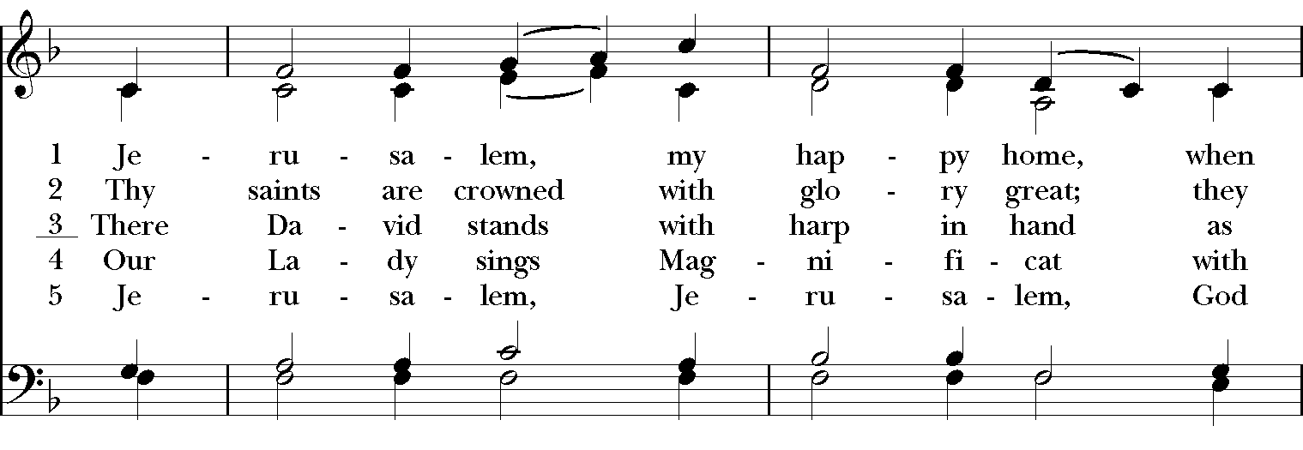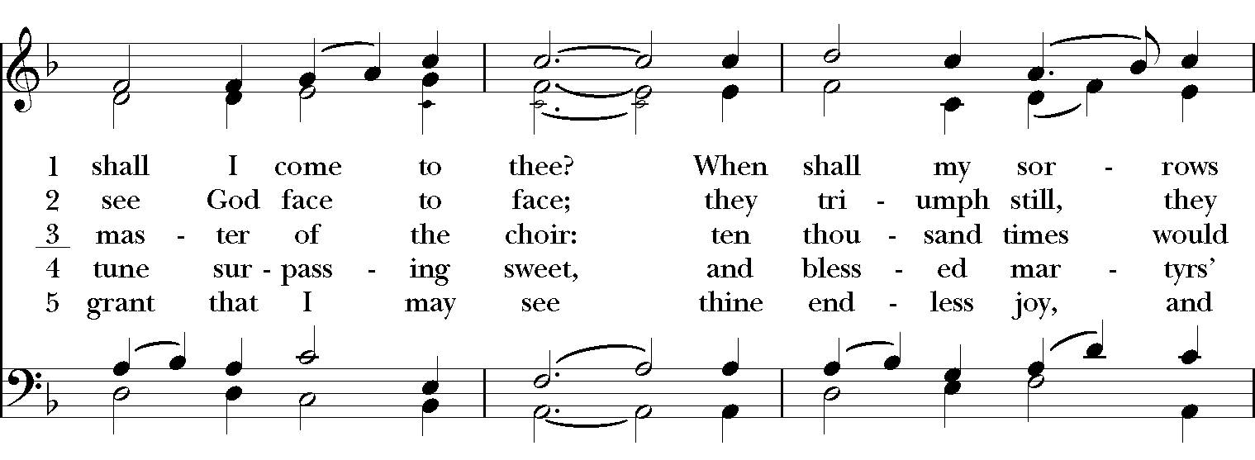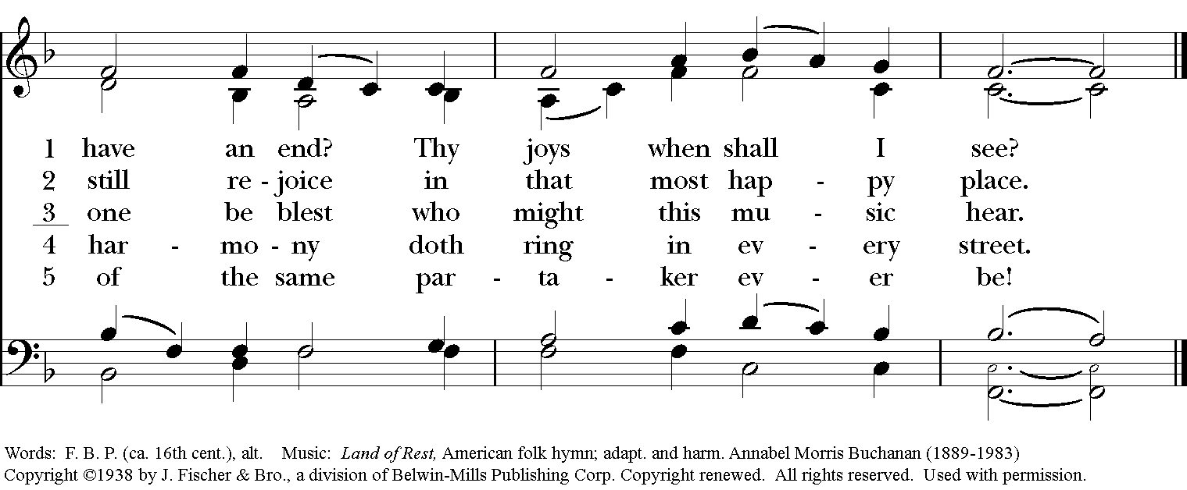

Gospel

Deacon: The Holy Gospel According to Matthew (25:1-13)
People: Glory to you, Lord Christ.
Jesus said, “Then the kingdom of heaven will be like this. Ten bridesmaids took their lamps and went to meet the bridegroom. Five of them were foolish, and five were wise. When the foolish took their lamps, they took no oil with them; but the wise took flasks of oil with their lamps. As the bridegroom was delayed, all of them became drowsy and slept. But at midnight there was a shout, ‘Look! Here is the bridegroom! Come out to meet him.’ Then all those bridesmaids got up and trimmed their lamps. The foolish said to the wise, ‘Give us some of your oil, for our lamps are going out.’ But the wise replied, ‘No! there will not be enough for you and for us; you had better go to the dealers and buy some for yourselves.’ And while they went to buy it, the bridegroom came, and those who were ready went with him into the wedding banquet; and the door was shut. Later the other bridesmaids came also, saying, ‘Lord, lord, open to us.’ But he replied, ‘Truly I tell you, I do not know you.’ Keep awake therefore, for you know neither the day nor the hour.”
Deacon: The Gospel of the Lord.
People: Praise to you, Lord Christ.

Sermon The Rev. Canon Dr. Lee Anne Reat

The Nicene Creed
We believe in one God,
the Father, the Almighty,
the maker of heaven and earth,
of all that is, seen and unseen.
We believe in one Lord, Jesus Christ,
the only Son of God,
eternally begotten of the Father,
God from God, Light from Light,
true God from true God,
begotten, not made,
of one Being with the Father.
Through him all things were made.
For us and for our salvation
he came down from heaven:
by the power of the Holy Spirit
he became incarnate from the Virgin Mary,
and was made man.
For our sake he was crucified under Pontius Pilate;
he suffered death and was buried.
On the third day he rose again
in accordance with the Scriptures;
He ascended into heaven
and is seated on the right hand of the Father.
He will come again in glory to judge the living and the dead,
and his kingdom will have no end.
We believe in the Holy Spirit, the Lord, the giver of life,
who proceeds from the Father and the Son.
With the Father and the Son he is worshiped and glorified.
He has spoken through the Prophets.
We believe in one holy catholic and apostolic Church.
We acknowledge one baptism for the forgiveness of sins.
We look for the resurrection of the dead,
and the life of the world to come. Amen.

The Prayers of the People

In peace, we pray to you Lord God.

Silence

Let us pray. Founder of our faith, we ask your guidance for the Church, for its unity, and for the work it does in the world. Give grace to its leaders, especially Justin, archbishop of Canterbury; Michael, our presiding bishop; Tom, our diocesan bishop; Lee Anne, our priest; Rick, our deacon; and all the members of this parish.
R: Let your priests be clothed with righteousness; let your faithful people sing for joy.

Ruler over the nations, we pray for this country and its leaders in an unsettling time. Grant wisdom to all who serve in positions of leadership throughout the world.
R: For dominion belongs to the Lord, and he rules over the nations.

Lord of the harvest, we offer thanks for the beauty and abundance of this season. May we consider how best to tend the Earth and to share what You have given us, so that all may eat and be satisfied by your goodness. We pray for the ministries this church supports, especially Rainbow Table, Springfield Promise Neighborhood, Springfield Peace Center, and Partners in Ministry in Liberia.
R: He covers the heavens with clouds, and prepares rain for the earth;
He makes grass grow upon the mountains, and green plants to serve humankind.

Giver of every good gift, we pray for those celebrating birthdays this week,
R: Let the righteous be glad and rejoice before God; Let them also be merry and joyful.

Great Physician, we pray for healing and comfort for all those in need or pain, especially Dick, Judy, Susan, Linda, Dodi, Laura, Bonnie, Alice, Joy, Diana, James, Joy, Jane, Joni, Kim, Bobby, Ruth, Sarah, Traudie, Lexie, Norm, and Keith. May they remember that You are with them and those who care for them.
R: Surely you behold trouble and misery; you see it and take it into your own hand.
The helpless commit themselves to you; for you are the helper of orphans.

Just Judge, we ask your aid for all those in trouble, bringing before You prisoners and captives, refugees and the oppressed. We pray for those most vulnerable throughout the world, especially women and children.
R: Let justice roll down like waters, and righteousness like an ever-flowing stream.

Lord over life and death, we pray for all who have died, asking light and peace for them and those who mourn.
R: Precious in the sight of the Lord is the death of his servant.

We pray to you also for the forgiveness of our sins.
Have mercy upon us, most merciful Father;
in your compassion forgive us our sins,
known and unknown,
things done and left undone;
and so uphold us by your Spirit
that we may live and serve you in newness of life,
to the honor and glory of your Name;
through Jesus Christ our Lord. Amen.

Priest: Almighty God, have mercy on you, forgive you all your sins through our Lord Jesus Christ, strengthen you in all goodness, and by the power of the Holy Spirit keep you in eternal life. Amen.

And now, as our Savior Christ has taught us, we are bold to say:
Our Father, who art in heaven, hallowed be thy Name,
thy kingdom come, thy will be done, on earth as it is in heaven.
Give us this day our daily bread.
And forgive us our trespasses, as we forgive those who trespass against us.
And lead us not into temptation, but deliver us from evil.
For thine is the kingdom, and the power, and the glory, for ever and ever. Amen.

Closing Hymn: “Lift up your heads, ye mighty gates” Hymnal 436
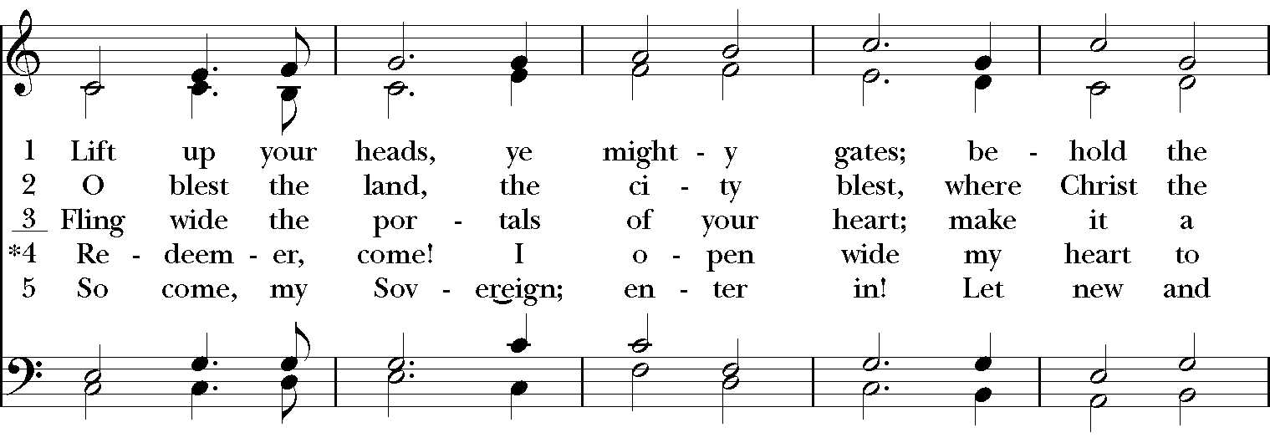
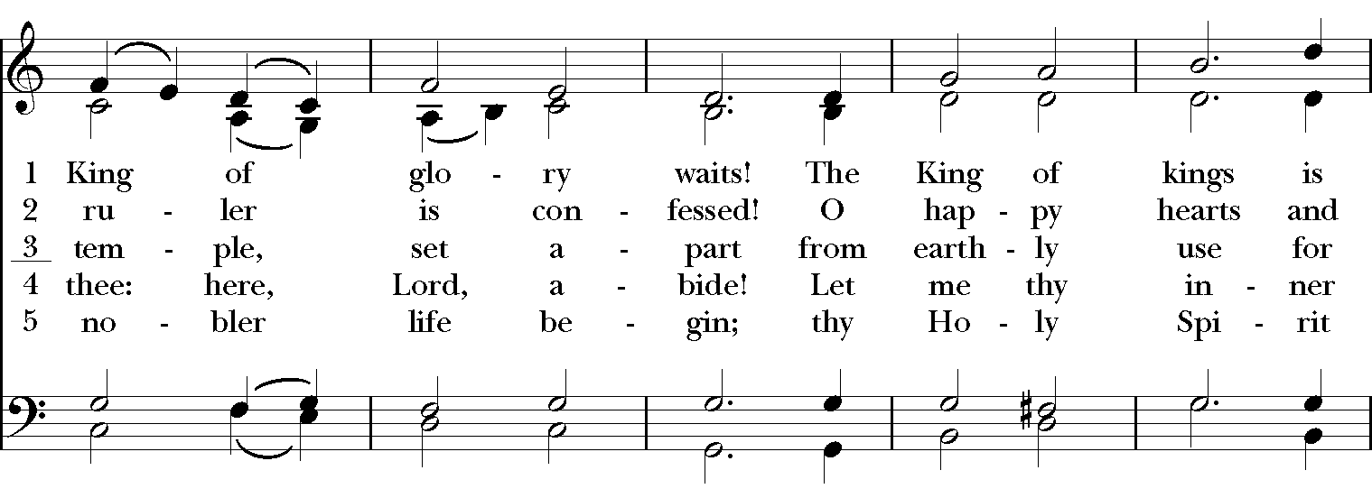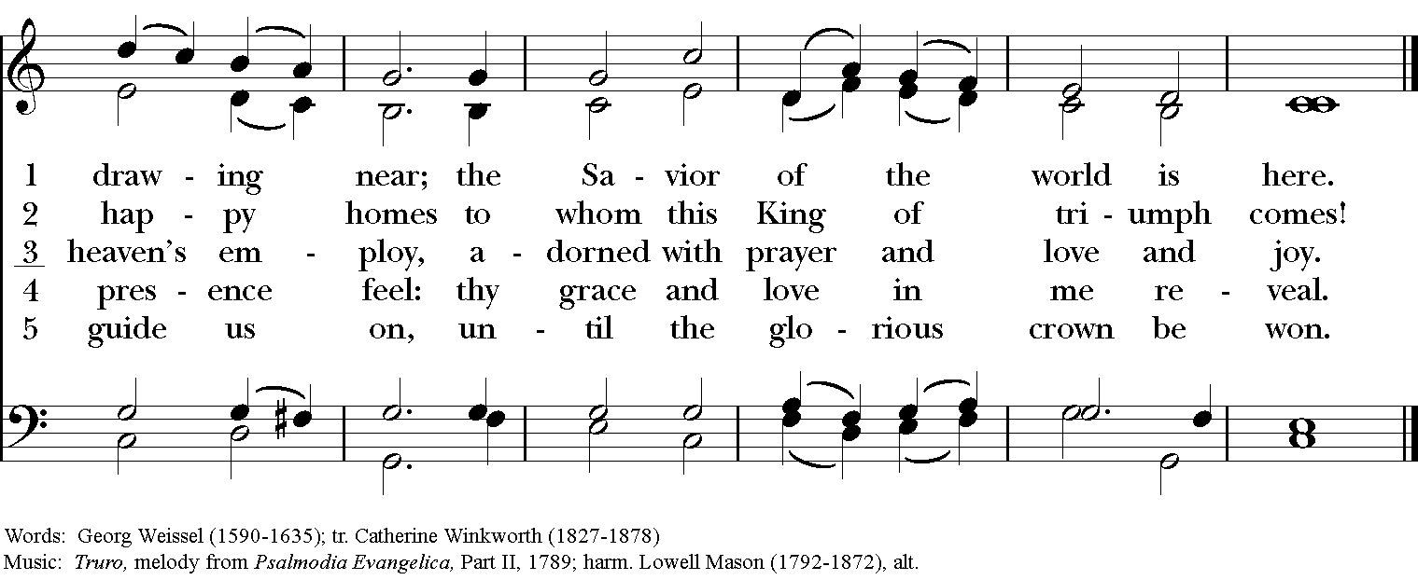
Blessing
May the Spirit of truth lead you into all truth, giving you grace to confess that Jesus Christ is Lord, and to proclaim the wonderful works of God; And the blessing of God Almighty, the
Father, the Son, and the Holy Spirit, be among you, and remain with you always. Amen.

Announcements

Dismissal
Deacon: Go in peace to love and serve the Lord.
People: Thanks be to God!
Postlude: “Allegro“ from Sonata in C Major K545 - Mozart
Thank you for your spiritual presence with us this morning!
Although we're physically apart, we are united in prayer, worship, and holy love!

Transition Priest-In-Charge: The Rev. Dr. Canon Lee Anne Reat
Deacon: The Rev. Dr. Rick Incorvati
Music Director: Dr. Chris Durrenberger
Lector: Liz Wheeler
Singers: Liz Wheeler, Joy Carter, Ed Hasecke, Fred Bartenstein
Technology: Steve Ide
Slideshow: Ed Hasecke
Parish Administrator and Program Coordinator: Kelly Zeller
Coffee Hour Host: Ron Dowling

