Christ Episcopal Church in Springfield, Ohio
Service of the Word
Twentieth Sunday after Pentecost: October 10th, 2021 at 9 am

Prelude: “Jesu, Joy of Man’s Desiring” - Werde Munter/arr. Keene

Opening Hymn: “Christ, Whose Glory Fills the Skies” Hymnal 7
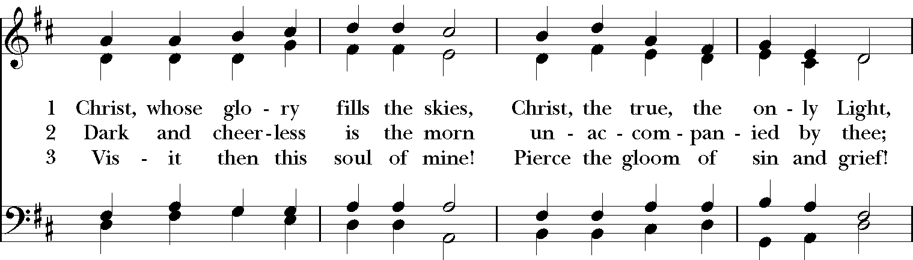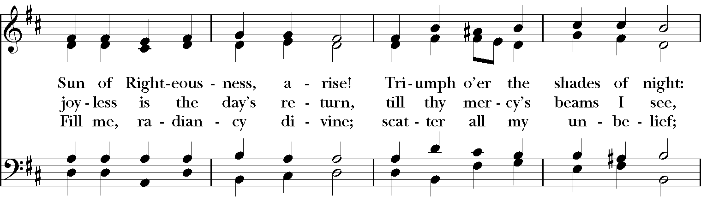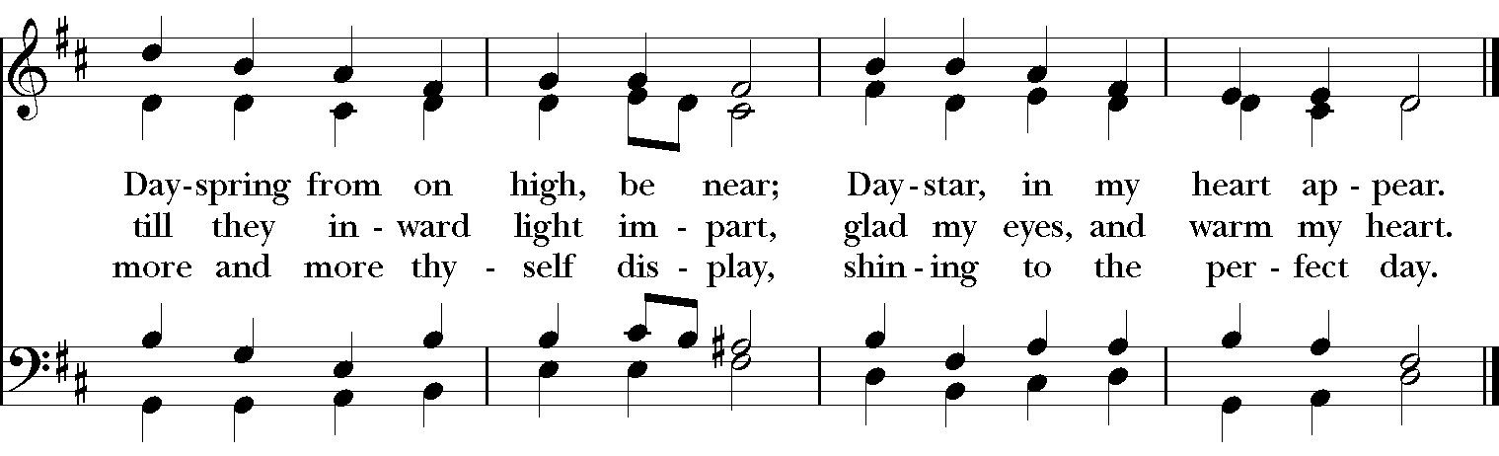

Celebrant: Blessed be God: Father, Son, and Holy Spirit.
People: And blessed be his kingdom, now and for ever. Amen.

The Collect of the Day
Celebrant: The Lord be with you.
People: And also with you.
Celebrant: Let us pray.
Lord, we pray that your grace may always precede and follow us, that we may continually be given to good works; through Jesus Christ our Lord, who lives and reigns with you and the Holy Spirit, one God, now and for ever. Amen.

THE LESSONS
THE FIRST READING Amos 5:6-7, 10-15

Seek the Lord and live,
or he will break out against the house of Joseph like fire,
and it will devour Bethel, with no one to quench it.
Ah, you that turn justice to wormwood,
and bring righteousness to the ground!

They hate the one who reproves in the gate,
and they abhor the one who speaks the truth.
Therefore, because you trample on the poor
and take from them levies of grain,
you have built houses of hewn stone,
but you shall not live in them;
you have planted pleasant vineyards,
but you shall not drink their wine.
For I know how many are your transgressions,
and how great are your sins—
you who afflict the righteous, who take a bribe,
and push aside the needy in the gate.
Therefore the prudent will keep silent in such a time;
for it is an evil time.

Seek good and not evil,
that you may live;
and so the Lord, the God of hosts, will be with you,
just as you have said.
Hate evil and love good,
and establish justice in the gate;
it may be that the Lord, the God of hosts,
will be gracious to the remnant of Joseph.
Lector: The Word of the Lord.
People: Thanks be to God.

PSALM 90:12-17 Domine, refugium
12 So teach us to number our days *
that we may apply our hearts to wisdom.
13 Return, O Lord; how long will you tarry? *
be gracious to your servants.
14 Satisfy us by your loving-kindness in the morning; *
so shall we rejoice and be glad all the days of our life.
15 Make us glad by the measure of the days that you afflicted us *
and the years in which we suffered adversity.
16 Show your servants your works *
and your splendor to their children.
17 May the graciousness of the Lord our God be upon us; *
prosper the work of our hands; prosper our handiwork.

THE SECOND LESSON Hebrews 4:12-16
The word of God is living and active, sharper than any two-edged sword, piercing until it divides soul from spirit, joints from marrow; it is able to judge the thoughts and intentions of the heart. And before him no creature is hidden, but all are naked and laid bare to the eyes of the one to whom we must render an account.

Since, then, we have a great high priest who has passed through the heavens, Jesus, the Son of God, let us hold fast to our confession. For we do not have a high priest who is unable to sympathize with our weaknesses, but we have one who in every respect has been tested as we are, yet without sin. Let us therefore approach the throne of grace with boldness, so that we may receive mercy and find grace to help in time of need.
Lector: The Word of the Lord.
People: Thanks be to God.
SQUENCE HYMN: “Take my life and let it be” Hymnal 707
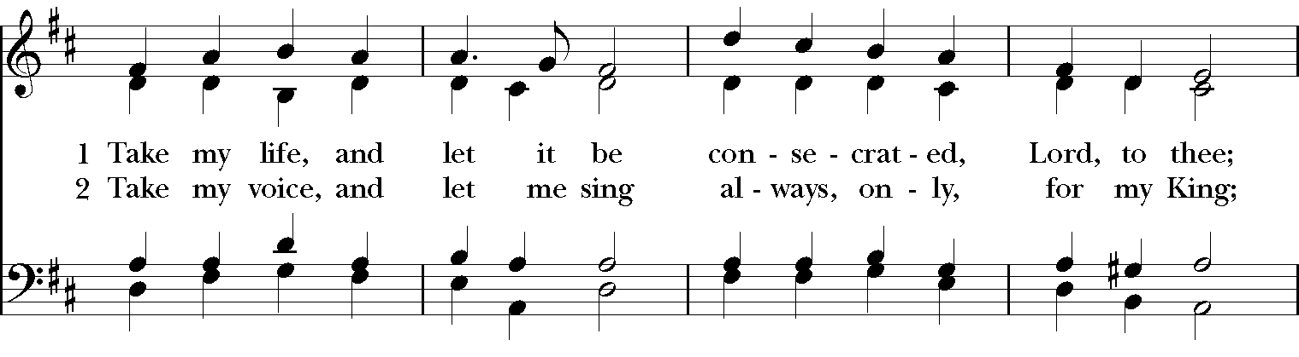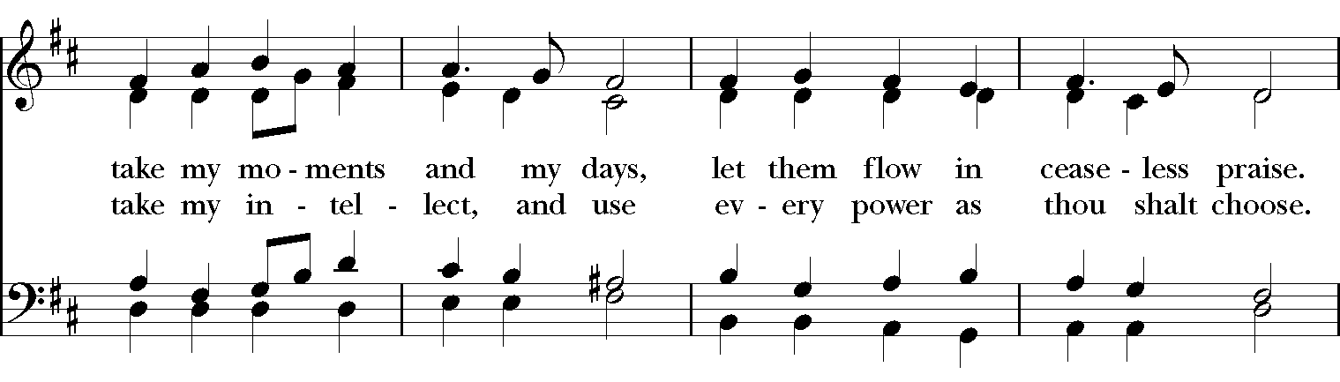
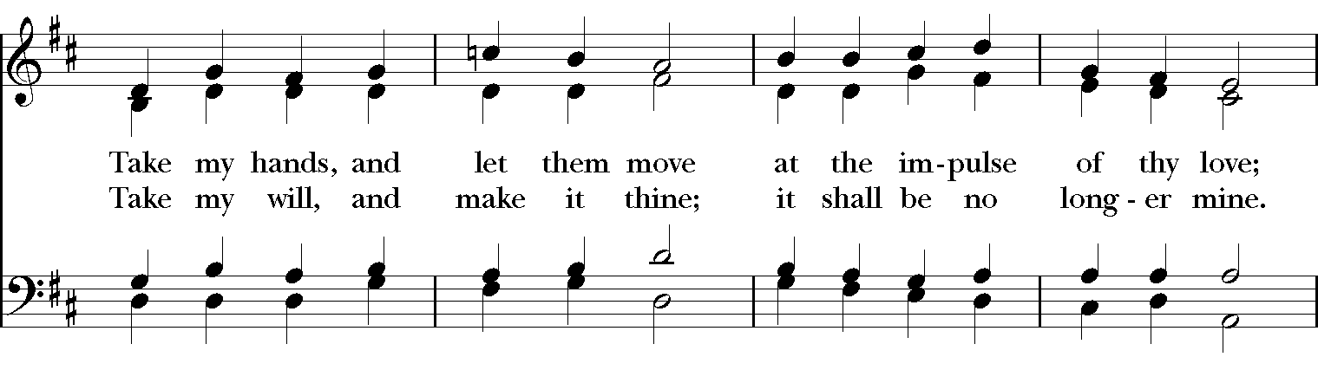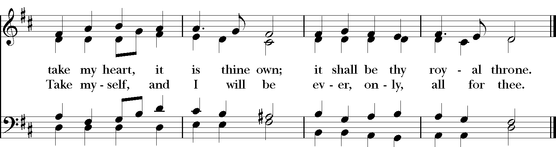
GOSPEL
Celebrant: The Holy Gospel of our Lord Jesus Christ according to Mark (Mark 10:17-31).
People: Glory to you, Lord Christ.
As Jesus was setting out on a journey, a man ran up and knelt before him, and asked him, “Good Teacher, what must I do to inherit eternal life?” Jesus said to him, “Why do you call me good? No one is good but God alone. You know the commandments: ‘You shall not murder; You shall not commit adultery; You shall not steal; You shall not bear false witness; You shall not defraud; Honor your father and mother.’” He said to him, “Teacher, I have kept all these since my youth.” Jesus, looking at him, loved him and said, “You lack one thing; go, sell what you own, and give the money to the poor, and you will have treasure in heaven; then come, follow me.” When he heard this, he was shocked and went away grieving, for he had many possessions.

Then Jesus looked around and said to his disciples, “How hard it will be for those who have wealth to enter the kingdom of God!” And the disciples were perplexed at these words. But Jesus said to them again, “Children, how hard it is to enter the kingdom of God! It is easier for a camel to go through the eye of a needle than for someone who is rich to enter the kingdom of God.” They were greatly astounded and said to one another, “Then who can be saved?” Jesus looked at them and said, “For mortals it is impossible, but not for God; for God all things are possible.”

Peter began to say to him, “Look, we have left everything and followed you.” Jesus said, “Truly I tell you, there is no one who has left house or brothers or sisters or mother or father or children or fields, for my sake and for the sake of the good news, who will not receive a hundredfold now in this age—houses, brothers and sisters, mothers and children, and fields with persecutions—and in the age to come eternal life. But many who are first will be last, and the last will be first.”

Celebrant: The Gospel of the Lord.
People: Praise to you, Lord Christ.

Sermon The Rev. Canon Dr. Lee Anne Reat

The Nicene Creed
We believe in one God, the Father, the Almighty,
maker of heaven and earth, of all that is, seen and unseen.
We believe in one Lord, Jesus Christ, the only Son of God,
eternally begotten of the Father, God from God,
Light from Light, true God from true God,
begotten, not made, of one Being with the Father.
Through him all things were made.
For us and for our salvation he came down from heaven,
by the power of the Holy Spirit he became incarnate from the Virgin Mary,
and was made man.
For our sake he was crucified under Pontius Pilate;
he suffered death and was buried.
On the third day he rose again in accordance with the Scriptures;
he ascended into heaven and is seated at the right hand of the Father.
He will come again in glory to judge the living and the dead, and his kingdom will have no end.
We believe in the Holy Spirit, the Lord, the giver of life,
who proceeds from the Father, and the Son.
With the Father and the Son he is worshiped and glorified,
he has spoken through the Prophets.
We believe in one holy catholic and apostolic Church.
We acknowledge one baptism for the forgiveness of sins.
We look for the resurrection of the dead, and the life of the world to come. Amen.

THE PRAYERS OF THE PEOPLE

In peace, we pray to you Lord God. Congregational responses are in bold.
Silence

Giver of every good gift, we thank you for your generosity in giving us more than we can ask or imagine.

Give grace to church leaders, especially Justin, Archbishop of Canterbury; Michael, our presiding bishop; Wayne, our provisional diocesan bishop; Lee Anne, our priest; and members of the vestry. In your time, send us the priest this church needs.
R: Giver of every good gift, grant grace.

Give wisdom to world leaders in a time of pandemic and natural disasters. Give special grace to refugees and those seeking justice.
R: Giver of every good gift, grant wisdom.

Give hope to those suffering any illness or affliction, especially Leigh, Charlene, Faye, Chris, Bonnie, Alice, Diana, James, Joy, Jane, Joni, Kim, Bobby, Sarah, Traudie, Lexie, and Keith.
R: Giver of every good gift, grant hope.

Give strength to those laboring in the ministries we support as a church especially Rainbow Table, Springfield Promise Neighborhood, Springfield Peace Center, Partners in Ministry in Liberia.
R: Giver of every good gift, grant strength.

Give joy to those celebrating anniversaries this week, especially Dan & Judy.
R: Giver of every good gift, grant joy.

Grant peace and light to those who have died and comfort to those who grieve.
R: Giver of every good gift, in the midst of loss grant hope.

*THE COLLECT FOR PEACE
Grant, O God, that your holy and life-giving Spirit may so move every human heart, that barriers which divide us may crumble, suspicions disappear, and hatreds cease; that our divisions being healed, we may live in justice and peace; through Jesus Christ our Lord. Amen.

THE CONFESSION AND ABSOLUTION
Priest: Let us confess our sins against God and our neighbor.
All: Most merciful God, we confess that we have sinned against you in thought, word, and deed, by what we have done, and by what we have left undone. We have not loved you with our whole heart; we have not loved our neighbors as ourselves. We are truly sorry and we humbly repent. For the sake of your Son Jesus Christ, have mercy on us and forgive us; that we may delight in your will, and walk in your ways, to the glory of your Name. Amen.

Priest: Almighty God, have mercy on you, forgive you all your sins through our Lord Jesus Christ, strengthen you in all goodness, and by the power of the Holy Spirit keep you in eternal life. Amen.

And now, as our Savior Christ has taught us, we are bold to say:
Our Father, who art in heaven, hallowed be thy Name,
thy kingdom come, thy will be done, on earth as it is in heaven.
Give us this day our daily bread.
And forgive us our trespasses, as we forgive those who trespass against us.
And lead us not into temptation, but deliver us from evil.
For thine is the kingdom, and the power, and the glory, for ever and ever. Amen
Closing Hymn: “Come my way, my Truth , my Life” Hymnal 487

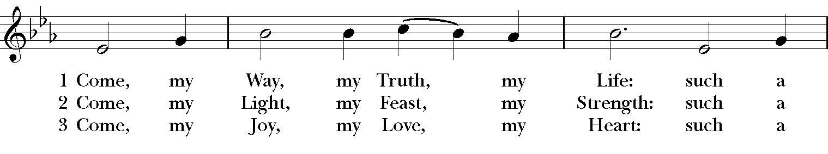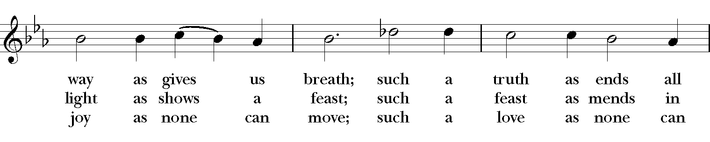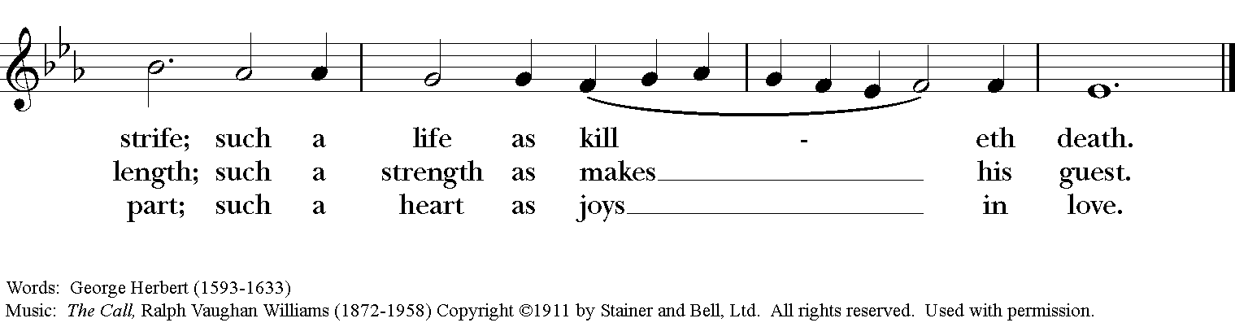

*THE BLESSING
Christ who has nourished us with himself the living bread, make you one in praise and love, and raise you up at the last day; and the blessing God Almighty, the Father, the Son, and the Holy Spirit, be among you, and remain with you always. Amen.

ANNOUNCEMENTS

*THE DISMISSAL Celebrant: Go in peace to love and serve the Lord.
People: Thanks be to God.
POSTLUDE: “Andante” from Sonata in C Major K545 - Mozart
Thank you for your spiritual presence with us this morning!
Although we're physically apart, we are united in prayer, worship, and holy love!
Priest-In-Charge: The Rev. Dr. Canon Lee Anne Reat
Music Director: Dr. Chris Durrenberger
Lector: Liz Wheeler
Singers: Liz Wheeler, Joy Carter, Basil Fett, Chris Oldstone-Moore, and Fred Bartenstein
Technology: Steve Ide
Slideshow: Ed Hasecke
Parish Administrator and Program Coordinator: Kelly Zeller

