Christ Episcopal Church in Springfield, Ohio
Service of the Word
October 11th, 2020 at 9 am: Nineteenth Sunday after Pentecost
Note: We invite you to light a candle on your table or home altar before worship begins.

Prelude:

Opening Hymn: “Chris, Whose Glory Fills the Skies” Hymnal 7
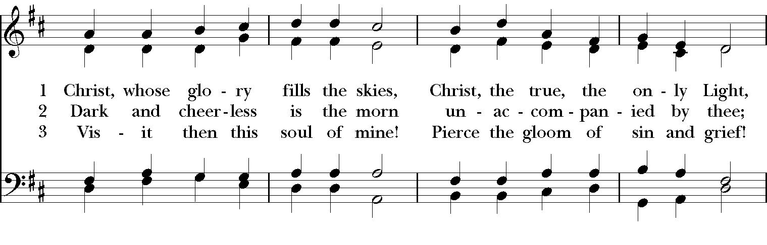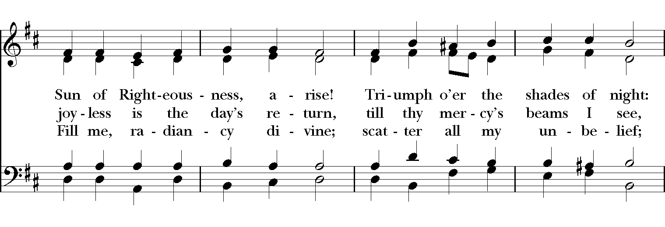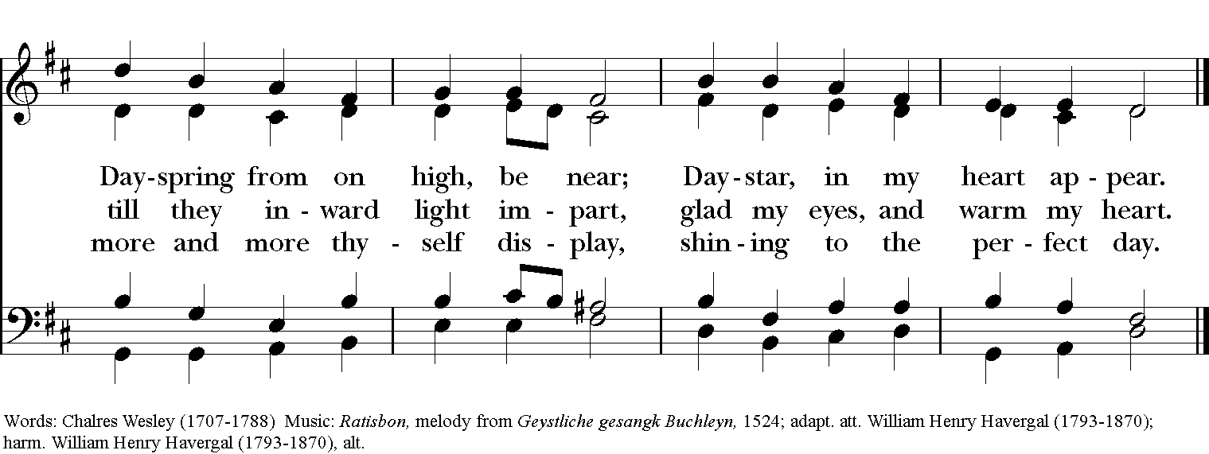

Celebrant: Blessed be God: Father, Son, and Holy Spirit.
People: And blessed be God’s kingdom, now and for ever. Amen.

Celebrant: Lord, have mercy.
People: Christ, have mercy.
Celebrant: Lord, have mercy.
The Collect of the Day

Celebrant: The Lord be with you.
People: And also with you.
Celebrant: Let us pray.

Lord, we pray that your grace may always precede and follow us, that we may continually be given to good works; through Jesus Christ our Lord, who lives and reigns with you and the Holy Spirit, one God, now and for ever. Amen.

The Lessons

The First Reading: Exodus 32:1-14
When the people saw that Moses delayed to come down from the mountain, the people gathered around Aaron, and said to him, “Come, make gods for us, who shall go before us; as for this Moses, the man who brought us up out of the land of Egypt, we do not know what has become of him.” Aaron said to them, “Take off the gold rings that are on the ears of your wives, your sons, and your daughters, and bring them to me.” So all the people took off the gold rings from their ears, and brought them to Aaron. He took the gold from them, formed it in a mold, and cast an image of a calf; and they said, “These are your gods, O Israel, who brought you up out of the land of Egypt!” When Aaron saw this, he built an altar before it; and Aaron made proclamation and said, “Tomorrow shall be a festival to the Lord.” They rose early the next day, and offered burnt offerings and brought sacrifices of well-being; and the people sat down to eat and drink, and rose up to revel.
The Lord said to Moses, “Go down at once! Your people, whom you brought up out of the land of Egypt, have acted perversely; they have been quick to turn aside from the way that I commanded them; they have cast for themselves an image of a calf, and have worshiped it and sacrificed to it, and said, ‘These are your gods, O Israel, who brought you up out of the land of Egypt!’” The Lord said to Moses, “I have seen this people, how stiff-necked they are. Now let me alone, so that my wrath may burn hot against them and I may consume them; and of you I will make a great nation.”
But Moses implored the Lord his God, and said, “O Lord, why does your wrath burn hot against your people, whom you brought out of the land of Egypt with great power and with a mighty hand? Why should the Egyptians say, ‘It was with evil intent that he brought them out to kill them in the mountains, and to consume them from the face of the earth’? Turn from your fierce wrath; change your mind and do not bring disaster on your people. Remember Abraham, Isaac, and Israel, your servants, how you swore to them by your own self, saying to them, ‘I will multiply your descendants like the stars of heaven, and all this land that I have promised I will give to your descendants, and they shall inherit it forever.’” And the Lord changed his mind about the disaster that he planned to bring on his people.

Reader: The Word of the Lord.
People: Thanks be to God.

Psalm 106:1-6, 19-23 Confitemini Domino, Et fecerunt vitulum

1 Hallelujah!
Give thanks to the Lord, for he is good, *
for his mercy endures for ever.

2 Who can declare the mighty acts of the Lord *
or show forth all his praise?

3 Happy are those who act with justice *
and always do what is right!

4 Remember me, O Lord, with the favor you have for your people, *
and visit me with your saving help;

5 That I may see the prosperity of your elect
and be glad with the gladness of your people, *
that I may glory with your inheritance.

6 We have sinned as our forebears did; *
we have done wrong and dealt wickedly.

19 Israel made a bull-calf at Horeb *
and worshiped a molten image;

20 And so they exchanged their Glory *
for the image of an ox that feeds on grass.

21 They forgot God their Savior, *
who had done great things in Egypt,

22 Wonderful deeds in the land of Ham, *
and fearful things at the Red Sea.

23 So he would have destroyed them,
had not Moses his chosen stood before him in the breach, *
to turn away his wrath from consuming them.

Second Lesson: Philippians 4:1-9
My brothers and sisters, whom I love and long for, my joy and crown, stand firm in the Lord in this way, my beloved.
I urge Euodia and I urge Syntyche to be of the same mind in the Lord. Yes, and I ask you also, my loyal companion, help these women, for they have struggled beside me in the work of the gospel, together with Clement and the rest of my co-workers, whose names are in the book of life.
Rejoice in the Lord always; again I will say, Rejoice. Let your gentleness be known to everyone. The Lord is near. Do not worry about anything, but in everything by prayer and supplication with thanksgiving let your requests be made known to God. And the peace of God, which surpasses all understanding, will guard your hearts and your minds in Christ Jesus.
Finally, beloved, whatever is true, whatever is honorable, whatever is just, whatever is pure, whatever is pleasing, whatever is commendable, if there is any excellence and if there is anything worthy of praise, think about these things. Keep on doing the things that you have learned and received and heard and seen in me, and the God of peace will be with you.

Reader: The Word of the Lord.
People: Thanks be to God.

Sequence Hymn: “O For a closer walk with God” Hymnal 683
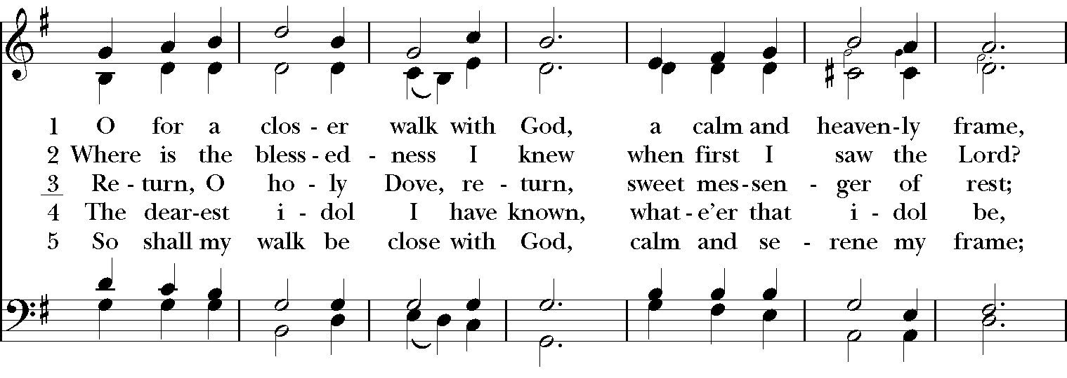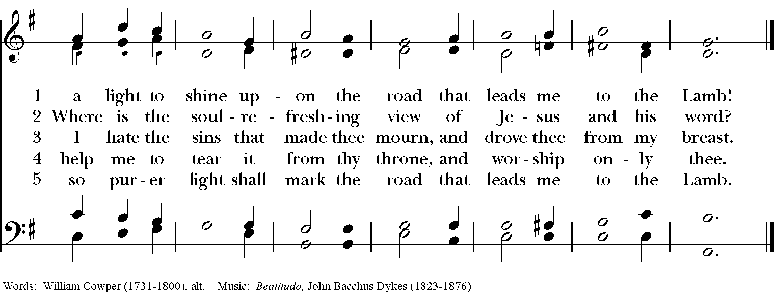

Gospel
Deacon: The Holy Gospel According to Matthew (22:1-14)
People: Glory to you, Lord Christ.
Once more Jesus spoke to the people in parables, saying: “The kingdom of heaven may be compared to a king who gave a wedding banquet for his son. He sent his slaves to call those who had been invited to the wedding banquet, but they would not come. Again he sent other slaves, saying, ‘Tell those who have been invited: Look, I have prepared my dinner, my oxen and my fat calves have been slaughtered, and everything is ready; come to the wedding banquet.’ But they made light of it and went away, one to his farm, another to his business, while the rest seized his slaves, mistreated them, and killed them. The king was enraged. He sent his troops, destroyed those murderers, and burned their city. Then he said to his slaves, ‘The wedding is ready, but those invited were not worthy. Go therefore into the main streets, and invite everyone you find to the wedding banquet.’ Those slaves went out into the streets and gathered all whom they found, both good and bad; so the wedding hall was filled with guests.
“But when the king came in to see the guests, he noticed a man there who was not wearing a wedding robe, and he said to him, ‘Friend, how did you get in here without a wedding robe?’ And he was speechless. Then the king said to the attendants, ‘Bind him hand and foot, and throw him into the outer darkness, where there will be weeping and gnashing of teeth.’ For many are called, but few are chosen.”
Deacon: The Gospel of the Lord.
People: Praise to you, Lord Christ.

Today’s reflection is a stewardship video

The Nicene Creed

We believe in one God,
the Father, the Almighty,
the maker of heaven and earth,
of all that is, seen and unseen.
We believe in one Lord, Jesus Christ,
the only Son of God,
eternally begotten of the Father,
God from God, Light from Light,
true God from true God,
begotten, not made,
of one Being with the Father.
Through him all things were made.
For us and for our salvation
he came down from heaven:
by the power of the Holy Spirit
he became incarnate from the Virgin Mary,
and was made man.
For our sake he was crucified under Pontius Pilate;
he suffered death and was buried.
On the third day he rose again
in accordance with the Scriptures;
He ascended into heaven
and is seated on the right hand of the Father.
He will come again in glory to judge the living and the dead,
and his kingdom will have no end.

We believe in the Holy Spirit, the Lord, the giver of life,
who proceeds from the Father and the Son.
With the Father and the Son he is worshiped and glorified.
He has spoken through the Prophets.
We believe in one holy catholic and apostolic Church.
We acknowledge one baptism for the forgiveness of sins.
We look for the resurrection of the dead,
and the life of the world to come. Amen.

The Prayers of the People

In peace, we pray to you Lord God.

Silence

For all people in their daily life and work; especially Rainbow Table, Springfield Promise Neighborhood, Springfield Peace Center, Partners in Ministry in Liberia.
For our families, friends, and neighbors, and for those who are alone.

For this community, the nation, and the world;
For all who work for justice, freedom, and peace.

For the just and proper use of your creation;
For the victims of hunger, fear, injustice, and oppression.

For all who are in danger, sorrow, or any kind of trouble;
For those who minister to the sick, the friendless, and the needy.

For the peace and unity of the Church of God;
For all who proclaim the Gospel, and all who seek the Truth.

For Michael, our Presiding Bishop, and Thomas, our Bishop; and all bishops and other ministers;
For all who serve God in his Church.

For the special needs and concerns of this congregation.
Laura, Bonnie, Alice, Joy, Diana, James, Joy, Jane, Joni, Kim, Bobby, Ruth, Sarah, Traudie, Lexie, Norm, and Keith.
May they remember that you are with them and those who care for them.

We than you, Lord, for all the blessings of this life, especially the birthdays of
Rosetta, Juanita, and Lexie; and anniversaries Jamie & Cameron.

We will exalt you, O God our King;
And praise your Name for ever and ever.

We pray for all who have died, that they may have a place in your eternal kingdom.

Lord, let your loving kindness be upon them;
Who put their trust in you.

We pray to you also for the forgiveness of our sins.
Have mercy upon us, most merciful Father;
in your compassion forgive us our sins,
known and unknown,
things done and left undone;
and so uphold us by your Spirit
that we may live and serve you in newness of life,
to the honor and glory of your Name;
through Jesus Christ our Lord. Amen.

Priest: Almighty God, have mercy on you, forgive you all your sins through our Lord Jesus Christ, strengthen you in all goodness, and by the power of the Holy Spirit keep you in eternal life. Amen.

And now, as our Savior Christ has taught us, we are bold to say:

Our Father, who art in heaven, hallowed be thy Name,
thy kingdom come, thy will be done, on earth as it is in heaven.
Give us this day our daily bread.
And forgive us our trespasses, as we forgive those who trespass against us.
And lead us not into temptation, but deliver us from evil.
For thine is the kingdom, and the power, and the glory, for ever and ever. Amen.
Closing Hymn: “Come my way, my Truth , my Life” Hymnal 487

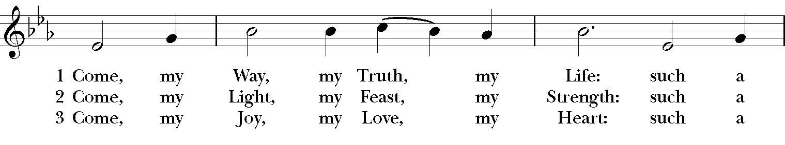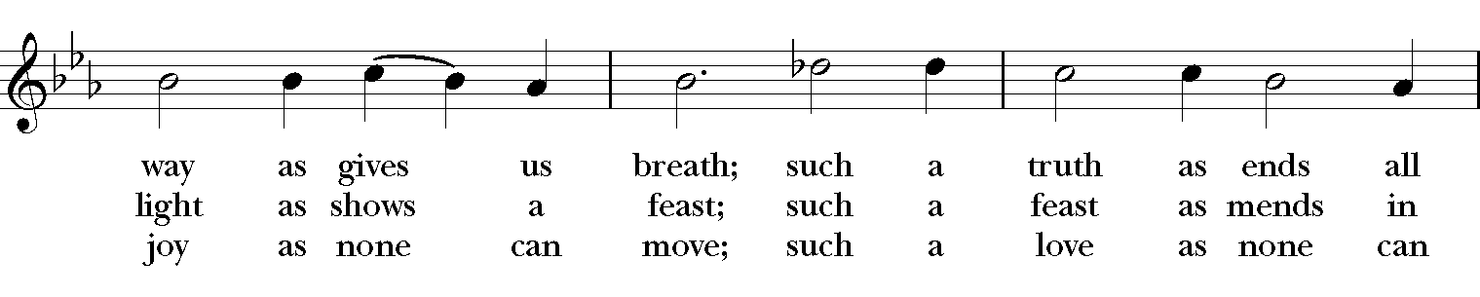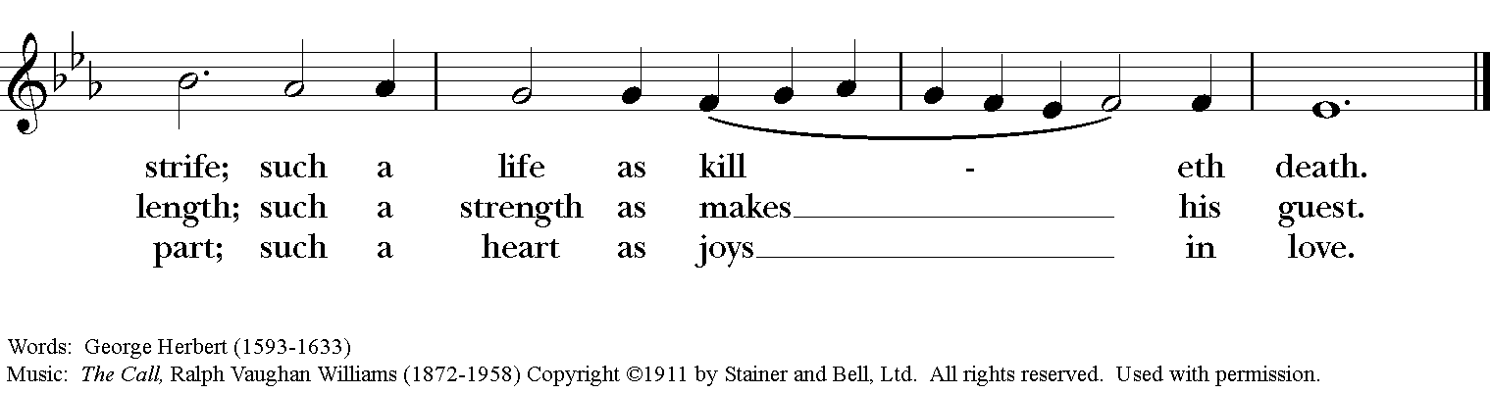

Blessing
May the Spirit of truth lead you into all truth, giving you grace to confess that Jesus Christ is Lord, and to proclaim the wonderful works of God; And the blessing of God Almighty, the Fa- ther, the Son, and the Holy Spirit, be among you, and remain with you always. Amen.
Announcements
Dismissal
Deacon: Go in peace to love and serve the Lord.
People: Thanks be to God!
Postlude:

Thank you for your spiritual presence with us this morning!
Although we're physically apart, we are united in prayer, worship, and holy love!

Transition Priest-In-Charge: The Rev. Dr. Canon Lee Anne Reat
Deacon: The Rev. Dr. Rick Incorvati
Music Director: Dr. Chris Durrenberger
Lector: Liz Wheeler
Singers: Liz Wheeler, Joy Carter, Ed Hasecke, Fred Bartenstein
Technology: Steve Ide
Slideshow: Ed Hasecke
Parish Administrator and Program Coordinator: Kelly Zeller
Coffee Hour Host: Ron Dowling

