Christ Episcopal Church in Springfield, Ohio
Service of the Word
October 18th, 2020 at 9 am: Twentieth Sunday after Pentecost
Note: We invite you to light a candle on your table or home altar before worship begins.

Prelude:

Opening Hymn: “Rock of Ages” Hymnal 685
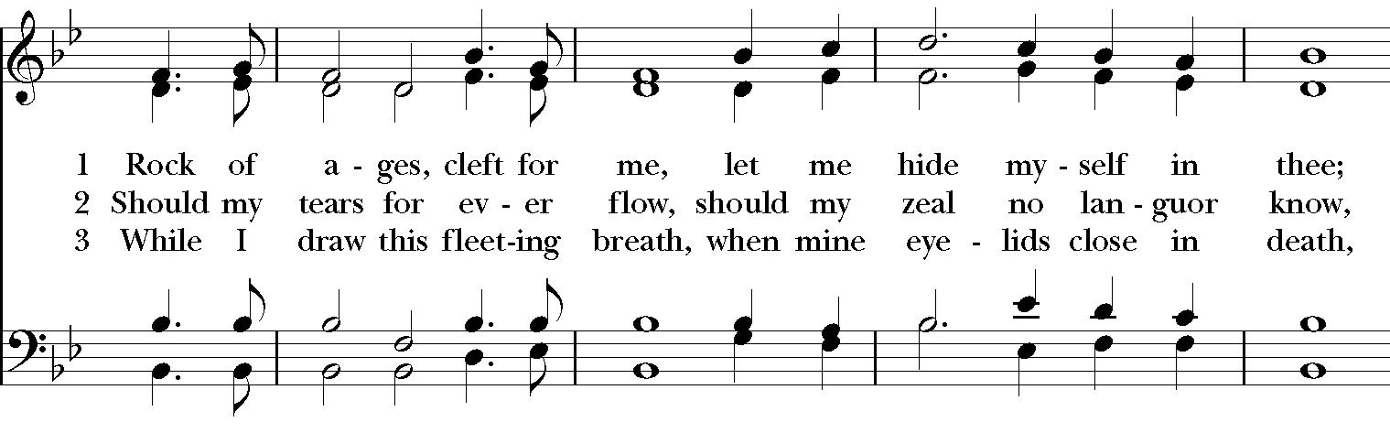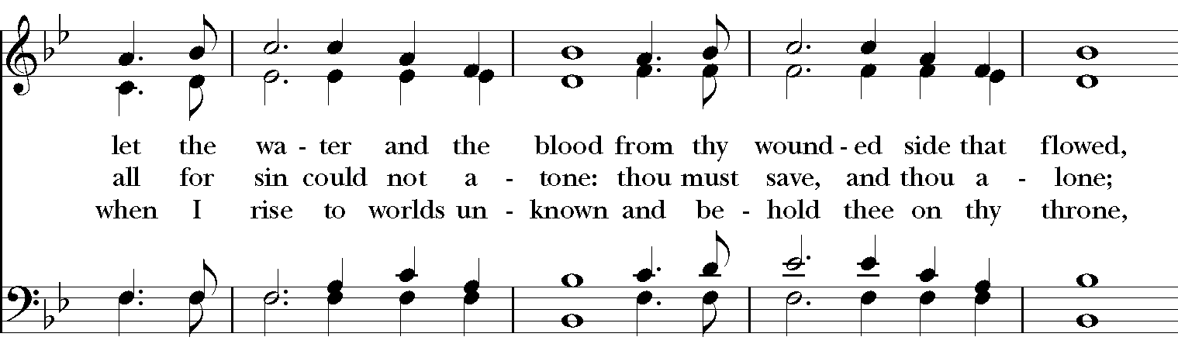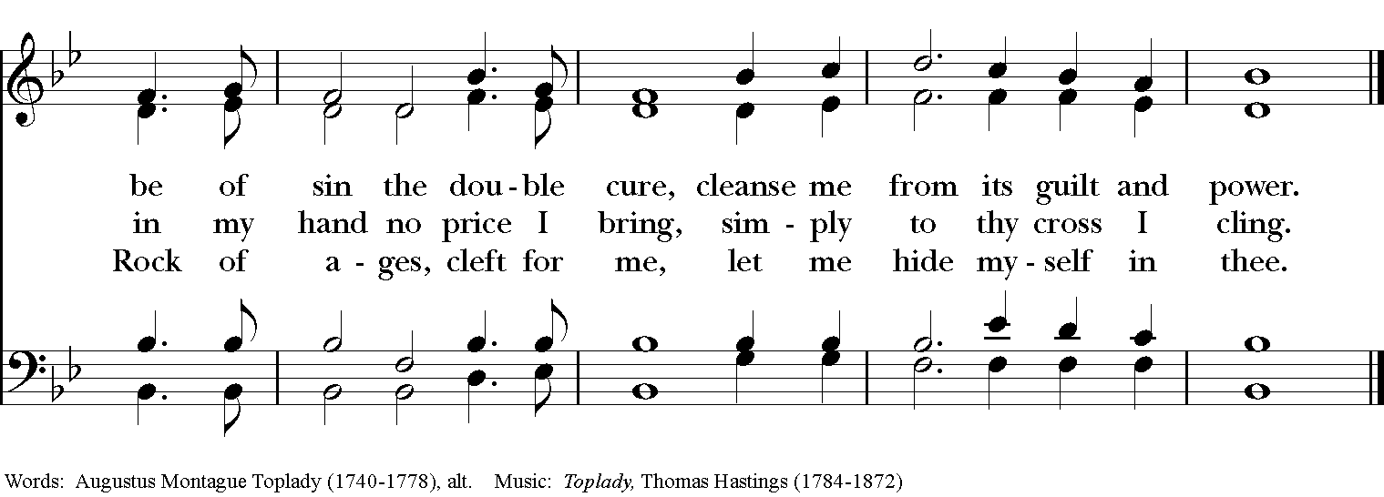

Celebrant: Blessed be God: Father, Son, and Holy Spirit.
People: And blessed be God’s kingdom, now and for ever. Amen.

Celebrant: Lord, have mercy.
People: Christ, have mercy.
Celebrant: Lord, have mercy.

The Collect of the Day

Celebrant: The Lord be with you.
People: And also with you.
Celebrant: Let us pray.

Almighty and everlasting God, in Christ you have revealed your glory among the nations: Preserve the works of your mercy, that your Church throughout the world may persevere with steadfast faith in the confession of your Name; through Jesus Christ our Lord, who lives and reigns with you and the Holy Spirit, one God, for ever and ever. Amen.

The Lessons

The First Reading: Exodus 33:12-23
Moses said to the Lord, “See, you have said to me, ‘Bring up this people’; but you have not let me know whom you will send with me. Yet you have said, ‘I know you by name, and you have also found favor in my sight.’ Now if I have found favor in your sight, show me your ways, so that I may know you and find favor in your sight. Consider too that this nation is your people.” He said, “My presence will go with you, and I will give you rest.” And he said to him, “If your presence will not go, do not carry us up from here. For how shall it be known that I have found favor in your sight, I and your people, unless you go with us? In this way, we shall be distinct, I and your people, from every people on the face of the earth.”
The Lord said to Moses, “I will do the very thing that you have asked; for you have found favor in my sight, and I know you by name.” Moses said, “Show me your glory, I pray.” And he said, “I will make all my goodness pass before you, and will proclaim before you the name, ‘The Lord’; and I will be gracious to whom I will be gracious, and will show mercy on whom I will show mercy. But,” he said, “you cannot see my face; for no one shall see me and live.” And the Lord continued, “See, there is a place by me where you shall stand on the rock; and while my glory passes by I will put you in a cleft of the rock, and I will cover you with my hand until I have passed by; then I will take away my hand, and you shall see my back; but my face shall not be seen.”

Reader: The Word of the Lord.
People: Thanks be to God.

Psalm 99 Dominus regnavit

1 The Lord is King; let the people tremble; *
he is enthroned upon the cherubim;let the earth shake.

2 The Lord is great in Zion; *
he is high above all peoples.

3 Let them confess his Name, which is great and awesome; *
he is the Holy One.

4 "O mighty King, lover of justice, you have established equity; *
you have executed justice and righteousness in Jacob."

5 Proclaim the greatness of the Lord our God and fall down before his footstool; *
he is the Holy One.

6 Moses and Aaron among his priests, and Samuel among those who call upon his Name, *
they called upon the Lord, and he answered them.

7 He spoke to them out of the pillar of cloud; *
they kept his testimonies and the decree that he gave them.

8 O Lord our God, you answered them indeed; *
you were a God who forgave them, yet punished them for their evil deeds.

9 Proclaim the greatness of the Lord our God and worship him upon his holy hill; *
for the Lord our God is the Holy One.

Second Lesson: 1 Thessalonians 1:1-10

Paul, Silvanus, and Timothy, To the church of the Thessalonians in God the Father and the Lord Jesus Christ:

Grace to you and peace.

We always give thanks to God for all of you and mention you in our prayers, constantly remembering before our God and Father your work of faith and labor of love and steadfastness of hope in our Lord Jesus Christ. For we know, brothers and sisters beloved by God, that he has chosen you, because our message of the gospel came to you not in word only, but also in power and in the Holy Spirit and with full conviction; just as you know what kind of persons we proved to be among you for your sake. And you became imitators of us and of the Lord, for in spite of persecution you received the word with joy inspired by the Holy Spirit, so that you became an example to all the believers in Macedonia and in Achaia. For the word of the Lord has sounded forth from you not only in Macedonia and Achaia, but in every place your faith in God has become known, so that we have no need to speak about it. For the people of those regions report about us what kind of welcome we had among you, and how you turned to God from idols, to serve a living and true God, and to wait for his Son from heaven, whom he raised from the dead-- Jesus, who rescues us from the wrath that is coming.

Reader: The Word of the Lord.
People: Thanks be to God.

Sequence Hymn: “Nearer, My God, to Thee” Hymnal LEVAS II 54
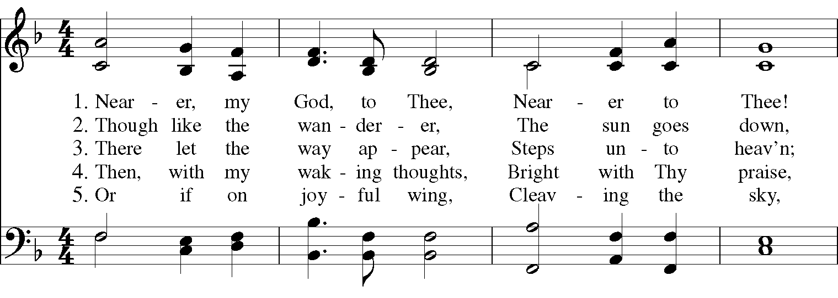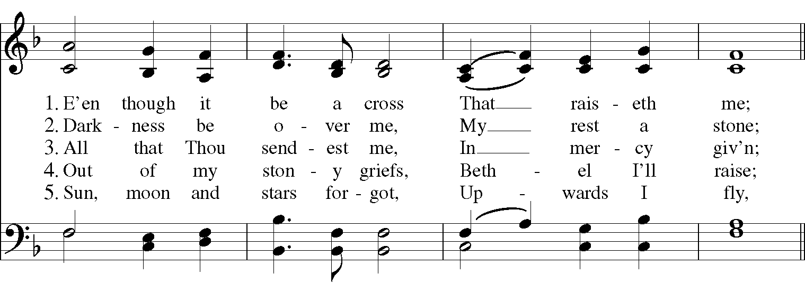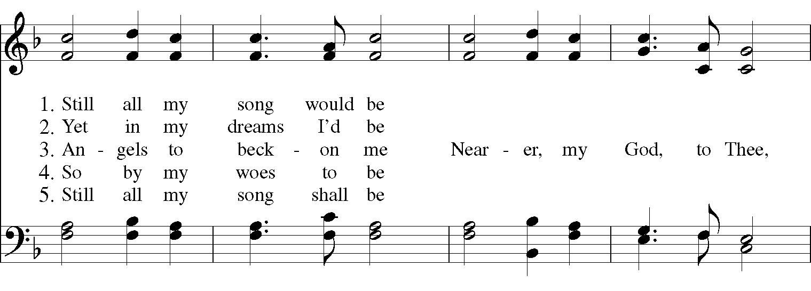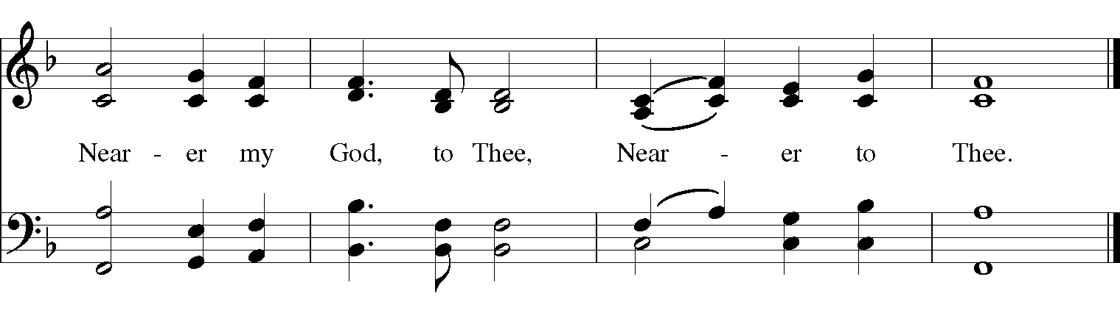

Gospel

Deacon: The Holy Gospel According to Matthew (22:15-22)
People: Glory to you, Lord Christ.
The Pharisees went and plotted to entrap Jesus in what he said. So they sent their disciples to him, along with the Herodians, saying, “Teacher, we know that you are sincere, and teach the way of God in accordance with truth, and show deference to no one; for you do not regard people with partiality. Tell us, then, what you think. Is it lawful to pay taxes to the emperor, or not?” But Jesus, aware of their malice, said, “Why are you putting me to the test, you hypocrites? Show me the coin used for the tax.” And they brought him a denarius. Then he said to them, “Whose head is this, and whose title?” They answered, “The emperor’s.” Then he said to them, “Give therefore to the emperor the things that are the emperor’s, and to God the things that are God’s.” When they heard this, they were amazed; and they left him and went away.

Deacon: The Gospel of the Lord.
People: Praise to you, Lord Christ.

A reflection on the Scripture is offered by Pastor Ernest Brown

The Nicene Creed
We believe in one God,
the Father, the Almighty,
the maker of heaven and earth,
of all that is, seen and unseen.
We believe in one Lord, Jesus Christ,
the only Son of God,
eternally begotten of the Father,
God from God, Light from Light,
true God from true God,
begotten, not made,
of one Being with the Father.
Through him all things were made.
For us and for our salvation
he came down from heaven:
by the power of the Holy Spirit
he became incarnate from the Virgin Mary,
and was made man.
For our sake he was crucified under Pontius Pilate;
he suffered death and was buried.
On the third day he rose again
in accordance with the Scriptures;
He ascended into heaven
and is seated on the right hand of the Father.
He will come again in glory to judge the living and the dead,
and his kingdom will have no end.

We believe in the Holy Spirit, the Lord, the giver of life,
who proceeds from the Father and the Son.
With the Father and the Son he is worshiped and glorified.
He has spoken through the Prophets.
We believe in one holy catholic and apostolic Church.
We acknowledge one baptism for the forgiveness of sins.
We look for the resurrection of the dead,
and the life of the world to come. Amen.

The Prayers of the People

In peace, we pray to you Lord God.

Silence

For all people in their daily life and work; especially Children’s Rescue Center/The Ark, Christ Church Food Pantry, The Fuller Center for Housing, and Safe Harbor House.
For our families, friends, and neighbors, and for those who are alone.

For this community, the nation, and the world;
For all who work for justice, freedom, and peace.

For the just and proper use of your creation;
For the victims of hunger, fear, injustice, and oppression.

For all who are in danger, sorrow, or any kind of trouble;
For those who minister to the sick, the friendless, and the needy.

For the peace and unity of the Church of God;
For all who proclaim the Gospel, and all who seek the Truth.

For Michael, our Presiding Bishop, and Thomas, our Bishop; and all bishops and other ministers;
For all who serve God in his Church.

For the special needs and concerns of this congregation.
Laura, Bonnie, Alice, Joy, Diana, James, Joy, Jane, Joni, Kim, Bobby, Ruth, Sarah, Traudie, Lexie, Norm, and Keith.
May they remember that you are with them and those who care for them.
We than you, Lord, for all the blessings of this life, especially the birthdays of
Anne, Joan, Sophie, and Ann; and anniversaries Don & Liz.

We will exalt you, O God our King;
And praise your Name for ever and ever.

We pray for all who have died, that they may have a place in your eternal kingdom.

Lord, let your loving kindness be upon them;
Who put their trust in you.

We pray to you also for the forgiveness of our sins.
Have mercy upon us, most merciful Father;
in your compassion forgive us our sins,
known and unknown,
things done and left undone;
and so uphold us by your Spirit
that we may live and serve you in newness of life,
to the honor and glory of your Name;
through Jesus Christ our Lord. Amen.

Priest: Almighty God, have mercy on you, forgive you all your sins through our Lord Jesus Christ, strengthen you in all goodness, and by the power of the Holy Spirit keep you in eternal life. Amen.

And now, as our Savior Christ has taught us, we are bold to say:

Our Father, who art in heaven, hallowed be thy Name,
thy kingdom come, thy will be done, on earth as it is in heaven.
Give us this day our daily bread.
And forgive us our trespasses, as we forgive those who trespass against us.
And lead us not into temptation, but deliver us from evil.
For thine is the kingdom, and the power, and the glory, for ever and ever. Amen.

Closing Hymn: “Jesus Shall Reign” Hymnal 544
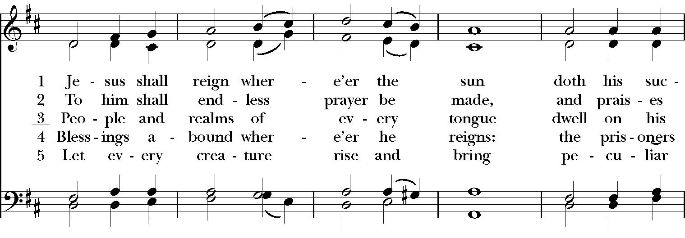

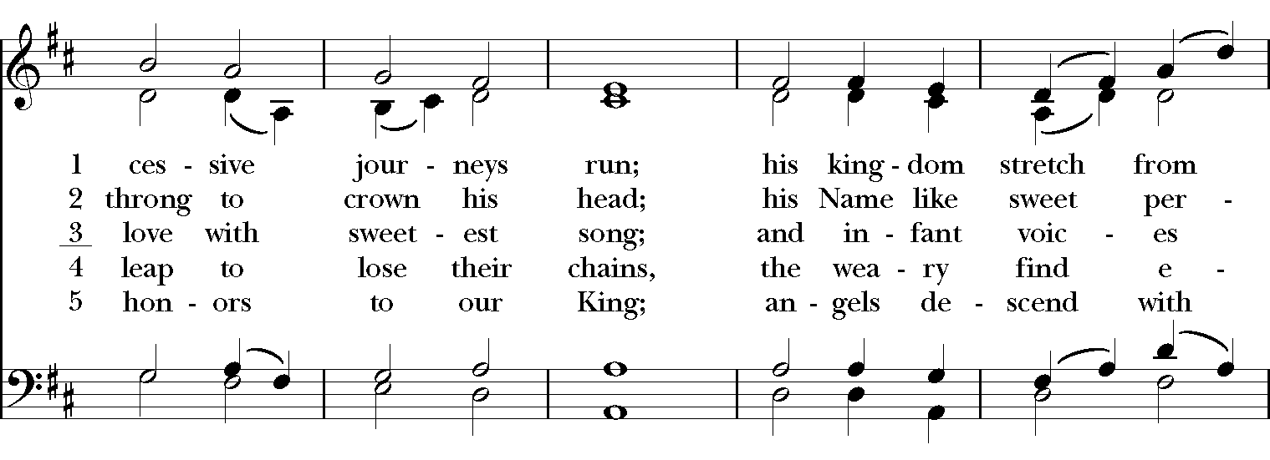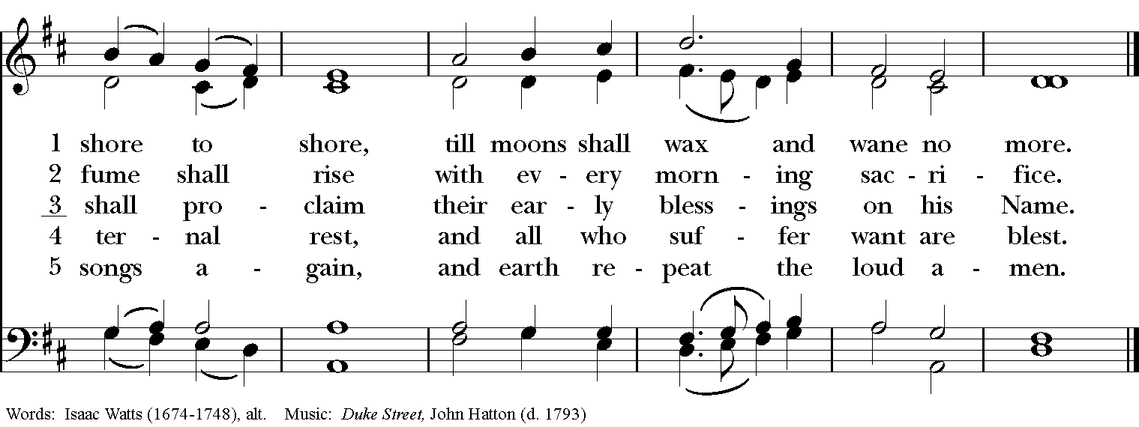

Blessing
May the Spirit of truth lead you into all truth, giving you grace to confess that Jesus Christ is Lord, and to proclaim the wonderful works of God; And the blessing of God Almighty, the Fa- ther, the Son, and the Holy Spirit, be among you, and remain with you always. Amen.
Announcements
Dismissal
Deacon: Go in peace to love and serve the Lord.
People: Thanks be to God!
Postlude:

Thank you for your spiritual presence with us this morning!
Although we're physically apart, we are united in prayer, worship, and holy love!

Transition Priest-In-Charge: The Rev. Dr. Canon Lee Anne Reat
Deacon: The Rev. Dr. Rick Incorvati
Guest Pastor Ernest Brown, St. John Missionary Baptist Church
Music Director: Dr. Chris Durrenberger
Guest Organist: Kent Brooks
Lector: Diane Rode
Singers: Liz Wheeler, Joy Carter, Ed Hasecke, Fred Bartenstein
Technology: Steve Ide
Slideshow: Ed Hasecke
Parish Administrator and Program Coordinator: Kelly Zeller
Coffee Hour Host: Ron Dowling

