Christ Episcopal Church in Springfield, Ohio
Service of the Word
Twenty-Second Sunday after Pentecost: October 24th, 2021 at 9 am

Prelude: "When Jesus Left His Father's Throne" – Kingsfold/arr. David Schelat

Opening Hymn: “Hail thou once despised Jesus” Hymnal 495
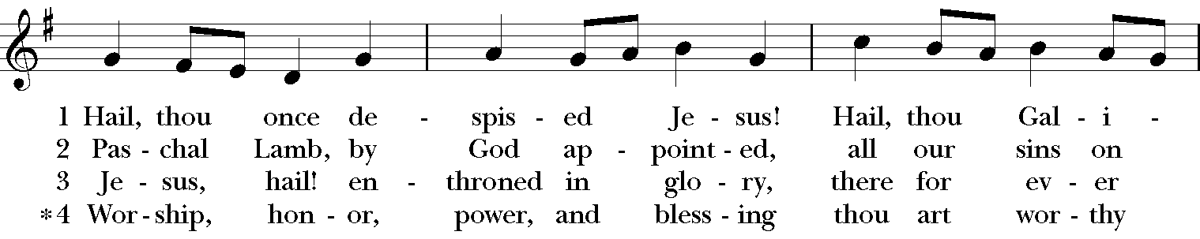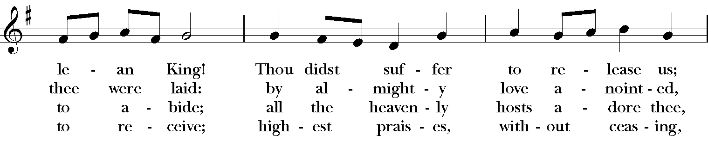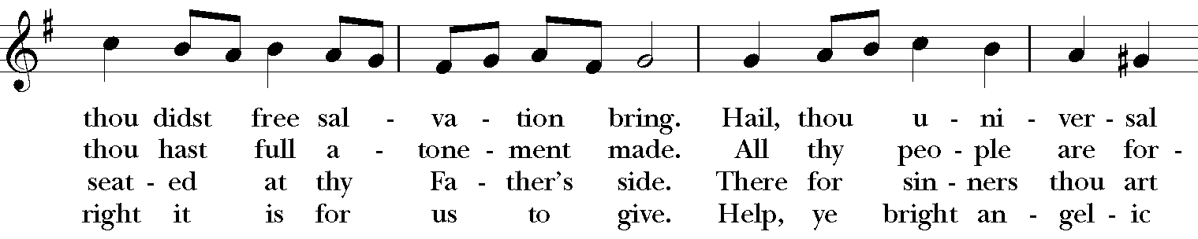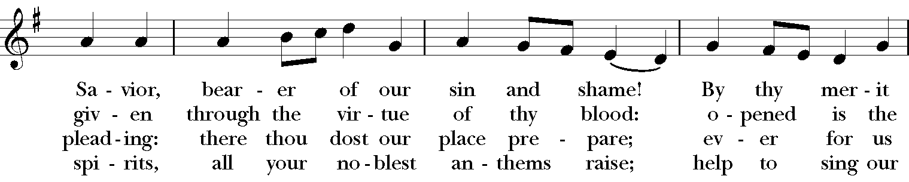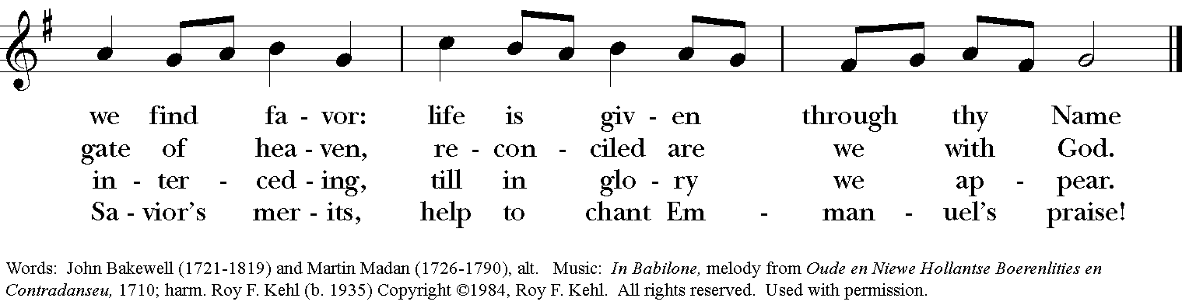

Celebrant: Blessed be God: Father, Son, and Holy Spirit.
People: And blessed be his kingdom, now and for ever. Amen.

The Collect of the Day
Celebrant: The Lord be with you.
People: And also with you.
Celebrant: Let us pray.
Almighty and everlasting God, increase in us the gifts of faith, hope, and charity; and, that we may obtain what you promise, make us love what you command; through Jesus Christ our Lord, who lives and reigns with you and the Holy Spirit, one God, for ever and ever. Amen.

THE LESSONS

THE FIRST READING Jeremiah 31:7-9

Thus says the Lord:

Sing aloud with gladness for Jacob,
and raise shouts for the chief of the nations;
proclaim, give praise, and say,
“Save, O Lord, your people,
the remnant of Israel.”

See, I am going to bring them from the land of the north,
and gather them from the farthest parts of the earth,
among them the blind and the lame, those with child and
those in labor, together;
a great company, they shall return here.
With weeping they shall come,
and with consolations I will lead them back,
I will let them walk by brooks of water,
in a straight path in which they shall not stumble;
for I have become a father to Israel,
and Ephraim is my firstborn.
Lector: The Word of the Lord.
People: Thanks be to God.

Psalm 126 In convertendo
1 When the Lord restored the fortunes of Zion, *
then were we like those who dream.
2 Then was our mouth filled with laughter, *
and our tongue with shouts of joy.
3 Then they said among the nations, *
"The Lord has done great things for them."
4 The Lord has done great things for us, *
and we are glad indeed.
5 Restore our fortunes, O Lord, *
like the watercourses of the Negev.
6 Those who sowed with tears *
will reap with songs of joy.
7 Those who go out weeping, carrying the seed, *
will come again with joy, shouldering their sheaves.

THE SECOND LESSON Hebrews 7:23-28
The former priests were many in number, because they were prevented by death from continuing in office; but Jesus holds his priesthood permanently, because he continues forever. Consequently he is able for all time to save those who approach God through him, since he always lives to make intercession for them.

For it was fitting that we should have such a high priest, holy, blameless, undefiled, separated from sinners, and exalted above the heavens. Unlike the other high priests, he has no need to offer sacrifices day after day, first for his own sins, and then for those of the people; this he did once for all when he offered himself. For the law appoints as high priests those who are subject to weakness, but the word of the oath, which came later than the law, appoints a Son who has been made perfect forever.
Lector: The Word of the Lord.
People: Thanks be to God.

SQUENCE HYMN: “O Jesus, I have promised” Hymnal 655
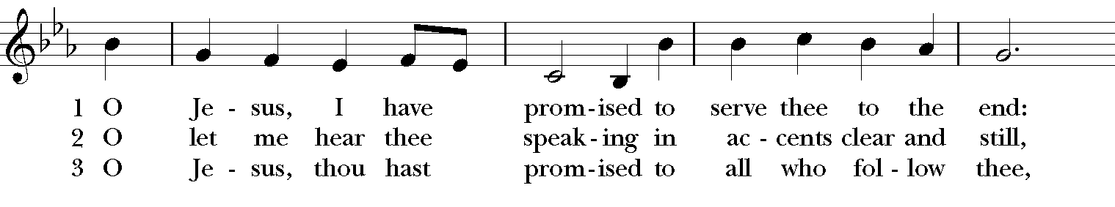
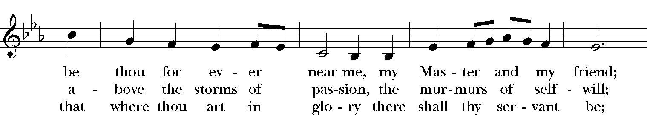

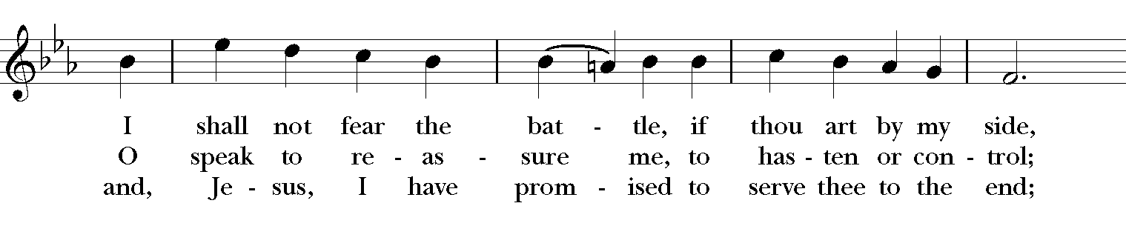

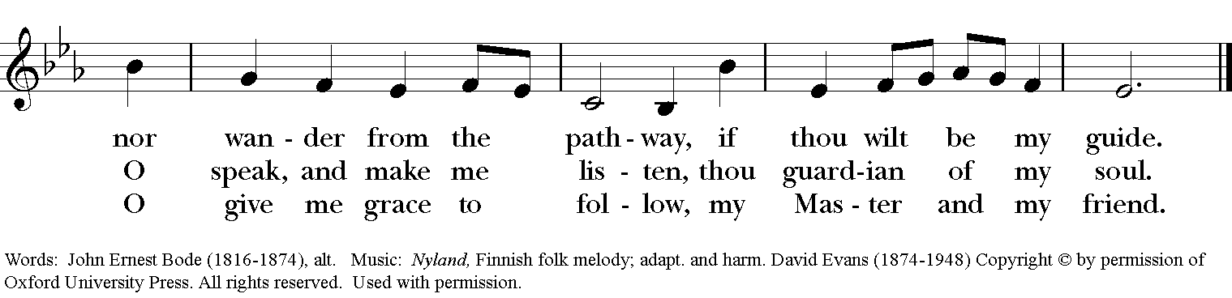

GOSPEL
Celebrant: The Holy Gospel of our Lord Jesus Christ according to Mark (Mark 10:46-52).
People: Glory to you, Lord Christ.
Jesus and his disciples came to Jericho. As he and his disciples and a large crowd were leaving Jericho, Bartimaeus son of Timaeus, a blind beggar, was sitting by the roadside. When he heard that it was Jesus of Nazareth, he began to shout out and say, “Jesus, Son of David, have mercy on me!” Many sternly ordered him to be quiet, but he cried out even more loudly, “Son of David, have mercy on me!” Jesus stood still and said, “Call him here.” And they called the blind man, saying to him, “Take heart; get up, he is calling you.” So throwing off his cloak, he sprang up and came to Jesus. Then Jesus said to him, “What do you want me to do for you?” The blind man said to him, “My teacher, let me see again.” Jesus said to him, “Go; your faith has made you well.” Immediately he regained his sight and followed him on the way.
Celebrant: The Gospel of the Lord.
People: Praise to you, Lord Christ.

Sermon The Rev. Canon Dr. Lee Anne Reat

The Nicene Creed
We believe in one God, the Father, the Almighty,
maker of heaven and earth, of all that is, seen and unseen.
We believe in one Lord, Jesus Christ, the only Son of God,
eternally begotten of the Father, God from God,
Light from Light, true God from true God,
begotten, not made, of one Being with the Father.
Through him all things were made.
For us and for our salvation he came down from heaven,
by the power of the Holy Spirit he became incarnate from the Virgin Mary,
and was made man.
For our sake he was crucified under Pontius Pilate;
he suffered death and was buried.
On the third day he rose again in accordance with the Scriptures;
he ascended into heaven and is seated at the right hand of the Father.
He will come again in glory to judge the living and the dead, and his kingdom will have no end.
We believe in the Holy Spirit, the Lord, the giver of life,
who proceeds from the Father, and the Son.
With the Father and the Son he is worshiped and glorified,
he has spoken through the Prophets.
We believe in one holy catholic and apostolic Church.
We acknowledge one baptism for the forgiveness of sins.
We look for the resurrection of the dead, and the life of the world to come. Amen.

THE PRAYERS OF THE PEOPLE

In peace, we pray to you Lord God. Congregational responses are in bold.
Silence

Giver of every good gift, we thank you for your generosity in giving us more than we can ask or imagine.

Give grace to church leaders, especially Justin, Archbishop of Canterbury; Michael, our presiding bishop; Wayne, our provisional diocesan bishop; Lee Anne, our priest; and members of the vestry. In your time, send us the priest this church needs.
R: Giver of every good gift, grant grace.

Give wisdom to world leaders in a time of pandemic and natural disasters. Give special grace to refugees and those seeking justice.
R: Giver of every good gift, grant wisdom.

Give hope to those suffering any illness or affliction, especially Leigh, Charlene, Faye, Chris, Bonnie, Alice, Diana, James, Joy, Jane, Joni, Kim, Sarah, Traudie, Lexie, and Keith.
R: Giver of every good gift, grant hope.

Give strength to those laboring in the ministries we support as a church especially Children’s Rescue Center/The Ark, Christ Church Food Pantry, The Fuller Center for Housing, and Safe Harbor Housing.
R: Giver of every good gift, grant strength.

Give joy to those celebrating birthdays this week, especially Ann, Rose, Becca, Barbara, and anniversaries Joe & Kathy.
R: Giver of every good gift, grant joy.

Grant peace and light to those who have died and comfort to those who grieve.
R: Giver of every good gift, in the midst of loss grant hope.

*THE COLLECT FOR PEACE
Grant, O God, that your holy and life-giving Spirit may so move every human heart, that barriers which divide us may crumble, suspicions disappear, and hatreds cease; that our divisions being healed, we may live in justice and peace; through Jesus Christ our Lord. Amen.

THE CONFESSION AND ABSOLUTION
Priest: Let us confess our sins against God and our neighbor.
All: Most merciful God, we confess that we have sinned against you in thought, word, and deed, by what we have done, and by what we have left undone. We have not loved you with our whole heart; we have not loved our neighbors as ourselves. We are truly sorry and we humbly repent. For the sake of your Son Jesus Christ, have mercy on us and forgive us; that we may delight in your will, and walk in your ways, to the glory of your Name. Amen.

Priest: Almighty God, have mercy on you, forgive you all your sins through our Lord Jesus Christ, strengthen you in all goodness, and by the power of the Holy Spirit keep you in eternal life. Amen.

And now, as our Savior Christ has taught us, we are bold to say:
Our Father, who art in heaven, hallowed be thy Name,
thy kingdom come, thy will be done, on earth as it is in heaven.
Give us this day our daily bread.
And forgive us our trespasses, as we forgive those who trespass against us.
And lead us not into temptation, but deliver us from evil.
For thine is the kingdom, and the power, and the glory, for ever and ever. Amen

Closing Hymn: “How firm a foundation” Hymnal 637
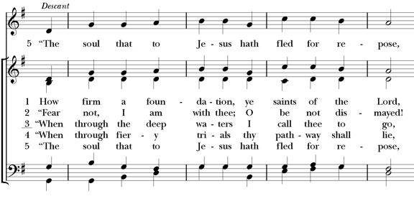
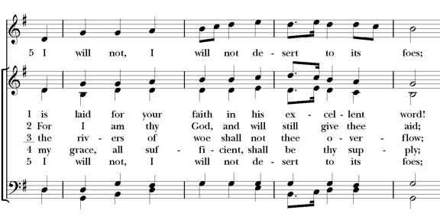
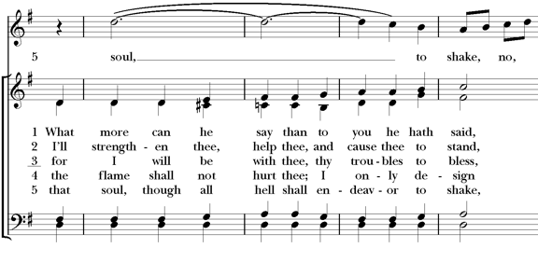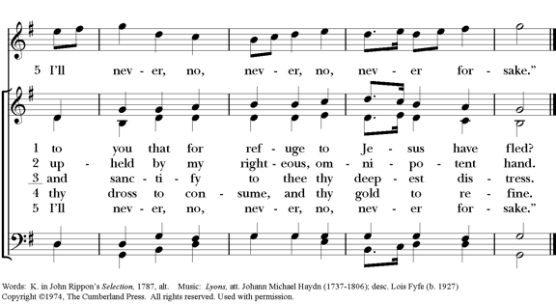

*THE BLESSING
Christ who has nourished us with himself the living bread, make you one in praise and love, and raise you up at the last day; and the blessing God Almighty, the Father, the Son, and the Holy Spirit, be among you, and remain with you always. Amen.

ANNOUNCEMENTS

*THE DISMISSAL Celebrant: Go in peace to love and serve the Lord.
People: Thanks be to God.

POSTLUDE: “When Jesus Wept” – arr. Callahan

Thank you for your spiritual presence with us this morning!
Although we're physically apart, we are united in prayer, worship, and holy love!
Priest-In-Charge: The Rev. Dr. Canon Lee Anne Reat
Music Director: Dr. Chris Durrenberger
Lector: Liz Wheeler
Singers: Liz Wheeler, Joy Carter, Basil Fett, Chris Oldstone-Moore, and Fred Bartenstein
Technology: Steve Ide
Slideshow: Ed Hasecke
Parish Administrator and Program Coordinator: Kelly Zeller

