Christ Episcopal Church in Springfield, Ohio
Service of the Word
October 25th, 2020 at 9 am: Twenty-First Sunday after Pentecost
Note: We invite you to light a candle on your table or home altar before worship begins.

Prelude: “Jerusalem, My Happy Home” - Land of Rest/arr. Callahan

Opening Hymn: “O God, our help in ages past” Hymnal 680
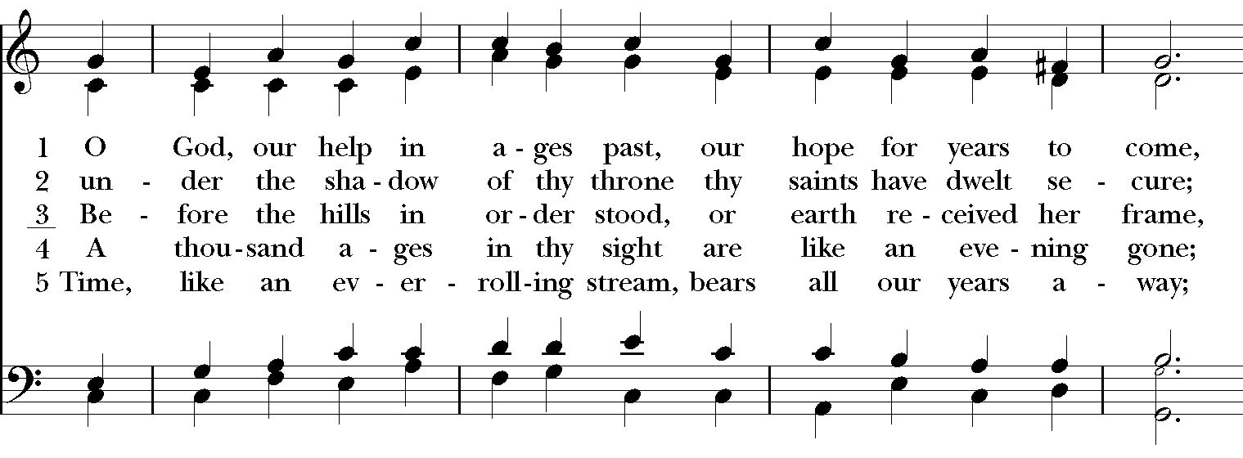
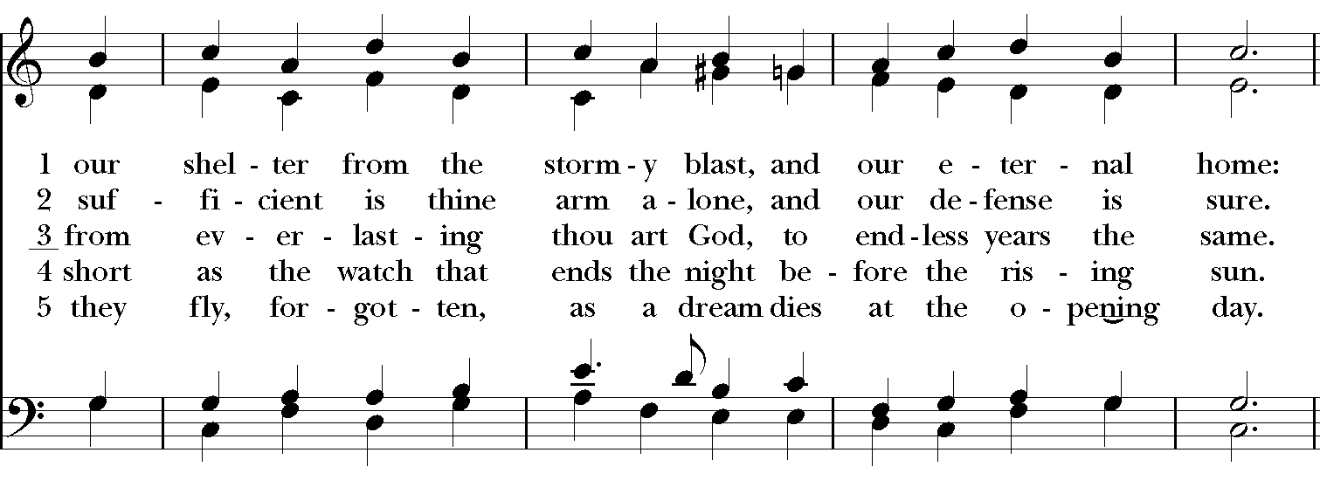
Celebrant: Blessed be God: Father, Son, and Holy Spirit.
People: And blessed be God’s kingdom, now and for ever. Amen.

Celebrant: Lord, have mercy.
People: Christ, have mercy.
Celebrant: Lord, have mercy.

The Collect of the Day

Celebrant: The Lord be with you.
People: And also with you.
Celebrant: Let us pray.
Almighty and everlasting God, increase in us the gifts of faith, hope, and charity; and, that we may obtain what you promise, make us love what you command; through Jesus Christ our Lord, who lives and reigns with you and the Holy Spirit, one God, for ever and ever. Amen.
The Lessons

The First Reading: Deuteronomy 34:1-12

Moses went up from the plains of Moab to Mount Nebo, to the top of Pisgah, which is opposite Jericho, and the Lord showed him the whole land: Gilead as far as Dan, all Naphtali, the land of Ephraim and Manasseh, all the land of Judah as far as the Western Sea, the Negeb, and the Plain—that is, the valley of Jericho, the city of palm trees—as far as Zoar. The Lord said to him, “This is the land of which I swore to Abraham, to Isaac, and to Jacob, saying, ‘I will give it to your descendants’; I have let you see it with your eyes, but you shall not cross over there.” Then Moses, the servant of the Lord, died there in the land of Moab, at the Lord’s command. He was buried in a valley in the land of Moab, opposite Beth-peor, but no one knows his burial place to this day. Moses was one hundred twenty years old when he died; his sight was unimpaired and his vigor had not abated. The Israelites wept for Moses in the plains of Moab thirty days; then the period of mourning for Moses was ended.

Joshua son of Nun was full of the spirit of wisdom, because Moses had laid his hands on him; and the Israelites obeyed him, doing as the Lord had commanded Moses.

Never since has there arisen a prophet in Israel like Moses, whom the Lord knew face to face. He was unequaled for all the signs and wonders that the Lord sent him to perform in the land of Egypt, against Pharaoh and all his servants and his entire land, and for all the mighty deeds and all the terrifying displays of power that Moses performed in the sight of all Israel.

Reader: The Word of the Lord.
People: Thanks be to God.

Psalm 90:1-6, 13-17 Domine, refugium

1 Lord, you have been our refuge *
from one generation to another.

2 Before the mountains were brought forth, or the land and the earth were born, *
from age to age you are God.

3 You turn us back to the dust and say, *
"Go back, O child of earth."

4 For a thousand years in your sight are like yesterday when it is past *
and like a watch in the night.

5 You sweep us away like a dream; *
we fade away suddenly like the grass.

6 In the morning it is green and flourishes; *
in the evening it is dried up and withered.

13 Return, O Lord; how long will you tarry? *
be gracious to your servants.

14 Satisfy us by your loving-kindness in the morning; *
so shall we rejoice and be glad all the days of our life.

15 Make us glad by the measure of the days that you afflicted us *
and the years in which we suffered adversity.

16 Show your servants your works *
and your splendor to their children.

17 May the graciousness of the Lord our God be upon us; *
prosper the work of our hands; prosper our handiwork.

Second Lesson: 1 Thessalonians 2:1-8
You yourselves know, brothers and sisters, that our coming to you was not in vain, but though we had already suffered and been shamefully mistreated at Philippi, as you know, we had courage in our God to declare to you the gospel of God in spite of great opposition. For our appeal does not spring from deceit or impure motives or trickery, but just as we have been approved by God to be entrusted with the message of the gospel, even so we speak, not to please mortals, but to please God who tests our hearts. As you know and as God is our witness, we never came with words of flattery or with a pretext for greed; nor did we seek praise from mortals, whether from you or from others, though we might have made demands as apostles of Christ. But we were gentle among you, like a nurse tenderly caring for her own children. So deeply do we care for you that we are determined to share with you not only the gospel of God but also our own selves, because you have become very dear to us.

Reader: The Word of the Lord.
People: Thanks be to God.

Sequence Hymn: “Lord, make us instruments of your peace” Hymnal 593
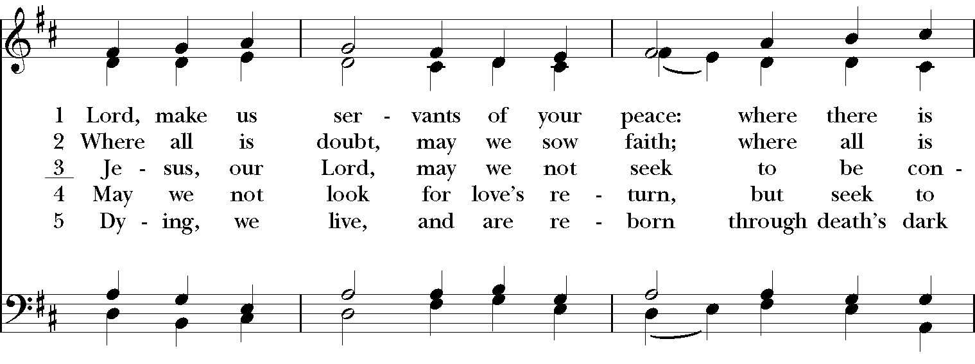

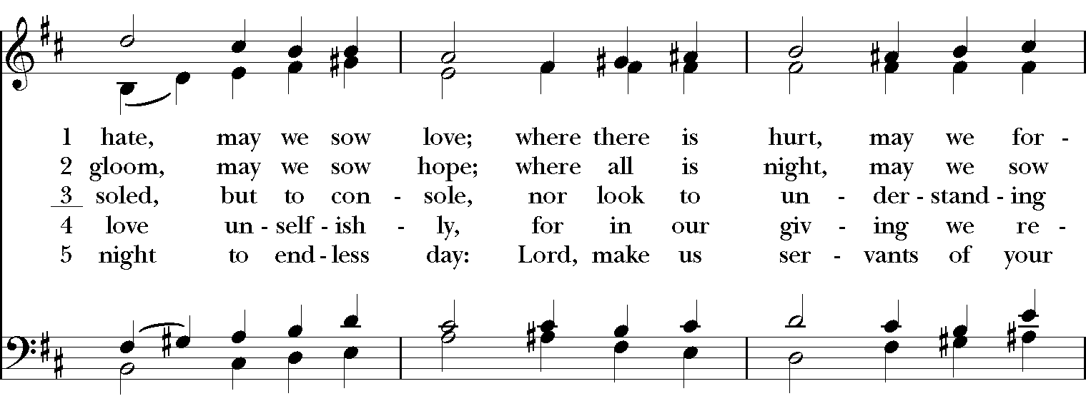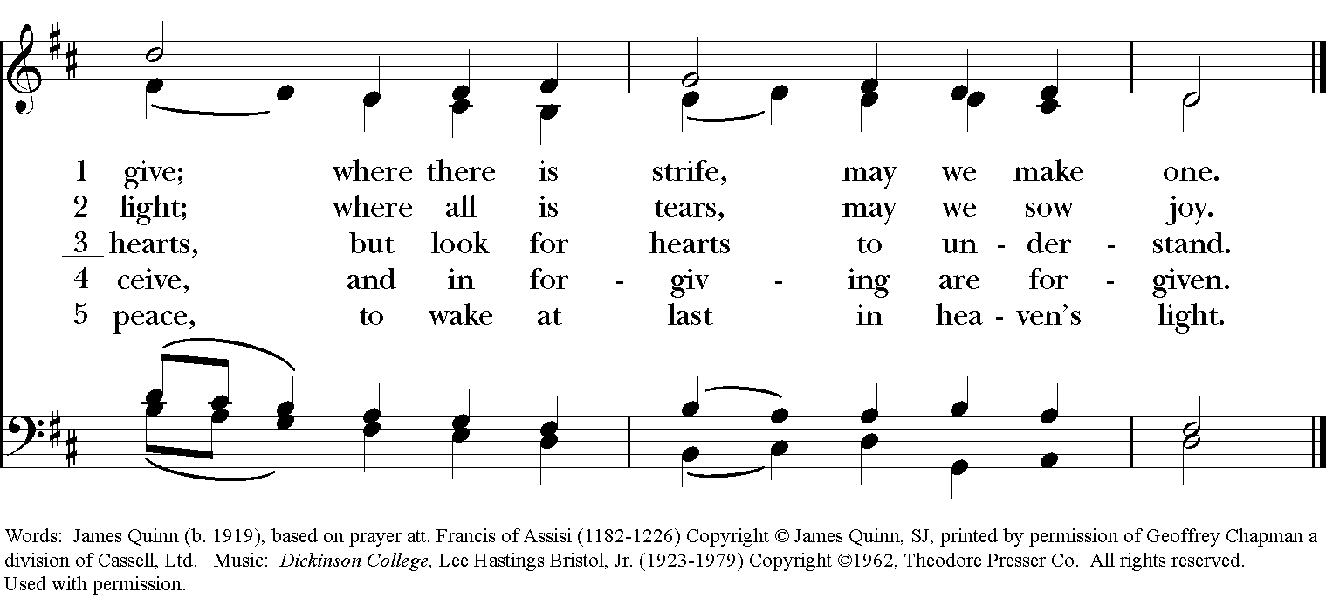
Gospel

Deacon: The Holy Gospel According to Matthew (22:34-46)
People: Glory to you, Lord Christ.
When the Pharisees heard that Jesus had silenced the Sadducees, they gathered together, and one of them, a lawyer, asked him a question to test him. “Teacher, which commandment in the law is the greatest?” He said to him, “’You shall love the Lord your God with all your heart, and with all your soul, and with all your mind.’ This is the greatest and first commandment. And a second is like it: ‘You shall love your neighbor as yourself.’ On these two commandments hang all the law and the prophets.”
Now while the Pharisees were gathered together, Jesus asked them this question: “What do you think of the Messiah? Whose son is he?” They said to him, “The son of David.” He said to them, “How is it then that David by the Spirit calls him Lord, saying,

‘The Lord said to my Lord,
“Sit at my right hand,
until I put your enemies under your feet”’?

If David thus calls him Lord, how can he be his son?” No one was able to give him an answer, nor from that day did anyone dare to ask him any more questions.
Deacon: The Gospel of the Lord.
People: Praise to you, Lord Christ.

Sermon The Rev. Canon Dr. Lee Anne Reat

The Nicene Creed
We believe in one God,
the Father, the Almighty,
the maker of heaven and earth,
of all that is, seen and unseen.
We believe in one Lord, Jesus Christ,
the only Son of God,
eternally begotten of the Father,
God from God, Light from Light,
true God from true God,
begotten, not made,
of one Being with the Father.
Through him all things were made.
For us and for our salvation
he came down from heaven:
by the power of the Holy Spirit
he became incarnate from the Virgin Mary,
and was made man.
For our sake he was crucified under Pontius Pilate;
he suffered death and was buried.
On the third day he rose again
in accordance with the Scriptures;
He ascended into heaven
and is seated on the right hand of the Father.
He will come again in glory to judge the living and the dead,
and his kingdom will have no end.
We believe in the Holy Spirit, the Lord, the giver of life,
who proceeds from the Father and the Son.
With the Father and the Son he is worshiped and glorified.
He has spoken through the Prophets.
We believe in one holy catholic and apostolic Church.
We acknowledge one baptism for the forgiveness of sins.
We look for the resurrection of the dead,
and the life of the world to come. Amen.

The Prayers of the People

In peace, we pray to you Lord God.

Silence

For all people in their daily life and work; especially Clark County Literacy Coalition, Episcopal Community Ministries, Second Harvest Food Bank, and Interfaith Hospitality Network.
For our families, friends, and neighbors, and for those who are alone.

For this community, the nation, and the world;
For all who work for justice, freedom, and peace.

For the just and proper use of your creation;
For the victims of hunger, fear, injustice, and oppression.

For all who are in danger, sorrow, or any kind of trouble;
For those who minister to the sick, the friendless, and the needy.

For the peace and unity of the Church of God;
For all who proclaim the Gospel, and all who seek the Truth.

For Michael, our Presiding Bishop, and Thomas, our Bishop; and all bishops and other ministers;
For all who serve God in his Church.

For the special needs and concerns of this congregation.

Laura, Bonnie, Alice, Joy, Diana, James, Joy, Jane, Joni, Kim, Bobby, Ruth, Sarah, Traudie, Lexie, Norm, and Keith.
May they remember that you are with them and those who care for them.

We thank you, Lord, for all the blessings of this life, especially the birthdays of
Rose, Becca, and Barbara; and anniversaries Joe & Kathy.

We will exalt you, O God our King;
And praise your Name for ever and ever.

We pray for all who have died, that they may have a place in your eternal kingdom.

Lord, let your loving kindness be upon them;
Who put their trust in you.
We pray to you also for the forgiveness of our sins.
Have mercy upon us, most merciful Father;
in your compassion forgive us our sins,
known and unknown,
things done and left undone;
and so uphold us by your Spirit
that we may live and serve you in newness of life,
to the honor and glory of your Name;
through Jesus Christ our Lord. Amen.

Priest: Almighty God, have mercy on you, forgive you all your sins through our Lord Jesus Christ, strengthen you in all goodness, and by the power of the Holy Spirit keep you in eternal life. Amen.

And now, as our Savior Christ has taught us, we are bold to say:

Our Father, who art in heaven, hallowed be thy Name,
thy kingdom come, thy will be done, on earth as it is in heaven.
Give us this day our daily bread.
And forgive us our trespasses, as we forgive those who trespass against us.
And lead us not into temptation, but deliver us from evil.
For thine is the kingdom, and the power, and the glory, for ever and ever. Amen.

Closing Hymn: “Rise up, ye saints of God” Hymnal 551
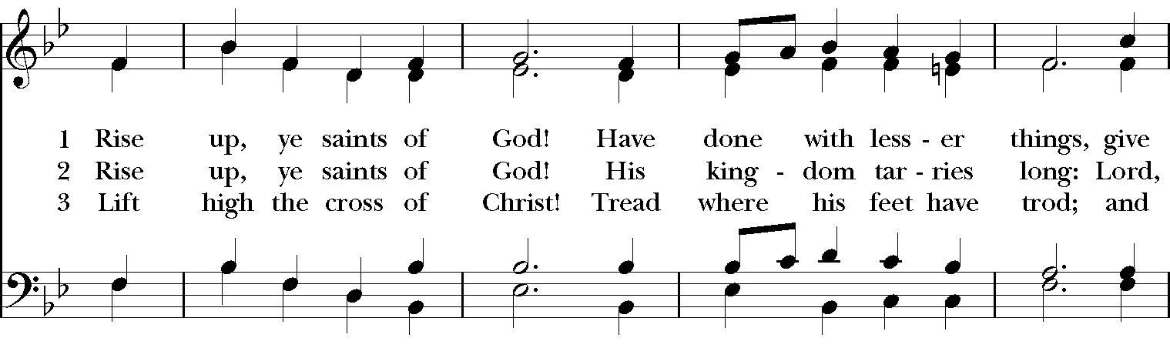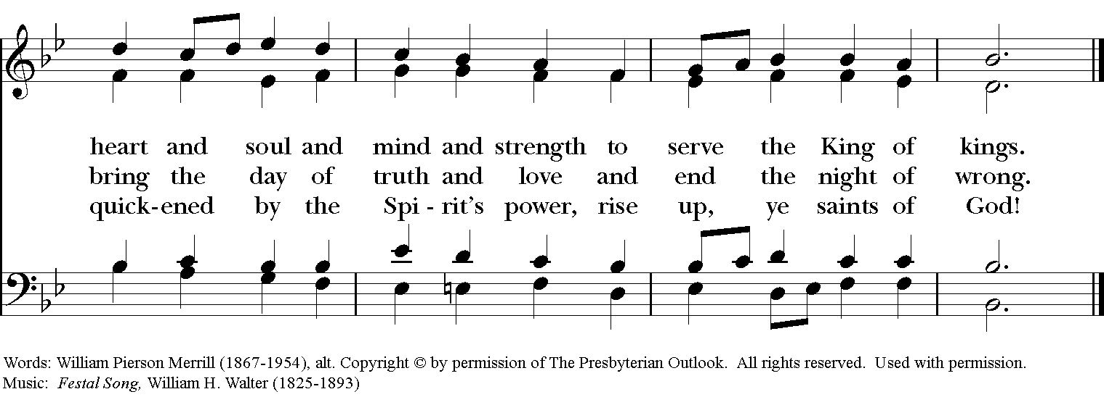

Blessing
May the Spirit of truth lead you into all truth, giving you grace to confess that Jesus Christ is Lord, and to proclaim the wonderful works of God; And the blessing of God Almighty, the
Father, the Son, and the Holy Spirit, be among you, and remain with you always. Amen.

Announcements
Dismissal
Deacon: Go in peace to love and serve the Lord.
People: Thanks be to God!
Postlude: “Adagio” from Sonata in B-flat major K570 - Mozart

Thank you for your spiritual presence with us this morning!
Although we're physically apart, we are united in prayer, worship, and holy love!

Transition Priest-In-Charge: The Rev. Dr. Canon Lee Anne Reat
Deacon: The Rev. Dr. Rick Incorvati
Music Director: Dr. Chris Durrenberger
Lector: Fred Bartenstein
Singers: Liz Wheeler, Joy Carter, Ed Hasecke, Fred Bartenstein
Technology: Steve Ide
Slideshow: Ed Hasecke
Parish Administrator and Program Coordinator: Kelly Zeller
Coffee Hour Host: Fred Bartenstein

