Christ Episcopal Church in Springfield, Ohio
Service of the Word
Nineteenth Sunday after Pentecost: October 3rd, 2021 at 9 am

PRELUDE: Reflection on “Faith of Our Fathers“ - St Catherine/arr. Callahan

Opening Hymn: “Christ is the world’s true light” Hymnal 552
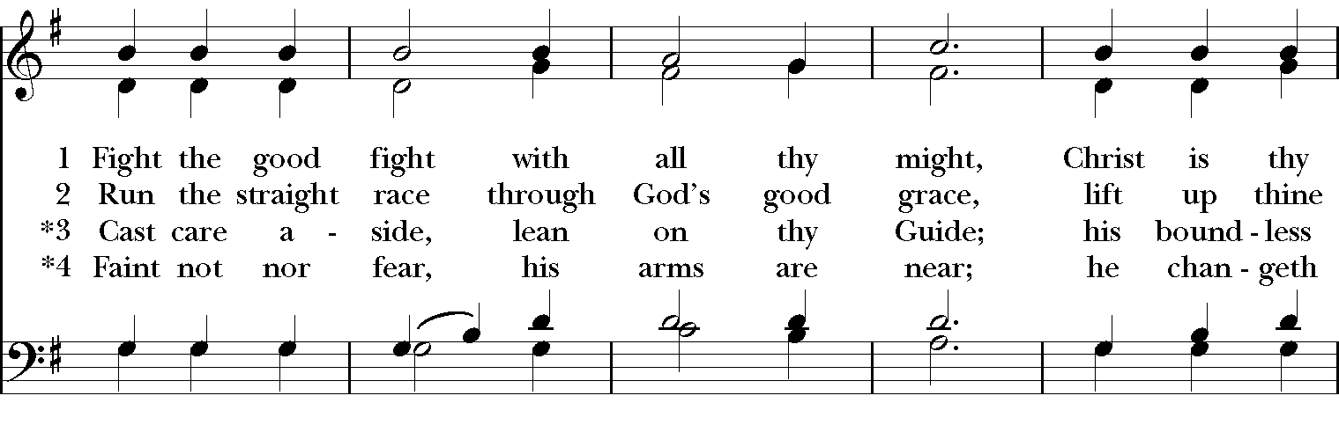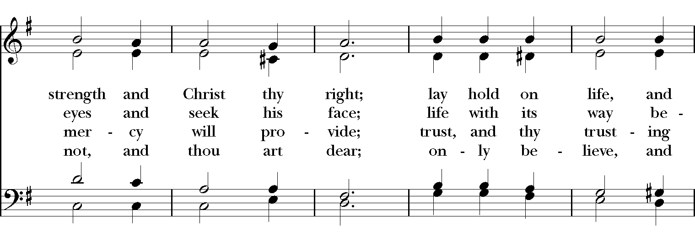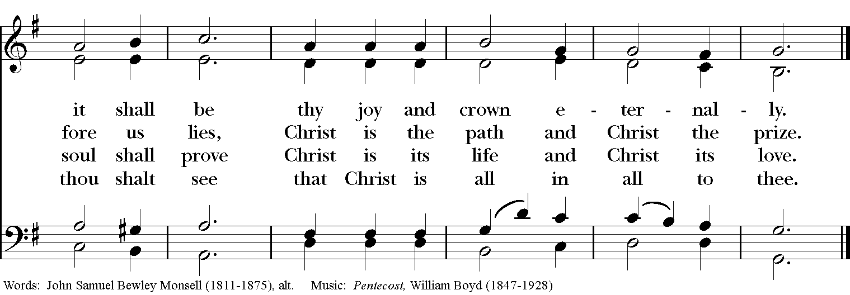

Celebrant: Blessed be God: Father, Son, and Holy Spirit.
People: And blessed be his kingdom, now and for ever. Amen.

The Collect of the Day
Celebrant: The Lord be with you.
People: And also with you.
Celebrant: Let us pray.
Almighty and everlasting God, you are always more ready to hear than we to pray, and to give more than we either desire or deserve: Pour upon us the abundance of your mercy, forgiving us those things of which our conscience is afraid, and giving us those good things for which we are not worthy to ask, except through the merits and mediation of Jesus Christ our Savior; who lives and reigns with you and the Holy Spirit, one God, for ever and ever. Amen.

THE LESSONS
THE FIRST READING Genesis 2:18-24

The Lord God said, “It is not good that the man should be alone; I will make him a helper as his partner.” So out of the ground the Lord God formed every animal of the field and every bird of the air, and brought them to the man to see what he would call them; and whatever the man called every living creature, that was its name. The man gave names to all cattle, and to the birds of the air, and to every animal of the field; but for the man there was not found a helper as his partner. So the Lord God caused a deep sleep to fall upon the man, and he slept; then he took one of his ribs and closed up its place with flesh. And the rib that the Lord God had taken from the man he made into a woman and brought her to the man. Then the man said,

“This at last is bone of my bones
and flesh of my flesh;
this one shall be called Woman,
for out of Man this one was taken.”

Therefore a man leaves his father and his mother and clings to his wife, and they become one flesh.
Lector: The Word of the Lord.
People: Thanks be to God.

PSALM 8 Domine, Dominus noster
1 O Lord our Governor, *
how exalted is your Name in all the world!
2 Out of the mouths of infants and children *
your majesty is praised above the heavens.
3 You have set up a stronghold against your adversaries, *
to quell the enemy and the avenger.
4 When I consider your heavens, the work of your fingers, *
the moon and the stars you have set in their courses,
5 What is man that you should be mindful of him? *
the son of man that you should seek him out?
6 You have made him but little lower than the angels; *
you adorn him with glory and honor;
7 You give him mastery over the works of your hands; *
you put all things under his feet:
8 All sheep and oxen, *
even the wild beasts of the field,
9 The birds of the air, the fish of the sea, *
and whatsoever walks in the paths of the sea.
10 O Lord our Governor, *
how exalted is your Name in all the world!

THE SECOND LESSON Hebrews 1:1-4; 2:5-12
Long ago God spoke to our ancestors in many and various ways by the prophets, but in these last days he has spoken to us by a Son, whom he appointed heir of all things, through whom he also created the worlds. He is the reflection of God’s glory and the exact imprint of God’s very being, and he sustains all things by his powerful word. When he had made purification for sins, he sat down at the right hand of the Majesty on high, having become as much superior to angels as the name he has inherited is more excellent than theirs.

Now God did not subject the coming world, about which we are speaking, to angels. But someone has testified somewhere,

“What are human beings that you are mindful of them,
or mortals, that you care for them?
You have made them for a little while lower than the angels;
you have crowned them with glory and honor,
subjecting all things under their feet.”

Now in subjecting all things to them, God left nothing outside their control. As it is, we do not yet see everything in subjection to them, but we do see Jesus, who for a little while was made lower than the angels, now crowned with glory and honor because of the suffering of death, so that by the grace of God he might taste death for everyone.

It was fitting that God, for whom and through whom all things exist, in bringing many children to glory, should make the pioneer of their salvation perfect through sufferings. For the one who sanctifies and those who are sanctified all have one Father. For this reason Jesus is not ashamed to call them brothers and sisters, saying,

“I will proclaim your name to my brothers and sisters, in the midst of the congregation I will praise you.”
Lector: The Word of the Lord.
People: Thanks be to God.
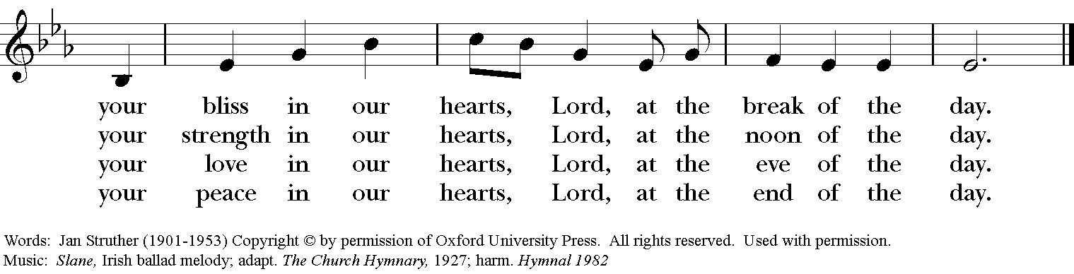
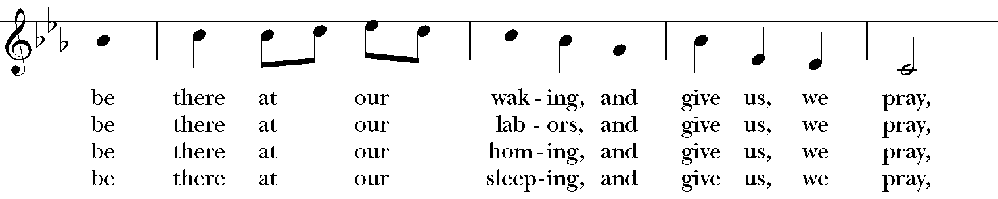
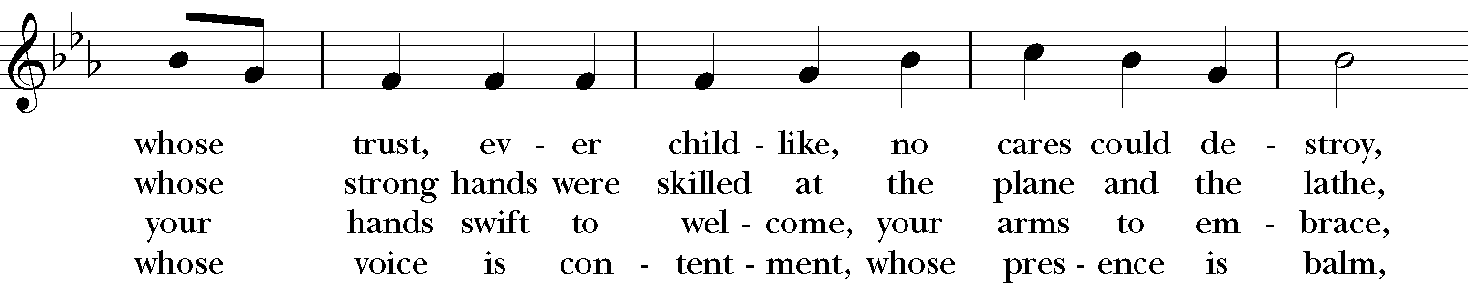
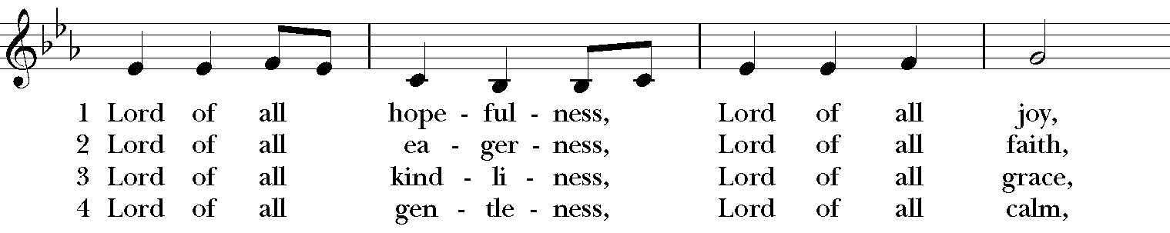
SQUENCE HYMN: “Lord of all hopefulness” Hymnal 482

GOSPEL
Celebrant: The Holy Gospel of our Lord Jesus Christ according to Mark (Mark 10:2-16).
People: Glory to you, Lord Christ.
Some Pharisees came, and to test Jesus they asked, “Is it lawful for a man to divorce his wife?” He answered them, “What did Moses command you?” They said, “Moses allowed a man to write a certificate of dismissal and to divorce her.” But Jesus said to them, “Because of your hardness of heart he wrote this commandment for you. But from the beginning of creation, ‘God made them male and female.’ ‘For this reason a man shall leave his father and mother and be joined to his wife, and the two shall become one flesh.’ So they are no longer two, but one flesh. Therefore what God has joined together, let no one separate.”

Then in the house the disciples asked him again about this matter. He said to them, “Whoever divorces his wife and marries another commits adultery against her; and if she divorces her husband and marries another, she commits adultery.”

People were bringing little children to him in order that he might touch them; and the disciples spoke sternly to them. But when Jesus saw this, he was indignant and said to them, “Let the little children come to me; do not stop them; for it is to such as these that the kingdom of God belongs. Truly I tell you, whoever does not receive the kingdom of God as a little child will never enter it.” And he took them up in his arms, laid his hands on them, and blessed them.
Celebrant: The Gospel of the Lord.
People: Praise to you, Lord Christ.

Sermon The Rev. Canon Dr. Lee Anne Reat

The Nicene Creed
We believe in one God, the Father, the Almighty,
maker of heaven and earth, of all that is, seen and unseen.
We believe in one Lord, Jesus Christ, the only Son of God,
eternally begotten of the Father, God from God,
Light from Light, true God from true God,
begotten, not made, of one Being with the Father.
Through him all things were made.
For us and for our salvation he came down from heaven,
by the power of the Holy Spirit he became incarnate from the Virgin Mary,
and was made man.
For our sake he was crucified under Pontius Pilate;
he suffered death and was buried.
On the third day he rose again in accordance with the Scriptures;
he ascended into heaven and is seated at the right hand of the Father.
He will come again in glory to judge the living and the dead, and his kingdom will have no end.
We believe in the Holy Spirit, the Lord, the giver of life,
who proceeds from the Father, and the Son.
With the Father and the Son he is worshiped and glorified,
he has spoken through the Prophets.
We believe in one holy catholic and apostolic Church.
We acknowledge one baptism for the forgiveness of sins.
We look for the resurrection of the dead, and the life of the world to come. Amen
THE PRAYERS OF THE PEOPLE

In peace, we pray to you Lord God. Congregational responses are in bold.
Silence

Giver of every good gift, we thank you for your generosity in giving us more than we can ask or imagine.

Give grace to church leaders, especially Justin, Archbishop of Canterbury; Michael, our presiding bishop; Wayne, our provisional diocesan bishop; Lee Anne, our priest; and members of the vestry. In your time, send us the priest this church needs.
R: Giver of every good gift, grant grace.

Give wisdom to world leaders in a time of pandemic and natural disasters. Give special grace to refugees and those seeking justice.
R: Giver of every good gift, grant wisdom.

Give hope to those suffering any illness or affliction, especially Leigh, Charlene, Faye, Chris, Bonnie, Alice, Diana, James, Joy, Jane, Joni, Kim, Bobby, Sarah, Traudie, Lexie, and Keith.
R: Giver of every good gift, grant hope.

Give strength to those laboring in the ministries we support as a church especially Springfield Farmer’s Market, Project Woman, Children’s Defense Fund Freedom Schools, The YMCA, and Jefferson St. Oasis Garden.
R: Giver of every good gift, grant strength.

Give joy to those celebrating birthdays this week, especially Destany, Juanita, and Lexie, and anniversaries, Jamie & Cameron.
R: Giver of every good gift, grant joy.

Grant peace and light to those who have died and comfort to those who grieve.
R: Giver of every good gift, in the midst of loss grant hope.

*THE COLLECT FOR PEACE
Grant, O God, that your holy and life-giving Spirit may so move every human heart, that barriers which divide us may crumble, suspicions disappear, and hatreds cease; that our divisions being healed, we may live in justice and peace; through Jesus Christ our Lord. Amen.

THE CONFESSION AND ABSOLUTION
Priest: Let us confess our sins against God and our neighbor.
All: Most merciful God, we confess that we have sinned against you in thought, word, and deed, by what we have done, and by what we have left undone. We have not loved you with our whole heart; we have not loved our neighbors as ourselves. We are truly sorry and we humbly repent. For the sake of your Son Jesus Christ, have mercy on us and forgive us; that we may delight in your will, and walk in your ways, to the glory of your Name. Amen.

Priest: Almighty God, have mercy on you, forgive you all your sins through our Lord Jesus Christ, strengthen you in all goodness, and by the power of the Holy Spirit keep you in eternal life. Amen.

And now, as our Savior Christ has taught us, we are bold to say:
Our Father, who art in heaven, hallowed be thy Name,
thy kingdom come, thy will be done, on earth as it is in heaven.
Give us this day our daily bread.
And forgive us our trespasses, as we forgive those who trespass against us.
And lead us not into temptation, but deliver us from evil.
For thine is the kingdom, and the power, and the glory, for ever and ever. Amen

CLOSING HYMN: “All creatures of our God and King” Hymnal 400

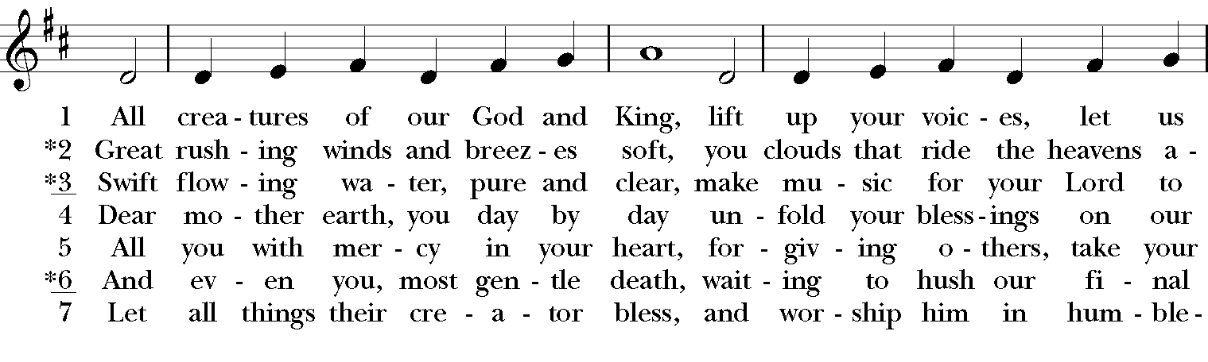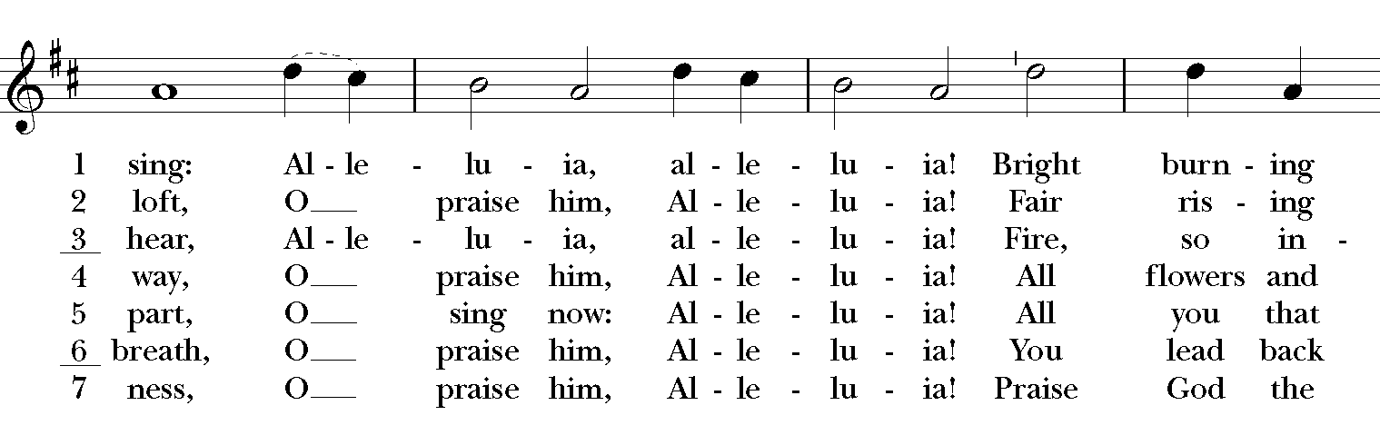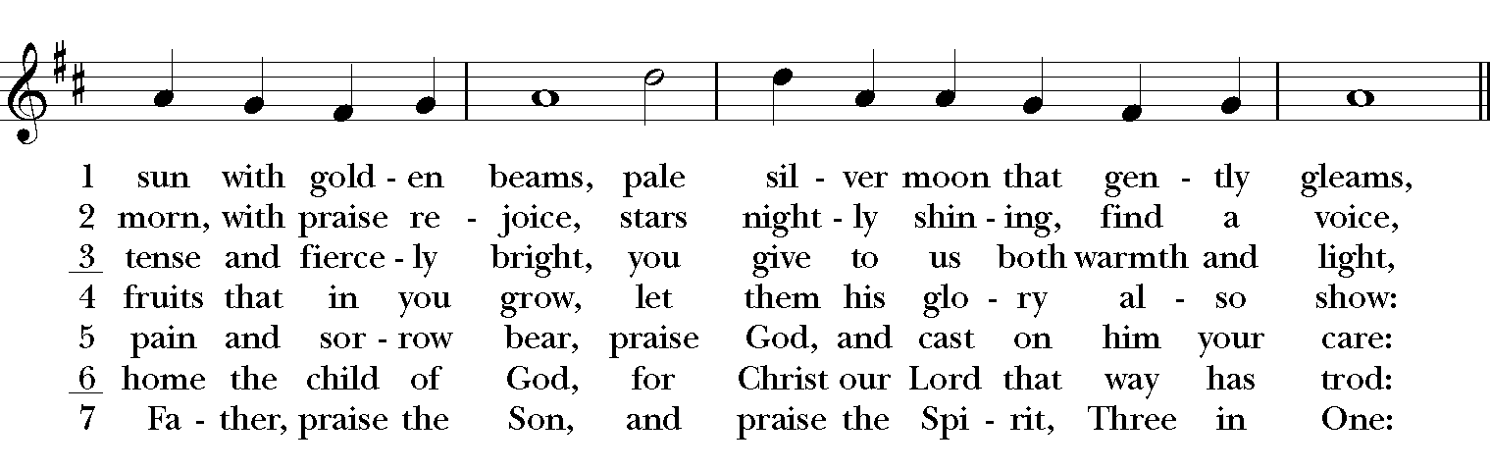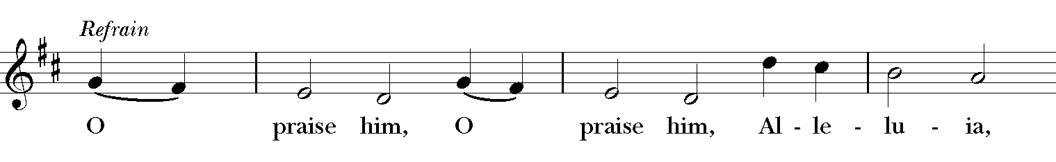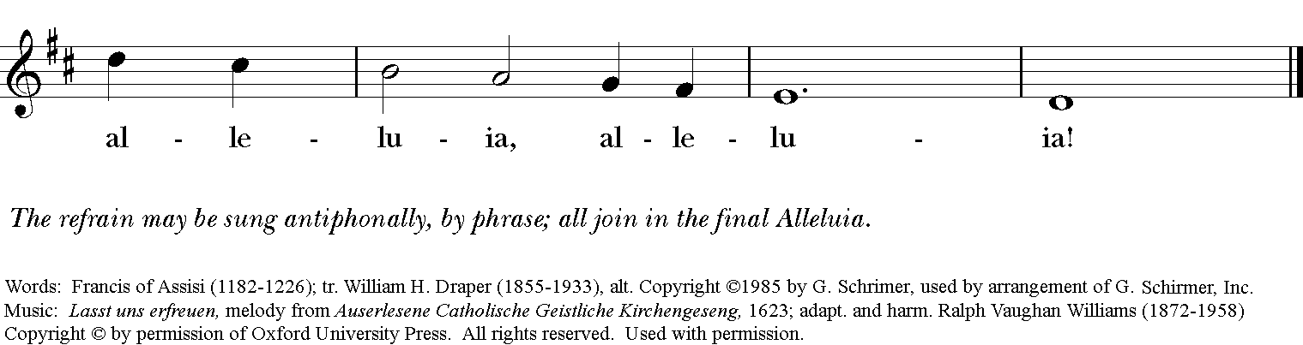

*THE BLESSING
Christ who has nourished us with himself the living bread, make you one in praise and love, and raise you up at the last day; and the blessing God Almighty, the Father, the Son, and the Holy Spirit, be among you, and remain with you always. Amen.

ANNOUNCEMENTS

*THE DISMISSAL Celebrant: Go in peace to love and serve the Lord.
People: Thanks be to God.

POSTLUDE: “The Glory of God in Nature” - Beethoven

Thank you for your spiritual presence with us this morning!
Although we're physically apart, we are united in prayer, worship, and holy love!
Priest-In-Charge: The Rev. Dr. Canon Lee Anne Reat
Music Director: Dr. Chris Durrenberger
Lector: Diane Rode
Singers: Liz Wheeler, Joy Carter, Basil Fett, Chris Oldstone-Moore, and Fred Bartenstein
Technology: Steve Ide
Slideshow: Ed Hasecke
Parish Administrator and Program Coordinator: Kelly Zeller

