Christ Episcopal Church in Springfield, Ohio
Service of the Word
October 4th, 2020 at 9 am: Eighteenth Sunday after Pentecost
Note: We invite you to light a candle on your table or home altar before worship begins.

Prelude:

Opening Hymn: “Awake My soul, Stretch Every Gladness” Hymnal 546
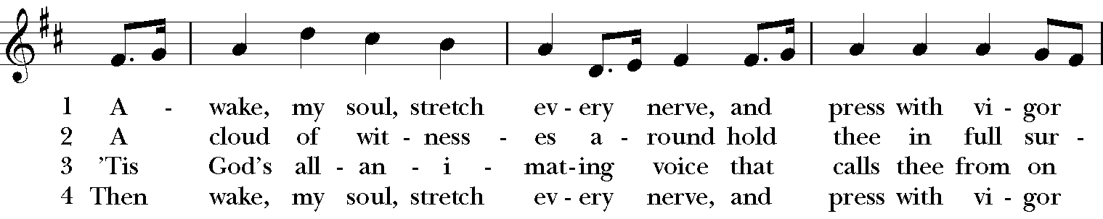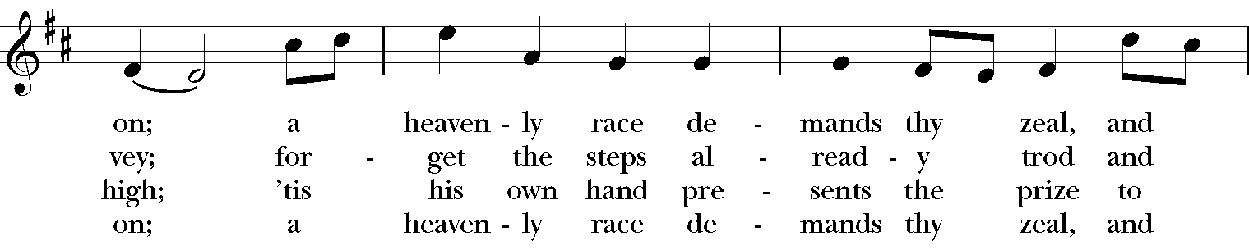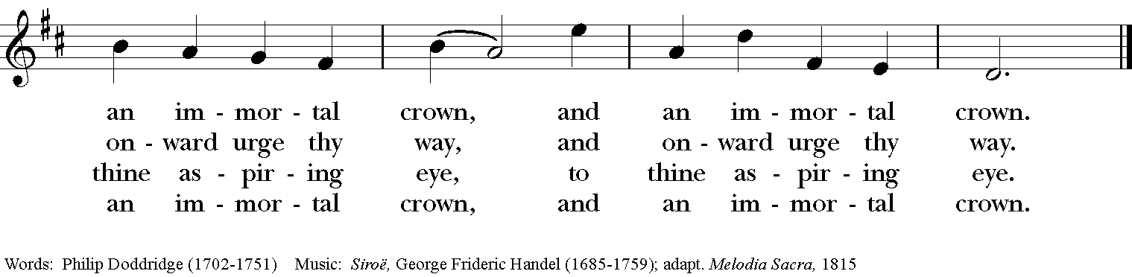

Celebrant: Blessed be God: Father, Son, and Holy Spirit.
People: And blessed be God’s kingdom, now and for ever. Amen.

Celebrant: Lord, have mercy.
People: Christ, have mercy.
Celebrant: Lord, have mercy.

The Collect of the Day

Celebrant: The Lord be with you.
People: And also with you.
Celebrant: Let us pray.

Almighty and everlasting God, you are always more ready to hear than we to pray, and to give more than we either desire or deserve: Pour upon us the abundance of your mercy, forgiving us those things of which our conscience is afraid, and giving us those good things for which we are not worthy to ask, except through the merits and mediation of Jesus Christ our Savior; who lives and reigns with you and the Holy Spirit, one God, for ever and ever. Amen.

The Lessons

The First Reading: Exodus 20:1-4, 7-9, 12-20

Then God spoke all these words:

I am the Lord your God, who brought you out of the land of Egypt, out of the house of slavery; you shall have no other gods before me.

You shall not make for yourself an idol, whether in the form of anything that is in heaven above, or that is on the earth beneath, or that is in the water under the earth.

You shall not make wrongful use of the name of the Lord your God, for the Lord will not acquit anyone who misuses his name.

Remember the sabbath day, and keep it holy. For six days you shall labour and do all your work.

Honor your father and your mother, so that your days may be long in the land that the Lord your God is giving you.

You shall not murder.

You shall not commit adultery.

You shall not steal.

You shall not bear false witness against your neighbor.

You shall not covet your neighbor’s house; you shall not covet your neighbor’s wife, or male or female slave, or ox, or donkey, or anything that belongs to your neighbor.

When all the people witnessed the thunder and lightning, the sound of the trumpet, and the mountain smoking, they were afraid and trembled and stood at a distance, and said to Moses, “You speak to us, and we will listen; but do not let God speak to us, or we will die.” Moses said to the people, “Do not be afraid; for God has come only to test you and to put the fear of him upon you so that you do not sin.”

Reader: The Word of the Lord.
People: Thanks be to God.

Psalm 19 Caeli enarrant

1 The heavens declare the glory of God, *
and the firmament shows his handiwork.

2 One day tells its tale to another, *
and one night imparts knowledge to another.

3 Although they have no words or language, *
and their voices are not heard,

4 Their sound has gone out into all lands, *
and their message to the ends of the world.

5 In the deep has he set a pavilion for the sun; *
it comes forth like a bridegroom out of his chamber;
it rejoices like a champion to run its course.

6 It goes forth from the uttermost edge of the heavens and runs about to the end of it again; *
nothing is hidden from its burning heat.

7 The law of the Lord is perfect and revives the soul; *
the testimony of the Lord is sure and gives wisdom to the innocent.

8 The statutes of the Lord are just and rejoice the heart; *
the commandment of the Lord is clear and gives light to the eyes.

9 The fear of the Lord is clean and endures for ever; *
the judgments of the Lord are true and righteous altogether.

10 More to be desired are they than gold, more than much fine gold, *
sweeter far than honey, than honey in the comb.

11 By them also is your servant enlightened, *
and in keeping them there is great reward.

12 Who can tell how often he offends? *
cleanse me from my secret faults.

13 Above all, keep your servant from presumptuous sins; let them not get dominion over me; *
then shall I be whole and sound, and innocent of a great offense.

14 Let the words of my mouth and the meditation of my heart be acceptable in your sight, *
O Lord, my strength and my redeemer.

Second Lesson: Philippians 3:4b-14

If anyone else has reason to be confident in the flesh, I have more: circumcised on the eighth day, a member of the people of Israel, of the tribe of Benjamin, a Hebrew born of Hebrews; as to the law, a Pharisee; as to zeal, a persecutor of the church; as to righteousness under the law, blameless.

Yet whatever gains I had, these I have come to regard as loss because of Christ. More than that, I regard everything as loss because of the surpassing value of knowing Christ Jesus my Lord. For his sake I have suffered the loss of all things, and I regard them as rubbish, in order that I may gain Christ and be found in him, not having a righteousness of my own that comes from the law, but one that comes through faith in Christ, the righteousness from God based on faith. I want to know Christ and the power of his resurrection and the sharing of his sufferings by becoming like him in his death, if somehow I may attain the resurrection from the dead.

Not that I have already obtained this or have already reached the goal; but I press on to make it my own, because Christ Jesus has made me his own. Beloved, I do not consider that I have made it my own; but this one thing I do: forgetting what lies behind and straining forward to what lies ahead, I press on toward the goal for the prize of the heavenly call of God in Christ Jesus.

Reader: The Word of the Lord.
People: Thanks be to God.

Sequence Hymn: “I’m pressing Out the Upward Way” Hymnal LEVAS II 165

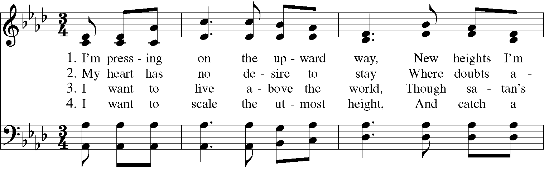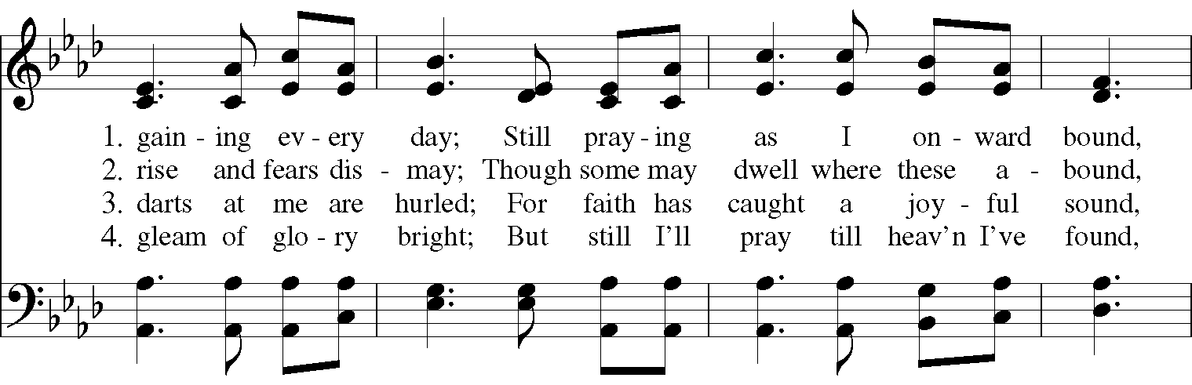

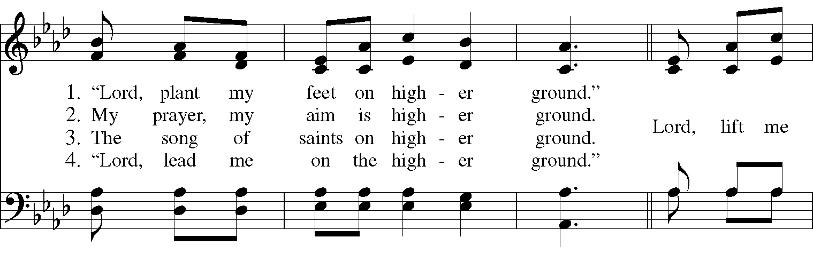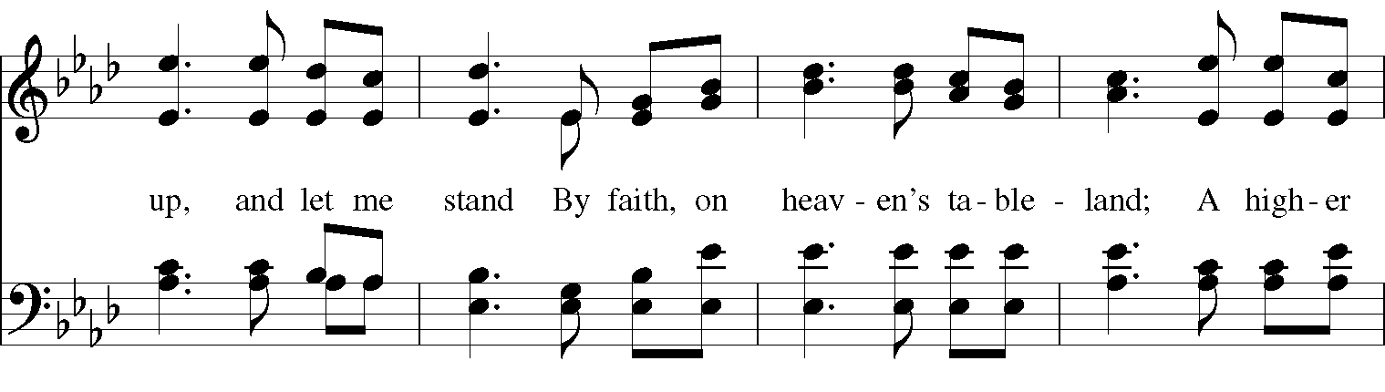
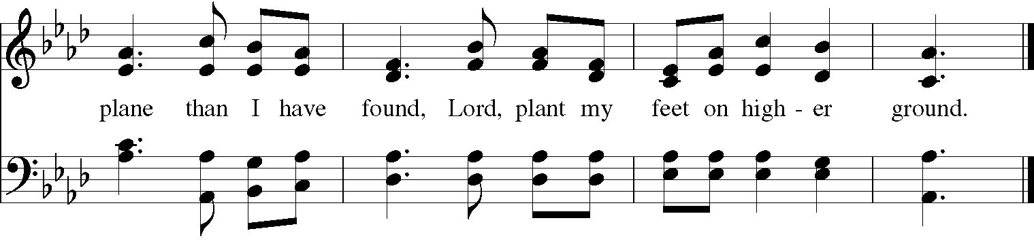
Gospel
Deacon: The Holy Gospel According to Matthew (21:33-46)
People: Glory to you, Lord Christ.
Jesus said, “Listen to another parable. There was a landowner who planted a vineyard, put a fence around it, dug a wine press in it, and built a watchtower. Then he leased it to tenants and went to another country. When the harvest time had come, he sent his slaves to the tenants to collect his produce. But the tenants seized his slaves and beat one, killed another, and stoned another. Again he sent other slaves, more than the first; and they treated them in the same way. Finally he sent his son to them, saying, ‘They will respect my son.’ But when the tenants saw the son, they said to themselves, ‘This is the heir; come, let us kill him and get his inheritance.” So they seized him, threw him out of the vineyard, and killed him. Now when the owner of the vineyard comes, what will he do to those tenants?” They said to him, “He will put those wretches to a miserable death, and lease the vineyard to other tenants who will give him the produce at the harvest time.”
Jesus said to them, “Have you never read in the scriptures:
‘The stone that the builders rejected
has become the cornerstone;
this was the Lord’s doing,
and it is amazing in our eyes’?
Therefore I tell you, the kingdom of God will be taken away from you and given to a people that produces the fruits of the kingdom. The one who falls on this stone will be broken to pieces; and it will crush anyone on whom it falls.”
When the chief priests and the Pharisees heard his parables, they realized that he was speaking about them. They wanted to arrest him, but they feared the crowds, because they regarded him as a prophet.
Deacon: The Gospel of the Lord.
People: Praise to you, Lord Christ.

A reflection on the Scripture is offered by Pastor Cynthia Atwater

The Nicene Creed

We believe in one God,
the Father, the Almighty,
the maker of heaven and earth,
of all that is, seen and unseen.
We believe in one Lord, Jesus Christ,
the only Son of God,
eternally begotten of the Father,
God from God, Light from Light,
true God from true God,
begotten, not made,
of one Being with the Father.
Through him all things were made.
For us and for our salvation
he came down from heaven:
by the power of the Holy Spirit
he became incarnate from the Virgin Mary,
and was made man.
For our sake he was crucified under Pontius Pilate;
he suffered death and was buried.
On the third day he rose again
in accordance with the Scriptures;
He ascended into heaven
and is seated on the right hand of the Father.
He will come again in glory to judge the living and the dead,
and his kingdom will have no end.

We believe in the Holy Spirit, the Lord, the giver of life,
who proceeds from the Father and the Son.
With the Father and the Son he is worshiped and glorified.
He has spoken through the Prophets.
We believe in one holy catholic and apostolic Church.
We acknowledge one baptism for the forgiveness of sins.
We look for the resurrection of the dead,
and the life of the world to come. Amen.

The Prayers of the People

In peace, we pray to you Lord God.

Silence

For all people in their daily life and work; especially Springfield Farmer’s Market, Project Woman, Children’s Defense Fund Freedom Schools, The YMCA, and Jefferson St. Oasis Garden.
For our families, friends, and neighbors, and for those who are alone.

For this community, the nation, and the world;
For all who work for justice, freedom, and peace.

For the just and proper use of your creation;
For the victims of hunger, fear, injustice, and oppression.

For all who are in danger, sorrow, or any kind of trouble;
For those who minister to the sick, the friendless, and the needy.

For the peace and unity of the Church of God;
For all who proclaim the Gospel, and all who seek the Truth.

For Michael, our Presiding Bishop, and Thomas, our Bishop; and all bishops and other ministers;
For all who serve God in his Church.

For the special needs and concerns of this congregation.
Laura, Bonnie, Alice, Joy, Diana, James, Joy, Jane, Joni, Kim, Bobby, Ruth, Sarah, Traudie, Lexie, Norm, and Keith.
May they remember that you are with them and those who care for them.

Hear us, Lord;
For your mercy is great.
We than you, Lord, for all the blessings of this life, especially the birthdays of
Jeannie, Marilee, and Diana.

We will exalt you, O God our King;
And praise your Name for ever and ever.

We pray for all who have died, that they may have a place in your eternal kingdom.

Lord, let your loving kindness be upon them;
Who put their trust in you.

We pray to you also for the forgiveness of our sins.
Have mercy upon us, most merciful Father;
in your compassion forgive us our sins,
known and unknown,
things done and left undone;
and so uphold us by your Spirit
that we may live and serve you in newness of life,
to the honor and glory of your Name;
through Jesus Christ our Lord. Amen.

Priest: Almighty and eternal God, ruler of all things in heaven and earth: Mercifully accept the prayers of your people, and strengthen us to do your will; through Jesus Christ our Lord. Amen.

And now, as our Savior Christ has taught us, we are bold to say:

Our Father, who art in heaven, hallowed be thy Name,
thy kingdom come, thy will be done, on earth as it is in heaven.
Give us this day our daily bread.
And forgive us our trespasses, as we forgive those who trespass against us.
And lead us not into temptation, but deliver us from evil.
For thine is the kingdom, and the power, and the glory, for ever and ever. Amen.

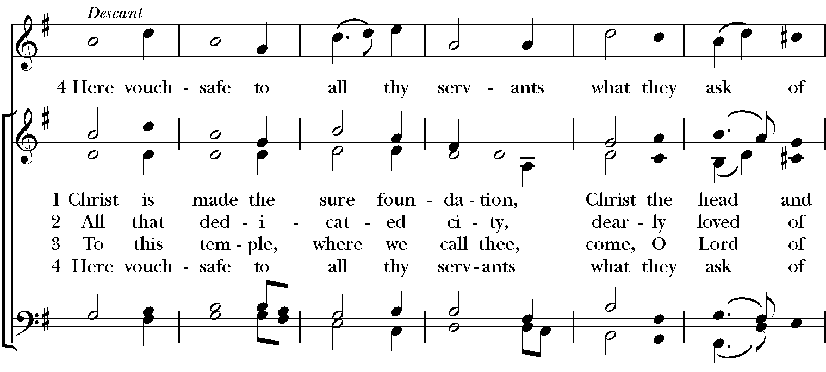
Closing Hymn: “Christ is made the sure foundation” Hymnal 518

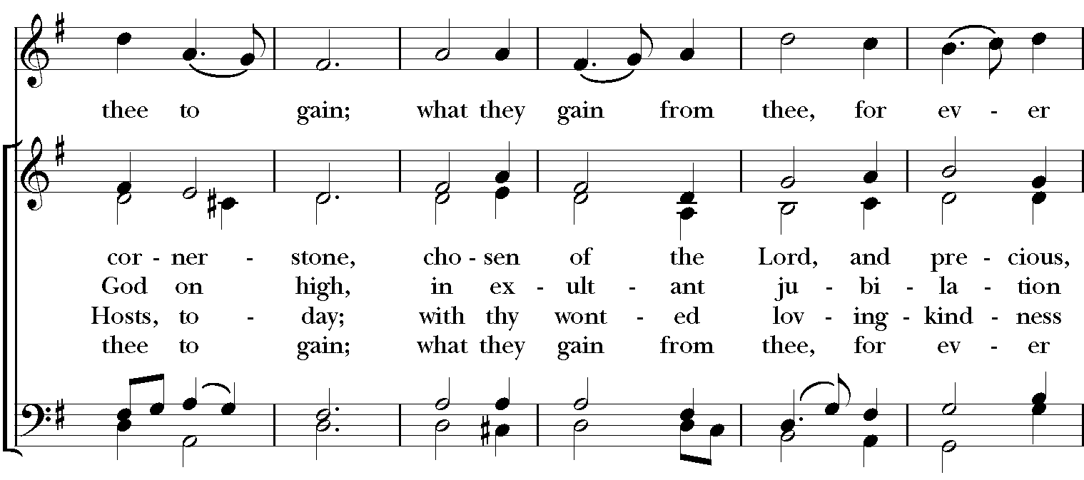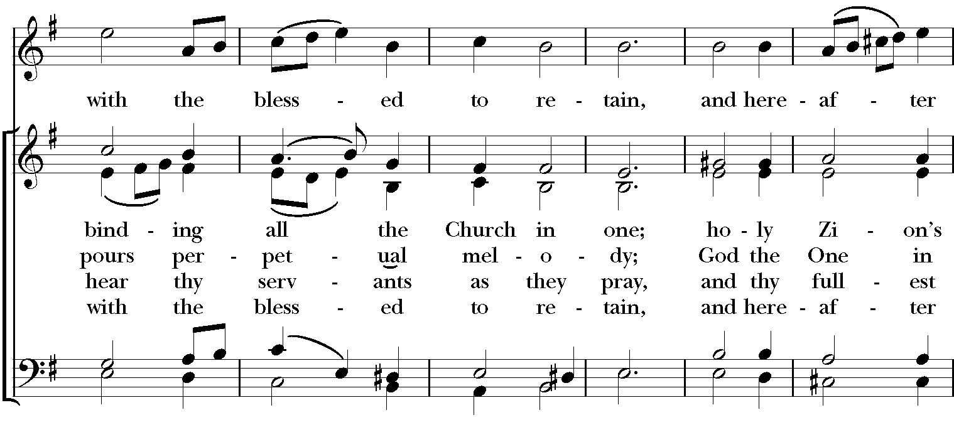
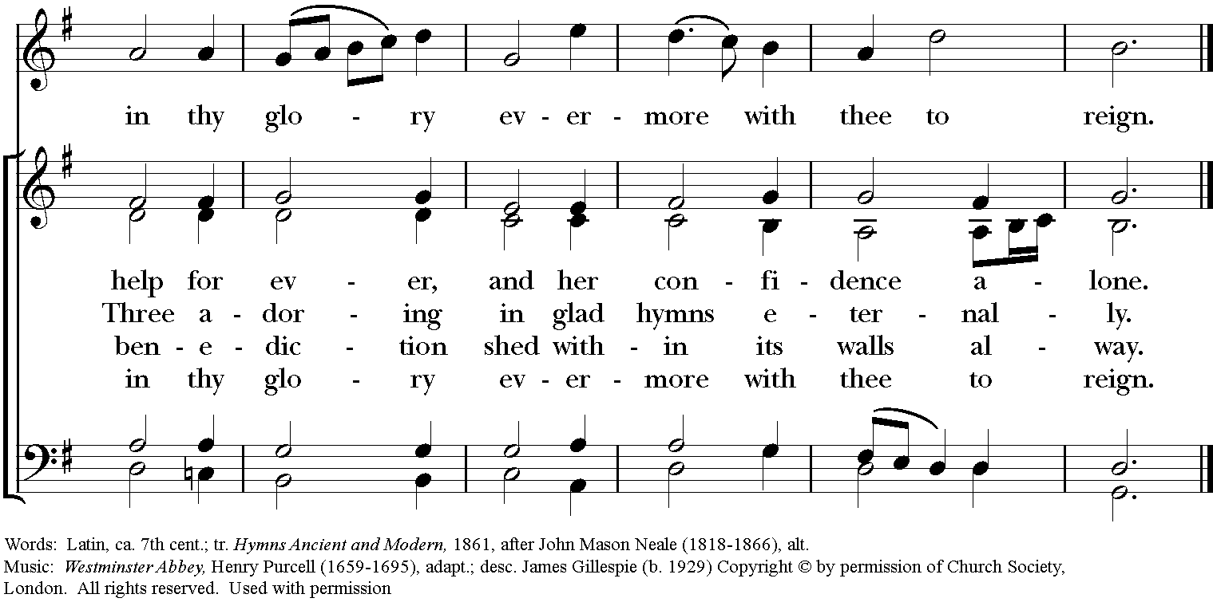
Blessing
May the Spirit of truth lead you into all truth, giving you grace to confess that Jesus Christ is Lord, and to proclaim the wonderful works of God; And the blessing of God Almighty, the Fa- ther, the Son, and the Holy Spirit, be among you, and remain with you always. Amen.
Announcements
Dismissal
Deacon: Go in peace to love and serve the Lord. Alleluia, alleluia!
People: Thanks be to God! Alleluia, alleluia!
Postlude:

Thank you for your spiritual presence with us this morning!
Although we're physically apart, we are united in prayer, worship, and holy love!

Transition Priest-In-Charge: The Rev. Dr. Canon Lee Anne Reat
Deacon: The Rev. Dr. Rick Incorvati
Music Director: Dr. Chris Durrenberger
Guest Speaker: Pastor Cynthia Atwater
Guest Organist: Kent Brooks
Lector: Anne Strothman
Singers: Liz Wheeler, Joy Carter, Ed Hasecke, Fred Bartenstein
Technology: Steve Ide
Slideshow: Ed Hasecke
Parish Administrator and Program Coordinator: Kelly Zeller
Coffee Hour Host: Fred Bartenstein

