Christ Episcopal Church in Springfield, Ohio
Service of the Word
September 20th, 2020 at 9 am: Sixteenth Sunday after Pentecost
Note: We invite you to light a candle on your table or home altar before worship begins.

Prelude: "There Is a Balm in Gilead" - African American Spiritual

Opening Hymn: “God is Love” Hymnal 577
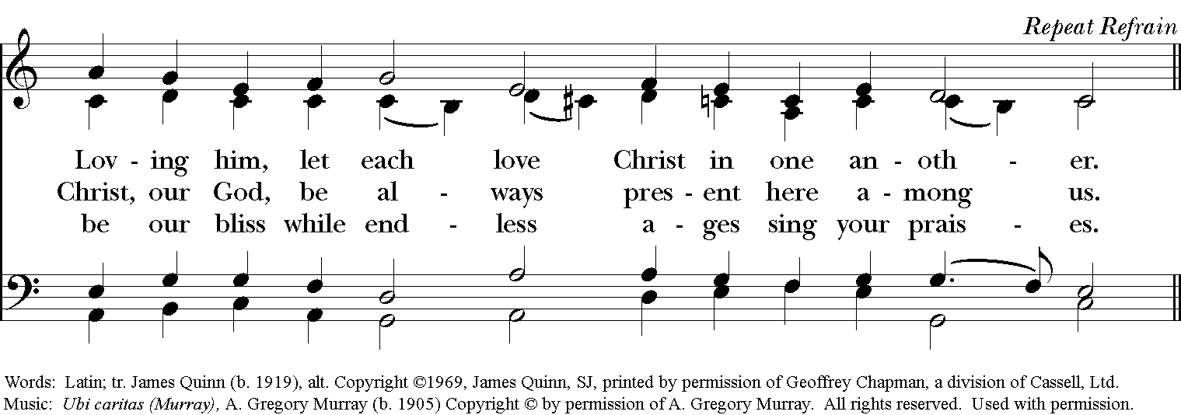
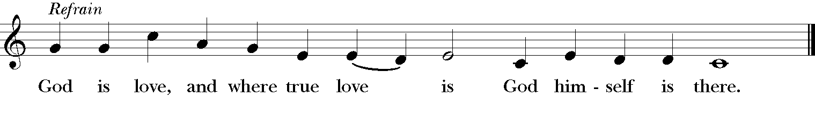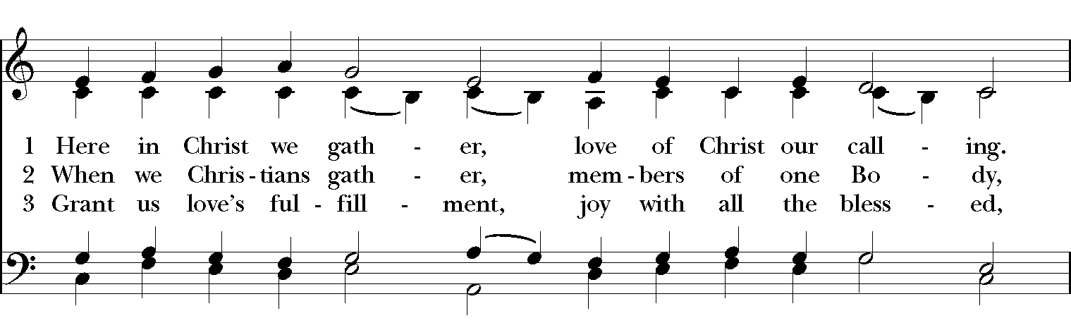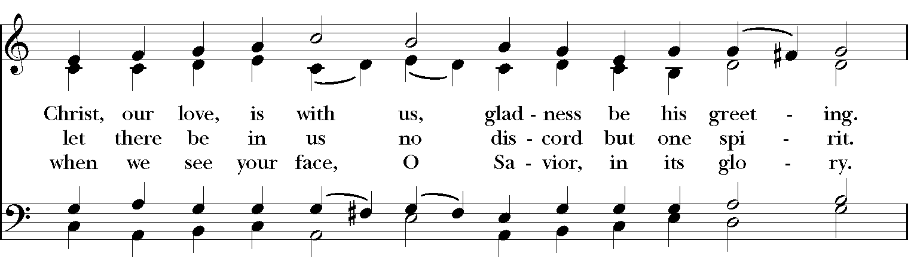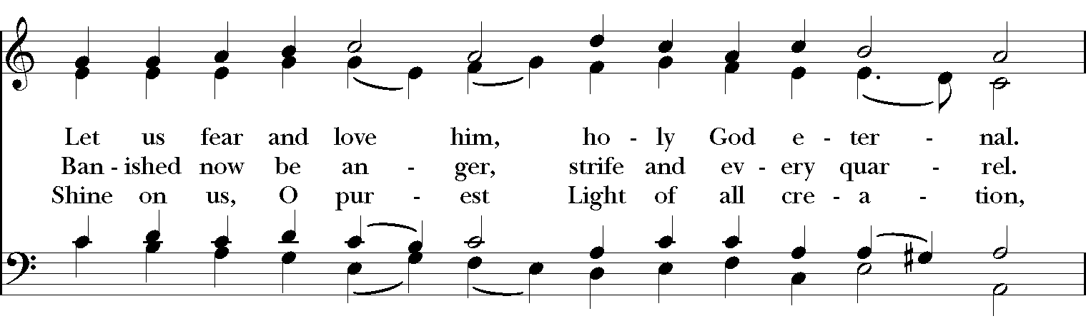

Celebrant: Blessed be God: Father, Son, and Holy Spirit.
People: And blessed be God’s kingdom, now and for ever. Amen.

Celebrant: Lord, have mercy.
People: Christ, have mercy.
Celebrant: Lord, have mercy.

The Collect of the Day

Celebrant: The Lord be with you.
People: And also with you.
Celebrant: Let us pray.

Grant us, Lord, not to be anxious about earthly things, but to love things heavenly; and even now, while we are placed among things that are passing away, to hold fast to those that shall endure; through Jesus Christ our Lord, who lives and reigns with you and the Holy Spirit, one God, for ever and ever. Amen.

The Lessons

The First Reading: Exodus 16:2-15
The whole congregation of the Israelites complained against Moses and Aaron in the wilderness. The Israelites said to them, “If only we had died by the hand of the Lord in the land of Egypt, when we sat by the fleshpots and ate our fill of bread; for you have brought us out into this wilderness to kill this whole assembly with hunger.”

Then the Lord said to Moses, “I am going to rain bread from heaven for you, and each day the people shall go out and gather enough for that day. In that way I will test them, whether they will follow my instruction or not. On the sixth day, when they prepare what they bring in, it will be twice as much as they gather on other days.” So Moses and Aaron said to all the Israelites, “In the evening you shall know that it was the Lord who brought you out of the land of Egypt, and in the morning you shall see the glory of the Lord, because he has heard your complaining against the Lord. For what are we, that you complain against us?” And Moses said, “When the Lord gives you meat to eat in the evening and your fill of bread in the morning, because the Lord has heard the complaining that you utter against him—what are we? Your complaining is not against us but against the Lord.”

Then Moses said to Aaron, “Say to the whole congregation of the Israelites, ‘Draw near to the Lord, for he has heard your complaining.’“ And as Aaron spoke to the whole congregation of the Israelites, they looked toward the wilderness, and the glory of the Lord appeared in the cloud. The Lord spoke to Moses and said, “I have heard the complaining of the Israelites; say to them, ‘At twilight you shall eat meat, and in the morning you shall have your fill of bread; then you shall know that I am the Lord your God.’“
In the evening quails came up and covered the camp; and in the morning there was a layer of dew around the camp. When the layer of dew lifted, there on the surface of the wilderness was a fine flaky substance, as fine as frost on the ground. When the Israelites saw it, they said to one another, “What is it?” For they did not know what it was. Moses said to them, “It is the bread that the Lord has given you to eat.

Reader: The Word of the Lord.
People: Thanks be to God.

Psalm 105:1-6, 37-45 Confitemini Domino
1 Give thanks to the Lord and call upon his Name; *
make known his deeds among the peoples.
2 Sing to him, sing praises to him, *
and speak of all his marvelous works.
3 Glory in his holy Name; *
let the hearts of those who seek the Lord rejoice.
4 Search for the Lord and his strength; *
continually seek his face.
5 Remember the marvels he has done, *
his wonders and the judgments of his mouth,
6 O offspring of Abraham his servant, *
O children of Jacob his chosen.
37 He led out his people with silver and gold; *
in all their tribes there was not one that stumbled.
38 Egypt was glad of their going, *
because they were afraid of them.
39 He spread out a cloud for a covering *
and a fire to give light in the night season.
40 They asked, and quails appeared, *
and he satisfied them with bread from heaven.
41 He opened the rock, and water flowed, *
so the river ran in the dry places.
42. For God remembered his holy word *
and Abraham his servant.
43 So he led forth his people with gladness, *
his chosen with shouts of joy.
44 He gave his people the lands of the nations, *
and they took the fruit of others' toil,
45 That they might keep his statutes *
and observe his laws.
Hallelujah!

Second Lesson: Philippians 1:21-30

To me, living is Christ and dying is gain. If I am to live in the flesh, that means fruitful labor for me; and I do not know which I prefer. I am hard pressed between the two: my desire is to depart and be with Christ, for that is far better; but to remain in the flesh is more necessary for you. Since I am convinced of this, I know that I will remain and continue with all of you for your progress and joy in faith, so that I may share abundantly in your boasting in Christ Jesus when I come to you again.

Only, live your life in a manner worthy of the gospel of Christ, so that, whether I come and see you or am absent and hear about you, I will know that you are standing firm in one spirit, striving side by side with one mind for the faith of the gospel, and are in no way intimidated by your opponents. For them this is evidence of their destruction, but of your salvation. And this is God's doing. For he has graciously granted you the privilege not only of believing in Christ, but of suffering for him as well-- since you are having the same struggle that you saw I had and now hear that I still have.

Reader: The Word of the Lord.
People: Thanks be to God.

Sequence Hymn: “O Praise Ye the Lord” Hymnal 432
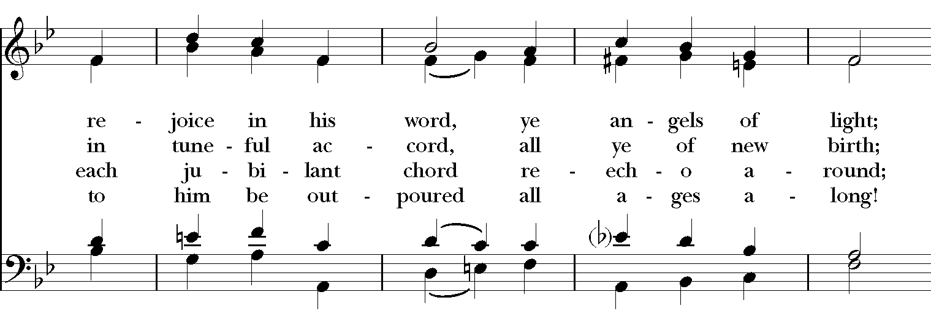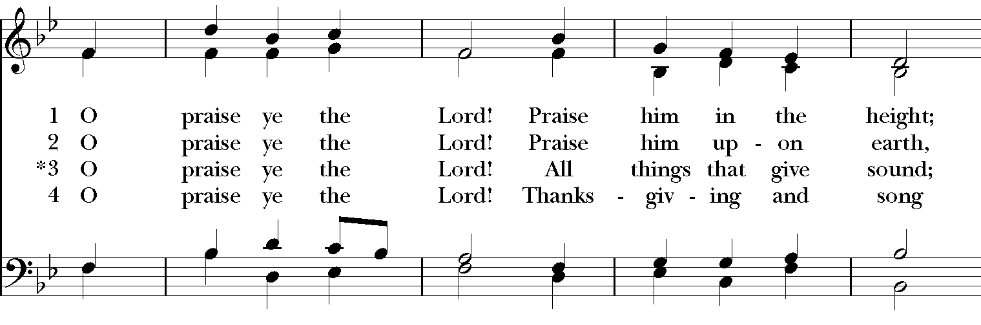
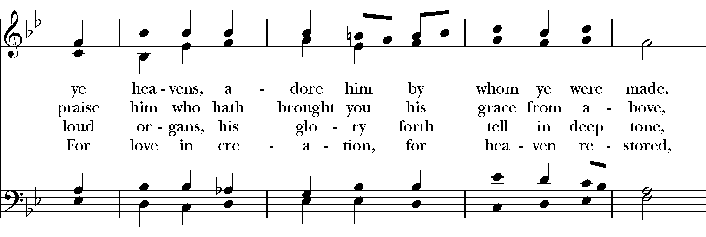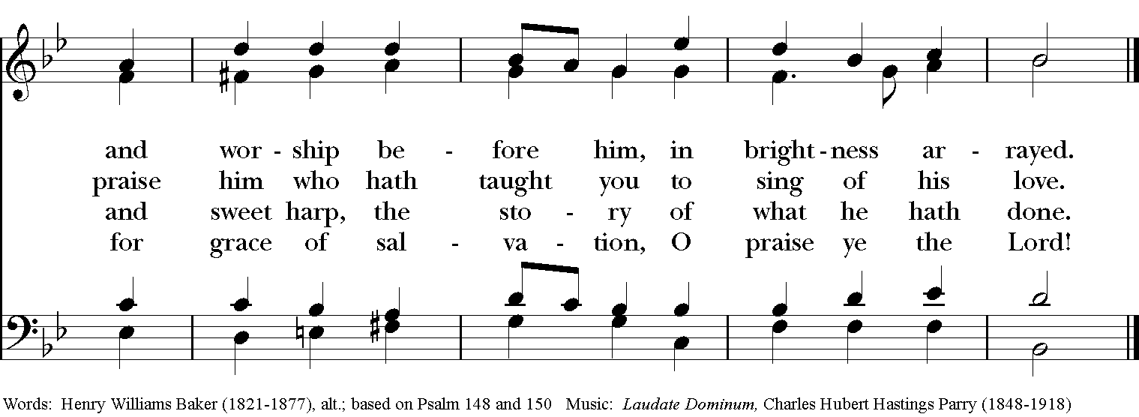

Gospel
Deacon: The Holy Gospel According to Matthew (20:1-16)
People: Glory to you, Lord Christ.
Jesus said, “The kingdom of heaven is like a landowner who went out early in the morning to hire laborers for his vineyard. After agreeing with the laborers for the usual daily wage, he sent them into his vineyard. When he went out about nine o’clock, he saw others standing idle in the marketplace; and he said to them, ‘You also go into the vineyard, and I will pay you whatever is right.’ So they went. When he went out again about noon and about three o’clock, he did the same. And about five o’clock he went out and found others standing around; and he said to them, ‘Why are you standing here idle all day?’ They said to him, ‘Because no one has hired us.’ He said to them, ‘You also go into the vineyard.’ When evening came, the owner of the vineyard said to his manager, ‘Call the laborers and give them their pay, beginning with the last and then going to the first.’ When those hired about five o’clock came, each of them received the usual daily wage. Now when the first came, they thought they would receive more; but each of them also received the usual daily wage. And when they received it, they grumbled against the landowner, saying, ‘These last worked only one hour, and you have made them equal to us who have borne the burden of the day and the scorching heat.’ But he replied to one of them, ‘Friend, I am doing you no wrong; did you not agree with me for the usual daily wage? Take what belongs to you and go; I choose to give to this last the same as I give to you. Am I not allowed to do what I choose with what belongs to me? Or are you envious because I am generous?’ So the last will be first, and the first will be last.”

Deacon: The Gospel of the Lord.
People: Praise to you, Lord Christ.

A reflection on the Scripture is offered by The Rev. Dr. Peggy Turner

The Nicene Creed

We believe in one God,
the Father, the Almighty,
the maker of heaven and earth,
of all that is, seen and unseen.
We believe in one Lord, Jesus Christ,
the only Son of God,
eternally begotten of the Father,
God from God, Light from Light,
true God from true God,
begotten, not made,
of one Being with the Father.
Through him all things were made.
For us and for our salvation
he came down from heaven:
by the power of the Holy Spirit
he became incarnate from the Virgin Mary,
and was made man.
For our sake he was crucified under Pontius Pilate;
he suffered death and was buried.
On the third day he rose again
in accordance with the Scriptures;
He ascended into heaven
and is seated on the right hand of the Father.
He will come again in glory to judge the living and the dead,
and his kingdom will have no end.

We believe in the Holy Spirit, the Lord, the giver of life,
who proceeds from the Father and the Son.
With the Father and the Son he is worshiped and glorified.
He has spoken through the Prophets.
We believe in one holy catholic and apostolic Church.
We acknowledge one baptism for the forgiveness of sins.
We look for the resurrection of the dead,
and the life of the world to come. Amen.

The Prayers of the People

In peace, we pray to you Lord God.

Silence

For all people in their daily life and work; especially Children’s Rescue /The Ark, Christ Church Food Pantry, The Fuller Center for Housing, and Safe Harbor House.
For our families, friends, and neighbors, and for those who are alone.

For this community, the nation, and the world;
For all who work for justice, freedom, and peace.

For the just and proper use of your creation;
For the victims of hunger, fear, injustice, and oppression.

For all who are in danger, sorrow, or any kind of trouble;
For those who minister to the sick, the friendless, and the needy.

For the peace and unity of the Church of God;
For all who proclaim the Gospel, and all who seek the Truth.

For Michael, our Presiding Bishop, and Thomas, our Bishop; and all bishops and other ministers;
For all who serve God in his Church.

For the special needs and concerns of this congregation.
Laura, Bonnie, Alice, Joy, Diana, James, Joy, Jane, Joni, Kim, Bobby, Ruth, Larry, Sarah, Traudie, Lexie, Norm, and Keith.
May they remember that you are with them and those who care for them.

Hear us, Lord;
For your mercy is great.

We than you, Lord, for all the blessings of this life, especially the birthdays of
Madison, Dawn, D.J., and anniversaries Dana & Cathy and Chris & Jennifer.

We will exalt you, O God our King;
And praise your Name for ever and ever.

We pray for all who have died, that they may have a place in your eternal kingdom.

Lord, let your loving kindness be upon them;
Who put their trust in you.

We pray to you also for the forgiveness of our sins.
Have mercy upon us, most merciful Father;
in your compassion forgive us our sins,
known and unknown,
things done and left undone;
and so uphold us by your Spirit
that we may live and serve you in newness of life,
to the honor and glory of your Name;
through Jesus Christ our Lord. Amen.

Priest: Almighty and eternal God, ruler of all things in heaven and earth: Mercifully accept the prayers of your people, and strengthen us to do your will; through Jesus Christ our Lord. Amen.

And now, as our Savior Christ has taught us, we are bold to say:

Our Father, who art in heaven, hallowed be thy Name,
thy kingdom come, thy will be done, on earth as it is in heaven.
Give us this day our daily bread.
And forgive us our trespasses, as we forgive those who trespass against us.
And lead us not into temptation, but deliver us from evil.
For thine is the kingdom, and the power, and the glory, for ever and ever. Amen.

Closing Hymn: “Strengthen For Service” Hymnal 312

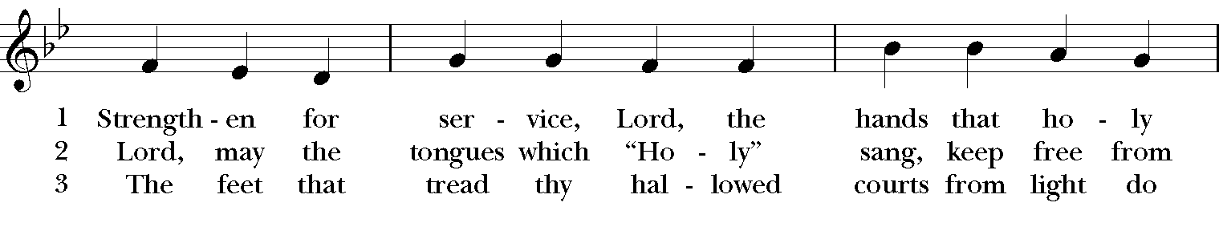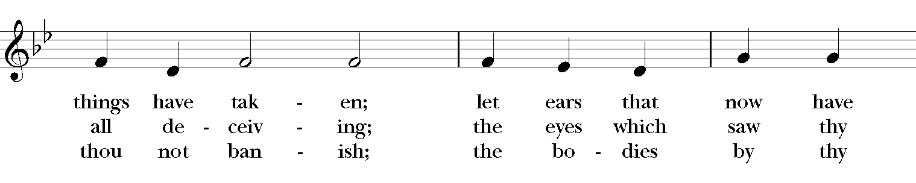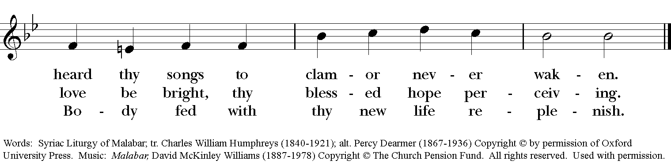

Blessing
May the Spirit of truth lead you into all truth, giving you grace to confess that Jesus Christ is Lord, and to proclaim the wonderful works of God; And the blessing of God Almighty, the Fa- ther, the Son, and the Holy Spirit, be among you, and remain with you always. Amen.
Announcements
Dismissal
Deacon: Go in peace to love and serve the Lord. Alleluia, alleluia!
People: Thanks be to God! Alleluia, alleluia!

Postlude: "Let There Be Peace on Earth" by Jill Jackson & Sy Miller

Thank you for your spiritual presence with us this morning!
Although we're physically apart, we are united in prayer, worship, and holy love!

Transition Priest-In-Charge: The Rev. Dr. Canon Lee Anne Reat
Deacon: The Rev. Dr. Rick Incorvati
Guest Speaker: The Rev. Dr. Peggy Turner
Guest Organist: Kent Brooks
Lector: Fred Bartenstein
Singers: Liz Wheeler, Joy Carter, Ed Hasecke, Fred Bartenstein
Technology: Steve Ide
Slideshow: Ed Hasecke
Parish Administrator and Program Coordinator: Kelly Zeller
Coffee Hour Host: Fred Bartenstein

