Christ Episcopal Church in Springfield, Ohio
Service of the Word
Eighteenth Sunday after Pentecost: September 26th, 2021 at 9 am

PRELUDE: “Come Down, O Love Divine“ - Down Ampney/arr. Callahan

Opening Hymn: “Shepherd of Souls” Hymnal 343
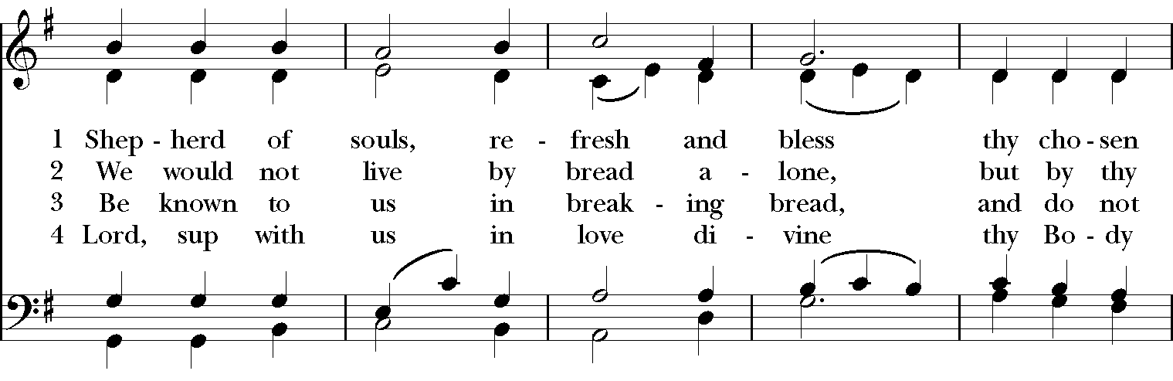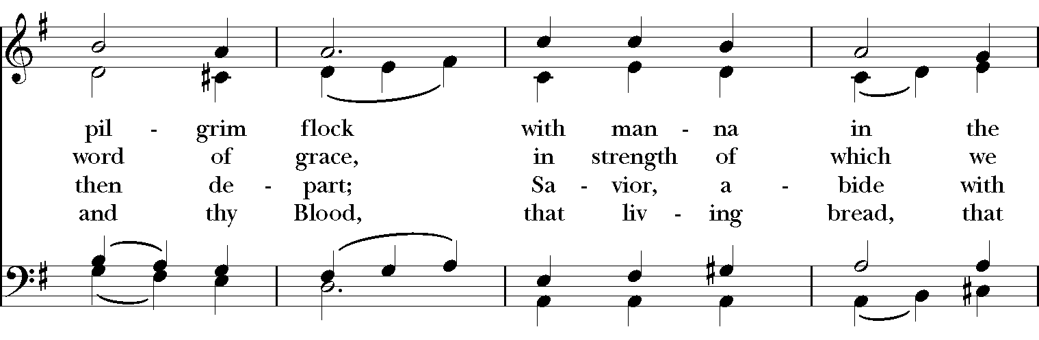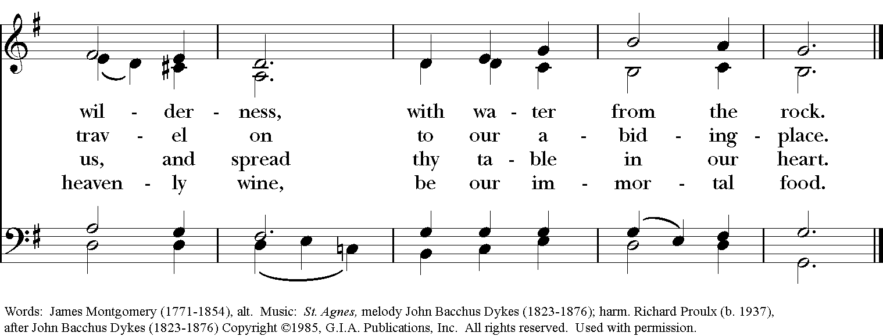

Celebrant: Blessed be God: Father, Son, and Holy Spirit.
People: And blessed be his kingdom, now and for ever. Amen.

The Collect of the Day
Celebrant: The Lord be with you.
People: And also with you.
Celebrant: Let us pray.
O God, you declare your almighty power chiefly in showing mercy and pity: Grant us the fullness of your grace, that we, running to obtain your promises, may become partakers of your heavenly treasure; through Jesus Christ our Lord, who lives and reigns with you and the Holy Spirit, one God, for ever and ever. Amen.

THE LESSONS

THE FIRST READING Numbers 11:4-6, 10-16, 24-29
The rabble among them had a strong craving; and the Israelites also wept again, and said, “If only we had meat to eat! We remember the fish we used to eat in Egypt for nothing, the cucumbers, the melons, the leeks, the onions, and the garlic; but now our strength is dried up, and there is nothing at all but this manna to look at.”

Moses heard the people weeping throughout their families, all at the entrances of their tents. Then the Lord became very angry, and Moses was displeased. So Moses said to the Lord, “Why have you treated your servant so badly? Why have I not found favor in your sight, that you lay the burden of all this people on me? Did I conceive all this people? Did I give birth to them, that you should say to me, ‘Carry them in your bosom, as a nurse carries a sucking child,’ to the land that you promised on oath to their ancestors? Where am I to get meat to give to all this people? For they come weeping to me and say, ‘Give us meat to eat!’ I am not able to carry all this people alone, for they are too heavy for me. If this is the way you are going to treat me, put me to death at once—if I have found favor in your sight—and do not let me see my misery.”

So the Lord said to Moses, “Gather for me seventy of the elders of Israel, whom you know to be the elders of the people and officers over them; bring them to the tent of meeting, and have them take their place there with you.

So Moses went out and told the people the words of the Lord; and he gathered seventy elders of the people, and placed them all around the tent. Then the Lord came down in the cloud and spoke to him, and took some of the spirit that was on him and put it on the seventy elders; and when the spirit rested upon them, they prophesied. But they did not do so again.

Two men remained in the camp, one named Eldad, and the other named Medad, and the spirit rested on them; they were among those registered, but they had not gone out to the tent, and so they prophesied in the camp. And a young man ran and told Moses, “Eldad and Medad are prophesying in the camp.” And Joshua son of Nun, the assistant of Moses, one of his chosen men, said, “My lord Moses, stop them!” But Moses said to him, “Are you jealous for my sake? Would that all the Lord’s people were prophets, and that the Lord would put his spirit on them!”
Lector: The Word of the Lord.
People: Thanks be to God.

PSALM 19:7-14 Caeli enarrant
7 The law of the Lord is perfect and revives the soul; *
the testimony of the Lord is sure and gives wisdom to the innocent.
8 The statutes of the Lord are just and rejoice the heart; *
the commandment of the Lord is clear and gives light to the eyes.
9 The fear of the Lord is clean and endures for ever; *
the judgments of the Lord are true and righteous altogether.
10 More to be desired are they than gold, more than much fine gold, *
sweeter far than honey, than honey in the comb.
11 By them also is your servant enlightened, *
and in keeping them there is great reward.
12 Who can tell how often he offends? *
cleanse me from my secret faults.
13 Above all, keep your servant from presumptuous sins;
let them not get dominion over me; *
then shall I be whole and sound, and innocent of a great offense.
14 Let the words of my mouth and the meditation of my heart
be acceptable in your sight, *
O Lord, my strength and my redeemer.

THE SECOND LESSON James 5:13-20
Are any among you suffering? They should pray. Are any cheerful? They should sing songs of praise. Are any among you sick? They should call for the elders of the church and have them pray over them, anointing them with oil in the name of the Lord. The prayer of faith will save the sick, and the Lord will raise them up; and anyone who has committed sins will be forgiven. Therefore confess your sins to one another, and pray for one another, so that you may be healed. The prayer of the righteous is powerful and effective. Elijah was a human being like us, and he prayed fervently that it might not rain, and for three years and six months it did not rain on the earth. Then he prayed again, and the heaven gave rain and the earth yielded its harvest.

My brothers and sisters, if anyone among you wanders from the truth and is brought back by another, you should know that whoever brings back a sinner from wandering will save the sinner's soul from death and will cover a multitude of sins.
Lector: The Word of the Lord.
People: Thanks be to God.
SQUENCE HYMN: “How Sweet the name of Jesus sounds ” Hymnal 644
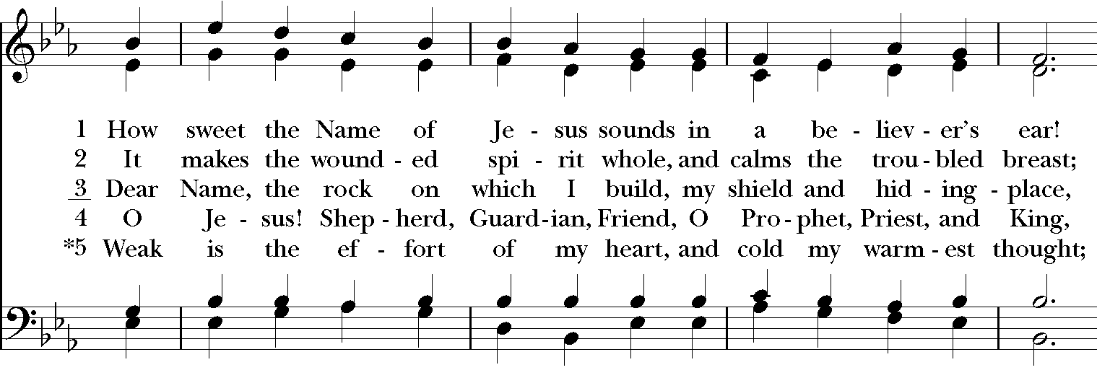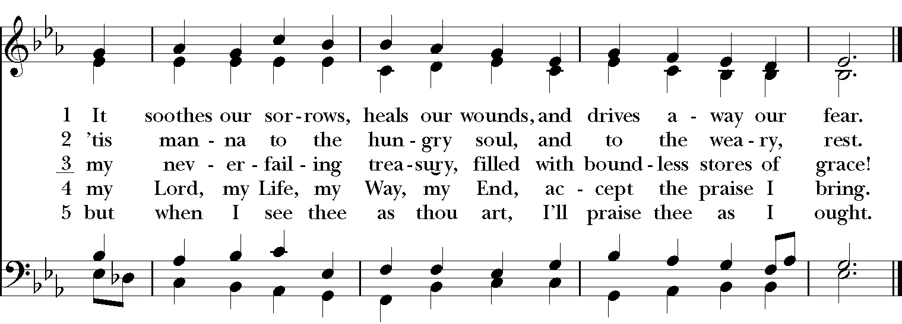
GOSPEL
Celebrant: The Holy Gospel of our Lord Jesus Christ according to Mark (Mark 9:38-50).
People: Glory to you, Lord Christ.
John said to Jesus, “Teacher, we saw someone casting out demons in your name, and we tried to stop him, because he was not following us.” But Jesus said, “Do not stop him; for no one who does a deed of power in my name will be able soon afterward to speak evil of me. Whoever is not against us is for us. For truly I tell you, whoever gives you a cup of water to drink because you bear the name of Christ will by no means lose the reward.

“If any of you put a stumbling block before one of these little ones who believe in me, it would be better for you if a great millstone were hung around your neck and you were thrown into the sea. If your hand causes you to stumble, cut it off; it is better for you to enter life maimed than to have two hands and to go to hell, to the unquenchable fire. And if your foot causes you to stumble, cut it off; it is better for you to enter life lame than to have two feet and to be thrown into hell. And if your eye causes you to stumble, tear it out; it is better for you to enter the kingdom of God with one eye than to have two eyes and to be thrown into hell, where their worm never dies, and the fire is never quenched.

“For everyone will be salted with fire. Salt is good; but if salt has lost its saltiness, how can you season it? Have salt in yourselves, and be at peace with one another.”
Celebrant: The Gospel of the Lord.
People: Praise to you, Lord Christ.

Sermon The Rev. Canon Dr. Lee Anne Reat
The Nicene Creed
We believe in one God, the Father, the Almighty,
maker of heaven and earth, of all that is, seen and unseen.
We believe in one Lord, Jesus Christ, the only Son of God,
eternally begotten of the Father, God from God,
Light from Light, true God from true God,
begotten, not made, of one Being with the Father.
Through him all things were made.
For us and for our salvation he came down from heaven,
by the power of the Holy Spirit he became incarnate from the Virgin Mary,
and was made man.
For our sake he was crucified under Pontius Pilate;
he suffered death and was buried.
On the third day he rose again in accordance with the Scriptures;
he ascended into heaven and is seated at the right hand of the Father.
He will come again in glory to judge the living and the dead, and his kingdom will have no end.
We believe in the Holy Spirit, the Lord, the giver of life,
who proceeds from the Father, and the Son.
With the Father and the Son he is worshiped and glorified,
he has spoken through the Prophets.
We believe in one holy catholic and apostolic Church.
We acknowledge one baptism for the forgiveness of sins.
We look for the resurrection of the dead, and the life of the world to come. Amen.

THE PRAYERS OF THE PEOPLE

In peace, we pray to you Lord God. Congregational responses are in bold.
Silence

Giver of every good gift, we thank you for your generosity in giving us more than we can ask or imagine.

Give grace to church leaders, especially Justin, Archbishop of Canterbury; Michael, our presiding bishop; Wayne, our provisional diocesan bishop; Lee Anne, our priest; and members of the vestry. In your time, send us the priest this church needs.
R: Giver of every good gift, grant grace.

Give wisdom to world leaders in a time of pandemic and natural disasters. Give special grace to refugees and those seeking justice.
R: Giver of every good gift, grant wisdom.

Give hope to those suffering any illness or affliction, especially Leigh, Charlene, Faye, Chris, Bonnie, Alice, Diana, James, Joy, Jane, Joni, Kim, Bobby, Sarah, Traudie, Lexie, and Keith.
R: Giver of every good gift, grant hope.

Give strength to those laboring in the ministries we support as a church especially Clark County Literacy Coalition, Episcopal Community Ministries, Second Harvest Food Bank, and Interfaith Hospitality Network.
R: Giver of every good gift, grant strength.

Give joy to those celebrating birthdays this week, especially Myra Dean, Chris, Jake, Jeannie, Marilee, and Diana.
R: Giver of every good gift, grant joy.

Grant peace and light to those who have died and comfort to those who grieve.
R: Giver of every good gift, in the midst of loss grant hope.

*THE COLLECT FOR PEACE
Grant, O God, that your holy and life-giving Spirit may so move every human heart, that barriers which divide us may crumble, suspicions disappear, and hatreds cease; that our divisions being healed, we may live in justice and peace; through Jesus Christ our Lord. Amen.

THE CONFESSION AND ABSOLUTION
Priest: Let us confess our sins against God and our neighbor.
All: Most merciful God, we confess that we have sinned against you in thought, word, and deed, by what we have done, and by what we have left undone. We have not loved you with our whole heart; we have not loved our neighbors as ourselves. We are truly sorry and we humbly repent. For the sake of your Son Jesus Christ, have mercy on us and forgive us; that we may delight in your will, and walk in your ways, to the glory of your Name. Amen.

Priest: Almighty God, have mercy on you, forgive you all your sins through our Lord Jesus Christ, strengthen you in all goodness, and by the power of the Holy Spirit keep you in eternal life. Amen.

And now, as our Savior Christ has taught us, we are bold to say:
Our Father, who art in heaven, hallowed be thy Name,
thy kingdom come, thy will be done, on earth as it is in heaven.
Give us this day our daily bread.
And forgive us our trespasses, as we forgive those who trespass against us.
And lead us not into temptation, but deliver us from evil.
For thine is the kingdom, and the power, and the glory, for ever and ever. Amen

CLOSING HYMN: “At the name of Jesus” Hymnal 435 Vs. 1-14
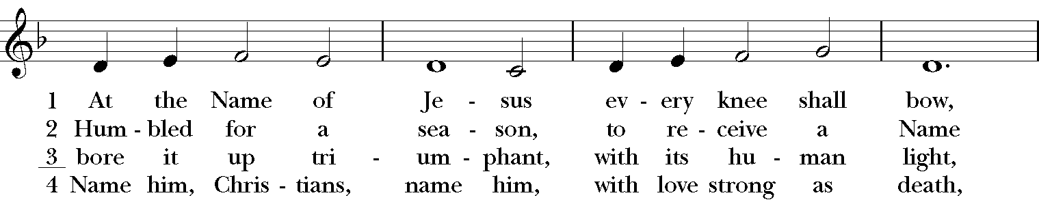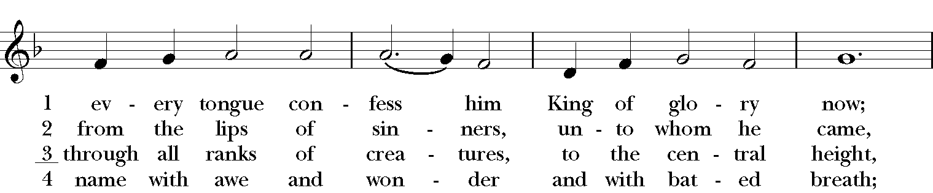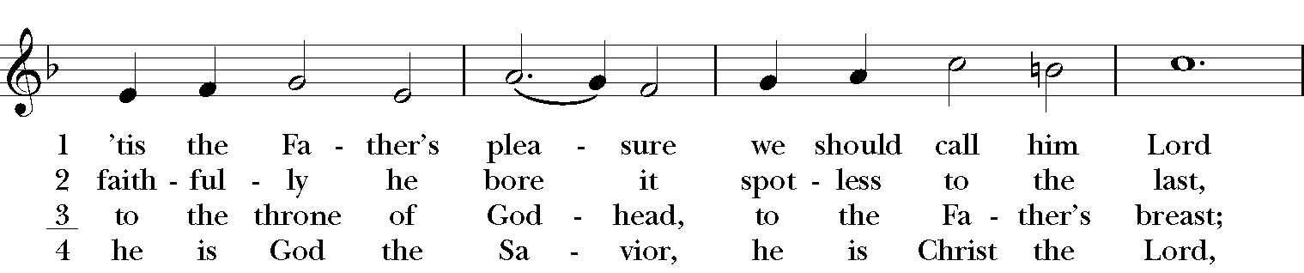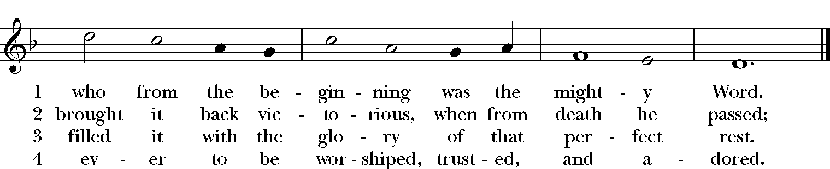

*THE BLESSING
Christ who has nourished us with himself the living bread, make you one in praise and love, and raise you up at the last day; and the blessing God Almighty, the Father, the Son, and the Holy Spirit, be among you, and remain with you always. Amen.
ANNOUNCEMENTS

*THE DISMISSAL Celebrant: Go in peace to love and serve the Lord.
People: Thanks be to God.

POSTLUDE: Meditation on “Hamburg” - Mason/arr. Callahan

Thank you for your spiritual presence with us this morning!
Although we're physically apart, we are united in prayer, worship, and holy love!
Priest-In-Charge: The Rev. Dr. Canon Lee Anne Reat
Music Director: Dr. Chris Durrenberger
Lector: Keith Doubt
Singers: Liz Wheeler, Joy Carter, Basil Fett, Chris Oldstone-Moore, and Fred Bartenstein
Technology: Steve Ide
Slideshow: Ed Hasecke
Parish Administrator and Program Coordinator: Kelly Zeller

