Christ Episcopal Church in Springfield, Ohio
Service of the Word
September 27th, 2020 at 9 am: Seventeenth Sunday after Pentecost
Note: We invite you to light a candle on your table or home altar before worship begins.

Prelude:

Opening Hymn: “Shepherd of Souls” Hymnal 343
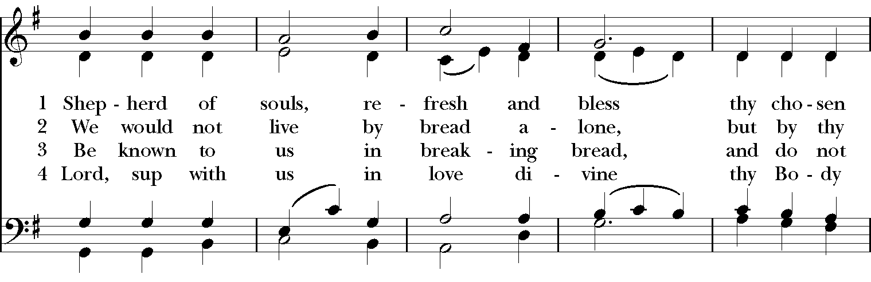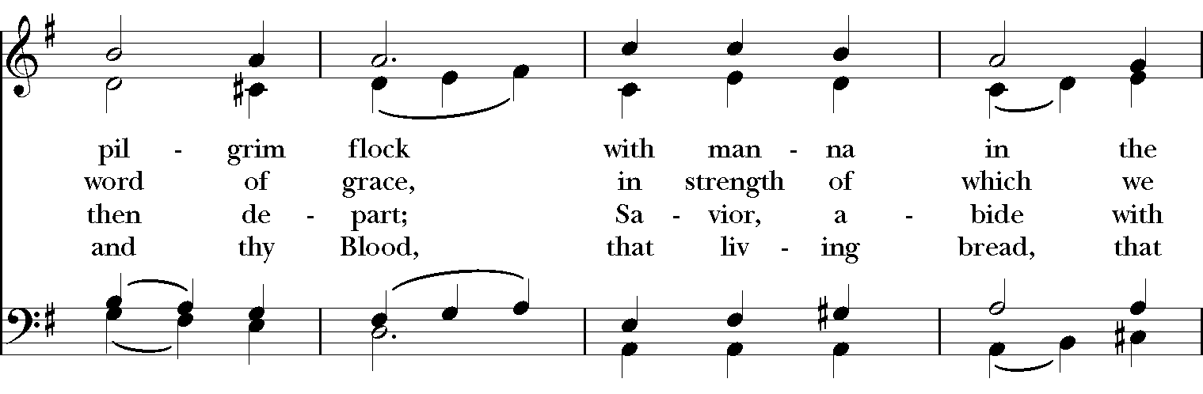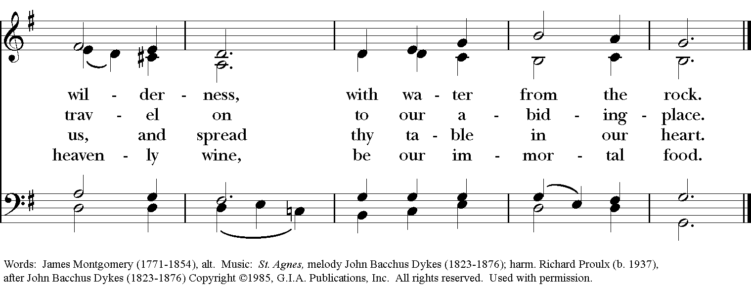

Celebrant: Blessed be God: Father, Son, and Holy Spirit.
People: And blessed be God’s kingdom, now and for ever. Amen.

Celebrant: Lord, have mercy.
People: Christ, have mercy.
Celebrant: Lord, have mercy.

The Collect of the Day

Celebrant: The Lord be with you.
People: And also with you.
Celebrant: Let us pray.

O God, you declare your almighty power chiefly in showing mercy and pity: Grant us the fullness of your grace, that we, running to obtain your promises, may become partakers of your heavenly treasure; through Jesus Christ our Lord, who lives and reigns with you and the Holy Spirit, one God, for ever and ever. Amen.

The Lessons

The First Reading: Ezekiel 18:1-4, 25-32

The word of the Lord came to me: What do you mean by repeating this proverb concerning the land of Israel, “The parents have eaten sour grapes, and the children’s teeth are set on edge”? As I live, says the Lord God, this proverb shall no more be used by you in Israel. Know that all lives are mine; the life of the parent as well as the life of the child is mine: it is only the person who sins that shall die.

Yet you say, “The way of the Lord is unfair.” Hear now, O house of Israel: Is my way unfair? Is it not your ways that are unfair? When the righteous turn away from their righteousness and commit iniquity, they shall die for it; for the iniquity that they have committed they shall die. Again, when the wicked turn away from the wickedness they have committed and do what is lawful and right, they shall save their life. Because they considered and turned away from all the transgressions that they had committed, they shall surely live; they shall not die. Yet the house of Israel says, “The way of the Lord is unfair.” O house of Israel, are my ways unfair? Is it not your ways that are unfair?

Therefore I will judge you, O house of Israel, all of you according to your ways, says the Lord God. Repent and turn from all your transgressions; otherwise iniquity will be your ruin. Cast away from you all the transgressions that you have committed against me, and get yourselves a new heart and a new spirit! Why will you die, O house of Israel? For I have no pleasure in the death of anyone, says the Lord God. Turn, then, and live.
Reader: The Word of the Lord.
People: Thanks be to God.

Psalm 25:1-8 Ad te, Domine, levavi
1 To you, O Lord, I lift up my soul; my God, I put my trust in you; *
let me not be humiliated, nor let my enemies triumph over me.
2 Let none who look to you be put to shame; *
let the treacherous be disappointed in their schemes.
3 Show me your ways, O Lord, *
and teach me your paths.
4 Lead me in your truth and teach me, *
for you are the God of my salvation; in you have I trusted all the day long.
5 Remember, O Lord, your compassion and love, *
for they are from everlasting.
6 Remember not the sins of my youth and my transgressions; *
remember me according to your love and for the sake of your goodness, O Lord.
7 Gracious and upright is the Lord; *
therefore he teaches sinners in his way.
8 He guides the humble in doing right *
and teaches his way to the lowly.

Second Lesson: Philippians 2:1-13

If then there is any encouragement in Christ, any consolation from love, any sharing in the Spirit, any compassion and sympathy, make my joy complete: be of the same mind, having the same love, being in full accord and of one mind. Do nothing from selfish ambition or conceit, but in humility regard others as better than yourselves. Let each of you look not to your own interests, but to the interests of others. Let the same mind be in you that was in Christ Jesus,

who, though he was in the form of God,
did not regard equality with God
as something to be exploited,

but emptied himself,
taking the form of a slave,
being born in human likeness.

And being found in human form,
he humbled himself
and became obedient to the point of death--
even death on a cross.

Therefore God also highly exalted him
and gave him the name
that is above every name,

so that at the name of Jesus
every knee should bend,
in heaven and on earth and under the earth,

and every tongue should confess
that Jesus Christ is Lord,
to the glory of God the Father.

Therefore, my beloved, just as you have always obeyed me, not only in my presence, but much more now in my absence, work out your own salvation with fear and trembling; for it is God who is at work in you, enabling you both to will and to work for his good pleasure.

Reader: The Word of the Lord.
People: Thanks be to God.

Sequence Hymn: “When We Walk With the Lord” Hymnal LEVAS II 205

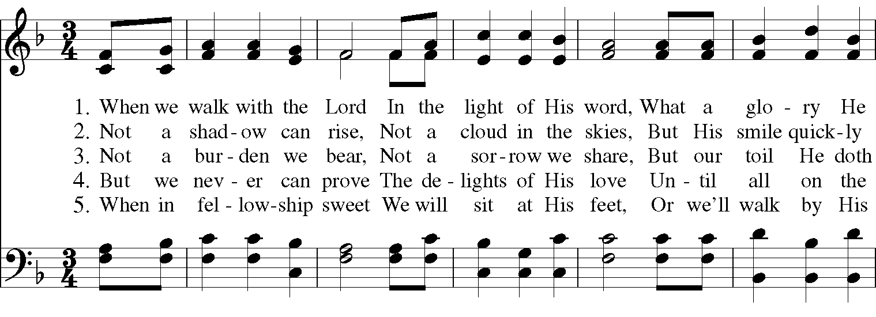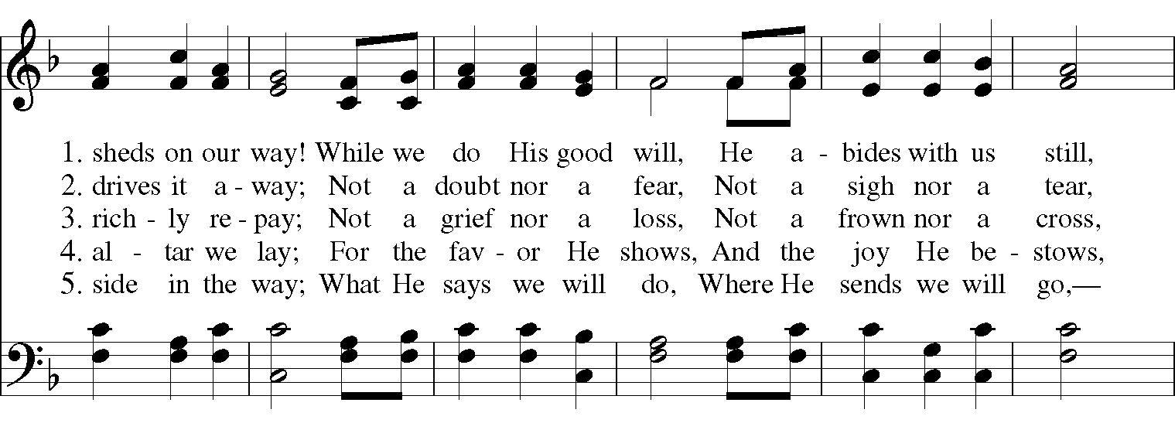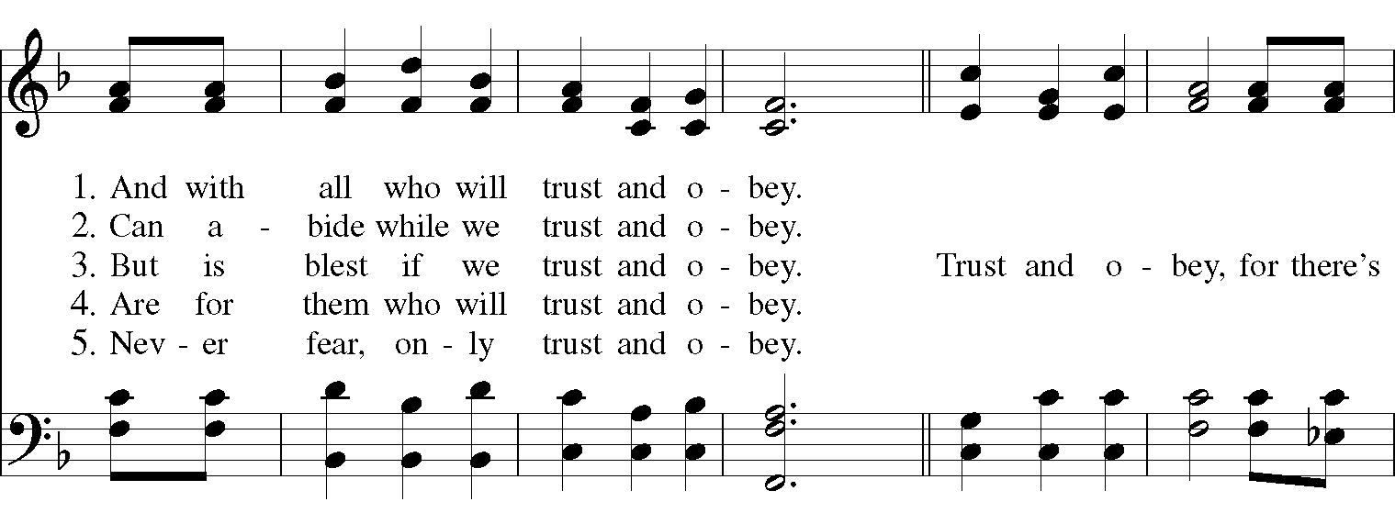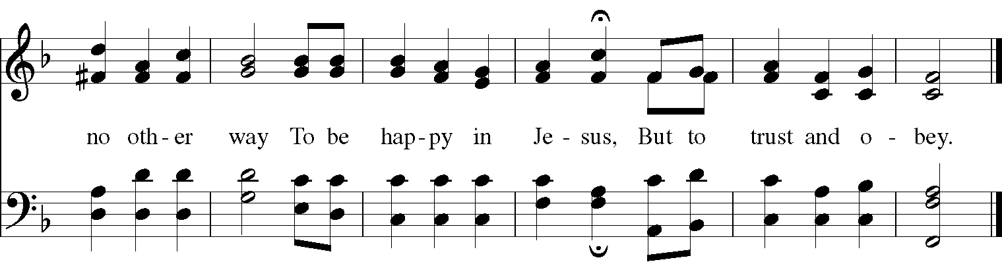

Gospel
Deacon: The Holy Gospel According to Matthew (21:23-32)
People: Glory to you, Lord Christ.
When Jesus entered the temple, the chief priests and the elders of the people came to him as he was teaching, and said, “By what authority are you doing these things, and who gave you this authority?” Jesus said to them, “I will also ask you one question; if you tell me the answer, then I will also tell you by what authority I do these things. Did the baptism of John come from heaven, or was it of human origin?” And they argued with one another, “If we say, ‘From heaven,’ he will say to us, ‘Why then did you not believe him?’ But if we say, ‘Of human origin,’ we are afraid of the crowd; for all regard John as a prophet.” So they answered Jesus, “We do not know.” And he said to them, “Neither will I tell you by what authority I am doing these things.

“What do you think? A man had two sons; he went to the first and said, ‘Son, go and work in the vineyard today.’ He answered, ‘I will not’; but later he changed his mind and went. The father went to the second and said the same; and he answered, ‘I go, sir’; but he did not go. Which of the two did the will of his father?” They said, “The first.” Jesus said to them, “Truly I tell you, the tax collectors and the prostitutes are going into the kingdom of God ahead of you. For John came to you in the way of righteousness and you did not believe him, but the tax collectors and the prostitutes believed him; and even after you saw it, you did not change your minds and believe him.

Deacon: The Gospel of the Lord.
People: Praise to you, Lord Christ.

A reflection on the Scripture is offered by Pastor Heather Husted

The Nicene Creed

We believe in one God,
the Father, the Almighty,
the maker of heaven and earth,
of all that is, seen and unseen.
We believe in one Lord, Jesus Christ,
the only Son of God,
eternally begotten of the Father,
God from God, Light from Light,
true God from true God,
begotten, not made,
of one Being with the Father.
Through him all things were made.
For us and for our salvation
he came down from heaven:
by the power of the Holy Spirit
he became incarnate from the Virgin Mary,
and was made man.
For our sake he was crucified under Pontius Pilate;
he suffered death and was buried.
On the third day he rose again
in accordance with the Scriptures;
He ascended into heaven
and is seated on the right hand of the Father.
He will come again in glory to judge the living and the dead,
and his kingdom will have no end.

We believe in the Holy Spirit, the Lord, the giver of life,
who proceeds from the Father and the Son.
With the Father and the Son he is worshiped and glorified.
He has spoken through the Prophets.
We believe in one holy catholic and apostolic Church.
We acknowledge one baptism for the forgiveness of sins.
We look for the resurrection of the dead,
and the life of the world to come. Amen.

The Prayers of the People

In peace, we pray to you Lord God.

Silence

For all people in their daily life and work; especially Clark County Literacy Coalition, Episcopal Community Ministries, Second Harvest Food Bank, and Interfaith Hospitality Network.
For our families, friends, and neighbors, and for those who are alone.

For this community, the nation, and the world;
For all who work for justice, freedom, and peace.

For the just and proper use of your creation;
For the victims of hunger, fear, injustice, and oppression.

For all who are in danger, sorrow, or any kind of trouble;
For those who minister to the sick, the friendless, and the needy.

For the peace and unity of the Church of God;
For all who proclaim the Gospel, and all who seek the Truth.

For Michael, our Presiding Bishop, and Thomas, our Bishop; and all bishops and other ministers;
For all who serve God in his Church.

For the special needs and concerns of this congregation.
Laura, Bonnie, Alice, Joy, Diana, James, Joy, Jane, Joni, Kim, Bobby, Ruth, Larry, Sarah, Traudie, Lexie, Norm, and Keith.

Hear us, Lord;
For your mercy is great.

We thank you, Lord, for all the blessings of this life, especially the birthdays of
Julie, Jim, Myra, Chris, and Jake and, especially the anniversaries Jim & Cheryl.

We will exalt you, O God our King;
And praise your Name for ever and ever.

We pray for all who have died, that they may have a place in your eternal kingdom.

Lord, let your loving kindness be upon them;
Who put their trust in you.

We pray to you also for the forgiveness of our sins.

Have mercy upon us, most merciful Father;
in your compassion forgive us our sins,
known and unknown,
things done and left undone;
and so uphold us by your Spirit
that we may live and serve you in newness of life,
to the honor and glory of your Name;
through Jesus Christ our Lord. Amen.

Priest: Almighty God, have mercy on you, forgive you all your sins through our Lord Jesus Christ, strengthen you in all goodness, and by the power of the Holy Spirit keep you in eternal life. Amen.

And now, as our Savior Christ has taught us, we are bold to say:

Our Father, who art in heaven, hallowed be thy Name,
thy kingdom come, thy will be done, on earth as it is in heaven.
Give us this day our daily bread.
And forgive us our trespasses, as we forgive those who trespass against us.
And lead us not into temptation, but deliver us from evil.
For thine is the kingdom, and the power, and the glory, for ever and ever. Amen.

Closing Hymn: “Come Thou Fount” Hymnal 686
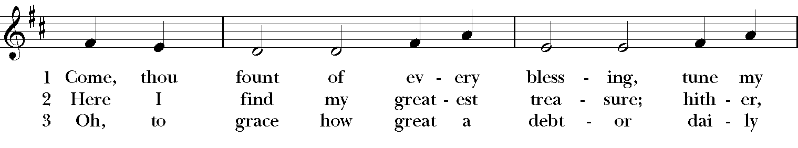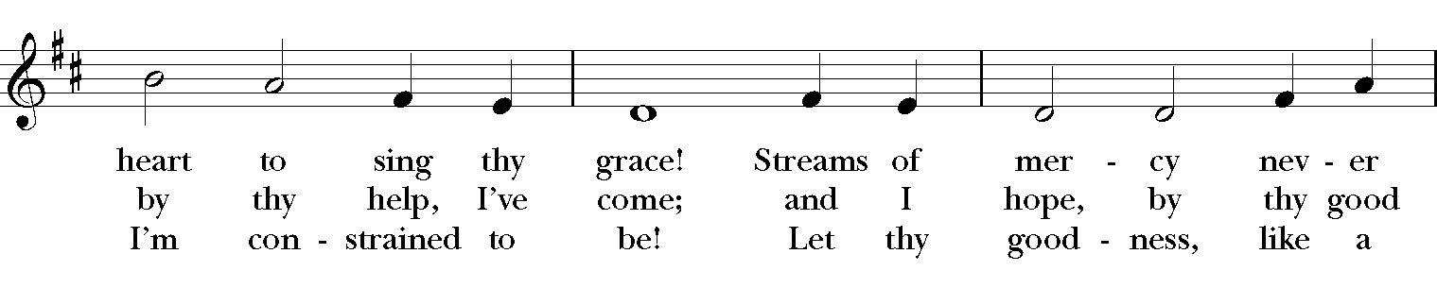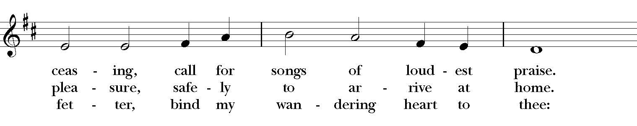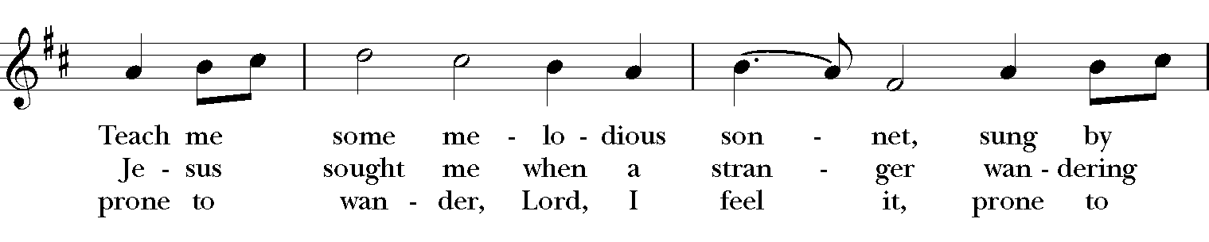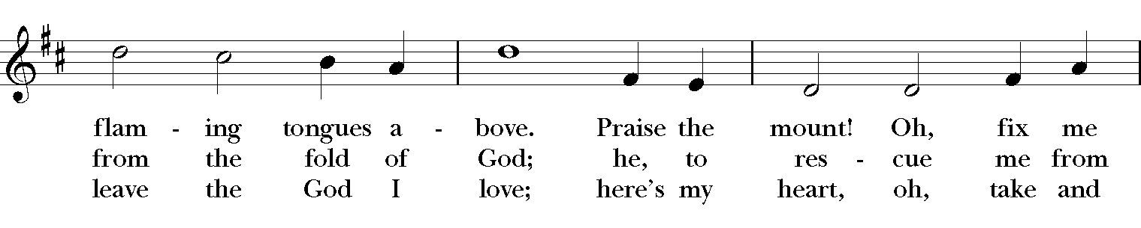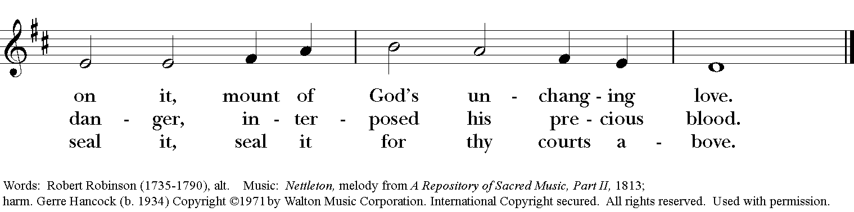

Blessing
May the Spirit of truth lead you into all truth, giving you grace to confess that Jesus Christ is Lord, and to proclaim the wonderful works of God; And the blessing of God Almighty, the Fa- ther, the Son, and the Holy Spirit, be among you, and remain with you always. Amen.
Announcements
Dismissal
Deacon: Go in peace to love and serve the Lord. Alleluia, alleluia!
People: Thanks be to God! Alleluia, alleluia!
Postlude: “Prelude in D-flat Major” opus 28 #15 - Chopin

Thank you for your spiritual presence with us this morning!
Although we're physically apart, we are united in prayer, worship, and holy love!

Transition Priest-In-Charge: The Rev. Dr. Canon Lee Anne Reat
Deacon: The Rev. Dr. Rick Incorvati
Music Director: Dr. Chris Durrenberger
Guest Speaker: Pastor Heather Husted
Guest Organist: Kent Brooks
Lector: Keith Doubt
Singers: Liz Wheeler, Joy Carter, Ed Hasecke, Fred Bartenstein
Technology: Steve Ide
Slideshow: Ed Hasecke
Parish Administrator and Program Coordinator: Kelly Zeller
Coffee Hour Host: Susan Doubt

