Christ Episcopal Church in Springfield, Ohio
Service of the Word
Twenty-fifth Sunday after Pentecost: November 14th, 2021 at 9 am

Prelude: Prelude: “Jerusalem, My Happy Home” - Land of Rest/arr. Callahan

OPENING HYMN: “Precious Lord, take my hand” Hymn LEVAS II 106

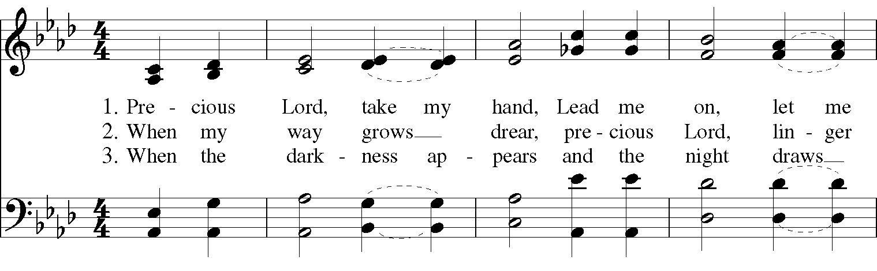

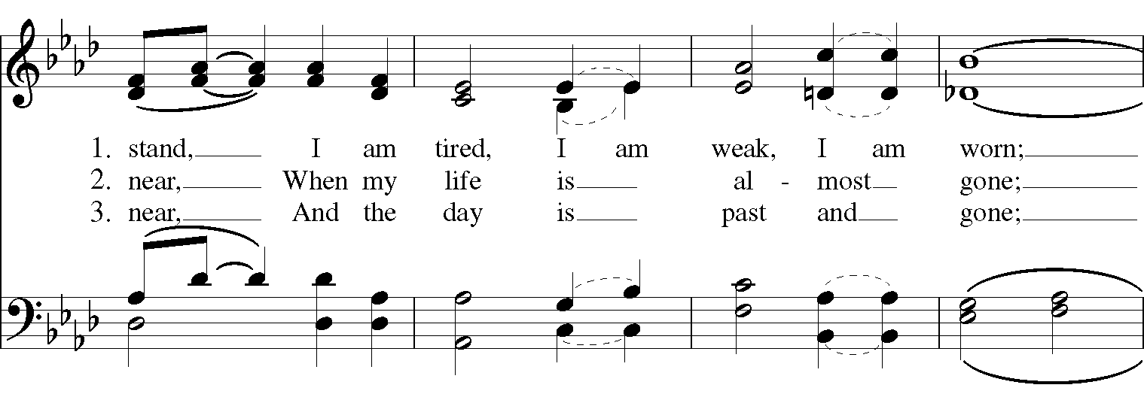

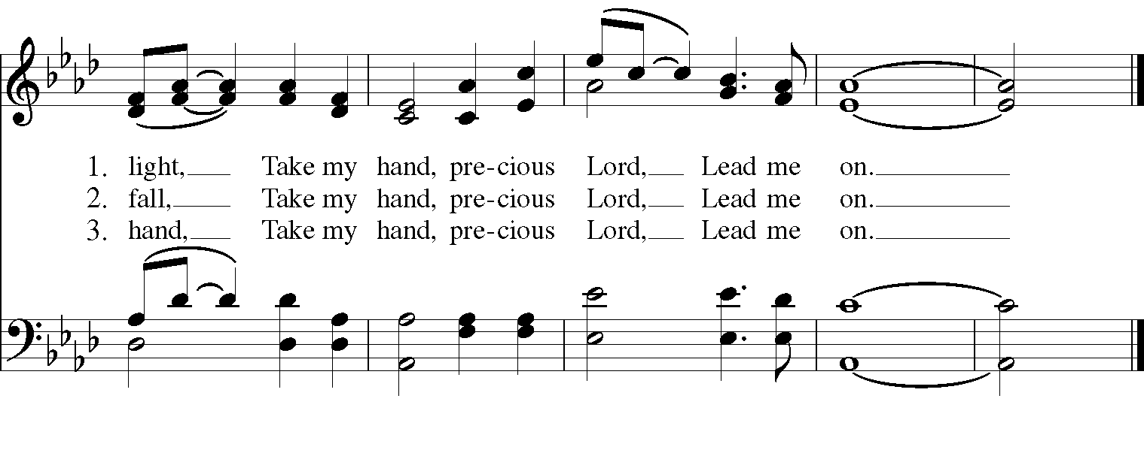
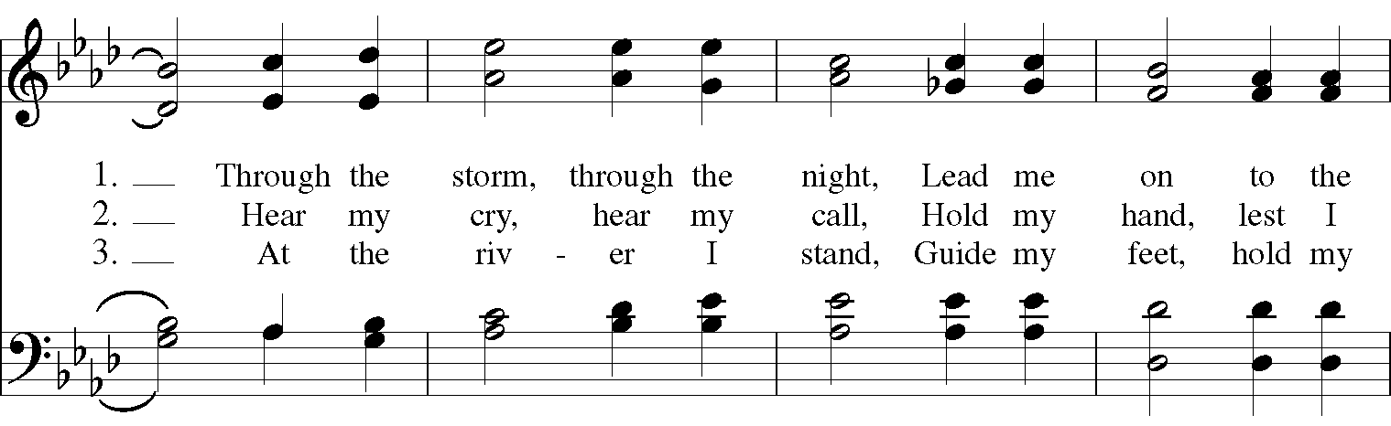

Celebrant: Blessed be God: Father, Son, and Holy Spirit.
People: And blessed be his kingdom, now and for ever. Amen.

The Collect of the Day
Celebrant: The Lord be with you.
People: And also with you.
Celebrant: Let us pray.
Blessed Lord, who caused all holy Scriptures to be written for our learning: Grant us so to hear them, read, mark, learn, and inwardly digest them, that we may embrace and ever hold fast the blessed hope of everlasting life, which you have given us in our Savior Jesus Christ; who lives and reigns with you and the Holy Spirit, one God, for ever and ever. Amen.

THE LESSONS

THE FIRST READING Daniel 12:1-3

The Lord spoke to Daniel in a vision and said, “At that time Michael, the great prince, the protector of your people, shall arise. There shall be a time of anguish, such as has never occurred since nations first came into existence. But at that time your people shall be delivered, everyone who is found written in the book. Many of those who sleep in the dust of the earth shall awake, some to everlasting life, and some to shame and everlasting contempt. Those who are wise shall shine like the brightness of the sky, and those who lead many to righteousness, like the stars forever and ever.”
Lector: The Word of the Lord.
People: Thanks be to God.

Psalm 116 Conserva me, Domine

1 Protect me, O God, for I take refuge in you; *
I have said to the Lord, "You are my Lord, my good above all other."
2 All my delight is upon the godly that are in the land, *
upon those who are noble among the people.
3 But those who run after other gods *
shall have their troubles multiplied.
4 Their libations of blood I will not offer, *
nor take the names of their gods upon my lips.
5 O Lord, you are my portion and my cup; *
it is you who uphold my lot.
6 My boundaries enclose a pleasant land; *
indeed, I have a goodly heritage.
7 I will bless the Lord who gives me counsel; *
my heart teaches me, night after night.
8 I have set the Lord always before me; *
because he is at my right hand I shall not fall.
9 My heart, therefore, is glad, and my spirit rejoices; *
my body also shall rest in hope.
10 For you will not abandon me to the grave, *
nor let your holy one see the Pit.
11 You will show me the path of life; *
in your presence there is fullness of joy, and in your right hand are pleasures for evermore.

THE SECOND LESSON Hebrews 10:11-25
Every priest stands day after day at his service, offering again and again the same sacrifices that can never take away sins. But when Christ had offered for all time a single sacrifice for sins, “he sat down at the right hand of God,” and since then has been waiting “until his enemies would be made a footstool for his feet.” For by a single offering he has perfected for all time those who are sanctified. [And the Holy Spirit also testifies to us, for after saying,
“This is the covenant that I will make with them
after those days, says the Lord:
I will put my laws in their hearts,
and I will write them on their minds,”
he also adds,
“I will remember their sins and their lawless deeds no more.”
Where there is forgiveness of these, there is no longer any offering for sin.]
Therefore, my friends, since we have confidence to enter the sanctuary by the blood of Jesus, by the new and living way that he opened for us through the curtain (that is, through his flesh), and since we have a great priest over the house of God, let us approach with a true heart in full assurance of faith, with our hearts sprinkled clean from an evil conscience and our bodies washed with pure water. Let us hold fast to the confession of our hope without wavering, for he who has promised is faithful. And let us consider how to provoke one another to love and good deeds, not neglecting to meet together, as is the habit of some, but encouraging one another, and all the more as you see the Day approaching.
Lector: The Word of the Lord.
People: Thanks be to God.

SQUENCE HYMN: “Come thou almighty King” Hymn 365

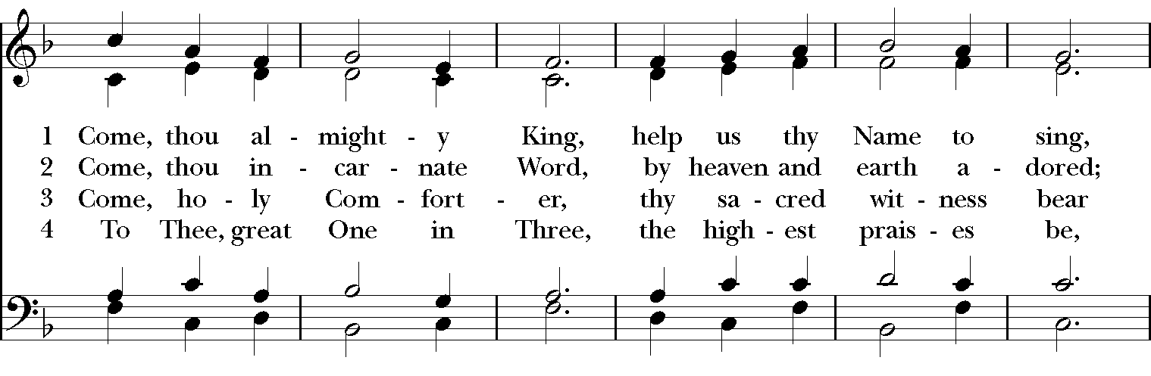

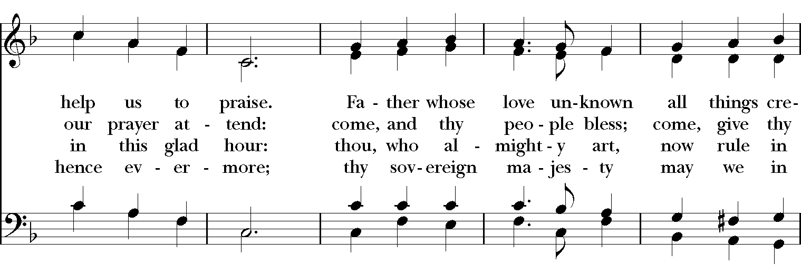

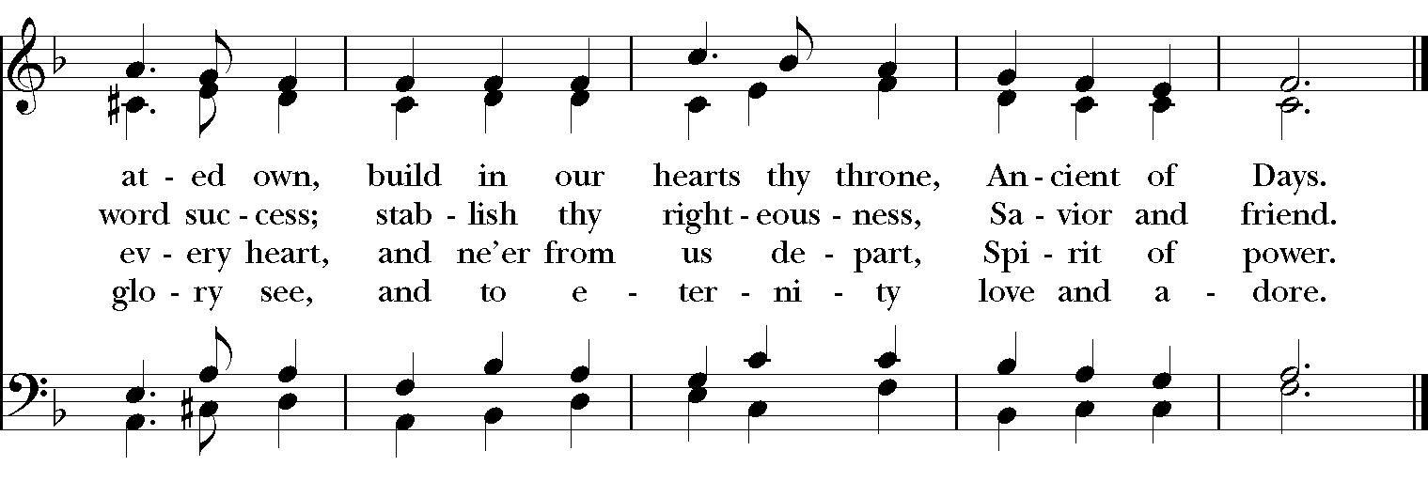

GOSPEL
Celebrant: The Holy Gospel of our Lord Jesus Christ according to Mark (Mark 13:1-8).
People: Glory to you, Lord Christ.
As Jesus came out of the temple, one of his disciples said to him, “Look, Teacher, what large stones and what large buildings!” Then Jesus asked him, “Do you see these great buildings? Not one stone will be left here upon another; all will be thrown down.”

When he was sitting on the Mount of Olives opposite the temple, Peter, James, John, and Andrew asked him privately, “Tell us, when will this be, and what will be the sign that all these things are about to be accomplished?” Then Jesus began to say to them, “Beware that no one leads you astray. Many will come in my name and say, ‘I am he!’ and they will lead many astray. When you hear of wars and rumors of wars, do not be alarmed; this must take place, but the end is still to come. For nation will rise against nation, and kingdom against kingdom; there will be earthquakes in various places; there will be famines. This is but the beginning of the birth pangs.”
Celebrant: The Gospel of the Lord.
People: Praise to you, Lord Christ.

Sermon The Rev. Canon Dr. Lee Anne Reat

The Nicene Creed
We believe in one God, the Father, the Almighty,
maker of heaven and earth, of all that is, seen and unseen.
We believe in one Lord, Jesus Christ, the only Son of God,
eternally begotten of the Father, God from God,
Light from Light, true God from true God,
begotten, not made, of one Being with the Father.
Through him all things were made.
For us and for our salvation he came down from heaven,
by the power of the Holy Spirit he became incarnate from the Virgin Mary,
and was made man.
For our sake he was crucified under Pontius Pilate;
he suffered death and was buried.
On the third day he rose again in accordance with the Scriptures;
he ascended into heaven and is seated at the right hand of the Father.
He will come again in glory to judge the living and the dead, and his kingdom will have no end.
We believe in the Holy Spirit, the Lord, the giver of life,
who proceeds from the Father, and the Son.
With the Father and the Son he is worshiped and glorified,
he has spoken through the Prophets.
We believe in one holy catholic and apostolic Church.
We acknowledge one baptism for the forgiveness of sins.
We look for the resurrection of the dead, and the life of the world to come. Amen.

THE PRAYERS OF THE PEOPLE

In peace, we pray to you Lord God. Congregational responses are in bold.
Silence

Giver of every good gift, we thank you for your generosity in giving us more than we can ask or imagine.

Give grace to church leaders, especially Justin, Archbishop of Canterbury; Michael, our presiding bishop; Wayne, our provisional diocesan bishop; Lee Anne, our priest; and members of the vestry. In your time, send us the priest this church needs.
R: Giver of every good gift, grant grace.
Give wisdom to world leaders in a time of pandemic and natural disasters. Give special grace to refugees and those seeking justice.
R: Giver of every good gift, grant wisdom.

Give hope to those suffering any illness or affliction, especially Leigh, Charlene, Faye, Chris, Bonnie, Alice, Diana, James, Joy, Jane, Joni, Kim, Sarah, Traudie, Lexie, and Keith.
R: Giver of every good gift, grant hope.

Give strength to those laboring in the ministries we support as a church especially Clark County Literacy Coalition, Episcopal Community Ministries, Second Harvest Food Bank, and Interfaith Hospitality Network.
R: Giver of every good gift, grant strength.

Give joy to those celebrating birthdays this week, especially Miles and Susan, and anniversaries Rick & Anne.
R: Giver of every good gift, grant joy.

Grant peace and light to those who have died and comfort to those who grieve.
R: Giver of every good gift, in the midst of loss grant hope.

*THE COLLECT FOR PEACE
Grant, O God, that your holy and life-giving Spirit may so move every human heart, that barriers which divide us may crumble, suspicions disappear, and hatreds cease; that our divisions being healed, we may live in justice and peace; through Jesus Christ our Lord. Amen.

THE CONFESSION AND ABSOLUTION
Priest: Let us confess our sins against God and our neighbor.
All: Most merciful God, we confess that we have sinned against you in thought, word, and deed, by what we have done, and by what we have left undone. We have not loved you with our whole heart; we have not loved our neighbors as ourselves. We are truly sorry and we humbly repent. For the sake of your Son Jesus Christ, have mercy on us and forgive us; that we may delight in your will, and walk in your ways, to the glory of your Name. Amen.

Priest: Almighty God, have mercy on you, forgive you all your sins through our Lord Jesus Christ, strengthen you in all goodness, and by the power of the Holy Spirit keep you in eternal life. Amen.

And now, as our Savior Christ has taught us, we are bold to say:
Our Father, who art in heaven, hallowed be thy Name,
thy kingdom come, thy will be done, on earth as it is in heaven.
Give us this day our daily bread.
And forgive us our trespasses, as we forgive those who trespass against us.
And lead us not into temptation, but deliver us from evil.
For thine is the kingdom, and the power, and the glory, for ever and ever. Amen

CLOSING HYMN: “Praise my soul, King of Heaven” Hymnal 410
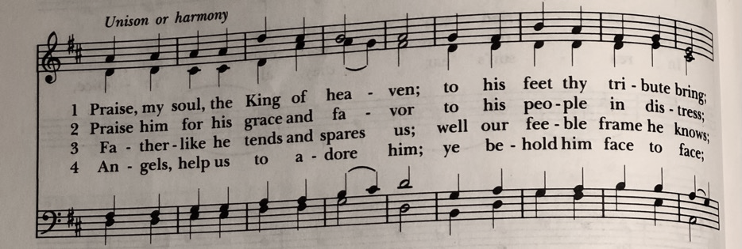

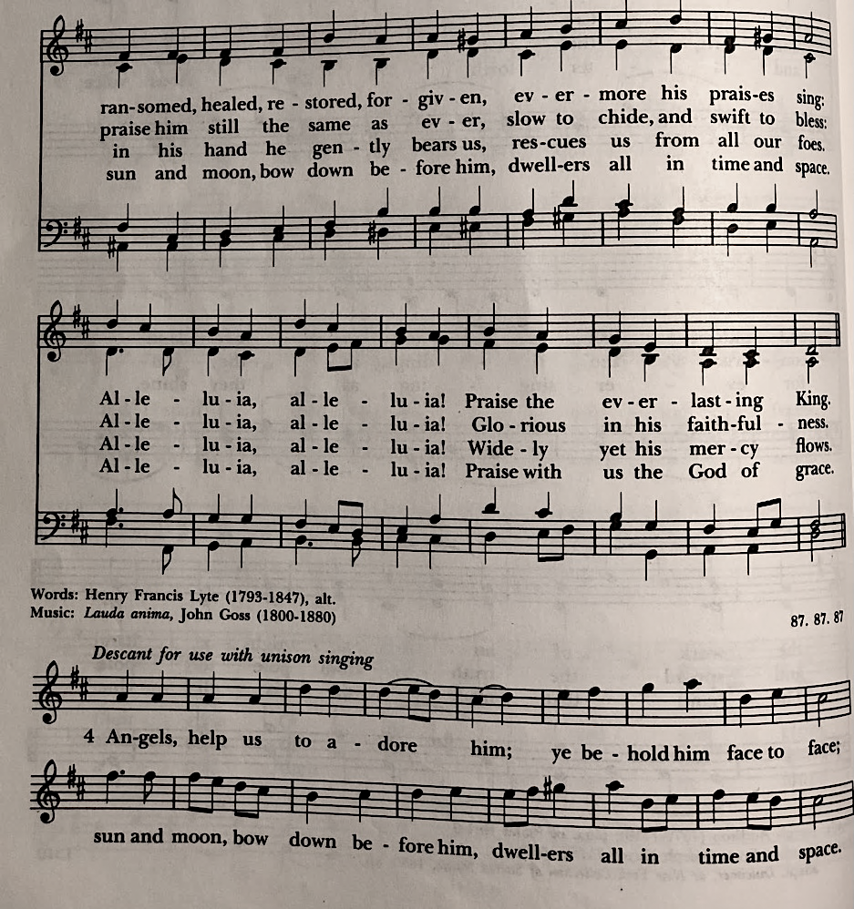

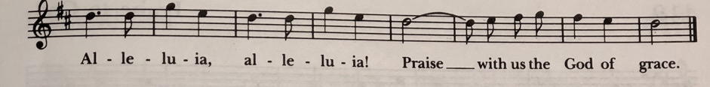

*THE BLESSING
Christ who has nourished us with himself the living bread, make you one in praise and love, and raise you up at the last day; and the blessing God Almighty, the Father, the Son, and the Holy Spirit, be among you, and remain with you always. Amen.

ANNOUNCEMENTS

*THE DISMISSAL Celebrant: Go in peace to love and serve the Lord.
People: Thanks be to God.

POSTLUDE: “Allegro“ from Sonata in C Major K545 – Mozart

Thank you for your spiritual presence with us this morning!
Although we're physically apart, we are united in prayer, worship, and holy love!
Priest-In-Charge: The Rev. Dr. Canon Lee Anne Reat
Music Director: Dr. Chris Durrenberger
Lector: Liz Wheeler
Singers: Liz Wheeler, Joy Carter, Basil Fett, Chris Oldstone-Moore, and Fred Bartenstein
Technology: Steve Ide
Slideshow: Ed Hasecke
Parish Administrator and Program Coordinator: Kelly Zeller

